Objectives:
- Design and deploy a scalable network architecture using AWS Transit Gateway to simplify network connectivity between multiple VPCs.
- Configure VPC endpoints to securely access AWS services without internet gateways or NAT gateways, ensuring data privacy and minimizing exposure to external threats.
Note:
- Create 4 VPCs in 4 different regions and set up Transit Gateway.
- Do not use default VPCs.
- Prepare a document with all the screenshots and push it to a GitHub repo, then share the URL.

- Step1: 4 Different IP Address
- 1.) VPC-A (N. Virginia, us-east-1) 10.0.0.0/16
- 2.) VPC-B (OHIO -us-east-2) → 10.1.0.0/16
- 3). VPC-C (California, us-west-1) 10.2.0.0/16
- 4.) VPC-D (Oregon, us-west-2) → 10.3.0.0/16

- Step2: Create 4 VPCS in Different regions
- Go to VPC Console Create VPC VPC Settings VPC Only Name
- VPC-1 N.Virginia IPv4 CIDR 10.0.0.0/16 Create VPC
- Subnets:
- Create 4 Private subnets in different regions
- Route Tables:
- Create a 4 Route Table for each set of subnets and associate them
- Attached IGW to One VPC (N.Virginia

Vpc of viriginia
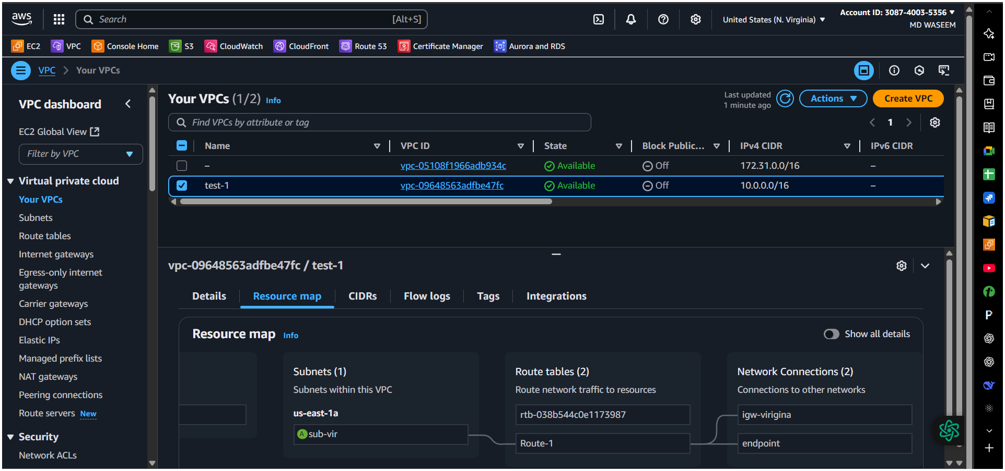

Vpc of ohio
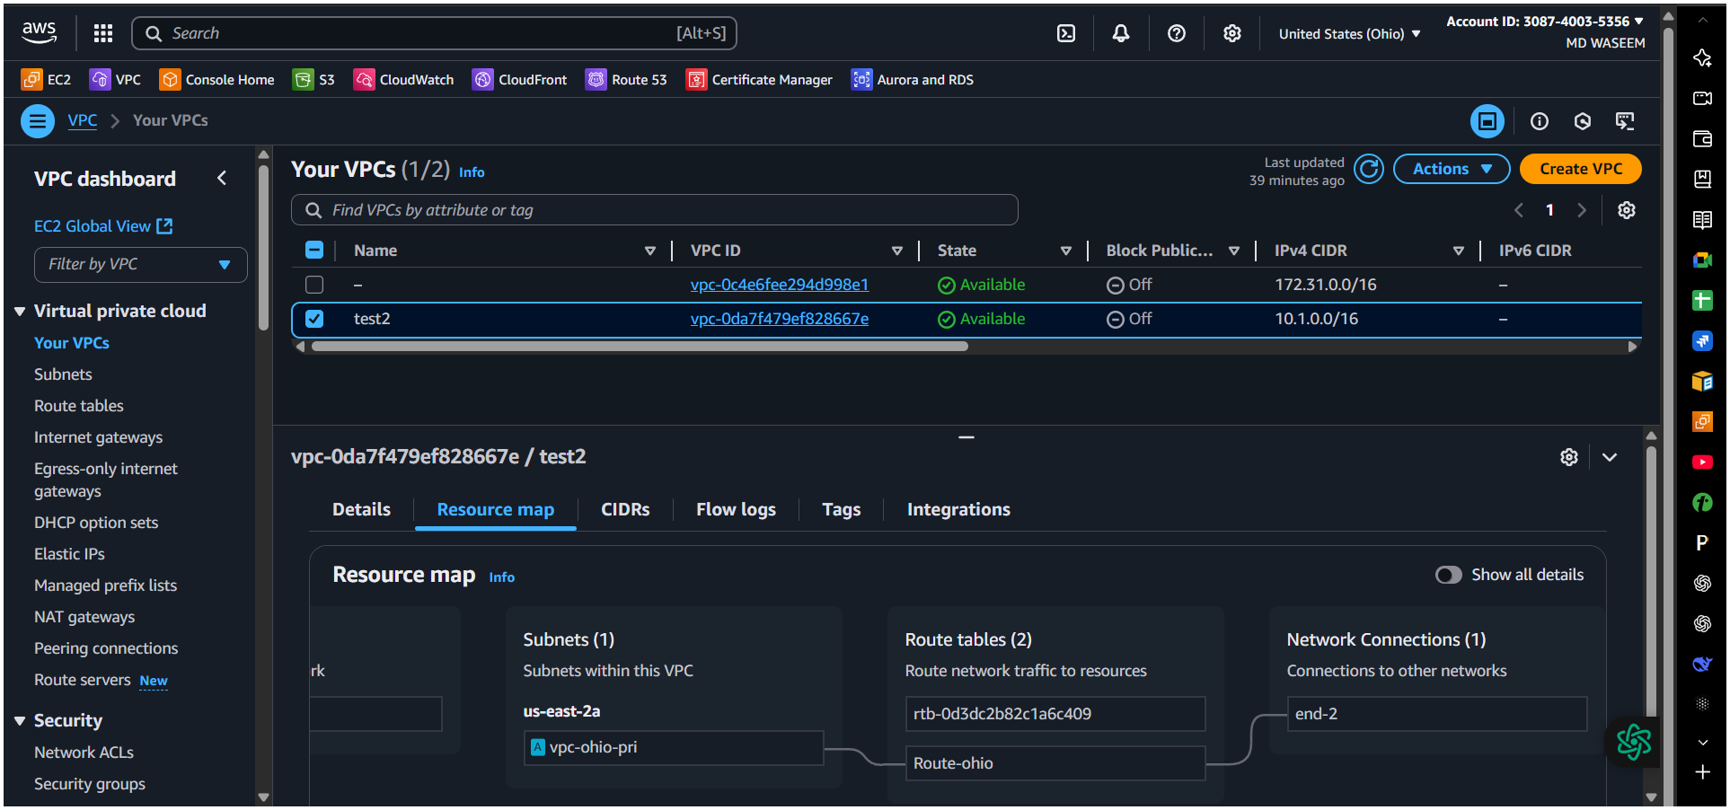

Vpc of california
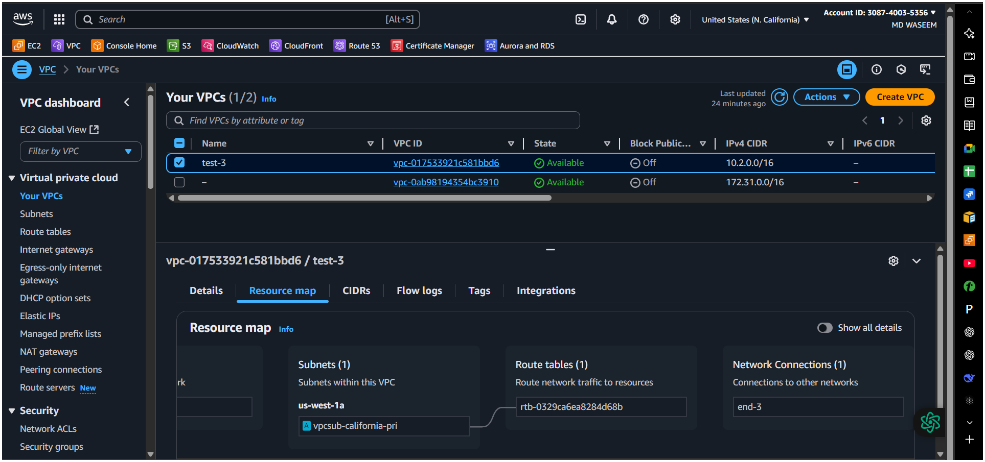

Vpc of oregon
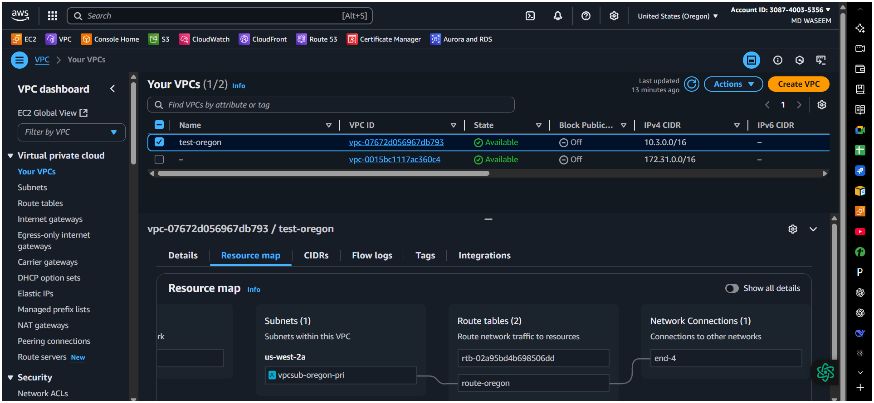

Here we are creating vpc subnet route and its internet gatway(only in primary region)
Step 3: Create Transit Gateways:
a. Create a Transit Gateway
VPC Console → Transit Gateways → Create transit gateway
Transit of virginia
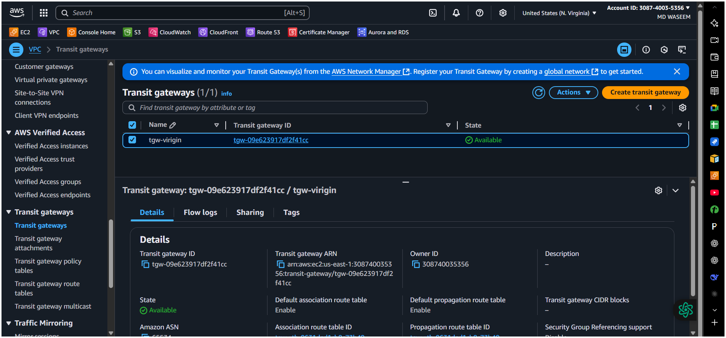
Now we have to create transit gateway in all region and also need to add transit gateway attachment and finally need to add peering by adding transit gateway id of all region at a time
  - Transit gateway of ohio
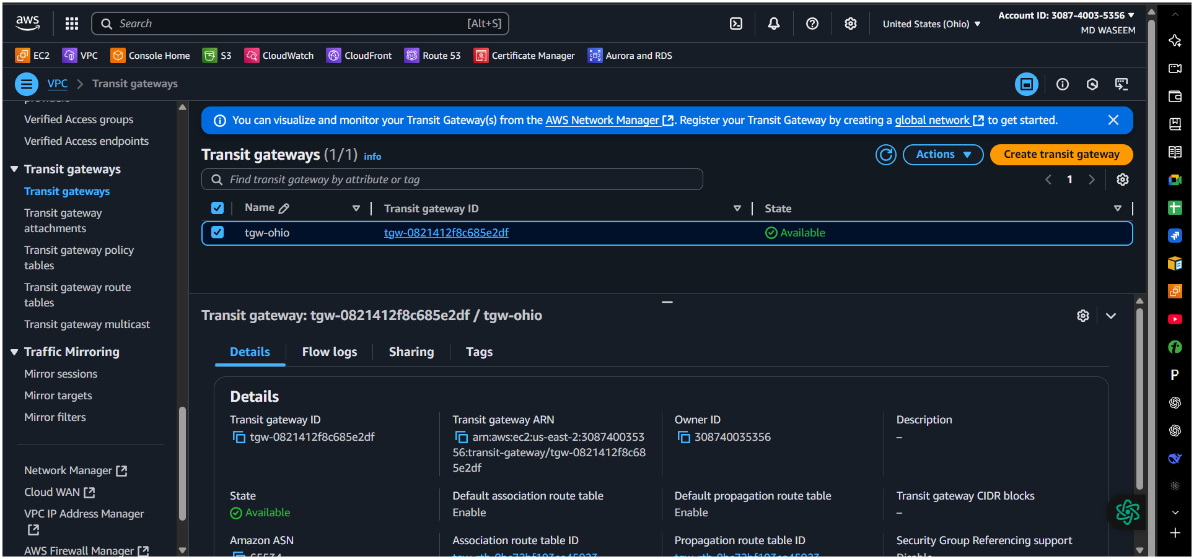
  - Transit gateway from California
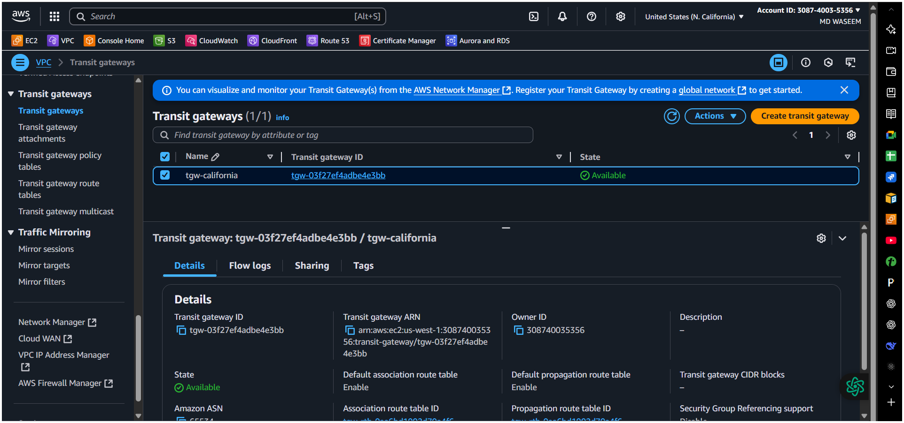

Transit gateway from Oregon
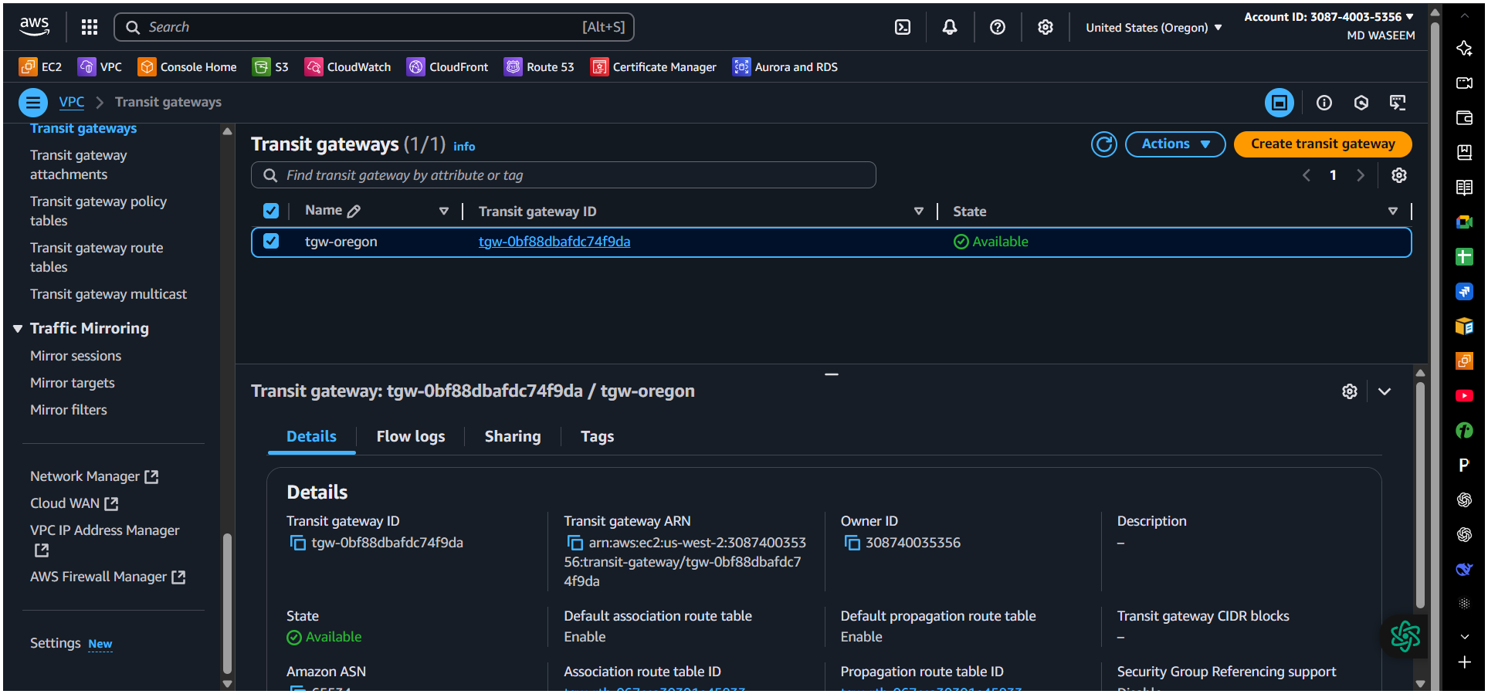
  - Sending request from primary region (Virginia)
  - The one which selected are peering connected with another region.

- Go to Transit Gateway Attachments → Create transit gateway attachment
- Attachment type: VPC
- Choose VPC: Select the regional VPC
- Subnets: Select private subnets
- Create attachment
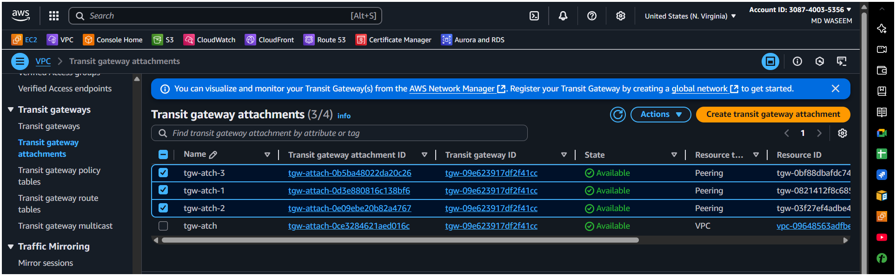

Peering accepted from ohio
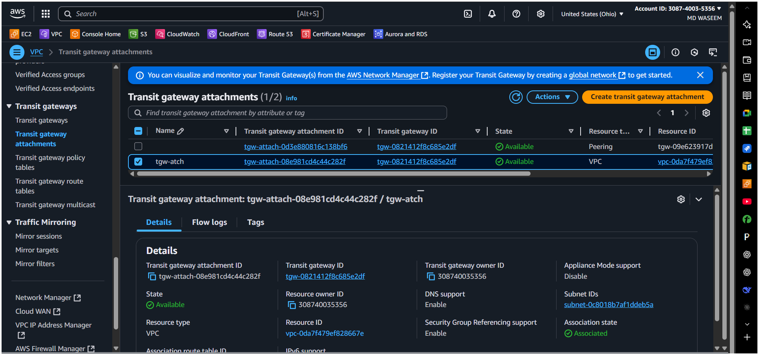

peering accepted from California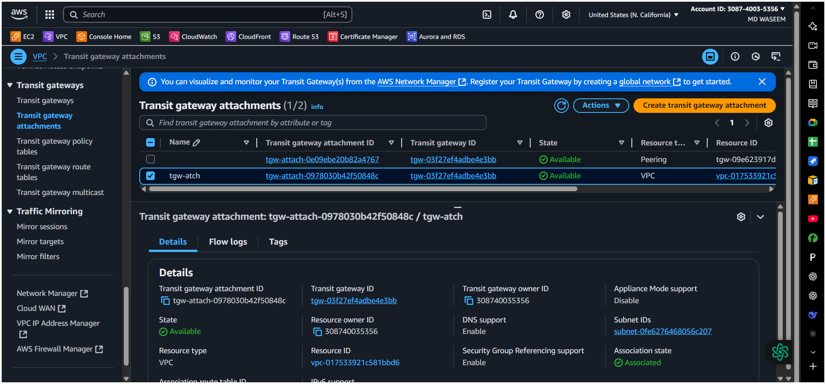

Here we have accepted from Oregon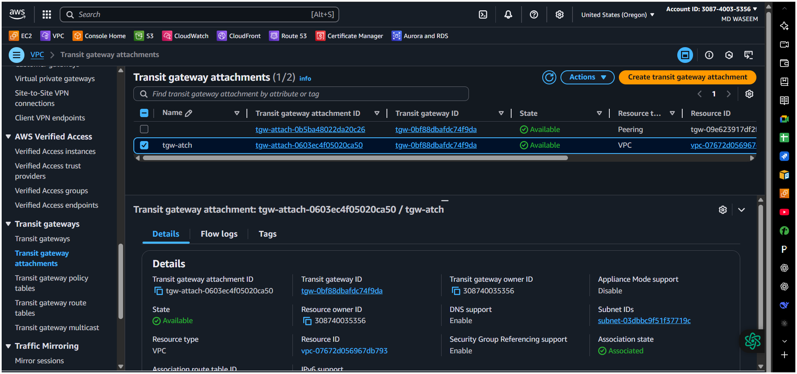

Here in transit gateway route table Route tab VPC CIDR range of all region except the current region (Virginia)

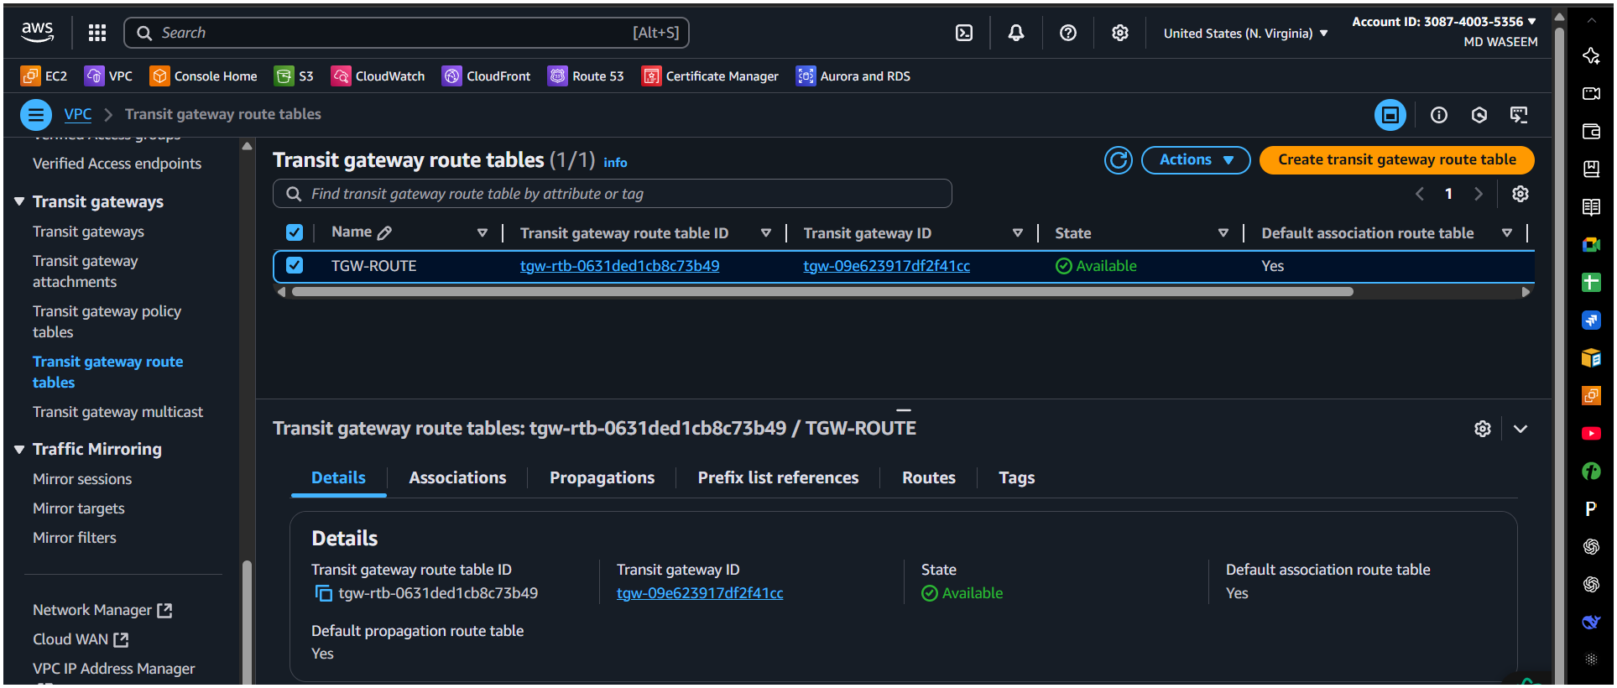

Here is the added CIRD ranges of all other region. (virginia)
. Associate VPC Attachment with TGW Route Table
Navigate: Transit Gateway Route Tables
Select TGW’s route table
Choose Associations → Create association
Pick the VPC attachment.
d. Update VPC Route Tables
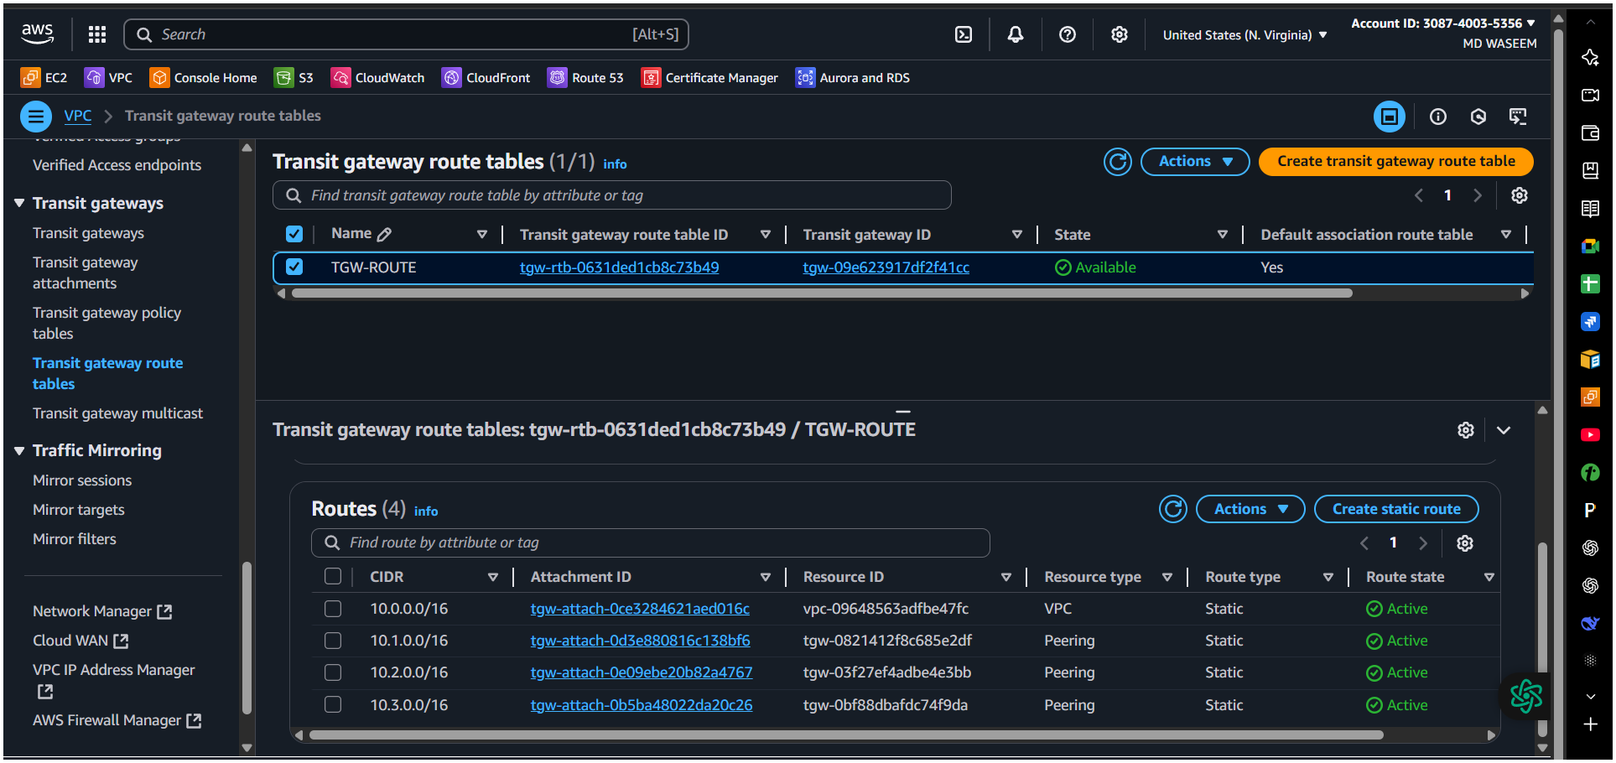
here we add the CIRD of all other region except the current region
Route of ohio
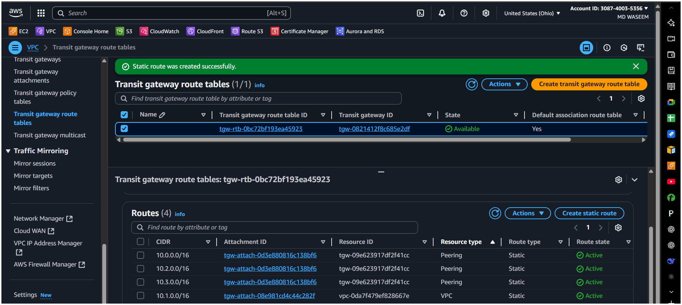

Route of California here we have add of CIDR range of other except the current
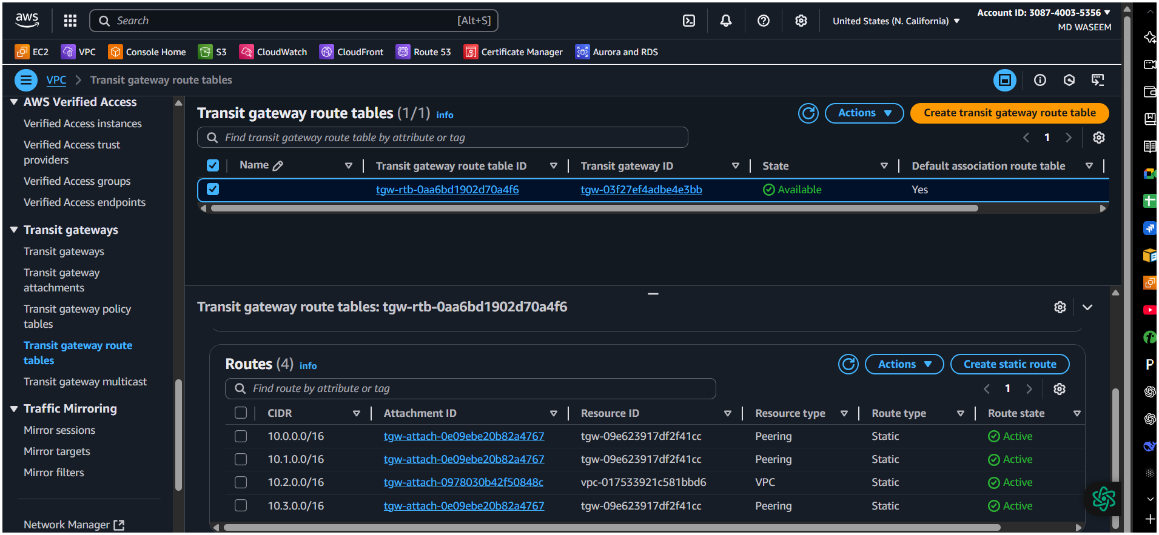
Route from Oregon add CIRD of all region except the current region.
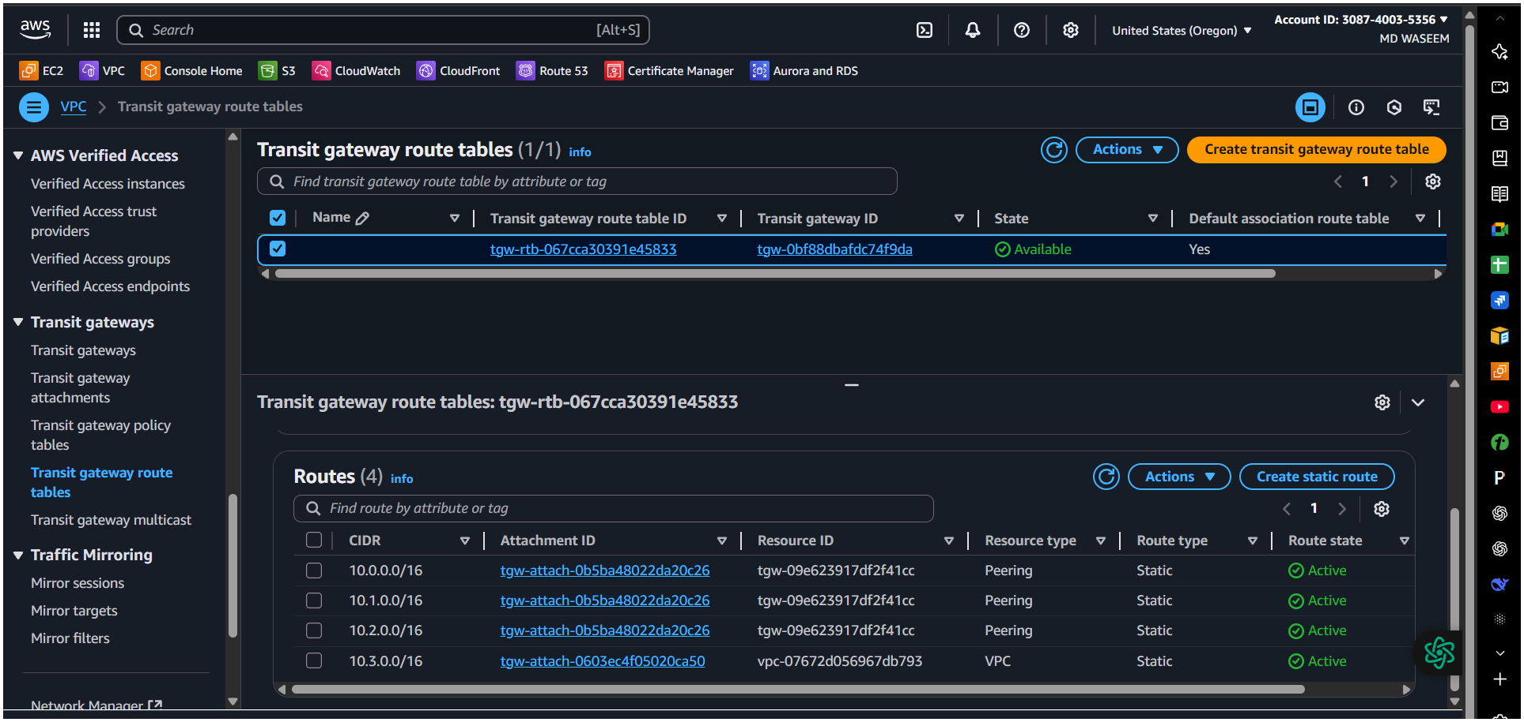

Now vpc route add the same CIRD of other region add in (Destination) and in transit gateway (target)
Do the same in all other region by add CIDR range and select transit gateway In target.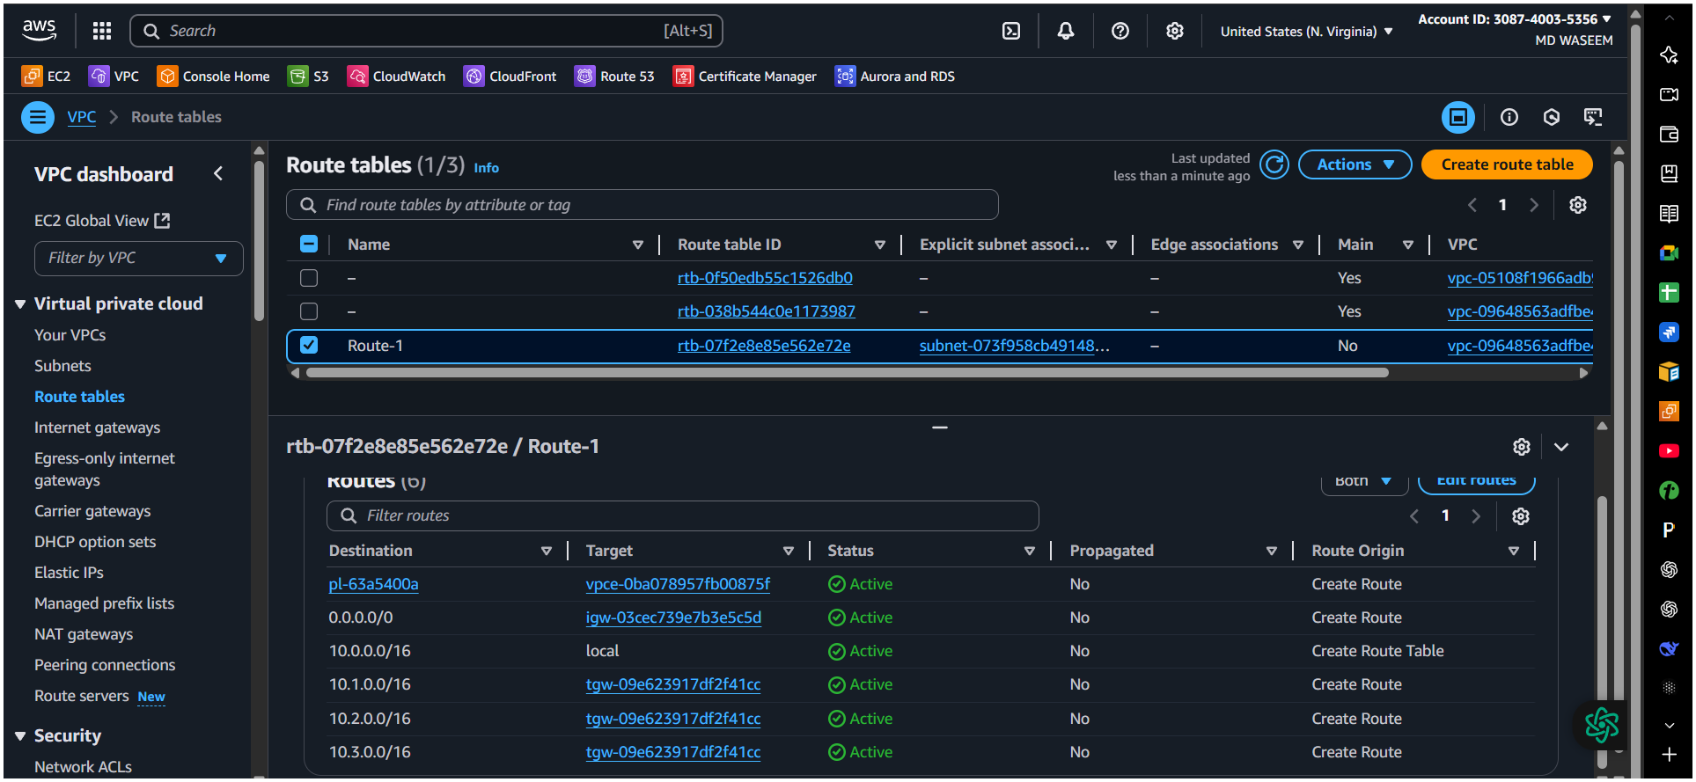

Now we need to create Endpoint all of region.
Create Endpoint add this in servicesearch of s3 (type) gateway.
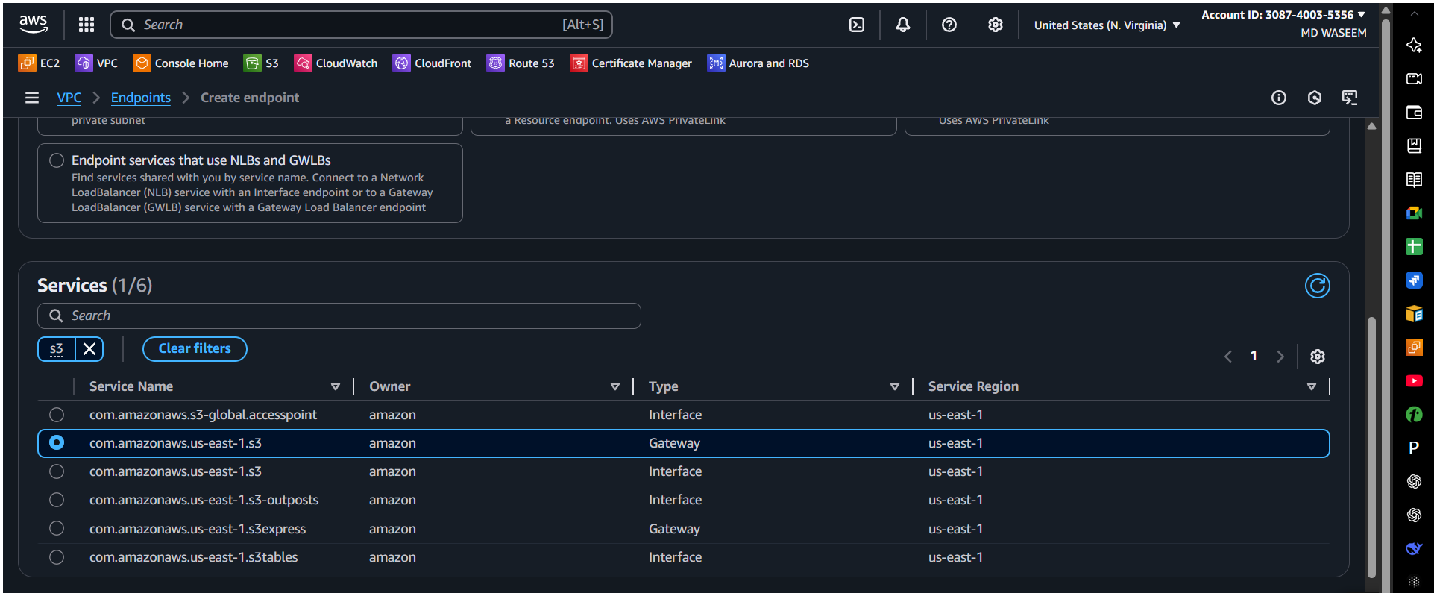
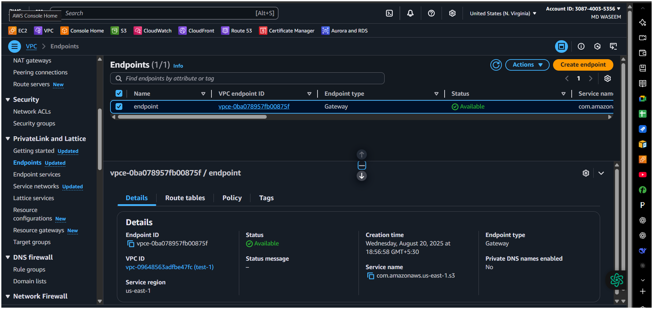

Now create instances for all 4 region
Instances of virginia 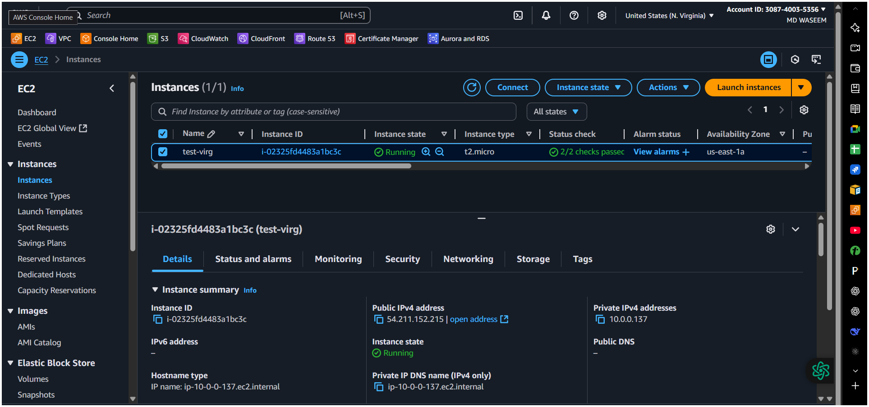
Now create all other 3 region instances same as the above

Now here we all set to make ping (check connection)
Connecting from Virginia to ohio✅
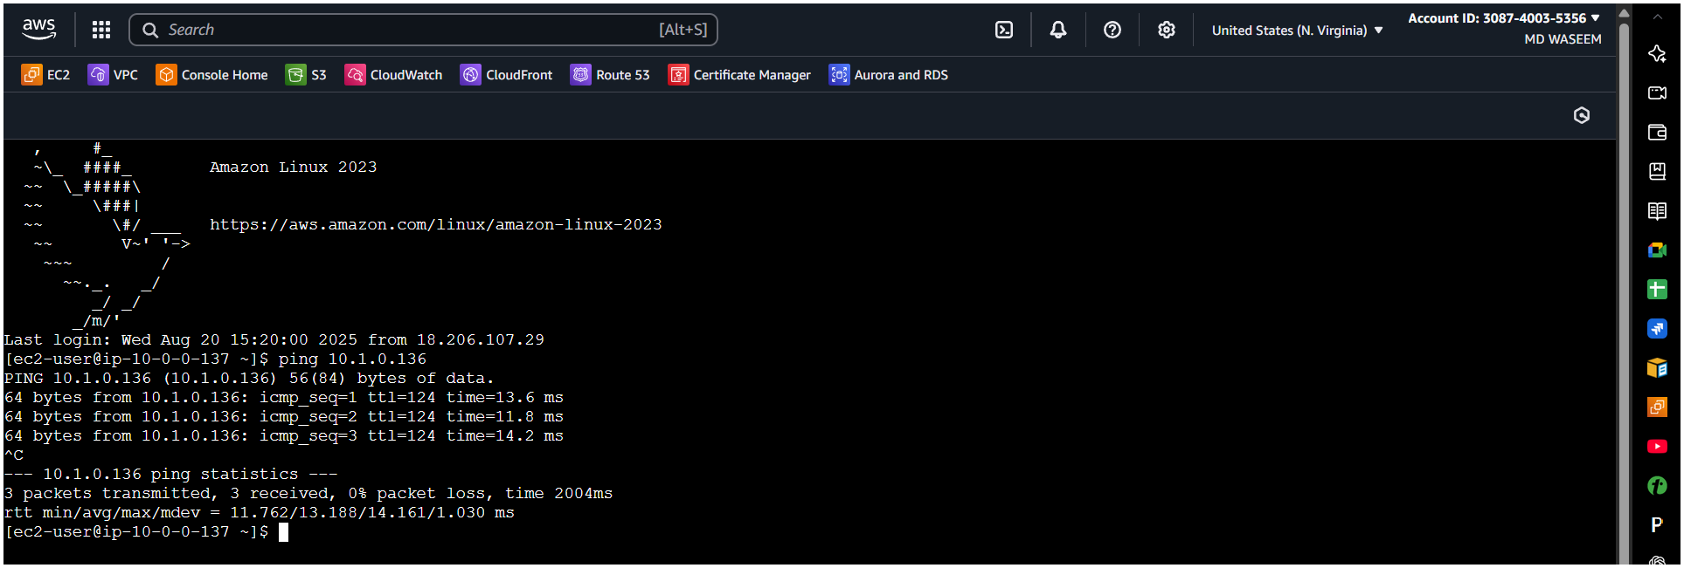
Connecting from Virginia to California ✅
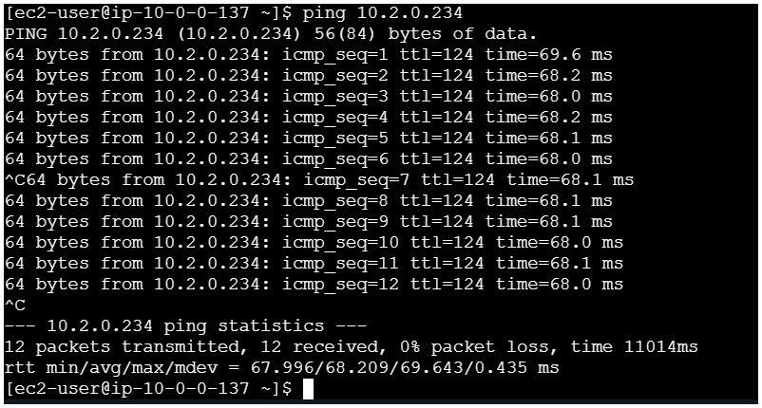

Connecting from Virginia to Oregon✅
