Brief Explanation of RDS
Amazon RDS (Relational Database Service) is a managed database service that simplifies setup, operation, and scaling of relational databases in the cloud. It automates administrative tasks like hardware provisioning, database setup, patching, and backups while providing cost-efficient and resizable capacity.
1) Create Mariadb Db On Ec2.
MARIA DB INSTALLATION
# Update system
sudo dnf update -y
# Search available MariaDB versions
sudo dnf search mariadb
# Install MariaDB server (default version in AL2023 is 10.5+)
sudo dnf install -y mariadb105-server
# Enable and start MariaDB
sudo systemctl enable --now mariadb
# Check status
systemctl status mariadb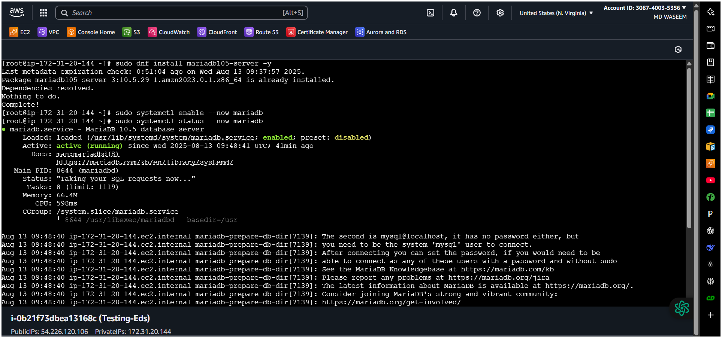
Here I have installed in bash
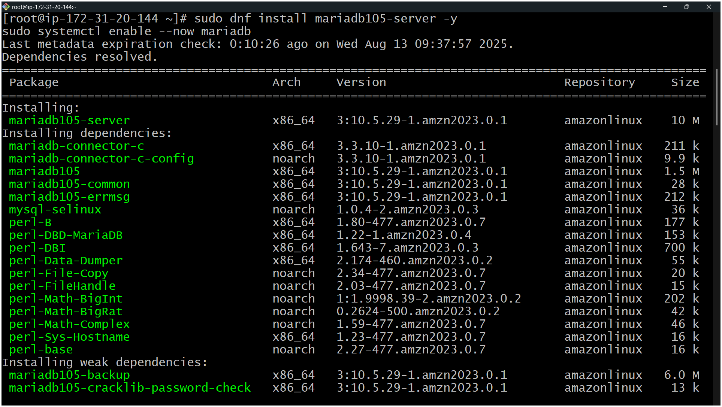
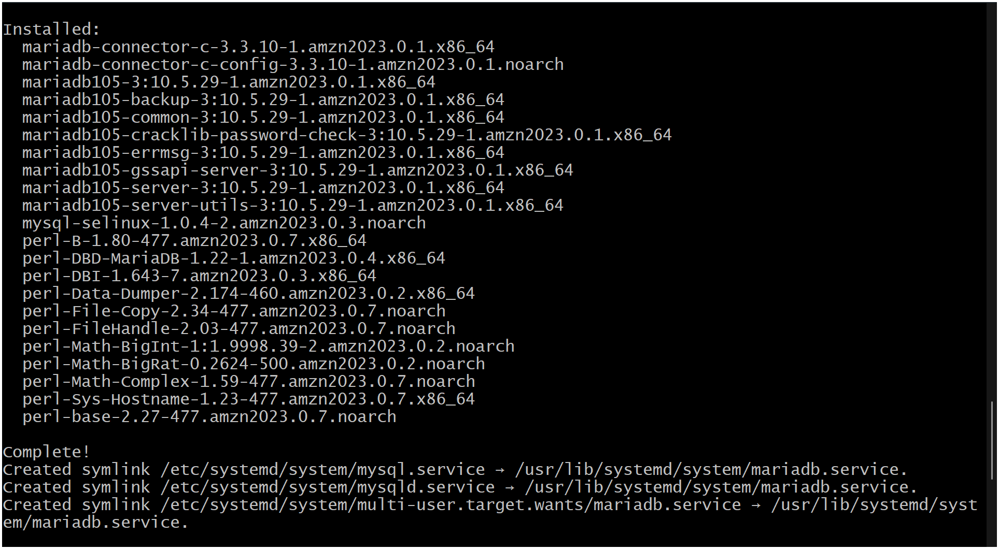
Lsof -i tcp:3306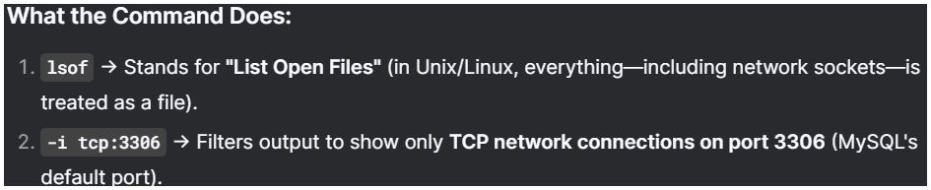
Set Environmental Variables
===========================
DBName=ec2db
DBPassword=admin123456
DBRootPassword=admin123456
DBUser=ec2dbuser
Database Setup on EC2 Instance:
===============================
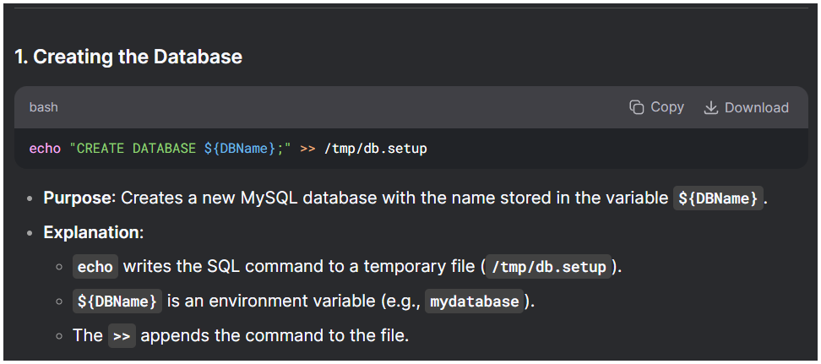
echo "CREATE DATABASE ${DBName};" >> /tmp/db.setup

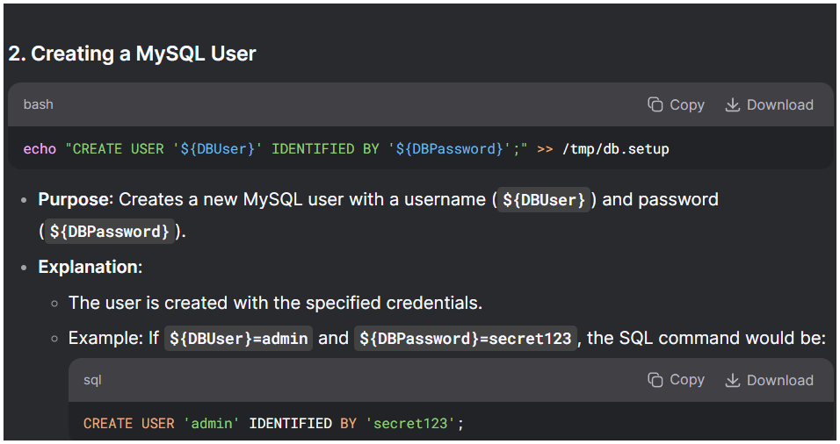
echo "CREATE USER '${DBUser}' IDENTIFIED BY '${DBPassword}';" >> /tmp/db.setup
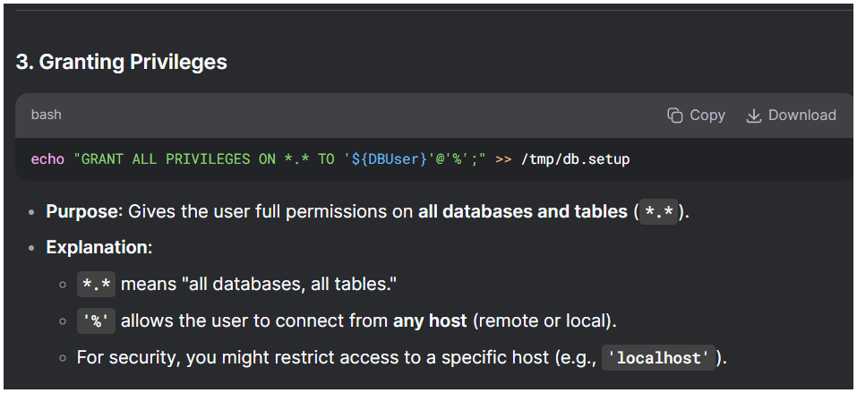
echo "GRANT ALL PRIVILEGES ON *.* TO '${DBUser}'@'%';" >> /tmp/db.setup
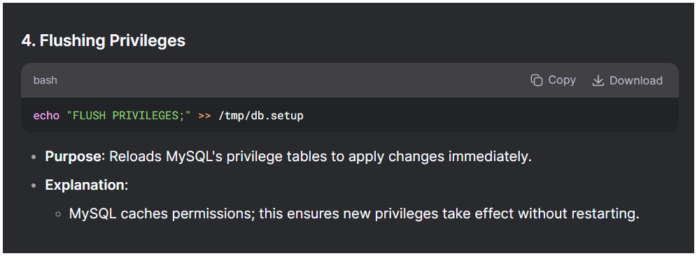
echo "FLUSH PRIVILEGES;" >> /tmp/db.setup
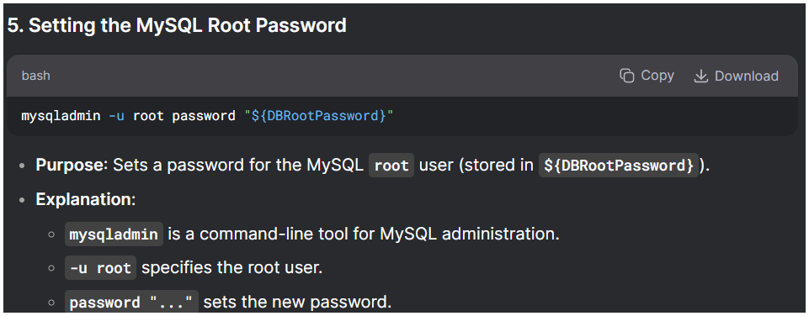
mysqladmin -u root password "${DBRootPassword}"
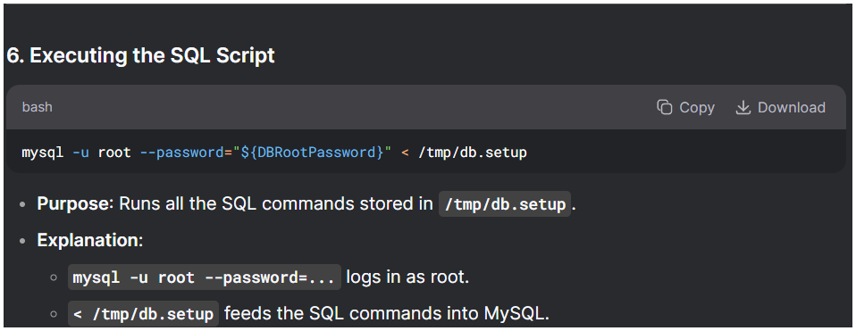
mysql -u root --password="${DBRootPassword}" < /tmp/db.setup
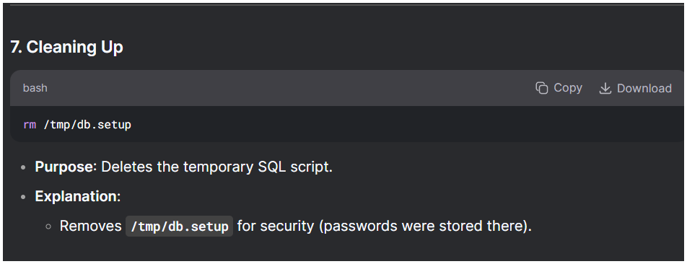
rm /tmp/db.setup
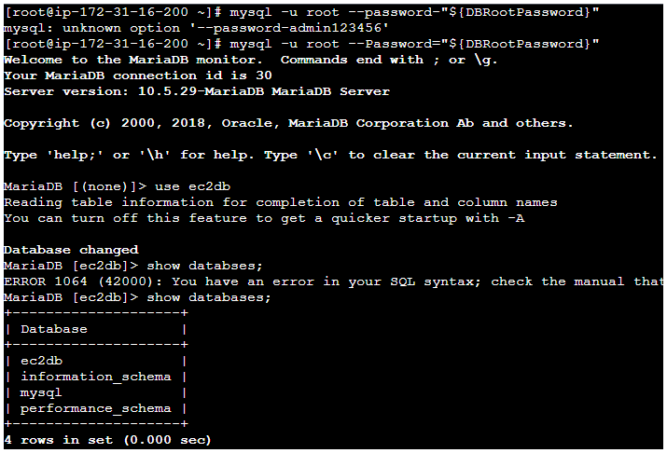
Show databases;
Why these settings?
- EBS gp3 gives predictable SSD performance and lets you raise IOPS/throughput separately from size (good for DBs.
- Locking 3306 to known sources reduces exposure.

1. Deployment & High Availability (HA)
Setting | Aurora | RDS for MariaDB
Multi-AZ Deployment | ✅ Yes (Aurora Replicas) | ✅ Yes (Standby instance)
Read Replicas | ✅ Up to 15 (low-latency, auto-scaling) | ✅ Up to 5 (async replication)
Failover Time | ~30 sec (faster) | ~60-120 sec (slower)
Storage Auto-Scaling | ✅ Yes (10GB → 128TB) | ✅ Yes (up to 64TB)
Key Differences:
- Aurora uses a shared storage cluster, while RDS MariaDB uses traditional EBS volumes.
- Aurora Replicas share storage, reducing replication lag compared to RDS async replicas.

2. Performance & Scaling
Setting | Aurora | RDS for MariaDB
Storage Type | SSD-backed, auto-scaling | GP2/GP3/IO1 (EBS)
Max Connections | Higher (depends on DB size) | Limited by instance type
Parallel Queries | ✅ Yes (Aurora MySQL) | ❌ No
Scaling (Reads) | ✅ Fast (Aurora Replicas) | ✅ Manual (Read Replicas)
Scaling (Writes) | ✅ Fast (Aurora Serverless v2) | ❌ Requires manual upgrade
Key Differences:
- Aurora has 5x performance boost over standard MySQL/MariaDB due to optimized storage and caching.
- RDS MariaDB is more traditional, with predictable EBS-based performance.

3. Backup & Recovery
Setting | Aurora | RDS for MariaDB
Automated Backups | ✅ Yes | ✅ Yes
Point-in-Time Recovery (PITR) | ✅ Yes | ✅ Yes
Backup Retention | 1-35 days | 1-35 days
Snapshot Export to S3 | ✅ Yes | ✅ Yes
Fast Cloning | ✅ Yes (copy-on-write) | ❌ No
Key Differences:
- Aurora allows instantaneous snapshots (no performance impact).
- RDS MariaDB backups may slow down I/O during snapshots.

4. Security & Compliance
Setting | Aurora | RDS for MariaDB
Encryption at Rest | ✅ Yes (KMS) | ✅ Yes (KMS)
Encryption in Transit | ✅ Yes (SSL/TLS) | ✅ Yes (SSL/TLS)
IAM Authentication | ✅ Yes | ✅ Yes
Network Isolation (VPC) | ✅ Yes | ✅ Yes
Automated Patching | ✅ Yes | ✅ Yes
Key Differences:
- Both support AWS KMS encryption, but Aurora has tighter integration with IAM roles.

5. Cost Comparison
Setting | Aurora | RDS for MariaDB
Pricing Model | Per vCPU + storage | Per instance + storage
Storage Cost | Higher (but more efficient) | Lower (EBS-based)
Serverless Option | ✅ Aurora Serverless v2 | ❌ No
Key Differences:
- Aurora is ~20% more expensive but offers better performance.
- RDS MariaDB is cheaper for small workloads.

6. When to Use Which?
Choose Aurora If:
✔ Need high performance (5x faster than MySQL/MariaDB).
✔ Want automatic scaling (Aurora Serverless v2).
✔ Need low-latency read replicas (Aurora Replicas).
Choose RDS for MariaDB If:
✔ Prefer traditional MariaDB compatibility.
✔ Have budget constraints (cheaper for small workloads).
✔ Don’t need Aurora’s advanced features.

Final Recommendation
- For mission-critical, high-performance apps → Aurora.
- For cost-sensitive, traditional MariaDB workloads → RDS MariaDB.

2) Insert Some Dummy Data

IN mariadb type the below
- Create table student (id INT, name VARCHAR (45));
- INSERT INTO student VALUES (1,’Emran’);
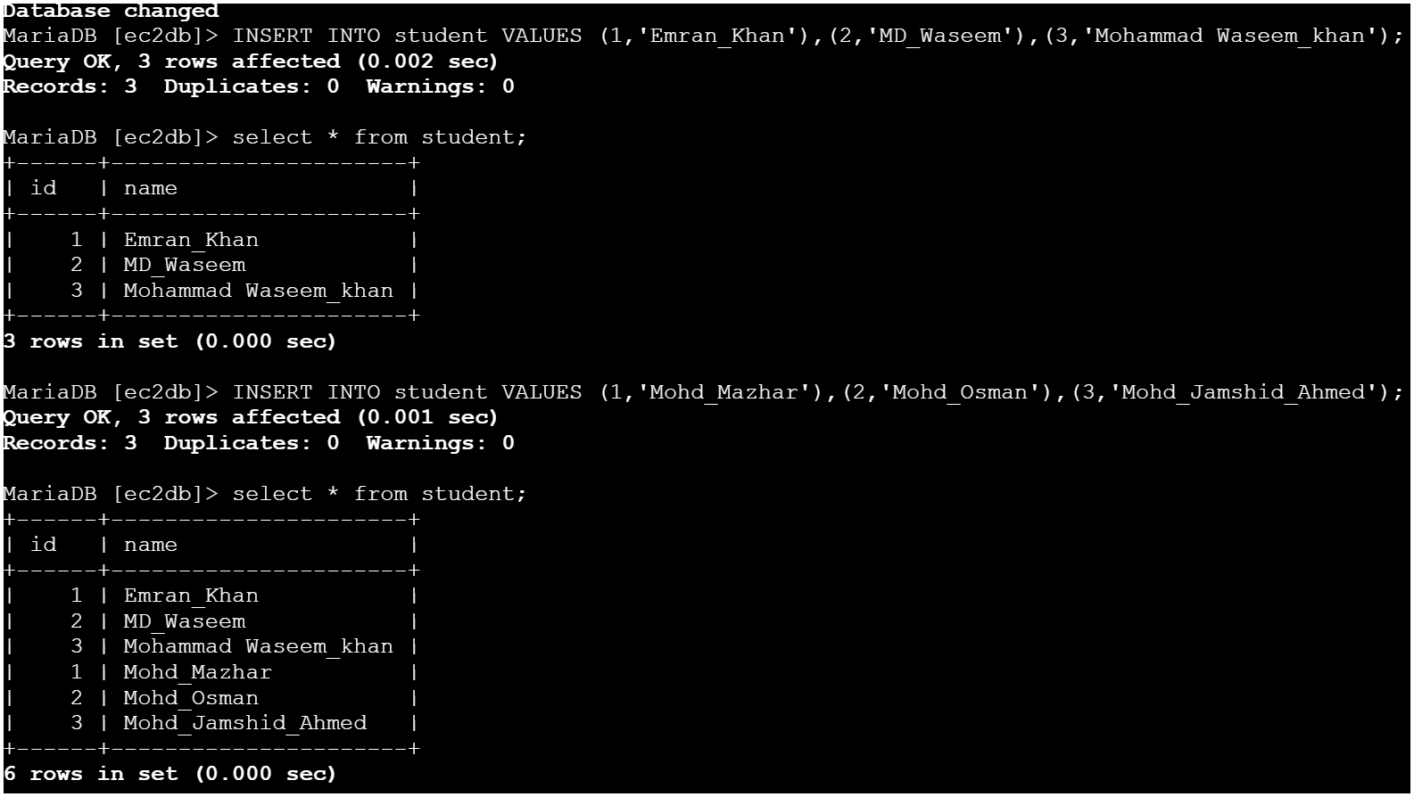

3) Take The Backup Of Dummy Data On Ec2
1. Backup of ec2db →(stay in root user and type this)
mysqldump -u root -p ec2db > /tmp/ec2db.sql
Enter password:
2. Dump file saved at /tmp/ec2db.sql
3. Checking file exist or not. ls -lh /tmp/ec2db.sql
4. View content head /tmp/ec2db.sql
5) launch MariaDB RDS instance.
Open AWS Console → RDS → Databases → Create
database
Engine options → Choose MariaDB
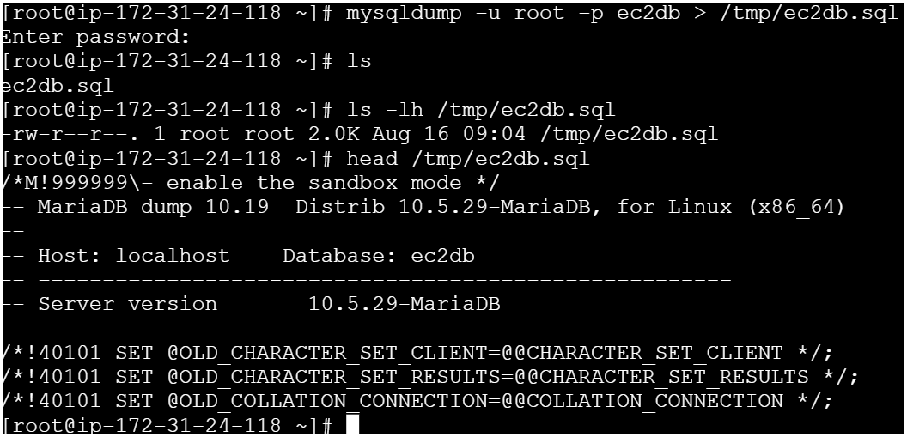
4) Launch Mariadb RDS Instance.
- Open AWS Console → RDS → Databases → Create
Database
- Engine options → Choose MariaDB
- Version → Choose e.g. 10.6
- Templates → “Free tier” or “Production”
- DB instance identifier → e.g., mariadb-lab
- Master username → admin
- Master password → set strong password
- Instance configuration → Choose db.t3.micro for free tier
- Connectivity →
- ● VPC: Choose your VPC
- ● Public access: No (recommended)
- ● Security group: Choose SG that allows port 3306 from EC2
- Database authentication → Password authentication
Click Create database
Wait for Status → Available
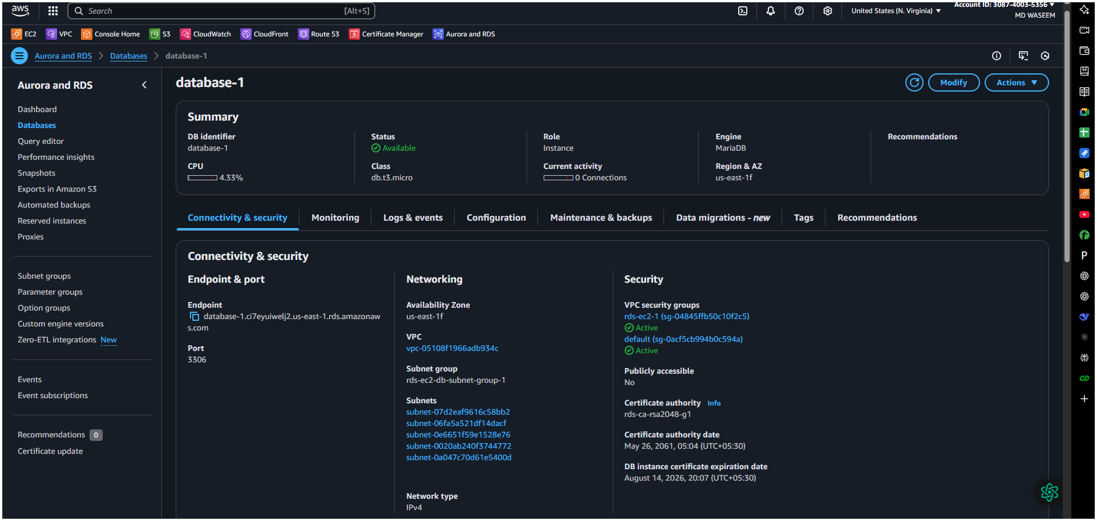
5) Migrate Database From Ec2 To RDS.
. Get the dump of your existing DB on EC2
Taking backup →(stay in root use and type this)
mysqldump -u root -p ec2db > ec2db.sql
2. Login to maridb
mysql -h database-1.c030o8c66sum.us-
east-1.rds.amazonaws.com -P 3306 -u admin -p
Enter Password
3. Create Database Rdsdb; And Exit
I got this error cause I have already created before ( for testing )
4. Migrate the DB dump that you have taken in step 1 to RDS.
mysql -h database-1.c030o8c66sum.us-
east-1.rds.amazonaws.com -P 3306 -u admin -p rdsdb < ec2db.sql
Enter Password Of Your Database Here
5. Connect to your RDS DB instance
mysql -h database-1.c030o8c66sum.us-
east-1.rds.amazonaws.com -P 3306 -u admin -p
Enter the password of your database here

6.Show databases;
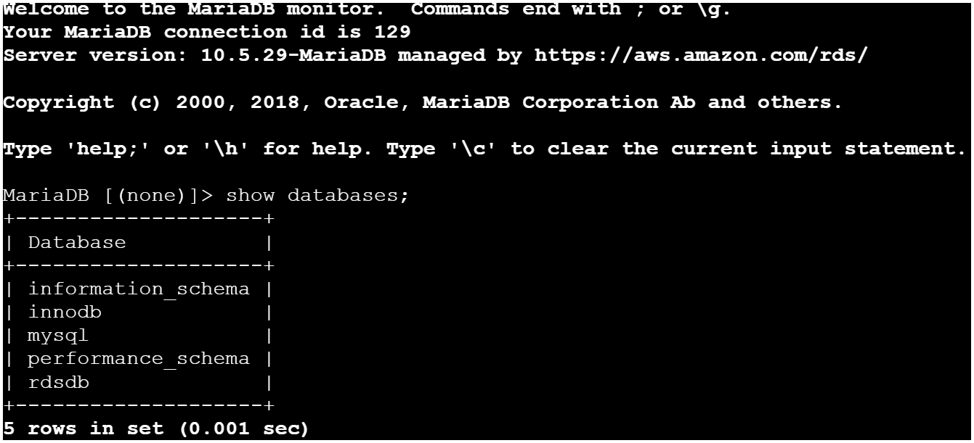

7. Use rdsdb;
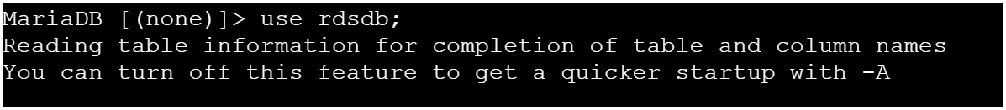
8. Show tables;
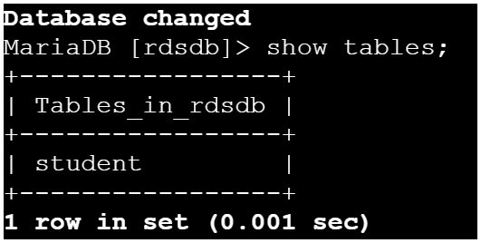
9. Describe student;
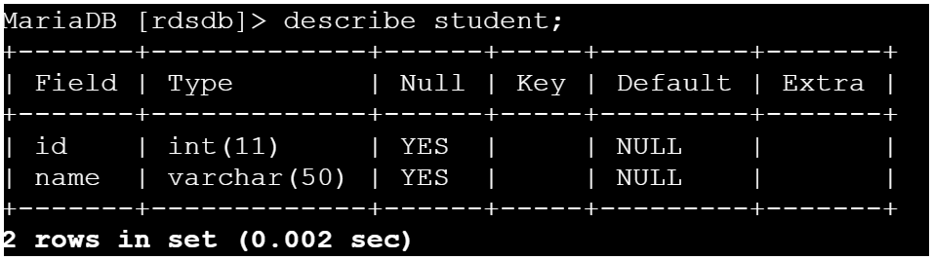
10. Select * from student;
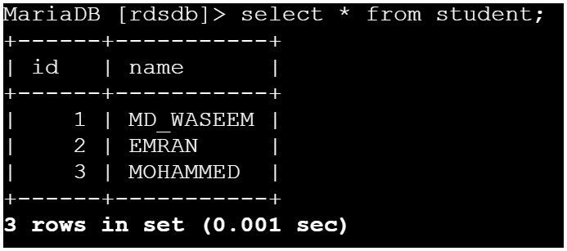
6) Install MySQL DB on ec2
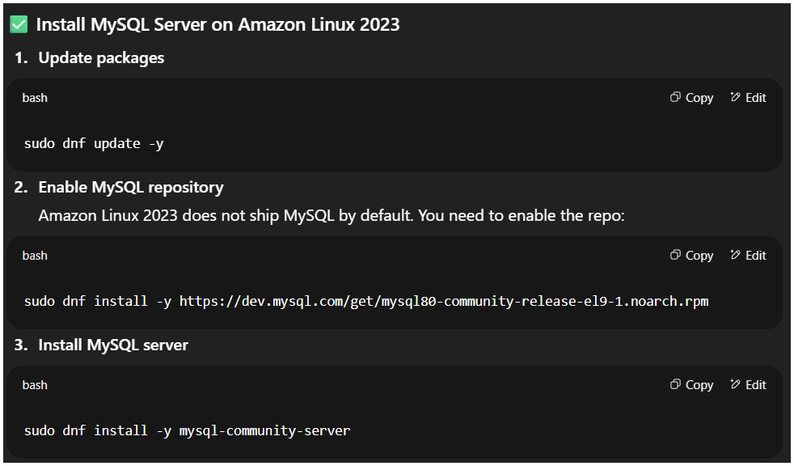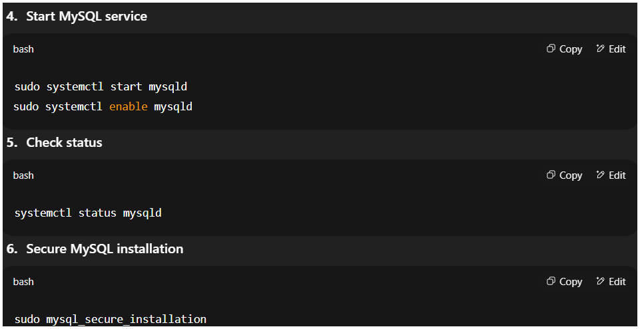
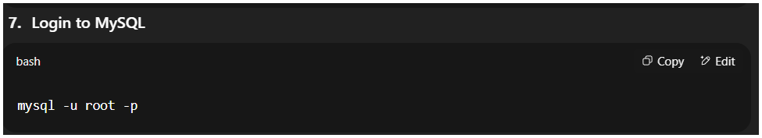

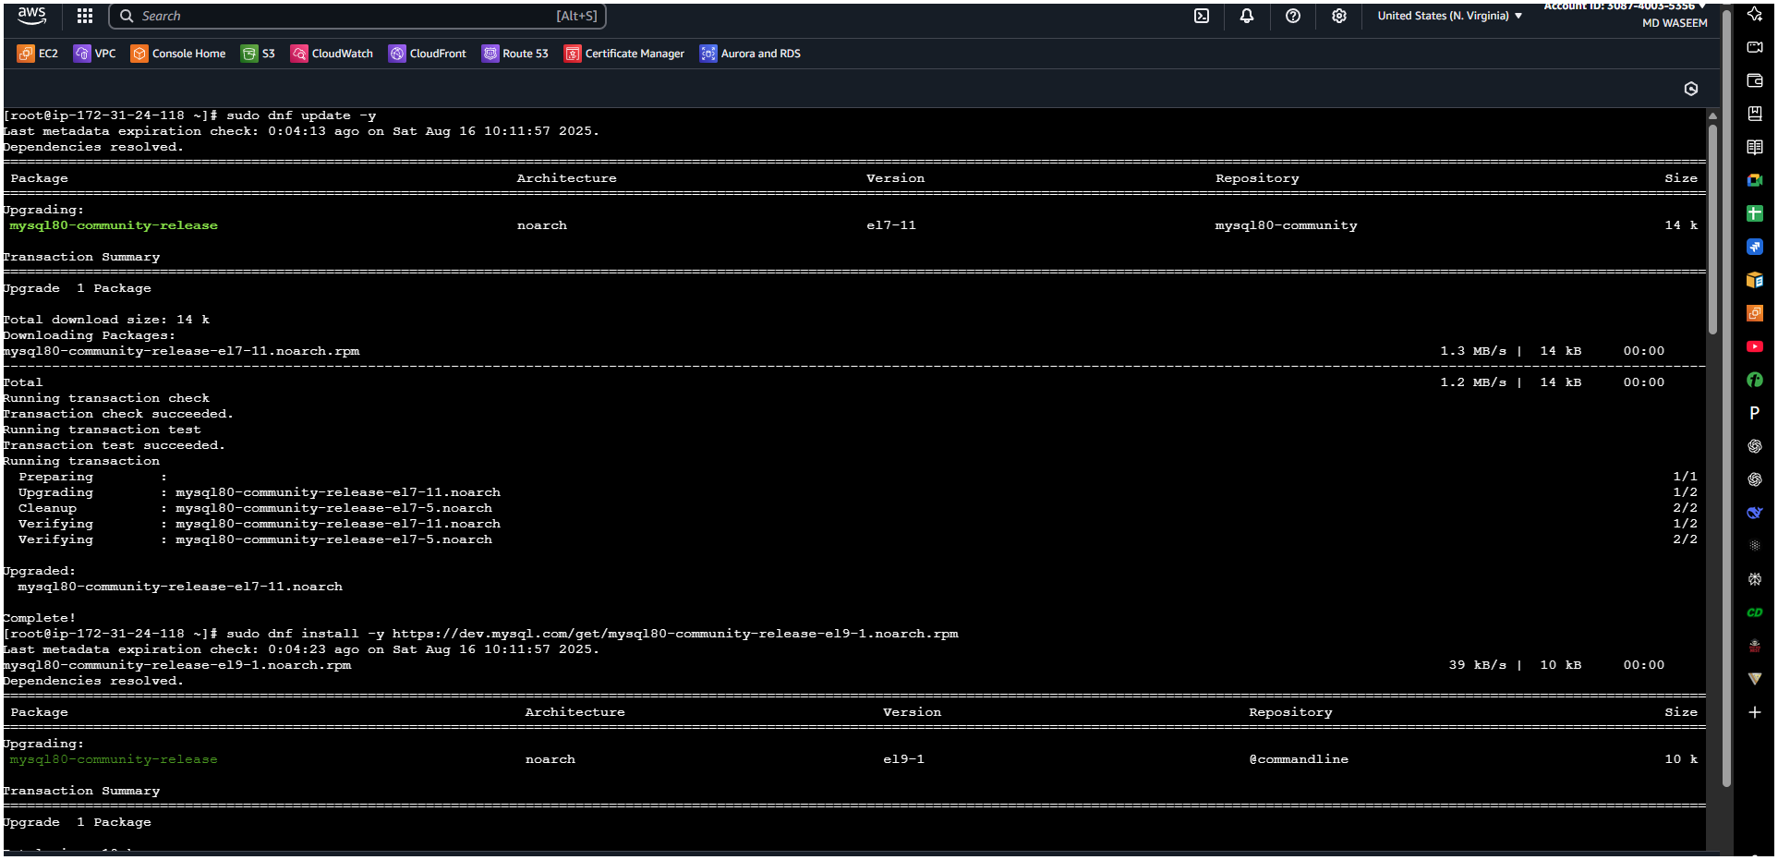
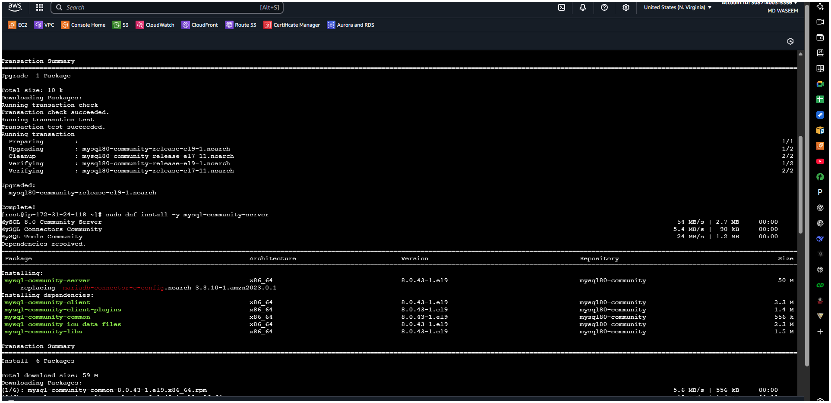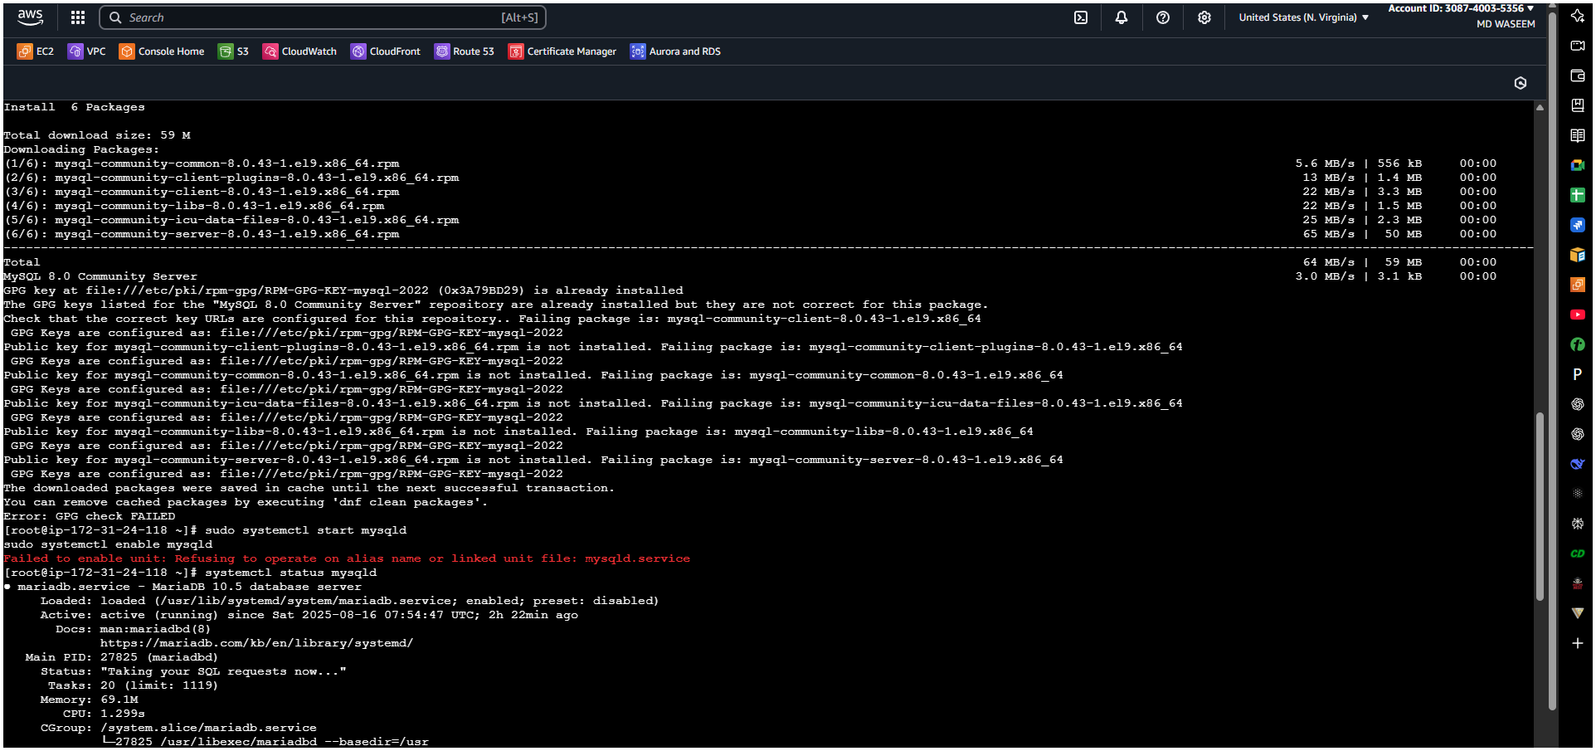
7) Launch MySQL RDS image.

🔹 Step 1: Open RDS Console
- Go to AWS Console → RDS → Databases → Create database

🔹 Step 2: Choose Database Creation Method
- Select Standard create (for more control).
- Or choose Easy create (AWS picks defaults for you).

🔹 Step 3: Choose Engine
- Select MySQL
- Choose the version (e.g., MySQL 8.0).

🔹 Step 4: Templates
- Production (high availability, Multi-AZ, backups, monitoring).
- Dev/Test (cheaper, for learning/testing).

🔹 Step 5: Settings
- DB instance identifier → e.g., my-mysql-db
- Master username → e.g., admin
- Master password → set a strong password

🔹 Step 6: Instance Configuration
- Choose instance type → e.g., db.t3.micro (free tier eligible).

🔹 Step 7: Storage
- Select storage type → e.g., gp3
- Set allocated storage (default: 20 GB).
- Enable storage autoscaling if needed.

🔹 Step 8: Connectivity
- VPC → choose default VPC (or custom if you have one).
- Subnet group → select default.
- Public access → Choose Yes if you want to connect from outside AWS.
- VPC security group → create new or choose existing (make sure port 3306 is allowed).

🔹 Step 9: Additional Configuration
- Database name → e.g., testdb
- DB parameter groups, option groups → leave default.
- Backup, Monitoring, Maintenance → leave defaults (or customize).

🔹 Step 10: Launch
- Click Create database
- Wait a few minutes → Status will become Available

🔹 Step 11: Connect to RDS
- Go to RDS → Databases → Click your DB.
- Copy the endpoint (something like mydb.abc123xyz.us-east-1.rds.amazonaws.com).
- On your EC2 or local machine, run:
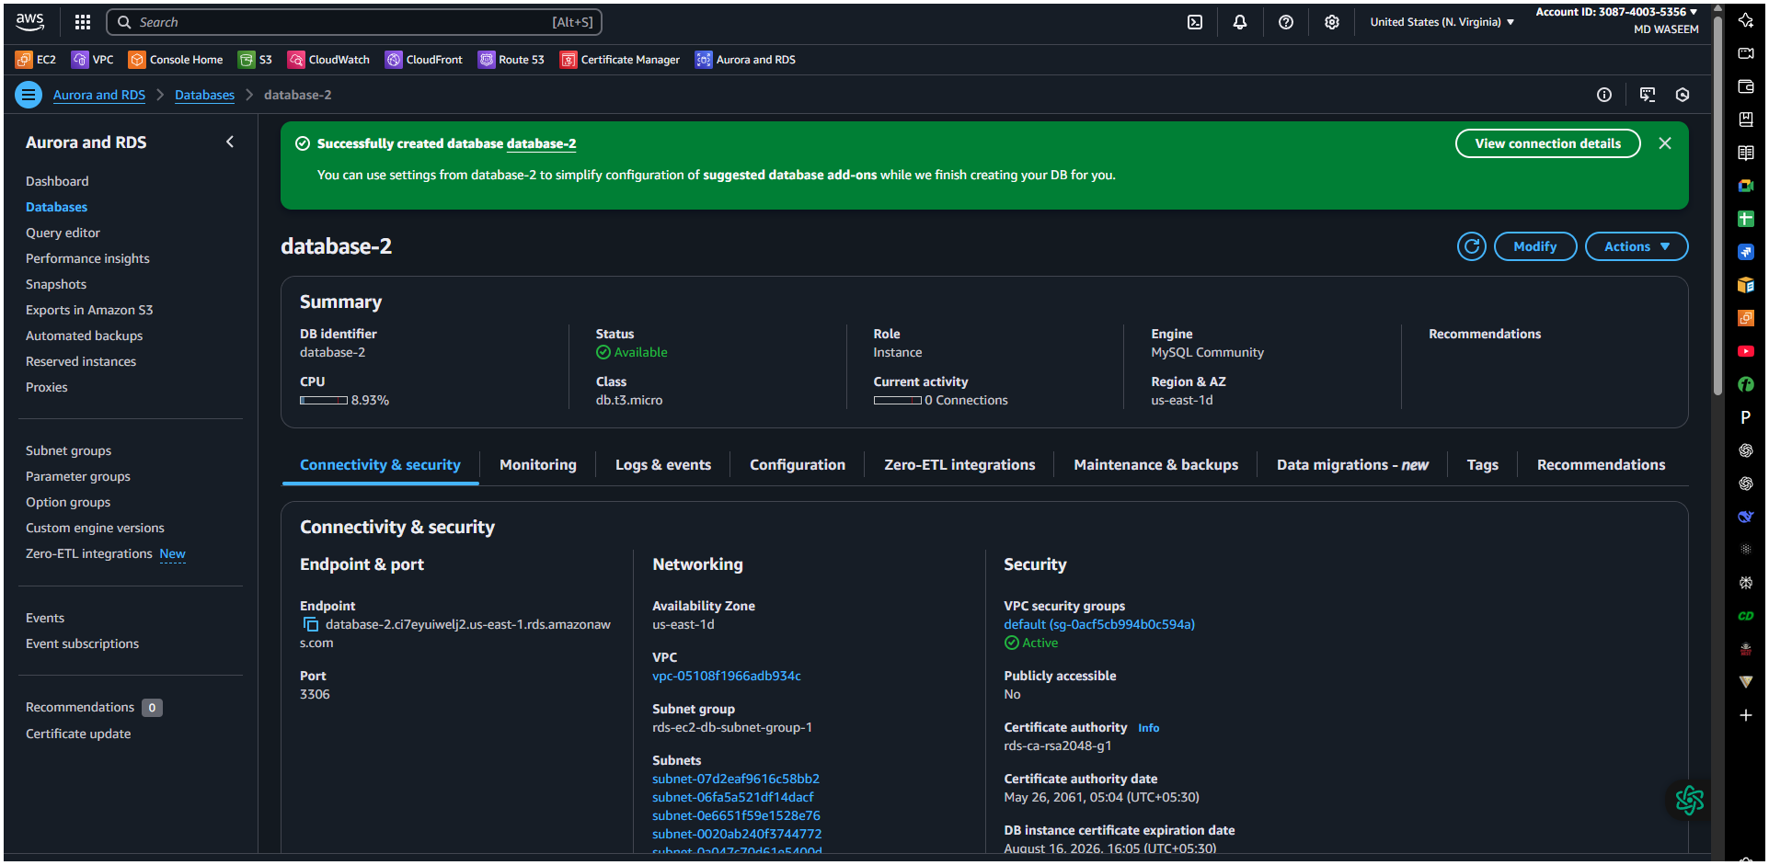

TESTING@mysql RDS IMG
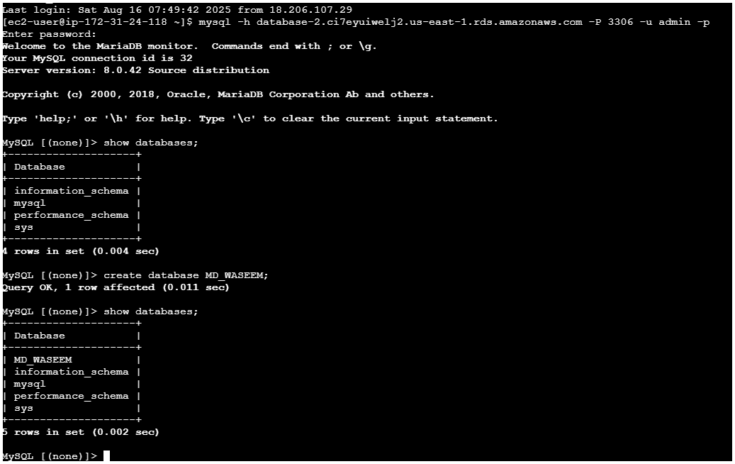

8) Configure multi AZ
In AWS Console → RDS → Select your DB → Modify or (we
can go from action → convert to Multi-AZ)
Under Availability & In AWS Console → RDS → Select your DB → Modify or (we
can go from action → convert to Multi-AZ)
Under Availability & durability, enable Multi-AZ deployment
Apply immediately durability, enable Multi-AZ deployment
Apply immediately
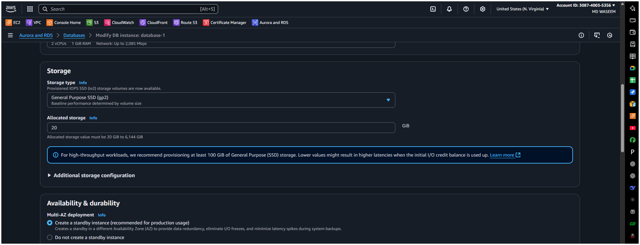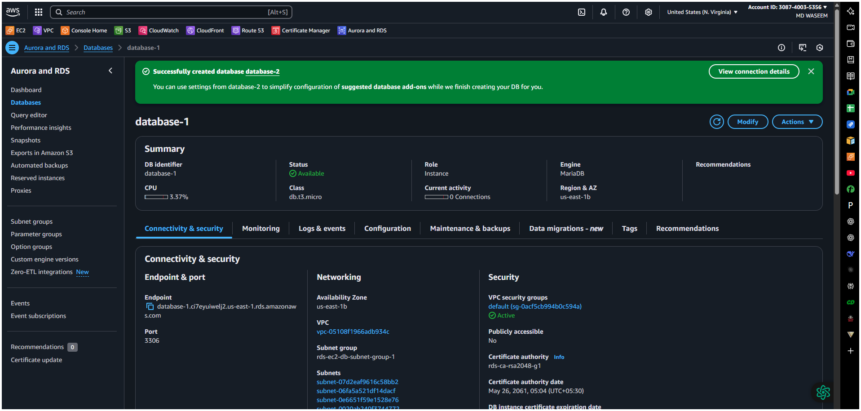
In configuration tab we can check multi-AZ us-east-1d
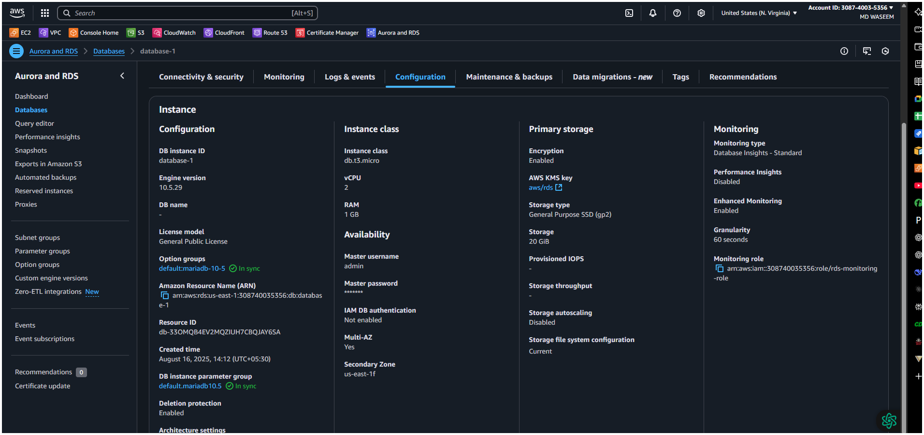

9) Take Backup of DB and restore the DB
Go to actions → snapshot and name it and create 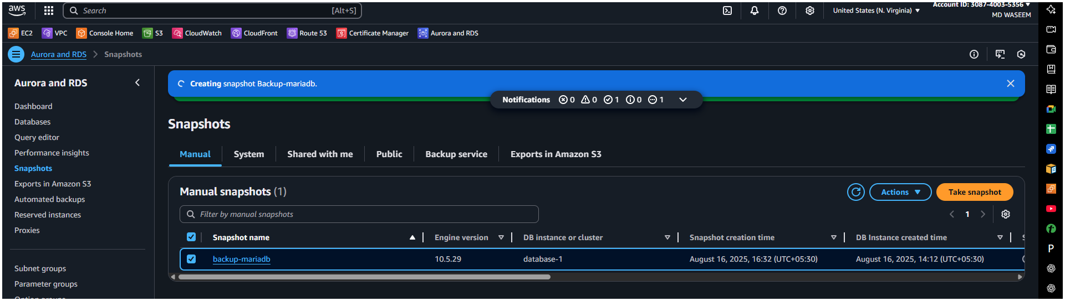
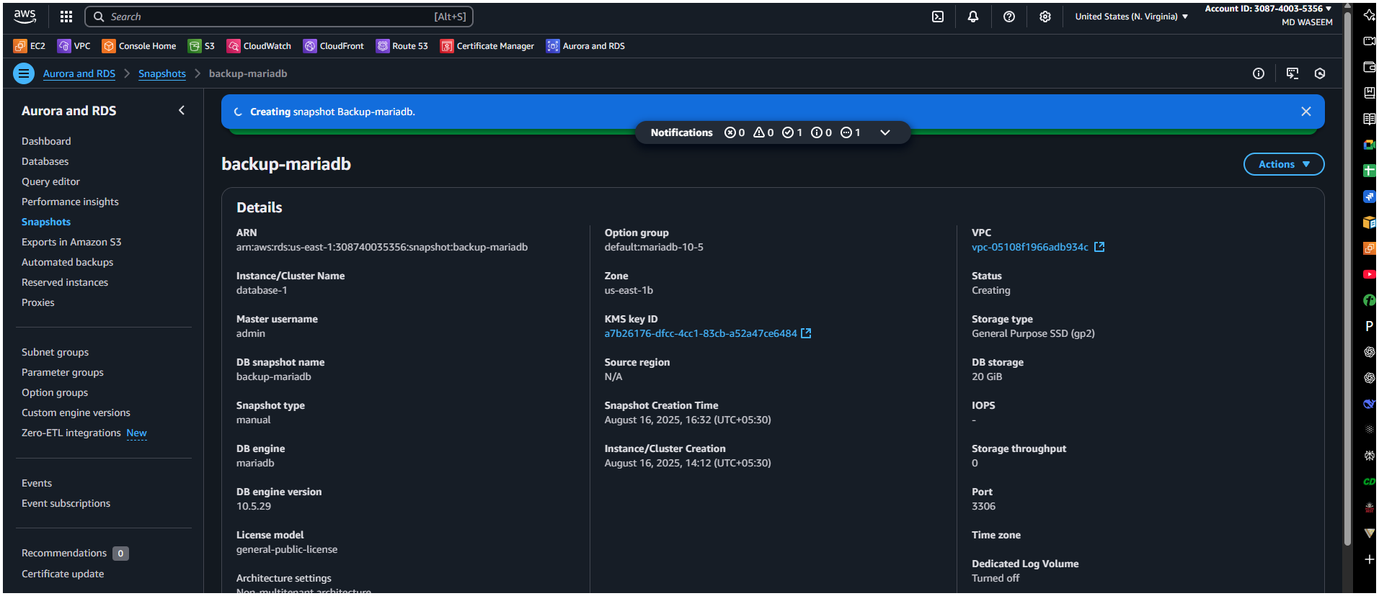
10) Create Read Replica

What is a Read Replica?
A Read Replica is a copy of your primary (source) database that only handles read operations. It helps:
- Offload read traffic from the primary database (improving performance).
- Scale read-heavy workloads (e.g., analytics, reporting, dashboards).
- Reduce latency by placing replicas in different regions.
- Serve as a backup (though not a replacement for backups).

Key Differences: Read Replica vs. Multi-AZ
Feature | Read Replica | Multi-AZ
Purpose | Read scaling | High availability (HA)
Writes allowed? | No (read-only) | Yes (primary instance)
Automatic failover? | No (manual promotion) | Yes (auto-failover)
Replication type | Asynchronous | Synchronous (for standby)
Use case | Reporting, analytics | Mission-critical workloads

How to Create a Read Replica in AWS RDS (MySQL) - Step by Step

Prerequisites
✅ A running RDS MySQL instance (primary DB).
✅ Automatic backups must be enabled (required for replicas).

Step 1: Go to AWS RDS Console
- Log in to the AWS Management Console.
- Navigate to RDS > Databases.

Step 2: Select the Source DB Instance
- Click on the primary MySQL DB you want to replicate.
- Click Actions > Create read replica.
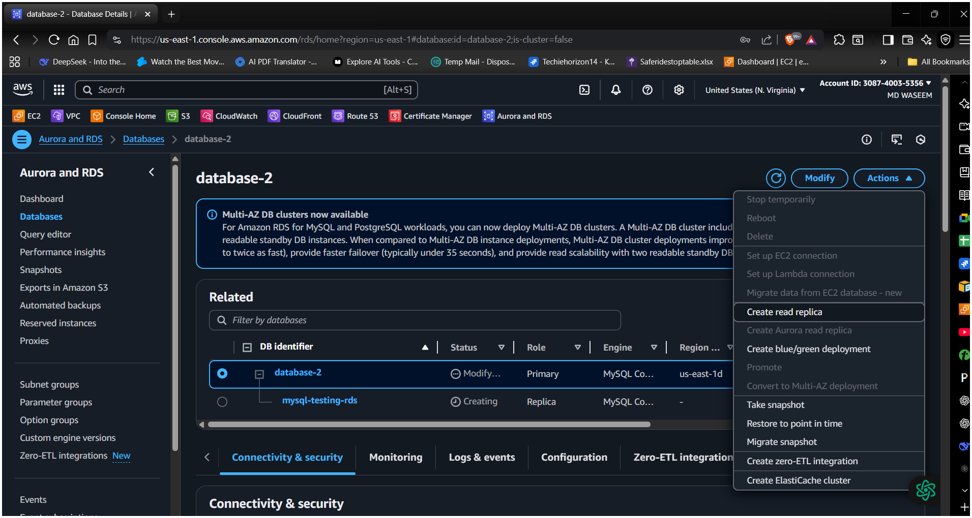

Step 3: Configure the Read Replica

1. Replica Settings
- DB instance identifier: Enter a unique name (e.g., mysql-replica-1).
- Instance class: Choose the same or smaller size than the primary.
- Multi-AZ deployment: (Optional) Enable for HA on the replica itself.

2. Connectivity & Storage
- Virtual Private Cloud (VPC): Same as primary (or cross-region if needed).
- Public access: Disable unless required.
- Storage type: SSD (gp2/io1) for better performance.

3. Additional Settings
- Enable automatic backups: Recommended (required for future replicas).
- Maintenance window: Set a low-traffic time.

Step 4: Launch the Read Replica
- Click Create read replica.
- Wait ~5-15 mins for AWS to provision and sync the replica.
@@@@it took me 20 min@@@@
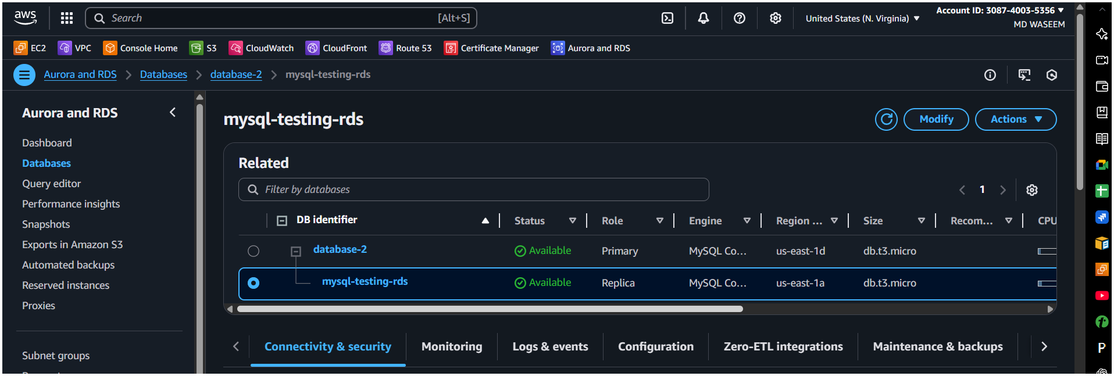

Step 5: Verify & Use the Read Replica
✅ Check replication status:
- Go to RDS > Databases and check the replica’s status.
- Once "Available", it’s ready for read traffic.
✅ Test read operations:
- Connect to the replica’s endpoint (different from the primary).
- Run SELECT queries to confirm it works.
✅ Monitor replication lag:
- Use Amazon CloudWatch metrics (ReplicaLag).
- High lag? Check workload or resize the replica.

