- Create one VPC,with 1 one public subnet and 1 private subnet.
Steps:
- Go to AWS Console → VPC → Your VPCs → Create VPC:
  - Name tag: MyVPC
  - IPv4 CIDR: 10.0.0.0/16
  - Enable DNS Hostnames and DNS Resolution.
  - Click Create VPC.
- Create Subnets:
  - Public Subnet:
    - Name: Public-Subnet
    - CIDR: 10.0.1.0/24
    - Availability Zone: us-east-1a
  - Private Subnet:
    - Name: Private-Subnet
    - CIDR: 10.0.2.0/24
    - Availability Zone: us-east-1a
- Create Internet Gateway:
  - Go to Internet Gateways → Create IGW.
  - Attach IGW to MyVPC.
- Create Route Tables:
  - Public Route Table:
    - Associate Public Subnet.
    - Add route: 0.0.0.0/0 → Internet Gateway.
  - Private Route Table:
    - Associate Private Subnet.
    - (Will use NAT Gateway if needed later).

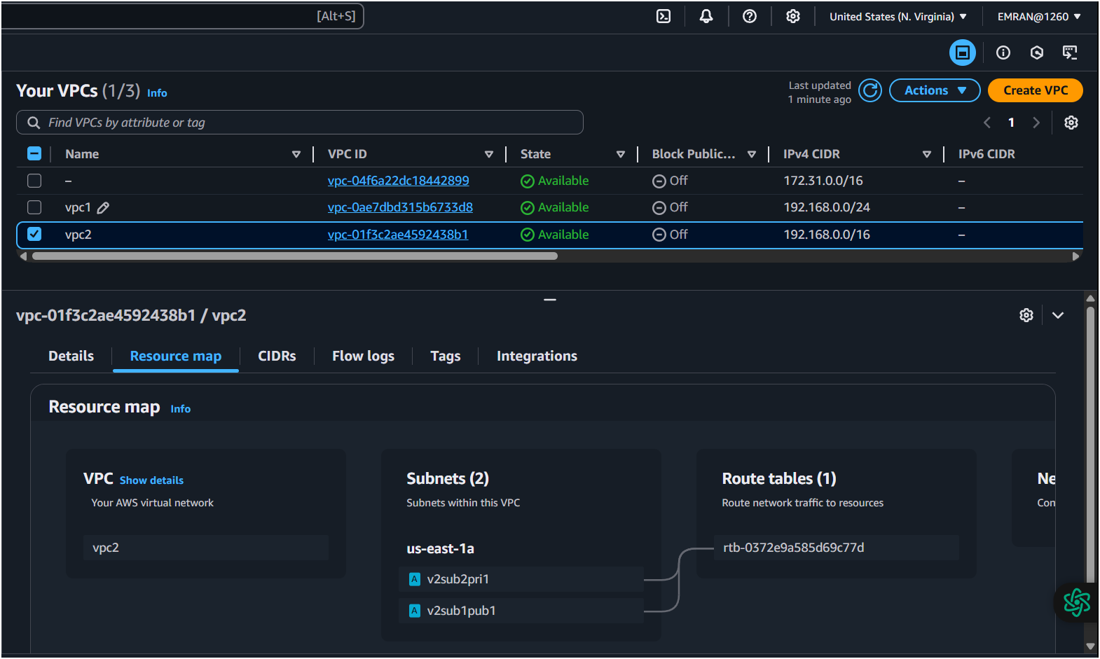
- Enable VPC peering for cross account. (You can collaborate with your friend and do this task).
Steps:
- Create VPC in Region 1 (e.g., us-east-1) and another VPC in Region 2 (e.g., us-west-1).
- Go to VPC Peering → Create Peering Connection:
  - Requester: VPC in us-east-1
  - Accepter: VPC in us-west-1
  - Enable Cross-Region Peering.
- Accept the peering request in Accepter Region.
- Update Route Tables in both VPCs:
  - Add route to peer VPC’s CIDR via Peering Connection.
- Ensure Security Groups & NACLs allow traffic between both VPCs.

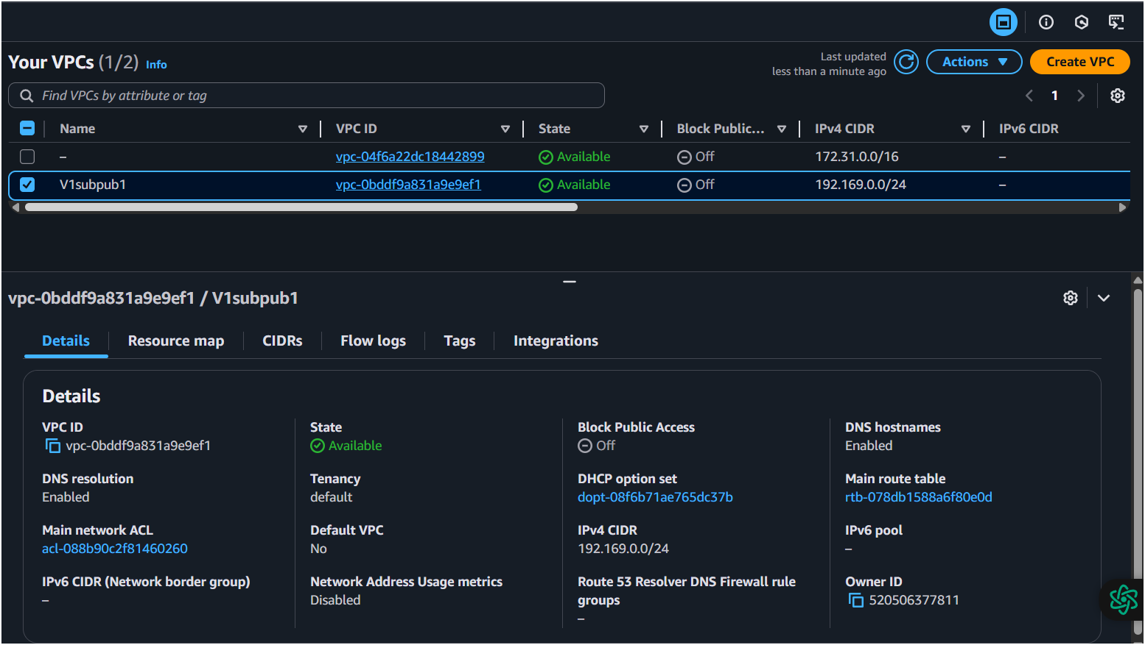
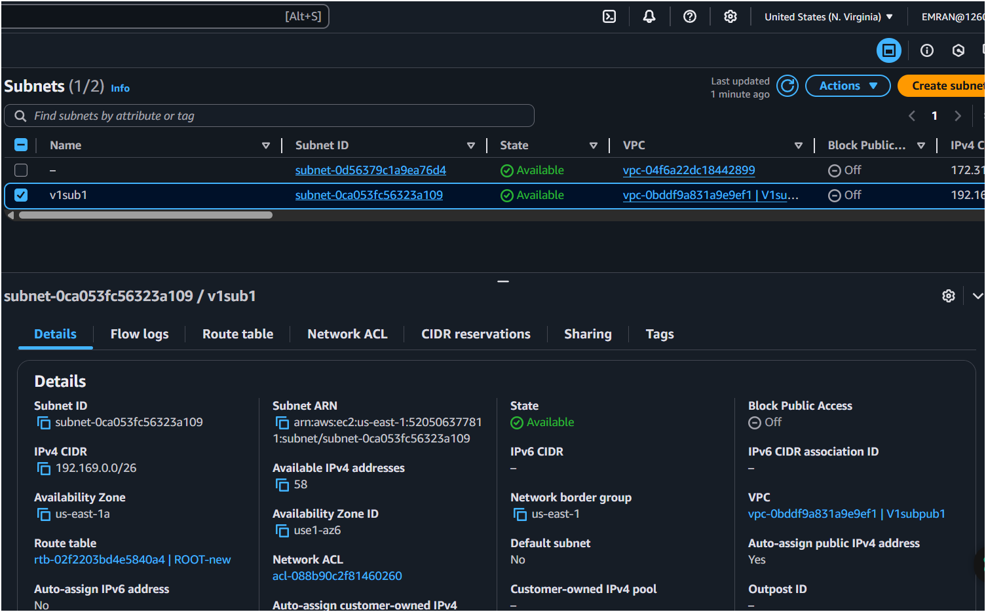
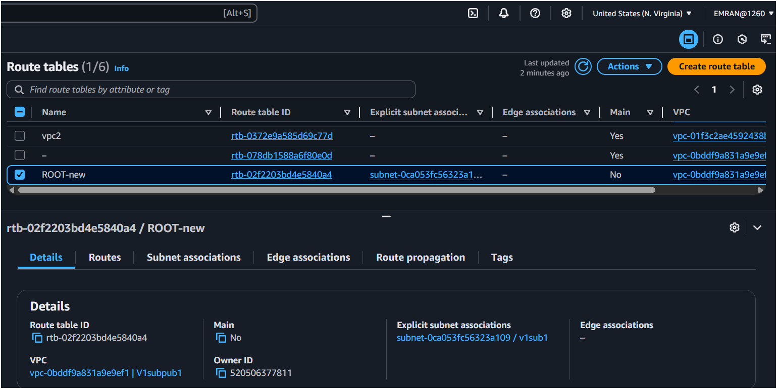
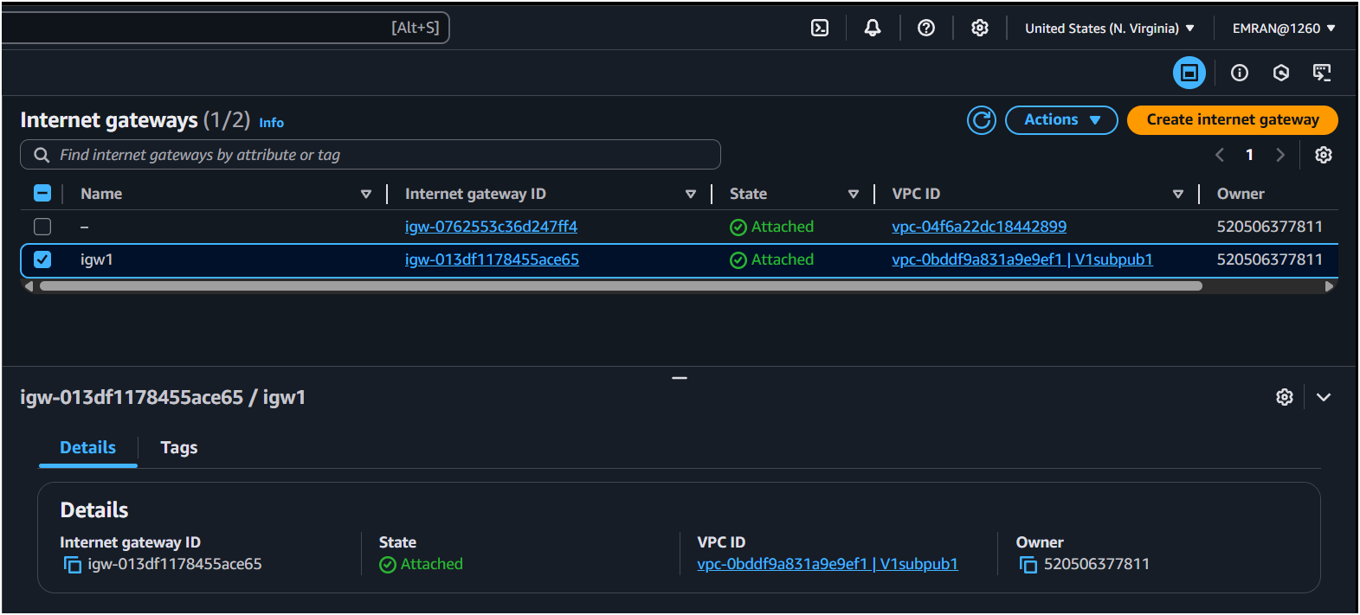
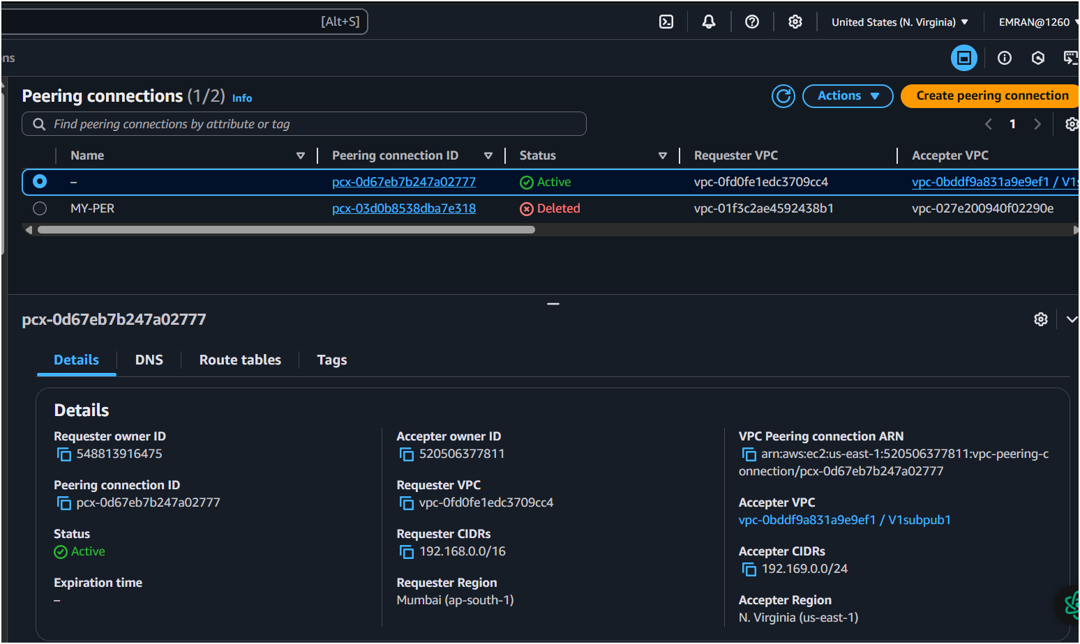
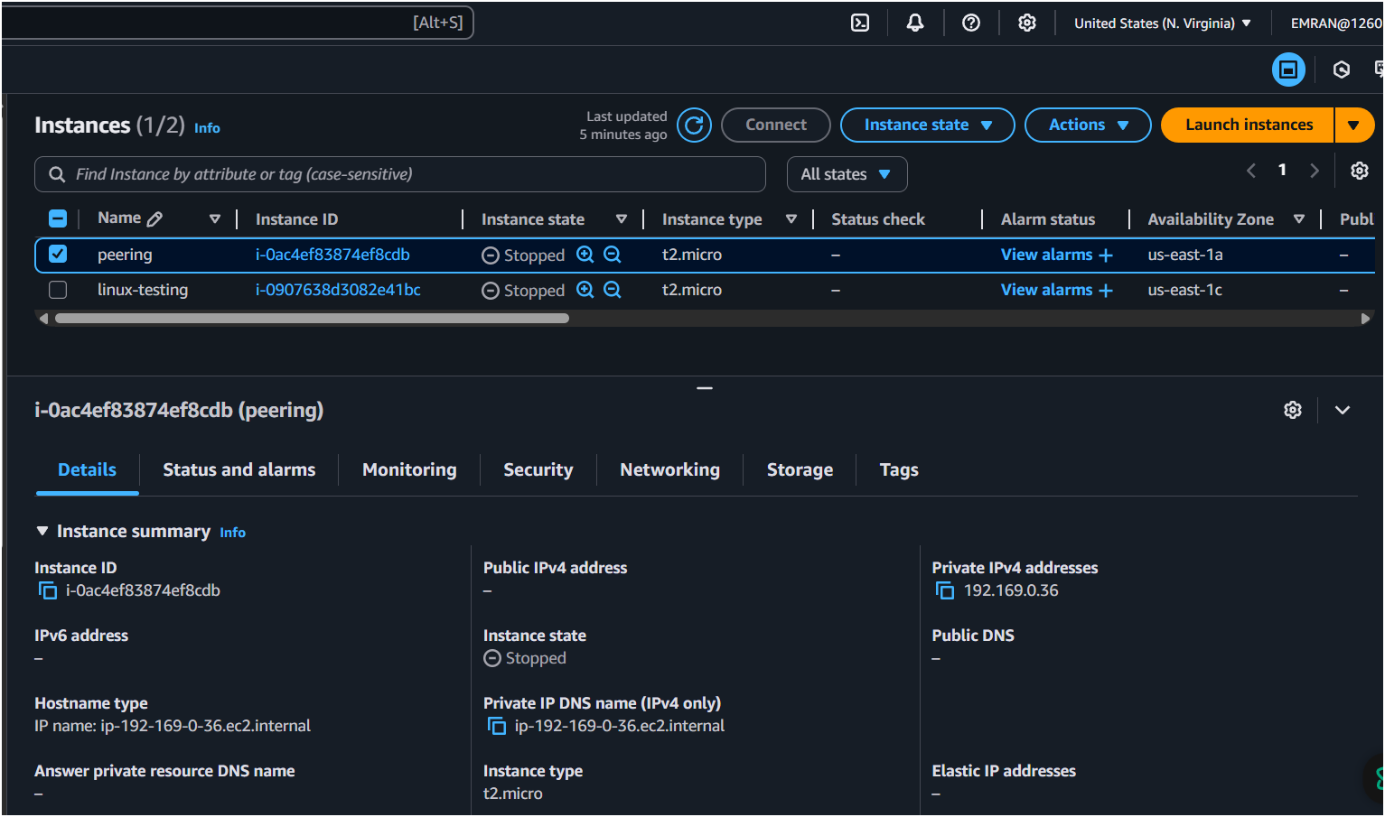
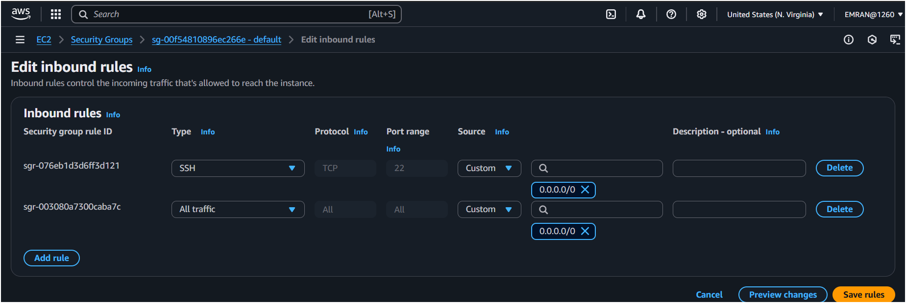
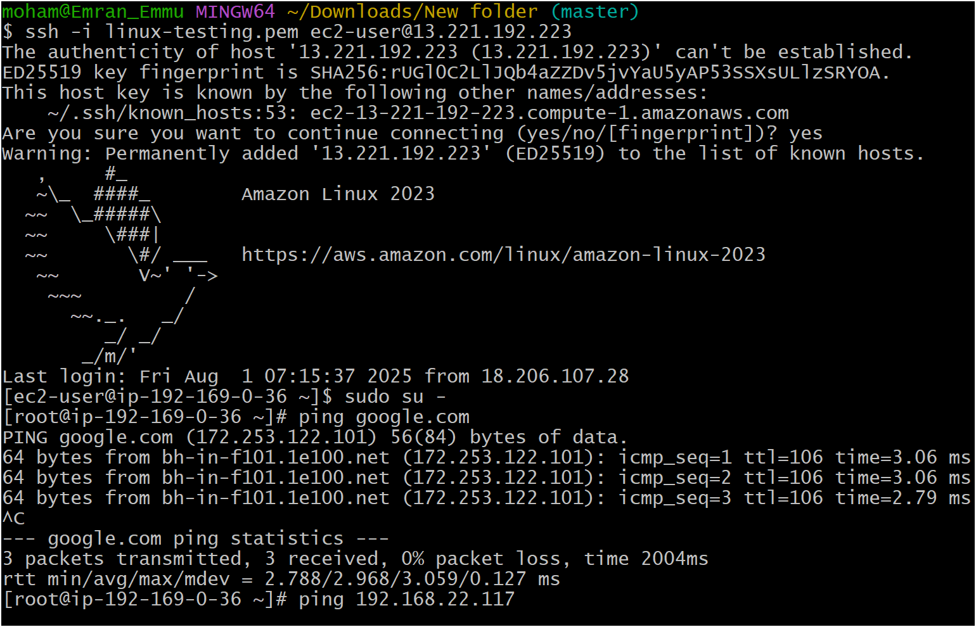
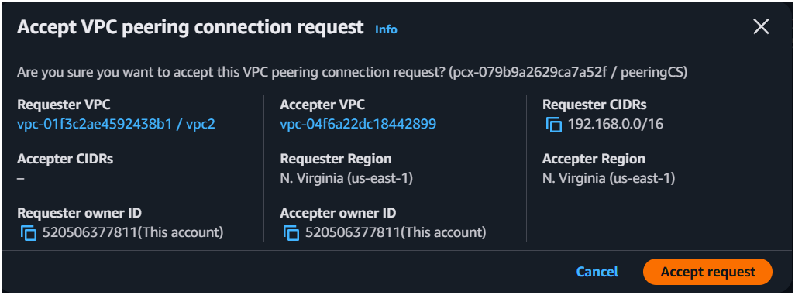

- Enable VPC peering for cross region.
Steps:
- Create VPC in Region 1 (e.g., us-east-1) and another VPC in Region 2 (e.g., us-west-1).
- Go to VPC Peering → Create Peering Connection:
  - Requester: VPC in us-east-1
  - Accepter: VPC in us-west-1
  - Enable Cross-Region Peering.
- Accept the peering request in Accepter Region.
- Update Route Tables in both VPCs:
  - Add route to peer VPC’s CIDR via Peering Connection.
- Ensure Security Groups & NACLs allow traffic between both VPCs.

- Setup VPC Transist gateway.
Steps:
- Go to Transit Gateway → Create Transit Gateway:
  - Name: My-TGW
  - ASN: Leave default or customize.
- Create Attachments:
  - Attach VPCs to Transit Gateway.
- Update Route Tables of each VPC:
  - Add routes pointing to Transit Gateway.
- Use Transit Gateway to connect multiple VPCs in same or different regions.

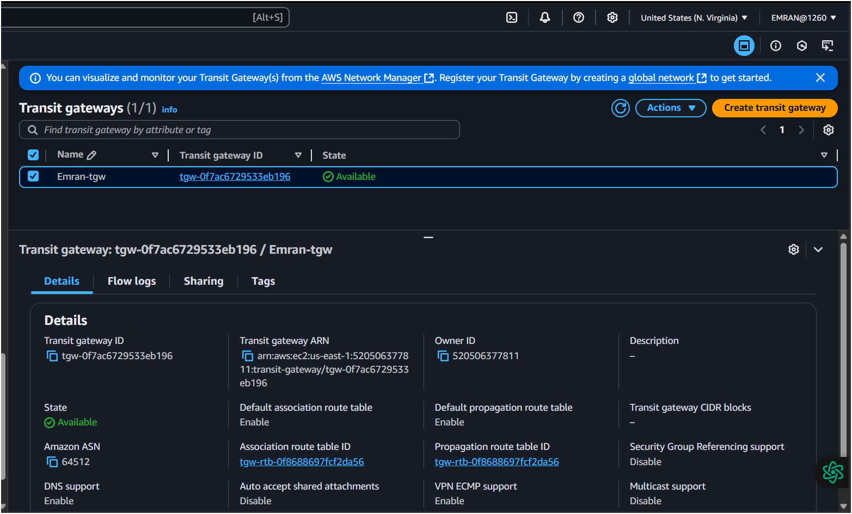
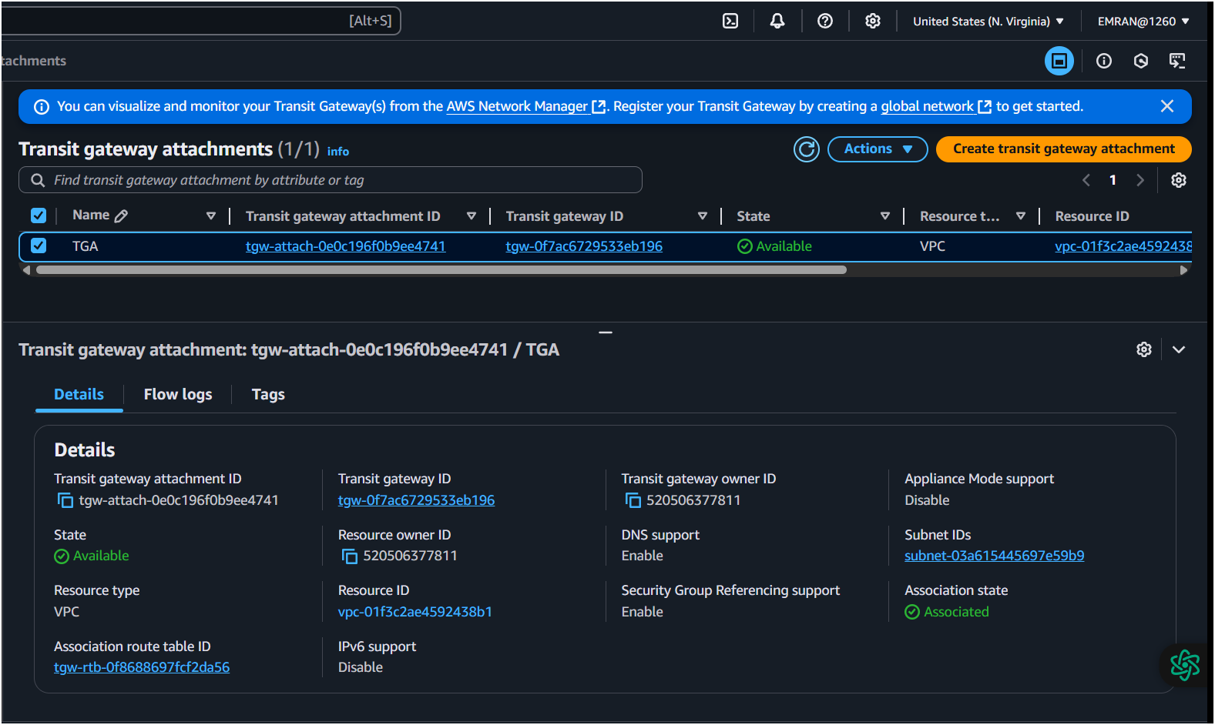
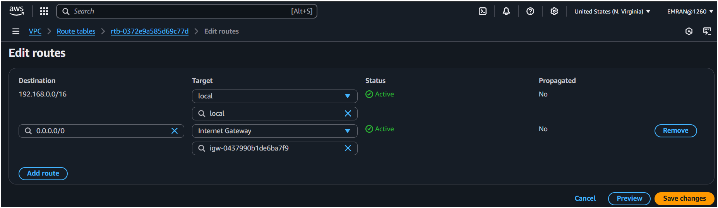
- Setup VPC End Point.
Steps:
- Go to VPC → Endpoints → Create Endpoint.
- Choose Service Name (e.g., com.amazonaws.us-east-1.s3 for S3).
- Select VPC: MyVPC.
- Choose Subnets: Select Private Subnet (for private access).
- Select Security Group: Allow required traffic.
- Enable Private DNS for AWS services.
- Create endpoint.

