- Install nginx and run nginx on port number 81.

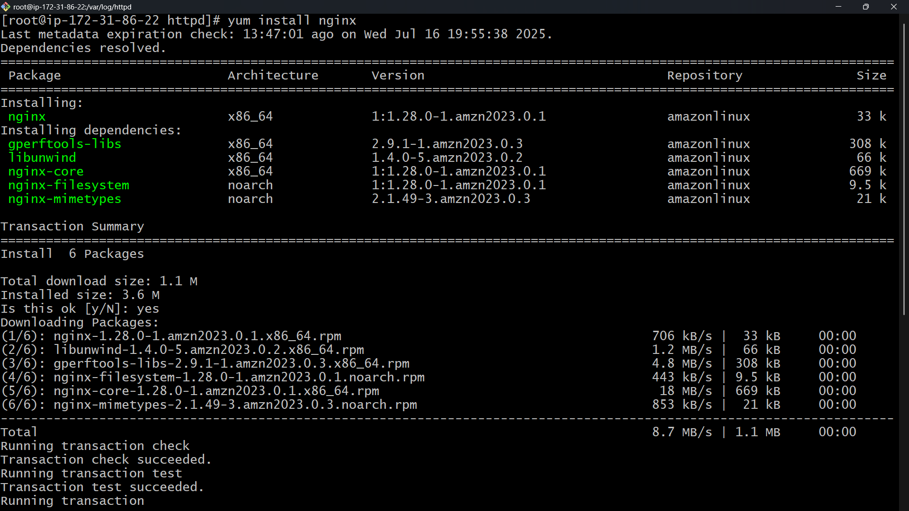
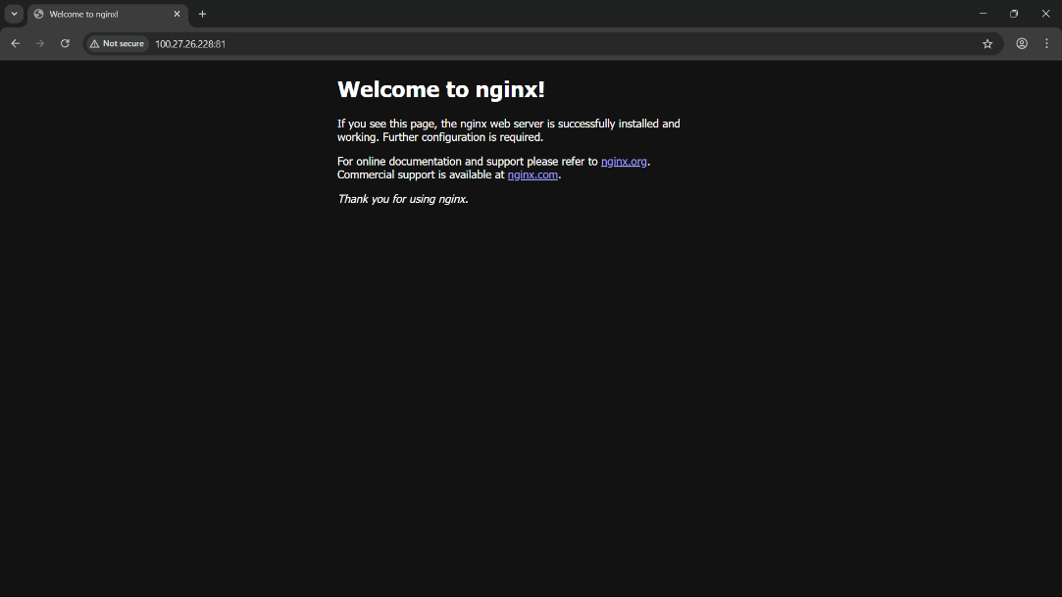

2) Deploy a sample index.html file on nginx.
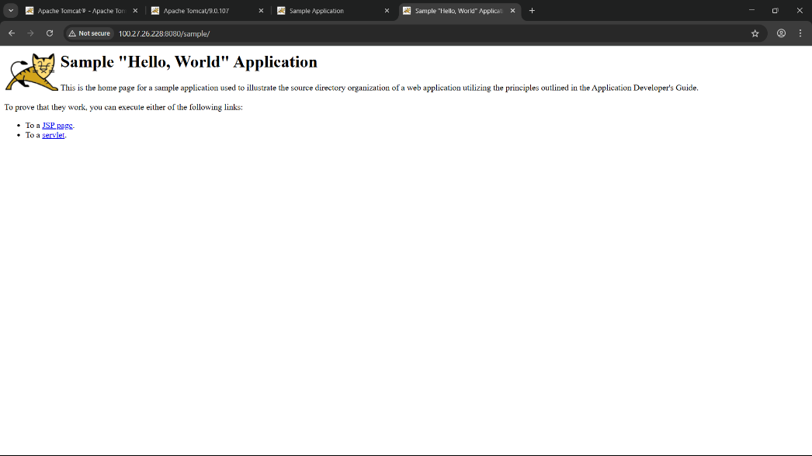

3) Install Apache and run Apache on port number 82
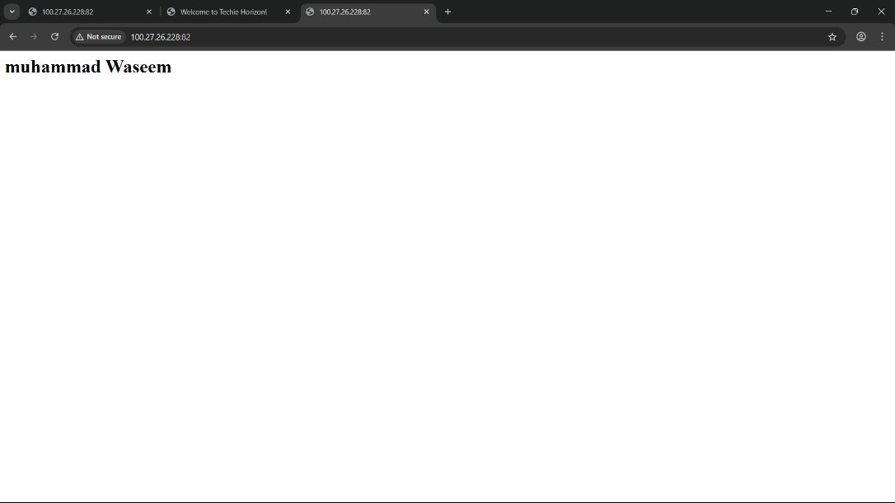
4) Deploy a sample index.html file on Apache. 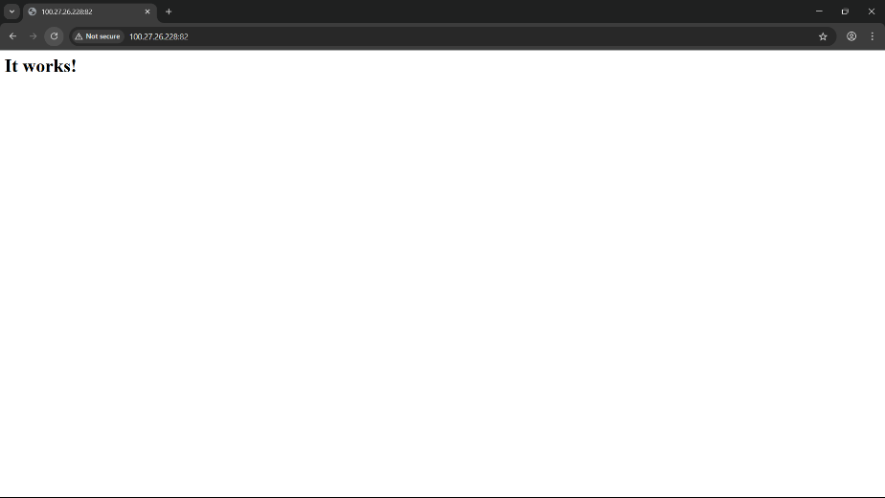
5) Install Apache tomcat on port number 8082
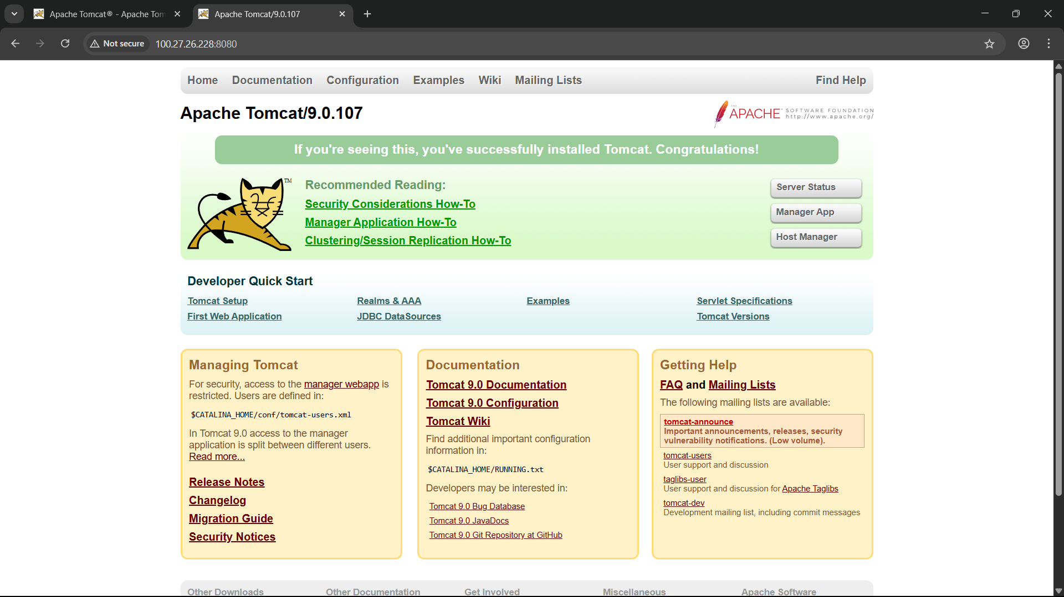
6) Deploy a sample app on webapps
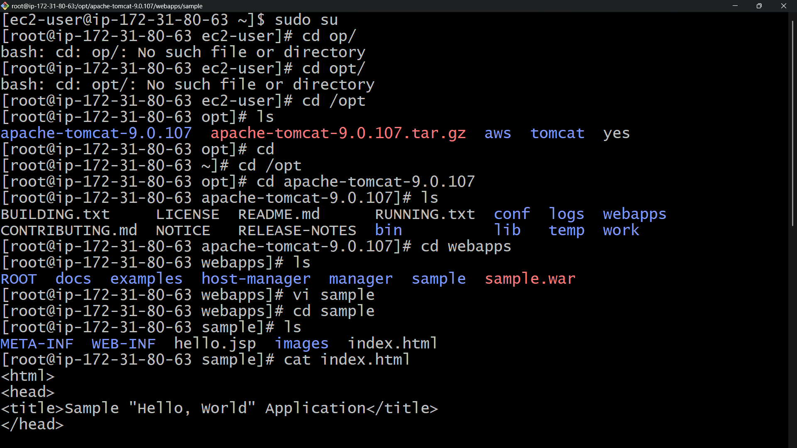

7) Create a tomcat.service file for tomcat.

8) Configure HA Proxy server

