- Create VPC with 2 private and 2 public subnets.
• Go to AWS Management Console → VPC → Your VPCs → Create VPC.
- Name tag: MyVPC
- IPv4 CIDR block: 10.0.0.0/16
- Enable DNS Resolution and DNS Hostnames (or do in step 2).
- Click Create VPC.
• Create subnets:
- Subnet 1 (Public): 10.0.1.0/24
- Subnet 2 (Public): 10.0.2.0/24
- Subnet 3 (Private): 10.0.3.0/24
- Subnet 4 (Private): 10.0.4.0/24
- Assign subnets to 2 different AZs for high availability

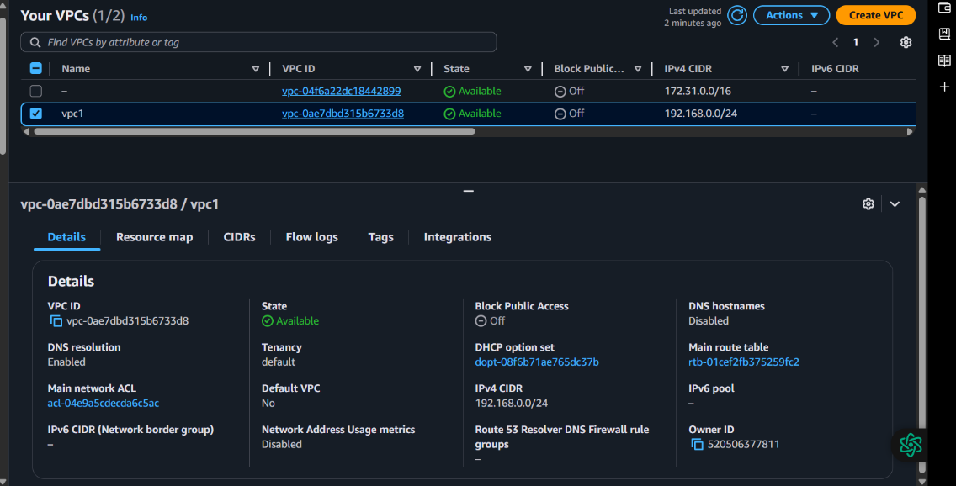
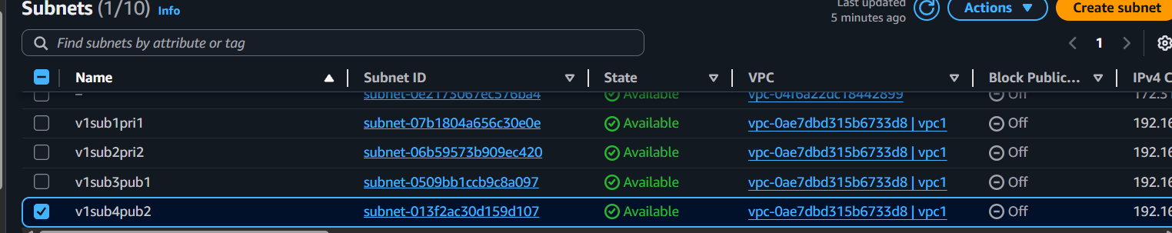
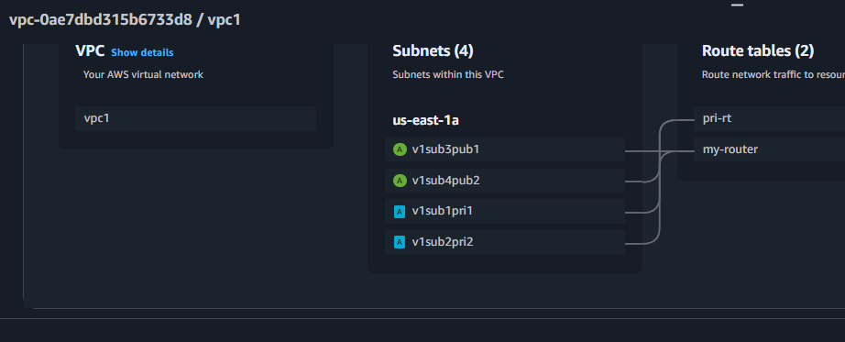
- 2) Enable DNS Hostname in VPC
Go to VPC → Your VPCs → Select VPC → Actions → Edit DNS Hostnames → Enable.

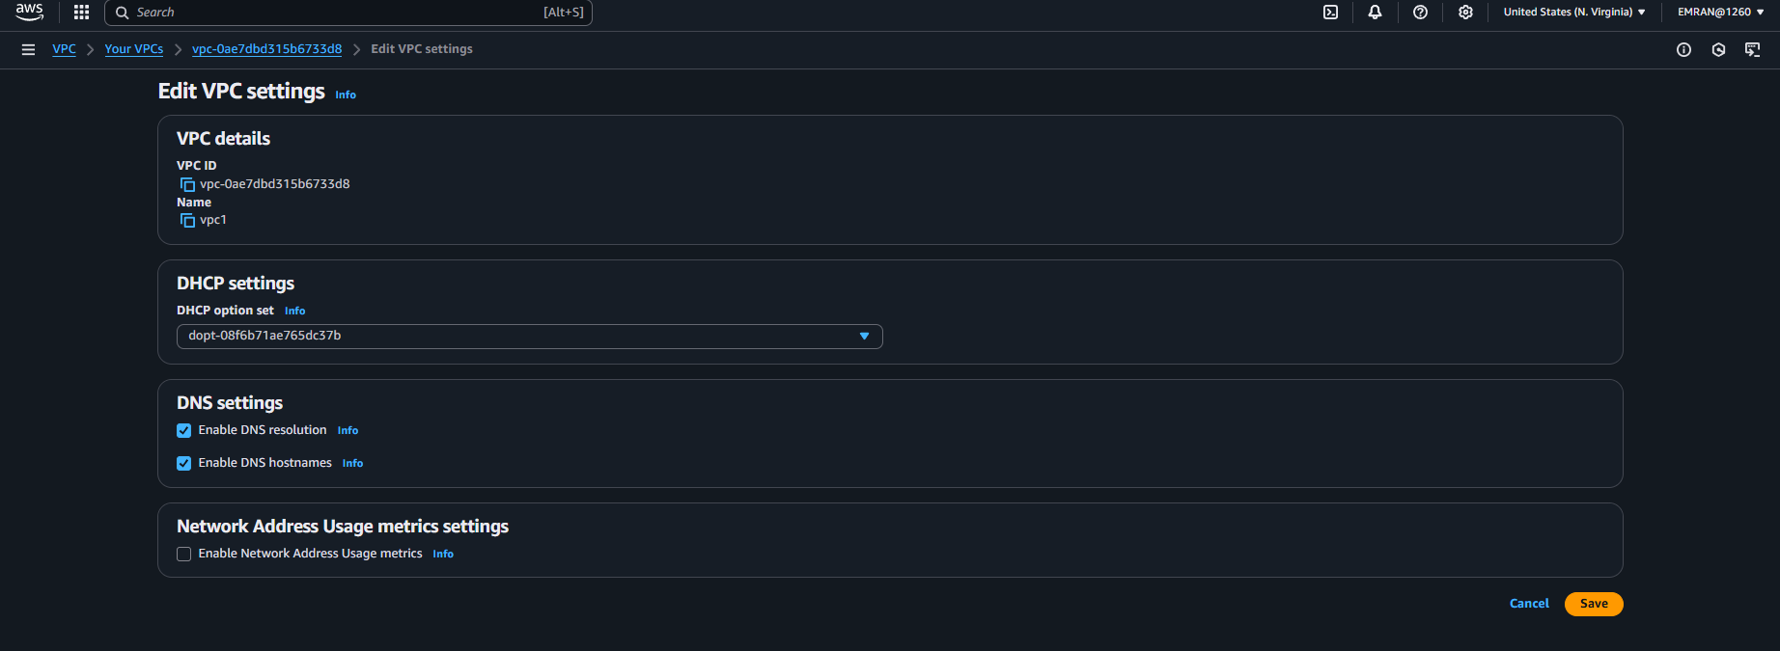
- Enable Auto Assign Public ip in 2 public subnets
Go to Subnets → Select Public Subnet → Actions → Modify auto-assign IP settings.
Check Enable auto-assign public IPv4 address.
Do this for both public subnets.
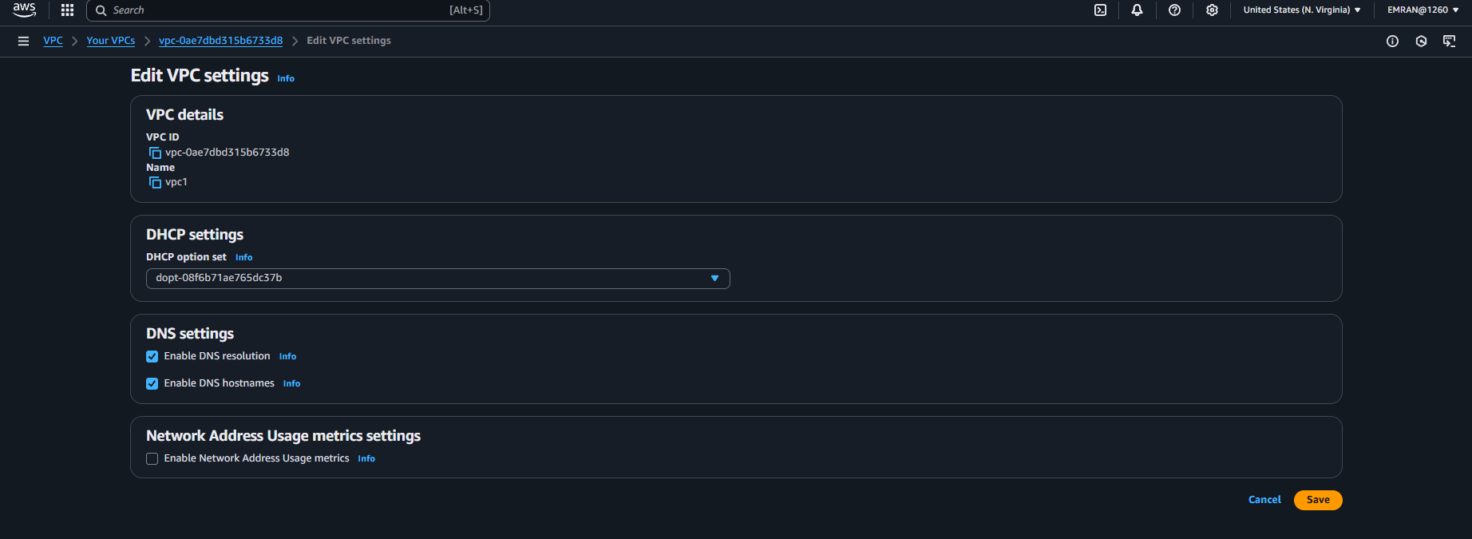

- Add 2 private subnets in private route table
• Create Route Table: Private-RT.
• Associate private subnets (10.0.3.0/24 and 10.0.4.0/24) with Private-RT.
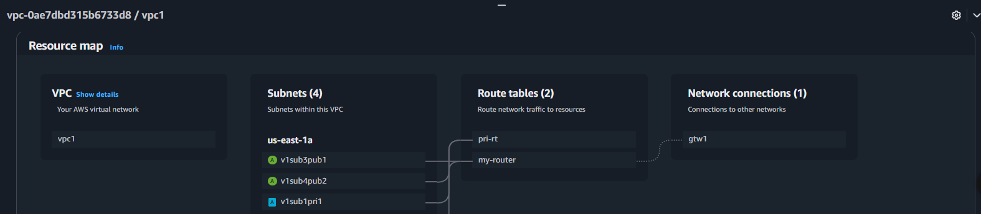
- Add 2 public subnets in public route table
• Create Route Table: Public-RT.
• Associate public subnets (10.0.1.0/24 and 10.0.2.0/24) with Public-RT.

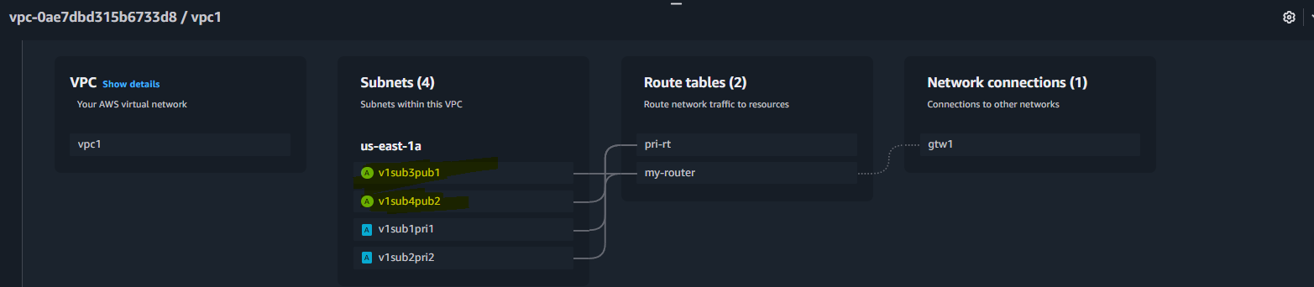
- Public route table will have the routes to internet and local
Create Internet Gateway:
- Go to Internet Gateways → Create IGW → Attach to VPC.
Add route in Public-RT:
- Destination: 0.0.0.0/0
- Target: Internet Gateway
Local route is added by default (10.0.0.0/16 → local).

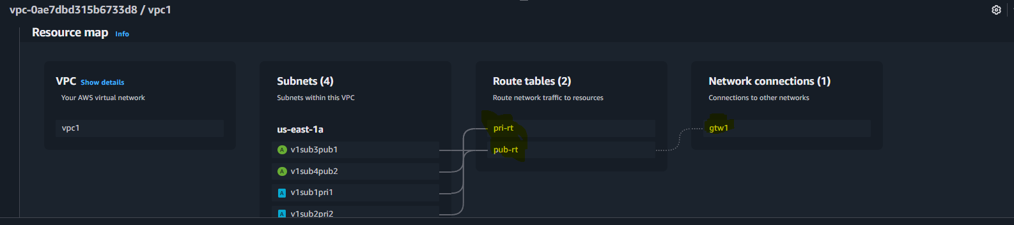
- Create Ec2 in public subnet with t2micro and install php
• Go to EC2 → Launch Instance:
- Name: Public-EC2
- AMI: Amazon Linux 2
- Instance type: t2.micro
- Network: MyVPC
- Subnet: Public Subnet (10.0.1.0/24)
- Enable Auto-assign Public IP.
• Add Security Group:
- Allow SSH (port 22) from your IP.
- Allow HTTP (port 80) from anywhere.
After launch, SSH into instance:
Install php
sudo yum update -y
sudo amazon-linux-extras enable php8.0
sudo yum install -y php-cli php-pdo php-fpm php-json php-mysqlnd httpd
sudo systemctl enable httpd
sudo systemctl start httpd
echo "<?php phpinfo(); ?>" > /var/www/html/index.php
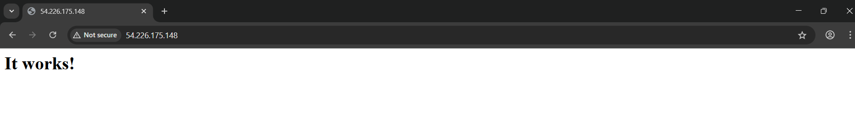

8) Configure Nat gateway in public subnet and connect to private Instance
Create Elastic IP.
Go to NAT Gateways → Create:
- Subnet: Public Subnet (10.0.1.0/24)
- Elastic IP: Select created one.
Add route in Private Route Table:
- Destination: 0.0.0.0/0
- Target: NAT Gateway
Private EC2 will now access internet via NAT.

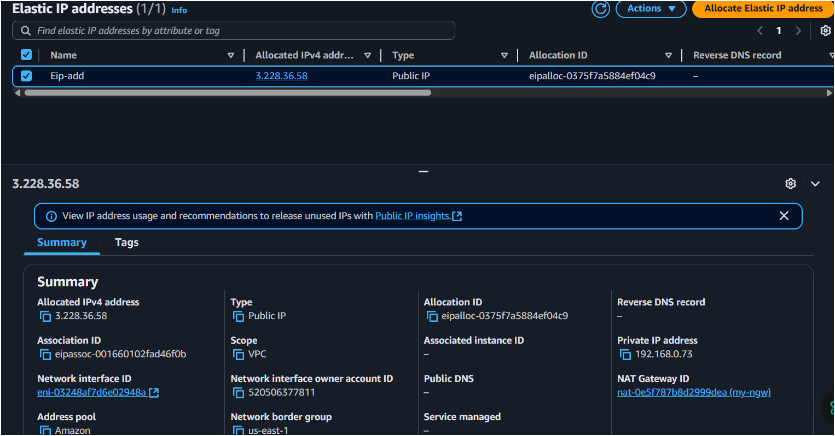
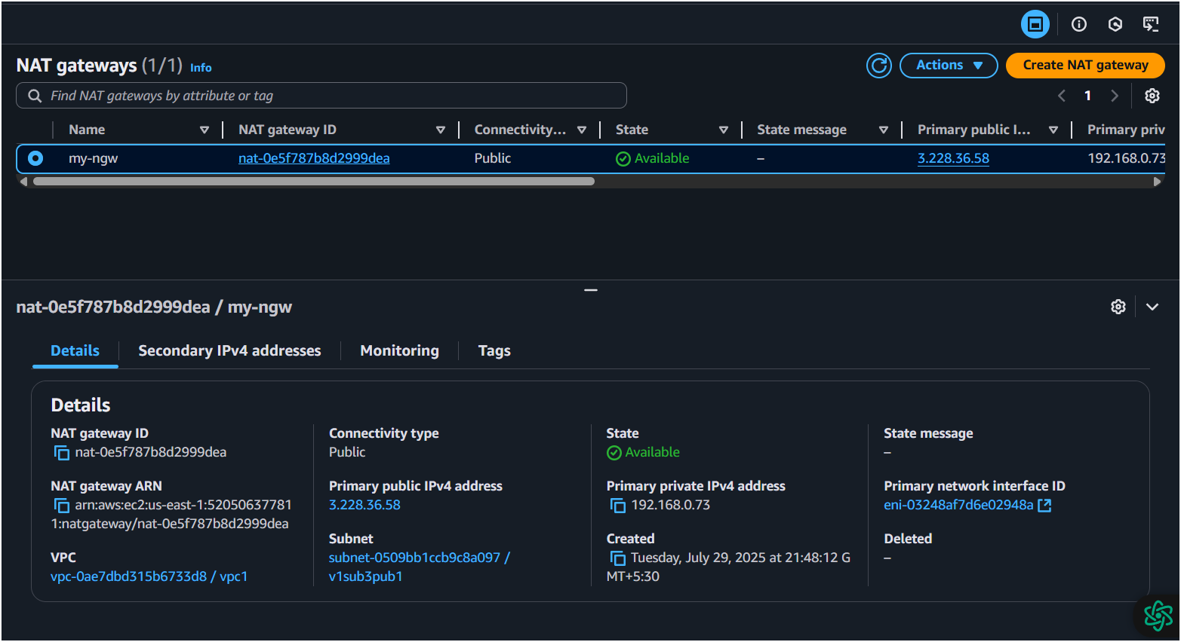
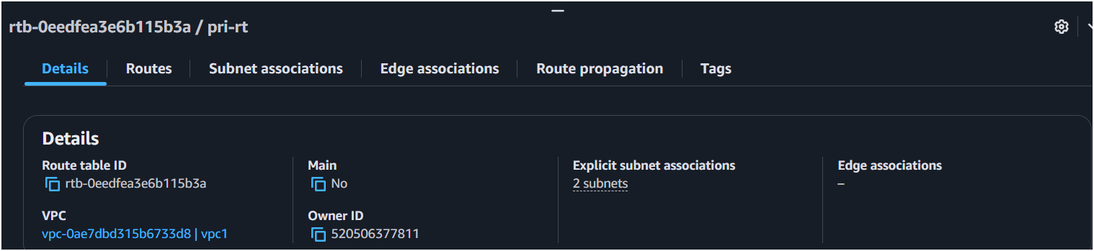
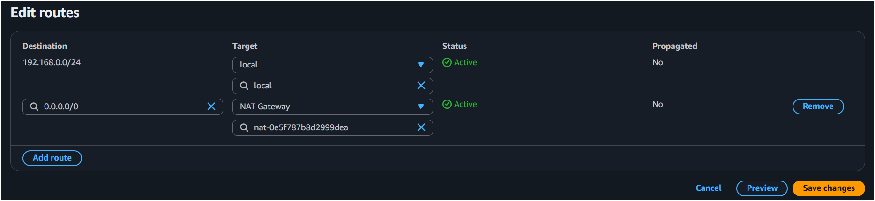

9) Install Apache Tomcat in private ec2 and deploy a sample app.
• Launch EC2 in Private Subnet:
- Subnet: 10.0.3.0/24
- No public IP (because private).
• SSH via Bastion Host (Public EC2):
ssh -i my-key.pem ec2-user@<public-ec2-ip>
ssh ec2-user@<private-ec2-private-ip>
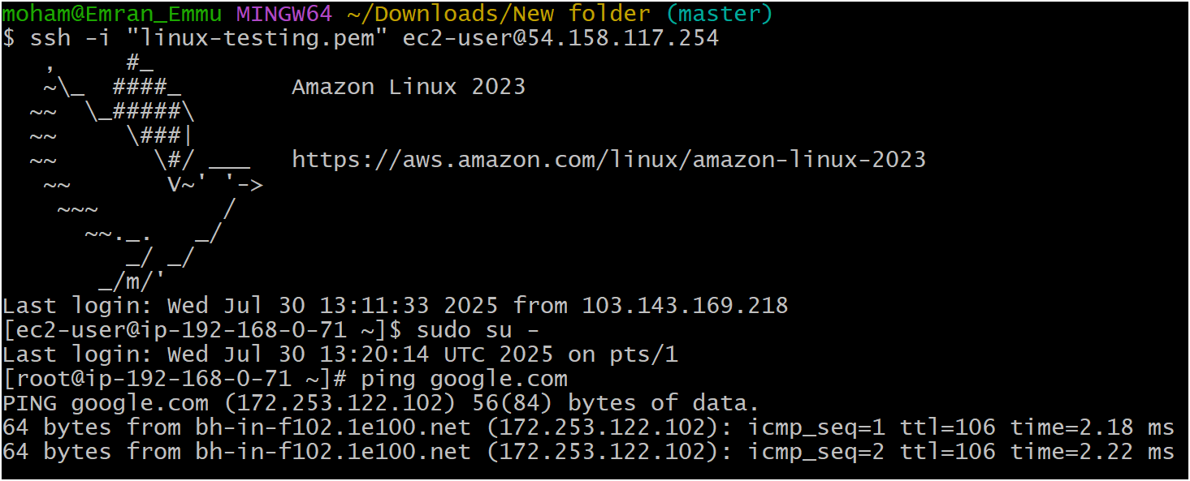
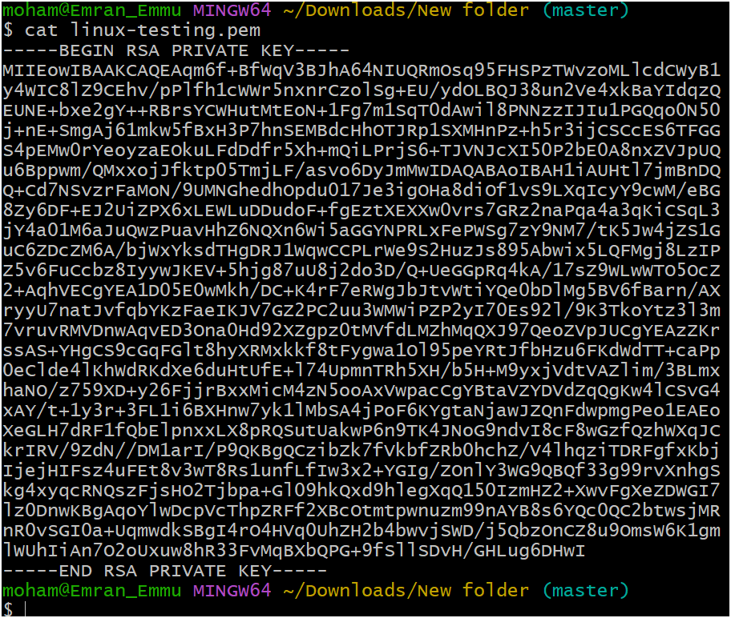
- Install Tomcat:
sudo yum update -y
cd /opt
sudo wget https://downloads.apache.org/tomcat/tomcat-10/v10.1.20/bin/apache-tomcat-10.1.20.tar.gz
sudo tar -xvzf apache-tomcat-10.1.20.tar.gz
sudo mv apache-tomcat-10.1.20 tomcat
sudo chmod +x /opt/tomcat/bin/*.sh
/opt/tomcat/bin/startup.sh
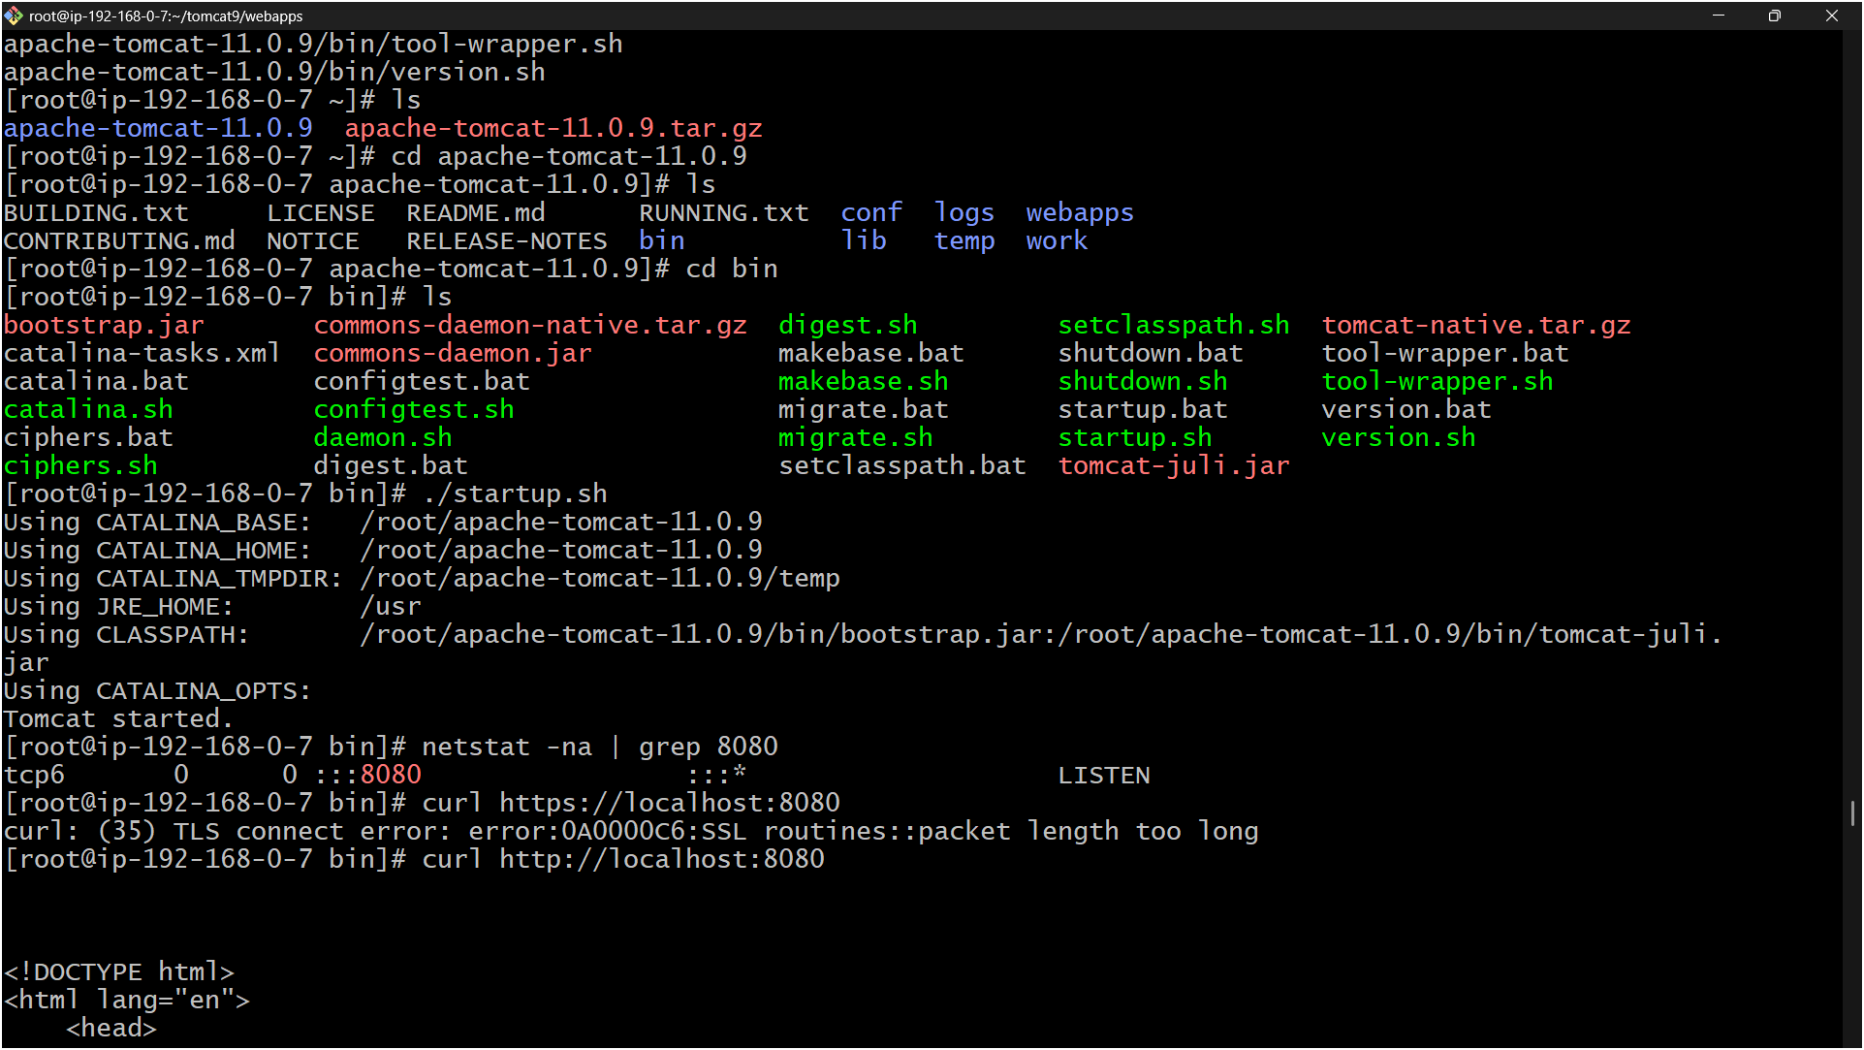
- Deploy Sample WAR:
cd /opt/tomcat/webapps
sudo wget https://tomcat.apache.org/tomcat-10.1-doc/appdev/sample/sample.war
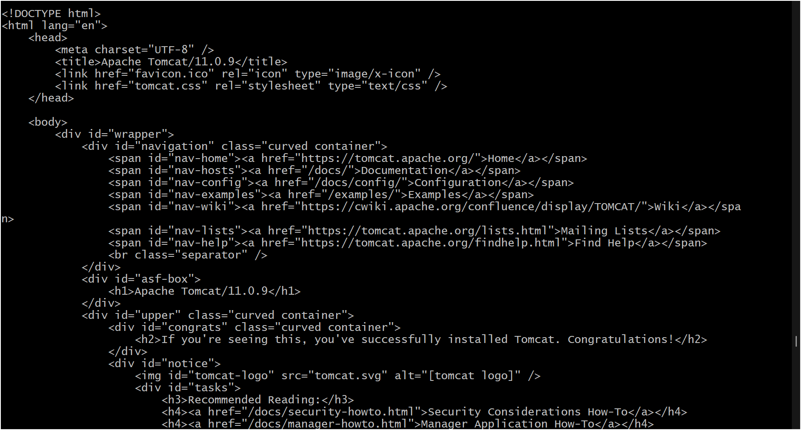
10) Configure VPC flow logs and store the logs in s3 and CloudWatch.
- Go to VPC → Flow Logs → Create Flow Log:
  - Filter: All
  - Destination: CloudWatch Logs or S3 Bucket.
- If S3:
  - Select/create S3 bucket.
- If CloudWatch:
  - Create new Log Group and Role.
- Click Create.

