**Question 2:-**

Imagine a server with the following specs:

- 4 times Intel(R) Xeon(R) CPU E7-4830 v4 @ 2.00GHz

- 64GB of ram

- 2 tb HDD disk space

- 2 x 10Gbit/s nics

The server is used for SSL offloading and proxies around 25000 requests per second.

Please let us know which metrics are interesting to monitor in that specific case and how would you do that? What are the challenges of monitoring this?

**Solution : -**

SSL offloading there are two different ways to accomplish it

1.SSL Termination

2.SSL Termination SSL Bridging

In your case I am assuming that it SSL Termination and diagram like below

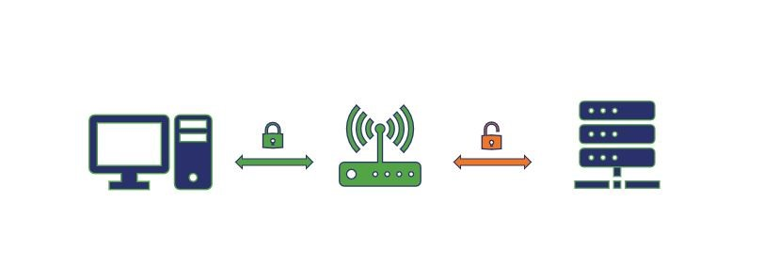

We are considering this high performance SSL termination happening through HA proxy and its version 1.6. So following metrics need to tune and monitor. I will use grafana to monitor those metrics.

**Monitoring metrics :-**

**CPU :-**

CPU should definitely go high because SSL handshake is not a normal 3 way handshake, it is rather a 5 way handshake.

**Ulimit:-**

Number of open file number should be increased as i am expecting very high hit. By default number of open file limit is 1024.

Following way we can increase the number of open files from 1024 to 50000

#Echo “500000” >> /etc/sysctl.conf

#cat /etc/security/limits.conf

root soft nofile 500000

root hard nofile 500000

**TCP/IP connection :-**

By default 450 TCP/IP connection can be established because of kernel parameter tuning.

Following kernel parameter need to tune for your scenario.

#vi /etc/sysctl.conf

net.ipv4.ip_local_port_range 1024 65535

net.ipv4.tcp_tw_reuse = 1

net.ipv4.tcp_tw_recycle = 1

net.ipv4.tcp_fin_timeout = 30

#sysctl -p

**Grafana for monitoring below metrics**  : -

Network with TCP/IP connection status:-

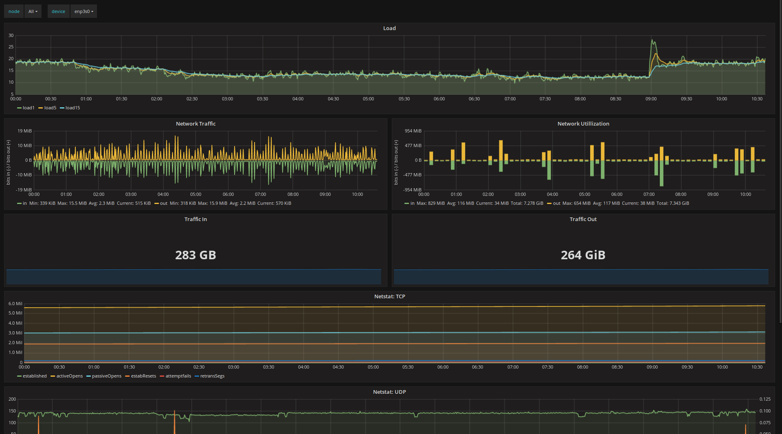

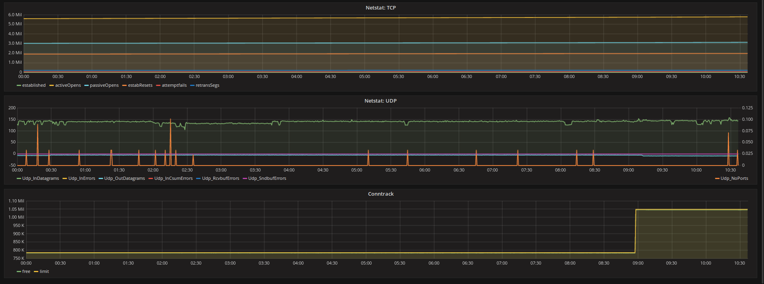

CPU uses monitoring with All core status:-

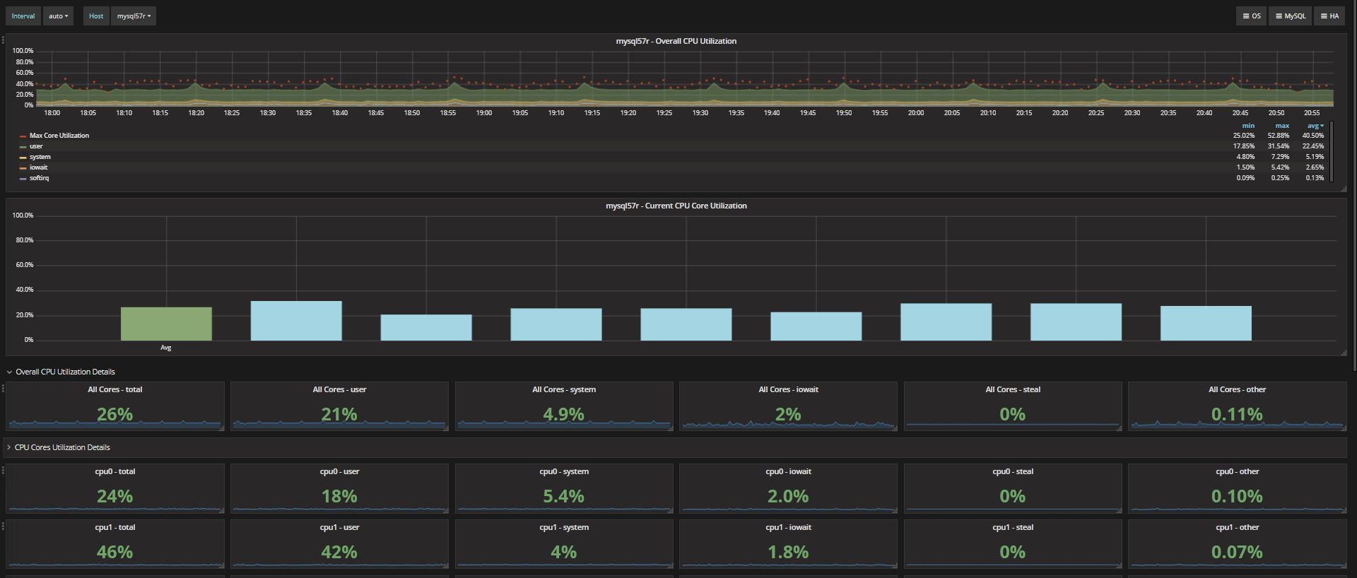

RAM uses monitoring:-

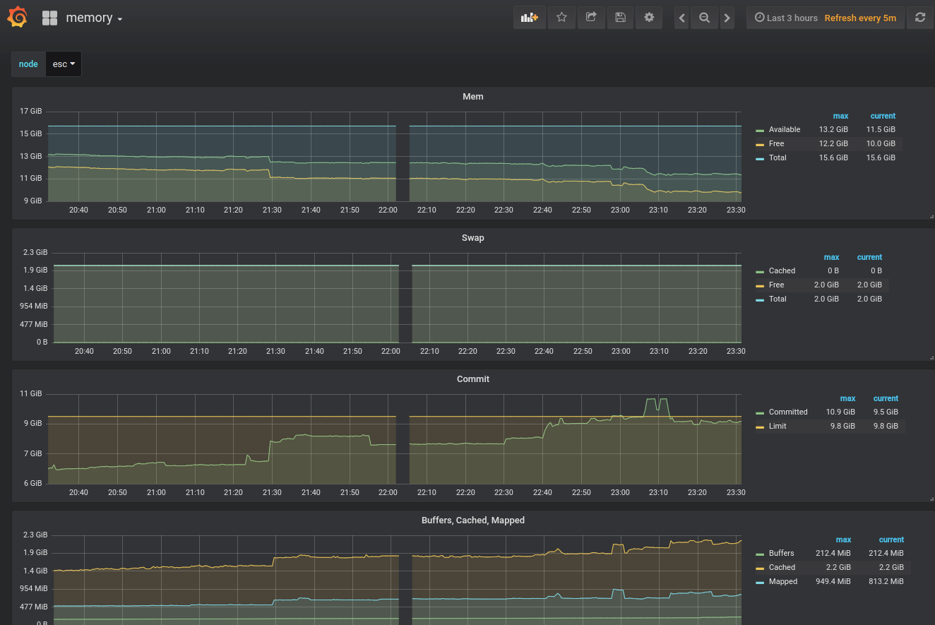

Process monitoring :-

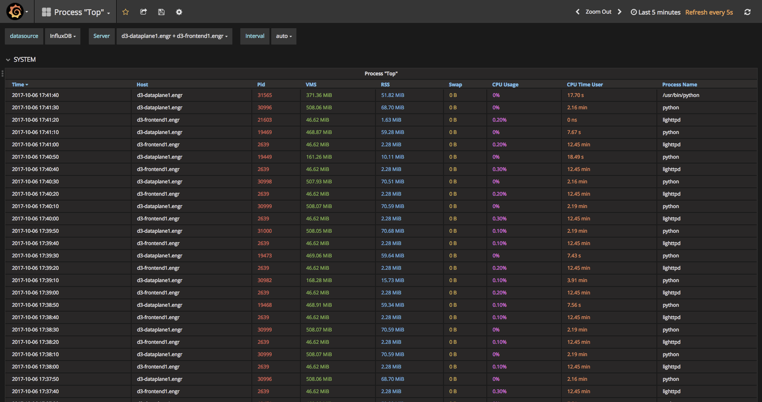

DISK IOPS 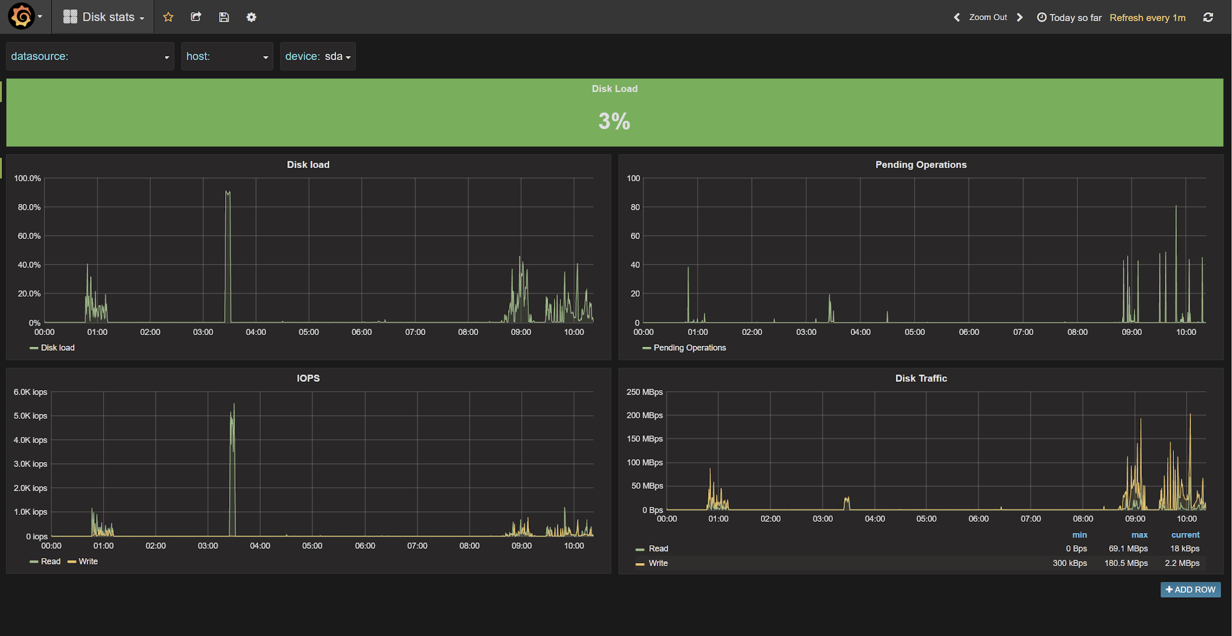

Number of Open Files

