**EE 313-HW1-REPORT-EMRE ÇİFÇİ**

In this report, I am going to briefly present both the plots and the comments on the first homework of EE313.

1st Question:

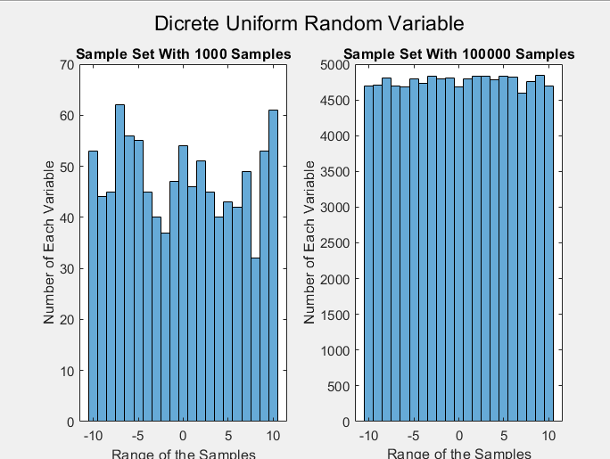

In this question, as the titles suggest, we are working on the discrete random variable with different number of sets. (1000 and 100000) Just like we know from the definition of the discrete uniform random variable, we expect a uniform distribution of the samples. When we have 100k samples instead of 1k, we approach the ideal/uniform distribution of the samples.

2nd Question:

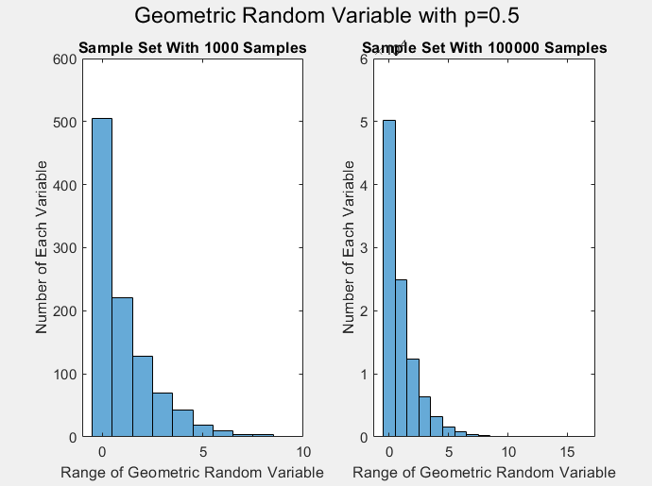

In this question, we observe the effect of increasing the number of samples from 1k to 100k on the geometric random variable with p=0.5. As a result, we realize that this effect makes the distribution of the samples closer to the one that the geometric random variable does. (For p=0.5 🡪 0.5^x 🡪 1 half of the samples at x=0, 1 quarter of the samples at x=1…)

3rd Question:

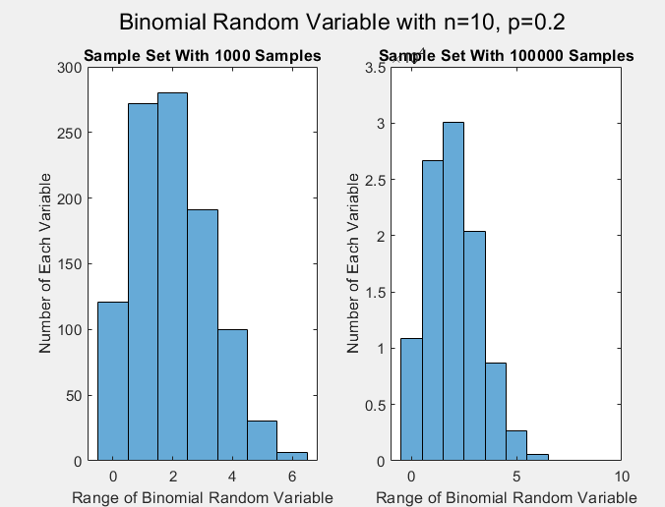

In this question, we observe the effect of increasing the number of samples from 1k to 100 on the binomial random variable with p=0.2 and n=10. Just like we explained in the previous questions, we get closer to the real binomial random variable distribution as we increase the number of samples.

4th Question:

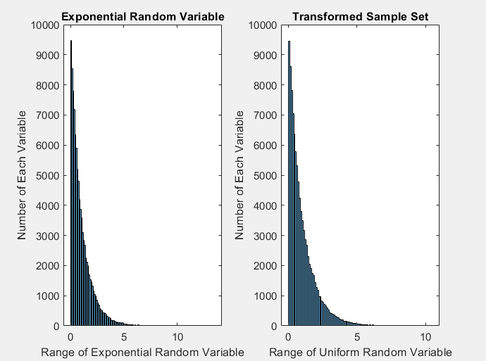

In this question, we observe the difference between two approaches to obtain the binomial random variable distribution. First, we directly find the exponential random variable distribution of 100k samples. Then, we find the continuous uniform random variable U with 100k samples and find their transformed values using -ln(1-u). The results appear similar since the number of the samples are the same.