February 24th 2021, Warsaw

MA Ewelina Błońska

eblonska1@swps.edu.pl

Department of Management

SWPS University of Social Sciences and Humanities

Warsaw, Poland

**Letter of Recommendation**

To Whom it May Concern,

It is my great pleasure to recommend Mr Emre Ulusal (59599) for admission to Erasmus Program. I have been teaching him for winter semester 2020/21 and during that time I observed his grow into an outstanding individual who excels in both academic and personal pursuits. I am convinced that taking part in the Erasmus Program would give him a great chance to improve his language skills, broaden his horizons and get to know new cultures.

Throughout this semester Emre tried to be an active participant in all discussions, projects and teamwork. Undoubtedly, he can be described as an ambitious, goal-oriented and dedicated student who consistently seeks out constructive feedback therefore can improve his language skills.

If his performance in my class is a good indication of how he would perform as an Erasmus student, he would be a positive asset to your program. His current level of English can be described as upper-intermediate (B2), both written and spoken.

If I can be of any further assistance, or provide you with any further information, please do not hesitate to contact me.

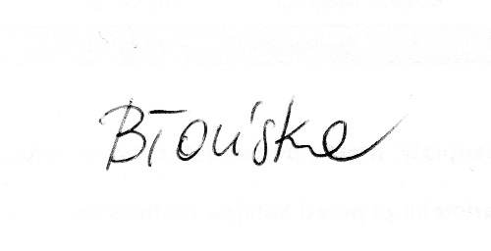

Ewelina Błońska