**GIT PURR! Git Commands Explained with Cats!**

**git purr (git pull)**

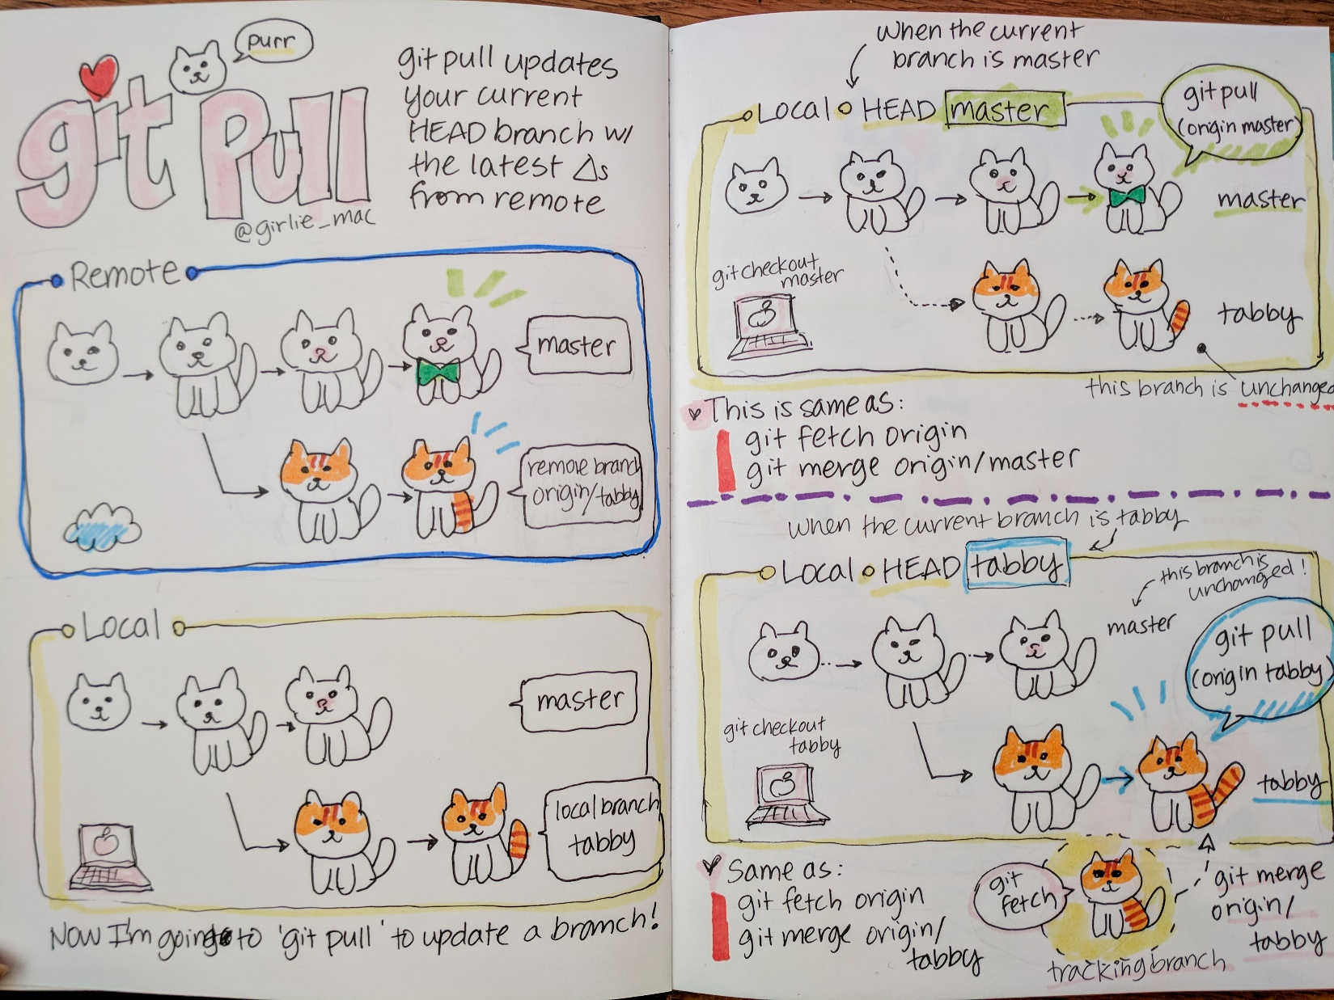

**git meowge (git merge & git rebase)**

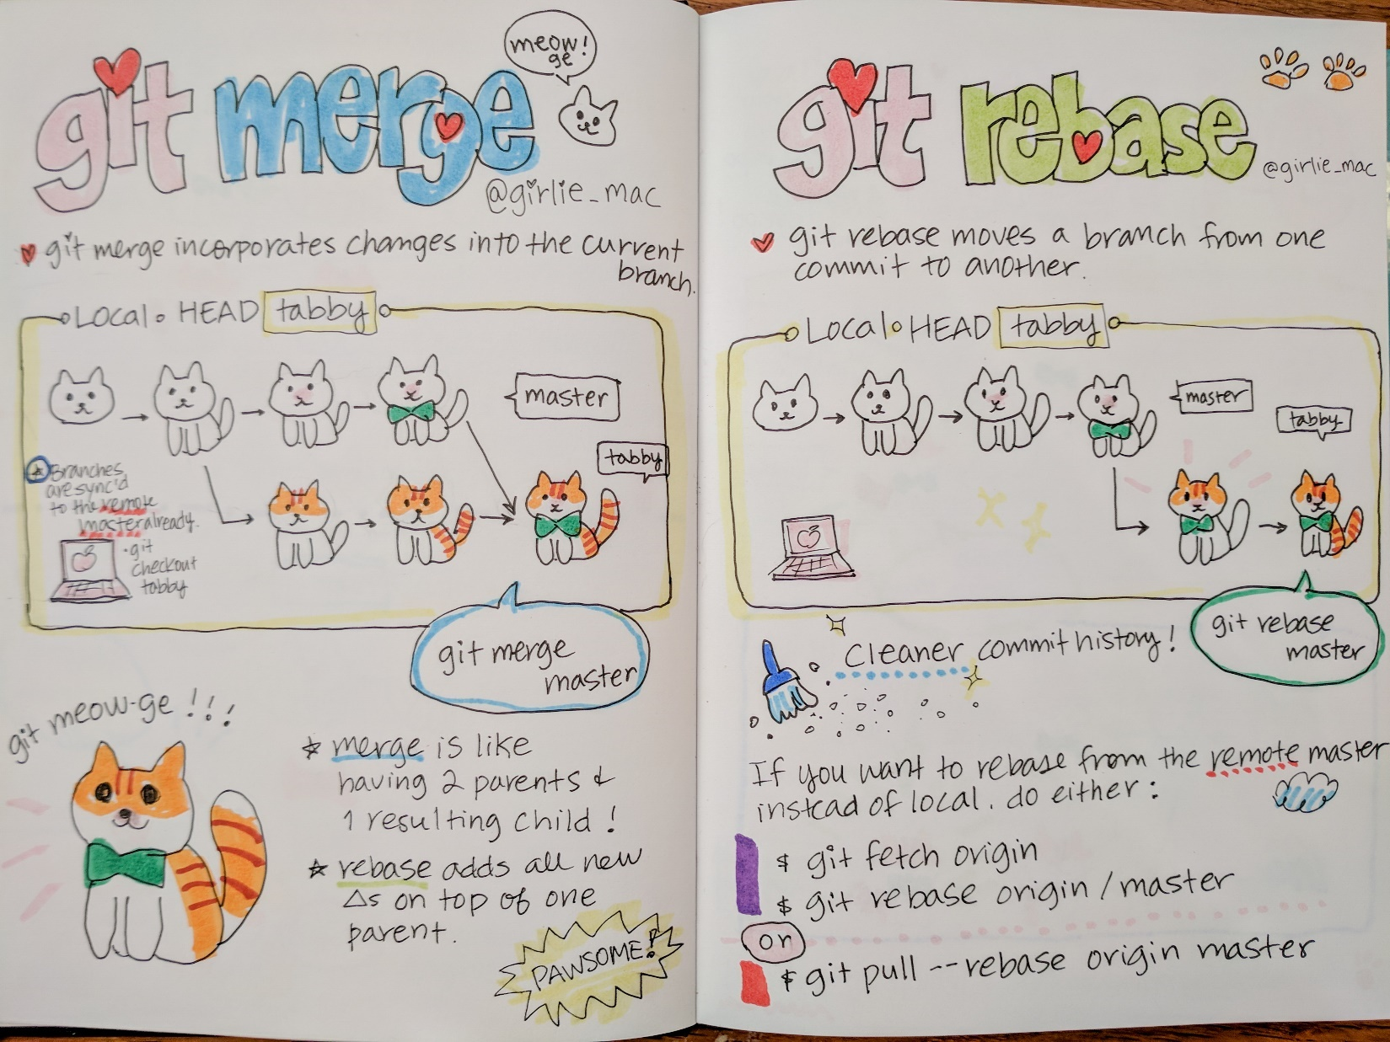

**git puss (git push)**

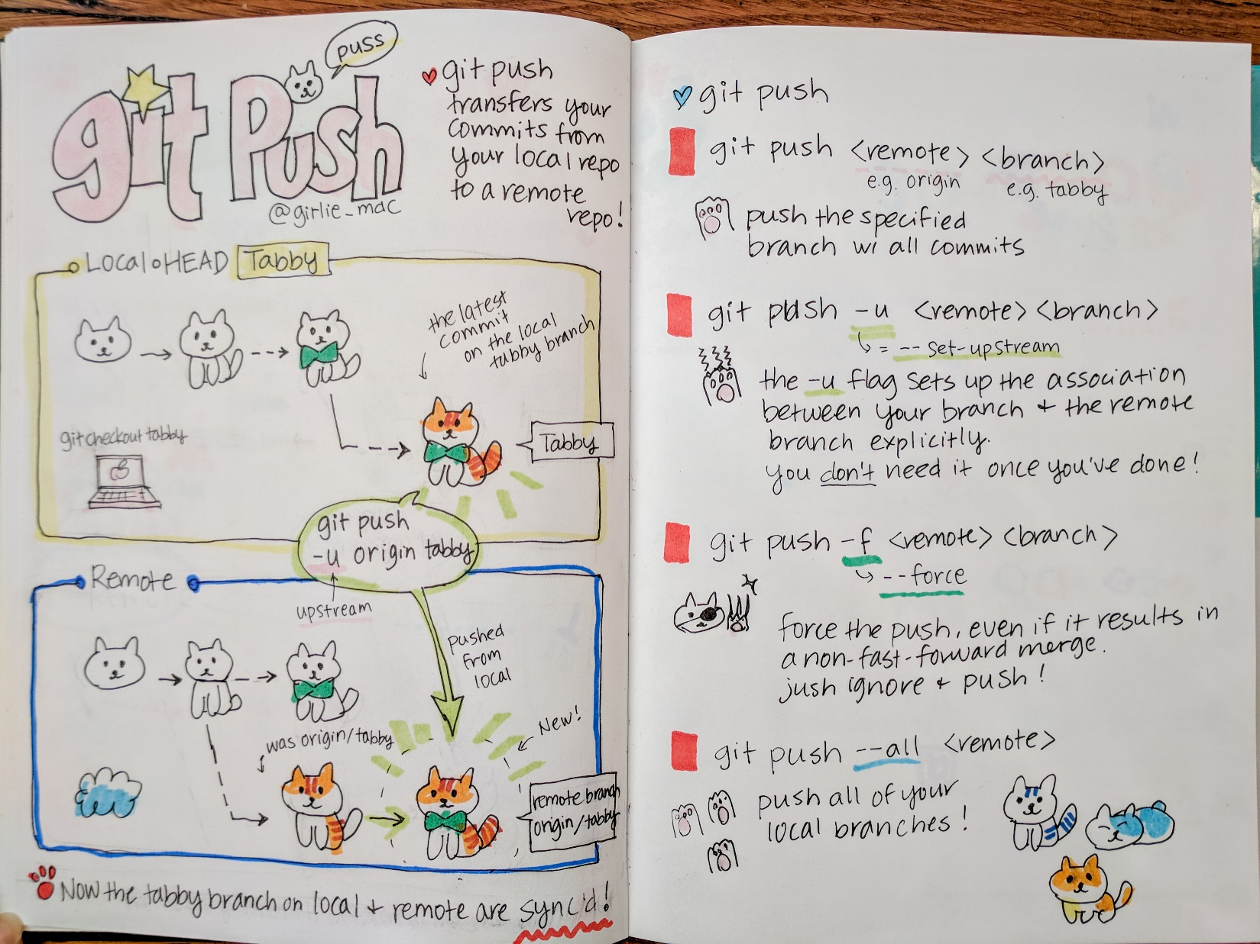

**git cherry-pick & git log**

Now I “handwrite” the doodle digitally with Procreate on iPad! 