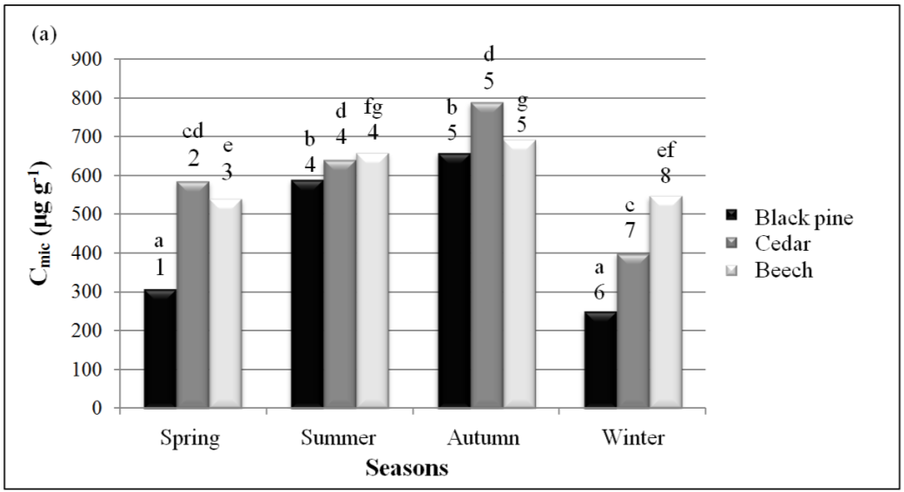

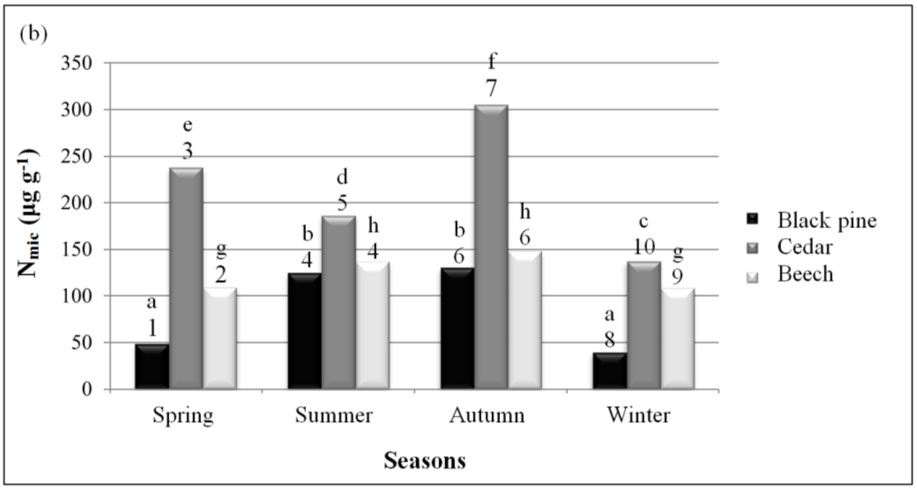

Figure 3. Changes in microbial biomass carbon=Cmic (a) and nitrogen= Nmic (b) among the tree species and seasonal pattern. Values shown by different number among the tree species and letter among the seasons and are significantly different (P≤0.05).