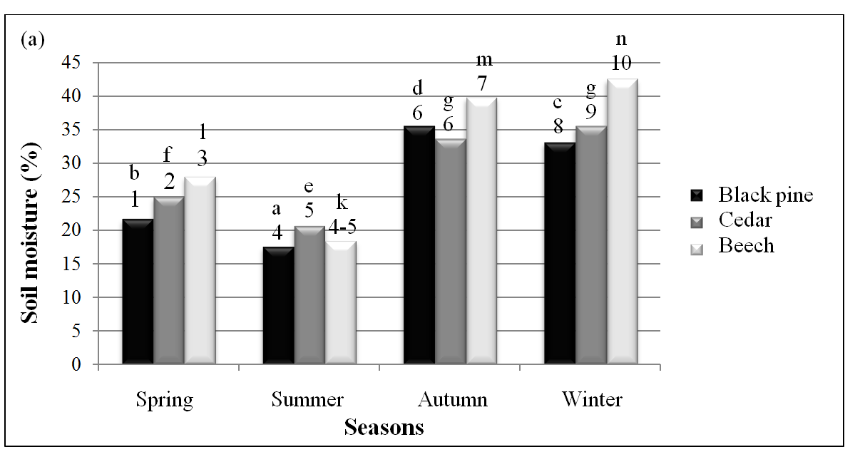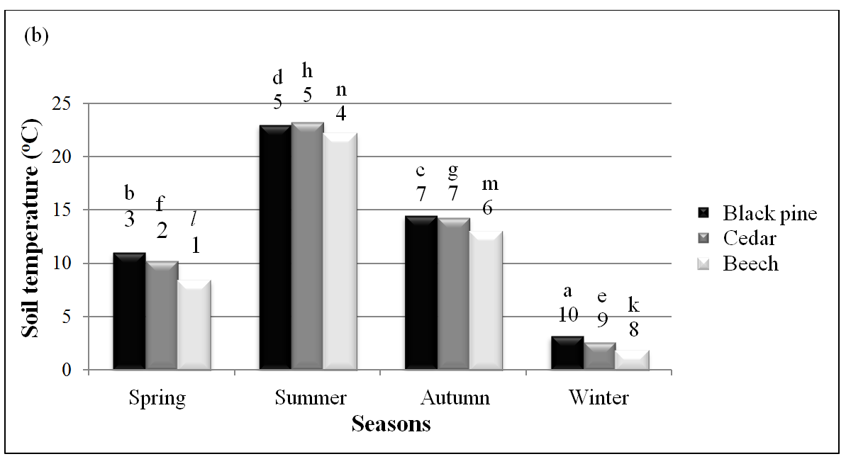

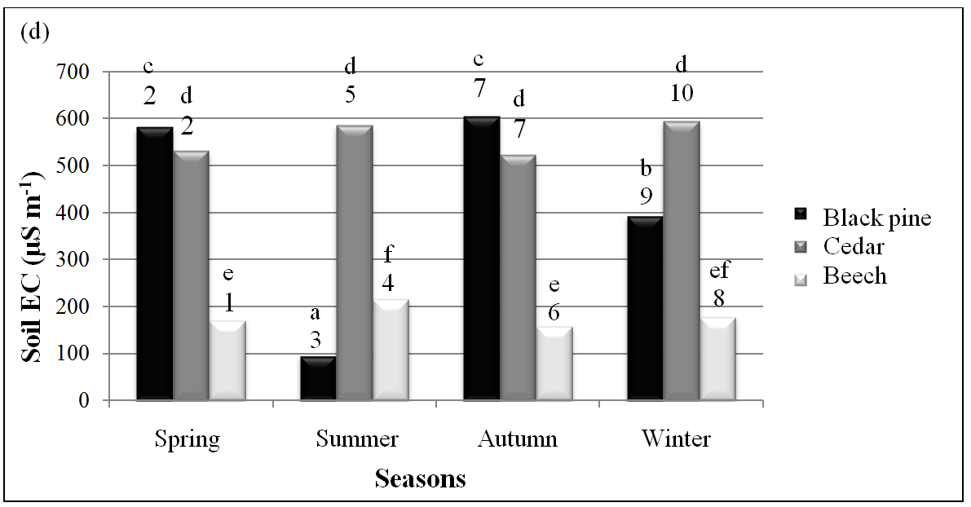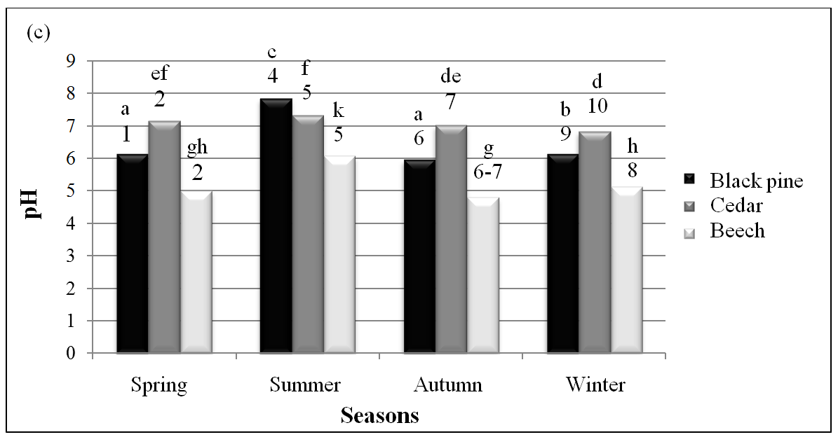

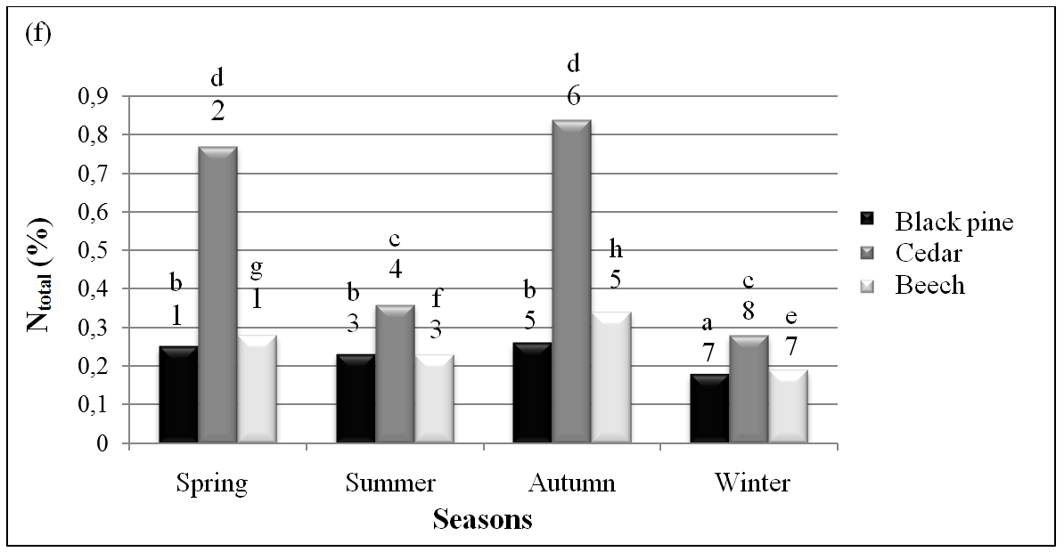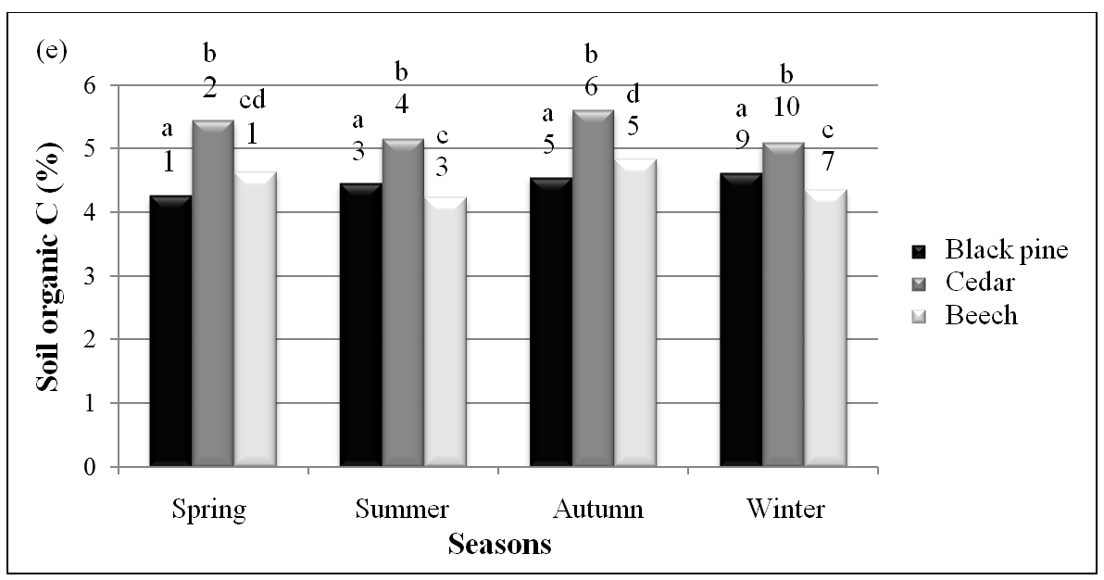

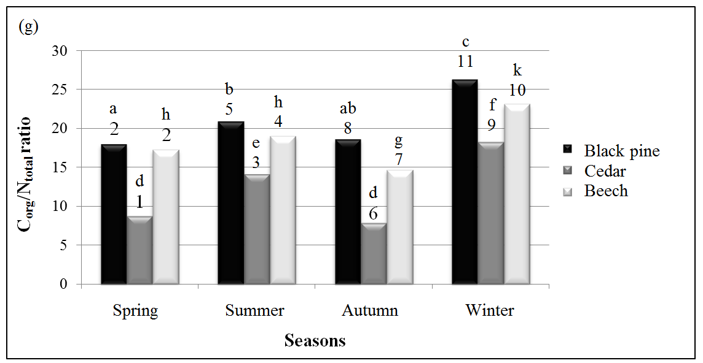

Figure 2. Changes in some physical and chemical soil properties among the tree species and seasonal pattern: (a) soil moisture, (b) soil temperature, (c) pH, (d) electrical conductivity=EC, (e) soil organic carbon, (f) total nitrogen=Ntotal and (g) soil organic carbon to total nitrogen ratio=Corg/Ntotal. Values shown by different number among the tree species and letter among the seasons and are significantly different (P≤0.05).