COMP 11124 – Interactive Software Design

Coursework 2

Group 8
B01835558 Abdullah, Muhammad Leader
B01832063 Khalid, Zubair
B01832569 Bener, Emre
B01820313 Sedhai, Bigyan
B01841891 Ahmad, Moiz

Week 1

Exercise 1.0.
This exercise is about installing Python. I already had Python installed. But since I’m on Arch Linux, here are 2 ways I was able to confirm that I had Python on my system:

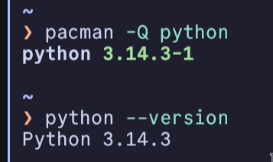
Exercise 1.1.
This exercise is about installing VS Code.
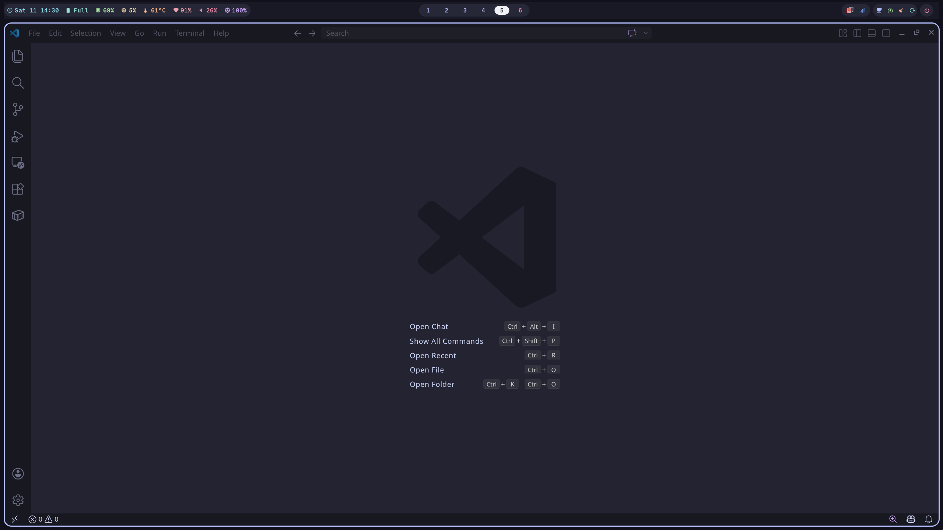
And here is me running the 1st week’s Python example inside VS Code:
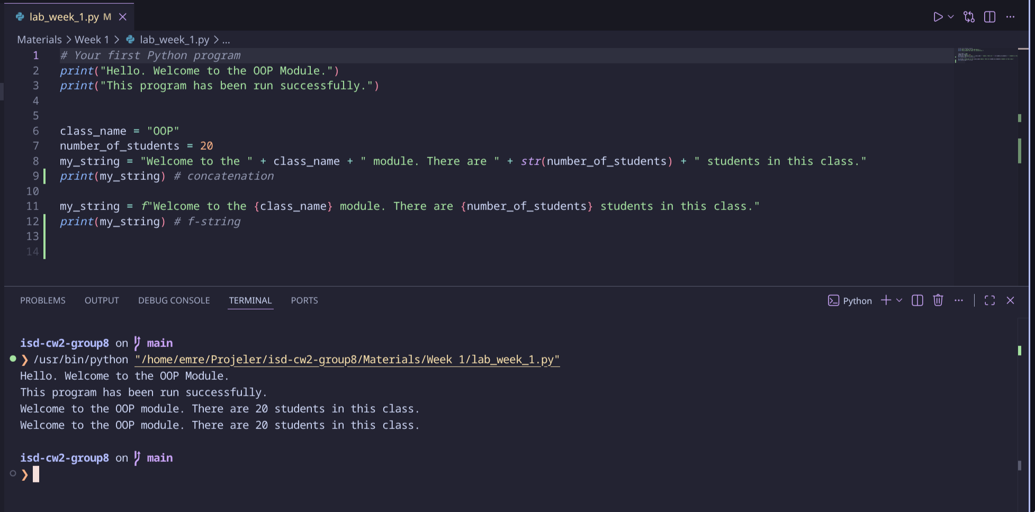
I have also made sure that I have Python extension installed:
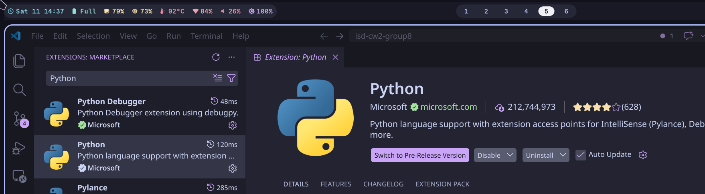
As the lab work explains, I have “Python” indicator at the bottom-right of my screen as well:
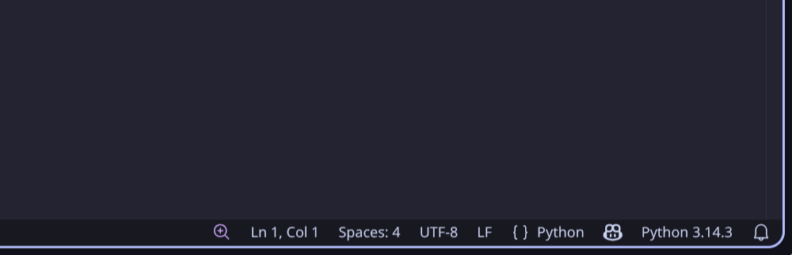

Exercise 1.2.
This exercise explains that it’s possible to run Python scripts via terminal. Here is me using Kitty terminal emulator with with Fish shell (with Starship configured) to run the week 1 Python example:
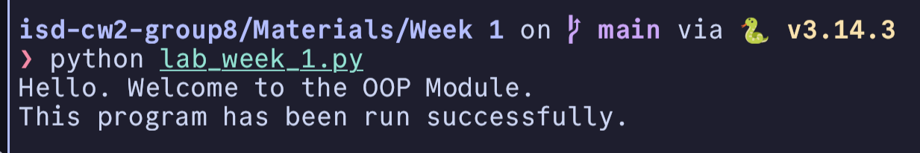

Exercise 2.1.
This exercise is about understanding Python's basic data types and how to check and convert between them. Here are the types for the variables in the example:
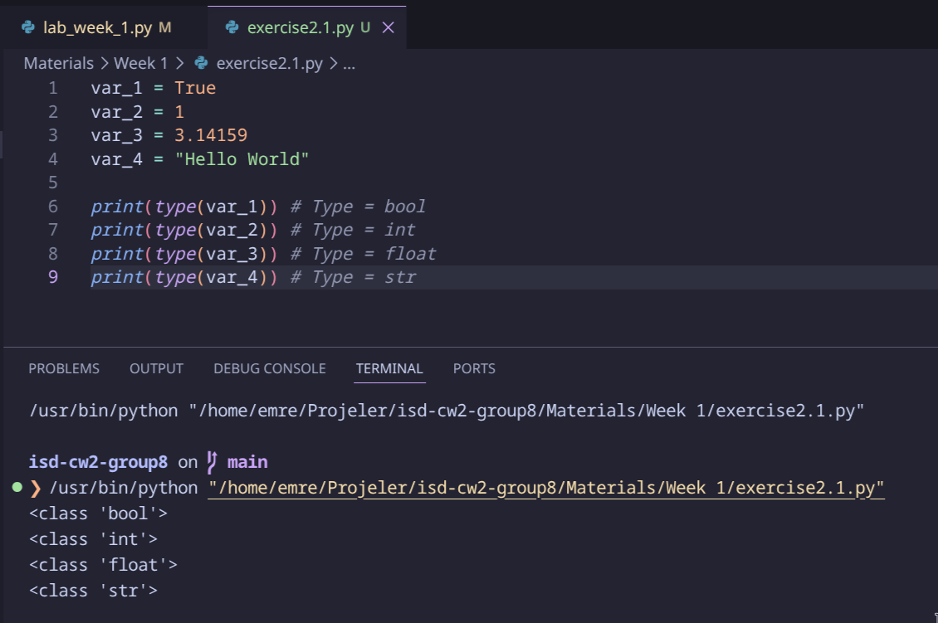
After understanding the operators, we apply them with two practical examples:

- Calculating an average: Create two numbers and compute: (num1 + num2) / 2
- Area of a rectangle: Create `length` and `width` variables and compute: length * width

These are simple examples but they get you used to combining variables and operators to solve actual problems.

Exercise 2.2.
This exercise goes deeper into strings. We already saw basic string usage, but now we learn that strings in Python are objects with built-in methods we can call.
String methods explained:
- .upper() -> converts the entire string to uppercase
- .lower() -> converts the entire string to lowercase
- .replace(old, new) -> swaps out part of the string for something else
- len(string) -> returns how many characters are in the string (this is a built-in function, not a method, so it's called as `len(my_string)` rather than `my_string>
Regarding f-strings: We've already seen these in the starter code, but now we get to create our own. We make variables for our name, number of classes, and campus, and combine them into a sentence. For example:
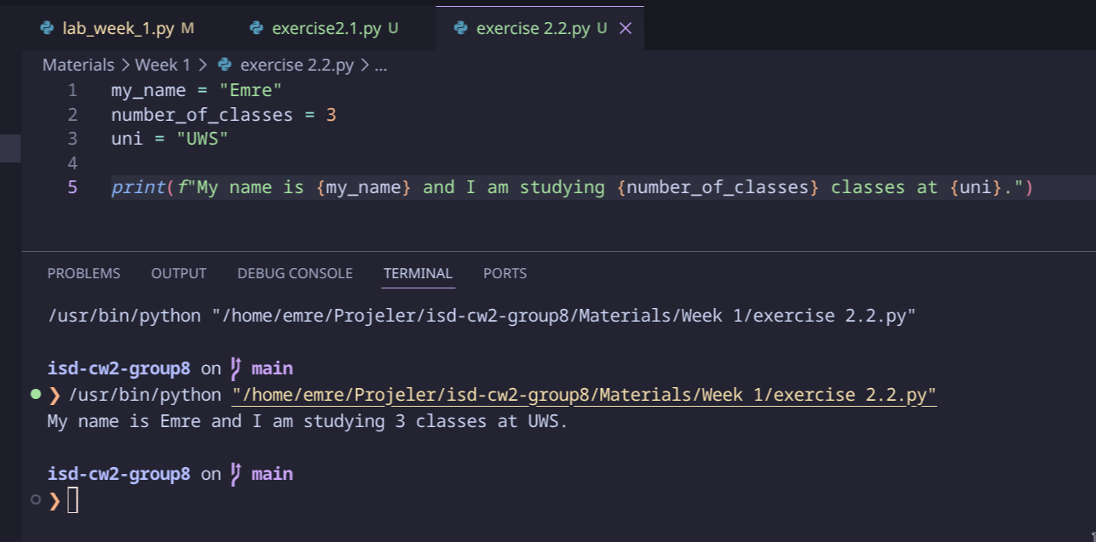
Compared to concatenation, f-strings handle type conversions automatically and are way easier to read as well.

Example 3.1.
We are writing a complete program that converts a Celsius temperature to Fahrenheit and Kelvin. Here is our implementation:
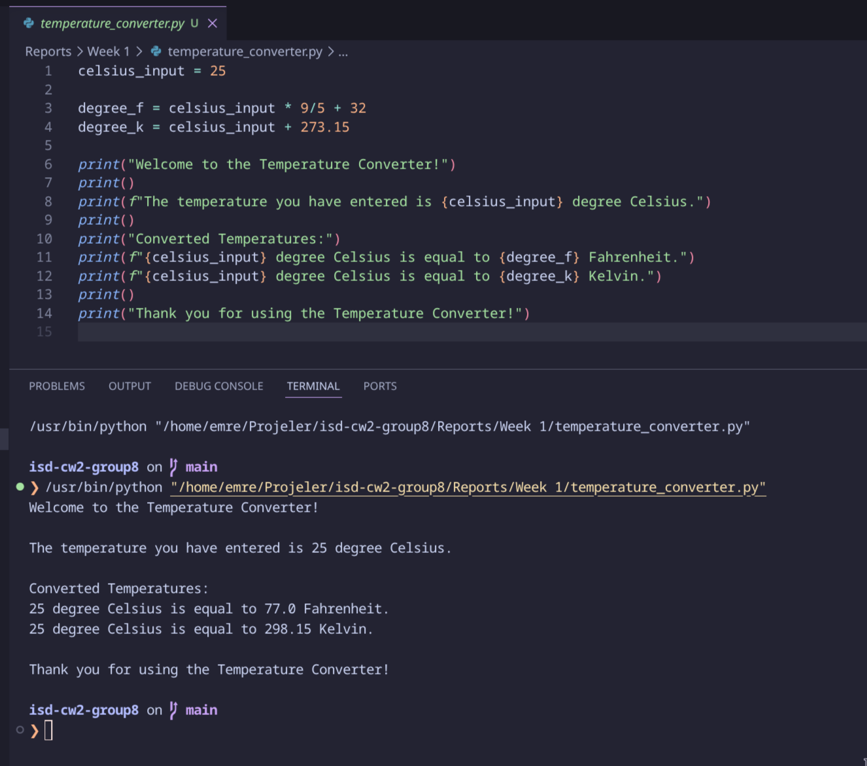

Bonus Code
There is an unexplored part in the code:
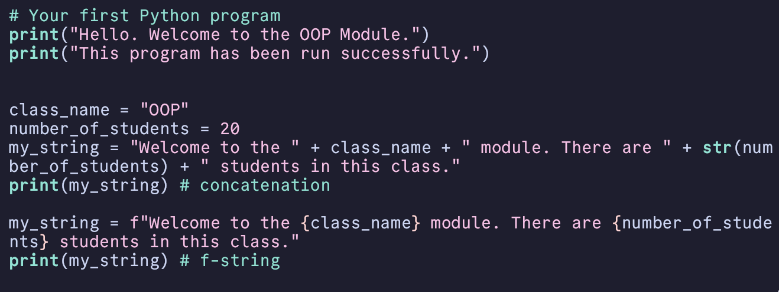
The original example did not print the `my_string` variable after initializing it twice in different ways.
With this modification, we can see 2 different ways to achive the same result, where the 1st example manually glues pieces together with +. while the 2nd example uses `f-strings` for a cleaner, one continuous string:
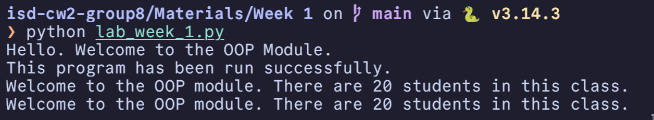

Week 2

Week 3

Week 4

Week 5

Week 6

Week 7

Week 8

