PART 1 : Basic structure of Tables
STUDENTS TABLE

student_id SERIAL( PL/pgSQL )=> INT PRIMARY KEY
student_first_name (Adı) VARCHAR
student_last_name (Soyadı) VARCHAR
student_gender (Cinsiyet) VARCHAR
student_birth_date (Doğum tarihi) DATE
student_address (Adres) VARCHAR
student_email (E-posta) VARCHAR
student_phone (Telefon numarası) VARCHAR
student_enrollment_date (Kayıt tarihi) DATE
department_id (Bölüm numarası) FOREIGN KEY INT REF DEPARTMENT TABLE
event_id (event numarası) FOREIGN KEY INT REF EVENTS TABLE
----------------------------------------------
DEPARTMENTS TABLE

department_id SERIAL( PL/pgSQL )=> INT PRIMARY KEY
department_name VARCHAR
faculty_id FOREIGN KEY INT REF FACULTY TABLE
-----------------------------------------------
FACULTIES TABLE

faculty_id SERIAL( PL/pgSQL )=> INT PRIMARY KEY
faculty_name VARCHAR
-----------------------------------------------

COURSES TABLE

course_id SERIAL( PL/pgSQL )=> INT PRIMARY KEY
course_code VARCHAR
course_name VARCHAR
course_description VARCHAR
course_credit INT
course_hours VARCHAR
department_id FOREIGN KEY INT REF DEPARTMENT TABLE
-----------------------------------------------

STUDENT_COURSES TABLE

student_course_id SERIAL( PL/pgSQL )=> INT PRIMARY KEY
student_id FOREIGN KEY INT REF STUDENT TABLE
course_id FOREIGN KEY INT REF COURSE TABLE
semester VARCHAR
year INT
-----------------------------------------------

INSTRUCTORS TABLE

instructor_id SERIAL( PL/pgSQL )=> INT PRIMARY KEY
instructor_first_name VARCHAR
instructor_last_name VARCHAR
instructor_birth_date DATE
instructor_gender VARCHAR
instructor_email VARCHAR
instructor_phone VARCHAR
department_id FOREIGN KEY INT REF DEPARTMENT TABLE
-----------------------------------------------

INSTRUCTORS_COURSES TABLE
instructor_courses_id SERIAL( PL/pgSQL )=> INT PRIMARY KEY
course_id FOREIGN KEY INT REF COURSE TABLE
instructor_id FOREIGN KEY INT REF INSTRUCTOR TABLE
-----------------------------------------------

COURSE_SCHEDULE TABLE
course_schedule_id SERIAL( PL/pgSQL )=> INT PRIMARY KEY
course_id FOREIGN KEY INT REF COURSE TABLE
instructor_id FOREIGN KEY INT REF INSTRUCTOR TABLE
room VARCHAR
day_of_week VARCHAR
start_time DATE
end_time DATE
-----------------------------------------------
EVENTS TABLE

event_id SERIAL( PL/pgSQL )=> INT PRIMARY KEY
event_title VARCHAR
event_description VARCHAR
event_date DATE
event_location VARCHAR
-----------------------------------------------
GRADES TABLE

grade_id SERIAL( PL/pgSQL )=> INT PRIMARY KEY
student_id FOREIGN KEY INT REF STUDENT TABLE
course_id FOREIGN KEY INT REF COURSE TABLE
midterm_grade INT
final_grade INT
average_grade INT
PART 2: SQL Queries for creating tables
1- FACULTIES TABLE

CREATE TABLE faculties (
id SERIAL PRIMARY KEY,
name VARCHAR(50)
);

2- DEPARTMENTS TABLE

CREATE TABLE departments (
id SERIAL PRIMARY KEY,
name VARCHAR(50),
faculty_id INT
ADD FOREIGN KEY (faculty_id) REFERENCES faculties(id);

);

3- STUDENTS TABLE

CREATE TABLE students (
id SERIAL PRIMARY KEY,
first_name VARCHAR(50),
last_name VARCHAR(50),
gender CHAR(1),
birth_date DATE,
address VARCHAR(255),
email VARCHAR(100),
phone VARCHAR(20),
enrollment_date DATE,
department_id INT REFERENCES departments(id)
event_id INT REFERENCES events(id)
);

4- COURSES TABLE

CREATE TABLE courses (
id SERIAL PRIMARY KEY,
code VARCHAR(20),
name VARCHAR(50),
description TEXT,
credit INT,
hours INT,
department_id INT REFERENCES departments(id)
);

5- INSTRUCTORS TABLE

CREATE TABLE instructors (
id SERIAL PRIMARY KEY,
first_name VARCHAR(50),
last_name VARCHAR(50),
birth_date DATE,
gender CHAR(1),
email VARCHAR(100),
phone VARCHAR(20),
department_id INT REFERENCES departments(id)
);

6- COURSE SCHEDULE TABLE

CREATE TABLE course_schedule (
id SERIAL PRIMARY KEY,
course_id INT,
instructor_id INT,
room VARCHAR(20),
day_of_week INT,
start_time TIME,
end_time TIME,
FOREIGN KEY (course_id) REFERENCES courses(id),
FOREIGN KEY (instructor_id) REFERENCES instructors(id)
);

7- GRADES TABLE

CREATE TABLE grades (
id SERIAL PRIMARY KEY,
student_id INT,
course_id INT,
midterm_grade INT,
final_grade INT,
average_grade INT,
FOREIGN KEY (student_id) REFERENCES students(id),
FOREIGN KEY (course_id) REFERENCES courses(id)
);

8- STUDENT_COURSES TABLE

CREATE TABLE student_courses (
id SERIAL PRIMARY KEY,
student_id INT,
course_id INT,
semester INT,
year INT,
FOREIGN KEY (student_id) REFERENCES students(id),
FOREIGN KEY (course_id) REFERENCES courses(id)
);

9- COURSE_INSTRUCTORS TABLE

CREATE TABLE course_instructors (
course_id INT,
instructor_id INT,
PRIMARY KEY (course_id, instructor_id),
FOREIGN KEY (course_id) REFERENCES courses(id),
FOREIGN KEY (instructor_id) REFERENCES instructors(id)
);

10- EVENTS TABLE

CREATE TABLE events (
id SERIAL PRIMARY KEY,
title VARCHAR(255),
description TEXT,
event_date DATE,
location VARCHAR(255));
PART 3: SQL Queries for inserting data

INSERT INTO students(first_name,last_name,gender,birth_date,address,email,phone,enrollment_date,department_id,event_id) VALUES
('jon','snow','m','2000-05-19','a city b street', 'kinginthenorth@gmail.com', '25637255','2022-12-12',1,1),
('arya','stark','f','2004-04-02','c city d street','nonamegirl@gmail.com','11225566', '2023-02-14',2,1),
('tanjiro','kamado','m','2000-10-19','e city f street','hinokamikagura@gmail.com','77785269','2021-01-10',1,1),
('jesse','pinkman','m','1990-03-22', 'g city h street', 'whatsup@gmail.com','44485694','2020-04-24',3,2),
('dean','winchester','m','1992-01-01','t city u street','familybusiness@gmail.com','78912332','2018-09-15',1,3)

--------------------
INSERT INTO faculties(name) VALUES('engineering')
---------------------
INSERT INTO departments(name,faculty_id) VALUES
('computer engineering',1),
('machine engineering',1),
('chemical engineering',1)
-------------------------

INSERT INTO events(title,description,event_date,location) VALUES
('meeting','meeting with student','2023-11-11','school'),
('cooking','cook something','2022-04-03','caravan'),
('hunting','kill the demons','2020-06-22','abandoned house')
------------------
INSERT INTO instructors(first_name,last_name,birth_date,gender,email,phone,department_id) VALUES
('Ygritte','Nothing','1990-01-14','f','youknownothing@gmail.com','55517895',1),
('Joseph','Ledet','1980-03-15','m','bestteacherever@gmail.com','25677418',1),
('Syrio','Forel','1977-03-13','m','nottoday@gmail.com','47458965',2),
('No Face','Man','1988-05-24','m','valarmorghulis@gmail.com','78945622',2),
('Walter','White','1975-02-25','m','saymyname@gmail.com','99548222',3),
('Saul','Goodman','1985-08-27','m','bettercallsaul@gmail.com','36544712',3),
('Sakonji','Urokodaki','1960-02-01','m','masterurokodaki@gmail.com','78955522',1),
('John','Winchester','1978-07-17','m','givemecolt@gmail.com','45788221',1),
('Bobby','Singer','1975-12-11','m','ohboys@gmail.com','96587412',1)
---------------------------------------------
INSERT INTO courses(code,name,description,credit,hours,department_id) VALUES
('CS200','programming','javascript programming',5,2,1),
('CS202','database','DB management',6,2,1),
('MS101','Intro to Machine','machine 101 course',4,2,2),
('MS102','Advanced Machine','machine 102 course',6,2,2),
('KM101','Chemical Materials','intro chemical materials',4,2,3),
('KM106','Chemical Experiments','intro chemical experiments',3,2,3),
('CS303','Monster Organization','Hunting wild monsters',5,2,1),
('CS304','Weapon Architecture','Gun care',5,2,1)
---------------------------------------------------------------+

INSERT INTO course_instructors VALUES
(1,1),
(1,7),
(2,2),
(3,3),
(4,4),
(5,5),
(6,6),
(7,8),
(8,9)
-----------------------------------------------------

INSERT INTO course_schedule(course_id,instructor_id,room,day_of_week,start_time,end_time) VALUES
(1,1,'d302',1,'08:00','10:00'),
(2,2,'d301',1,'08:00','10:00'),
(3,3,'m222',2,'09:00','11:00'),
(4,4,'m333',2,'09:00','11:00'),
(1,7,'c111',3,'10:00','12:00'),
(5,5,'g123',4,'13:00','15:00'),
(6,6,'g321',4,'13:00','15:00'),
(2,2,'d555',5,'08:00','10:00'),
(7,8,'d666',5,'08:00','10:00'),
(8,9,'d777',5,'08:00','10:00')

-----------------------------------------------------
INSERT INTO grades(student_id,course_id,midterm_grade,final_grade,average_grade) VALUES
(1,1,40,80,60),
(1,2,30,70,50),
(2,3,60,100,80),
(2,4,40,100,70),
(3,1,10,90,50),
(4,5,50,100,75),
(4,6,100,100,100),
(5,2,20,60,40),
(5,7,100,60,80),
(5,8,40,80,60)
------------------------------------------------------

INSERT INTO student_courses(student_id,course_id,semester,year) VALUES
(1,1,1,2022),
(1,2,2,2022),
(2,3,1,2023),
(2,4,2,2023),
(3,1,1,2021),
(4,5,1,2020),
(4,6,2,2020),
(5,2,2,2018),
(5,7,2,2018),
(5,8,2,2018)

PART 4: SQL Query for view
CREATE VIEW unnormalized_data AS
SELECT
students.id as student_id,
students.first_name as student_first_name,
students.last_name as student_last_name,
students.gender as student_gender,
students.birth_date as student_birth_date,
students.address as student_address,
students.email as student_email,
students.phone as student_phone,
students.enrollment_date as student_enrollment_date,
departments.id as department_id,
departments.name as department_name,
faculties.id as faculty_id,
faculties.name as faculty_name,
courses.id as course_id,
courses.code as course_code,
courses.name as course_name,
courses.description as course_description,
courses.credit as course_credit,
courses.hours as course_hours,
instructors.id as instructor_id,
instructors.first_name as instructor_first_name,
instructors.last_name as instructor_last_name,
instructors.birth_date as instructor_birth_date,
instructors.gender as instructor_gender,
instructors.email as instructor_email,
instructors.phone as instructor_phone,
course_schedule.id as course_schedule_id,
course_schedule.room as course_schedule_room,
course_schedule.day_of_week as course_schedule_day_of_week,
course_schedule.start_time as course_schedule_start_time,
course_schedule.end_time as course_schedule_end_time,
grades.id as grade_id,
grades.midterm_grade as grade_midterm_grade,
grades.final_grade as grade_final_grade,
grades.average_grade as grade_average_grade,
events.id as event_id,
events.title as event_title,
events.description as event_description,
events.event_date as event_date,
events.location as event_location
FROM students
JOIN departments ON students.department_id = departments.id
JOIN faculties ON departments.faculty_id = faculties.id
JOIN student_courses ON students.id = student_courses.student_id
JOIN courses ON student_courses.course_id = courses.id
JOIN course_instructors ON courses.id = course_instructors.course_id
JOIN instructors ON course_instructors.instructor_id = instructors.id
JOIN course_schedule ON courses.id = course_schedule.course_id AND instructors.id = course_schedule.instructor_id
JOIN events ON students.event_id = events.id
JOIN grades ON students.id = grades.student_id AND courses.id = grades.course_id;

PART 5: E-R Diagram Image
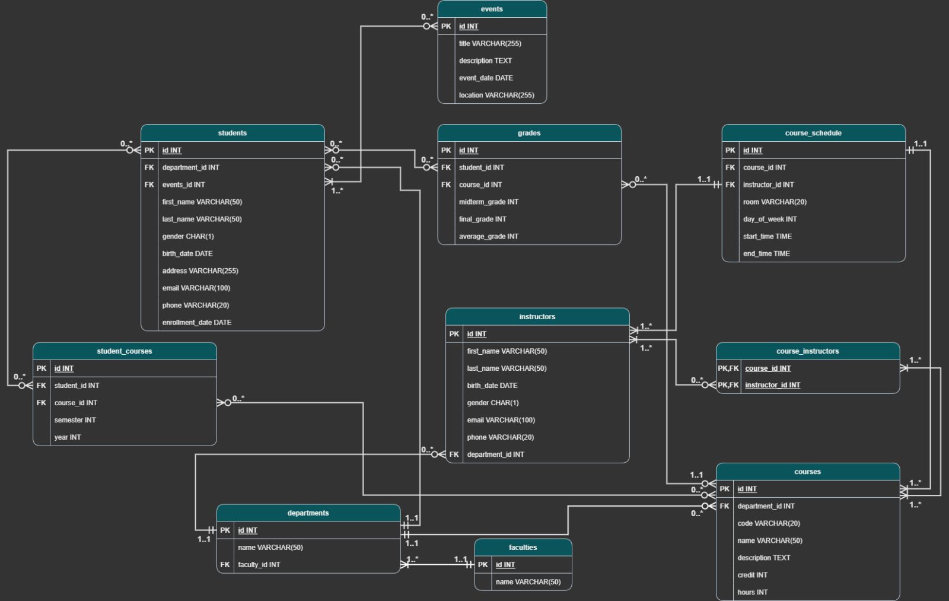

PART 6: GROUP MEMBERS
MUSTAFA EMRE OZTURK => 20180808030
ANIL BERKAN ÜZREK => 20200808027
SEVGİ SARICA => 20190808066
BERAT BERKE DEMİR => 20220808610
MUSTAFA MERT CAN => 20220808705

