Admin Authentication

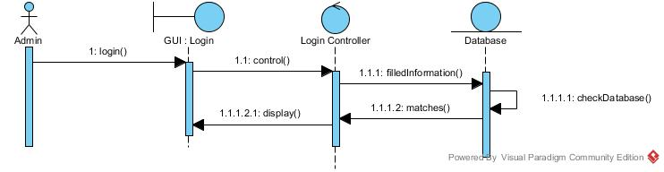

Admin Login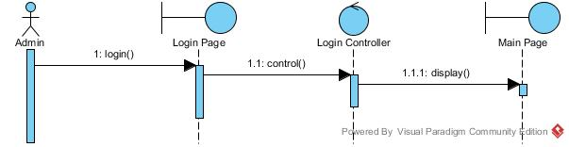

Admin List of Doctor-Add Doctor-Delete Doctor

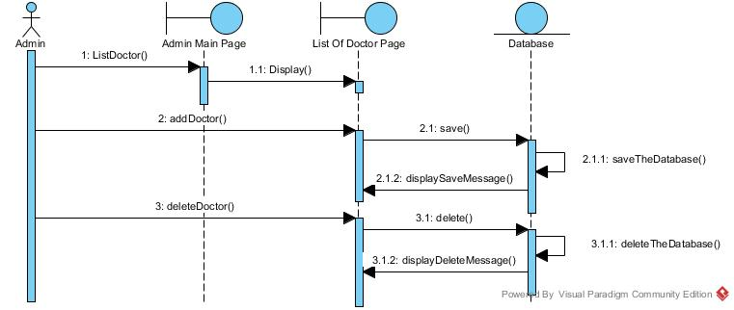

Admin Request of Doctor

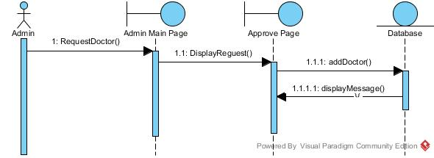

Admin List of Drug-Add Drug – Delete Drug

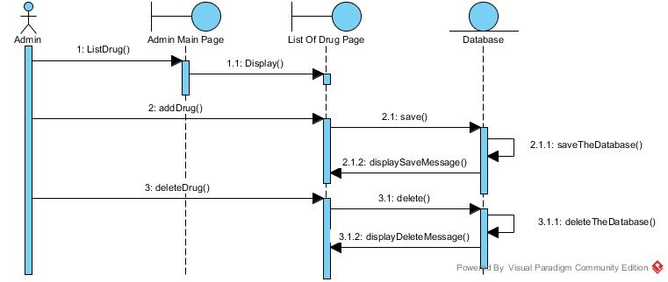

Admin Update Drug