Naslov

Za tilesete sem uporabil
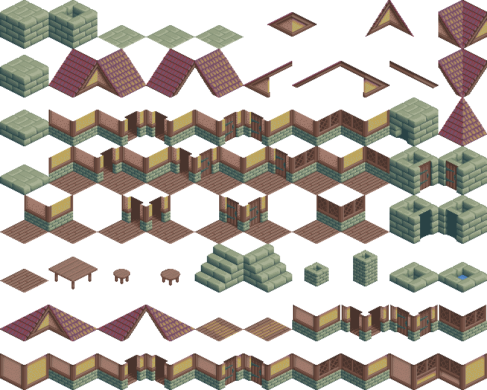
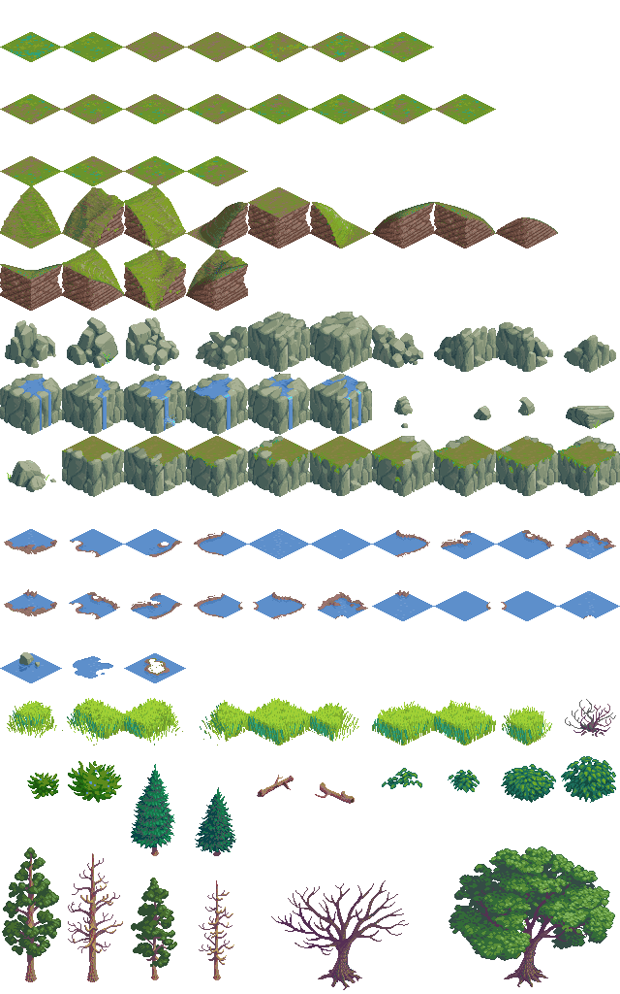
1Na sliki je povezava do speltne strani, kjer sem najdu tilesete

Pytmx help:
https://www.pygame.org/project-Tiled+TMX+Loader-2036-.html
https://www.reddit.com/r/pygame/comments/27yzex/getting_started_with_pytmx_making_collideable/

Metode: https://pytmx.readthedocs.io/en/latest/genindex.html
Source code: https://pytmx.readthedocs.io/en/latest/_modules/pytmx/pytmx.html#parse_properties

Pygame sprites: https://www.pygame.org/docs/ref/sprite.html
https://www.geeksforgeeks.org/python/pygame-creating-sprites/

Collision:
https://github.com/justinmeister/PyTMX-Examples/tree/master/Make%20Collideable%20Rectsđ

Pomoč za PyAutoGui: https://pyautogui.readthedocs.io/en/latest/

Pygame help:
https://www.reddit.com/r/pygame/comments/1clx5lg/how_to_hide_the_title_bar/

Help za importanje file-ov iz drugih folderjev
https://www.geeksforgeeks.org/python/python-import-module-from-different-directory/

https://gamedev.stackexchange.com/questions/121832/how-to-integrate-tiled-maps-and-collision-detection-with-pygame

Chat GPT sem uporabil za izračunavanje colisiona, velikosti tileov, spiritov

