

**American International University- Bangladesh**

**CSC 3215: Web Technologies**

**CO1 and CO3 Evaluation**

**Project Report**

**Spring 2019-2020**

**Project Title:** Social Site

**Section:** J

|  |  |
| --- | --- |
| Student Name | Student Id |
| Emrul Hossain Minhaz | **18-36040-1** |
| Mia Asif | **18-36030-1** |
| Sultan Ahmed | **18-36017-1** |

**Introduction:**

This Social Site is for those users who wants faster and easier ways to contact with their friends and family.

This Social gives them a smooth and effective surfacing though online messaging and connect each-other. This a user friendly and secure browsing though internet.

**Background Study:**

We have studied and gathered knowledge from the following sources

<https://www.youtube.com/results?search_query=uml+daigrams>

<https://www.investopedia.com/terms/s/social-networking.asp>

<https://royal.pingdom.com/the-software-behind-facebook/>

**Requirement Analysis:**

1. **User Category:**

There are two types of Users here. They are:

* System
* User

1. **Feature List:**

In this project the “System” has the following features:

* Approve User Account
* Register User Profile
* Check User Account
* Delete User Profile
* Send/Receive Messages into Database
* Make System Announcement
* Release System Updates
* Send User warning
* Suspend User Account

In this project the “User” has the following features:

* Send Friend Request
* Edit Profile
* Post Messaging
* Report Account
* Uploads Photos

**Design:**

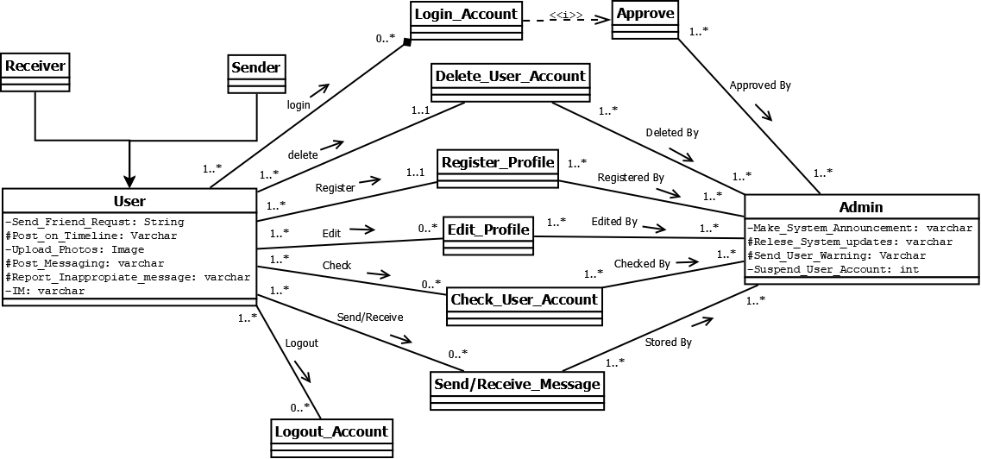

Fig: Class Diagram

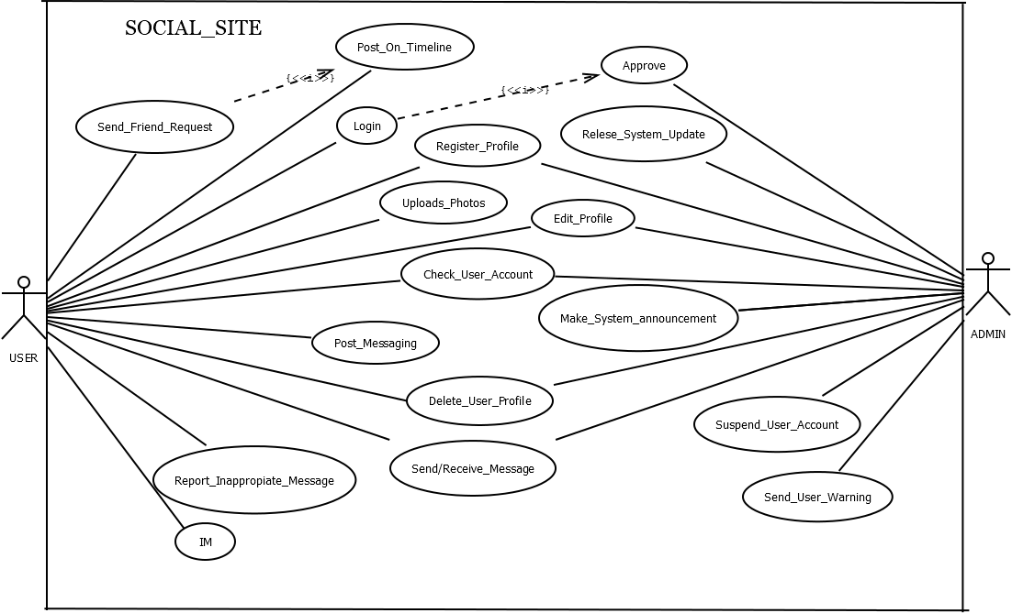

Fig: Use Case Diagram

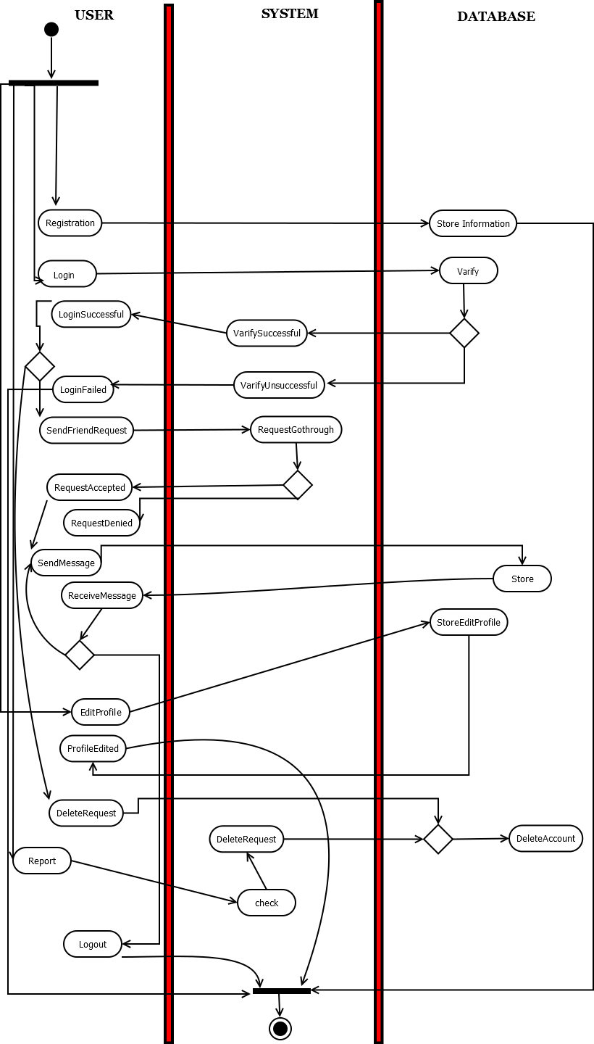

Fig: Activity Diagram

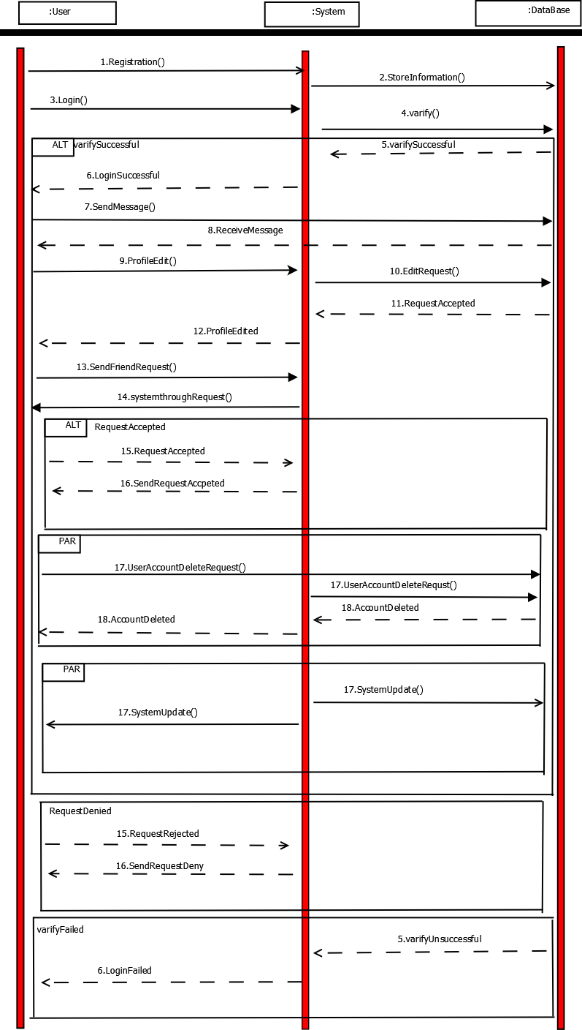

Fig: Sequence Diagram

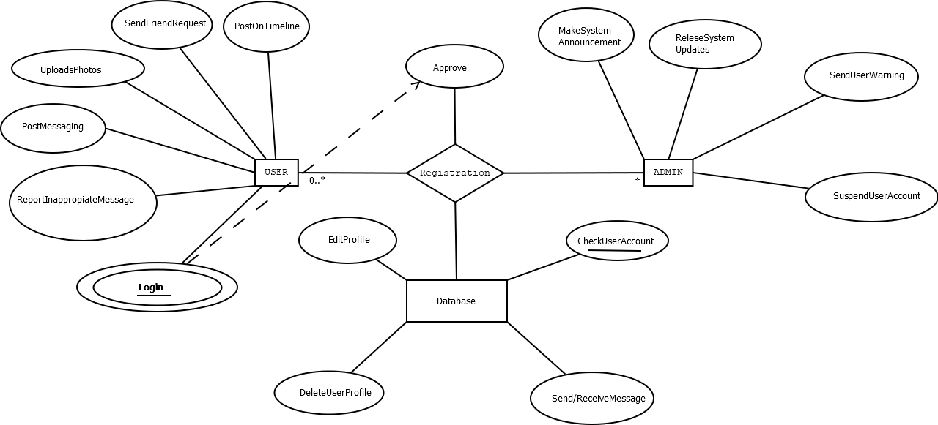

Fig: Entity Diagram

**Tools Used:**

To develop this project, we have used the following:

* Web Browser
* Dia
* Text Editor
* Photo Editor

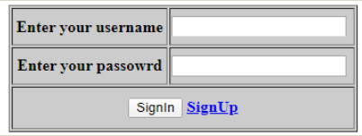

This is a Login Page Where username and password that allows a person to log in our system.

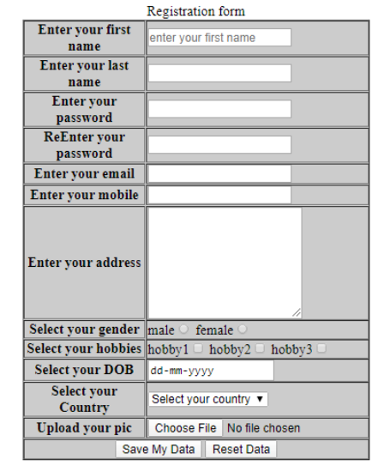

This is a Registration Page Where email and password that allows a person to register in our system.

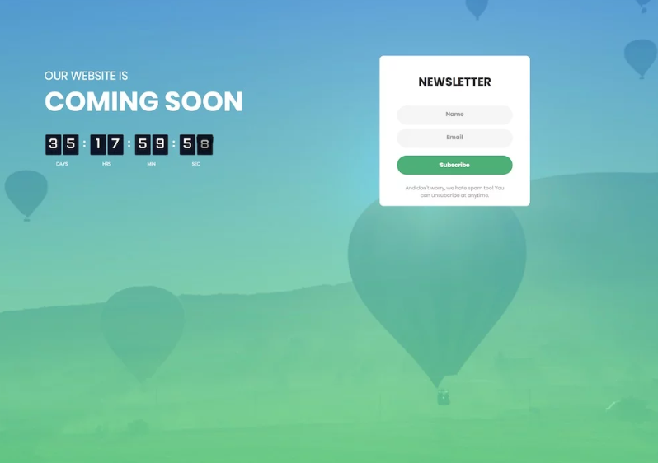

This the home page for social site which is under construction. Feature will be added soon by which user can able to chat and things.

**Impact of this Project:**

People are so busy today; however, they cannot connect each-other via internet many a time. Sometime if it is possible, they can face a lot of major security issues and also effectiveness of the site issues. So then this project come alone with a positive vibe to give user a user friendly and efficient surface to connect with friends and families.

* + **Uniqueness:** There are so many unique features in this site.

♦ **Security Issue:** User can assure secured surfacing though on this site.

♦ **Information Stored:** Well Stored of User information.

* **Feedbacks:** User can give their feedbacks and share their ideas which possibly taken by the developers.
* **Upcoming Events:** User will get a lot of features like photo editing and share them, upload linkable files, connect their account with google, Facebook etc.

**Limitations and Possible Future Improvements:**

There a lot of things can be done but unfortunately lack of time and enough resources these things could not done in this update. But good news is, a high possible to update these upcoming features as soon as possible. And will try to improve previous lacking’s and fix bugs.

|  |  |  |  |  |  |
| --- | --- | --- | --- | --- | --- |
| **CO1 and CO3 Evaluation: Project Report Evaluation** | | | | | |
| **Project Proposal**  **(5)** | **Background**  **Study**  **(5)** | **Requirement Analysis**  **(5)** | **Entity**  **Diagram**  **(5)** | **System Images**  **against the**  **Specification (5)** | **Total (25)** |
|  |  |  |  |  |  |
|  | | | | | |