

**CHITTAGON UNIVERSITY OF ENGINEERING & TECHNOLOGY (CUET)**

**DEPARTMENT OF COMPUTER SCIENCE & ENGINEERING**

**CHITTAGONG-4349**

**(Project Proposal)**

**Application for the Approval of B.Sc. Engineering Project**

**(Computer Science & Engineering)**

Date: 27-12-2016

|  |  |  |  |
| --- | --- | --- | --- |
| 1. | **Name of the student**  **Student Id**  **Session** | :  :  : | Md. Emruz Hossain  1204084  2015-2016 |
| 2. | **Present Address** | : | Room No. A-402, Bangabandhu Hall, CUET |
| 3. | **Name of the Supervisor**  **Designation** | :  : | Dr. Mohammad Shamsul Arefin  Professor  Department of Computer Science & Engineering  Chittagong University of Engineering & Technology |
| 4. | **Name of the Department**  **Program** | :  : | Computer Science & Engineering (CSE)  B.Sc. Engineering |
| 5. | **Date of first Enrollment in**  **the program** | : | 6th March 2013 |
| 6. | **Tentative Title** | : | MVTS: A Framework for Maritime Vehicle Tracking. |

**7. Background and present state:**

Bangladesh is land of river. It has more than 700 rivers including the Padma, the Meghna and the Jamuna. According to BIWTA (Bangladesh Inland Water Transport Authority) the total length of the waterways of Bangladesh is 24,000 km. Out of this 24,000 km about 5,968 km is navigable by mechanized vessels. These navigable waterways are reduced to 3,865 km in dry season [1]. Historically waterways were the main medium of transportation in this country. Although highway transportation is becoming more popular in present days, still the main transportation medium of many regions of this country especially for the southern regions such as Khulna, Barishal, Patuakhali, Vola etc. is waterway. Every year millions of people and million tons of cargo are transported through waterway. Waterway is the cheapest way of transportation in Bangladesh. It plays very important role in national economy of this county.

Though waterways play an important role in transportation of Bangladesh, we have seen this sector is always neglected. Very few steps are taken by Bangladesh govt. to modernize this sector compare to the other transportation sectors. As a result, in one hand the waterway is losing its importance and on the other hand life of the passengers remains unsafe. Every year we see hundreds of death in various maritime accidents.

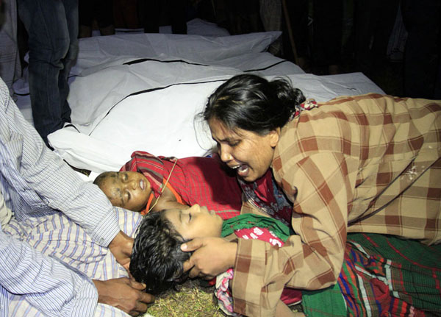

Fig. 8.1. Mother lost her child in ferry accident.

If we look at the statistics of the past decade we will see that on average more than 22 maritime accidents happened which causes about more than 152 deaths per year.

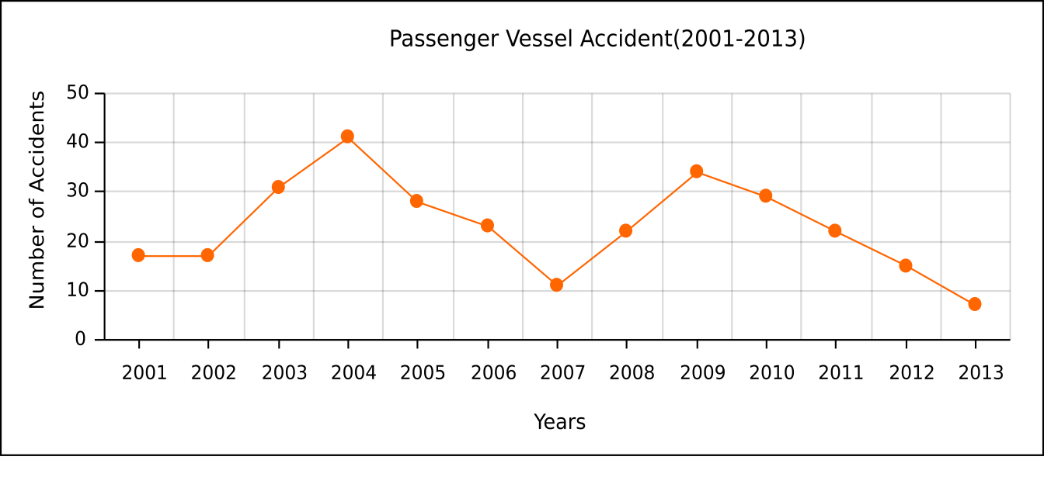

Fig. 8.2. Year-vs-Accident graph [2].

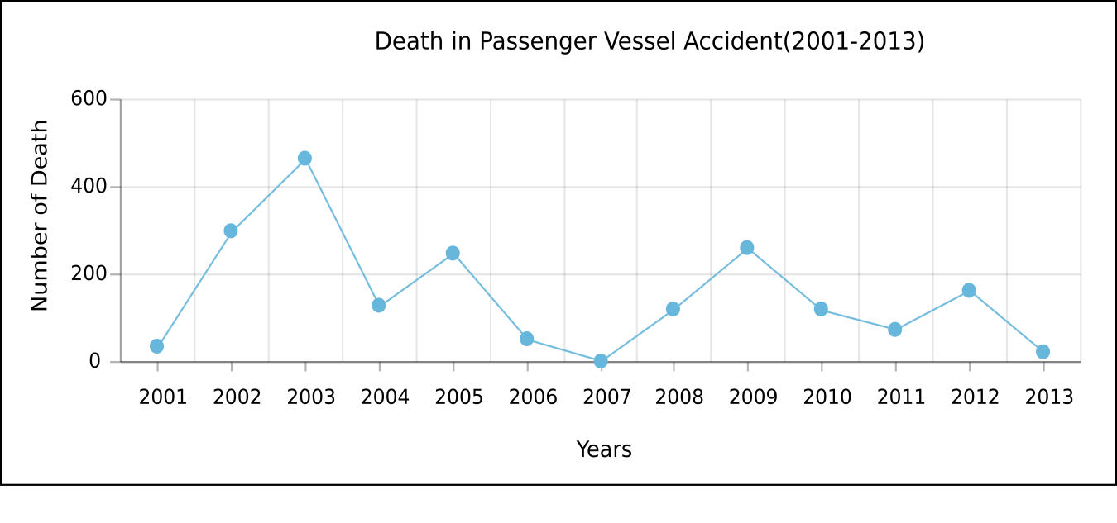

Fig. 8.3. Year-vs-Death graph [2].

Now if we look at the causes of maritime accidents then we will see that most of the accidents happened because of adverse weather and overloading [Figure 8.4]. The vessels don’t have any system for listening weather forecast and to communicate with nearest rescue team in case of emergency. Again there are no sufficient passenger vessels. As a result the existing vessels carry 4 to 5 times of their capacity. This situation gets worse in different festival like Eid or Puja. On that time launches are overloaded very dangerously that sometime causes accident.

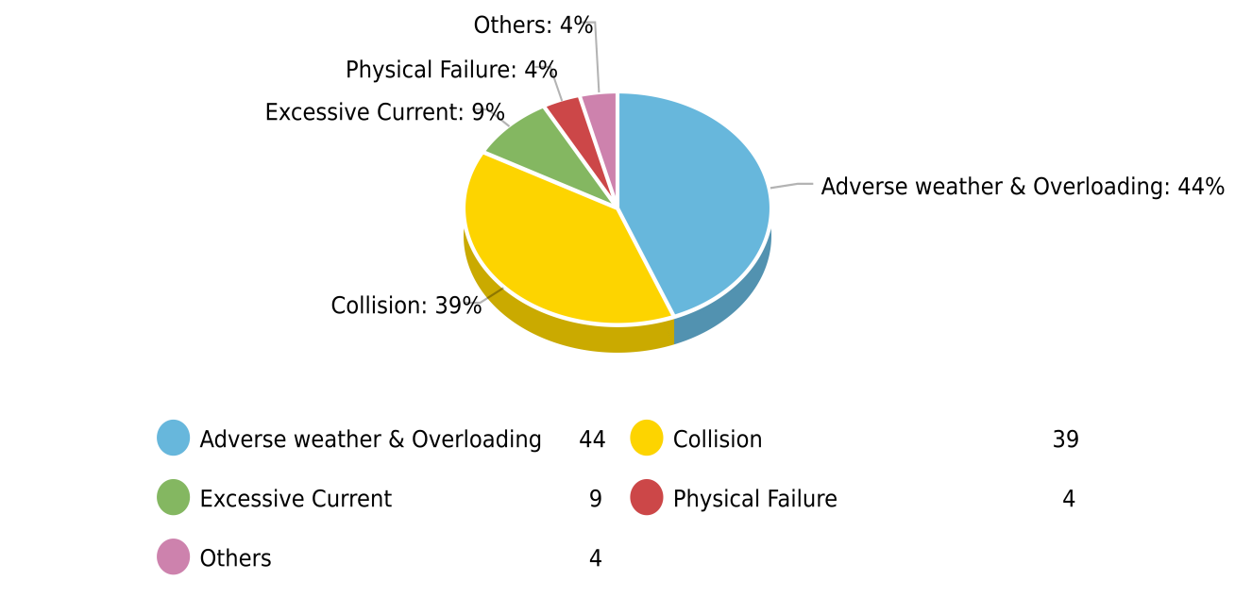

Fig. 8.4. Percentage of accident type [3, Fig. 2].

The second major cause of accidents is collision. About 39% [Figure 8.4] accidents happened because of collision between different vessels. Cargo ships are the most likely victims of this type of accidents. Unskilled drivers and lack of proper knowledge are main reason for collision type accidents.

An accident ruins hundreds of family. Every year march of hundred death and tears of hundred mother, father and relatives in riverside touches our heart. It is time to modernize the waterways in order to prevent this death march and to preserve the importance of waterways in transportation.

1. **Literature survey:**

Many studies have been done in this sector in last few years. Most of the studies tried to explore the causes and types of accidents. Very few works are done to solve this problem using modern technology.

In 2006 Huq and Dewan [4] tried to find the causes of the maritime accidents. They distributed accidents according to geographical location. They have found in their study that most of the accidents happened due to collision. They identify overloading and poor vessel condition as second major cause of maritime accidents.

In 2009 A.K. Azad [5] tried to identify different factors that cause fatalities of passenger vessels. He studied several major maritime accidents deeply. He classified the accidents according to cause, operating shift, location etc. He showed that the weakness of law enforcement, mismanagement, negligence, and irresponsibility of concern authorities, profit centered attitude of vessel owners, corruption and insufficient budget are the underlying cause of these tragic disasters.

In 2010 Awal, Islam and Hoque [3] studied on more than 450 accidents case. They analyzed accidents in different aspects. They gave more emphasis on collision type accidents. They have shown that a major numbers of accidents happened because of seasonal storm combined with overloading.

In 2014 Rahman and Rosli [6] proposed an overload detection system using HCC (High Capacity Compressor). They have also proposed “Elevator Concept” for handling overload. But “Elevator Concept” will increase loading and unloading time of a vessel. Furthermore, since HCC technology needs to be implanted in the door of a vessel and it can only sense weight if passengers go through it, this technology can be easily bypassed.

In 2015 Abir, Rafiq and Roy [7] design a low cost “Black Box” for maritime vehicles. These “Black Box” will hold passenger count and other important information’s for a vessel.

1. **Objectives:**

The objectives of this study are followings,

* To detect overload condition.
* To track vessel in real-time based on GPS/GSM.
* To provide drivers a way to know the location of other vessels.
* To provide passengers a way to know the status of their desired vessel.
* To track drawn vessel based on ULB and acoustic ping receiver.

**11. Methodology:**

We will divide the entire tracking system into three major sub-systems. These sub-systems are,

1. On terminal tracking system.
2. On route tracking system.
3. Drawn vessel tracking system.

The first sub-system will work when a vessel is loading in terminal. An overload detector will continuously track the load status of the vessel. When overload will occur the system will set



Fig. 11.1. On route tracking system.

alarm and will disable the vessel’s engine such that the vessel never becomes able to leave the terminal in overloaded condition. In this sub-system passengers also will be able to check the load status of their desired vessel via their mobile app. Flowchart for handling overload condition is given below,

FlowOverloadHandling

After starting journey the second sub-system will be activated. It will continuously monitor the vessel using GPS/GSM. If any emergency situation is created this system will immediately notify to the server. Drivers will be able to see the location of other vessels in Google map. This will work like radar at night or in foggy environment. So the drivers will be able to navigate their vessel without collision. In this sub-system the passenger will be able to know expected time to reach their destination using their mobile app.



Fig. 11.2. On route tracking system.

Flow chart for emergency condition reporting is given below,

EmergencyConditionReporting

The third sub-system is for tracking drawn vessel. Ordinary GPS system does not work under water. Thus we have to use special technology to track drawn vessel. For tracking under water a special device named Underwater Locator Beacon (ULB) [8] will be installed in every vessel. These ULB’s are activated by water. When it does activate it emits about 37.5 KHz acoustic signal that can be locate from 1-5 km away depending on water condition. ULB’s can work properly in depth up-to 2,000 meters. They can emit signal for 30 days after activated in a rate of 1 pulse/sec. This acoustic signal can be detect using acoustic ping receiver. Receiver can detect signal and can locate the source using Doppler shift effect.

UnderWaterVehicleDetector (1)

Fig. 11.3. Drawn vehicle tracking system.

**12. Conclusion:**

Maritime vehicle accidents can be reduced in a great number by preventing the vessels from carrying overloaded passengers and goods. The best result can be obtained from a system if and only if the respective authority uses it properly. It is not impossible to bypass a technology. So law enforcement agencies must be strict and the vessel owners must be sincere. Without skilled and trained driver accidents can never be stopped. Safety of thousands of people’s life should not be given in hand of an untrained driver. We should remember that “An accident causes lifetime tears of a family”.

1. **References:**

[1] Bangladesh Inland Water Transport Authority (BIWTA). Information of Waterways[Online]. Available: <http://www.biwta.gov.bd/website/?page_id=2>

[2] Dhaka Tribune. (2014, May 5). Above 4,000 Deaths from Launch Accidents in 38 Years[Online]. Available: <http://archive.dhakatribune.com/bangladesh/2014/may/05/above-4000-deaths-launch-accidents-38-years>

[3] Z. I. Awal, M. R. Islam and M. Hoque “Collision of Marine Vehicles in Bangladesh: A Study on Accident Characteristics,” Disaster Prevention and Management, vol. 19, no. 5,2010, pp. 582-595, Nov. 2010.

[4] N. A. Huq and A. M. Dewan “Launch Disasters in Bangladesh: A Geographical Study,” Geografia - Malaysian Journal of Society and Space, vol. 2, pp. 19-30, Aug. 2006.

[5] A. K. Azad “Riverine Passenger Vessel Disaster in Bangladesh: Options for Mitigation and Safety,” M.S. thesis, Dept. Disaster Management, BRAC University, Dhaka, Bangladesh, 2009.

[6] N. S. F. A. Rahman and H. Z. Rosli “An Innovation Approach for Improving Passenger Vessels Safety Level: Overload Problem,” IJBTS, vol. 2, no. 2, Dec. 2014.

[7] I. K. Abir, R. Rafique and S. Roy “Low Cost Marine Black Box Design”, M.S. thesis, Dept. Elect. Eng., BRAC University, Dhaka, Bangladesh, Aug. 2015.

[8] Wikipedia. (2016, Nov. 18). Underwater Locator Beacon[Online]. Available: <https://en.wikipedia.org/wiki/Underwater_locator_beacon>

[9] American Diving Supply. RJE International STI-350 Surface Acoustic Receiver[Online]. Available: <http://www.americandivingsupply.com/RJE-International-STI-350-Surface-Acoustic-Receive-p/sti-350.htm>

1. **Cost Estimation:**

The approximate cost to implement this system is given below,

1. Overload detection system(2 pieces) TK. 10,000
2. GPS/GSM tracking system TK. 7,500
3. Raspberry Pi3 + Monitor + Kit Tk. 15,000
4. Server PC Tk. 88,000
5. ULB + Surface Acoustic Receiver Tk. 11,38,000

Total Tk 12,58,500