CHITTAGONG UNIVERSITY OF ENGINEERING & TECHNOLOGY(CUET)

DEPARTMENT OF COMPUTER SCIENCE & ENGINEERING

CHITTAGONG-4349

(Project Proposal)

Application for the Approval of B.Sc. Engineering Project

(Computer Science & Engineering)

Date: 09-01-2017

1. Name of the student : Md. Emruz Hossain

Student Id : 1204084

Session : 2015-2016

2. Present Address : Room No. A-402, Bangabandhu Hall, CUET

3. Name of the Supervisor : Dr. Mohammad Shamsul Areﬁn

Designation : Professor

Department of Computer Science & Engineering

Chittagong University of Engineering & Technology

4. Name of the Department : Computer Science & Engineering (CSE)

Program : B.Sc. Engineering

5. Date of ﬁrst Enrollment in

the program : 6th March 2013

6. Tentativ e Title : RVTS: A Framework for Tracking Riverine Vehicles.

7. Background and Present State:

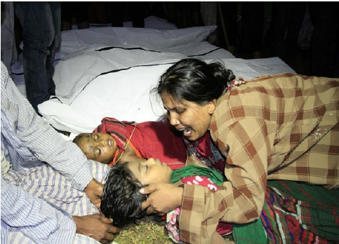

Bangladesh is land of river. It has more than 700 rivers including the Padma, the Meghna and the Jamuna. According to BIWTA (Bangladesh Inland Water Transport Authority) the total length of the waterways of Bangladesh is 24,000 km. Out of this 24,000 km about 5,968 km is navigable by mechanized vessels. These navigable waterways are reduced to 3,865 km in dry season [1]. Historically waterways were the main medium of transportation in this country. Although highway transportation is becoming more popular in present days, still the main transportation medium of many regions of this country especially for the southern regions such as Khulna, Barishal, Patuakhali, Vola etc. is waterway. Every year millions of people and million tons of cargo are transported through waterway. Waterway is the cheapest way of transportation in Bangladesh. It plays very important role in national economy of this county.

Though waterways play an important role in transportation of Bangladesh, we have seen this sector is always neglected [2,3]. Very few steps are taken by Bangladesh govt. to modernize this sector compare to the other transportation sectors. As a result, in one hand the waterway is losing its importance and on the other hand life of the passengers remains unsafe. Every year we see hundreds of death in various maritime accidents.

Figure 1: Mother lost her child in ferry accident [4].

If we look at the statistics of the past decade we will see that on average more tha 22 maritime accidents happened which causes about more than 152 deaths per year.

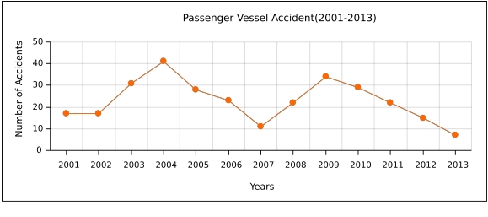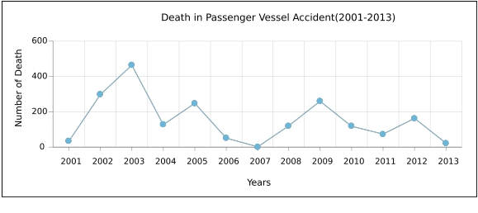

Figure 2: Year-vs-Accident graph [5].

Figure 3: Year-vs-Death graph [5]

Now if we look at the causes of maritime accidents then we will see that most of the accidents happened because of adverse weather and overloading [Figure 4]. The vessels dont have any system for listening weather forecast and to communicate with nearest rescue team in case of emergency. Again there are no suﬃcient passenger vessels. As a result the existing vessels carry 4 to 5 times of their capacity. This situation gets worse in diﬀerent festival like Eid or Puja. On that time launches are overloaded very dangerously that sometime causes accident. The second major cause of accidents is collision. About 39% [Figure 4] accidents happened because of collision between diﬀerent vessels. Cargo ships are the most likely victims of this type of accidents. Unskilled drivers and lack of proper knowledge are main

Figure 4: Percentage of accident type [6, Fig. 2].

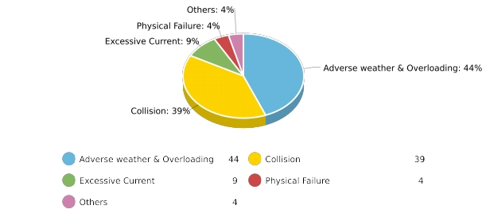

reason for collision type accidents.

An accident ruins hundreds of family. Every year march of hundred death and tears of hundred mother, father and relatives in riverside touches our heart. It is time to modernize the waterways in order to prevent this death march and to preserve the importance of waterways in transportation.

8. Literature Review:

Many studies have been done in this sector in last few years. Most of the studies tried to explore the causes and types of accidents. Very few works are done to solve this problem using modern technology.

In 2006 Huq et al. [7] tried to ﬁnd the causes of the maritime accidents. They distributed accidents according to geographical location. They have found in their study that most of the accidents happened due to collision. They identify overloading and poor vessel condition as second major cause of maritime accidents.

In 2009 A.K. Azad [8] tried to identify diﬀerent factors that cause fatalities of passenger vessels. He studied several major maritime accidents deeply. He classiﬁed the accidents according to cause, operating shift, location etc. He showed that the weakness of law en- forcement, mismanagement, negligence, and irresponsibility of concern authorities, proﬁt centered attitude of vessel owners, corruption and insuﬃcient budget are the underlying cause of these tragic disasters.

In 2010 Awal et al. [6] studied on more than 450 accidents case. They have analyzed accidents in diﬀerent aspects. They gave more emphasis on collision type accidents. They have shown that a major numbers of accidents happened because of seasonal storm combined with overloading.

In 2014 Rahman et al. [9] proposed an overload detection system using HCC (High Ca- pacity Compressor). They have also proposed “Elevator Concept”for handling overload. But “Elevator Concept”will increase loading and unloading time of a vessel. Furthermore, since HCC technology needs to be implanted in the door of a vessel and it can only sense weight if passengers go through it, this technology can be easily bypassed.

In 2015 Abir et al. [10] design a low cost “Black Box”for maritime vehicles. These “Black Box”will hold passenger count and other important informations for a vessel.

9. Objectives:

The objectives of this study are as follows,

• To detect overload condition.

• To track the location of vessel in real-time based on GPS/GSM.

• To provide drivers a way to know the location of other vessels.

• To provide passengers a way to know the status of their desired vessel.

10. Methodology:

The overall system architechture is shown in Figure 5. The “Central Monitoring Unit” will monitor the sensors and it will communicate with server using “Communication Module”. The “Communication Module” is consist of a GPS module and a GSM module. GPS module will receive GPS signal and calculate vehicle location. The GSM module will transform the location and other information to the server using GSM network. The “Overload Detector” is consist of some water sensors and an ardunio circuit. It will measure the load level and will inform to the “Central Monitoring Unit”. If overload is detected then the central monitoring unit will disable the vessel’s engine so that the vessel never become able to leave the terminal in overloaded condition. It will also set alarm to warn the existing passengers of the vessel. If overload is handled then the central monitoring unit will re-enable the engine and reset alarm. The “Lean Angle Detector” is consist of an ardunio circuit two load sensor one of which will be at left side and another will be at right side of the vessel. It will measure the angle diﬀerences between left side and right side of the vessel. If the lean angle rise over an tolerable range

it will notify to the “Central Monitoring Unit”. The “Display” will show diﬀerent satus of the system and it will show the location other vessels in google map.

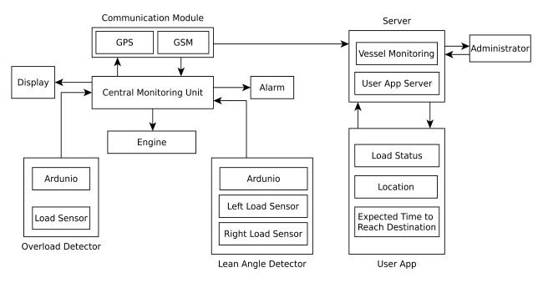

Figure 5: System Architecture of MVTS.

On the server side, the “Server” will perform two types of task. It will monitor all the vessel’s condition and will provide service to the user applications. The “User App” will provide diﬀerent services to the passenger like load status, location and expected time to reach destination based on vessel speed.

We will divide the entire tracking system into two major sub-systems. These sub-systems are,

• On terminal tracking system.

• On route tracking system.

The ﬁrst sub-system will work when a vessel is loading in terminal. An overload detector will continuously track the load status of the vessel. This will ensure saftey of the passengers. In this sub-system passengers will be able to check the load status of their desired vessel via their mobile app. They will be warned if their desired vessel is in overloaded condition. Flowchart for handling overload condition is shown in Figure 6.

Figure 6: Flow chart for overload detection system.

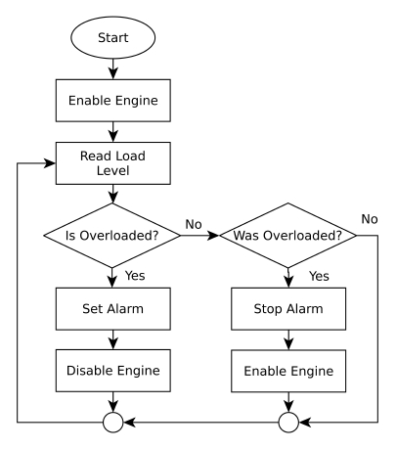

After starting journey the second sub-system will be activated. The GPS of communication module will receive satellite signal and compute GPS location of the vessel.It it will send the location information to the server using GSM module. The drivers will be able to see the real time location of other vessels in google map. This will help to identify other vessels at night or in foggy environment. So the drivers will be able to navigate their vessel without collision. This will reduce collision type accidents which is second major type of accidents. In this sub-system the passenger will be able to know the current locaiton of their vessel using their mobile application. They will also be abled to know the expected time to reach their destination based on speed of the vessel.

The “Lean Angle Detector” will continuously monitor the angle between left side and right side of the vessel. If any emergency situation is arised this system will immediately notify to the central monitoring unit. The central monitoring unit will send and emergency report to the server. Flow chart for emergency condition reporting is shown in Figure 7.

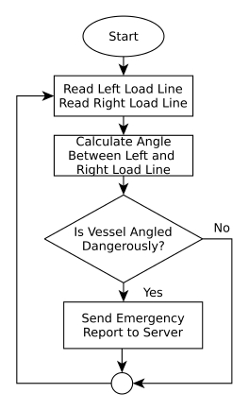

Figure 7: Flow chart for emergency situation reporting.

11. Conclusion:

Maritime vehicle accidents can be reduced in a great number by preventing the vessels from carrying overloaded passengers and goods. The best result can be obtained from a system if and only if the respective authority uses it properly. It is not impossible to bypass a technology. So law enforcement agencies must be strict and the vessel owners must be sincere. We should remember that “An accident causes lifetime tears of a family”.

12. References:

[1] Bangladesh Inland Water Transport Authority (BIWTA), “Information of waterways”,

[Online]. Available at: [http://www.biwta.gov.bd/website/?page](http://www.biwta.gov.bd/website/?page_id=2) [id=2](http://www.biwta.gov.bd/website/?page_id=2)

[2] The Gurdian, (2013, Nov 6), “Potentials of inland water transport in Bangladesh”,

[Online]. Available at: [http://www.theguardianbd.com/potentials-inland-water-transport-](http://www.theguardianbd.com/potentials-inland-water-transport-bangladesh/)

[bangladesh/](http://www.theguardianbd.com/potentials-inland-water-transport-bangladesh/)

[3] MediaBangladesh.net, “3.41 trillion taka Bangladesh budget for 2016-17 ﬁscal year”,

[Online]. Available at: [http://www.mediabangladesh.net/2-95-trillion-bangladesh-budget-](http://www.mediabangladesh.net/2-95-trillion-bangladesh-budget-2016-17/)

[2016-17/](http://www.mediabangladesh.net/2-95-trillion-bangladesh-budget-2016-17/)

[4] Arab News (2014, May 16), “12 dead as Bangla ferry carrying hundreds sinks”, [On-

line]. Available at: [http://www.arabnews.com/news/571451?page=1&quicktabs](http://www.arabnews.com/news/571451?page=1&quicktabs_stat2=0) [stat2=0#](http://www.arabnews.com/news/571451?page=1&quicktabs_stat2=0)

[5] Dhaka Tribune (2014, May 5), “Above 4,000 deaths from launch accidents in 38 years”,

[Online]. Available at: [http://archive.dhakatribune.com/bangladesh/2014/may/05/above-](http://archive.dhakatribune.com/bangladesh/2014/may/05/above-4000-deaths-launch-accidents-38-years)

[4000-deaths-launch-accidents-38-years](http://archive.dhakatribune.com/bangladesh/2014/may/05/above-4000-deaths-launch-accidents-38-years)

[6] Z. I. Awal, M. R. Islam and M. Hoque, “Collision of marine vehicles in Bangladesh:

A study on accident characteristics”, in proc. Disaster Prevention and Management, vol.

19, no. 5, pp. 582-595, Nov. 2010.

[7] N. A. Huq and A. M. Dewan, “Launch disasters in Bangladesh: A geographical study”,

in proc. Geograﬁa - Malaysian Journal of Society and Space, vol. 2, pp. 19-30, Aug. 2006.

[8] A. K. Azad, “Riverine passenger vessel disaster in Bangladesh: Options for mitigation

and safety”, M.S. thesis, Dept. Disaster Management, BRAC University, Dhaka, Bangladesh,

2009.

[9] N. S. F. A. Rahman and H. Z. Rosli, “An innovation approach for improving passen-

ger vessels safety level: Overload problem”, in proc. IJBTS, vol. 2, no. 2, Dec. 2014.

[10] I. K. Abir, R. Raﬁque and S. Roy, “Low cost marine black box design”, M.S. thesis,

Dept. Elect. Eng., BRAC University, Dhaka, Bangladesh, Aug. 2015.

13. CSE Undergraduate Student (CUGS) Committee

reference

Meeting No: Resolution No: Date:

14. Number of Under-Graduate Student(s) working with

the Supervisor at Present: 12

Signature of the student(s)

Signature of the Supervisor

Signature of the Head of the Department