This project is puzzling game in a snake.

In this game you must reach the end and get every red point.

There is different obstacle like walls, lasers (2 types one kills you if you touch it the other one cut the back of your snake), arrows (which force a direction), teleporter, number of passage.

If you want to try it you can do it by download it, create a web server and go to index.html.

If you want to give me feedback, new game play mechanics that you think will be good, or other maps or help with design (you will see I’m not even good in pixel art ^^) you can send me an email at [*game.growth38@gmail.com*](mailto:game.growth38@gmail.com)

I’m using phaserJS, here is levels.

Thank you.

Level 1

-movement

-start & end

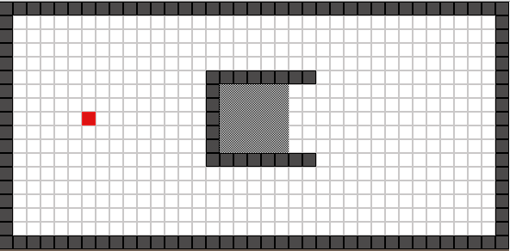

Level 2

-blue bubble

- 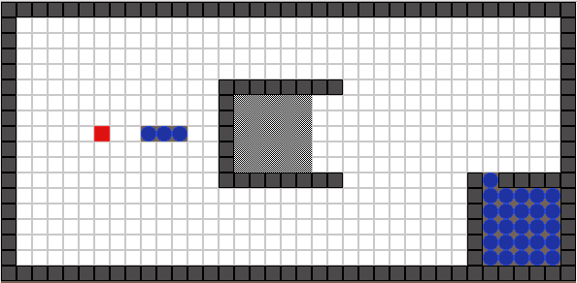

Level 3

-red bubble

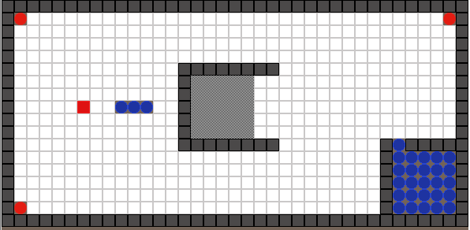

Level 4

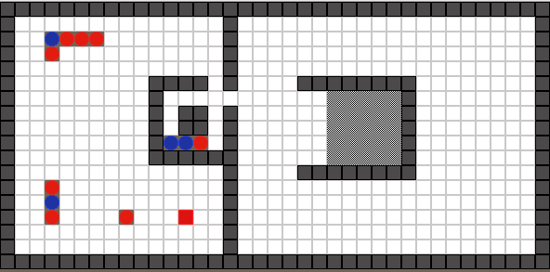

Level 5

-arrow

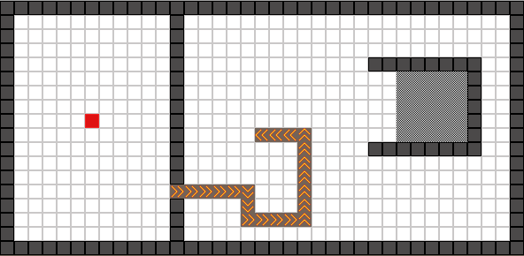

Level 6

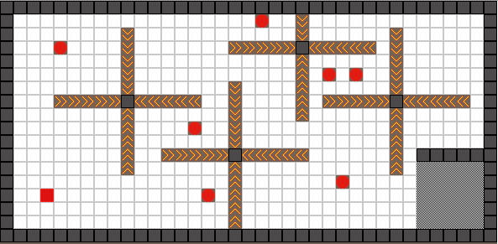

Level 7

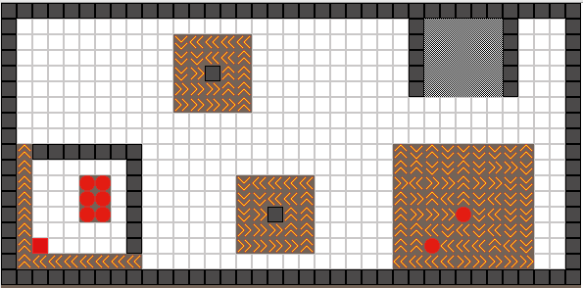

Level 8

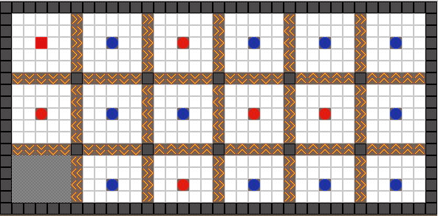

Level 9

-red laser

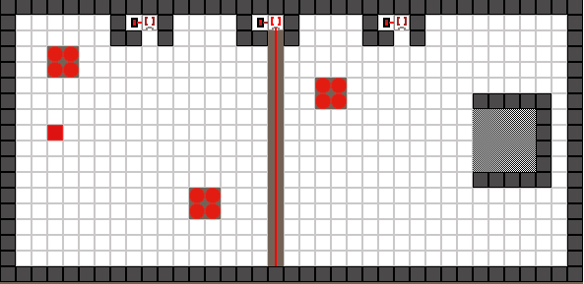

Level 10

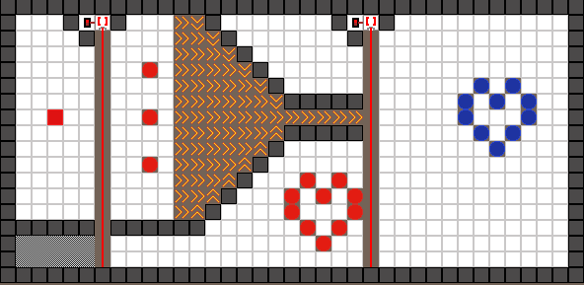

Level 11

-cut you

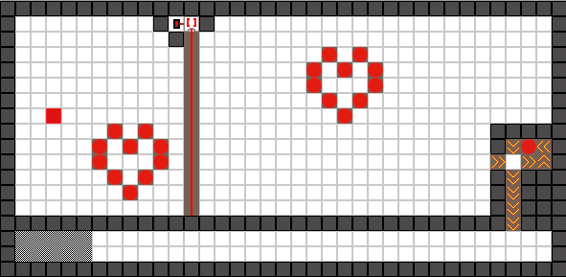

Level 12

-blue laser

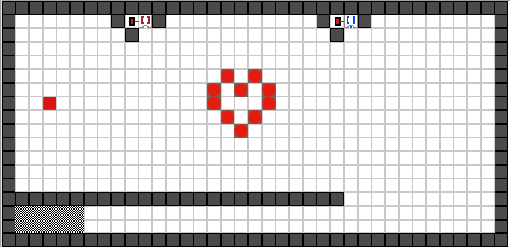

Level 13

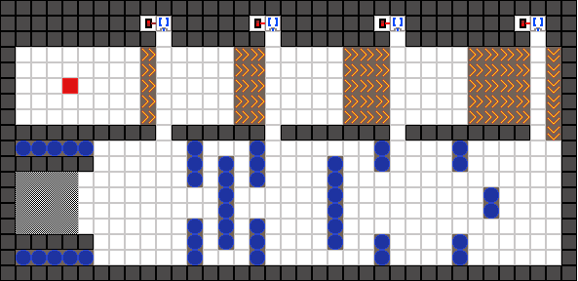

Level 14

-teleportation

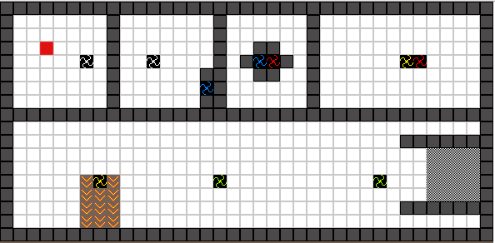

Level 15

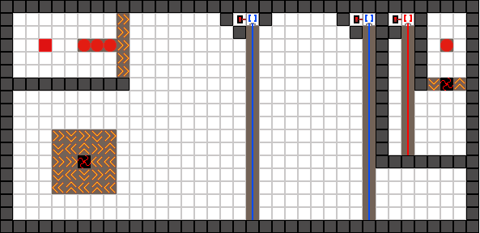

Level 16

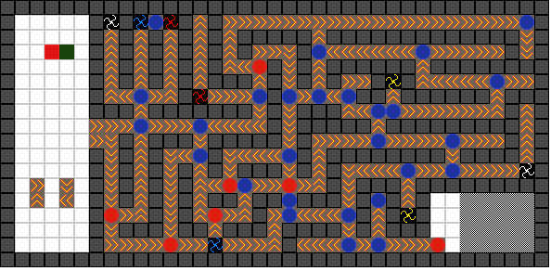

Level 17

-number of passage

- 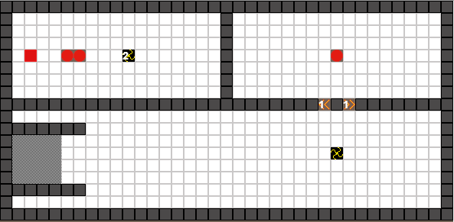

Level 18

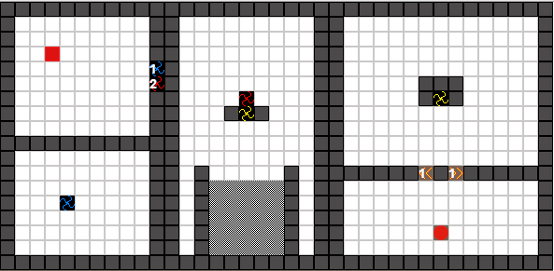

Level 19

