In 2003 SA Chemical Engineering Congress, SAIChE, p. CD.

Critical Comparison of Activity Coefficient Based Vapour–Liquid Equilibrium Models

Heinrich Badenhorst, Muriel Grobler, Derick TROLLIP, Walter Focke
University of Pretoria

Correspondence to:

Walter Focke

Department of Chemical Engineering, University of Pretoria

PO Box 35285, Menlo Park 0102, South Africa
Tel: +27 12 420 2588, Fax: +27 12 420 2516, E-mail: xyris@mweb.co.za

Abstract
The ability of several activity coefficient models to correlate low-pressure isothermal vapour-liquid equilibrium data was tested. With two adjustable parameters, the local composition models clearly outperformed mean field models. However, the difference between NRTL and a van der Waals model with three parameters was insignificant. The composition dependence of the Quasi-chemical, NRTL, Wilson and Uniquac-type models arises from the way in which local composition effects are taken into account. The poor correlating performance of the Uniquac models casts doubt on the validity of local surface area fractions as a local composition measure. None of the models were able to correlate the data well when the adjustable parameters were assumed temperature-independent.

Introduction

Accurate vapour–liquid equilibrium (VLE) and liquid–liquid equilibrium (LLE) data is essential for reliable design of distillation and solvent extraction equipment (Palmer, 1987). Consequently much effort has been expended into developing suitable theoretical and semi-empirical thermodynamic models. However, this has proven to be a formidable task that has not yet been satisfactorily resolved (Nicolaides, et al., 1978, Walas, 1985, Prausnitz et al., 1999).

The γ-Φ formalism is deemed adequate for low-pressure VLE. It provides the following basic equation relating vapour and liquid mole fractions (Raal and Mühlbauer, 1998):
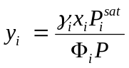 (1)

The vapour phase correction factors, Φ_{i}, can be calculated using a suitable equation of state, e.g. the truncated virial equation of state. The activity coefficients (γ_{i}) correct for the deviations from ideal solution behaviour in the liquid phase. They are obtained by appropriate differentiation of the excess Gibbs energy (g^{E} = g^{E} (T,P,x_{i})) with respect to mole fractions (Malanowski et al., 1992). In principle, knowledge of g^{E}’s dependence on temperature, pressure and composition provides a complete description of the thermodynamic behaviour of the liquid solution. Unfortunately thermodynamic theory does not prescribe explicit functional forms for g^{E}. This necessitates empirical and semi-rational approaches (Walas, 1985). Ideally, the chosen expression would enable the temperature, pressure and the composition of co-existing multi-component phases to be represented within experimental errors. However, since g^{E} is in effect pressure-independent at low to moderate pressures, activity coefficients are considered to be functions of composition and temperature only (Raal and Mühlbauer, 1998).

Numerous empirical and semi-theoretical activity coefficient models have been proposed (Hála et al., 1967, Walas, 1985, Malanowski et al., 1992). Table 1 shows that they can be classified into five main families: the mean field van der Waals and the quasi-chemical, Wilson, NRTL and Uniquac “local composition” (LC) types. The most familiar models are the Margules, Van Laar, Wilson, NRTL and UNIQUAC. The DECHEMA VLE data collection (Gmehling et al., 1979) reports experimental data together with a comparison of the results obtained by fitting the classic equations to the data. It is known that these forms have several shortcomings: They are generally unable to simultaneously correlate VLE, LLE and heat-of-mixing data sets and their implicit temperature dependence does not predict real variations (Nicolaides, et al., 1978, Gmehling et al., 1983, Palmer, 1987, Cairns, et al. 1988, Walas, 1985). More seriously, they sometimes do not even correlate real data within experimental accuracy. This suggests a need for the development of more accurate expressions for g^{E}.

The ideal g^{E} model would have a minimum of adjustable parameters that would (a) preferably be temperature independent, (b) not be correlated, and (c) demonstrably be related to molecular properties (Lee et al., 1987, Sandler et al., 1987). Such a model would require a minimum amount of data to fix parameter values, it would be possible to extrapolate data to other temperatures with confidence and predictive versions using group contribution methods could be developed. Some current models are capable of predicting multi-component phase behaviour from knowledge of binary data. However, the ultimate goal is to achieve this using only pure component property values as input (Malanowski et al., 1992).

The purpose of this survey was firstly, to attempt a classification of the available models (See Appendix and Table 1) and secondly to compare their relative performance with respect to correlating isothermal VLE data. It is only a first step towards identifying promising concepts and/or theories that will hopefully aid future development of superior g^{E} models.
Table 1: Classification of Activity Coefficient Models
Model-type, Key/general form for g^{E}/RT | # | Model name (Reference)
- Mean field  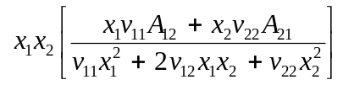  “Random mixture” van der Waals theory. All models in this family are special cases of the above general form (Focke, 2004). | M1  M2  M3  M4 M5  M6  M7 | Porter (1921)  Margules (Walas, 1985)  Van Laar (Walas, 1985)  Scatchard (1931)  Scatchard-Hamer (1935)  SSF (Rogalski et al., 1977)  Focke (2004)
- NRTL  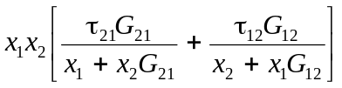  Enthalpic two-fluid local mole fraction LC models | N1  N2  N3  N4 | NRTL (Renon et al., 1968)  NRTL-b (Huron et al., 1979)  Bruin (1970)  Morisue (1972)
- Wilson  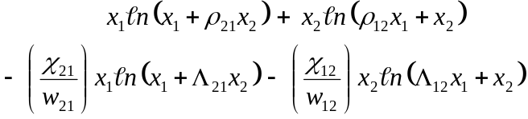  Two-fluid local volume fraction LC models. With the exception of Feix, all models in this family are special cases of the above general form | W1  W2  W3  W4  W5  W6  W7  W8  W9  W10 | Wilson (1964)  Wilson-3 (Wilson, 1964)  Hiranuma (a)-3 (1974)  Tsuboka et al. (1975)  Feix et al., 1980)  Hiranuma (b)-3&4 (1983)  Lee et al. (1983)  Rowley (1984)  Nishimura et al. (1985)  Huang (Huang et al., 1994)
- Quasi-Chemical (Q-C)  Andiappan model:  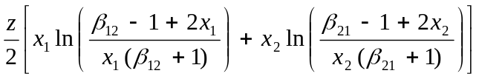  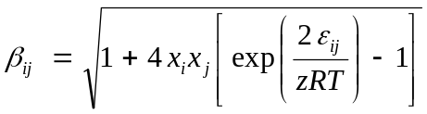  Two-fluid lattice-based model using the quasi-chemical approximation for local compositions. | Q1  Q2  Q3  Q4 | Q-C (Guggenheim, 1952)  Andiappan et al. (1972)  Sabarathinam et al. (1982)  Nagata et al. (1976)  Noda et al. (1980)
- Uniquac  Two-fluid local surface fraction LC models | U1  U2  U3  U4  U5 | Uniquac (Abrams et al., 1975)  Lyngby (Larsen, et al., 1987).  Dortmund (Weidlich et al., 1987)  LSG (Vera et al., 1977)  LCG (Vera et al., 1977)
- Others (including combinations) | O1  O2  O3  O4  O5 | Liebermann et al. (1972)  Wang et al. (1983).  Sandler et al. (1987)  Shealy, et al. (1988)  Ruckenstein et al. (1999)

Computer Modelling

Twelve binary systems (See Table 2), comprising 56 isothermal VLE data sets and a total of 771 P-x-y data points were used for model testing. They were obtained from the DECHEMA data collection (Gmehling et al., 1977-1996). The selected data sets all complied with the DECHEMA thermodynamic consistency tests. The data were correlated using a Microsoft Excel® spreadsheet.

As was the practice in the DECHEMA data set (Gmehling et al., 1977-1996), the vapour phase correction factors, Φ_{i}, were neglected, i.e. the vapour was assumed ideal. The experimental values for the liquid composition were entered into the model equations to calculate predicted values for the activity coefficients, γ_{i}, according to the excess Gibbs energy (g^{E}) model to be tested. The adjustable constants were determined for each isothermal data set by minimising the average absolute error in the vapour phase composition using Excel’s Solver® function. The mean deviation per system was then computed by averaging over the temperature sets.

Table 2: Isothermal Vapour-Liquid Data Sets used for testing Activity Coefficient Models
System / Data Set | No. | 1 | 2 | 3 | 4 | 5 | 6 | 7 | 8 | 9 | 10 | 11 | N
Acetone (1) | T/°C | 15 | 20 | 30 | 35 | 40 | 50 | 55 | 55.1
Chloroform (2) | n | 9 | 9 | 9 | 9 | 9 | 9 | 9 | 9 |  |  |  | 72
Benzene (1) | T/°C | 8 | 10 | 14 | 20 | 24.9 | 25 | 40 | 45 | 55 | 60 | 70
Cyclohexane (2) | n | 12 | 10 | 12 | 12 | 10 | 11 | 15 | 5 | 15 | 10 | 12 | 124
Butylglycol (1) | T/°C | 5 | 25 | 45 | 65 | 85 | 110
Water (2) | n | 8 | 8 | 8 | 8 | 9 | 22 |  |  |  |  |  | 63
Hexafluorobenzene (1) | T/°C | 30 | 40 | 50 | 60 | 70
Benzene (2) | n | 11 | 10 | 10 | 10 | 9 |  |  |  |  |  |  | 50
Ethanol (1) | T/°C | 25 | 30 | 40 | 50
Hexane (2) | n | 9 | 9 | 17 | 18 |  |  |  |  |  |  |  | 53
Ethanol (1) | T/°C | 35 | 50 | 55 | 70 | 75
Toluene (2) | n | 10 | 9 | 10 | 11 | 11 |  |  |  |  |  |  | 51
Ethanol (1) | T/°C | 25 | 40 | 50 | 55 | 70 | 75
Water (2) | n | 10 | 13 | 12 | 13 | 13 | 9 |  |  |  |  |  | 70
Methanol (1) | T/°C | 35 | 45 | 55 | 90
Benzene (2) | n | 9 | 26 | 13 | 6 |  |  |  |  |  |  |  | 54
Methanol (1) | T/°C | 25 | 35 | 45 | 55
Cyclohexane (2) | n | 7 | 4 | 20 | 26 |  |  |  |  |  |  |  | 57
2-Propanol (1) | T/°C | 30 | 40 | 55 | 58
Cyclohexane (2) | n | 17 | 11 | 24 | 10 |  |  |  |  |  |  |  | 53
Tetrahydrofuran (1) | T/°C | 25 | 50 | 70
Water (2) | n | 11 | 20 | 14 |  |  |  |  |  |  |  |  | 45
Water (1) | T/°C | 50 | 70 | 80 | 90
Pyridine (2) | n | 27 | 11 | 15 | 17 |  |  |  |  |  |  |  | 70

Correlation results for the Margules, Van Laar, Wilson, NRTL and UNIQUAC models are reported in the DECHEMA data collection. However, due to data correlation errors discovered in this set, revised results were generated for these models. Unfortunately it was not possible to test the LSG and LCG models, as they require pure component structural parameters that were only available for some of the components of the chosen systems. Attempts were also made to correlate the data using temperature-independent adjustable parameters.

Results and Discussion

Problems were encountered with parameter estimation. Often several local minima for the composition error as a function of the parameters were observed, especially where the data set included few data points or more than two adjustable parameters. This made it difficult to find absolute minima, and it is questionable whether the results are in fact the absolute minima in all cases. Table 3 shows, by way of the UNIQUAC model as example, that the same problem also occurred in the DECHEMA data collection: Significantly better results were obtained in this study for some data sets, not only in the average vapour composition errors, but also in the apparent parameter temperature dependence as shown in Figure 1.

Table 3: Uniquac Vapour Composition Errors for the Water-Pyridine System
 | DECHEMA | Current results
Temperature (°C) | 10³ Δy_{i} | 10³ Δy_{i}
50 | 19,6 | 12,9
50 (2) | 23,2 | 21,2
69.86 | 17,3 | 13,9
80 | 18,3 | 14,7
89.83 | 17,9 | 14,0
Average | 19,3 | 15,3

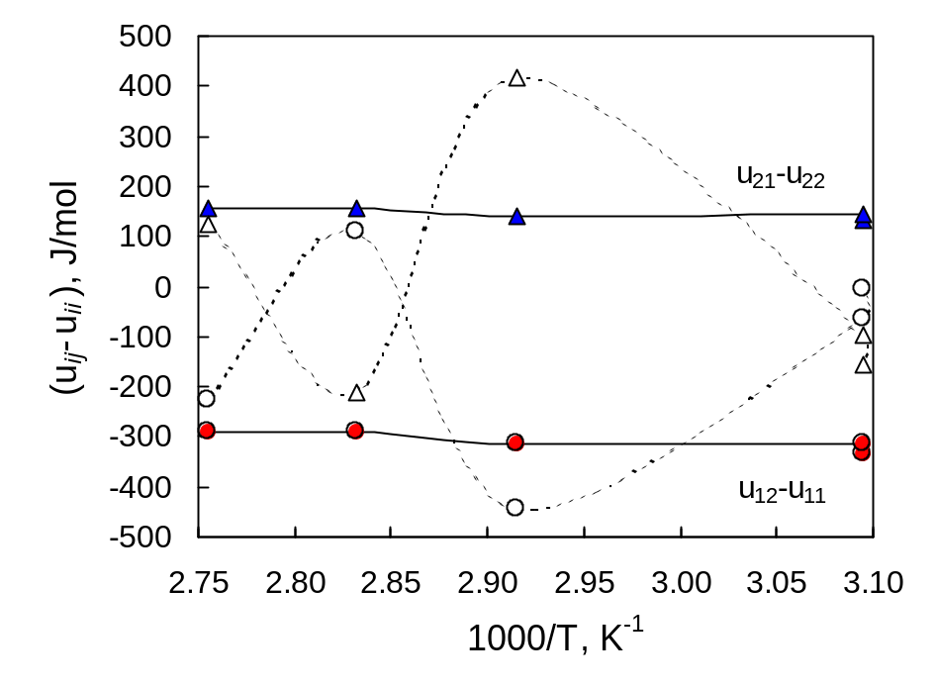
Figure 1: Parameter temperature dependence as reported by DECHEMA (…………) and as obtained in the current study (_______) for the system water (1) – pyridine (2).

Figure 2 shows the global vapour composition errors averaged per data set over the entire temperature range and over all the systems. As expected, data correlation improves as the number of adjustable parameters increases. However, there are noteworthy exceptions with the three-parameter equations. Overall performance was best with the four-parameter Nishimura model while NRTL was the best three-parameter model. Wilson outperformed all other two-parameter contenders including the three-parameter Nishimura and Ruckenstein equations. TK-Wilson has the advantage over Wilson of being capable of predicting liquid-liquid phase splitting. It was basically on par with Wilson. Regarding the set of two-parameter models, the LC models clearly outperformed the mean field models. Of the latter, Van Laar was the best, followed by Margules while Rogalski performed worst. However, the performance of the general three-parameter mean field van der Waals equation approaches that of NRTL.

Figure 2 also reveals that LC models based on local mole or volume fractions outperformed the Uniquac equations (based on local surface area fractions) by a significant margin. This poses a question with respect to the validity of local surface area fractions as a measure for local composition.

The standard Uniquac equation incorporates the Guggenheim-Stavermann combinatorial entropy expression. It was later discovered that this equation exaggerates the effect of molecular size (Kikic et al. 1980, Sayegh et al., 1980). The Dortmund (Weidlich et al., 1987) and Lyngby (Larsen et al., 1987)) modifications of Uniquac were proposed to correct this problem. The present results agree with the conclusions of Lohmann et al. (2001) that the Dortmund version provides better correlation performance.

Conclusions and Recommendations

The excess Gibbs free energy expressions for liquid mixtures mentioned in the open literature can be classified into five main families: the mean field van der Waals and the quasi-chemical, Wilson, NRTL and Uniquac “local composition” (LC) types. Fundamentally the LC-type models, in their most general forms, all combine Scott’s two-liquid theory with the “local composition” concept. However, they differ with respect to the manner in which local compositions are accounted for.

The ability of these models to correlate low-pressure isothermal vapour-liquid equilibrium was tested using twelve binary systems comprising 56 data sets obtained from the DECHEMA data collection. It was found that the 2-parameter LC models clearly outperformed 2-parameter mean field models. However, excellent data fits, comparable to NRTL, were obtained with a new three-parameter mean field model. NRTL and Wilson-type models also did significantly better than the Uniquac models. Thus, the wisdom of quantifying local compositions in terms of local surface area fractions must be questioned.

In the Uniquac group, Dortmund was found to be superior when compared to the Lyngby and standard versions. It was also found that the Dechema data collection does not always report the best parameter values for the data sets listed. This is especially a problem with the Uniquac model where the DECHEMA fits occasionally indicate erratic temperature dependence for the energy parameters. In the present study a smoother and less pronounced temperature dependence was observed.

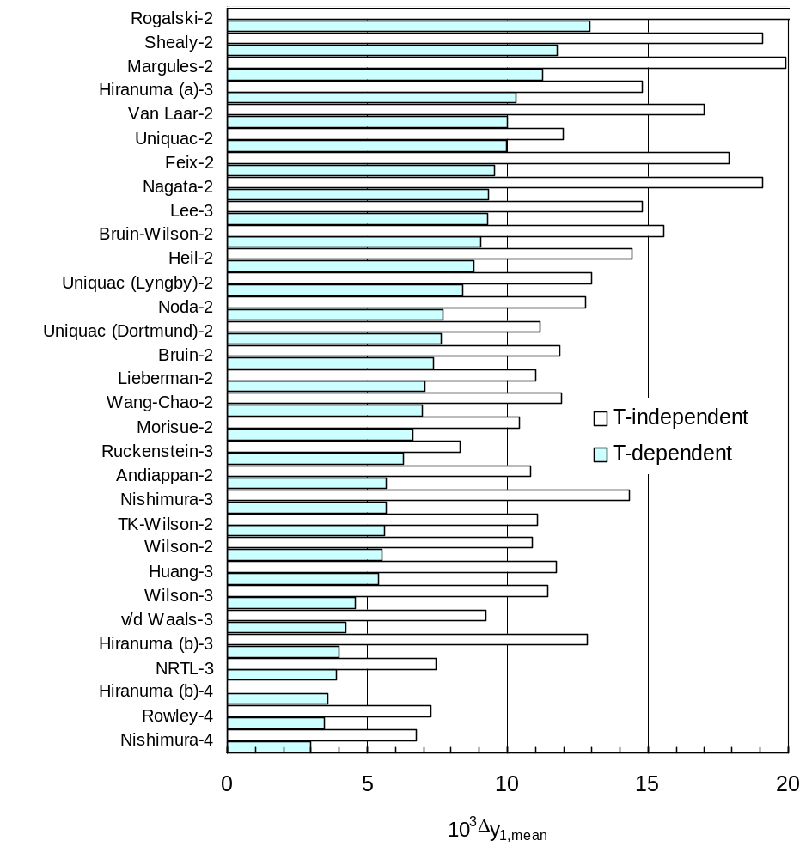
Figure 2: Mean vapour composition errors averaged over all systems and data sets. The number of adjustable parameters is indicated number next to the model name.

Acknowledgement

Financial support for this research from the THRIP program of the Department of Trade and Industry and the National Research Foundation of South Africa as well as Xyris Technology is gratefully acknowledged.

References

Abrams, D.S. and Prausnitz, J.M. (1975). Statistical Thermodynamics of Liquid Mixtures: A New Expression for the Excess Gibbs Energy of Partly or Miscible Systems. A.I.Ch.E. J. 21, 116-127.
Andiappan, A.N. and McLean, A.Y. (1972). Prediction of Vapor-Liquid Equilibria: Derivation of a New Expression for Vapor-Liquid Equilibrium Correlations. Can. J. Chem. Eng. 50, 384-389.
Bruin, S. (1970). Activity Coefficient Relations in Miscible and Partially Miscible Multicomponent Mixtures. Ind. Eng. Chem. Fundam. 9, 305-314.
Cairns, B.P. and Furzer, I.A. (1988). Sensitivity Testing with the Predictive Thermodynamic Models NRTL, Uniquac, ASOG and UNIFAC in Multicomponent Separations of Methanol-acetone-chloroform. Chem. Eng. Sci. 43, 495-501.
Feix, G., Bittrich, H-J. and Lempe, D. (1980). Eine 2-Parameter-Gleichung zur Beschreibung von Phasengleichgewichten in Partiell Miscbaren Systemen. Coll. Czech. Chem. Comm. 45, 2035-2041.
Focke, W.W. (2003). Composition Dependence of the Excess Gibbs Energy for a Binary Liquid Mixture Predicted by the Wong-Sandler Postulates and the van der Waals EOS. Submitted for publication.
Gmehling, J. and Onken, U. (1977-1996). Vapor–liquid equilibrium data collection, Part 1 in Chemistry Data, Parts 1–7, Behrens, D. and Eckermann, R. (Eds.), Dechema, Frankfurt a.M.
Gmehling, J. and Kolbe, B. (1983). Limitations of Modern Expressions for the Gibbs Energy. Fluid Phase Equilibria 13, 227-242.
Guggenheim, E.A. (1952). Mixtures, Clarendon Press, Oxford.
Hála, E., Pick, J., Fried, V. and Vilím, O. (1967). Vapour-Liquid Equilibrium, 2nd Ed., Pergamon, Oxford.
Heil, J.F. and Prausnitz, J.M. (1966). Phase Equilibria in Polymer Solutions. A.I.Ch.E. J. 12, 678-684.
Hildebrandt, J.H. and Scott, R.L. (1950). The Solubility of Electolytes. 3rd Ed., Reinhold, New York.
Hiranuma, M. (1974). A New Expression Similar to the Three-Parameter Wilson Equation. J. Chem. Eng. Japan 13, 219-223.
Hiranuma, M. (1983). Equation Suitable for Estimation of Ternary Liquid-liquid Equilibria with Binary Wilson Parameters. Ind. Eng. Chem. Fund. 22, 364-366.
Huang, J-H. and Lee L-S. (1994). A Modification of the Wilson Equation with only Binary Parameters for Ternary Liquid-Liquid Equilibria. Fluid Phase Equilibria 101, 27-51.
Kikic, I., Alessi, P., Rasmussen, P. and Fredenslund, A. (1980). On the Combinatorial Part of the UNIFAC and UNIQUAC Models. Can. J. Chem. Eng. 58, 253-258.
Kracht, C., Friese, T., Ulbig, P. and Schulz, S. (1999). Development of an Enthalpy-based Group-contribution Model. J. Chem. Thermodyn. 1, 587-613.
Larsen, B.L., Rasmussen, P. and Fredenslund, A. (1987). A Modified UNIFAC Group-Contribution Model for the Prediction of Phase Equilibria and Heats of Mixing. Ind. Eng. Chem. Res. 26, 2274-2286.
Lee, L.L. Chung T.H. and Starling K.E. (1983). A Molecular Theory for the Thermodynamic Behavior of Polar Mixtures: The Statistical-Mechanical Local-Composition Model. Fluid Phase Equilibria 12, 105-124.
Lee, K-H. and Sandler, S.I. (1987). The Generalised van der Waals Partition Function-IV, Local Composition Models for Mixtures of Unequal-Size Molecules. Fluid Phase Equilibria 34, 113-147.
Lieberman, E. and Fried, V. (1972). Estimation of the Excess Gibbs Free Energy and Enthalpy of Mixing of Binary Bon-associated Mixtures, Ind. Eng. Chem. Fund. 11, 350-354.
Lohmann, J. and Gmehling, J. (2001). Modified UNIFAC (Dortmund): Reliable Model for the Development of Thermal Separation Processes. J. Chem. Eng. Japan, 34, 43-54.
Malanowski, S. and Anderko, A. (1992). Modeling Phase Equilibria. John Wiley, New York.
Maurer, G. and Prausnitz, J.M. (1978). On the Derivation and Extension of the Uniquac Equation. Fluid Phase Equilibria 2 91-99.
Morisue, T., Noda, K. and Ishida, K. (1972). A Discussion of the Excess Gibbs Free Energy of Liquid Mixtures based on the Local Composition. J. Chem. Eng. Japan 5, 219-223.
Nagata, I. and Nagashima, M. (1976). Correlation and Prediction of Vapor-Liquid and Liquid-Liquid Equilibria. J. Chem. Eng. Japan 9, 6-11.
Nicolaides, G.L. and Eckert, C.A. (1978). Optimal Representation of Binary Liquid Mixture Nonidealities. Ind. Eng. Chem. Fund. 17, 331-340.
Nishimura, Y., Iwai, Y. and Arai, Y. (1985). A Correlation of Ternary Liquid-Liquid Equilibria by a Modified Wilson Equation. J. Chem. Eng. Japan 18, 377-381.
Noda, K. and K Ishida (1980). A Modified Quasi-Chemical Theory based on Local Composition. J. Chem. Eng. Japan 13, 334-336.
Palmer, D.A. (1987). Handbook of Applied Thermodynamics. CRC Press, Boca Raton.
Prausnitz, J.M., Lichtenthaler, R.N. and de Azevedo, E.G. (1999) Molecular Thermodynamics of Fluid-Phase Equilibria, Prentice Hall, New Jersey.
Porter, A. W. (1921). On the Vapour-Pressures of Mixtures. Trans. Faraday Soc. 16, 336-
Raal, J. D., and Mühlbauer, A. L. (1998). Phase Equilibrium. Measurement and Computation. Taylor & Francis, Washington.
Renon, H. and Prausnitz, J. M. (1968). Local Compositions in Thermodynamic Excess Functions for Liquid Mixtures. A.I.Ch.E. J. 14, 135-144.
Renon, H. and Prausnitz, J.M. (1969). Derivation of the Three-Parameter Wilson Equation for the Excess Gibbs Energy of Liquid Mixtures. A.I.Ch.E. J. 15, 784-785.
Rogalski, M. and Malanowski, S. (1977). A new Equation for Correlation of Vapour-Liquid Equilibrium Data of Strongly Non-ideal Mixtures. Fluid Phase Equilibria 1, 137-152.
Rowley, R.L. and Battler, J.R. (1984). Local-Composition Models and Predictions of Binary Liquid-Liquid Binodal Curves from Heats of Mixing. Fluid Phase Equilibria 18, 111-130.
Ruckenstein, E. and Shulgin, L. (1999). Modified Local Composition and Flory-Huggins Equations for Nonelectrolyte Solutions. Ind. Eng. Chem. Res. 38, 4092-4099.
Sabarathinam, P.L. and Andiappan, A.N. (1982). A New Expression for Predicting Multicomponent VLE Data. J. Chem. Eng. Japan 15, 229-231.
Sandler, S.I. and Lee, K-H. (1987). The Generalised van der Waals Partition Function-IV. Local Composition Models for Mixtures of Unequal-size Molecules. Fluid Phase Equilibria, 34, 113-147.
Sayegh, S.G. and Vera, J.H. (1980). Lattice-Model Expressions for the Combinatorial Entropy of Liquid Mixtures: A Critical Discussion. Chem. Eng. J. 19, 1-10.
Scatchard, G. and W.J. Hamer (1935). The Application of Equations for the Chemical Potentials to Partially Miscible Solutions. J. Am. Chem. Soc. 57, 1805-1809.
Scatchard, G. (1931). Equilibria in Non-electrolyte Solutions in Relation to the Vapor Pressures and Densities of the Components. Chem. Rev. 8, 321-333.
Scott, R.L. (1956). Corresponding States Treatment of Nonelectrolyte Solutions. J. Chem. Phys. 25, 193-205.
Shealy, G.S. and Sandler, S.I. (1988). The Excess Gibbs Free Energy of Aqueous Nonelectrolyte Solutions. A.I.Ch.E. J. 34, 1065-1074.
Tsuboka, T. and Katayama, T. (1975). Modified Wilson Equation for Vapor-Liquid and Liquid-Liquid Equilibria. J. Chem. Eng. Japan 8, 181-187.
Tsuboka, T. and Katayama, T. (1975). Correlations Based on Local Fraction Model between new Excess Gibbs Energy Equations. J. Chem. Eng. Japan 8, 404-405.
Vera, J.H., Sayegh, S.G. and Ratcliff, M. (1977). A Quasi Lattice-local Composition Model for the Excess Gibbs Free Energy of Liquid Mixtures. Fluid Phase Equilibria 1,113-135.
Wang, W. and Chao, K.C. (1983). The Complete Local Concentration Model Activity Coefficients. Chem. Eng. Sci. 9, 1483-1492.
Walas S. M. (1985). Phase Equilibrium in Chemical Engineering, Butterworth, Boston pp. 178-182,
Wilson, G.M. (1964). Vapor-Liquid Equilibrium. XI. A New Expression for the Excess Free Energy of Mixing. J. Am. Chem. Soc. 86, 127-130.
Weidlich, U. and Gmehling, J. (1987). A Modified UNIFAC Model. 1. Prediction of VLE, h^{E}, and γ∞. Ind. Eng. Chem. Res. 26, 1372-1381.

Notation
A_{ij} = constant, mean field model [-]  a^{E} = Helmholtz free energy [J/mol]  g^{E} = excess Gibbs free energy [J/mol]  G_{ij} = Renon local composition parameter (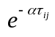) [-]  g_{ij} = Renon energy of interaction between i-j pair of molecules [J/mol]  h_{ij} = Rowley enthalpy of interaction between i-j pair of molecules [J/mol]  h = enthalpy [J/mol]  M = configurational thermodynamic property  P = pressure [Pa]  q = molecular size/shape factor  R = Gas constant (R = 8,3143214) [J/(mol.K)]  T = absolute temperature (K)  u_{ij} = Uniquac i-j interaction energy [J/mol]  V = molar volume [m³/mol]  v_{ii} = molar volume of component i [m³/mol]  v_{ij} = mean field i-j interaction volume [m³/mol]  w_{ij} = dimensionless free energy parameter  ((λ_{ij} – λ_{jj})/RT)) [-]  x_{i} = liquid mole fraction of component i  x_{ij} = local mole fraction of molecule i in the immediate neighbourhood of molecule j  y_{i} = vapour mole fraction of component i  z = lattice coordination number | Greek Letters  α = Renon non-randomness parameter [-]  β = Quasi-chemical non-randomness factor [-]  χ_{ij} = interaction enthalpy ((h_{ij} – h_{jj})/RT) [-]  ε_{ij} = Quasi-chemical interaction energy [-]  γ = activity coefficient [-]  Λ = Wilson LC factor 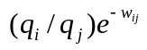 [-]  λ_{ij} = Wilson i-j interaction free energy [J/mol]  ρ_{ij} = molar volume ratio v_{i}/v_{j} [-]  τ_{ij} = dimensionless interaction free energy  ((g_{ij} – g_{jj})/RT) [-]  Φ_{i} = vapour phase correction factor [-]  Subscripts  i, j = component indices  sat = saturated  Superscripts  E = excess  (i) = pertaining to hypothetical fluid i.

Appendix: A General form for the NRTL and Wilson Local Composition Models

The model for a binary mixture shown in Figure 3 recognises the fact that a liquid mixture is composed of two different types of cells (Prausnitz et al., 1999). The nearest neighbours, of a central molecule of component (i), define cell type (i). In terms of the two-fluid theory of Scott (Scott, 1956), a configurational thermodynamic property (M) of the binary mixture is a composition average of the properties of the two hypothetical reference fluids defined by the two different cells in the mixture:
M_{mix} = x₁ M⁽¹⁾ + x₂ M⁽²⁾ (A-1)
This theory is readily extended to multi-component mixtures with the assumption of m types of cells (so-called m-fluid theory).

Owing to differences in molecular size and shape and also the strength of intermolecular interactions, the composition in the vicinity of a central molecule of type (i) differs from the overall composition (Wilson, 1964). This redistribution is described by a weighted Boltzmann distribution:
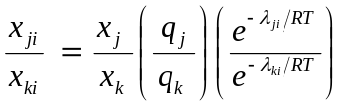 (A-2)
Molecule of
component 1

Molecule of component 2

Hypothetical Fluid (1)
Hypothetical Fluid (2)
λ₁₂
λ₂₂
λ₁₁
λ₂₁
The parameter λ_{ij} is proportional to the interaction energy between a central molecule of type i with a molecule of type j

Figure 3. Schematic illustration of the two-fluid theory and local compositions in a binary mixture. In cell (1) a molecule of component (1) is located at the centre whereas cell (2) has a molecule of component (2) at the centre.

In equation (A-2) the free energy parameter λ_{ji} characterises the j-i molecular interaction and q_{j} represents a geometric factor compensating for the shape and size of molecules of type j. It is disputed whether the molecular interaction energies (λ_{ji}) given in these equations should be interpreted as potential energies, Gibbs free energies or enthalpies. Rowley and Battler (Rowley and Battler, 1984) consider the λ_{ji} to be separate and independent of the enthalpic interactions between the j-i pair of molecules. With this assumption they obtain the following expression for the excess enthalpy:
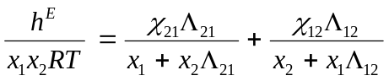 (A-3)
With: 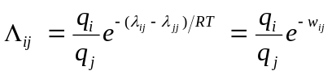 (A-4)
The Gibbs-Helmholtz equation provides a relationship between the excess Gibbs energy and the excess enthalpy:
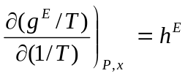 (A-5)
Integrating from 1/T → 0 to 1/T yields:
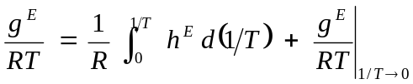 (A-6)
It is reasonable to assume that at high temperatures the mixture will behave like an athermal solution. Thus, following Tsuboka and Katayama, the last term on the right is substituted by the negative of Flory’s excess entropy contribution to g^{E}:
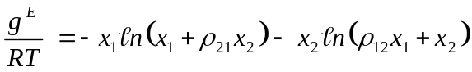 (A-7)
If the q_{i} and λ_{ji} are assumed temperature independent, the integrant can be evaluated and the procedure yields a generalised Wilson form for the excess Gibbs energy proposed by Rowley, et al. (1984):
(A-8)
If, on the other hand h^{E} is assumed temperature independent and the solutions behaves ideal at high temperatures, the integration leads to g^{E} = h^{E}, and the NRTL equation results:
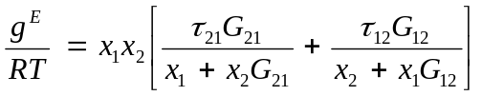 (A-9)
(Note that NRTL notation assumes: q _{i} = 1; w _{ij} = ατ_{ij} and χ _{ij} = τ_{ij})

Maurer’s (Maurer et al., 1978) derivation of the Uniquac equation proceeds along similar lines: An expression for the excess Helmholtz energy (a^{E}) is obtained by integration of a two-fluid local composition-based internal energy expression. Instead of the Flory equation, it uses the Staverman-Guggenheim entropy expression (Guggenheim, 1952) as the high temperature boundary condition. Finally, the excess Gibbs energy is obtained by equating it to the resulting excess Helmholtz energy expression, i.e. (g^{E})_{T,P} ≈ (a^{E})_{T,V}. This is permissible, as Hildebrandt and Scott (Hildebrandt et al., 1950) have shown that there is a negligible difference between the two excess energies at low pressures.

