Table A2(A): Rational function expressions for the Excess Free energy
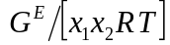
A | Porter
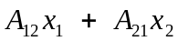 | Margules
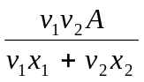 | Scatchard-Hildebrandt  G Scatchard Chem Rev 8 (1931) 321 - 333
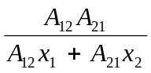 | Van Laar  (See Walas [3])
NRTL  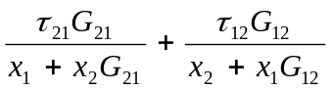 | H Renon and JM Prausnitz  AIChE J 14 (1968) 135 - 144  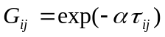 and 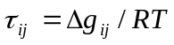
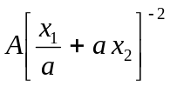 | SSF (1)M Rogalski and S Malanowski  Fluid Phase Equilibria 1 (1977) 137 - 152
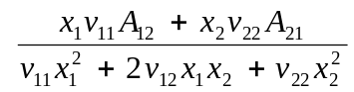 | FG
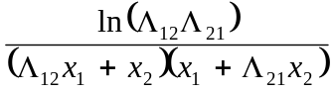 | S Bruin Ind. Eng. Chem. Fund. 9 (1970) 305 – 314  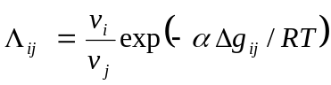
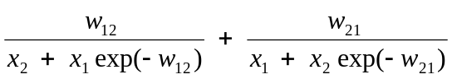  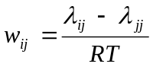 | T Morisue, K Noda & K Ishida  J Chem. Eng. Japan 5 (1972) 219-223

Table A2(B) Quasichemical and Modified Quasichemical models
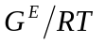
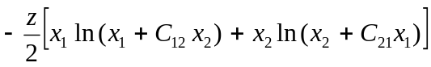  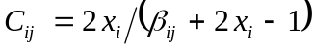  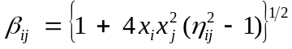  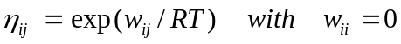 | Quasi-Chemical Model  EA Guggenheim, “Mixtures” Clarendon Press, Oxford (1952)
Modified Quasichemical (a)  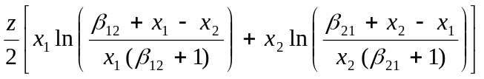 | AN Andiappan & AY McLean  Can. J. Chem. Eng. 50 (1972) 384 – 389  P Sabarathunam and A Andiappan  J Chem. Eng. Japan 15 (1982) 229-231
Modified Quasichemical (b) | I Nagata and M Nagashima  J Chem. Eng. Japan 9 (1976) 6-11
Modified Quasichemical (c) | K Noda and K Ishida  J Chem. Eng. Japan 13 (1980) 334-336

Table A2(C) Wilson and Modified Wilson models
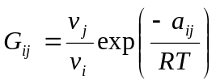 | GM Wilson  J Am Chem Soc 86 (1963) 127 -130
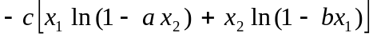  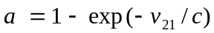 and 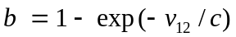  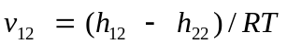 and 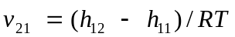 and 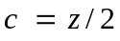 | Modified Wilson  H Renon and JM Prausnitz  AIChE J 15 (1969) 784 - 785
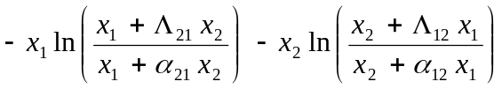  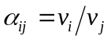 and 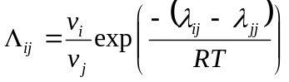 | T Tsuboka and T Katayama  J Chem. Eng. Japan 8 (1975) 181-187
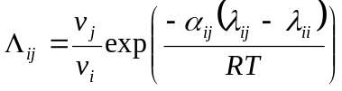 and 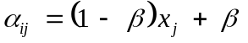 | Y Nishimura et al  J Chem. Eng. Japan 18 (1985) 377 - 381
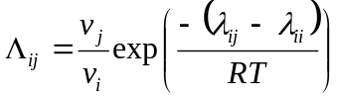 | M Hiranuma  J Chem. Eng. Japan 13 (1974) 219-223
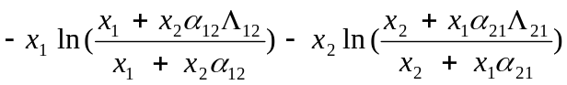 | M Hiranuma  Ind. Eng. Chem. Fund. 22 (1983) 364 - 366
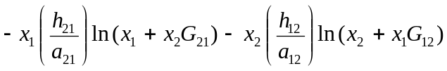  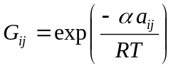 | RL Rowley and JR Battler  Fluid Phase Equilibria 18 (1984) 111 - 130
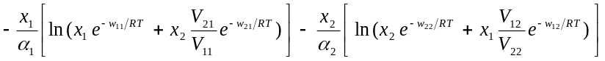  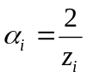 | LL Lee, TH Chung and KE Starling  Fluid Phase Equilibria 12 (1983) 105 - 124
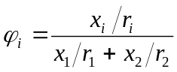 | J-H Huang and L-S Lee  Fluid Phase Equilibria 101 (1994) 27 - 51
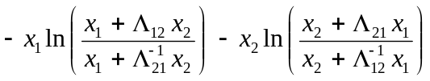 | G Feix, H-J Bittrich and D Lempe  Coll. Czech. Chem. Commun. 45 (1980) 2035 – 2041.

