**Literature**

Parametric

Finite number of parameters such as building mass, stiffness and damping ratio.

Non-parametric

Infinite number of parameters, estimating the model without full understanding of physical systems. This method is effective in predicting complex systems.

* Assuming linear models may be insufficient especially when the non-linear part of the process is dominating. (K & Jung Mi Kim, 2016)

1. **Process Knowledge Issue**

* Poorly understood process because of complexity
* Not sure of the process knowledge

1. **Process Identification Issue**

* The headache of off-line training that might be required.
* The trade-off between the persistent excitation of signals for correct identification and the steady-state system response for control performance.
* Assumption of the model structure.
* The model convergence.
* System stability issues in real applications.

1. Identification-based control methods are not well suited to process control because identification and control are always conflicting.
2. Good control leads to steady state of the set-point, controller output and the process variable

* The variables will not have the information about the process characteristics.

1. Good identification requires persistent excitation of the controller output and process variable. (Van Doren, 2003)

**Online Detection**

By comparing the output of the model with the true process output, one can detect when the process dynamics change.

* If the model id good, the difference between the model output and the process output is small

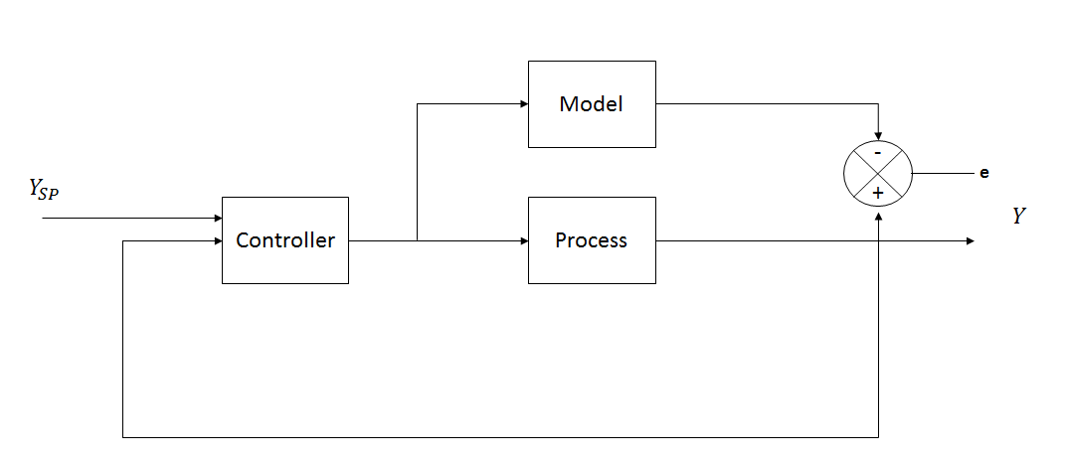

Figure 1: Model Validation

* Another fault detection approach is to use a recursive parameter estimator in the same way as the model-based continuous adaptive controller.

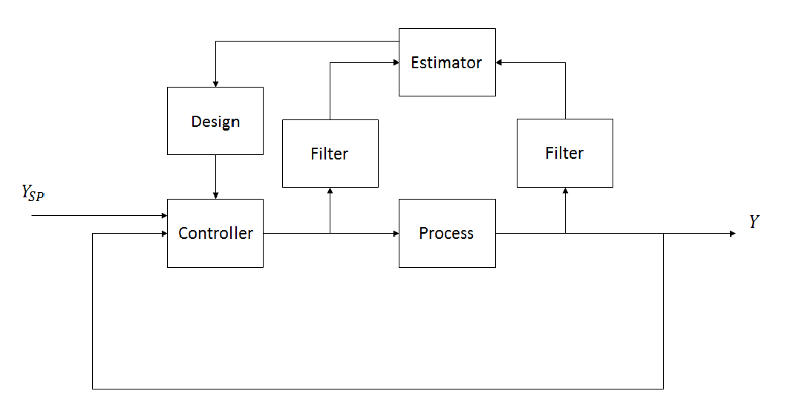

Figure 2: Adaptive Control

**Parameter Estimation Methods**

* A common tuning procedure is to use the recursive parameter estimation to determine a low-order discrete time model of the process and use it to design a controller
* Sampling period must be related to the time constant of the closed-loop system. (Astrom & Hagglund, 1995)

**Input Signals**

* Step function
* PRBS
* Autoregressive moving average process
* Sum of sinusoids

**Methods**

* RLS does not give consistent parameter estimates for systems with correlated equation errors.
* For low-order systems the deviations of the estimates from true values are often smaller.
* For high-order systems the deviations are often more substantial
* RIV algorithm gives consistent parameter estimates. (Stoicha & Soderstrom, 1989)

**Adaptive Controllers**

1. A mistuned controller may not be detected simply because the process runs at steady state
2. **On-demand Tuning**

Get the process reaction curve using the controller output as an input to the process and tune the controller based on the reaction curve.

* Requires continual attention of the user to determine when the loop needs tuning
* Requires the user’s active participation in waiting for the response.

1. Insufficient manpower
2. Frequent changes in environment

* Non-linear processes
* Plant parameters are changing with time( e.g change of process gain due to gradual fouling of a heat surface)
* One set of tuning constants cannot satisfy the entire operating range.

1. Perturbation signal

* For some sensitive processes, it is not acceptable to perturb the process for the purpose of tuning.

Not all control loops require adaptive control

* For many time-invariant systems, on-demand tuning can be very effective.
* For some slow but known time-varying processes or non-linear processes, a well-tuned gain schedule controller works well.

History and Milestone of adaptive control (self-tuning)

* Controller will change its own controller settings to adapt to process changes
* Can correct improperly tuned controller loops
* Tuning without human intervention
* Reduces engineering time
* All process to which PID is applied can be approximated by first-order-plus-dead-time models, the parameters of this model are converted to useful PID settings

Two types of adaptive controllers;

* Adaptive control (self-tuning regulator) – identification based adaptive control
* Heuristic and pattern recognition-based approach – expert-based adaptive control

1. The STR will converge to the optimal controller settings even if the noise is not white (in which case the system cannot be properly identified by at least the least square method.

2. One of the key challenges is to distinguish the effects of disturbance dynamics from the process input/output dynamics so that the adaptive controller does not produce incorrect tuning results.

**Challenges of Identification-based adaptive control**

*Dead-time*

* Dead-time is the non-linear element with respect to process identification.
* Linear identification cannot estimate the process dynamics and the dead-time simultaneously.

Identify multiple process models, each with a different assumed value for dead-time, select the best fit.

Employ a higher order mdel and then estimate the dead-time based on the significance of the identified parameters.

Use a non-linear estimator that could identify both the parameter and dead-time simultaneously.

*Start-up and PRBS*

* During start-up, controller may be very poor until a reasonable model has been identified.

PRBS speeds up the process of identification; however, external excitation is not acceptable for many process.

Alternatively use a less disturbing step-test or starting with preliminary model.

* According to the authors experience, the LS method breaks down when the noise-to-signal ratio exceeds 0.2
* The instrumental variable method is more resistant to noise, but at the expense of requiring more computation.

**Identifiability**

* A necessary condition for closed-loop identification is that the process input signal be independent of the process output signal.
* The identified model is verified by checking residues, if the level of confidence is high on the identified model, the model will be presented to the user.
* Identification porting is not necessary for loop tuning purposes (Van Doren, 2003).

**Model Validation**

* For good model, the model output should explain all patterns in process output due to the input.
* However, the model output should not be identical to noise-free process output since the process output has a component that is caused by the disturbance (Stoicha & Soderstrom, 1989).

**Offline identification drawbacks**

* Data has to be sequential, i.e. no missing data.
* Cannot track parameter changes in the process.
* Storing of large amounts of data.

**Online identification**

* The necessity of storing data is removed
* Can track changes in the parameters
* No matrix inversion.
* No need for sequential data, parameters are updated each time a new sample comes in (Hastings & Sage, n.d.).