**Literature**

*Offline Identification*

Offline identification is relatively the oldest techniquefor model prediction, it is easier to perform in terms of mathematical complexity than its counterpart, online identification. The online identification is essentially a modification of offline technique and is popular in modern plants that implement adaptive controllers. Not every plant needs an online identification, for example if a process is well known to be time-invariant then an offline is efficient.

The system investigated in this paper is a 2-input-2-output multivariable case both in open loop and closed loop. To facilitate the understanding of system identification in general a method for identification will be presented, particularly the least-square method. A general single-input-single-output linear system is described by

$y\left(t\right)+ a_{1}y\left(t-1\right)+a_{2}y\left(t-2\right)+…+a_{na}y\left(t-na\right)=b_{1}u\left(t-1\right)+b_{2}u\left(t-1\right)+…{+b}_{nb}u\left(t-nb\right)$

Where y(t) is output and u(t) is the input. The difference equation difference equation above can be easily be transformed to either the time or the Laplace domain, this paper is making use of the difference equation for simulation and identification. Equation 1 can be written in matrix format as

$y\left(t\right)= φ(t)θ$

where

$φ(t)= \left[\begin{matrix}-y(t-1) & -y(t-1) & \begin{matrix}⋯ & -y(t-na) & \begin{matrix}u(t-1) & u(t-2) & \begin{matrix}⋯ & u(t-nb)\end{matrix}\end{matrix}\end{matrix}\end{matrix}\right]$

$θ= \left[\begin{matrix}a_{1} \\ a_{2} \\ \begin{matrix}⋮ \\ \begin{matrix}a_{na} \\ b_{1} \\ \begin{matrix}b_{2} \\ ⋮ \\ b_{nb}\end{matrix}\end{matrix}\end{matrix}\end{matrix}\right]$

This paper will also employ the ARMAX model using shift operators, this model structure is written as

$A\left(z^{-1}\right)y\left(t\right)=B\left(z^{-1}\right)u\left(t\right)$

$y\left(t\right)=\frac{B\left(z^{-1}\right)}{A\left(z^{-1}\right)}u(t)$

where $A\left(z^{-1}\right)=1+a_{1}z^{-1}+a_{2}z^{-2}+…+a_{na}z^{-na}$

$B\left(z^{-1}\right)=1+b_{1}z^{-1}+b_{2}z^{-2}+…+b_{nb}z^{-nb}$

In the equation above, z-1 denotes the backward shift operator so that

$$z^{-1}u\left(t\right)=u(t-1)$$

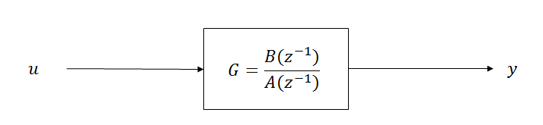

Unlike the model, the real process contains disturbance elements such as noise that are neither correlated to the input nor the process output. The real process for SISO system is shown in the figure below.

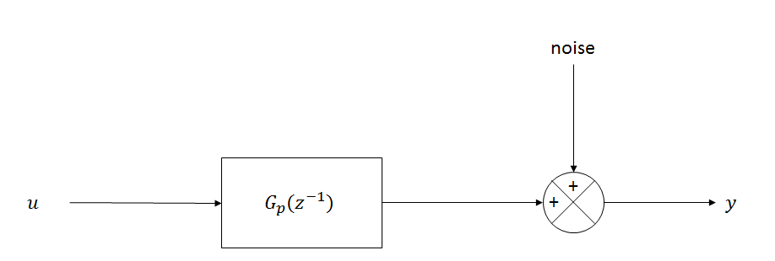

The system above is assumed to be generating data for offline identification. This system is represented by

$$y\left(t\right)= G_{p}\left(z^{-1}\right)u\left(t\right)+e(t)$$

**Least-Squares Estimator**

The least square method minimizes the error between the process output and the model output. By evaluating the gradient of the function that gives the residual error, it can be shown that the minimum error occurs at

$$\hat{θ}={\left[\sum_{t=1}^{N}{φ^{T}(t)φ(t)}\right]}^{-1}\left[\sum_{t=1}^{N}{φ^{T}(t)y(t)}\right]$$

If we define a variable

$$P\left(t\right)={\left[\sum_{t=1}^{N}{φ^{T}(t)φ(t)}\right]}^{-1}$$

Then it follows that

$$P^{-1}\left(t\right)=P^{-1}\left(t-1\right)+φ^{T}(t)φ(t)$$

$$\hat{θ}(t)=P(t)\left[\sum_{s=1}^{t-1}{φ^{T}(s)φ(s)}+ φ^{T}(t)y(t)\right]$$

$$\hat{θ}(t)=P\left(t\right)[P^{-1}\left(t-1\right)\hat{θ}\left(t-1\right)+φ^{T}(t)y(t)]$$

$$\hat{θ}\left(t\right)=\hat{θ}\left(t-1\right)+ P(t)φ^{T}(t)[y\left(t\right)-φ(t)\hat{θ}\left(t-1\right)]$$

The algorithm above is known as the recursive identification by least-square method. This algorithm can be put into more useful form that eliminates matrix inversion, particularly the updating of P(t), the equation for P(t) is equivalent to

$$P\left(t\right)=P\left(t-1\right)-\frac{P(t-1)φ^{T}(t)φ(t)P(t-1)φ^{T}(t)}{[1+ φ(t)P(t-1)φ^{T}(t)]}$$

Thus

$$\hat{θ}\left(t\right)=\hat{θ}\left(t-1\right)+K(t)ε(t)$$

$$K\left(t\right)=P(t) φ^{T}(t)$$

$$ε\left(t\right)=y\left(t\right)- φ(t)\hat{θ}\left(t-1\right)$$

The algorithm above also applies to multivariable systems since multiple-input-multiple-output is merely an addition of multiple-input-single-output systems. It is as easy to identify a MISO system as is to identify as SISO system. The least-square method is, however, valid under certain condition, these conditions are

* The system should have a white noise for estimated parameters to converge to true values.
* For high-order systems, the deviation of the estimated parameters from true values is often more substantial than with low-order systems.
* The least-square method is sensitive to signal-to-noise ratio.

The process used in this paper has a white noise with a noise-to-signal ratio of < 0.1, this should be fine as the maximum signal-to-noise ratio is 0.2 according to the literature. The system is a 2x2 multivariable system which is relatively low. Different noise levels will be investigated also to determine the noise-to-signal ratio at which the least-square method breaks down.