**Results from Simulations**

The simulation was run for 500 minutes using a sampling interval of 1 minute. The real process was simulated using the difference equation as shown in (), hence the true parameters as shown in (theta) are presented in the table below.

|  |  |
| --- | --- |
| Parameter | True Value |
| a11 (b1 + b3) | 1.214 |
| a22 (-b1b3) | -0.3114 |
| a33 (a1) | 0.6321 |
| a44 (-a1b3) | -0.5351 |
| a55 (a3) | 0.0307 |
| a66 (-a3b1) | -0.0113 |
| b11 (b4 + b2) | -1.425 |
| b22 (-b4b2) | 0.4966 |
| b33 (a4) | 0.3935 |
| b44 (-a4b2) | -0.3221 |
| b55 (a2) | 0.0906 |
| b66 (-a2b4) | -0.05497 |

The parameters in the table above are functions of the parameters in table (), the functions are indicated in brackets, see table () for reference. Equation () is re-written as

|  |  |  |
| --- | --- | --- |
|  |  | () |

|  |  |  |
| --- | --- | --- |
|  |  | () |

The parameter estimates are

|  |  |  |
| --- | --- | --- |
|  |  | () |

The estimated parameters are expected to converge to the true parameters as given in table() above. The open-loop identification was simulated for 100 time units in offline mode and the response is given in the figure below.

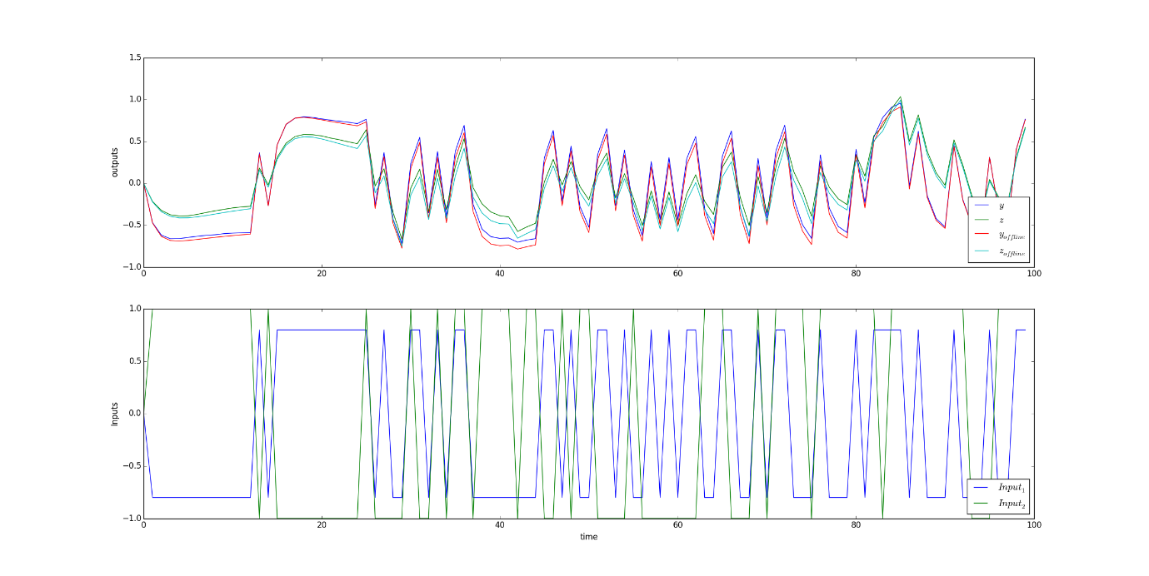

The response above is due to a PRBS signal for both inputs with the properties given below.

|  |  |  |
| --- | --- | --- |
| Input (PRBS) | Mean | Variance (σ2) |
| Input 1 | 0 | 0.8 |
| Input 2 | 0 | 1 |

The identification results are given in the table below.

|  |  |  |
| --- | --- | --- |
| Parameter | Estimated Value | True Value |
| a11 (b1 + b3) | 1.280 | 1.214 |
| a22 (-b1b3) | -0.334 | -0.3114 |
| a33 (a1) | 0.631 | 0.6321 |
| a44 (-a1b3) | -0.576 | -0.5351 |
| a55 (a3) | 0.030 | 0.0307 |
| a66 (-a3b1) | -0.0137 | -0.0113 |
| b11 (b4 + b2) | 1.474 | 1.425 |
| b22 (-b4b2) | -0.525 | -0.4966 |
| b33 (a4) | 0.393 | 0.3935 |
| b44 (-a4b2) | -0.341 | -0.3221 |
| b55 (a2) | 0.0906 | 0.0906 |
| b66 (-a2b4) | -0.0599 | -0.05497 |