**-----** **Digital Twin AI server -----**

**A. Environment:**

+ Window10

**B. Programs:**

+ Docker Desktop 3.3.1

+ Python 3.9

**C. Source:**

+ Document.pdf

+ Digital Twin AI server v0.5.zip

+ DigitalTwinDB.sql

+ PointCloudData.zip

**D. Installation:**

1. Install Docker Desktop for Window:

*https://docs.docker.com/docker-for-windows/install/*

2. Install Python 3.9 for Window:

*https://www.microsoft.com/en-us/p/python-39/9p7qfqmjrfp7?activetab=pivot:overviewtab*

3. Install Mysql server on Docker desktop (from terminal):

*\*Make sure Docker desktop is running. Open Window Terminal:*

3.1. Pull image mysql server for docker:

> docker pull mysql

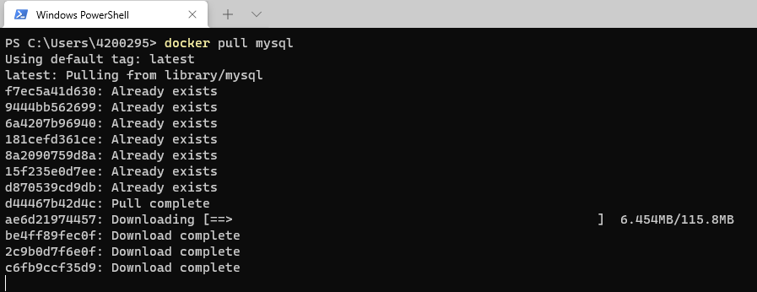

3.2. Create container from image mysql and run:

> docker run --add-host host.docker.internal:host-gateway -p 3306:3306 --name mysql --network bridge -v G:\mysql:/var/lib/mysql -e MYSQL_ROOT_PASSWORD=123 -d mysql

+ "--add-host host.docker.internal:host-gateway": *Add a custom host-to-IP mapping (host:ip).*

+ "-p 3306:3306": *Publish a container's port(s) to the host.*

+ "--name mysql": *Assign a name to the container.*

+ "--network bridge": *Connect a container to network "bridge".*

+ "-v G:\mysql:/var/lib/mysql": *Bind mount a volume "window_volume:ubuntu-container_volume".(*Create folder “mysql” in volume “G:\” first)*

+ "-e MYSQL_ROOT_PASSWORD=123": *Set password for "root" account.*

+ "-d": *Run container in background and print container ID.*

+ "mysql": *Name of image docker.*

4. Install Phpmyadmin for manager sql (from terminal):

*\*Make sure Docker desktop is running. Open Window Terminal:*

4.1. Pull image phpmyadmin for docker:

> docker pull phpmyadmin/phpmyadmin

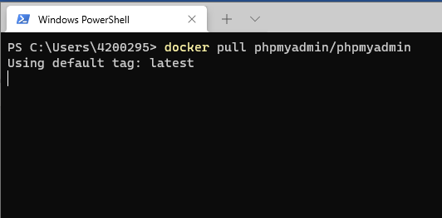

4.2. Create container from image phpmyadmin and run:

> docker run -p 8082:80 --name myadmin -d --link mysql:mysql --network bridge -e PMA_HOST=mysql phpmyadmin/phpmyadmin

+ "-p 8082:80": *Publish a container's port(s) to the host.*

+ "--name myadmin": *Assign a name to the container.*

+ "-d": *Run container in background and print container ID*.

+ "--link mysql:mysql": *Add link to mysql container.*

+ "--network bridge": *Connect a container to network "bridge".*

+ "-e PMA_HOST=mysql": *Define address/host name of the MySQL server.*

+ "phpmyadmin/phpmyadmin": *Name of image docker.*

*\* Results after creating and running the two docker container above.*

*+* Docker Container: *Open Docker Desktop -> Containers/Apps*

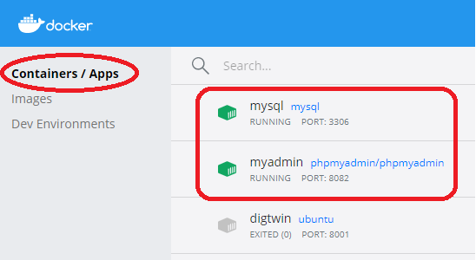

*+* Phpmyadmin: *Open browser -> http://localhost:8082/*

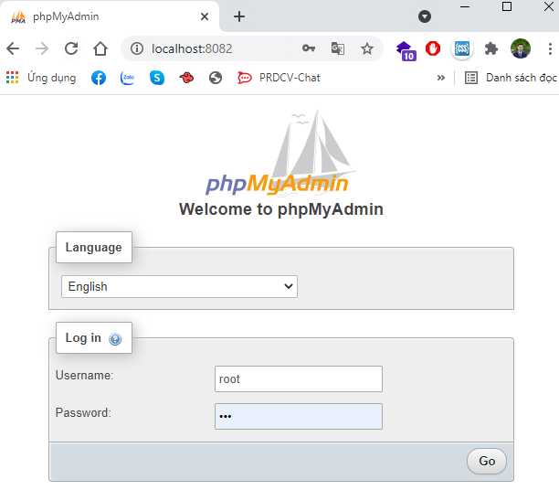

- Login with user(“root”) and password(“123”).

- Follow the steps in the image below to import Database.

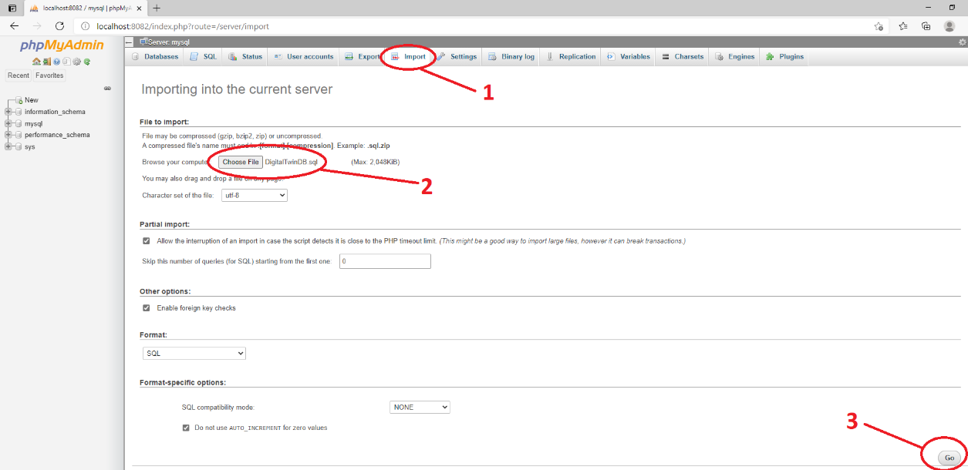

*+ Import -> Choose File -> Ok*

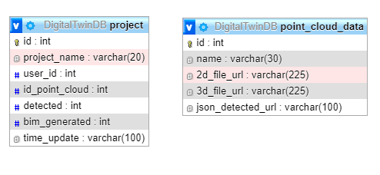

*Database for demo*

* Check the names of the files stored in the “point_cloud_data” table match the files in the “Digital Twin AI server v0.5/FTPserver” folder.

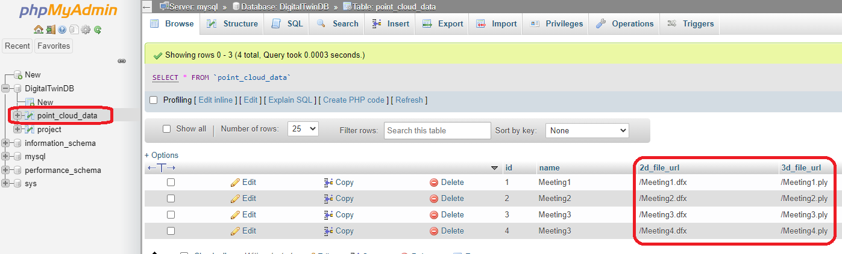

*Table “point_cloud_data”*

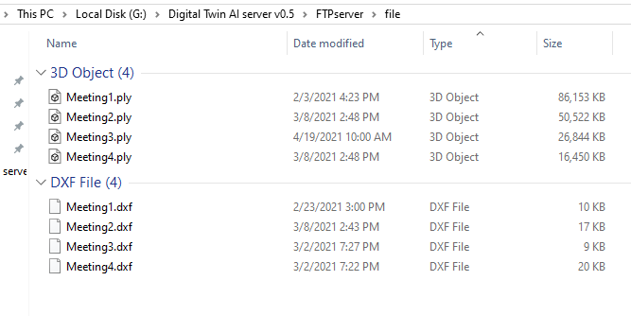

*Folder “Digital Twin AI server v0.5/FTPserver/file”*

* Copy the file to the directory if the file is missing and modify the data in the database.

5. Install modules Python:

*\*Open Window Terminal:*

+ Build API for http request:

> pip install flask

+ Get data from http request:

> pip install requests

+ Handling Cross Origin Resource Sharing:

> pip install flask_cors

+ Mysql connection:

> pip install --trusted-host pypi.org --trusted-host files.pythonhosted.org --trusted-host pypi.python.org mysql-connector-python

+ FTP server:

> pip install pyftpdlib

**E. Config:**

1.Server config: ServerConfig.py

*+ Server IP*

*+ Server port*

*+ API detection url*

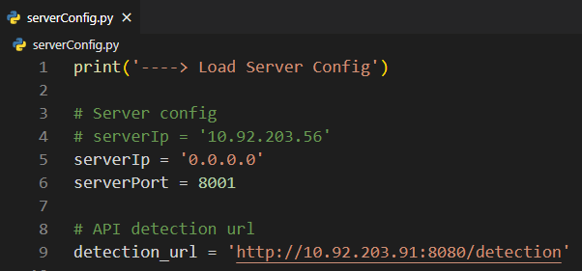

2.FTPConfig: FTPserver/ftp.py

*+ User name*

*+ Password*

*+ Root folder*

*+ IP FTP server*

*+ Port FTP server*

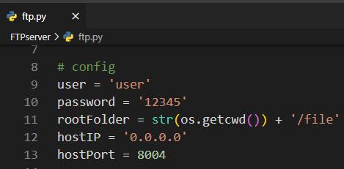

3.Database config: Database/config.py

*+ Ip hosting sql*

*+ User name*

*+ Password*

*+ Database name*

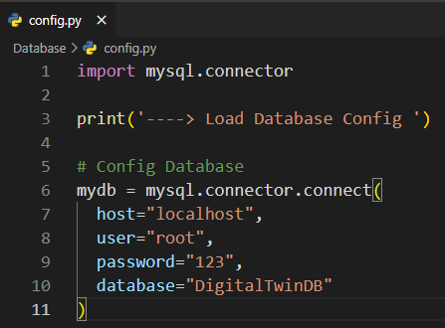

**F. Running server:**

+ Copy the source code to the any folder. Open this folder in Window terminal

Example: *G:\Digital Twin AI server v0.5/*

+ Run AI server:

Open folder “*Digital Twin AI server v0.5”* in the terminal:

> python3 main.py

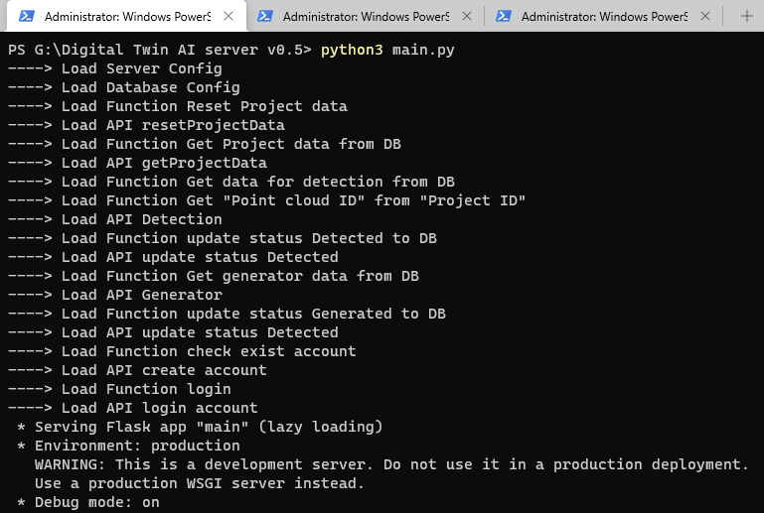

+ Run FTP server:

Open folder “*Digital Twin AI server v0.5/FTPserver”* in the terminal:

> python3 ftp.py

