Work Instruction: EZ Metadata Creator – APAC

# Link:

<https://2raxaxqzarwdf6ffwlnacj.streamlit.app/APAC_Zone>

# Purpose

Generate metadata files (Excel and CSV) for environmental restrictions applied to vehicles based on zone, days, time, and vehicle characteristics.

# 1. Initial Data Entry

**Zone Name**: Manually enter the name of the environmental zone.

**Zone ID**: Manually enter the unique identifier of the zone.

**Vehicle Categories**: Select the vehicle categories affected by the EZ condition (e.g., AUTO, TRUCK, BUS).

**Vehicle Restriction Value**: Type of restriction applied to the EZ condition (e.g., LICENSE PLATE NUMBER, MAX TOTAL WEIGHT).

⚠️ The following inputs might seem repetitive, but they are necessary to properly generate the metadata.

**EzTag**: Tag associated with the restriction (e.g., LicensePlate, Date).

**EzRestriction**: Tag related to the subtype of the restriction (e.g., ODD-EVEN).

**Start Day / End Day:** Date range in which the environmental zone restriction applies. If only the month range is needed, it can be defined here.  
For example, if you define 01-01-2025 to 31-12-2025, the months reflected will be “1-12”.

**Time Range:** Time of the restriction (e.g., 07:00–10:00).  
If the restriction has no time, keep the default format and manually remove it in the editable tables.

**Ez Description**: General description of the restriction.

**Lang Description**: Language of the description.

**Web-Site for EZ**: URL of the source where the EZ zone restriction information is located.

# ****2. Define Values and Application Days****

* **Days to Apply Restriction**: Select the days (e.g., Monday, Tuesday).  
  These values will be reflected based on the restriction type, either by generating a record per day or grouping the days.  
  If this format is not convenient, you may manually edit the table, or if it’s a recurring case, contact the EZ LDO development team.
* **Restriction Values**: Select restriction values (e.g., 1, 2, ODD, EVEN).

**Max and Min Weight Restrictions**

There are special restrictions like Max Total Weight or Min Total Weight which will disable some inputs and require additional ones.  
If selecting this type of Vehicle Restriction Value, make sure to fill out all displayed fields.

**New City Option**

This option can be enabled before or after generating the metadata.  
When selected, new inputs will be requested to generate 2 new sheets in the metadata file — these are required when encoding for a new city.

✔️ Make sure to press the “Add New City Information” button once you’ve completed the above selections.

# 3. Generate Records

Click ‘Generate Records▶️’.  
The app will generate records in a DataFrame and display them on screen.  
  
These records are not the final metadata, but a preview of the provided information.  
Keep in mind that inputs are not static — they can be edited as many times as needed.  
Each time you press ‘Generate Records’, the new data will be added to the current list, allowing you to create multiple types of restrictions under the same Zone ID.  
To start over, simply refresh the page (all data will be lost).

# 4. Create APAC Metadata

Click ‘Create APAC Metadata🔵’.  
This will generate several editable tables in the APAC-required format.

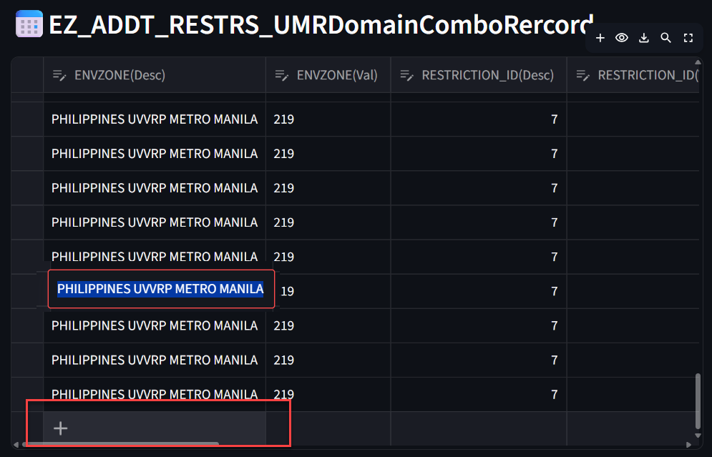If you need to edit any table, you’ll find buttons at the top and side to add, delete, or select records.

Clicking directly on a cell will allow you to edit its value.

# 5. Download Metadata Excel File

Click ‘Download APAC Metadata Excel File⬇️’.  
An .xlsx file will be generated containing all the corresponding sheets.

📝 Any changes made in the editable tables will be reflected in this downloadable file.

# 6. Generate MMT Files (CSV)

Click ‘Create MMT Files🗂️’.  
The following CSV files will be generated (if applicable):

***ADD_EZ_ADDT_RESTRS***

***ADD_EZ_REST***

***ADD_EZ_TIME_RESTR*In this section, it is not possible to add or edit records. Please ensure that the previous metadata is complete and accurate before generating the MMT files.**

If you edited records in the previous tables(Metadata) and need to sort by a specific record. Once the MMT file tables have been created, it is possible to sort in ascending or descending order.

In this example, vehicle categories were added to the metadata tables, and now in the MMT File Rest file, I can sort and export them that way.

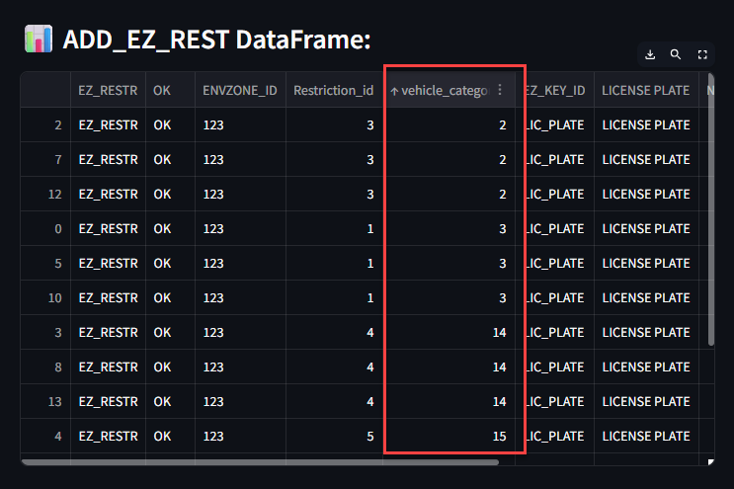

If this is confusing, you can download both files and edit them manually in Excel so they can be shared with your DBE.

**7. Final Review**

✅ Verify that the generated data matches the requested configuration.

✅ Confirm that the downloaded files are correctly named and properly formatted.

# ⚠️ Need Help?

If you have any special requirements or identify a potential improvement for the project, please contact the EZ - LDO development team, who will get in touch with you to develop your idea.