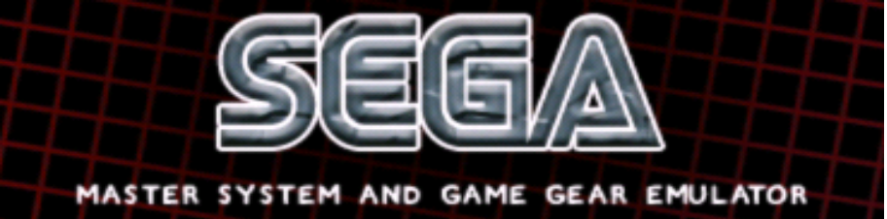

INTRODUCTION
SMSPlus emulates Sega's Master System and Game Gear systems. It was originally created by Charles MacDonald and ported to the Nintendo GameCube by The "Genesis Plus" Team. It is an open source emulator and a community project which aims to bring you blast processing into the past. Using this "emulator" you will be able to enjoy all of your classic 8bit games in all of their glory. SMSPlus has been converted from a PC based platform to run on the GameCube's proprietary PPC Gekko processor and features customized code to give you the best gaming experience possible.
This port is based on SMSPlus 1.3 sourcecode but it's also featuring a lot of modifications & additions to improve games compatibility, emulation accuracy and various peripheral supports. See changelog.txt for the whole history.

FEATURES
- accurate Sega Master System & Game Gear Emulation with sound
- FM unit emulation (Japanese Master System)
- 2 Players support
- Savestate support (compressed, saved on MCARD and SDCARD)
- Load a game from SDCARD or DVD (4.7GB support for Wii users)
- SMS BIOS support
- 3D glasses faking
- Light Phaser & Paddle emulation
- internal Game Database for automatic configuration
- Zipped rom support (.zip only)
- Original NTSC & PAL progressive rendering modes (240p/288p) support
- Interlaced (576i/480i) & Progressive (480p) TV mode support
- Wiimote, Nunchuk & Classic Controller support (WII mode only)
- full Overscan area (horizontal & vertical colored borders) emulation

CREDITS
- Original emulation code by Charles Mac Donald (http://cgfm2.emuviews.com/)
- Z80 core by the MAME team (http://mamedev.org/)
- SN76489 core by Maxim (http://www.smspower.org/maxim/)
- original Gamecube's port by softdev
- additional code (emulation core, extra features, compatibility fixes,…) by eke-eke
- graphical interface and icon design by brakken (http://www.tehskeen.net)
- libFAT port by Sven Peter (_svpe) & wintermute
- wiiuse library by Michael Laforest (para), Wii port by shagkur
- libOGC by shagkur, winterMute & various devs
- devkitPPC & Devkitpro by winterMute

SPECIAL THANKS

- softdev for all his great work and inspiration.
- Tmbinc for having made Gamecube homebrew possible.
- the Twiizer team and affiliates for the incredible stuff they discovered.
- people at Tehskeen's forums for their feedbacks and support.
- people at SMS Power forums for having provided so many useful technical informations

HOW TO COMPILE THE SOURCECODE ?

According to the GNU status of this project, the sourcecode MUST be provided for any binary releases you made. To recompile the sourcecode, you will need to have installed:

last DevkitPPC environment

last compiled libOGC sources

HOW TO RUN ?
smsplus_cube.dol is the application compiled in Gamecube mode. They can be loaded on a Gamecube or a Wii (using GC compatible mode) through various methods (Bootable DVD, SDLOAD,...). If you have no idea on how to load a DOL, please go here on follow the available guides: http://modyawii.tehskeen.com (Booting Homebrew Section).
smsplus_wii.dol is the application compiled compiled in WII mode, providing extra features like wiimotes and native SD slot support. It can be loaded on a Wii using either the TP Loader or the Homebrew Channel. See http://www.wiibrew.org/ and http://hbc.hackmii.com/ for more informations on how to run .dol and .elf files on your Wii. To use with Homebrew Channel, rename it as boot.dol and place with meta.xml & icon.png on your sdcard, in /apps/smsplus directory.

WHERE TO PUT ROMS ?
- On SDCARD, the program will look for the directory "/smsplus/roms". If the directory does not exist, the program will browse the SDCARD from the ROOT directory.
- In WII mode, insert the SDCARD in the native SD slot (SD-adapter are NOT supported).
- In GC mode, you can use any of the two CARDSLOTS with a dedicated SD-adapter like the SD-Gekko. The default used slot will be detected during initialization.
      - In GC mode only, you can also use a DVD to load the roms: the format of the image you burned must be ISO9960 compliant or you won't be able to read from it. The maximal readable size is 1.35GB for Gamecube users and 4.7GB for Wii users. A modchip is required in order to use DVD-R.
When putting ROMS either on DVD or SDCARD, it is recommended to use subdirectories: there is a limit of 1000 files per directory that could be read and the less files you put per directory, the fastest you will be able to browse them.

HOW TO USE ?
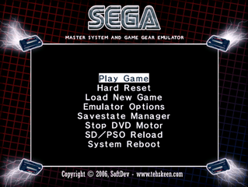
You'll start off with the main introduction screen and after pressing "A" you will be at the main menu.

When you are navigating through the menus, the following keys on your Gamecube controller are used:
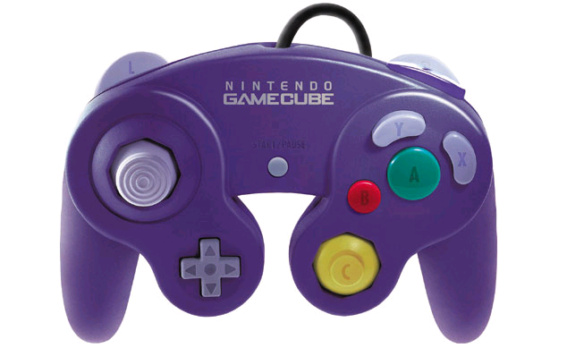

A Button : confirm selection

B Button : previous menu

Analog stick : items selection

D-PAD : items selection

WII version :
You can also navigate through the menu using the Wiimote and expansion controller. In the Menu, keys are mapped as the following:
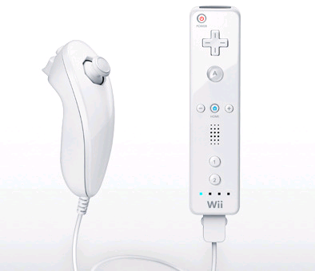

A Button : confirm selection

B Button : back to previous

D-PAD : items selection

Analog stick : items selection

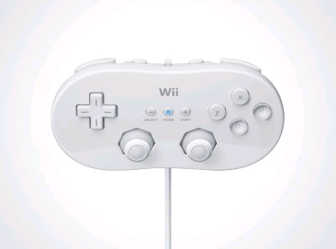

D-PAD : items selection

Left analog stick : items selection

Button B : back to previous

Button A: confirm selection

PLAY GAME
This will takes you into or back to the game. During gameplay, use a Gamecube pad to control.
WII version :
You can also use the Wiimote and expansion controllers. There are 3 possible configurations depending on the type of expansion controller that is inserted when you play a game:
- WIIMOTE only
- WIIMOTE + NUNCHUK combination
- CLASSIC CONTROLLER
Each of three configurations have a default key mapping listed below but can also be reconfigured separately (see “Configure Inputs” option) for each players. A maximum of 4 WIIMOTES can be synchronized.
The following table gives you the default mapping for each configuration, dark grey entries aren’t reconfigurable.
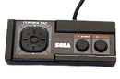 | 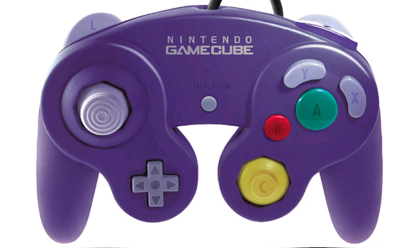 | 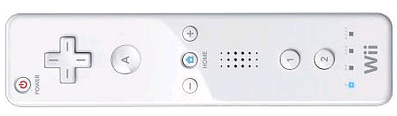
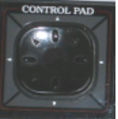 | 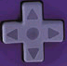   |  |  | 
  PAUSE | START
  BUTTON 1 | 
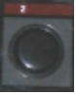  BUTTON 2 | 
MENU | Z
SOFT RESET | L + R

NOTE: Some games requires specific peripherals, such as PADDLE or LIGHT PHASER to be emulated. The program contains an internal game database and automatically activate emulation of these peripherals.
When the LIGHT PHASER is required: you can use D-pad or ANALOG Sticks to move the cursor but the best enjoyable way is to use the WIIMOTE to aim the screen. When using the WIIMOTE, Button A is automatically assigned as the TRIGGER button.

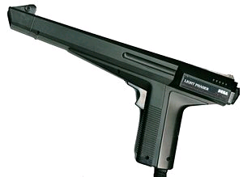
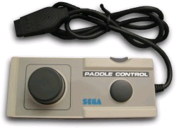
When the PADDLE is required, use either D-PAD or ANALOG Sticks to control the game. WIIMOTE pointing can also be used but isn't really precise in this case.

NOTE: Soft Reset can also be performed by pressing the Gamecube/Wii RESET button.
HARD RESET
This should be like switching OFF/ON the POWER button on a real Master System. This will completely reinitialize the genesis virtual machine.
LOAD NEW GAME
- In Wii mode, this will automatically let you browse into the SDCARD inserted in the native SD slot.
- In GC mode, you can choose to load a rom either from the SDCARD using a SD-adapter (slot is now automatically detected during initialization), or from a DVD.
A file selection menu should appear. In this new selection menu, the following controls can be used:
GAMECUBE PAD
- A button : load the selected file
- B button : go up one directory
- Z button : quit the file selection menu
- L/R triggers : go down/up one full page
- Left/Right buttons or Analog stick : scroll the selected entry's filename when it can't be full displayed
- Up/Down buttons or Analog stick : select previous/next file
WIIMOTE, WIIMOTE+NUNCHUK
- A button : load the selected file
- B button : go up one directory
- HOME button : quit the file selection menu
- -/+ Buttons: down/up one full page
- Left/Right buttons or Analog stick : scroll the selected entry's filename when it can't be full displayed
- Up/Down buttons or Analog stick : select previous/next file
CLASSIC CONTROLLER
- A button : load the selected file
- B button : go up one directory
- HOME button : quit the file selection menu
- L/R triggers: down/up one full page
- Left/Right buttons or Analog stick : scroll the selected entry's filename when it can't be full displayed
- Up/Down buttons or Analog stick : select previous/next file

FILE MANAGEMENT

Let you managed SRAM and FreezeState files:
- STATE Manager: Let you load/save FreezeState data from/to the selected device
- CONFIG Manager: Let you load/save current options in a configuration file on SDCARD
NOTE: In WII mode ONLY, the configuration file (smsplus.ini) is automatically loaded at startup and saved every time an option is modified. The file location is /smsplus/ on the SDCARD.
For each submenu, you can choose the device type (for SDCARD, the default slot is automatically detected upon startup). Be sure to set this according to your system configuration before saving/loading files.
- DEVICE: Let you choose the device to use (SDCARD , MCARD SLOT A, MCARD SLOT B).

NOTES: When using NGC Memory Card in SLOTA, some mounting errors may occur. In this case, remove and insert the Memory Card again before trying to save/load anything or use SLOTB. Be sure to have also enough space on the Card before trying to save something (Freeze State files are usually compressed).

When using SDCARD, the directory /smsplus/saves is automatically created.

EMULATOR OPTIONS

Display Options
Aspect let you choose the Display Aspect Ratio:
- ORIGINAL mode automatically set the correct aspect ratio exactly as if you connected a real Master System on your TV. In this mode, the full resolution (720 x 480 or 720x574 pixels) is used to include horizontal and vertical borders around the active display area.
- STRETCH mode let you adjust horizontal and vertical scale values so that the active display fits your TV screen. When using this mode, borders are not emulated.

Render let you choose the Display Rendering mode:
- ORIGINAL let you use the original Master System rendering mode: this mode outputs a progressive 240 lines (288 lines for PAL) display.
- BILINEAR vertically scales (using hardware filtering features) the original display to a 480 lines (574 lines for PAL) interlaced display. In this mode, because of the higher resolution, games generally look better than on the real hardware but some artifacts might appear during intensive and fast action.
- PROGRESS swith the rendering to Progressive Video Mode (480p), only use this with component cable and a compatible TV.

TV Mode let you choose the TV Mode to use:
- 50/60Hz: in this mode, the Gamecube automatically switch between the appropriates 50hz and 60Hz TV modes depending on the Master System current region mode. This makes PAL & NTSC games looking exactly like they did on a real console..
- 60Hz: in this mode, the Gamecube always use a 60Hz (NTSC or PAL60) TV mode, use this if your TV does not support 50Hz.

- 50Hz: in this mode, the Gamecube always use a 50Hz (PAL) TV mode, use this if your TV does not support 60Hz.

Borders let you enable/disable the border colour emulation: when ON, the background colour is used (like on a real console). When OFF, borders are forced to black. When ASPECT mode is set to STRETCH, this option is automatically set to OFF. On the other way, enabling this option automatically set ASPECT mode to ORIGINAL.

Center X/Center Y let you adjust the screen position while keeping the display aspect ratio.

Scale X/Scale Y let you adjust the display aspect ratio. This option is only accessible when using STRETCH aspect mode.

System Options

FM Type let you disable FM emulation (OFF) or choose between two FM emulators (YM2413,EMU2413). Please not that only some Japanese games feature FM music so enabling thiswill force the system into japanese mode.
Country let you force the region of the game. Let this to AUTO if you want the program to pick automatically the best setting for each game. Some games may be region protected.
Console let you force the type of console to be emulated (Master System 1, 2 or Japanese (MARK III), Gamegear...), Let this to AUTO if you want the program to pick automatically the best setting for each game.
Sprite Limit let you enable/disable emulation of original hardware limitation that can produce sprite flickering in some games. Disabling this option will reduce Sprite Flickering and improve display rendering.
Use BIOS let you enable/disable SMS BIOS support. If you want to use this feature (this is not required to play games), the BIOS rom (not provided) must be renamed as SMS_BIOS.sms and placed in the /smsplus/ directory, on the SDCARD.
Extra GG let you enable/disable the hidden display area, normally hidden by the original Game Gear LCD screen edges.
FREEZE AUTO let you enable/disable automatic FreezeState loading when a new game has been loaded and autosaving when you quit the emulator or load a new game. This option let you specify the location for the FreezeState files : SDCARD, MEMCARD (slot A or slot B)

Controls Options
Configure Player let you change the current player input (that should be modified by the options below.
GAMEPAD let you modify the way buttons are mapped on the gamecube pad. Just follow the instructions and press the desired buttons when asked.
WIIMOTE let you modify the way buttons are mapped on the current wiimote configuration (remember that 3 configurations can be used: WIIMOTE, WIIMOTE+NUNCHUK and CLASSIC CONTROLLER). Just follow the instructions and press the desired buttons when asked.

The last options differ between to GC and WII versions:
- GC version:
STOP DVD MOTOR
Stop the DVD motor and the disc from spinning during playtime (GC mode only)
SD/PSO RELOAD
if you correctly used SDLoad or PSOLoad, it will reboot to them.
SYSTEM REBOOT
This will reset the system (hot reset) .

- WII version:
RETURN TO LOADER
This will allow you to return to the Homebrew Channel or to TP Loader.
SYSTEM MENU
This will return to the Wii System Menu. Use this to quit the program if you are running it directly from is own channel.

Enjoy the Past !
Eke-Eke

