Development of Simulation Models for
Everglades Stormwater Treatment Areas (STAs)

Final Report
South Florida Water Management District




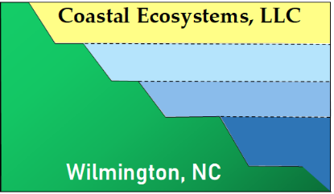

Work Order: 4600004014-WO05
November 2024
TABLE OF CONTENTS
Executive Summary i-5
1.0 Introduction 1-1
1.1 Descriptions of the STAs 1-1
1.2 Modeling Phosphorus Biogeochemistry in STA Wetlands 1-3
1.3 CASM 1-6
2.0 Modeling Phosphorus Biogeochemistry in STA Wetlands 2-1
2.1 Phase I Conceptual Model of Phosphorus Biogeochemical Cycling 2-1
2.2 Phase II Model Development 2-5
2.2.1 Study Site and Model Design 2-5
2.2.2 Empirical Data for Model Target Concentrations 2-7
2.2.3 Model Structure 2-10
2.3 Phase III Model Improvement 2-19
2.3.1 Hydrologic Model (Task 8.1) 2-19
2.3.2 Conceptual Model, Mass Balance, and Test Model (Tasks 8.2 and 8.3) 2-26
2.3.3 Calibration of the BGC Model (Task 8.4) 2-32
2.3.4 Sensitivity Analysis of the BGC Model (Task 8.5) 2-36
2.4 Summary & Significance 2-55
3.0 CASM-STA MODEL Development 3-1
CASM Model Physical Characteristics 3-1
3.1.1 Study Location Physical Description 3-1
3.1.2 Physical Data 3-1
3.1.3 Hydrodynamics and transport 3-3
3.2 CASM Food Web Model Components 3-4
3.2.1 Phytoplankton 3-4
3.2.2 Periphyton 3-5
3.2.3 Submerged aquatic vegetation (SAV) 3-5
3.2.4 Emergent aquatic vegetation (EAV) 3-5
3.2.5 Zooplankton 3-5
3.2.6 Benthic invertebrates 3-6
3.2.7 Fish 3-6
3.2.8 Excretion and egestion 3-6
3.2.9 Bioturbation 3-9
3.2.10 CASM-STA food web equations 3-9
3.3 Biogeochemical model 3-11
3.4 Model integration 3-11
3.5 CASM-STA Implementation 3-15
3.5.1 Calibration 3-15
3.5.2 Sensitivity analysis 3-26
4.0 Conclusions and Management implications 4-1
4.1 CASM-STA Management Implications 4-3
4.1.1 TP loadings 4-3
4.1.2 Consumer dynamics 4-7
4.2 Summary 4-8
5.0 References 5-1

Appendix A. SFWMD ESA CELLC STA BGC Model 9100 CODE A-1
Appendix B. CASM STA Control & Program Files A-11

LIST OF FIGURES
Figure 1-1. Location map for Everglades Stormwater Treatment Areas (STAs) south of Lake Okeechobee in south Florida. 1-1
Figure 1-2. Conceptual model for the transport and transformation of phosphorus in the stormwater treatment areas (STAs) that provide the basis for model development (taken from UF-WBL 2019). 1-7
Figure 2-1. Conceptual model of phosphorous biogeochemistry in STA wetlands. 2-2
Figure 2-2. Sampling location maps in STA-2 FW1 for (A) Water Column; (B) Macrophytes; (C) Soil P Concentrations; (D) Soil Porewater P Concentrations 2-5
Figure 2-3. Time series of average depth of STA-2 Flow-Way 1 from 1/1/2005 to 12/2020. The depth time series was combined with the flow-way area to calculate daily volume changes in the Phase II BGC Model. The time series was divided into equal parts for later Calibration and Validation of the BGC Model. 2-6
Figure 2-4. Summary of target P concentrations from STA-2 FW1 for the Biogeochemical Model. (A) Water column variables in the dry season (Nov-Apr). (B) Water column variables in the wet season (May-Oct). (C) Soil variables. (D) Other P variables in Biogeochemical Model. Note the doubling in magnitude between dry (A) and wet (B) seasons. 2-8
Figure 2-5. (A) Function to model effects of depth on Typha production. (B) Function to model effects of Typha shoot biomass on POP_{W} sinking. (C) Function to model resuspension of P_{FLOC} based on average daily wind speed. (D) Function to model relationship between total gross production and DIPW co-precipitation. See text for details. 2-17
Figure 2-6. Conceptual Hydrologic Model for the Biogeochemical Model of STA-2 FW1. 2-20
Figure 2-7. Results of calibration of Hydrologic Model of STA2 FW1 by varying the outflow parameter a_{OUT} from 2000-3500. The red line marks the average flow-way volume from the reference time series (km³). The optimal value was 3000 m3 d-1. The Nash-Sutcliffe comparative index values are provided (NSE). See text for details. 2-22
Figure 2-8. Time series of daily flow-way Q_{IN}, Q_{OUT}, volume, and depth for the target or reference values (black) and model predictions (red) for the Calibration period water years (5/1/2005 to 5/1/13). 2-23
Figure 2-9. Time series of daily flow-way Q_{IN}, Q_{OUT}, volume, and depth for the target or reference values (black) and model predictions (red) for the Validation period water years (5/1/2013 to 5/1/2020). 2-24
Figure 2-10. Scatterplots and linear regressions for the model results (x) and the reference data (y) for the Calibration (left side; 1/1/2005-12/31/2012) and Validation (right side; 1/1/2013-12/31/2020) periods. Included are the regression coefficient (r²), intercept (y0). and slope (b) for the monthly average flow-way outflow (Q_{OUT}; km³ d⁻¹), volume (km³), and depth (m). 2-25
Figure 2-11. Average annual sources and sinks for the Hydrologic Model of STA-2 FW1. 2-26
Figure 2-12. Conceptual annual DIPW budget. Arrows are annually summed rates in g P m⁻² y⁻¹. 2-28
Figure 2-13. Time series for net daily water column total phosphorus (TP) sources (black) and sinks (red). TP sources and sinks were calculated as sums of respective sources and sinks for water column particulate organic phosphorus (POP_{W}), dissolved organic phosphorus (DOP_{W}), dissolved inorganic phosphorus (DIP_{W}), and particulate inorganic phosphorus (PIP_{W}). 2-30
Figure 2-14. Average annual DIP_{W} budget generated using the updated Biogeochemical Model. Arrows are annually summed rates in g P m⁻² y⁻¹. 2-32
Figure 2-15. Time series of daily P loads to Biogeochemical Model of STA-2 FW1. 2-33
Figure 2-16. Calibration results. (A-E) k_{DOPSWX} (m⁻¹). (F-J). k_{DIPSWX} (m⁻¹). (K-N) a_{PRC} (g P g C⁻¹). 2-37
Figure 2-17. (A) Linear relationship to model effect of total gross production (g C m⁻³ d⁻¹) on DIP_{W} co-precipitation (g P m⁻³ d⁻¹). (B-D) Comparative bar charts for calibration of the updated Biogeochemical Model. The red line on each plot denotes the model target. 2-38
Figure 2-18. Calibration results. (A-E) k_{DOPSWX} (m⁻¹). (F-J). k_{DIPSWX} (m⁻¹). (K-N) a_{PRC} (g P g C⁻¹). 2-39
Figure 2-19. Time series of average monthly flow-way volumes (km³) predicted by the hydrologic component of the Biogeochemical Model of STA-2 FW1 for five different inflow (Q₀) simulations. The Q₀ series tested inflows that were -0.25X, -0.50X, base model, +1.5X, and +2.0. 2-41
Figure 2-20. Daily total phosphorus loads (Q_{TP}; g P m⁻² d⁻¹; black; left axis) and water column TP (TP_{W}; g P m⁻³; red; right axis) from the series to test the effects of variable inflow (Q₀) on the Biogeochemical Model of STA2 FW1. (A) -0.25X base model Q₀. (B) -0.50X base model Q₀. (C) Base model Q₀. (D) +1.5X base model Q₀. (E) +2.0X base model Q₀. Note increase in y-axis range in D and E. 2-42
Figure 2-21. Scatter plots of annual TP loading (Q_{TP}; g P m⁻² y⁻¹) vs average water column TP concentration (TP_{W}; g P m⁻³) resulting from the Q₀ series to alter TP loading to the model flow-way. (A) -0.25X. (B) -0.50X. (C) Base model. (D) +1.5X. (E) +2.0X. (F) Q_{TP} vs TP_{W} averages over all water years for each Q₀ simulation. 2-43
Figure 2-28. Scatter plots and linear regressions between total annual TP loading (QTP_{IN}; g P m-2 y⁻¹) and both the TP concentration of BGC Model water column (TPW; left axis; open circles; solid line) and the outflow ([TP]_{OUT}; right axis; solid squares; dashed line. (A) Results when k_{DOPSWX} was 0.001 d⁻¹. (B) Results when k_{DOPSWX} was 0.003 d⁻¹. (C) Results when k_{DOPSWX} was 0.005 d⁻¹. Included are the regression coefficient and parameter values. The most optimal scenario is highlighted in red. 2-54
Figure 3-1. Location of STA-2 FW1 in relation to the Everglades Agricultural Area and Water Conservation Areas. (From UF-WBL 2019). 3-2
Figure 3-2. Illustration of the simple compartmental representation of FW1 in STA-2 3-2
Figure 3-3. Allocation of the BGC (CELLC 2024) FW1 modeled volumes for each FW1 segment modeled by the CASM-STA. 3-1
Figure 3-4. Regression of BGC model and allocated segment A volumes (km⁻³) for the 2005 – 2012 calibration (left panel) and 2013 – 2020 validation (right panel) years. 3-1
Figure 3-5. Regression of BGC model and allocated segment B volumes (km⁻³) for the 2005 – 2012 calibration (left panel) and 2013 – 2020 validation (right panel) years. 3-2
Figure 3-6. Regression of BGC model and allocated segment C volumes (km⁻³) for the 2005 – 2012 calibration (left panel) and 2013 – 2020 validation (right panel) years. 3-2
Figure 3-7. Daily transport coefficients (1/day) from segment A to B computed for the calibration years (2005 – 2012, left panel) and validation years (2013 – 2020, right panel). 3-3
Figure 3-8. Daily transport coefficients (1/day) from segment A to B computed for the calibration years (2005 – 2012, left panel) and validation years (2013 – 2020, right panel). 3-3
Figure 3-9. Daily transport coefficients (1/day) from segment C out of FW1 computed for the calibration years (2005 – 2012, left panel) and validation years (2013 – 2020, right panel). 3-4
Figure 3-10. CASM-STA food web structure informed by SFWMD studies (e.g., Barton et al. 2020, 2021; Evans et al. 2019). 3-7
Figure 3-11. Regression analysis of total suspended solids versus fish weight based on data gleaned from Jimenez-Montealegre et al. (2002). 3-9
Figure 3-12. Conceptual biogeochemical (BGC) model of an STA wetland (CELLC 2024). 3-15
Figure 3-13. Integration of the historical CASM and the biogeochemical (BGC) model of an STA wetland to produce the CASM-STA. 3-19
Figure 4-1. Relationships between annual TP loading (g P/m²/y) to segment A and average daily flow-weighted TP concentration (g P/m³) in the outflow from segment C, (a) mean outflow P concentration, (b) minimum outflow P concentration, and (c) maximum P concentration. 4-5
Figure 4-2. Daily TP loadings (g P/m2/d) to segment A in the CASM-STA. 4-6

LIST OF TABLES
Table 2-1. Carbon pools in the STA Biogeochemical Model. 2-1
Table 2-2. Phosphorus pools in the STA Biogeochemical Model. 2-3
Table 2-3. List of Processes in the STA Biogeochemical Model. 2-4
Table 2-4. Model targets derived from Phase II data integration and analysis of STA-2 FW1. 2-9
Table 2-5. Comparisons between pore-water dissolved organic P (DOP) and inorganic P (DIP) from STA2 FW1 (Two different methods were used to determine the pore-water concentrations (Extract vs Peeper). All concentrations in g P m⁻². 2-10
Table 2-6. List of difference-based source-sink equations for each of the 15 carbon (C) and phosphorus (P) pools of the Biogeochemical Model of STA-2 FW1. See text for descriptions and units and Table 2-7 for parameter values. 2-12
Table 2-6 continued. List of difference-based source-sink equations for each of the 15 carbon (C) and phosphorus (P) pools of the Biogeochemical Model of STA-2 FW1. See text for descriptions and units and Table 2-7 for parameter values. 2-13
Table 2-7. List of initial concentrations and parameters for the Biogeochemical Model of STA-2 FW1 2-14
Table 2-8. Descriptive statistics for average monthly target volumes of STA-2 FW1 (VFW1; km³) for the calibration (CAL; 1/1/2005 to 12/31/2012) and validation (VAL; 1/1/2013 to 12/31/2020) periods. 2-22
Table 2-9. Descriptive statistics for the reference data (left side) and model results (right side) for the Calibration (1/1/2005-12/31/2012) and Validation (1/1/2013-12/31/2020) periods. Included are the minimum (MIN), maximum (MAX), average (AVG), and standard deviation (SD) for the flow-way daily outflow (QOUT; km³ d⁻¹), volume (km³), and depth (m) for the two time periods. 2-25
Table 2-10. Annual values for water column TP (TP_{W}; g P m⁻³) and net sources and net sinks (g P m⁻³ d⁻¹) for water column particulate organic phosphorus (POP_{W}), dissolved organic phosphorus (DOP_{W}), dissolved inorganic phosphorus (DIP_{W}), particulate inorganic phosphorus (PIP_{W}). and TP_{W}. 2-31
Table 2-11. The 23 parameters selected for calibration of the STA-2 FW1 Biogeochemical Model. 2-33
Table 2-12. Results of 69 individual model calibration simulations for the effects of altered magnitudes of 23 different parameters listed in Table 2-4. Extensions on end of each parameter name denote low (_L), base (_B), or high (_H) value from Table 2-4. Results ranked from highest to lowest average water column TP (g P m⁻³). 2-34
Table 2-13. The key parameters and their symbols, definitions, units, and value. 2-34
Table 2-14. The parameters and ranges of values for series to calibrate DOP, DIP, and PIP in the soil and water of the Biogeochemical Model of STA FW1. 2-35
Table 2-15. Summary of sensitivity tests for the Biogeochemical Model of STA-2 FW1. Provided are the test description, parameter, units, and range of test values for each parameter. 2-40
Table 2-16. Summary of average model flow-way volume (V_{MOD}; km³) and depth (h_{MOD}; m³) for each of the five simulations to vary inflow (Q₀). 2-41
Table 3-1. Transport rates (1/d) derived from BGC and EMP models for 2005 - 2012. 3-4
Table 3-2. Transport rates (1/d) derived from BGC and EMP models for 2013 - 2020. 3-5
Table 3-3. Length-weight parameters for fish and grass shrimp included in the CASM-STA food web. 3-7
Table 3-4. Bioenergetics parameters for fish species and grass shrimp included in the CASM-STA food web: consumption and respiration. 3-8
Table 3-5. Bioenergetics parameters for fish species and grass shrimp included in the Phase II CASM-STA food web: egestion and excretion. 3-8
Table 3-6. Governing equation for CASM-STA aquatic plants (phytoplankton, periphyton, SAV, EAV). 3-10
Table 3-7. Governing equation for CASM-STA consumers (zooplankton, benthic invertebrates, fish). 3-12
Table 3-8. Cross-comparison of CASM and Biogeochemical Model state variables and modeled consumer populations. 3-13
Table 3-9. List of CASM-STA bioenergetics-based parameters for aquatic plants. 3-14
Table 3-10. List of CASM-STA bioenergetics-based parameters for aquatic consumer populations. 3-14
Table 3-11. Equations for floc, litter and soils phosphorus state variables (g P m⁻²) added in developing the CASM-STA. 3-16
Table 3-12. Equations for water column phosphorus state variables (g P m⁻²) added in developing the CASM-STA. 3-16
Table 3-13. Cross-comparison of shared BGC and CASM-STA parameters. 3-17
Table 3-14. Cross-comparison of shared BGC and CASM-STA parameters. 3-19
Table 3-15. CASM-STA calibrated internal P cycling parameters (d⁻¹) compared to values from the calibrated BGC (CELLC 2024). 3-20
Table 3-16. Parameters/process rates that vary in relation to CASM-STA food web dynamics used in internal cycling among sediment and water column P state variables. 3-21
Table 3-17. Measured and modeled biomass (g C/m²) of STA-2 fish, grass shrimp, benthic infauna, and zooplankton included in the CASM-STA. 3-22
Table 3-18. Comparison of FW1 soil P pool target values and results from the Phase III CASM-STA model calibration (g P/m²). 3-23
Table 3-19. Comparison of FW1 water column P pool target values and results from the Phase III CASM-STA model calibration (g P/m³). 3-24
Table 3-20. Comparison of FW1 biological P pool target values and results from the Phase III CASM-STA model calibration (g P/m²). 3-24
Table 3-21. Mass-balance evaluation for Phase III CASM-STA sediment pools. 3-27
Table 3-22. Mass-balance evaluation for Phase III CASM-STA biota and TPw pools. 3-27
Table 4-1. Flow-weighted mean (FWM) concentrations and mass flux of TP in and TP out in FW1 and corresponding retention efficiencies. 4-4
Table 4-2. Comparison of CASM-STA modeled excretion based on original parameter (U) estimate and estimates derived from Barton et al. (2023) 4-7
Table 4-3. Comparison of CASM-STA modeled excretion, bioturbation, remineralization, and co-precipitation for segment C for 2005 – 2020. 4-8

APPENDICES
Appendix A - SFWMD ESA CELLC STA BGC Model 9100 Code

Executive SUMMARY
The Everglades Stormwater Treatment Areas (STAs) are freshwater wetlands constructed south of Lake Okeechobee to reduce TP concentrations in stormwater discharged to the Everglades Protection Area. Since operation started in 1994, the STAs have reduced incoming total phosphorus (TP) loads by about 77%. The dominant habitat types are broadly classified as either emergent aquatic vegetation (EAV) or submerged aquatic vegetation (SAV). While the SAV community composition has multiple species, cattail (Typha domingensis) is the dominant macrophyte in the EAV habitat.
Over twenty different studies of varying scope and complexity were conducted over roughly the past 25 years to evaluate hydrodynamics, vegetation, fauna, internal recycling, sediment accrual, P loading and net removal. While each of these studies provided insight into treatment wetland performance, they required integration to improve understanding of TP reduction in the STAs. A modeling framework was necessary to incorporate the vast amount of scientific information and better connect external TP loading to STA wetland biogeochemical concentrations and processes.
This three phase project was conducted to improve simulation modeling of phosphorus (P) cycling in the STAs. Phase I focused on model conceptualization and the acquisition and analyses of available data for depth, inflow, P loads, water chemistry, soils, macrophytes, and periphyton. These efforts led to first generation models in Phase II. Phase III focused on modifications and refinements to the models. Two parallel, inter-related modeling approaches were conceptualized and developed. The first approach was a Biogeochemical Model to combine the fundamental understanding of the wetland habitats and the available empirical data into a mechanistic modeling framework to quantify P cycling within the STAs. The second was an application of the Comprehensive Aquatic Systems Model (CASM) to include food webs relevant to the STAs along with the biogeochemical processes to quantify the role of higher trophic levels on P cycling.
The overall goal of the first modeling approach was to develop a simulation model of P biogeochemistry in STA wetlands (Biogeochemistry or BGC Model). The model was built upon the long-term data and information base from STA-2 FW1. This 744-hectare (1838.5 acres) cattail dominated flow-way had a comprehensive empirical database and removes about 86% of the incoming TP annually. The model was conceptualized to include TP loads, changes in depth and internal processing of TP over a 16-year period (1/1/2005 to 12/31/2020). It evolved from conceptualization (Phase I) into a first-generation mathematical model to simulate changes in P concentrations among the water, periphyton, SAV, Typha, and soils (Phase II). A Hydrologic Model and equation syntax to ensure mass balance were added so the model P concentrations could be calibrated, validated, tested, and trusted (Phase III).
There were inflows and outflows for the water column P constituents including phytoplankton (P_{PHYTO}; g P m⁻³), particulate organic P (POP_{W}; g P m⁻³), dissolved organic P (DOP_{W}; g P m⁻³), dissolved inorganic P (DIPW; g P m⁻³), and particulate inorganic P (PIP_{W}; g P m⁻³). Periphyton (P_{PPERI}; g P m⁻²) was the key primary producer and sink for DIP_{W}. While SAV had only shoots (P_{SAV}; g P m⁻²), the P content of Typha domingensis was divided into the shoots (P_{EAVSH}; g P m⁻²) and root-rhizomes (P_{EAVRR}; g P m⁻²). Variables for litter (P_{LITTER}) and floc (P_{FLOC}; g P m⁻²) were located at the soil-water interface. Similar to the water column, the four P constituents in the soil were particulate organic P (POP_{S}; g P m⁻²), dissolved organic P (DOP_{S}; g P m⁻²), dissolved inorganic P (DIP_{S}; g P m⁻²), and particulate inorganic P (PIP_{S}; g P m⁻²). The water column and soil compartments were connected by vertical processes.
The Phase III BGC Model underwent extensive testing through calibration of parameters, validation of predicted P concentrations for multiple variables, sensitivity analysis of model result, and final evaluation. The Hydrologic Model accurately and reliably predicted flow-way outflow, volume, and depth. P_{EAVSH}, P_{LITTER}, P_{FLOC}, and POP_{S} ranged from 0.5-4.0 g P m⁻² over the fifteen water years (5/1/2005 to 4/30/2020). P_{PERI}, P_{EAVRR}, P_{SAV}, DOP_{S}, DIP_{S}, and PIP_{S} ranged from 0.01-0.75 g P m⁻². Finally, P_{PHYTO}, POP_{W}, DOP_{W}, DIP_{W}, PIP_{W}, and TP_{W} ranged from near zero to approximately 0.25 g P m⁻³.
The BGC Model provided a platform to assess relationships between external TP loading (Q_{TP}) and the TP concentrations in the water column and outflow (TP_{W} and [TP]_{OUT}). The model flow-way removed only 58-63% of the annual TP load from WY2007-WY2012. When the depth increased during the second half of the simulation period, the flow-way removed up to 84-89% of the Q_{TP}. Overall, average annual water column TP_{W} was greatest (~0.1 g P m⁻³) when net annual removal was least. While water years with the greatest inflow and TP loading (WY2015 and WY2018) exhibited the lowest TP removal (58% and 63%), years with lower average annual HLR of 0.02-0.04 m d-1 and QTP loads (<0.6 g P m⁻² y⁻¹) such as WY2006 and WY2019 had the lowest water column TP (~0.05 g P m⁻³). The model development process, base model results, and a fully functional, easy to use desktop simulation model were the key research products. The BGC Model is a quantitative tool to help optimize TP removal by the STAs.

Introduction
This project was conducted to improve simulation modeling of phosphorus (P) cycling in the STAs. Two parallel, inter-related modeling approaches were conceptualized and developed in the first two project phases and refined in the third phase of the project. The first approach was a Biogeochemical Model to combine the fundamental understanding of the wetland habitats and the available empirical data into a mechanistic modeling framework to quantify P cycling within the STAs. The second was an application of the Comprehensive Aquatic Systems Model (CASM) to include food webs relevant to the STAs along with the biogeochemical processes to quantify the role of higher trophic levels on P cycling.

Descriptions of the STAs
The Everglades Stormwater Treatment Areas (STAs) are freshwater wetlands constructed south of Lake Okeechobee to reduce TP concentrations in stormwater discharged to the Everglades Protection Area (Figure 1-1). The STAs were built primarily on former agricultural areas which produced citrus, sugar cane, peanuts, vegetables, sod, and trees (Dombrowski 2019). Since operation started in 1994, the STAs have reduced incoming TP loads by about 77 percent resulting in an average outflow TP concentration of 31 µg L⁻¹ (1 µg L⁻¹ = 1 part per billion or ppb; Chimney 2021).
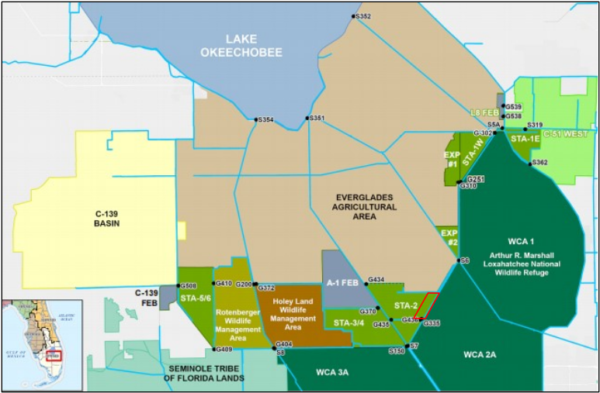
Figure Introduction-1. Location map for Everglades Stormwater Treatment Areas (STAs) south of Lake Okeechobee in south Florida.
The first prototype STA was completed in 1994 (Chimney 2019). Presently, there are five Everglades STAs: STA-1E, STA-1W, STA-2, STA-3/4, and STA-5/6 comprising ~62,000 acres (~25,000 hectares or ha) of treatment area currently permitted to operate. The total area includes expanded treatment areas for STA-1W, STA-2, STA-5/6. Two flow equalization basins (FEBs): FEBs A-1 and L-8, are operated to attenuate peak flows and improve inflow delivery rates to the STAs. STAs are operated under National Pollutant Discharge Elimination System (NPDES) and Everglades Forever Act (EFA) permits which mandate ultra-low annual outflow TP concentrations by 2027 to meet the water quality based effluent limit (WQBEL; FDEP 2012a; 2012b; 2017; FDEP and USEPA 2012). The STAs are a major component of the South Florida Water Management District (SFWMD) Restoration Strategies Regional Water Quality Plan (SFWMD 2012).
The NPDES and EFA permits establish the WQBEL for the STAs. The WQBEL has two components intended to ensure that TP outflows from the STAs may not cause or contribute to exceedances greater than the long-term geometric mean concentration within the EPA (presently 10 µg L⁻¹). First, the flow-weighted mean concentration (FWMC) of the STA outflow shall not exceed 13 µg L⁻¹ in more than 3 out of 5 water years on a rolling basis. Second, the annual FWMC from each STA shall not exceed 19 µg L⁻¹ in any water year. The WQBEL is separate from the 4-part test for the Everglades TP criterion (62-302.540(4)(d)1, Florida Administrative Code).
The STAs are wetland ecosystems with varying size, configuration, period of operation, and are divided into treatment cells and/or flow-ways by interior levees (Figure 1-1). The flow of water through the STAs is regulated via a variety of water control structures (e.g., pump stations, gates, culverts). The dominant habitat types in the treatment cells are broadly classified as either emergent aquatic vegetation (EAV) or submerged aquatic vegetation (SAV). While the SAV community composition has multiple species, cattail (Typha domingensis) is the dominant macrophyte in the EAV habitat. In many areas that were dominated by SAV, there has been an expansion of EAV, in part due to active management, which has created sub-cells of SAV surrounded by EAV to reduce the effect of storm driven water turbulence that can uproot the SAV. Many cells also have various species of floating aquatic vegetation (FAV). However, FAV species in the outflow cells, where water nutrient concentrations are low, are not considered effective in retaining P. Finally, free floating, epipelic and epiphytic periphyton communities are key components of the STA wetlands.
The upstream regions of STA cells are dominated by dense stands of cattail, which typically are very hardy plants with rapid and sustained growth in enriched environments. However, die backs have occurred in the STAs, reducing the ability of the emergent wetland to uptake P from the water column. While the proximal causes are not well understood, long periods of increased water depth can be associated with cattail stress and mortality (Chen et al., 2015; Diaz, 2018; Diaz and Vaughan 2019). In addition, floating mats of cattail can occur when the soils holding cattail roots de-laminate. These floating mats can cause significant damage to the surrounding vegetation, block water control structures, create short circuits, and generally reduce the P removal capacity of a given STA (Clark 2019, Clark and Glodzik 2020)
The distribution, growth, and resilience of wetland habitats within the STAs are modulated by multiple environmental drivers and management actions. These include variable soil characteristics, changes in community composition, fluctuations in water levels including occasional dry out, increased nutrient loads, and/or EAV plant rotations. Target depths for STA cells range from approximately 0.4 to 0.6 m. Experimental results indicated that eight weeks of continuous inundation at water depths above 0.85m stressed the cattail (Diaz et al. 2023).
Net TP removal from the water column occurs through fundamental wetland biogeochemical processes. These processes include plant and microbial primary production and nutrient uptake, particulate settling, chemical sorption, and deposition to the soil. The internal factors include antecedent land use, composition and status of the habitats, microbial activities, soil P dynamics, and the topography, size and shape of the STA cells. The external factors include weather patterns, inflow TP concentrations, phosphorus loading rates (PLRs), hydraulic loading rates (HLRs), changes in hydro-patterns and/or hydro-period, maintenance and enhancement activities, regional operations, and wildlife use. The STAs are integral components of a complex water management system with multiple objectives, particularly ecosystem restoration, water supply and flood control (SFWMD 2012).
The STAs are intensively managed systems involving various personnel for routine operation and maintenance of pumps, gates, and structures; planting of desired vegetation; and removal of unwanted vegetation. Scientists and engineers provide technical information and evaluation to ensure proper operation and optimal management, including collection and analysis of water quality, soil, vegetation, flow, and performance data. Water levels in each cell are monitored, and target stages are set from average ground elevations, depending on the dominant vegetation community and condition of the treatment cell. Corrective actions can be operational such as reducing inflow loading by redirecting flows, reducing target stages to allow vegetation to rejuvenate, adding temporary pumps or constructing divide levees, or major rehabilitation activities.

Modeling Phosphorus Biogeochemistry in STA Wetlands
Since the inception of the first STA in 1994 and the implementation of the Restoration Strategies Science Plan (RSSP), there has been great effort to study water, soils, and plants to understand P dynamics for improved management. Over twenty different studies of varying scope and complexity have been initiated under this plan to evaluate hydrodynamics, vegetation, fauna, internal loading, sediment accrual, P loading and net removal. While each of these studies provided separate insights into P reduction and treatment performance, these individual components required integration to improve understanding of TP reduction in the STAs. An effective integration and synthesis framework is necessary to process and analyze the vast amount of scientific information collected over roughly the past 25 years. This includes an abundance of recent data and observations for hydraulics and hydrology, water chemistry, soil chemistry and biogeochemistry, particle dynamics, vegetation, microbial processes, and fauna (James et al. 2024; UF-WBL 2019; Villapando and King 2019; Dombrowski, et al. 2020; Barton et al. 2020, 2021).
Simulation modeling provides a pathway to better understand potential changes in aquatic ecosystem attributes with projected changes in climate and water management (Wiegert 1975; Fitz et al. 1996; Malone et al. 2015; Buzzelli et al. 2015). Mechanistic models of wetland hydrology and biogeochemistry generate quantitative results based on the interactions among multiple dynamic processes (Buzzelli et al. 2000; Min et al. 2011). However, they often require considerable input data, many different parameters, time series of environmental patterns, and considerable time and effort to develop (Robson 2005). Thus, model complexity must balance over-simplification vs. over-parameterization to be useful for water and environmental management (Min et al. 2011; Paudel and Jawitz 2012). There are many examples of models for Everglades wetlands including those for natural ridges and sloughs, Water Conservation Areas (WCAs), STAs, and mesocosms (Raghunathan et al. 2001; Meyers and Fitzpatrick 2004; Jawitz et al. 2008; Walker and Kadlec 2011; Wang et al. 2012; Marios and Mitsch 2016; Ji and Jin 2016; UF-WBL 2019; Justin and Kadlec 2019).
Many of these previous models were not mechanistic and not developed nor considered for the dynamism of Everglades wetland P biogeochemistry. TP removed by an STA becomes a temporary or permanent part of the macrophytes, periphyton, litter, soil, and/or fauna. For example, Raghunathan et al. (2001) developed a spatially articulated model of TP fate in the Everglades with a single, empirically derived mass sinking term. Walker and Kadlec (2011) developed a storage based, mass-balance model of TP processing by the STAs. These authors indicated that internal processes are a source of model uncertainty. A version based on dispersive transport among zones of similarity was applied to WCA 1 by Wang et al. (2012). Although previously poor, the ability of this approach to predict TP concentrations less than 20 ppb (20 μg L-1; 0.020 g P m⁻³) improved with the introduction of a term for internal P cycling (P return flux; Justin and Kadlec 2019). However, this term was a fixed rate decreasing with distance from the inflow and not based on fundamental wetland biogeochemical processes.

One overall goal of this three-phase project was to develop a simulation model of P biogeochemistry in STA wetlands (Biogeochemistry or BGC Model). The model was built upon the long-term data and information base from a specific STA flow-way. The mechanistic model includes a full hydrologic sub-model to link inflows and TP loads, internal processing and TP removal, and outflows to the downstream boundary over a 16-year simulation period. The model development process, base model results, and a fully functional, easy to use desktop simulation model were the key research products. The BGC Model is a quantitative tool to help optimize TP removal by the STAs.
Phase I produced a conceptual model of P biogeochemically cycling which guided the identification and compilation of the necessary data for mathematical model development. The first objective of Phase II was to gather and analyze the data and information regarding the inflows and loads, water column attributes, periphyton, macrophytes, and soils. This effort resulted in target concentrations (g P m⁻² or g P m⁻³) for the P state variables or pools to be simulated in the BGC Model. The development of a fully functioning first generation base model was the second important outcome for Phase II. The spatial and temporal domains were defined as STA-2 FW1 (Figure 2-2) over a 16-year period (1/1/2005 to 12/31/2020), respectively. The first-generation model did not have a hydrologic sub-model as daily water volume (m³) was estimated as the product of the average depth and the flow-way area. Accounting for daily changes in depth and volume was followed by the prediction of surface and sub-surface light to drive photosynthesis, a trigonometric function for water temperature, and cattail above- and below-ground carbon (C) production. Equations for the remaining P biogeochemical components (periphyton, SAV, soil, water column) were introduced sequentially. Parameters were identified, assigned initial values, and calibrated relative to the target concentrations established in Phase I. Results from the first BGC model were validated, and the model was tested via sensitivity analysis to complete Phase II.
Phase III built upon the first two phases to produce a reliable model of P biogeochemical cycling in STA-2 FW1. The objectives were to develop a Hydrologic Model to predict flow-way water outflow and volume, revisit the Phase I Conceptual Model and Phase II empirically derived model targets, modify the BGC Model code to ensure mass balance within and among all P state variables, establish an updated base model incorporating all new elements and refinements, calibrate and validate base model results for separate time periods, evaluate model performance through a series of sensitivity tests, and use the modeling framework to recommend management options.
SFWMD continues to study the biogeochemical processes that determine the transport and transformation of P within and through the STAs. Important processes include the removal of dissolved inorganic P by actively growing populations of aquatic plants, include emergent aquatic vegetation (EAV), submerged aquatic vegetation (SAV), floating or attached assemblages of algae (broadly, periphyton), and phytoplankton. P cycles (“spirals”) through the STAs as a function of decomposition, sorption/desorption, hydrolysis, photolysis, diffusion, and advective transport. Recent research has focused on the potential for aquatic invertebrates and fish to excrete P and suspend sedimented P through physical disturbance (bioturbation) of STAs soils and sediments.
Through numerous historical and continuing studies and monitoring, substantial understanding of key P transport and transformation processes has accumulated. Previous efforts at synthesis have produced corresponding mathematical models (Paudel and Jawitz 2012; Juston et al. 2013; Juston et al. 2019, Larios et al. 2024). However, the models have often focused on physical transport with minimal representation of the complex biogeochemical processes that determine P movement through the STAs and ultimate discharge in relation to the WQBEL.

CASM
A second overall goal was to adapt an existing bioenergetics-based food-web/ecosystem model to the STAs, CASM-STA, CASM through the addition of P storages and fluxes. The CASM-STA model simulates P dynamics in three hydrologically connected spatial locations for the inflow, midflow, and outflow segments of STA-2 FW1 (Figure 2-2). Empirical inflows and outflows were the drivers to simulate daily water levels and flow velocities. P cycling was conceptualized similar to the Biogeochemical Model but also included the effects of excretion and bioturbation through zooplankton, benthic invertebrates, mosquitofish, largemouth bass, grass shrimp, and tilapia. Literature information and SFWMD data were used to construct the food web interactions and estimate model parameters. The CASM-STA model was run for the same two periods as the Biogeochemical Model with results suggesting that excretion and bioturbation are processes worth further consideration in developing an overall quantitative understanding of the cycling of P within the STAs.
The development of the CASM-STA was guided in part by the detailed conceptual model for P transport and transformation provided by UF-WBL (2019) (Figure 1-2). The model identifies important P pools and processes that determine the internal cycling dynamics of the constructed STAs. Primary production by aquatic plants, and associated nutrient uptake and decomposition are key biological processes that influence P dynamics. Important P pools include dissolved and particulate organic and inorganic P – both in the soils/sediments and water column. In addition to physical transport, biogeochemical processes including sorption/desorption, hydrolysis, and photolysis determine the ability of managed STAs to remove and sequester input phosphorus in relation to the WQBEL.
This project final report presents the status of the development, calibration/validation and evaluation of the CASM-STA developed for STA-2 FW1. Importantly, the resulting CASM-STA provides the functional capability to explore the implications of managing flows, SAV, EAV, and fish populations in relation to meeting STA requirements concerning the WQBEL. The final report draws fundamentally from previous project reports (Stantec 2024a through 2004f) and adds additional results and analysis developed since preparation of the individual project task reports.
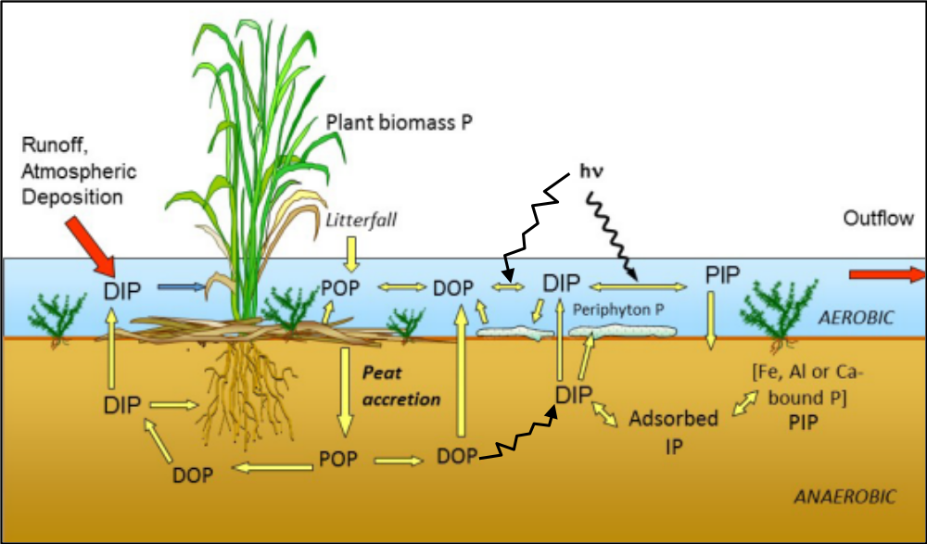
Figure Introduction-2. Conceptual model for the transport and transformation of phosphorus in the stormwater treatment areas (STAs) that provide the basis for model development (taken from UF-WBL 2019).

Modeling Phosphorus Biogeochemistry in STA Wetlands
This section details this project’s first approach to phosphorus modeling in the STAs. As part of this approach, a Biogeochemical Model was developed to combine the most current understanding of chemical and biological processes in the STA wetland habitats with the available empirical data and create a mechanistic modeling framework to quantify P cycling within the STAs.

Phase I Conceptual Model of Phosphorus Biogeochemical Cycling
The wetland ecosystem contained within STA-2 FW1 was assumed to be a single compartment composed of 93% EAV and 7% SAV habitats (see Study Site below). The flow-way was not sub-divided into smaller units for the BGC Model. The Phase I conceptual model was largely based on an illustration of wetland P processes in Everglades EAV wetlands (Figure 1-2; UF-WBL 2019). Water along with its particulate and dissolved P constituents enter the STAs through water control structures in the north and exit to the south. Carbon biomass production by phytoplankton (C_{PHYTO}; g C m⁻³), periphyton (C_{PERI}; g C m⁻³), the shoots and root-rhizomes of the EAV (C_{EAVSH} and C_{EARR}; g C m⁻²), and SAV (C=; g C m⁻²) was the primary source of new material for the ecosystem (Table 2-1).
Table Modeling Phosphorus Biogeochemistry in STA Wetlands-1. Carbon pools in the STA Biogeochemical Model.
Number | Abbreviation | Definition | Units
C1 | CPHYTO | Phytoplankton carbon | g C m-2
C2 | CPERI | Periphyton carbon | g C m-2
C3 | CSH | EAV shoot carbon | g C m-2
C4 | CRR | EAV root-rhizome carbon | g C m-2
C5 | CSAV | SAV carbon | g C m-2

The conceptual model was refined iteratively throughout all the three phases of the project. More pools were added, the connections were adjusted to reflect the most recent understanding and mathematical equations, and extraneous components were removed. Initially, a total of 13 major P pools (g P m⁻³ or g P m⁻²) were identified among the macrophytes, periphyton, water column, and soil. The number increased to 14 when submerged aquatic vegetation (SAV) shoots representing Chara sp. were added in Phase II. Although previously combined, splitting floc and litter P into two state variables in Phase III brought the final total of biogeochemical P compartments to 15 (Table 2-2; Figure 2-1).
There were inflows from the upstream boundary and outflows to the downstream boundary for each of the water column P constituents including phytoplankton (P_{PHYTO}; g P m⁻³), particulate organic P (POP_{W}; g P m⁻³), dissolved organic P (DOP_{W}; g P m⁻³), dissolved inorganic P (DIP_{W}; g P m⁻³), and particulate inorganic P (PIP_{W}; g P m⁻³). Periphyton (P_{PPERI}; g P m⁻²) was the key internal primary producer and sink for DIPW. While SAV had only shoots (P_{SAV}; g P m⁻²), the P content of Typha domingensis was divided into the shoots (PEAVSH; g P m⁻²) and root-rhizomes (P_{EAVRR}; g P m⁻²). The shoots were assumed to include the living leaves and shoot bases in order to identify the data for model targets. The newly created variables for P_{LITTER} and P_{FLOC} (g P m⁻²) were located at the soil-water interface. Similar to the water column, the four P constituents in the soil were particulate organic P (POP_{S}; g P m⁻²), dissolved organic P (DOP_{S}; g P m⁻²), dissolved inorganic P (DIP_{S}; g P m⁻²), and particulate inorganic P (PIP_{S}; g P m⁻²; Figure 2-1).
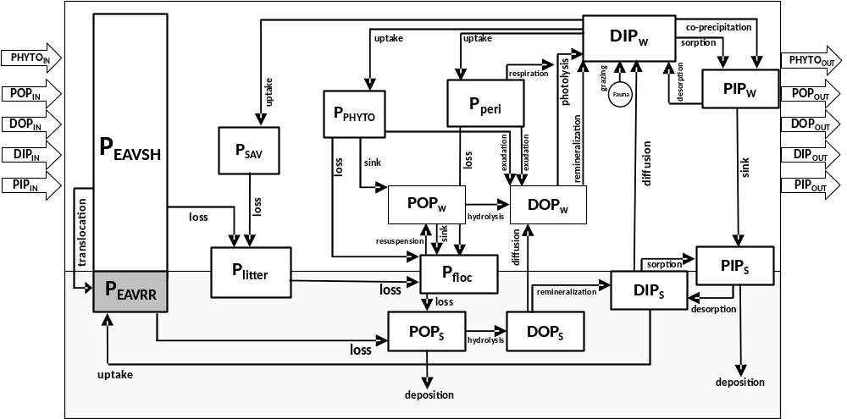
Figure Introduction-3. Conceptual model of phosphorous biogeochemistry in STA wetlands.

There were 19 fundamental biogeochemical processes (g P m⁻³ d⁻¹ or g P m⁻² d⁻¹) among the 15 P pools (Table 2-3). The gross production (g C m⁻³ d⁻¹ or g C m⁻² d⁻¹) by phytoplankton, periphyton, Typha, and SAV was offset by respiration, grazing, exudation, and loss (e.g. mortality). The loss terms for P_{EAVSH} and P_{PERI} represented sources of P_{LITTER} and P_{FLOC}, respectively (Figure 2-1). The P lost through SAV mortality also contributed to P_{LITTER} which then decomposed to P_{FLOC}. While POP_{W} sank downward to P_{FLOC}, resuspension introduced the floc back into the water column particulate pool depending upon wind conditions.

Table Modeling Phosphorus Biogeochemistry in STA Wetlands-2. Phosphorus pools in the STA Biogeochemical Model.
Number | Abbreviation | Definition | Units
1 | PPHYTO | Particulate organic P in phytoplankton | g P m-2
2 | PPERI | Particulate organic P in periphyton | g P m-2
3 | PSH | Particulate organic P in EAV shoots | g P m-2
4 | PRR | Particulate organic P in EAV root-rhizomes | g P m-2
5 | PLITTER | Particulate organic P in surface soil litter | g P m-2
6 | PFLOC | Particulate P in surface soil floc | g P m-2
7 | PSAV | Particulate P in SAV shoots | g P m-2
8 | POPS | Particulate organic P in soil | g P m-2
9 | DOPS | Dissolved organic P in soil | g P m-2
10 | DIPS | Dissolved inorganic P in soil | g P m-2
11 | PIPS | Particulate inorganic P in soil | g P m-2
12 | POPW | Particulate organic P in water column | g P m-3
13 | DOPW | Dissolved organic P in water column | g P m-3
14 | DIPW | Dissolved inorganic P in water column | g P m-3
15 | PIPW | Particulate inorganic P in water column | g P m-3

The decomposition of P_{FLOC} and the loss term for P_{EAVRR} were the sources of POP_{S}. Deposition (e.g. burial) provided a major loss pathway for POP_{S}. The hydrolysis POP to DOP and remineralizaion of DOP to DIP occurred in both the soil and water column. Exudation by periphyton, phytoplankton, and SAV contributed to DOP_{W}. The diffusive efflux from DOPS and photolysis of DOP_{W} were additional sources of DIP_{W}. Sorption and desorption represented the chemical cycling between DIP and PIP in the soil and water. The sinking of PIP_{W} was a primary source of PIP_{S}. The diffusive efflux of DIP_{S} was among multiple sources of DIP_{W} including remineralization, photolysis, respiration, and grazing. Uptake by the primary producers (periphyton, phytoplankton, SAV) and co-precipitation were loss pathways for DIP_{W} (Figure 2-1).

Table Modeling Phosphorus Biogeochemistry in STA Wetlands-3. List of Processes in the STA Biogeochemical Model.
Process | Symbol | Description | Units
Gross Production | GPP | Gross primary production by Typha, periphyton, and phytoplankton | g C m-2d-1
Respiration | R | Respiration by Typha, periphyton, and phytoplankton | g C m-2d-1
Loss | L | Loss of Typha, periphyton, and phytoplankton POP to mortality | g C m-2d-1
Translocation | TRS | Internal translocation of POP between shoots and root-rhizomes | g C m-2d-1
Grazing | GZ | Loss of SAV, periphyton, and phytoplankton POP to herbivorous grazing | g C m-2d-1
Exudation | EXU | Loss of periphyton, and phytoplankton POP to DOP in the water column | g C m-2d-1
Uptake | UP | Uptake of DIP from water or soil by Typha, periphyton, and phytoplankton | g P m-2d-1
Precipitation | PRC | Co-precipitation of DIP to PIP due to daytime gross production | g P m-2d-1
Excretion | EXC | Input to water column DIP via excretion by herbivores | g P m-2d-1
Resuspension | RES | Physical transport of POP and DIP from the soil to the water column | g P m-2d-1
Production | PRD | Production term for water and soil P pools | g P m-2d-1
Sinking | SNK | Sinking of POP from the water column to the soil | g P m-2d-1
Hydrolysis | HYD | Conversion of POP to DOP in the water column and soil via microbial decomposition | g P m-2d-1
Photolysis | PHT | Conversion of DOP to DIP in the water column and soil via photodegradation | g P m-2d-1
Remineralization | REM | Conversion of DOP to DIP in the water column and soil via microbial decomposition | g P m-2d-1
Soil-water Exchange | SWX | Movement of DIP and DOP between the soil and water column | g P m-2d-1
Sorption | SB | Loss of water column DIP to PIP pool via binding with inorganic Ca particles | g P m-2d-1
Desorption | DSB | Input to water column DIP from PIP pool via disassociation from inorganic Ca particles | g P m-2d-1
Deposition | DEP | Loss of POP in soil and PIP at the soil-water interface to long-term wetland elevation | g P m-2d-1

Phase II Model Development

Study Site and Model Design
STA-2 FW1 was Typha dominated and became operational in 2000-2001 (Figure 1-1 and Figure 2-2). This flow-way was unique among the STAs because the entire area (2032.7 acres or 822.6 hectares) was never farmed and was previously emergent wetlands and dense tree islands as part of Brown’s Farm Wildlife Management Area (Dombrowski 2019). This history coupled with the abundance of empirical data (water, macrophytes, soil) and the recent documentation of its long-term performance made it an optimal target for model development (UF-WBL 2019; Zhao and Piccone 2020). The spatial domain for the BGC Model was the entire area of FW1 (AFW1 = 7,446,215 m²) of which approximately 7% of AFW1 was classified as SAV/Open Water (521,235 m²).
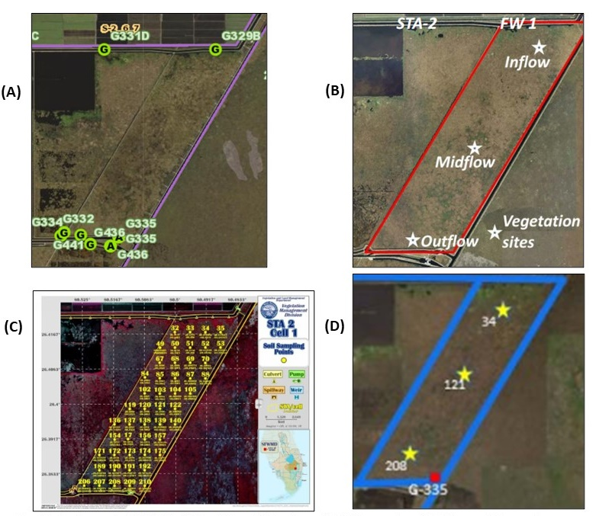
Figure Introduction-4. Sampling location maps in STA-2 FW1 for (A) Water Column; (B) Macrophytes; (C) Soil P Concentrations; (D) Soil Porewater P Concentrations
The first generation BGC Model treated STA-2 FW1 as a landscape scale flow-through flume with empirically determined rates of daily inflow (m³ d⁻¹), depth (m) and water volume (m³). Depth was introduced using a daily time series of average depth derived from stage data on the north (inflow) and south (outflow) flow-way boundaries (Figure 2-2). Volume was the product of the average depth and AFW1 (Figure 2-3). Thus, the inflow time series was used with P constituent concentrations observed at the north end of the flow-way to simulate TP loadings and not to affect water volume. The full Hydrologic Sub-Model was developed in a later task (See Phase III Task 8.3).
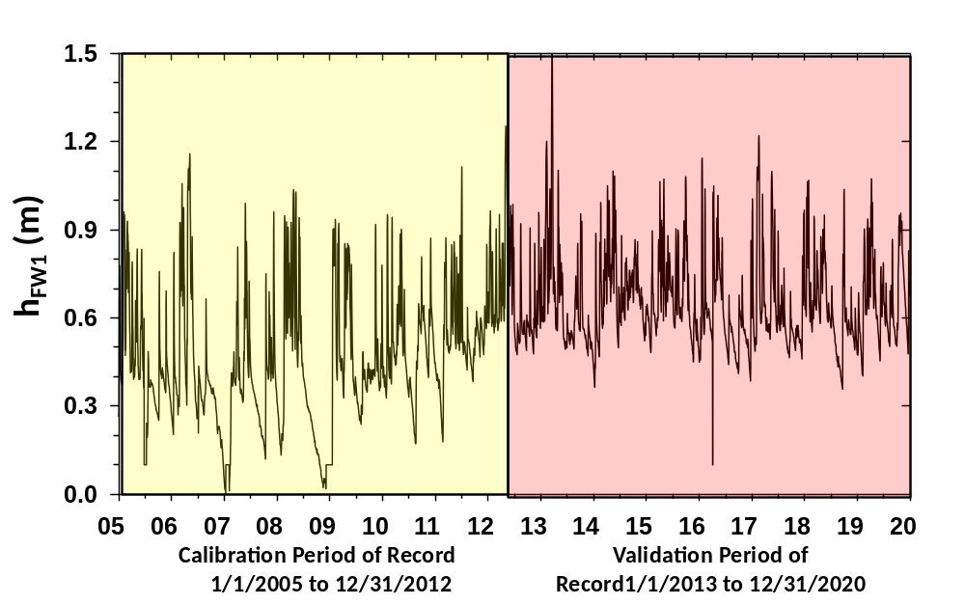
Figure Introduction-5. Time series of average depth of STA-2 Flow-Way 1 from 1/1/2005 to 12/2020. The depth time series was combined with the flow-way area to calculate daily volume changes in the Phase II BGC Model. The time series was divided into equal parts for later Calibration and Validation of the BGC Model.
While the model time domain was assumed to be the entire POR (1/1/2005 to 12/31/2020 = 5844 days = 192 months = 16 years), it was split into two separate intervals of seven water years for model Calibration (5/1/2006 to 4/30/2012) vs Validation (5/1/2013 to 4/30/2020; Figure 2-3). A water year (WY) is the period from May 1 to April 30 to include both wet (May-October) and dry (November-April) sub-tropical seasons. The BGC Model time periods were 2,922 days (8 calendar years = 96 months) for calibration and validation with an integration interval (dt) of 1.5 hrs (dt = 0.0625 d; sixteen time steps per day).

Empirical Data for Model Target Concentrations
The SFWMD provided the physical, water column, macrophyte, and soil data for EAV habitat model development (UF-WBL 2019; Villapando and King 2019; Dombrowski, et al. 2020). Information, parameter values, and model targets for periphyton were derived from SFWMD supported periphyton studies (Hagerthey et al. 2011; DB Environmental 2015; UF-WBL 2019). The values for some parameters were from local experiments, literature sources, and calibration.
The proto-model included average monthly water temperature (TW; °C) derived from local data. Eventually daily variations in temperature were modeled using a trigonometric function for south Florida aquatic ecosystems (Buzzelli et al. 2015). While the depth time series included days with negative depth for the depression in sub-surface water level at times of no surface water in STA-2 FW1, the minimum depth of the model flow-way (h_{MIN}) was set at 0.1 m for the remainder of the modeling project.
The concentrations of total phosphorus (TP), soluble reactive phosphorus (SRP), and total dissolved phosphorus (TDP) were monitored regularly by the SFWMD and determined at G329B (inflow) and G335 (outflow) at bi-weekly to monthly intervals over the model time period (2005-2020; Figure 2-4A). Thus,

Dissolved Inorganic Phosphorus = DIP = SRP
Dissolved Organic Phosphorus = DOP = TDP - DIP
Total Particulate Phosphorus = TP - TDP

The BGC Model required inflow concentrations for [POPW]_{IN}, [DOPW]_{IN}, [DIPW]_{IN}, and [PIPW]_{IN}. Since there were no regular monitoring data for the organic vs. inorganic fractionation of TPP, the POP:PIP ratio was initially assumed 80:20. The average inflow concentrations over the entire model time were constant at the inflow boundary to simplify model development. Variable inflow P concentrations were introduced in a later task (see Task 8.4 Calibration and Validation).
The data for macrophytes (e.g. vegetation), soil particulate attributes, and dissolved P in the soil were collected at locations in the upper (inflow), middle, and lower (outflow) zones of STA-2 FW1 (Figure 2-4B, C, and D). The multiple data sources were assembled and analyzed to derive target concentrations for the 15 P state variables and total phosphorus in the water (TPW) for the BGC Model (Figure 2-3; Table 2-4 and Table 2-5; CELLC 2022). In most cases values ranged widely seasonally and/or spatially.
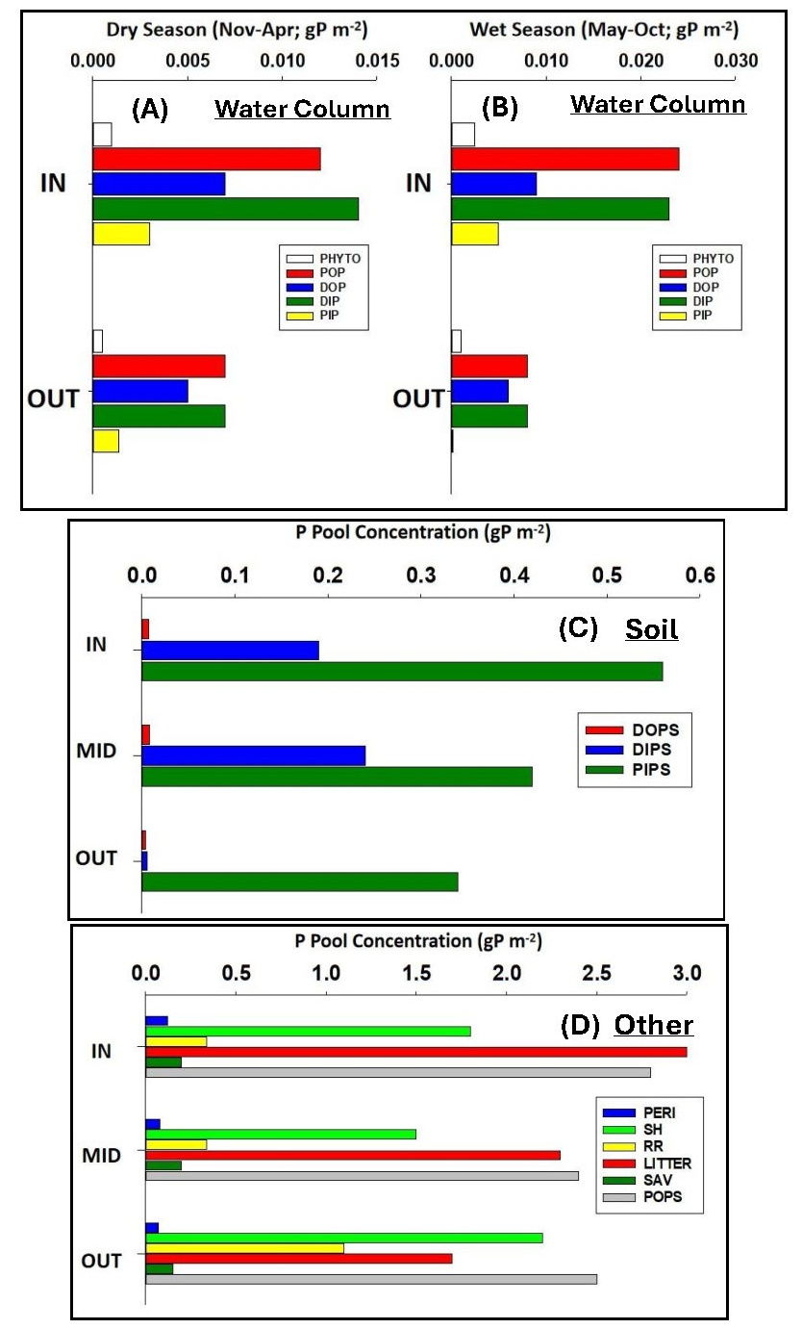
Figure Introduction-6. Summary of target P concentrations from STA-2 FW1 for the Biogeochemical Model. (A) Water column variables in the dry season (Nov-Apr). (B) Water column variables in the wet season (May-Oct). (C) Soil variables. (D) Other P variables in Biogeochemical Model. Note the doubling in magnitude between dry (A) and wet (B) seasons.
Table Modeling Phosphorus Biogeochemistry in STA Wetlands-4. Model targets derived from Phase II data integration and analysis of STA-2 FW1.
P POOLS | Target AVG + SD | CV
PPHYTO (g P m-3) | 0.002 + 0.001 | 50.0%
PPERI (g P m-2) | 0.05 + 0.03 | 60.0%
PEAVSH (g P m-2) | 1.95 + 0.87 | 44.6%
PEAVRR (g P m-2) | 0.83 + 0.62 | 75.3%
PLITTER (g P m-2) | 0.70 + 0.32 | 45.7%
PFLOC (g P m-2) | 1.64 + 0.65 | 39.8%
PSAV (g P m-2) | 0.16 + 0.04 | 25.0%
POPs (g P m-2) | 2.57 + 2.16 | 83.9%
DOPs (g P m-2) | 0.15 + 0.12 | 81.9%
DIPs (g P m-2) | 0.10 + 0.08 | 80.5%
PIPs (g P m-2) | 0.44 + 0.27 | 61.6%
POPw (g P m-3) | 0.0100 + 0.0100 | 100.0%
DOPw (g P m-3) | 0.0140 + 0.0074 | 52.5%
DIPw (g P m-3) | 0.0260 + 0.0282 | 108.4%
PIPw (g P m-3) | 0.0060 + 0.0025 | 41.9%
TPw (g P m-3) | 0.0560 + 0.0120 | 21.5%

The P concentrations of the biogeochemical pools ranged from 0.001-0.025 g P m⁻² in the dry and wet seasons at the inflow and outflow structures among the five water column constituents (P_{PHYTO}, POP_{W}, DOP_{W}, DIP_{W}, PIP_{W}; Figure 2-3). The average concentrations were divided by an estimated flow-way depth of 0.5 m to derive model targets of 0.002 ± 0.001 g P m⁻³, 0.010 ± 0.010 g P m⁻³ ,0.014±0.007 g P m⁻³, and 0.026 ± 0.028 g P m⁻³, 0.006 ± 0.003 g P m⁻³ for the five constituents (Table 2-4). While POP_{S} was comparatively high ranging from 2.25-2.75 g P m⁻², the PIP concentrations in the soil declined from approximately 0.55 g P m⁻² to ~0.30 g P m⁻² between the inflow and outflow zones of STA-2 FW1 (Figure 2-4C and 2-4D). The model targets for POP_{S} and PIPS were 2.57±2.16 g P m⁻² and 0.44 ± 0.27 g P m⁻², respectively (Table 2-4). P_{LITTER}, P_{FLOC}, P_{SAV}, P_{EAVSH}, and P_{PERI} ranged from 0.1-3.0 g P m⁻² with target concentrations of 0.07 ± 0.32 g P m⁻², 1.64 ± 0.65 g P m⁻², 0.16±0.04 g P m⁻², 1.95 ± 0.87 g P m⁻², and 0.83 ± 0.62 g P m⁻² (Table 2-4; Figure 2-4D). The most variable and difficult to determine target concentrations were for DOP_{S} and DIP_{S}. These biogeochemical pools are notoriously problematic to measure with accuracy or precision. Moreover, the concentrations were determined using two different approaches. The initial target values for DOP_{S} and DIP_{S} were set at 0.15 ± 0.12 g P m⁻² and 0.10 ± 0.08 g P m⁻², respectively (Table 2-4). However, the raw data from both laboratory extracts and in situ soil porewater equilibrators were revisited in later tasks (Task 8.4 Calibration & Validation). The concentrations of both soil porewater constituents from both approaches were less than previously estimated but extremely variable (Table 2-5). The implications of these data and model results are discussed in later sections.
Table Modeling Phosphorus Biogeochemistry in STA Wetlands-5. Comparisons between pore-water dissolved organic P (DOP) and inorganic P (DIP) from STA2 FW1 (Two different methods were used to determine the pore-water concentrations (Extract vs Peeper). All concentrations in g P m⁻².
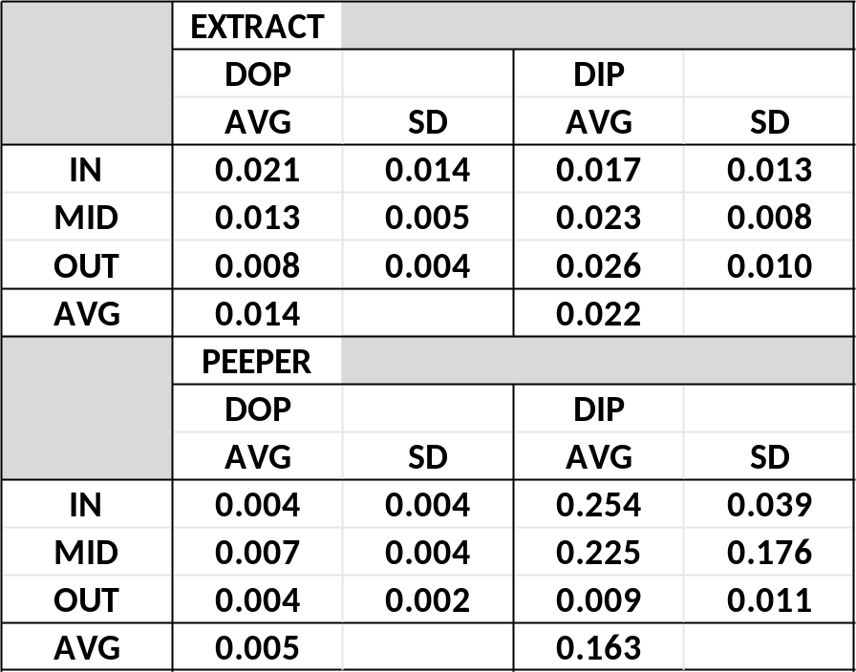

Model Structure
The changes in the concentrations of the five C (g C m⁻²) and ten P pools (g P m⁻³ or g P m⁻²) were determined every time step (dt = 1.5 hours = 0.0625 d) through source-sink difference equations (Table 2-6). The difference equations for the C pools (phytoplankton, periphyton, Typha shoots, Typha root-rhizomes and SAV) included gross production (GP), respiration (RS), uptake (UP), loss through mortality (LS), grazing (GZ), exudation (EXU), and translocation (TRS; g C m⁻² d⁻¹; Figure 2-1; Table 2-3; Table 2-6). Changes in phytoplankton biomass also included inflow and outflow calculations similar to the P constituents. Each of the gross production equations included a maximum rate (P_{MX}; d⁻¹), a temperature effect (Tfx), P limitation function, a maximum biomass self-limitation function, and the producer biomass (g C m⁻²; Table 2-7). Water temperature (T_{W}) had an exponential effect on gross production, respiration, remineralization of DOP, and decomposition of P_{LITTER} (Tfx; unitless).
Phytoplankton, periphyton and SAV required submarine irradiance. Surface irradiance was modeled using a trigonometric function with the maximum annual magnitude and a photoperiod function specified for 27°N latitude (Buzzelli et al. 2014; Table 17). Light was attenuated exponentially with depth and the combined effects of colored dissolved organic matter (color), turbidity (TURB), and chlorophyll a (CHL). The average values for color (112 Pt-Co units) and turbidity (2.5 NTU) from the intensive assessment of P were multiplied the constituent-specific attenuation factors (f_{CHL}, f_{TURB}; f_{COLOR}; Kelble et al. 2005; Villapando and King 2019). CHL (g CHL m⁻³) was calculated every time step from C_{PHYTO}, depth (m), and the C:CHL ratio (C:CHL = 0.25; James et al. 2005). The light formulation for periphyton included the effect of biomass self-shading (Buzzelli et al. 2014).
The Typha shoot equation included the effects of depth on growth (hfx) and limitation calculated using soil DIP and RR half-saturation parameter (k_{EAVRR}; g P m⁻²; Brix et al. 2010; Eqn. 3; Table 6). The modeling study by Eid et al. (2012) provided essential species-specific rates of gross production, respiration, and loss for shoot and root-rhizomes of Typha domingensis. In addition to these fundamental biological processes there were two custom functions essential for Typha modeling in the STAs (Figure 2-5A and 2-5B). First, the gross production rate of Typha shoots declined with increasing depth based on the effects of depth on cattail photosynthesis and growth in the STAs (Chen et al. 2010; Chen and Vaughan 2014; Diaz and Vaughan 2019).
The second custom function represented the effect of surface roughness due to Typha above-ground biomass (g C m⁻²) on the removal or sinking of POP_{W} (g P m⁻² d⁻¹). A hyperbolic relationship was applied because the effects of Typha were assumed to reach a limit as shoots approached the maximum biomass (C_{SHMX}). Values for the maximum sinking rate (0.0067 g P m⁻² d⁻¹; a_{TYPHA}) and the half-saturation shoot biomass (351.4 g C m⁻²; b_{TYPHA}) were determined through calibration of POP concentrations in the water column Table 2-7). Finally, translocation moved C from the Typha shoots to the root-rhizomes as a fraction of net primary production (NPP = GP - RS). All C concentrations and process rates were converted using C:P ratios of the respective pools (Table 2-7).
The P-based loss terms for Typha and SAV shoots provided the source of material for P_{LITTER} (Eqn. 6 Table 2-6). Slow decomposition to P_{FLOC} was the only loss term for P_{LITTER} (UF-WBL 2019). The P losses from periphyton and phytoplankton and POPW sinking were the other sources of P_{FLOC} (Eqn. 7). P_{FLOC} decreased via fast decomposition (P_{FLOCL}) and resuspension (P_{FLOCRES}).
Table Introduction-6. List of difference-based source-sink equations for each of the 15 carbon (C) and phosphorus (P) pools of the Biogeochemical Model of STA-2 FW1. See text for descriptions and units and Table 2-7 for parameter values.
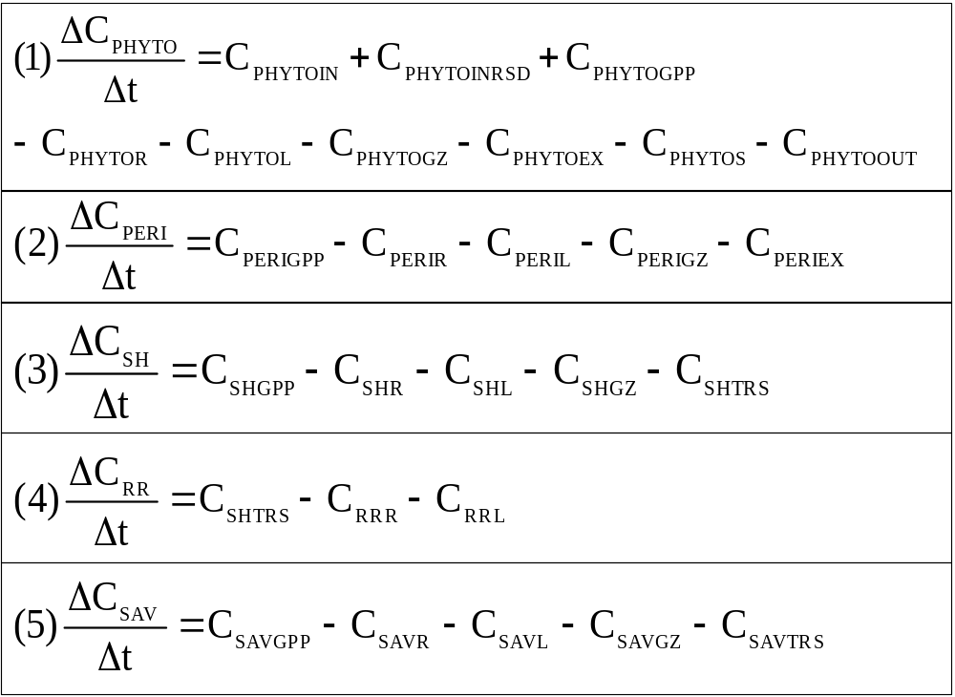
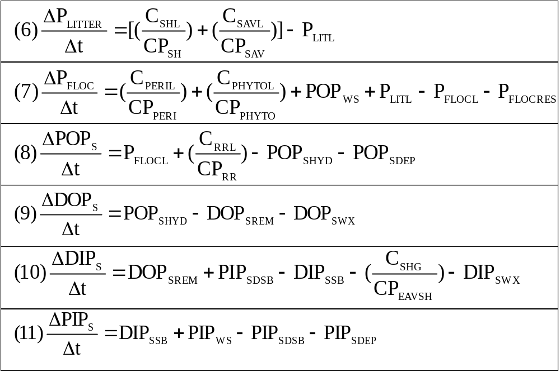

Table Introduction-7 continued. List of difference-based source-sink equations for each of the 15 carbon (C) and phosphorus (P) pools of the Biogeochemical Model of STA-2 FW1. See text for descriptions and units and Table 2-7 for parameter values.

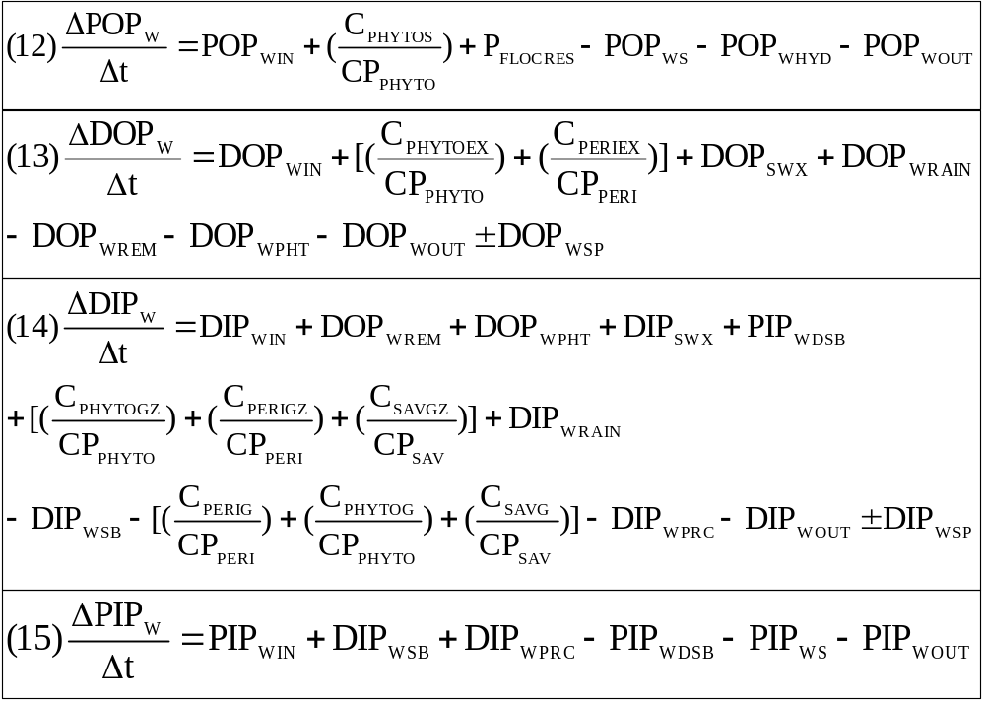

Table Modeling Phosphorus Biogeochemistry in STA Wetlands-8. List of initial concentrations and parameters for the Biogeochemical Model of STA-2 FW1
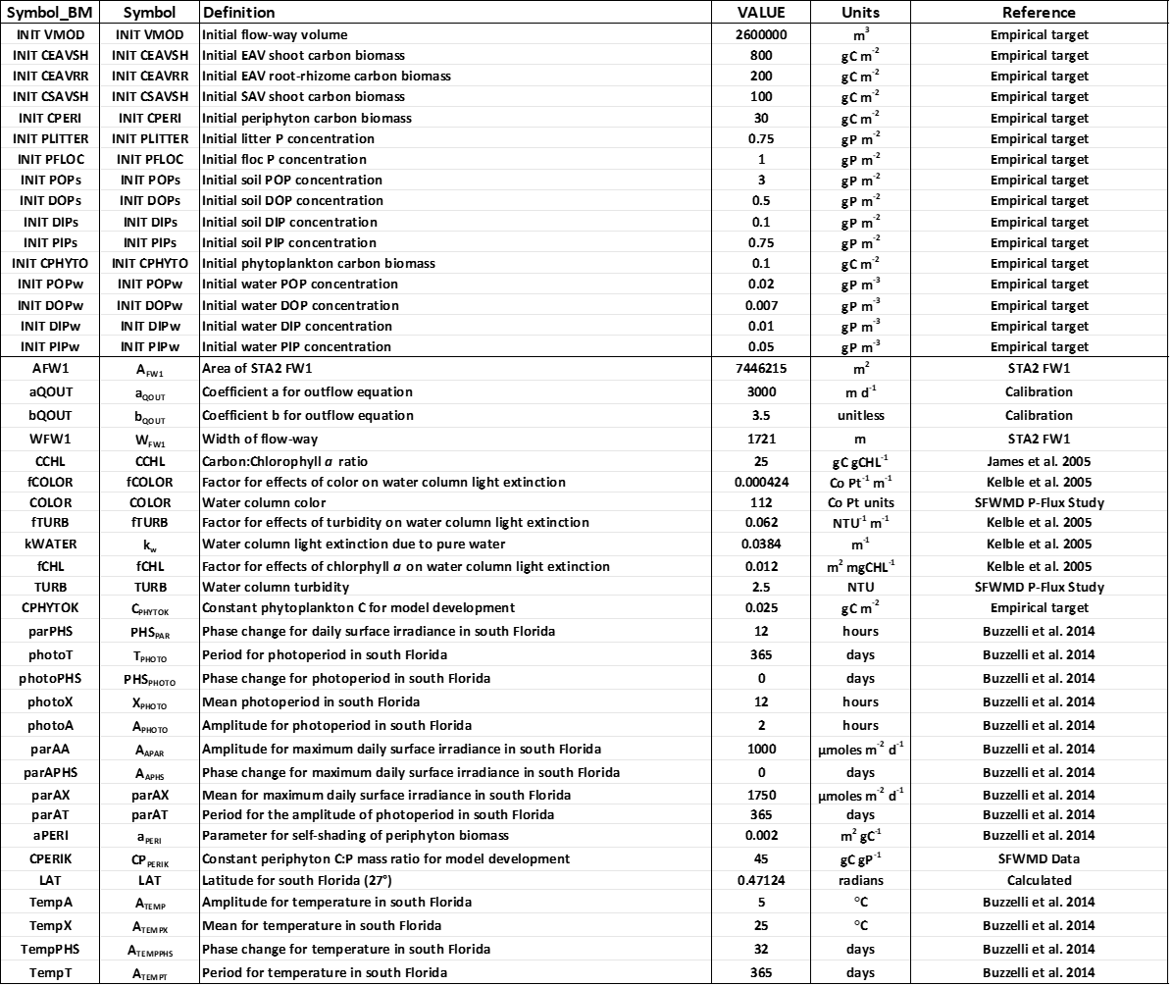
Table 2-7. Continued.
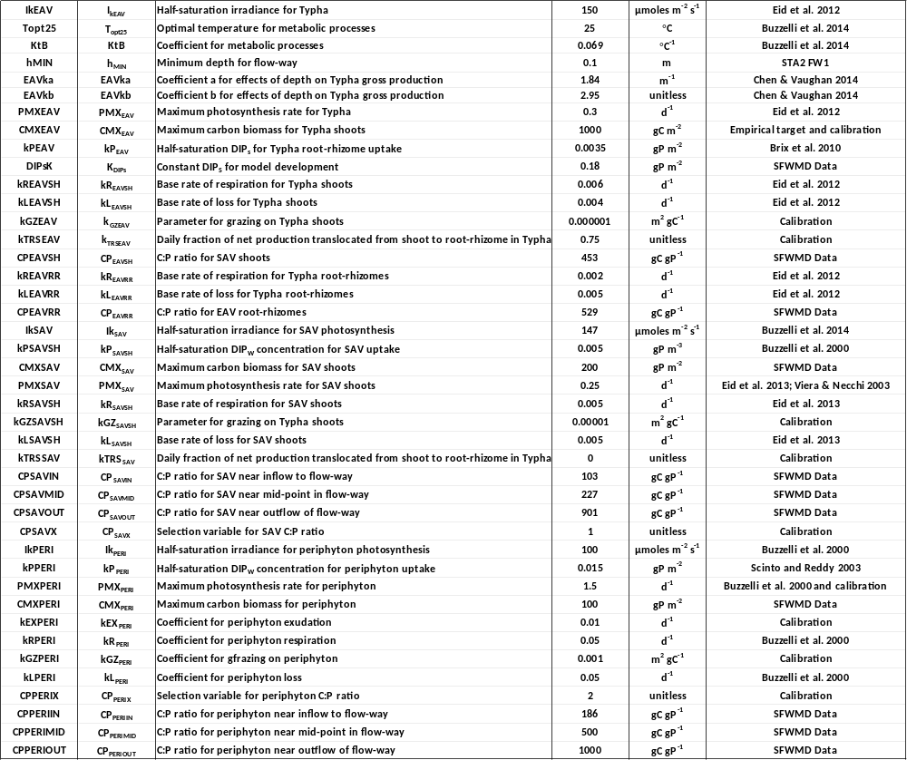
Table 2-7. Continued.
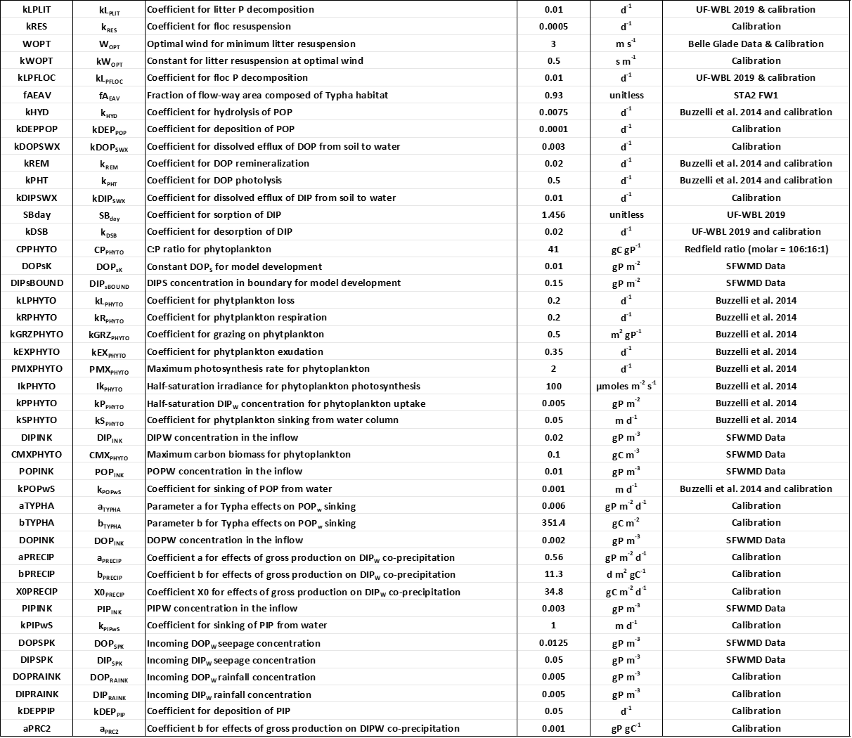
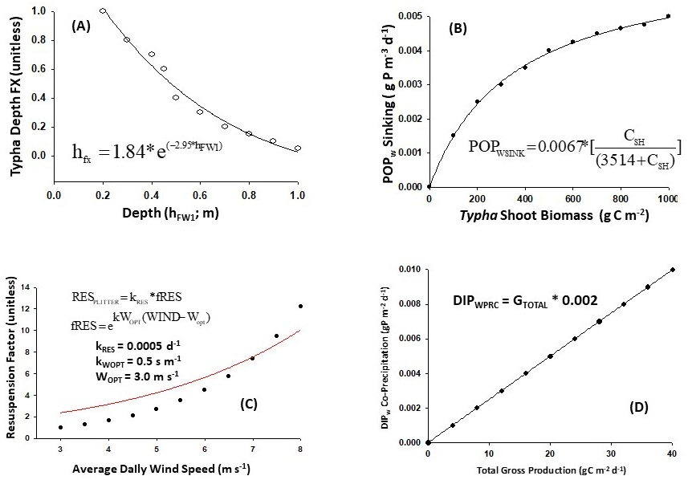
Figure Introduction-7. (A) Function to model effects of depth on Typha production. (B) Function to model effects of Typha shoot biomass on POP_{W} sinking. (C) Function to model resuspension of P_{FLOC} based on average daily wind speed. (D) Function to model relationship between total gross production and DIPW co-precipitation. See text for details.
Resuspension increased exponentially with average daily wind speeds greater than 3.0 m s⁻¹ using a base rate parameter (k_{RES}; Figure 2-5C; Table 2-7).
P_{FLOCL} and the loss of Typha root-rhizome P biomass were the sources of POP_{S} (Eqn. 8 Table 2-6). Hydrolysis to DOP_{S} (POP_{SHYD}) and deposition (POP_{SDEP}) were the two sink terms for POP_{S}. While POP_{S} hydrolysis was the only source term for DOP_{S}, it was lost through remineralization (DOP_{SREM}) and diffusive efflux to the water column (DOP_{SWX}). DOP remineralization and the desorption of PIP_{S} were the sources of soil DIP (DIP_{S}; Eqn. 10 Table 2-6). DIP_{S} was consumed by sorption to PIP_{S} (DIP_{SSB}), uptake by Typha as a function of gross production and C:P of the shoots (C_{SHG} and C_{PEAVSH}), and diffusive efflux to the water column (DIP_{SWX}). DIP_{SSB} and PIP sinking from the water column (PIP_{WS}) were the source terms for PIP_{S} (Eqn. 11 Table 2-6). Desorption and deposition (PIP_{SDEP}) provided the loss pathways. Phosphorus sorption and desorption experiments were conducted as part of a larger study of the STAs (UF-WBL 2019). The average rate of desorption was determined in these experiments and used as the initial value in the model (0.07 d⁻¹; UF-WBL 2019).
Each of the four water column P constituents (POP_{W}, DOP_{W}, DIP_{W}, PIP_{W}; g P m⁻³) had inflow (IN) and outflow (OUT) terms (Eqns. 12-15; Table 2-6). POP_{W} increased with the sinking of phytoplankton (C_{PHYTOS} and C_{PPHYTO}) and P_{FLOCRES}, and, decreased with sinking (POP_{WS}) and hydrolysis to DOP_{W} (POP_{WHYD}; Eqn. 12 Table 2-6). It was removed via two independent sinking processes (POP_{WS}). First, changes in concentration and depth were used to calculate sinking using a base rate parameter (k_{SNK}; m d⁻¹). The Typha surface roughness function was the second (see above; Figure 2-5B). Finally, hydrolysis (POP_{WHYD}) was a sink for POP_{W} and internal source of DOP_{W} in the water column.
Rainfall was a source term for both DOP_{W} and DIP_{W} (Eqns. 13 and 14 Table 2-6). Daily NEXRAD rainfall values (m³ d⁻¹) from the SFWMD DBHydro were imported into the model and multiplied by constant concentrations (Table 2-7). Daily seepage rates (m³ d⁻¹) across the four boundaries of the flow-way were developed using the surrounding stage water levels along with seepage coefficients based on differences in water levels (Zhao and Piccone 2018). While the daily input via seepage was small, there were a few occasions of seepage outflow. The minimum concentrations for DOPS and DIPS were applied to calculate the contribution of seepage.
Exudation (g C m⁻³ d⁻¹) by phytoplankton and periphyton (C_{PHYTOEX} and C_{PERIEX}) was converted to P using the C:P ratios (C_{PPHYTO}; C_{PPERI}) as a source of DOP_{W} (Eqn. 13; Table 2-6). While diffusive efflux from the soil was a source, DOP_{W} decreased via remineralization and photolysis to DIPW (DOP_{WREM} and DOP_{WPHT}). DIP_{W} had the greatest number of sources (seven) and sinks (5) among all model state variables (Eqn. 14 Table 2-6). The source terms included inflow (DIP_{WIN}), rain (DIP_{WRAIN}), DOP_{WREM}, DOP_{WPHT}, diffusive efflux from the soil (DIP_{SWX}), desorption of PIPW (PIPWDSB), and combined grazing on phytoplankton (C_{PHYTOGZ} and C_{PPHYTO}), periphyton (C_{PeriGZ} and C_{PPeri}), and SAV (C_{SAVGZ} and C_{PSAV}). The contribution of SAV was scaled by its relative area in STA-2 FW1 (7%). The five sink terms were outflow (DIP_{WOUT}), sorption (DIP_{WSB}), uptake (DIP_{WUP}), co-precipitation (DIP_{WPRC}), and seepage (DIP_{WSP}). DIP_{WUP} was calculated using the rates of gross production (G_{PPHYTO}, G_{PPERI}, G_{SAV}) multiplied by their respective C:P ratios (Table 2-7). The co-precipitation of DIP_{W} was simulated using a linear function between total gross production (g C m-3 d⁻¹) and loss to PIP_{W} (g P m⁻³ d⁻¹; Figure 2-5D; Dodds 2003; Grace 2003; Hagerthey et al. 2010 ). Similar to PIP_{S}, PIP_{W} increased with DIP_{WSB}, decreased PIP_{DSB}, and sank from the water column (PIP_{WS}).
The output from the first generation BGC Model developed in Phase II included time series of the P concentrations, basic comparisons between the target and average model P concentrations, and initial assessments of water column TP budgets and concentrations. There were many different evaluations performed during the Phase II model development. This report does not include these preliminary results because: 1) Several areas were identified to improve and refine the BGC Model in Phase III; and 2) Results presented in this document from the Phase III BGC Model are much more comprehensive and reliable. The Phase III tasks were to:
- Create Hydrologic Model of flow-way volume, depth and outflow for the BGC Model
(Task 8.1)
- Propose updates to the conceptual and mathematical BGM Models (Task 8.2)
- Transform the updated conceptual model into a functioning BGC Test Model with emphasis on source/sink relationships and total phosphorus mass balance (Task 8.3)
- Calibrate and validate predictions of P concentrations for different time periods (Task 8.4)
- Perform sensitivity analysis on the BGC Model (Task 8.5)

Phase III Model Improvement

Hydrologic Model (Task 8.1)
The BGC Model required a more complete hydrologic component to simulate daily changes in the depth and volume of STA-2 FW1 over the 5844-day model time period (1/1/20025 to 12/31/2020). A water budget approach similar to Zhao and Piccone (2019a and 2019b) was developed to include all sources (inflow, rainfall, seepage) and sinks (outflow, evapotranspiration, seepage) to model daily changes in the flow-way volume and depth. Volume (V_{MOD}; m³ or km³) was modeled as the daily integrated sum of inflow (Q₀; m³ d⁻¹), rainfall (Q_{RAIN}; m³ d⁻¹), outflow (Q_{OUT}; m³ d⁻¹), evapotranspiration (Q_{ET}; m³ d⁻¹), and seepage (Q_{SP}; m³ d⁻¹; Figure 2-6; Equation 1).

$$(1)V_{\text{MOD}}=V_{\text{MOD}(t−\text{dt})}+[(Q_{0}+Q_{\text{RAIN}})−(Q_{\text{OUT}}+Q_{\text{ET}})±(Q_{\text{SP}})]∗\text{dt}$$

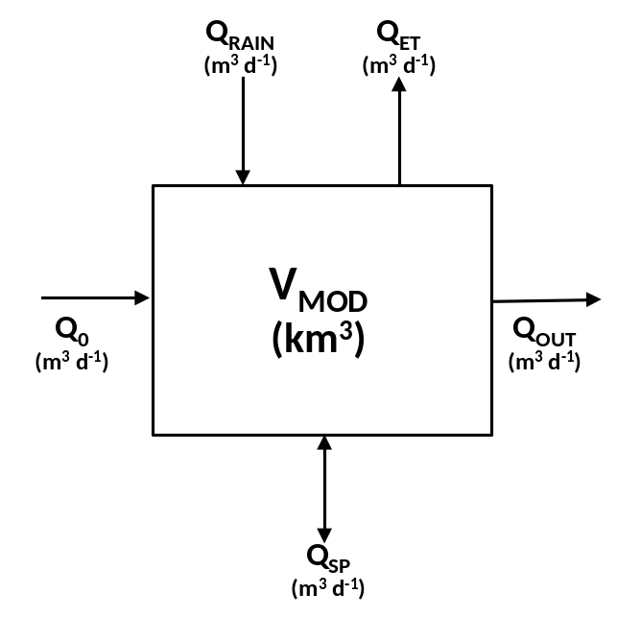
Figure Introduction-8. Conceptual Hydrologic Model for the Biogeochemical Model of STA-2 FW1.

Q₀ was the sum of the daily observed inflows through four water control structures on the north side of STA-2 FW1 (G329A, G329B, G329C, G329D; Zhao and Piccone 2019). Daily estimates of rainfall were developed from NEXRAD as Q_{RAIN} (SFWMD 2014) and evaporation Q_{ET} from satellite solar radiation estimates (Pathak 2008) for STA-2 FW1. Daily estimates of Q_{SP} across the four boundaries of the flow-way were developed using the surrounding stage water levels along with seepage coefficients based on differences in water levels (Zhao and Piccone 2018). These daily seepage estimates were positive into and negative out of the flow-way, respectively. The four boundary values were summed to provide a net daily estimate of seepage to the entire flow-way. Q_{OUT} was modeled using the approach of Kadlec and Knight (1996) for managed wetlands (Equation 2). The values for the parameters a_{OUT} and b_{OUT} were adjusted through a series of calibrations as the Hydrologic Model was developed iteratively by the SFWMD and Consultant. The Nash Sutcliffe index (NSE) was used to evaluate the performance of the calibration runs (Gupta et al. 2009). NSE values approaching or equal to 1.0 are the most desirable.

$$(2)Q_{\text{OUT}}=a_{\text{OUT}}∗W_{\text{FW}1}∗(h_{\text{mod}}−h_{\text{gate}})^{b_{\text{OUT}}}$$
Where:
a_{OUT} = 3000
b_{OUT} = 3.0
W_{FW1} = width of flow-way (1721 m)
h_{MOD} = modeled depth of flow-way
h_{MIN} = minimum depth for flow-way (0.1 m)

The STA-2 FW1 depth and volume time series which were applied in Phase II served as the references for the Hydrologic Model output. Additionally, the daily observations of Q_{OUT} at G335 were compared to the predicted outflow from the Hydrologic Model (Figure 2-2A). The time period was divided into two equal 2922-day sub-sets for Calibration (1/1/2005 to 12/31/2012) and Validation (1/1/2013 to 12/31/2020). First, the reference and model time series for Q₀, Q_{OUT}, V_{MOD}, and h_{MOD} were assessed graphically. Although the Hydrologic Model Q₀ was the same as the reference time series, it was included in the series of overlays as a check of model reliability. Descriptive statistics (minimum, maximum, average, standard deviation) were generated for both the data reference and model output for Q_{OUT}, V_{MOD}, and h_{MOD} in the Calibration and Validation time periods. Average monthly Q_{OUT}, V_{MOD}, and h_{MOD} were compared to the average monthly reference values for the Calibration and Validation sub-sets using least squares regression.
The reference volume time series for STA-2 FW1 for the entire model period (1/1/2005 to 12/31/2020) was derived by multiplying the average daily depth (h_{FW1}; m) by the flow-way area (7,446,215 m²; Figure 2-3). A t-test was attempted as a pairwise comparison of the 96 average monthly volumes between the CAL and VAL sub-sets. However, the comparison failed the Shapiro Wilks test for non-normality so a non-parametric Mann Whitney Rank Sum test was applied. There was a significant difference between median values that could not be explained by random variation. The flow-way volume time series for the CAL sub-set was more variable, less normally distributed, and had a lower mean volume than the VAL sub-set (0.0026 vs 0.0035 km³; Table 2-8). This is an important result when interpreting potential differences between model results over the entire simulation time.
The values of a_{OUT} (m d⁻¹) and b_{OUT} which resulted in the best approximation for the average volume of STA-2 FW1 were 3000 and 3.5 (Figure 2-7). The increase in the NSE value to 0.84 marked a huge improvement from previous efforts to calibrate the Hydrologic Model. These values were used in subsequent simulations for hydrologic and biogeochemical model evaluations and results.

Table Modeling Phosphorus Biogeochemistry in STA Wetlands-9. Descriptive statistics for average monthly target volumes of STA-2 FW1 (VFW1; km³) for the calibration (CAL; 1/1/2005 to 12/31/2012) and validation (VAL; 1/1/2013 to 12/31/2020) periods.
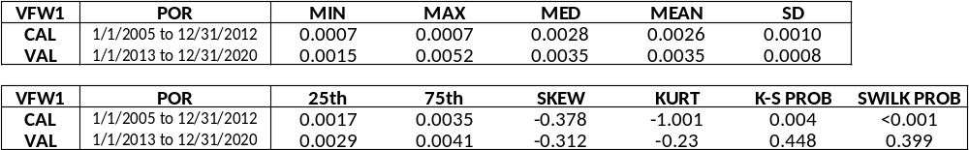
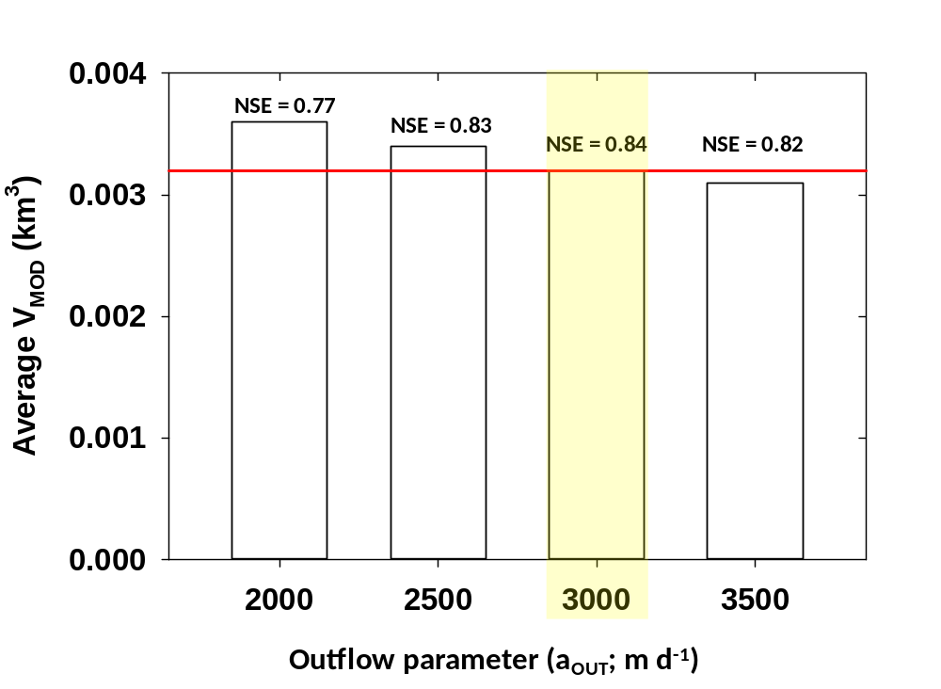
Figure Introduction-9. Results of calibration of Hydrologic Model of STA2 FW1 by varying the outflow parameter a_{OUT} from 2000-3500. The red line marks the average flow-way volume from the reference time series (km³). The optimal value was 3000 m3 d-1. The Nash-Sutcliffe comparative index values are provided (NSE). See text for details.

The reference and the model inflow time series were identical to each other in both the Calibration and Validation time periods (Figure 2-8A and 2-9A). The daily and seasonal variations in the observed and model Q_{OUT} were evident in both the Calibration and Validation periods (Figure 2-8B and 2-9B). Q_{OUT} averaged 0.016 ± 0.026 10⁶ m³ d⁻¹ and 0.018 ± 0.026x 10⁶ m³ d⁻¹ for the reference and model during the Calibration period (Table 2-9). These values increased to 0.027 ± 0.031 x10⁶ m³ d⁻¹ and 0.0040 ± 0.0036 x10⁶ m³ d⁻¹ as the reference average was greater in the Validation period. There was a significant and robust linear relationship between the average monthly model and reference Q_{OUT} in both time periods (Figure 2-10A and 2-10B). There was a wider distribution of values and an overall better fit between the model and data in the Validation period (r² = 0.98).
2005-2012
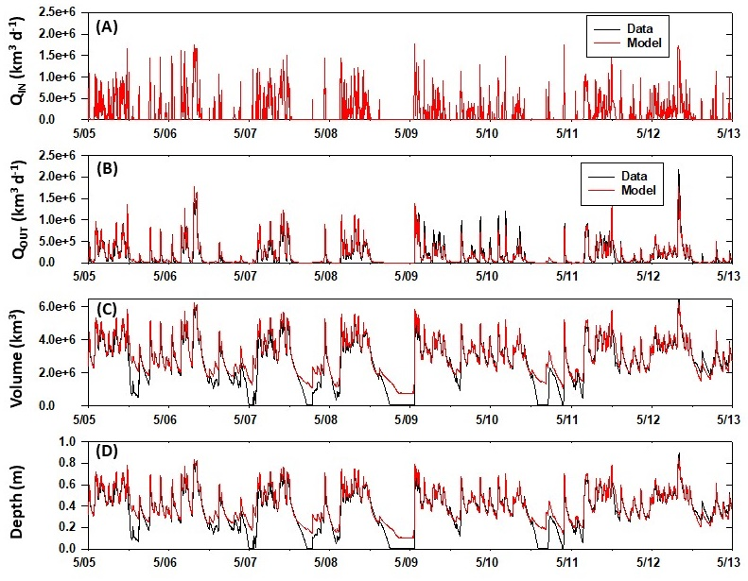
Figure Introduction-10. Time series of daily flow-way Q_{IN}, Q_{OUT}, volume, and depth for the target or reference values (black) and model predictions (red) for the Calibration period water years (5/1/2005 to 5/1/13).

The daily and seasonal variations in the observed and model flow-way volume (km³) were evident in the Calibration and Validation periods (Figure 2-8C and 2-9C). There were times of very low to zero volume in the reference time series not captured by the model (WY2008, WY2009, WY2010, WY2012; Figure 2-8C). This was not the case during the Validation period (Figure -9C). Flow-way water volume during Calibration averaged 0.271 ± 0.135 x 10⁶ m³ and 0.302 ± 0.114 x 10⁶ m³ for the reference and model, respectively (Table 2-9). These values increased to 0.375 ± 0.100 x10⁶ m³ and 0.341 ± 0.108 x10⁶ m³ as the reference average was greater but less variable during Validation. There was a significant and robust linear relationship between the average monthly model and reference volumes in both time periods (Figure 2-10C and 2-10D). There was a wider distribution of values and an overall better fit between the model and data in the Validation period (r² = 0.96) when flow-way depth and volume were more stable.
2013-2020
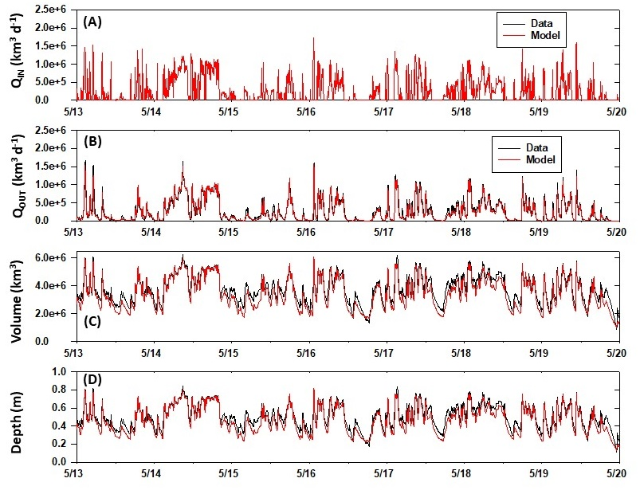
Figure Introduction-11. Time series of daily flow-way Q_{IN}, Q_{OUT}, volume, and depth for the target or reference values (black) and model predictions (red) for the Validation period water years (5/1/2013 to 5/1/2020).
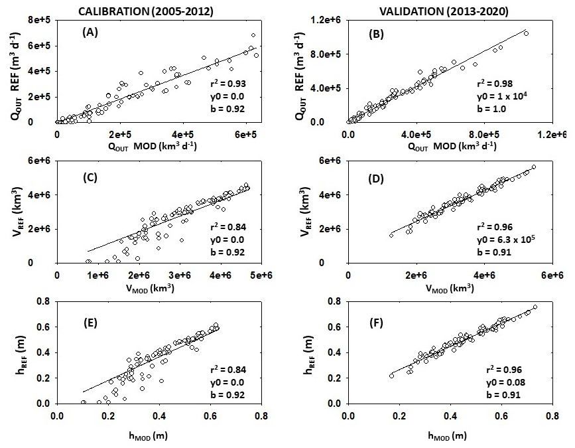
Figure Introduction-12. Scatterplots and linear regressions for the model results (x) and the reference data (y) for the Calibration (left side; 1/1/2005-12/31/2012) and Validation (right side; 1/1/2013-12/31/2020) periods. Included are the regression coefficient (r²), intercept (y0). and slope (b) for the monthly average flow-way outflow (Q_{OUT}; km³ d⁻¹), volume (km³), and depth (m).
Table Introduction-10. Descriptive statistics for the reference data (left side) and model results (right side) for the Calibration (1/1/2005-12/31/2012) and Validation (1/1/2013-12/31/2020) periods. Included are the minimum (MIN), maximum (MAX), average (AVG), and standard deviation (SD) for the flow-way daily outflow (QOUT; km³ d⁻¹), volume (km³), and depth (m) for the two time periods.
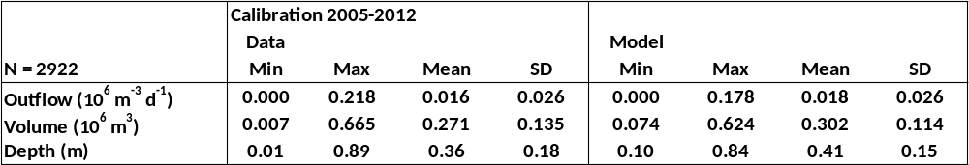
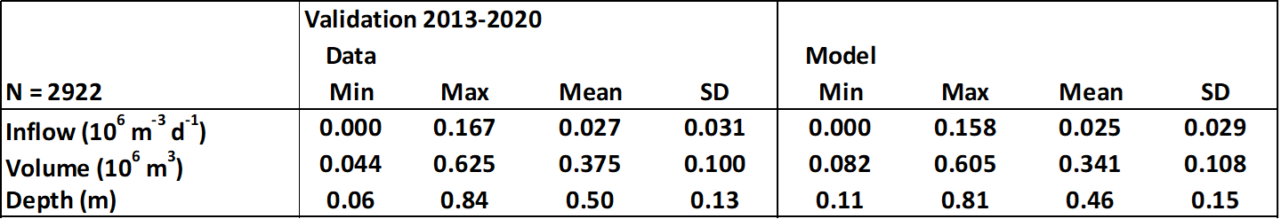
The patterns in depth and relative differences during and between the Calibration and Validation periods were the same as those for flow-way volume (Figure 2-8D and 2-9D). Flow-way depth averaged 0.36 ± 0.16 m and 0.41 ± 0.13 m for the reference and model during the Calibration period, and 0.50 ± 0.11 m and 0.46 ± 0.12 m in the Validation period (Table 2-9). There was a wider distribution of values and an overall better fit between the model and data in the Validation period (r² = 0.96; Figure 2-10F).
The annual water budget for STA-2 FW1 was dominated by inflow and outflow (0.08 km³ y⁻¹). The contributions of rainfall (0.01 km³ y⁻¹), evapotranspiration (0.01 km³ y⁻¹), and seepage (0.005 km³ y⁻¹) were comparatively small (Figure 2-11). The updated Hydrologic Model accurately and reliably predicted daily, seasonal, annual, and inter-annual changes in flow-way outflow, volume, and depth. These changes were incorporated into the BGC Model as it evolved with project tasks.
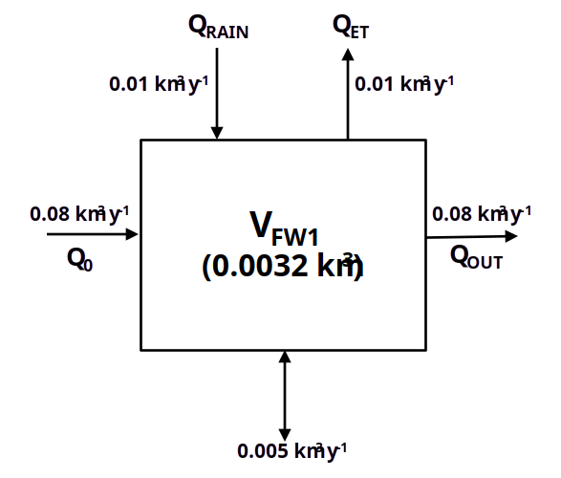
Figure Introduction-13. Average annual sources and sinks for the Hydrologic Model of STA-2 FW1.

Conceptual Model, Mass Balance, and Test Model (Tasks 8.2 and 8.3)
The BGC Model required an updated conceptual model (Figure 2-1), the introduction of accurate predictions of daily volume and depth from the Hydrologic Model, and a mathematical approach to ensure mass balance among all sources vs sinks within and among the TP pools. The dynamic and correct simulation of volume and depth were key to establish the mass balance model structure. The result was a fully functioning BGC Test Model which conserved P mass.
The previous BGC conceptual and mathematical models combined floc and litter into a single P pool at the soil-water interface. The updated Phase III conceptual model separated PLITTER and PFLOC reconfigured their connections to other variables and applied different rates of decomposition (Figure 2-1; Table 2-6; Eqn. 6 and Eqn 7). This change to the conceptual model greatly improved compatibility with the CASM-STA (Section 3, this report). A few other changes were considered including the addition of a second calcareous type of periphyton. This option was reserved for future versions of the BGC Model.
The BGC Test Model was constructed using most of the components from the Phase II model (temperature and light models, parameters and ratios, calculators and integrators, formulations for primary producers). Each state variable was introduced and evaluated sequentially before advancing to the next. Water column phytoplankton, POP, DOP, DIP, and PIP pools were connected to the hydrologic inputs and outputs through loadings and redefined using new mathematical code which ensured that: a) the mass was never below the minimum amount available; and b) the net source and sink processes balanced.
The Phase II BGC Model had an instability that resulted when DIPW concentrations were at or near zero. The sink terms continued to calculate losses when there was insufficient DIPW available in the compartment. This was problematic because it sometimes created negative concentrations and greatly influenced water column and soil PIP, which were totally driven by DIP sorption-desorption processes. These problems were fixed for the BGC Test Model in Phase III.
The solution was to pre-calculate each of the loss functions for a particular P state variable. For example, recall that the DIP_{W} difference equation had five separate sink terms: DIP_{WSPOUT}, DIP_{WOUT}, DIP_{WSB}, DIP_{WPRC}, and DIP_{WUP} (Figure 2-12; Eqn. 3).

$$\begin{aligned}(3)\frac{Δ{\text{DIP}}_{W}}{Δt}={\text{DIP}}_{\text{WIN}}+{\text{DOP}}_{\text{WREM}}+{\text{DOP}}_{\text{WPHT}}+{\text{DIP}}_{\text{SWX}}+{\text{PIP}}_{\text{WDSB}}+{\text{DIP}}_{\text{WGRZ}}+{\text{DIP}}_{\text{WRAIN}} \\ {\text{DIP}}_{\text{WOUT}}−{\text{DIP}}_{\text{WSB}}−{\text{DIP}}_{\text{WPRC}}−{\text{DIP}}_{\text{WUP}}−{\text{DIP}}_{\text{WSP}}\end{aligned}$$

The base rates for the sink terms were calculated (DIP_{WOUTC}, DIP_{WSBC}, DIP_{WPRCC}, DIP_{WUPC}, DIP_{WSPC}), summed for the total loss from the DIP_{W} state variable every time step (DIP_{WTLOSS}), and combined to calculate the fractional contributions for each (fDIP_{WOUT}, fDIP_{WSB}, fDIP_{WPRC}, fDIP_{WUP}, fDIP_{WSP}).

$$(4){\text{DIP}}_{\text{WOUTC}}={\text{DIP}}_{W}∗(\frac{Q_{\text{OUT}}}{V_{\text{MOD}}})$$
$$(5){\text{DIP}}_{\text{WSBC}}={\text{DIP}}_{W}∗{\text{SB}}_{\text{DAY}}$$
$$(6){\text{DIP}}_{\text{WPRCC}}=G_{\text{TOTAL}}∗a_{\text{PRC}}$$
$$(7){\text{DIP}}_{\text{WUPC}}=[(\frac{C_{\text{PERIG}}}{{\text{CP}}_{\text{PERI}}})+(\frac{C_{\text{PHYTOG}}}{{\text{CP}}_{\text{PHYTO}}})+(\frac{C_{\text{SAVG}}}{{\text{CP}}_{\text{SAV}}})]$$
$$(8){\text{DIP}}_{\text{WSPC}}={\text{DIP}}_{W}∗Q_{\text{SP}}$$
$$(9){\text{DIP}}_{\text{WTLOS}}={\text{DIP}}_{\text{WOUT}}+{\text{DIP}}_{\text{WSB}}+{\text{DIP}}_{\text{WPRC}}+{\text{DIP}}_{\text{WUP}}+{\text{DIP}}_{\text{WSP}}$$
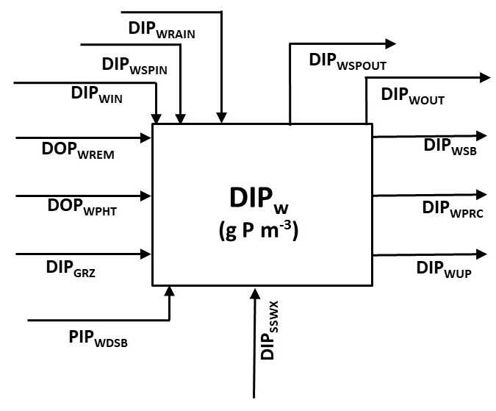
Figure Introduction-14. Conceptual annual DIPW budget. Arrows are annually summed rates in g P m⁻² y⁻¹.
The resulting equations for the sink terms were structured as conditional statements (Equations 10 through 14). If DIP_{W} (g P m⁻³) was sufficient, then the loss rate (g P m⁻³ d⁻¹) was the product of available DIP_{W} or the calculated loss rate (e.g. DIP_{WOUTC}), and the fractional contribution to the total loss from the state variable each time step (e.g. fDIP_{WOUT}).
$$(\text{10}){\text{DIP}}_{\text{WOUT}}=\text{IF}({\text{DIP}}_{W}>{\text{DIP}}_{\text{WOUTC}})\text{THEN}({\text{DIP}}_{W}∗{\text{fDIP}}_{\text{WOUT}})\text{ELSE}({\text{DIP}}_{\text{WOUTC}}∗{\text{fDIP}}_{\text{WOUT}})$$
$$(\text{11}){\text{DIP}}_{\text{WSB}}=\text{IF}({\text{DIP}}_{W}>{\text{DIP}}_{\text{WSBC}})\text{THEN}({\text{DIP}}_{W}∗{\text{fDIP}}_{\text{WSB}})\text{ELSE}({\text{DIP}}_{\text{WSBC}}∗{\text{fDIP}}_{\text{WSB}})$$
$$(\text{12}){\text{DIP}}_{\text{WPRC}}=\text{IF}({\text{DIP}}_{W}>{\text{DIP}}_{\text{WPRCC}})\text{THEN}({\text{DIP}}_{W}∗{\text{fDIP}}_{\text{WPRC}})\text{ELSE}({\text{DIP}}_{\text{WPRCC}}∗{\text{fDIP}}_{\text{WPRC}})$$
$$(\text{13}){\text{DIP}}_{\text{WUP}}=\text{IF}({\text{DIP}}_{W}>{\text{DIP}}_{\text{WUPC}})\text{THEN}({\text{DIP}}_{W}∗{\text{fDIP}}_{\text{WUP}})\text{ELSE}({\text{DIP}}_{\text{WUPC}}∗{\text{fDIP}}_{\text{WUP}})$$
$$(\text{14}){\text{DIP}}_{\text{WSP}}=\text{IF}({\text{DIP}}_{W}>{\text{DIP}}_{\text{WSPC}})\text{THEN}({\text{DIP}}_{W}∗{\text{fDIP}}_{\text{WSP}})\text{ELSE}({\text{DIP}}_{\text{WSPC}}∗{\text{fDIP}}_{\text{WSP}})$$
All of the water column TP constituents followed this approach for the multiple sink terms (POP_{W}, DOP_{W}, DIP_{W}, PIP_{W}; see Table 2-8). The daily summed sources and daily summed sinks (g P m⁻³ d⁻¹) were calculated for each of the constituents to check P mass balance. The sources and sinks among all four constituents were combined for daily comparison (g P m⁻³ d⁻¹) and to generate annual TP budgets (g P m⁻² y⁻¹).
There were peaks in TP sources relative to sinks apparent in the model time series (2006, 2007, 2008, 2009, 2012, 2018; Figure 2-13). These peaks were attributed to depth effects on the dynamics of POP_{W} creating minor differences in net annual TP sources and sinks in these earlier water years (Table 2-10). The overall agreement between TP sources and sinks improved in the second half of the simulation. The source and sink average annual rates were in balance for POP_{W} (1.47 vs 1.46 g P m⁻² y⁻¹), DOP_{W} (1.63 vs 1.63 g P m⁻² y⁻¹), DIP_{W} (6.59 vs 6.59 g P m⁻² y⁻¹), PIP_{W} (2.19 vs 2.19 g P m⁻² y⁻¹), and TP_{W} (11.87 vs 11.86 g P m⁻² y⁻¹; Table 2-10).
An average annual DIP_{W} budget was generated (Figure 2-14). DIP_{W} inputs from rain (DIP_{WRAIN}), seepage (DIP_{WSPIN}), DOP remineraization (DOP_{WREM}), and desorption (DIP_{WDSB}) were comparatively low (< 0.007 g P m⁻² y⁻¹). Inflow (DIP_{WIN}; 0.20 g P m⁻² y⁻¹), photolysis of DOP (DOP_{WPHT}; 0.72 g P m⁻² y⁻¹), and grazing (DIP_{WGRZ}; 2.0 g P m⁻² y⁻¹) were the major sources of DIPW. While the outward seepage was trivial, outflow (DIP_{WOUT}) and sorption (DIP_{WSB}) were 0.05 g P m⁻² y⁻¹ and 0.02 g P m⁻² y⁻¹, respectively (Figure 2-14). There was a 75% reduction between DIP_{WIN} and DIP_{WOUT}. Co-precipitation to PIP_{W} (DIP_{WPRC}) and uptake by the primary producers (DIP_{WUP}) were 0.84 g P m⁻² y⁻¹ and 2.1 g P m⁻² y⁻¹, respectively. A major proportion of the total DIP uptake was by periphyton.
The result of Task 8.3 was a stable BGC Model which conserved mass and was ready for variable inflow TP concentrations and loads, calibration and validation, and sensitivity analysis. These procedures were essential to further develop and complete the BGC Model of STA-2 FW1.

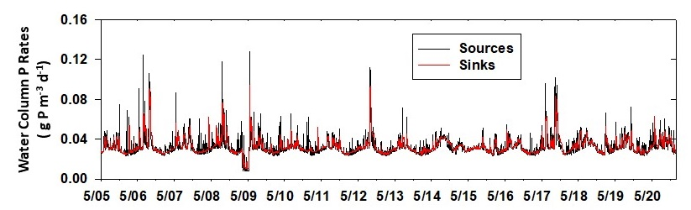
Figure Introduction-15. Time series for net daily water column total phosphorus (TP) sources (black) and sinks (red). TP sources and sinks were calculated as sums of respective sources and sinks for water column particulate organic phosphorus (POP_{W}), dissolved organic phosphorus (DOP_{W}), dissolved inorganic phosphorus (DIP_{W}), and particulate inorganic phosphorus (PIP_{W}).
Table Modeling Phosphorus Biogeochemistry in STA Wetlands-11. Annual values for water column TP (TP_{W}; g P m⁻³) and net sources and net sinks (g P m⁻³ d⁻¹) for water column particulate organic phosphorus (POP_{W}), dissolved organic phosphorus (DOP_{W}), dissolved inorganic phosphorus (DIP_{W}), particulate inorganic phosphorus (PIP_{W}). and TP_{W}.
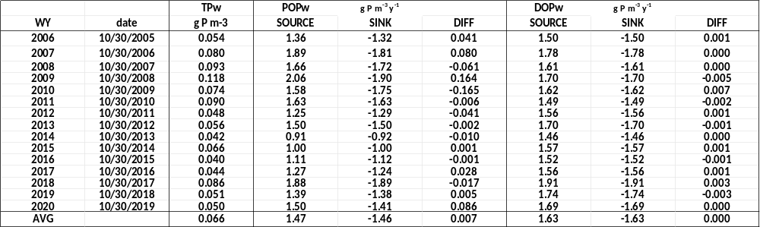
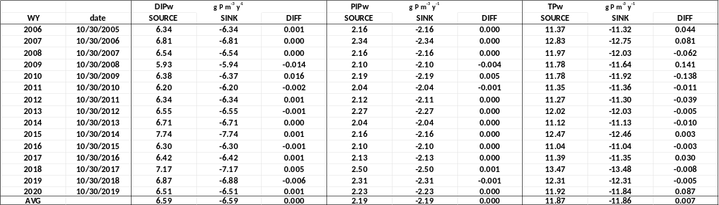

Calibration of the BGC Model (Task 8.4)
The objective of Task 8.4 was to calibrate and validate the Biogeochemical Model of STA-2 FW1 (BGC Model) conceptualized in Phase I, developed in Phase II, and improved in Task 8.3 of Phase III. The first step introduced variable inflow concentrations for the water column TP constituents; [POPW]_{IN}, [DOPW]_{IN}, [DIPW]_{IN}, [PIPW]_{IN}. While previous model versions applied the average inflow concentrations for each constituent, improvements in the Hydrologic Model provided the pathway to incorporate variable daily input concentrations. The inflow concentrations were based on those from G329A, G329B, G329C, G329D used by SFWMD to estimate TP loads to STA-2 FW1 over the same period as the model simulations (Figure 2-2). The incoming TP to the model was assumed to be composed of POP_{W} (25%), DOP_{W} (12.5%), DIP_{W} (50%), and PIP_{W} (12.5%). While [TP]_{IN} varied daily, the proportions among the four constituents were constant throughout the simulation. The concentrations were combined with the inflows for P loading to the model flow-way (g P m⁻³ d⁻¹). Loading rates varied intra- and inter-annually ranging up to 0.06-0.09 g P m⁻² d⁻¹ in wet seasons of 2006, 2008, 2012, and 2017 (Figure 2-15). The base BGC Model TP loads were manipulated by altering either the inflow volumes (Q₀) or the [TP]_{IN} concentrations (See Sensitivity Analysis).

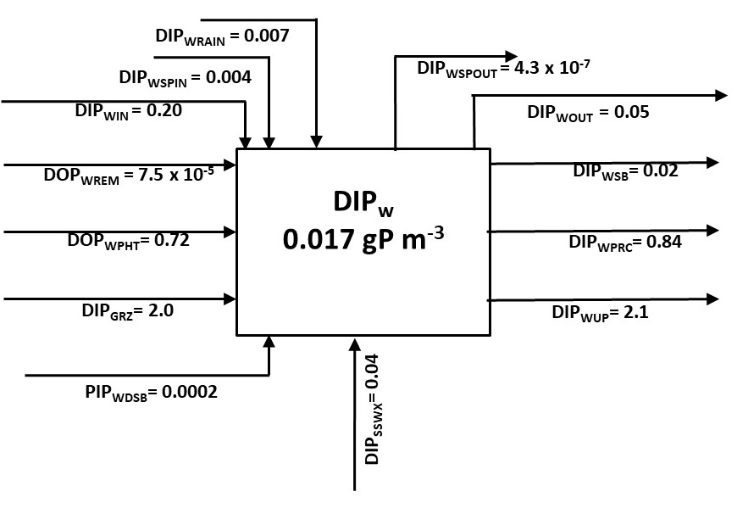
Figure Introduction-16. Average annual DIP_{W} budget generated using the updated Biogeochemical Model. Arrows are annually summed rates in g P m⁻² y⁻¹.

The 16 initial concentrations and 112 parameters were compiled to include the mathematical abbreviation (Symbol), base value, units, and reference (Table 2-7 and electronic Appendix). A total of 23 different parameters were identified with the greatest potential to affect the results of the BGC Model (Table 2-11). The effects of three different levels for each of the 23 parameters on the model average TP_{W} concentration (g P m⁻³) were assessed via 69 independent (23 x 3 = 69). The Task 8.3 BGC Test Model served as the source of the 23 base values which were then increased and decreased, respectively, for the calibration series.
Table Modeling Phosphorus Biogeochemistry in STA Wetlands-12. The 23 parameters selected for calibration of the STA-2 FW1 Biogeochemical Model.
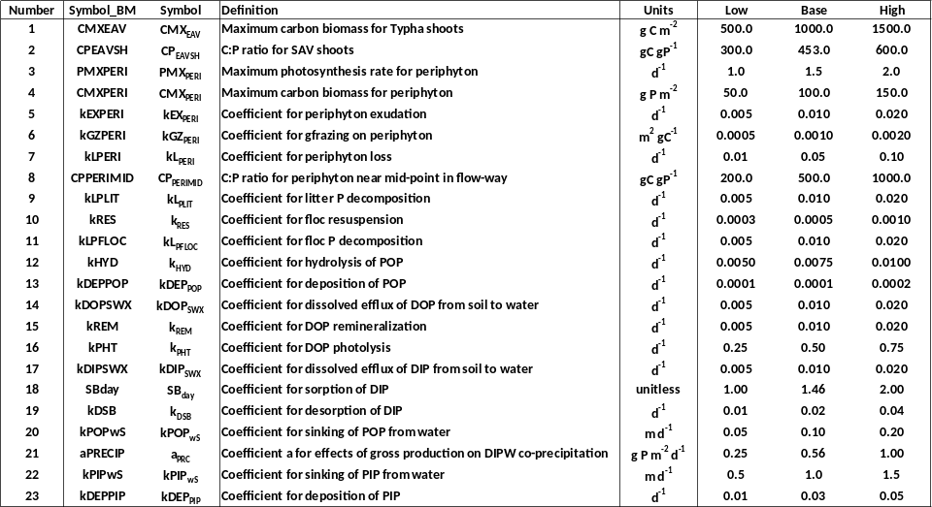
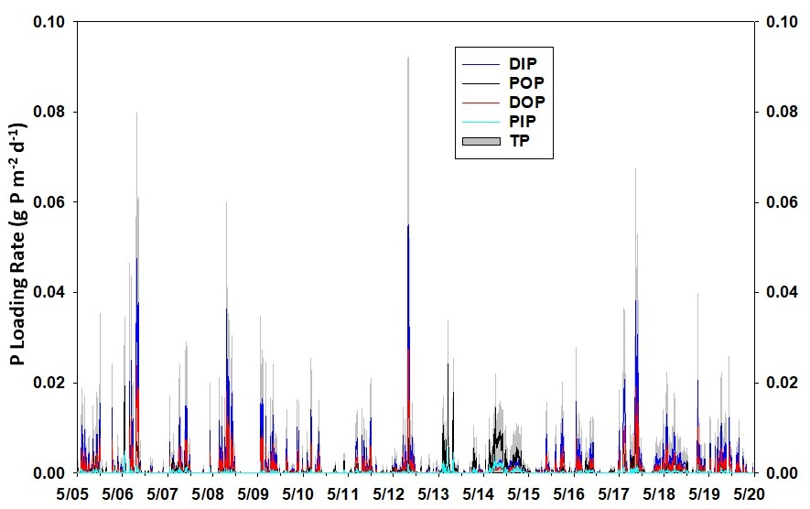
Figure Introduction-17. Time series of daily P loads to Biogeochemical Model of STA-2 FW1.
The resulting 69 averages were ranked from highest to lowest TP_{W} concentrations (Table 2-12). TP_{W} concentrations from the base model parameter values were generally in the middle of the range of the 69 average values. The effects of either the low or high test values for several specific parameters on model TP_{W} were evident. These included the periphyton C:P ratio (C_{PPERI}; g C g P⁻¹), the maximum periphyton photosynthetic rate (P_{MXPERI}; d⁻¹) and biomass (C_{MXPERI}; g C m⁻²), the rates of remineralization (k_{REM}; d⁻¹) and photolysis (k_{PHT}; d⁻¹) of DOP, the maximum Typha shoot biomass (C_{MXEAV}; g C m⁻²), and the rates of dissolved DOP and DIP efflux from the soil to the water (k_{DOPSWX} and k_{DIPSWX}; d⁻¹). Each of these were adjusted to the levels associated with the lowest average TPW concentrations during their respective calibration runs (Table 2-13).
Table Modeling Phosphorus Biogeochemistry in STA Wetlands-13. Results of 69 individual model calibration simulations for the effects of altered magnitudes of 23 different parameters listed in Table 2-4. Extensions on end of each parameter name denote low (_L), base (_B), or high (_H) value from Table 2-4. Results ranked from highest to lowest average water column TP (g P m⁻³).
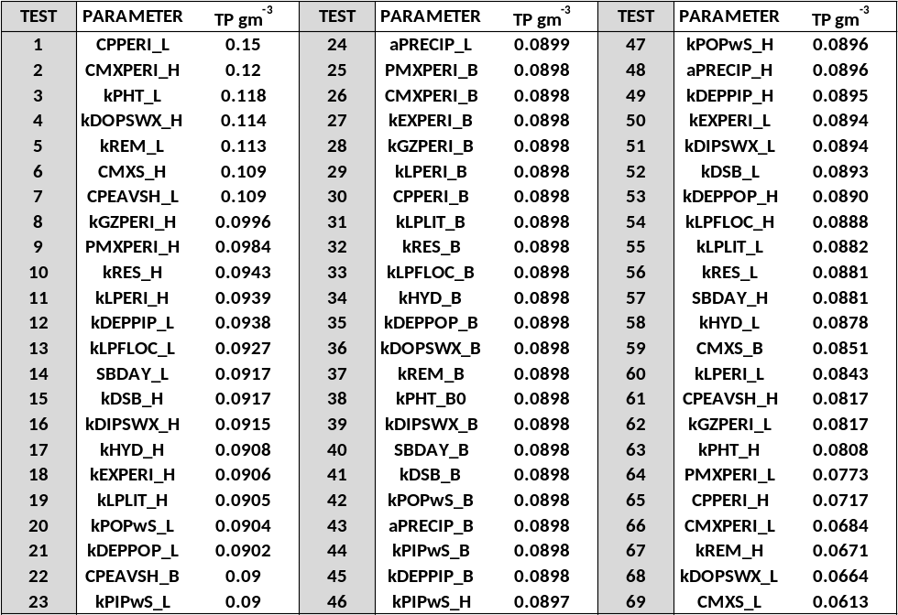

Table Modeling Phosphorus Biogeochemistry in STA Wetlands-14. The key parameters and their symbols, definitions, units, and value.
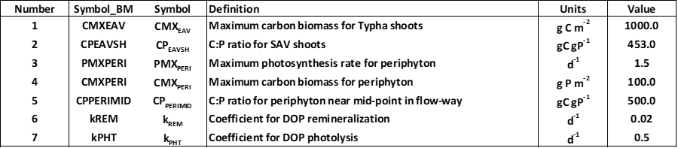

The model daily time series and average concentrations for all 15 pools were evaluated during calibration and tuning. Although the key parameters for overall TP_{W} concentrations were identified, the adjustments led to changes in some of the individual biogeochemical pools. In particular, the vertical processes of particulate sinking from the water and diffusive efflux from the soil were recognized as key to the predicted concentrations of DOP, DIP, and PIP in the water and soil. Twenty more simulations were performed to further assess the effects of varying each of four different parameters on the average concentrations. Five different values were used for each of the four parameters and evaluated using bar charts marked with reference lines for the respective BGC Model targets (DOP_{S}, DOP_{W}, DIP_{S}, DIP_{W}, PIP_{S}, PIP_{W}). The four parameters were k_{DOPSWX}, k_{DIPSWX}, the PIP vertical sinking rate (k_{PIPWS}; m d⁻¹), and the soil PIP deposition rate (k_{PIPDEP}; d⁻¹; Table 2-14).
Table Modeling Phosphorus Biogeochemistry in STA Wetlands-15. The parameters and ranges of values for series to calibrate DOP, DIP, and PIP in the soil and water of the Biogeochemical Model of STA FW1.
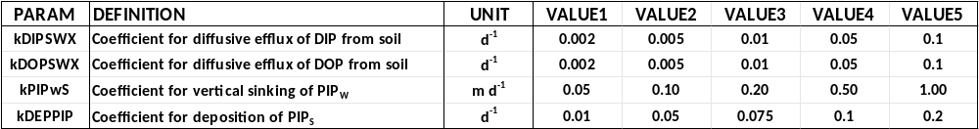
Varying the rate k_{DIPSWX} from 0.002-0.1 d⁻¹ did not affect the concentration of DIP in the soil (DIP_{S}; Figure 2-16A). However, increasing the value to >0.01 d⁻¹ elevated DIP_{W} and TP_{W} to 0.030 and 0.073 g P m⁻³, respectively (Figure 2-16B and 2-16C). This value was determined to be 0.007 d⁻¹ in a model of dissolved P diffusion in the STAs (UF-WBL 2019). Thus, k_{DIPSWX} = 0.01 d⁻¹ was considered optimal. In contrast, increasing the rate of DOP efflux from the soil (k_{DOPSWX}) from 0.002-0.1 d⁻¹ led to decreased DOP_{S} and greatly increased DOP_{W} (Figure 2-16D and 18E). Increasing k_{DOPSWX} from 0.01 d⁻¹ to 0.05 d⁻¹ decreased DOP_{S} by two-thirds and doubled DOPW. The changes were reflected in the model TPW concentrations (Figure 2-16F). In this case, 0.005 d⁻¹ was considered optimal. Varying the rate of PIP_{W} sinking from the water (k_{PIPWS}) from 0.05-1.0 m d⁻¹ did not affect the concentration of PIP in the soil (Figure 2-16G). However, there was an exponential decline in the PIP_{W} concentration and associated decreased TP_{W} (Figure 2-16H and 2-16I). Finally, increasing the rate of PIP_{S} deposition from 0.01-0.2 d⁻¹ led to a rapid decline in PIP_{S} from 7.9 g P m⁻² to 0.11 g P m⁻² but did not affect TP_{W} (Figure 2-16J and 2-16K).
The adjustments to the parameters which modulate DIP and PIP led to an evaluation of the function to simulate the co-precipitation of DIP_{W} (DIP_{WPRC}; g P m⁻³ d⁻¹) with increased total gross primary production (G_{TOTAL} = G_{PHYTO} + G_{PERI} + G_{SAV}; g C m⁻² d⁻¹; Figure 2-17A). A calibration series was performed to test the effects of varying the slope of the linear relationship (a_{PRC}) between G_{TOTAL} and DIP_{WPRC} from 0.001 to 0.01 g P g C⁻¹ on D_{IPW}, PIP_{W}, and TP_{W} (Figure 2-17B through 2-17D). Increasing a_{PRC} decreased model average DIP_{W} (0.0731 to 0.0439 g P m⁻³), increased model average PIP_{W} (0.079 to 0.117 g P m⁻³), and decreased model average TP_{W} (0.1249 to 0.0973 g P m⁻³). This calibration exercise indicated that a value of 0.002 g P g C⁻¹ might be optimal for a_{PRC} in the BGC Model (Figure 2-17B).

Sensitivity Analysis of the BGC Model (Task 8.5)
The objective of Task 8.5 was to perform sensitivity analysis on the Biogeochemical Model of STA-2 FW1 (BGC Model) conceptualized in Phase I, developed in Phase II, and improved in Phase III. The base BGC Model resulting from the Task 8.4 Calibration and Validation over the entire simulation period from 1/1/2005 to 12/31/2020 (5844 days) was used in this task. The consultant and the SFWMD STA modeling team identified four primary areas of emphasis for sensitivity analysis. The four were the evaluation of changes in inflow (Q0) on total phosphorus loads (QT_{P}; g P m⁻² d⁻¹) and water column TP (TP_{W}) in the model flow-way, the evaluation of changes in the incoming TP concentrations [TP]_{IN} on Q_{TP} and TP_{W}, and additional biogeochemical calibration to test for effects of three specific parameters. Finally, the sensitivity tests were repeated to evaluate the effects on the TP concentration in the model outflow ([TP]_{OUT}).
(Q_{TP}; g P m⁻² d⁻¹) was manipulated in two different series. Changing the inflow volumes (Q₀; m³ d⁻¹) and thus Q_{TP} was evaluated in the first series by altering each of the daily inflow values from the base case in a linear array (-0.25X, -0.5X, 1.0X or base, +1.5X, +2.0X). This was accomplished by creating 4 new daily time series in addition to the base case (Q₀). The changes in flow-way volume and depth were assessed for each of the five simulations. The resulting daily predictions for Q_{TP} and TP_{W} were used to generate monthly averages. Potential relationships between Q_{TP} (independent) and TP_{W} (dependent) for each simulation were evaluated via linear regressions using scatter plots of the average monthly values. The annual total Q_{TP} and average TPW were calculated and averaged over all water years for each simulation.
In the second series Q_{TP} was altered across the same linear array by creating a multiplicative factor within the model used to adjust the [TP]_{IN} by -0.25X, -0.5X, 1.0X or base, +1.5X, and +2.0X. In this series the incoming concentrations of POP_{W}, DOP_{W}, DIP_{W}, and PIP_{W} were changed to alter [TP]_{IN} and thus Q_{TP}. The simulations, processing of the output, calculations, and assessment for the five scenarios were identical to the inflow simulation series.
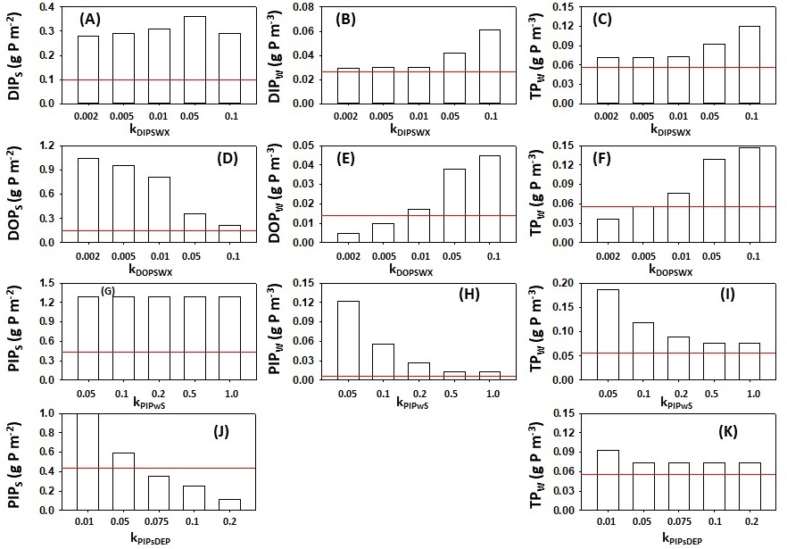
Figure Introduction-18. Calibration results. (A-E) k_{DOPSWX} (m⁻¹). (F-J). k_{DIPSWX} (m⁻¹). (K-N) a_{PRC} (g P g C⁻¹).
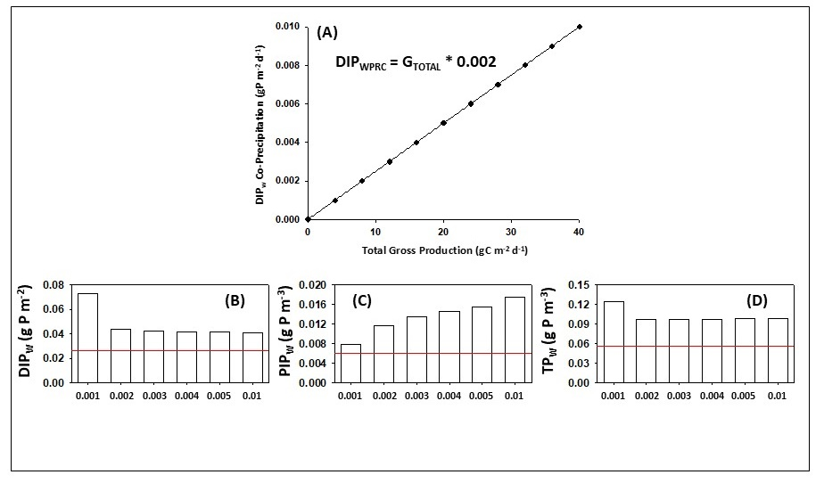
Figure Introduction-19. (A) Linear relationship to model effect of total gross production (g C m⁻³ d⁻¹) on DIP_{W} co-precipitation (g P m⁻³ d⁻¹). (B-D) Comparative bar charts for calibration of the updated Biogeochemical Model. The red line on each plot denotes the model target.
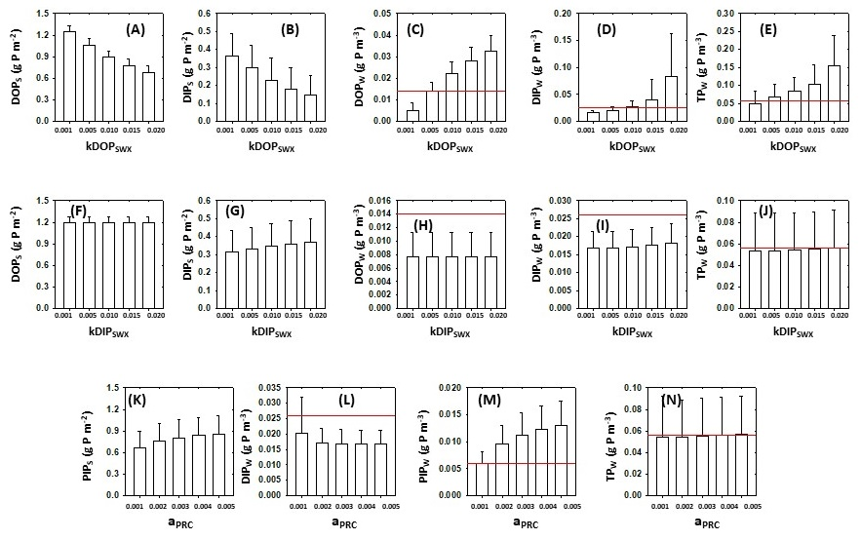
Figure Introduction-20. Calibration results. (A-E) k_{DOPSWX} (m⁻¹). (F-J). k_{DIPSWX} (m⁻¹). (K-N) a_{PRC} (g P g C⁻¹).
The BGC Model required further calibration to fine tune three important parameters. k_{DOPSWX}, k_{DIPSWX}, and a_{PRC} (Table 2-15). Five different values of each were applied across 15 separate simulations for the entire model simulation period (1/1/2005 to 12/31/2020; Table 2-15). The average and standard deviations for the concentrations of DOP_{S} (g P m⁻²), DIP_{S} (g P m⁻²), DOP_{W} (g P m⁻³), DIP_{W} (g P m⁻³), and TP_{W} (g P m⁻³) were calculated for each simulation. Finally, the five different sensitivity test series (k_{DOPSWX}, k_{DIPSWX}, a_{PRC}, Q₀, [TP]_{IN}) were repeated to evaluate the effects on [TP]_{OUT}.
Increasing k_{DOPSWX} from 0.001 to 0.02 d⁻¹ led to reductions in the average soil concentrations of DOP and DIP (Figure 2-18A and 2-18B). Not surprisingly the water column concentrations of DOP_{W}, DIP_{W}, and TP_{W} increased as more DOP released from the soil with increased k_{DOPSWX} (Figure 2-18C to 2-18E). In contrast, adjusting k_{DIPSWX} upward did not significantly affect DIPS, DOP_{S}, DOP_{W}, DIP_{W}, or TP_{W} (Figure 2-18F to 2-18J). Increasing a_{PRC} from 0.001 to 0.005 g C g P⁻¹ led to slightly increased PIP_{S} and PIP_{W} but did not affect TP_{W} (Figure 2-18K to 2-18N). The resulting base values for k_{DOPSWX} (0.005 d⁻¹), k_{DIPSWX} (0.01 d⁻¹), and a_{PRC} (0.001 g P g C⁻¹) were the same as the previous calibration values (Task 8.4).
Table Modeling Phosphorus Biogeochemistry in STA Wetlands-16. Summary of sensitivity tests for the Biogeochemical Model of STA-2 FW1. Provided are the test description, parameter, units, and range of test values for each parameter.
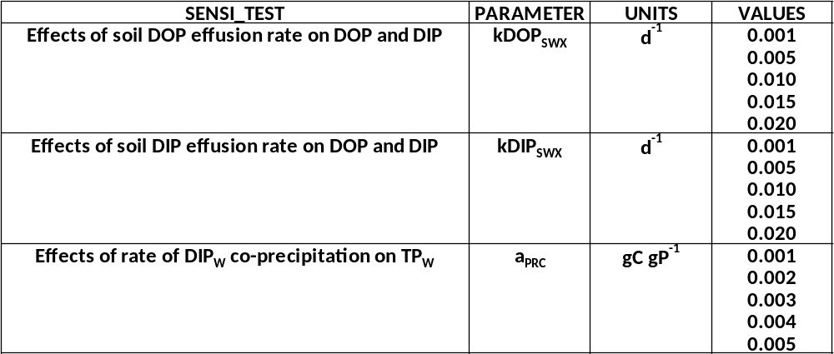

The Q₀ simulation series to alter Q_{TP} resulted in a range of flow-way model volumes (V_{MOD}) from 0.001-0.006 km3 (Figure 2-19). V_{MOD} averaged 0.0024 km3, 0.0028 km3, 0.0032 km3, 0.0035 km3, and 0.0037 km3 among the five simulations (Table 2-16). Similarly, average h_{MOD} varied with volume ranging from 0.324 m to 0.492 m with adjustments to model Q₀ (Table 2-16).
There were obvious differences between the volume and depth of the model flow-way between the Calibration (1/1/2005-12/31/2012) and Validation (1/1/2013-12/31/2020) periods (Table 2-8; Figure 2-20). Q₀ and Q_{TP} were more variable from WY2005-WY2012 than WY2013-WY2020. Inflow was generally reduced and less variable during the second half of the BGC Model time series (Figure 2-20).
Average annual Q_{TP} was greatest in WY2007, WY2009, WY2012, WY2017 ranging from 0.03 g P m⁻² d⁻¹ to > 0.1 g P m⁻² d⁻¹ among the five Q₀ series simulations (Figure 2-21). The TP_{W} concentrations exhibited minimal responses to increases or decreases in external TP loading except when inflow to the model flow-way was doubled (Figure 2-21A to 2-21E). There was no grand effect of altering inflow on TP loads and water column TP in the flow-way over all five simulations (Figure 2-21F).

Table Modeling Phosphorus Biogeochemistry in STA Wetlands-17. Summary of average model flow-way volume (V_{MOD}; km³) and depth (h_{MOD}; m³) for each of the five simulations to vary inflow (Q₀).
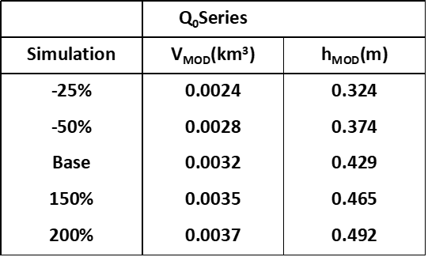
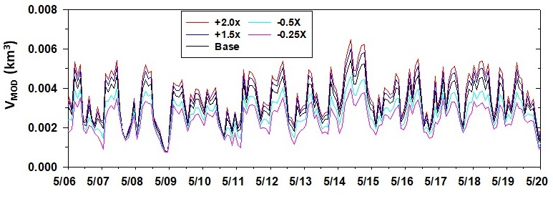
Figure Introduction-21. Time series of average monthly flow-way volumes (km³) predicted by the hydrologic component of the Biogeochemical Model of STA-2 FW1 for five different inflow (Q₀) simulations. The Q₀ series tested inflows that were -0.25X, -0.50X, base model, +1.5X, and +2.0.

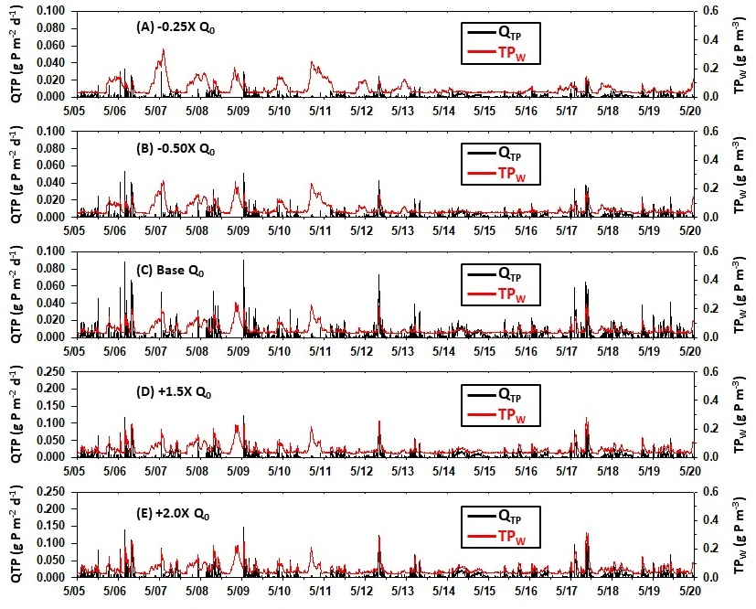
Figure Introduction-22. Daily total phosphorus loads (Q_{TP}; g P m⁻² d⁻¹; black; left axis) and water column TP (TP_{W}; g P m⁻³; red; right axis) from the series to test the effects of variable inflow (Q₀) on the Biogeochemical Model of STA2 FW1. (A) -0.25X base model Q₀. (B) -0.50X base model Q₀. (C) Base model Q₀. (D) +1.5X base model Q₀. (E) +2.0X base model Q₀. Note increase in y-axis range in D and E.
While altering Q₀ affected flow-way loading, volume, and depth, alterations to [TP]_{IN} only changed the daily TP loads. While the temporal patterns in Q_{TP} resulting from changing [TP]_{IN} were very similar to those resulting from the Q0 series, the magnitude of both the TP loads and TP_{W} were more variable (Figure 2-22). The decreases and increases in average Q_{TP} and TP_{W} when [TP]_{IN} was reduced or increased were greater than in the Q₀ series (Figure 2-22). Similar to the Q₀ series there were no apparent associations in most of the scatter plots (Figure 2-24A to 2-24D). However, TP_{W} increased significantly with elevated QT_{P} due to a doubling of [TP]_{IN} (Figure 2-24E). There was an overall robust relationship between external TP loading and internal water column TP concentrations when Q_{TP} was altered using the inflow concentrations (Figure 2-24F).

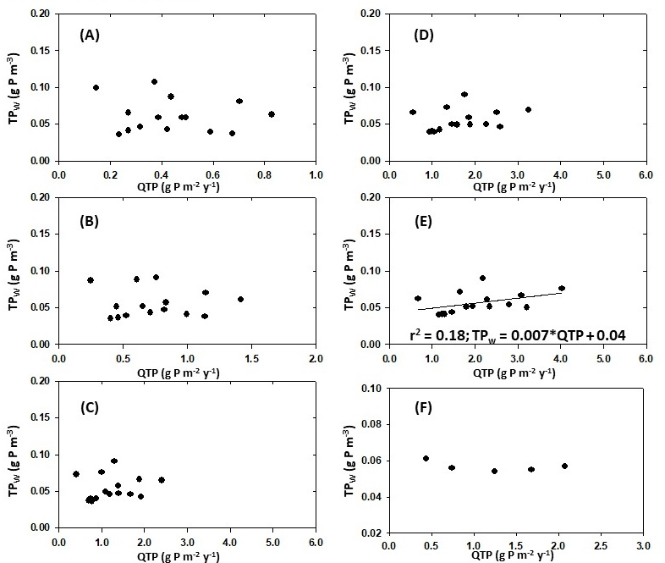
Figure Introduction-23. Scatter plots of annual TP loading (Q_{TP}; g P m⁻² y⁻¹) vs average water column TP concentration (TP_{W}; g P m⁻³) resulting from the Q₀ series to alter TP loading to the model flow-way. (A) -0.25X. (B) -0.50X. (C) Base model. (D) +1.5X. (E) +2.0X. (F) Q_{TP} vs TP_{W} averages over all water years for each Q₀ simulation.
Figure Modeling Phosphorus Biogeochemistry in STA Wetlands-22. Results from TP load simulation series. (A) Average annual TP loading Q_{TP} (gP m⁻² d⁻¹) from the Q₀ (open bars) and [TP]_{IN} (grey bars) for the Q₀ series. (B) Water column TP concentration TP_{W}(g P m⁻³) for the Q₀ (open bars) and [TP]_{IN} (grey bars)from the [TP_{}IN} series.
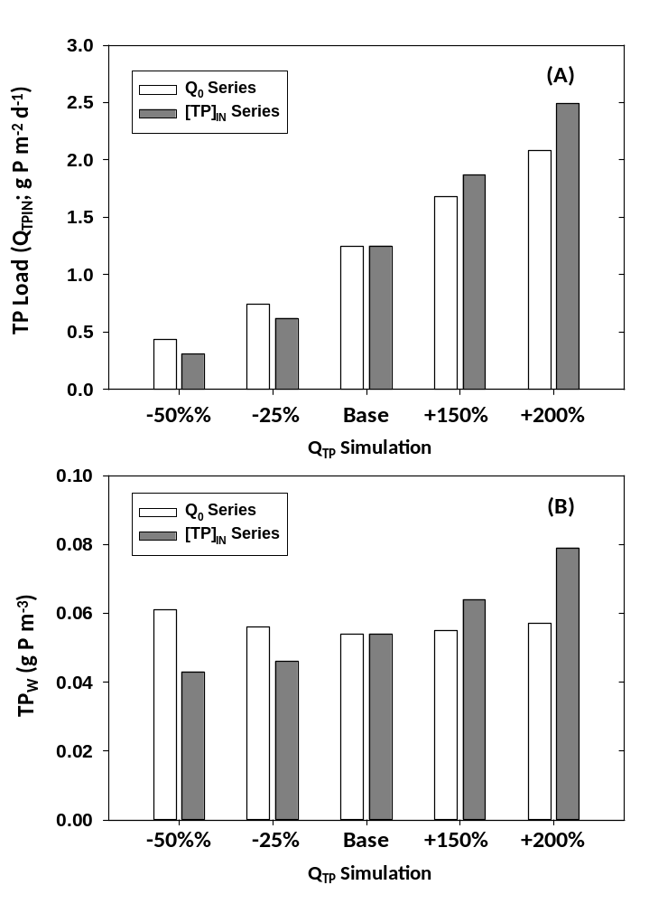

The effects of k_{DOPSWX} on [TP]_{OUT} were much greater than those of k_{DIPSWX} (Figure 2-25A and 2-25B). [TP]_{OUT} increased from 0.106 g P m⁻³ which was 19.8% less than the base value (0.106 g P m⁻³) to a maximum of 0.304 g P m⁻³ (+185.7%) when k_{DOPSWX} was 0.02 d⁻¹. Similar to k_{DIPSWX}, there were no discernable effects of a_{PRC} on the outflow TP concentrations (Figure 2-25C). It is important to emphasize that the base values for these three parameters were established using both soil and water column P concentrations across multiple calibrations in Task 8.4. There were differences in the [TP]_{OUT} concentrations resulting from the Q₀ and [TP]_{IN} series (Figure 2-25D and 2-25E). [TP]_{IN} increased from 0.012 g P m⁻³ or 89.1% less than the base value (0.106 g P m⁻³) to a maximum of 0.314 g P m⁻³ when the inflow to the model flow-way was doubled. This increase was in contrast to the dilution of the internal TP (TP_{W}) observed in the Q₀ series (Figure 2-25D and 2-25E).
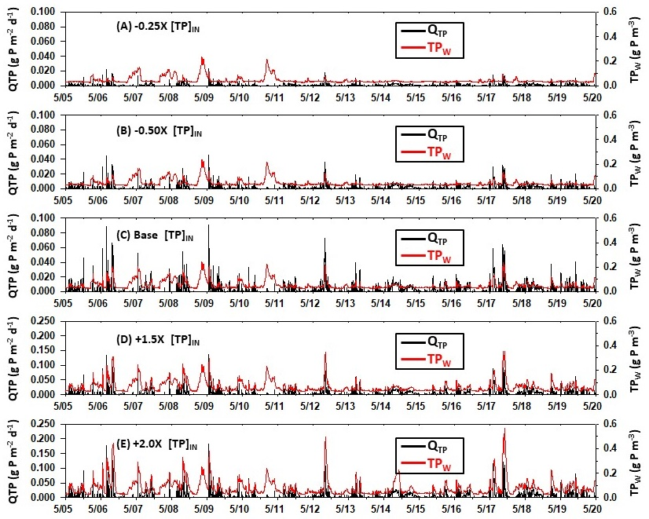
Figure Introduction-23. Daily total phosphorus loads (Q_{TP}; g P m⁻² d⁻¹; black; left axis) and water column TP (TP_{W}; g P m⁻³; red; right axis) from the series to test the effects of variable inflow (Q₀) on the Biogeochemical Model of STA2 FW1. (A) -0.25X base model Q₀. (B) -0.50X base model Q₀. (C) Base model Q₀. (D) +1.5X base model Q₀. (E) +2.0X base model Q₀. Note increase in y-axis range in D and E.
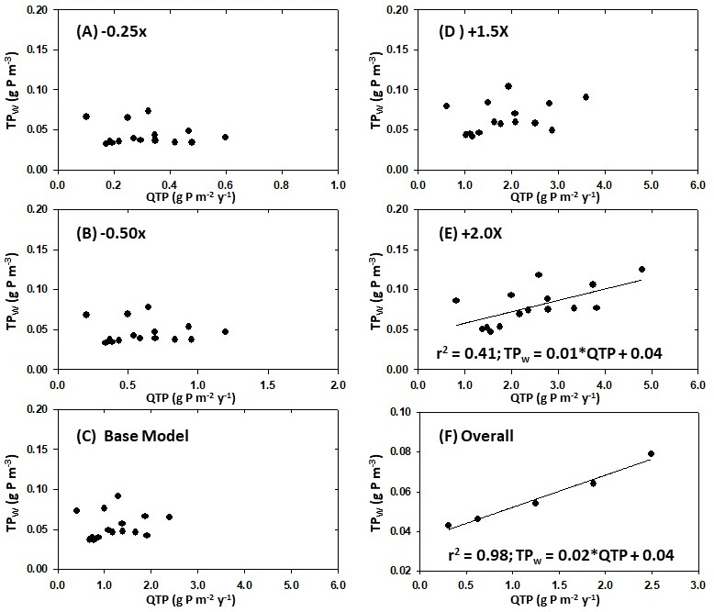
Figure Introduction-24. Scatter plots of annual TP loading (Q_{TP}; g P m⁻² y⁻¹) vs average water column TP concentration (TP_{W}; g P m⁻³) resulting from the Q₀ series to alter TP loading to the model flow-way. (A) -0.25X. (B) -0.50X. (C) Base model. (D) +1.5X. (E) +2.0X. (F) Q_{TP} vs TP_{W} averages over all water years for each Q₀ simulation.

Table Modeling Phosphorus Biogeochemistry in STA Wetlands-17. Results of sensitivity analysis to test effects of changes parameters and total phosphorus loading (Q_{TPIN}) on the TP concentration in the model outflow [TP]_{OUT}. Included are the average [TP]_{OUT} concentration from each test and the percent difference relative to the base value (shown in red). Test series included effects of a_{PRC}, k_{DIPSWX}, k_{DOPSWX}, Q₀, and [TP]_{IN}
 | aPRC |  | TPCOUT
TEST | VALUE | %DIF | VALUE |  | %DIF
1 | 0.001 |  | 0.106
2 | 0.002 | 100.0% | 0.097 |  | -8.8%
3 | 0.003 | 200.0% | 0.096 |  | -10.0%
4 | 0.004 | 300.0% | 0.096 |  | -10.3%
5 | 0.005 | 400.0% | 0.095 |  | -10.4%
 | kDIPSWX |  | TPCOUT
TEST | VALUE | %DIF | VALUE |  | %DIF
1 | 0.001 | -90.0% | 0.106 |  | -0.8%
2 | 0.005 | -50.0% | 0.106 |  | -0.6%
3 | 0.010 |  | 0.106
4 | 0.015 | 50.0% | 0.108 |  | 1.1%
5 | 0.020 | 100.0% | 0.109 |  | 2.8%
 | k_{DOPSWX} |  | TP_{COUT}
TEST | VALUE | %DIF | VALUE |  | %DIF
1 | 0.001 | -80.0% | 0.086 |  | -19.6%
2 | 0.005 |  | 0.106
3 | 0.010 | 50.0% | 0.188 |  | 43.3%
4 | 0.015 | 66.7% | 0.262 |  | 59.4%
5 | 0.020 | 75.0% | 0.304 |  | 65.0%
 | Q0 |  | TPCOUT
TEST | %DIF |  | VALUE | %DIF
1 | -25.0% |  | 0.012 | -89.1%
2 | -50.0% |  | 0.037 | -64.9%
3 | 100.0% |  | 0.106
4 | 150.0% |  | 0.201 | 89.0%
5 | 200.0% |  | 0.314 | 194.8%
 | TP_{CIN} |  | TP_{COUT}
TEST | %DIF |  | VALUE | %DIF
1 | -25.0% |  | 0.069 | -35.6%
2 | -50.0% |  | 0.078 | -26.8%
3 | 100.0% |  | 0.106
4 | 150.0% |  | 0.142 | 33.5%
5 | 200.0% |  | 0.185 | 73.6%

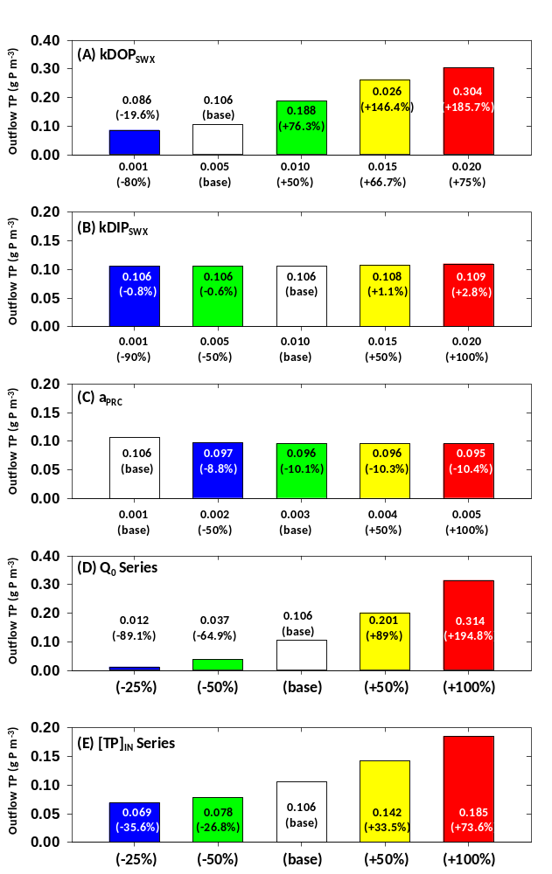
Figure Introduction-25. Results of sensitivity analysis to test effects of changes parameters and total phosphorus loading (Q_{TPIN}) on the TP concentration in the model outflow [TP]_{OUT}. Each bar plot provides the parameter values and percent difference from base model (x-axis) and the average [TP]_{OUT} concentrations and percent difference from base model (y-axis). The white bar indicates the base model value. (A) k_{DOPSWX}; (B) k_{DIPSWX}; (C) a_{PRC}; (D) Q₀ Series; (E) [TP]_{IN} Series. A value of 0.005 d⁻¹ was used for _{kDOPSWX} (see Summary & Sythesis).
Table Modeling Phosphorus Biogeochemistry in STA Wetlands-18. Data target concentrations and model concentrations for 15 phosphorus pools of Biogeochemical Model of STA-2 FW1.
P POOLS | DATA_AVG | DATA_SD | MOD_AVG | MOD_SD
PPHYTO (g P m-3) | 0.002 | 0.001 | 0.002 | 0.0003
PPERI (g P m-2) | 0.05 | 0.03 | 0.16 | 0.012
PSHOOT (g P m-2) | 1.95 | 0.87 | 1.94 | 0.10
PRR (g P m-2) | 0.83 | 0.62 | 0.58 | 0.09
PLITTER (g P m-2) | 0.70 | 0.32 | 0.82 | 0.09
PFLOC (g P m-2) | 1.64 | 0.65 | 1.63 | 0.12
PSAV (g P m-2) | 0.16 | 0.04 | 0.11 | 0.01
POPs (g P m-2) | 2.57 | 2.16 | 3.54 | 0.16
DOPs (g P m-2) | 0.15 | 0.12 | 1.15 | 0.09
DIPs (g P m-2) | 0.10 | 0.08 | 0.32 | 0.12
PIPs (g P m-2) | 0.44 | 0.27 | 0.64 | 0.22
POPw (g P m-3) | 0.0100 | 0.0100 | 0.0255 | 0.0300
DOPw (g P m-3) | 0.0140 | 0.0074 | 0.0100 | 0.0003
DIPw (g P m-3) | 0.0260 | 0.0282 | 0.0243 | 0.0123
PIPw (g P m-3) | 0.0060 | 0.0025 | 0.0062 | 0.0020
TPw (g P m-3) | 0.0560 | 0.0120 | 0.0660 | 0.0392

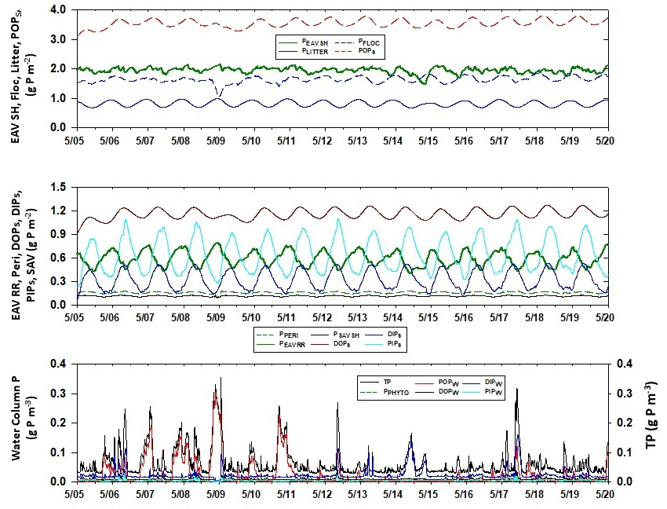
Figure Introduction-26. Daily time series for fifteen P pools resulting from the Phase III Biogeochemical Model.
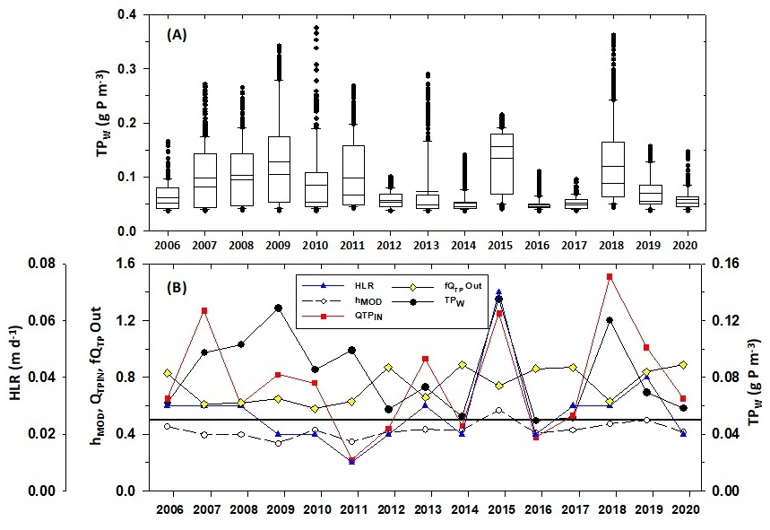
Figure Introduction-27. (A) Box and whisker plots showing distribution of BGC Model predictions of TP_{W} (g P m⁻³) for each water year (WY) from 2006-2020. (B) Annual values for multiple variables predicted using the BGC Model for each water year 2006-2020. Included are the average hydraulic loading rate (HLR; m d⁻¹), average depth (h_{MOD}; m), total TP load (Q_{TP}; g P m⁻² y⁻¹), the fraction of Q_{TP} removed by the flow-way (f_{QTP} Out), and the water column TP concentration (TP_{W}; g m⁻³; right axis).
Table Modeling Phosphorus Biogeochemistry in STA Wetlands-19. Average annual water column concentrations of POP_{W}, DOP_{W}, DIP_{W}, and TP_{W} (g P m⁻³) from the Biogeochemical Model of STA-2 FW1. The bottom row has the grand averages.
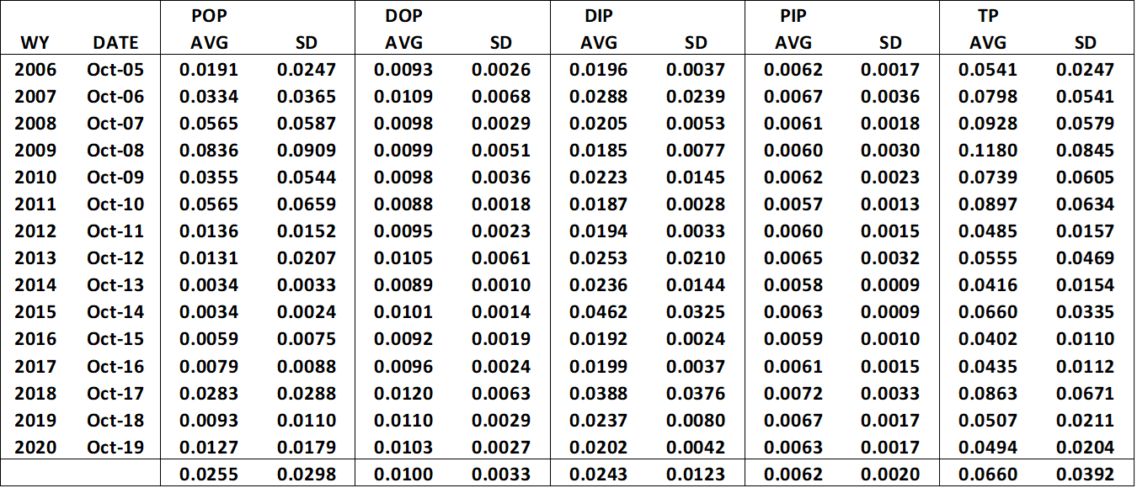

Table Modeling Phosphorus Biogeochemistry in STA Wetlands-20. Annual values for multiple variables from the BGC Model of STA2 FW1. Included are the average volume (V_{MOD}; km³), average depth (h_{MOD}; m), average hydraulic loading rate (HLR; m d⁻¹), total inflow and outflow TP loads (QTP_{IN} and QTP_{OUT}; g P m⁻² y⁻¹), the percentage of QTP_{IN} removed, the average and standard deviation of the outflow TP concentration from data ([TP]_{OUT} Data; g P m⁻³), the average outflow TP concentration from the BGC Model ([TP]_{OUT} Model; g P m⁻³), and the water column TP concentration from the BGC Model (TP_{W}; g P m⁻³).
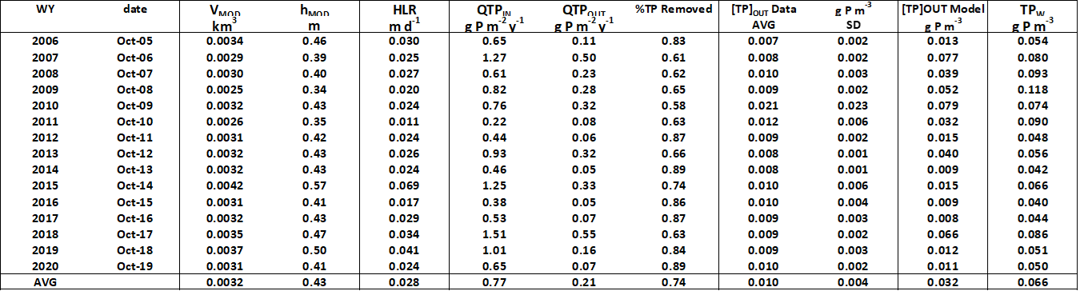

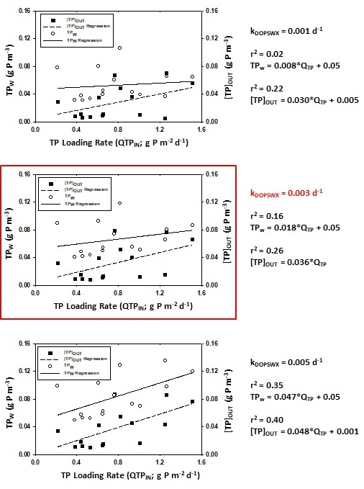
Figure Introduction-2428. Scatter plots and linear regressions between total annual TP loading (QTP_{IN}; g P m-2 y⁻¹) and both the TP concentration of BGC Model water column (TPW; left axis; open circles; solid line) and the outflow ([TP]_{OUT}; right axis; solid squares; dashed line. (A) Results when k_{DOPSWX} was 0.001 d⁻¹. (B) Results when k_{DOPSWX} was 0.003 d⁻¹. (C) Results when k_{DOPSWX} was 0.005 d⁻¹. Included are the regression coefficient and parameter values. The most optimal scenario is highlighted in red.

Summary & Significance
The BGC Model was developed in three Phases to integrate accumulated STA data and information, simulate patterns of and changes in the internal P biogeochemical concentrations, and evaluate wetland TP loading and removal at the flow-way scale. The model was based on a 744 hectare, cattail dominated flow-way with a comprehensive empirical database which removes ~86% of incoming TP annually (STA2 FW1). It evolved from the initial conceptualization (Phase I) into a first-generation mathematical model to simulate changes in P concentrations among the water, periphyton, SAV, Typha, and soils from 1/1/2005 to 12/31/2020 (Phase II). A Hydrologic Model and equation syntax to ensure mass balance were added so the simulated P concentrations could be calibrated, validated, and tested (Phase III).
The BGC Model results were sensitive to changes in several parameters. These included the periphyton C:P ratio (CP_{PERI}; g C g P⁻¹), the maximum periphyton photosynthetic rate (P_{MXPERI}; d⁻¹) and biomass (C_{MXPER}I; g C m⁻²), the rates of remineralization (k_{REM}; d⁻¹) and photolysis (k_{PHT}; d⁻¹) of DOP, the maximum Typha shoot biomass (C_{MXEAV}; g C m⁻²), and the rates of dissolved DOP and DIP efflux from the soil to the water (k_{DOPSWX} and k_{DIPSWX}; d⁻¹). Each of these were adjusted during extensive calibration and sensitivity analyses to generate lowest average TP_{W} concentrations. The resulting Phase III BGC Model was used to generate the daily time series of P concentrations and calculate the grand averages for comparison to the empirical targets (Figure 2-26). P_{EAVSH},, P_{LITTER}, P_{FLOC}, and POP_{S} ranged from 0.5-4.0 g P m⁻² over the fifteen water years (5/1/2005 to 4/30/2020 ). P_{PERI}, P_{EAVRR}, P_{SAV}, DOP_{S}, DIP_{S}, and PIP_{S} ranged from 0.01-0.75 g P m⁻². Finally, P_{PHYTO}, POP_{W}, DOP_{W}, DIP_{W}, PIP_{W}, and TP_{W} ranged from near zero to ~0.25 g P m⁻³. All of the phosphorus pools exhibited regular seasonal-annual periodicity except for POP_{W} (and thus TP_{W}). The oscillations resulted from the intra-annual variations in temperature indicative of the sub-tropical climate. While most of the model biogeochemical processes were driven by temperature predicted using a smooth trigonometric function, POP_{W} was largely driven by daily changes in depth and sinking from the water column (Figure 2-26).
The series of calibration steps improved the overall agreement between the average model P concentrations and the targets from STA2 FW1 (Table 18). Model averages for P_{PHYTO}, PEAVSH, P_{LITTER}, P_{FLOC}, P_{EAVRR}, P_{SAV}, POP_{S}, DIP_{S}, and PIP_{S} were very similar to the average target concentrations. The model periphyton (0.12 + 0.02 g P m⁻²) was elevated relative to the empirical average although the periphyton community and biomass vary greatly along the longitudinal axis of the flow-way. While POP_{W} (0.0150 + 0.0357 g P m-3) and DIP_{W} (0.0335 + 0.0059 g P m⁻³) were similar to the target P concentrations, model DOP_{W} (0.0031 + 0.0037 g P m⁻³) and PIP_{W} (0.0022 + 0.0022 g P m⁻³) were greater than the data averages (Table 18). Model TP_{W} was calculated daily by summing each of the four constituents (POP_{W}, DOP_{W}, DIP_{W}, PIP_{W}) and averaged over the entire 5488-day simulation (0.0974 + 0.0355 g P m⁻³; Table 18). Despite the redefined targets and parameter adjustments, soil DOP predicted by the model (0.62 + 0.09 g P m⁻²) was approximately three times greater than expected (0.15 + 0.12 g P m⁻²). DOP dynamics were perhaps the most uncertain processes in the BGC Model with implications for understanding potential responses to variable external TP loads (see below).
The average concentrations of POP_{W}, DOP_{W}, DIP_{W}, PIP_{W}, and TP_{W} were 0.026, 0.010, 0.024, 0.006, and 0.066 g P m⁻³, respectively (Table 2-19). POP_{W} had greater annual average concentrations the first half of the model time period and was overall more variable than the other three constituents (0.026 + 0.030 g P m-3). DOP_{W} (0.010 + 0.003 g P m-3) and PIP_{W} (0.006 + 0.002 g P m⁻³) did not vary greatly . Average annual DIP_{W} ranged from 0.019 + 0.008 g P m-3 (WY2009 and WY2011) to 0.046 + 0.003 g P m⁻³ (WY2015). TP_{W} concentrations ranged from a minimum of 0.040 + 0.011 g P m⁻³ (WY2016) to 0.118 + 0.085 g P m⁻³ (WY2009) when the POP_{W} concentration was greatest (0.084 + 0.091 g P m⁻³; Table 2-19).
The model TP_{W} concentrations had wide and skewed distributions in multiple water years leading up to WY2011 (Figure 2-27A). Except for WY2015 and WY2018, the ranges in predicted internal TP_{W} narrowed and declined over time. This was due to the stabilization of depth and POP_{W} concentrations in the Validation period from 2013-2020 (Figure 2-11; Figure 2-27). Average TP_{W} was least (<0.06 g P m⁻³) in WY2006, WY2011, WY2014, WY2016, and WY2017 (Figure 28B). In contrast, TP_{W} was greatest (>0.10 g P m⁻³) in WY2008, WY2009, WY2011, WY2015, and WY2018. It was evaluated relative to hydrologic variables and TP loading to the model flow-way.
The output from the base BGC Model over 15 water years was used to assess the inter-annual variations in and potential correlations among Q_{TP} inflow and outflow (g P m⁻² y⁻¹), TP_{W} (g P m⁻³), depth (m), hydraulic loading rate (HLR; m d⁻¹), and the percentage of Q_{TP} removed by the flow-way (Figure 27B; Table 2-20). Model [TP]_{OUT} (g P m⁻³) was calculated annually by dividing the annual net outgoing TP load (Q_{TPOUT}; P m⁻³ y⁻¹) by the annual net outflow (Q_{OUT}; m³ y⁻¹). The observed [TP]_{OUT} was calculated similarly using the outflow and TP load data from structure G335 at the south end of the flow-way for each water year. Associations among these variables could be used to help optimize TP removal by STA flow-ways and cells.
The maintenance of flow-way depth ~0.5 m promoted more predictable relationships among Q_{TP}, HLR, and TP_{W} (Figure 2-27B). While the average annual hMOD started at 0.46 m in WY2006, it was reduced until WY2012 (Table 2-20). The average HLR generally tracked the inter-annual fluctuations in depth during the first half of the simulation. The model flow-way removed only 58-63% of the annual TP load from WY2007=WY2012. The concentrations for both the internal water column TP concentrations (TP_{W}; 0.074-0.118 g P m⁻³) and the outflow TP concentration ([TP]_{OUT}; 0.009-0.021 g P m⁻³) were elevated during this time (Table 2-20). Annual average depth increased during the second half of the simulation period. Except for two high loading years(WY2015 and WY2018), the flow-way removed 84-89% of the Q_{TP} (Figure 2-27B). Q_{TP}, HLR, and TP_{W} were more closely aligned from WY20114-WY2020. It appears that the model flow-way performance (greatest removal and lowest TPW) was optimal when h_{MOD} and Q_{TP} were 0.5 and HLR was 0.03. The BGC Model provided a platform to assess relationships between external TP loading (Q_{TP}) and the resulting TP_{W} and [TP]_{OUT}.
The assessments between Q_{TP} and TP concentrations led to a final calibration series to better understand and apply the results of the BGC Model. Linear regressions between the average annual TP loads and the resulting internal and outflow TP concentrations were applied (Figure 2-28). The Phase III BGC Model predicted that the TP concentrations generally increased linearly with Q_{TP}. This result was expected based on the patterns in the multiple variable time series (Figure 2-28B). In particular, all three variables tracked during the second half of the simulation time. However, the thorough calibration and testing pointed to the rate of soil DOP efflux (k_{DOPSWX}) as perhaps the most pivotal parameter in the BGC Model. TP_{W} and [TP]_{OUT} increased non-linearly with greater values for k_{DOPSWX}. Moreover, there was added uncertainty regarding DOP processes since the data and targets for soil DOP and DIP were extremely variable and the model generally overestimated soil dissolved concentrations. Thus, simulations and regressions were performed for three different values of k_{DOPSWX} (0.001, 0.003, 0.005 d⁻¹; Figure 2-28). The comparative results indicated that increased rates of soil DOP efflux led to a more robust statistical relationship between Q_{TP} and TP_{W} and [TP]_{OUT}. While TP_{W} was not associated with increased TP loading at the lowest value of k_{DOPSWX} (0.001 d⁻¹), the model results suggested that [TP]_{OUT} was responsive when soil DOP efflux was minimal.

CASM-STA MODEL Development
This section describes the development of this project’s second modeling approach. This second approach was an application of the Comprehensive Aquatic Systems Model (CASM) to address and quantify the role of higher trophic levels on P cycling in the STAs along with the biogeochemical processes.

CASM Model Physical Characteristics
    - Study Location Physical Description
The CASM-STA was developed for initial application to the STA-2 FW1 system (Figure 3-1). The area is approximately 823 hectares (2,032 acres) with an average depth of 0.55 m and hydraulic residence time of 16 days (Zhao and Piccone 2020). Vegetation in FW1 is about 93% EAV (cattail) and 7% SAV. The average annual P load is 0.91 g P m⁻². The FW1 removes about 87% of the annual P loading and average concentrations of TP at the outflow are 0.012 g P m⁻³. To be consistent with the WQBEL requirements, outflow TP concentrations should be ≤ 13 µg/L in more that 3 of 5 water years on a rolling basis and the annual flow-weighted mean concentration should not exceed 19 µg/L (SFWMD 2012).
The initial model application divided the FW1 into three contiguous spatial segments: A, B, and C (Figure 3-2). One CASM-STA “node” is being implemented for each segment. A node is defined as the spatial location (m²) of one CASM-STA executable model. Constant surface areas were developed for segments A, B, and C. The total surface area of FW1 was divided equally to give segment areas of 2,479,589 m².
The CASM-STA model nodes are connected through hydrodynamics modeling results produced by the biogeochemical (BGC) model (CELLC 2024). Daily BGC modeled volumes are allocated to CASM-STA segments. Segment volumes are used to compute corresponding segment depth assuming a constant surface area. Daily differences in segment volumes are used to estimate simple linear transport through the segments.
    - Physical Data
Previous and continuing studies of the physical, chemical, and biological/ecological structure and function of the STAs provided critical data used in the development, calibration and evaluation of the CASM-STA. The SFWMD data, reports from previous studies, and the general technical literature were used to identify and collate data used to support the CASM-STA modeling.
Data describing the physical-chemical characteristics of the STA-2 FW1 were required to implement the CASM-STA. The model uses reported values of surface light intensity to drive photosynthesis of populations of phytoplankton, periphyton, SAV, and EAV represented in the CASM-STA.
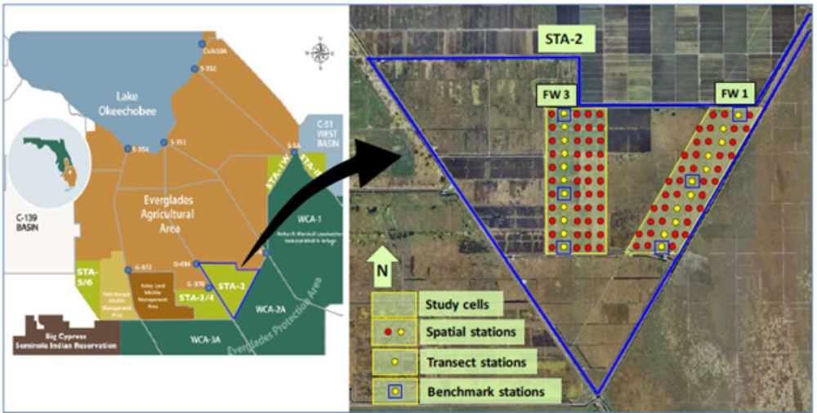
Figure Introduction-25. Location of STA-2 FW1 in relation to the Everglades Agricultural Area and Water Conservation Areas. (From UF-WBL 2019).

Figure Introduction-26. Illustration of the simple compartmental representation of FW1 in STA-2
used in developing the CASM-STA
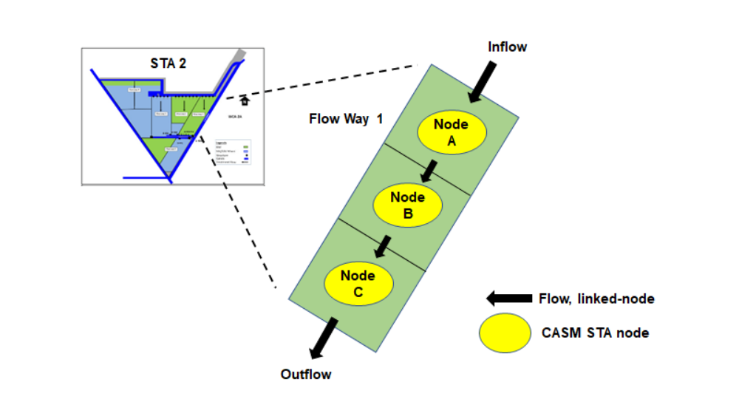
    - Hydrodynamics and transport
The BGC modeled (2005 – 2020) daily aggregate volumes for FW1 were allocated to define daily volumes for segments A, B, and C for use in the CASM-STA (Figure 3-3). The progression in decreasing volumes across the segments reflects the gradient in depths moving from the uppermost to the lower regions of FW1.
The volumes allocated to segments A, B, and C from the aggregate BGC FW1 model results were regressed against the same empirical volumes calculated for the calibration of the three-node CASM-STA (Stantec 2024a, 2024d). The simple allocation of the BGC results provided estimates of segment volumes that agreed very well with the empirical estimates for both the calibration and validation years (Figures 3-4 through 3-6). In all regression comparisons, the agreement was slightly greater for the validation years compared to the calibration years as indicated by the small increment in the R² values – about 0.94 for the calibration years versus about 0.97 for the validation years. The BGC model results, instead of historical data, were used to drive the hydrodynamics in the CASM-STA to facilitate future applications to scenarios of modeled alterations in hydrology produced by the BGC or any alternative physical model of the STAs.
The differences in daily allocations of volume for segments A, B, and C were used to compute corresponding flows and transport from segment A to B, segment B to C, and segment C to out of FW1 for the calibration and validation periods (Tables 3-1 and 3-2). The resulting transport coefficients (1/day) for segment A to B for the calibration years had a mean value was 0.098 d⁻¹ (range: 0.001 – 0.355), which is slightly greater than the 0.0625 d⁻¹ FW1 turnover rate reported by Zhao and Piccone (2019). Similarly, the daily transport from segment B to C was on average 0.103 d⁻¹ (range: 0.001 – 0.352. Transport (Q_{out}) from segment C to out of FW1 based on the daily allocations of volumes and flows was on average 0.110 d⁻¹ (range: 0.001 – 0.402).The values of the transport coefficients for the validation period were slightly higher, but on the same order of magnitude (Table 3-2).
The overall approach addressed the modeling objective of realistically simulating advective transport through the modeled segments without encumbering the computational demands of complex hydrological modeling. The time-varying transport factors reflect daily variations in inflows to segment A and corresponding adjustments to segment volumes and depths with an assumption of constant segment surface area. The results are in general similar to the value derived from Zhao and Piccone (2019) and suggest that advective flows, while important over certain time periods, do not dominate the overall physical characteristics of the modeled STA.
Tables 3-1 and 3-2 summarize the statistical characteristics of the transport coefficients derived for the calibration and validation years.
  - CASM Food Web Model Components
The food web structure for the CASM-STA was developed through collaboration with project participants, particularly SFWMD scientists, with additional support from the available technical literature that described the STAs. The following briefly describes the results of this effort.
    - Phytoplankton
Phytoplankton does not dominate the aquatic vegetation in FW1. However, to develop the CASM-STA, a single population of generically defined phytoplankton was defined to complete the specification of aquatic primary producers required for overall model functionality.

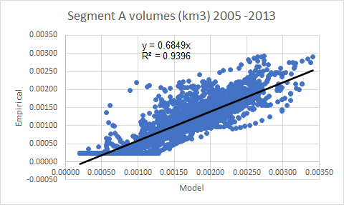
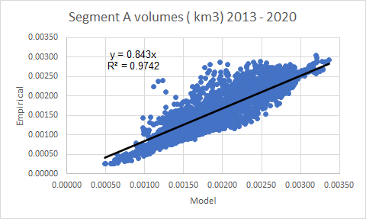
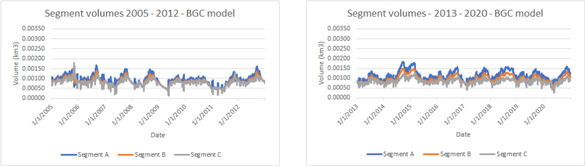
Figure Introduction-27. Allocation of the BGC (CELLC 2024) FW1 modeled volumes for each FW1 segment modeled by the CASM-STA.

Figure Introduction-28. Regression of BGC model and allocated segment A volumes (km⁻³) for the 2005 – 2012 calibration (left panel) and 2013 – 2020 validation (right panel) years.
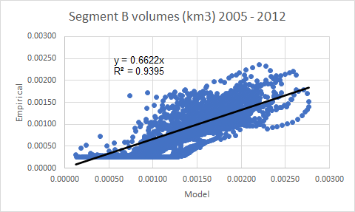
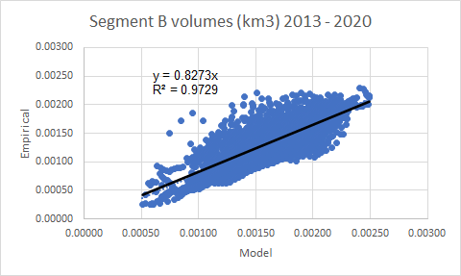
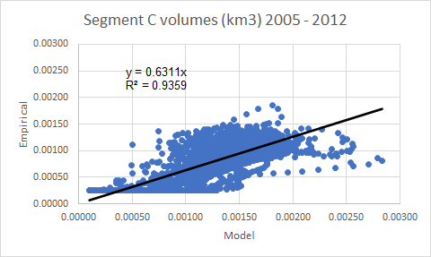
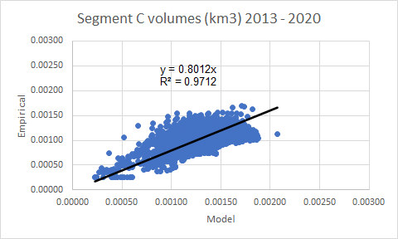

Figure Introduction-29. Regression of BGC model and allocated segment B volumes (km⁻³) for the 2005 – 2012 calibration (left panel) and 2013 – 2020 validation (right panel) years.

Figure Introduction-30. Regression of BGC model and allocated segment C volumes (km⁻³) for the 2005 – 2012 calibration (left panel) and 2013 – 2020 validation (right panel) years.

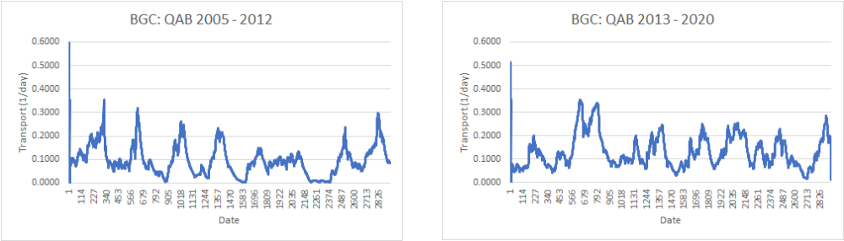
Figure Introduction-31. Daily transport coefficients (1/day) from segment A to B computed for the calibration years (2005 – 2012, left panel) and validation years (2013 – 2020, right panel).
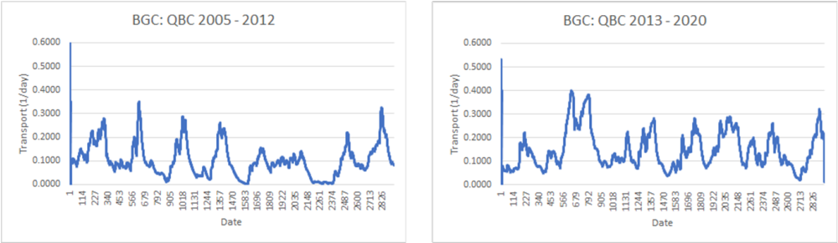
Figure Introduction-32. Daily transport coefficients (1/day) from segment A to B computed for the calibration years (2005 – 2012, left panel) and validation years (2013 – 2020, right panel).

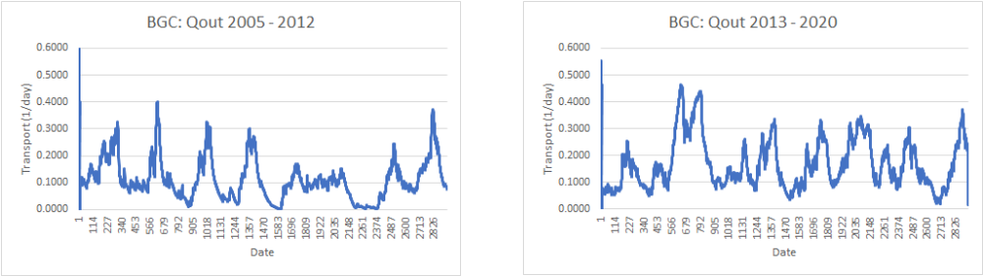
Figure Introduction-33. Daily transport coefficients (1/day) from segment C out of FW1 computed for the calibration years (2005 – 2012, left panel) and validation years (2013 – 2020, right panel).
Table CASM-STA MODEL Development-18. Transport rates (1/d) derived from BGC and EMP models for 2005 - 2012.
Model | mean | SD | CV (%) | Min | max
QAB
BGC | 0.0980 | 0.0632 | 64.5 | 0.0010 | 0.3545
EMP | 0.1045 | 0.0666 | 63.7 | 0.0015 | 0.4930
QBC
BGC | 0.1038 | 0.0681 | 65.7 | 0.0010 | 0.3511
EMP | 0.1101 | 0.0690 | 62.7 | 0.0015 | 0.4358
Qout
BGC | 0.1109 | 0.0754 | 68.0 | 0.0010 | 0.4015
EMP | 0.1166 | 0.0722 | 61.9 | 0.0015 | 0.3748

Table CASM-STA MODEL Development-19. Transport rates (1/d) derived from BGC and EMP models for 2013 - 2020.
Model | mean | SD | CV (%) |  | min | Max
QAB
BGC | 0.1337 | 0.0690 | 51.6 |  | 0.0113 | 0.3550
EMP | 0.1196 | 0.0640 | 53.5 |  | 0.0114 | 0.3465
QBC
BGC | 0.1492 | 0.0795 | 53.3 |  | 0.0128 | 0.4001
EMP | 0.1335 | 0.0730 | 54.7 |  | 0.0128 | 0.3696
Qout
BGC | 0.1700 | 0.0940 | 55.3 |  | 0.0147 | 0.4639
EMP | 0.1521 | 0.0858 | 56.4 |  | 0.0147 | 0.4302

    - Periphyton
Attached algae play an important role in the internal processing of P in the STAs. The CASM-STA includes one generalized population of periphyton; this structure is consistent with the SAV/EAV habitat model (CELLC 2022). Turner et al. (1999) reported mean periphyton standing crop in the WCA-2 as 513 g AFDW/m² (range: 3 – 1,251). Corresponding values for WCA-3 are a mean biomass of 233 g AFDW/m² and range of 213 – 253. These data were used to guide the initial development and calibration of the CASM-STA.
    - Submerged aquatic vegetation (SAV)
Submerged aquatic vegetation accounts for about 7% of the aquatic (non-algal) vegetation FW1 (CELLC 2022). A single generalized population of SAV was included in the CASM-STA food web structure.
    - Emergent aquatic vegetation (EAV)
Cattail dominates the EAV in FW1 and a single population of EAV was correspondingly included in the CASM-STA food web for this application.
    - Zooplankton
A single generic population of zooplankton was included in the CASM-STA food web. This was done to define a functionally complete food web and support the mainly planktivorous eastern mosquitofish included in the model (see fish section below). At the same time, zooplankton have been demonstrated to contribute to P cycling in aquatic systems (Wen and Peters 1994, Hargrave and Geen 1968). Developing a comprehensive model of P dynamics in the STAs reasonably required the inclusion of zooplankton, an important energetic nexus between aquatic primary producers (phytoplankton, periphyton) and higher-order consumers (e.g., invertebrates and fish).
    - Benthic invertebrates
Benthic invertebrates are key components of aquatic food webs in general and potentially important consumers in the STAs (Cummins 1973, Trexler and Loftus 2016). Two populations of benthic invertebrates were defined in the CASM-STA. One generalized population of benthic infauna was included in the model to represent those organisms (e.g., amphipods, oligochaetes, chironomids) inhabiting floating and settled algal mats and sediments within the FW1. These organisms were assumed to excrete DIP into the DIP_{w} pool (Kitchell et al. 1979).
A population of grass shrimp (Palaemonetes paludosus) was added to the CASM-STA food web per the original specifications of the modeling project and because of the abundance of this species in the STAs – with the potential to influence internal P dynamics as a function of excretion and egestion. Neither the benthic infauna nor the grass shrimp were assumed to physically alter the sediments (bioturbation).
    - Fish
The STAs include a diverse and abundant fish community that might impact P cycling (Evans et al. 2020, Barton et al. 2019). Representative large and small fish, and grass shrimp (Palaemonetes paludosus) were identified as food web components of interest. Based on reported relative abundance in the STAs (Barton et al. 2020), the eastern mosquitofish (Gambusia holbrooki) was identified as a representative small fish, and the largemouth bass (Micropterus salmoides) was similarly selected as a representative larger fish (Figure 3-10). Tilapia (Oreochromis niloticus) was added based on its relative abundance in the STAs and as a species associated with physical disturbance (bioturbation) of the sediments. A key objective in the development and implementation of the CASM-STA was to examine the potential importance of egestion, excretion, and bioturbation in influencing the internal P dynamics within the modeled FW1. Previous work reported by Barton et al. (2020) indicated the potential importance of fish in the cycling of P within the STAs.
Representative weights for individuals of the three modeled fish species based on reported average lengths and length-weight functions provided by www.fishbase.org (Table 3-3). These values were used in conjunction with biomass values reported for these species in the STAs (e.g., Barton et al. 2020) for purposes of estimating initial biomass conditions and calibration of fish growth and population sizes.
Specific rates (d⁻¹) of consumption (ingestion) and standard respiration for the selected fish and grass shrimp modeled in the CASM-STA were taken from literature values (Table 3-4).
    - Excretion and egestion
The processes of egestion, excretion, and bioturbation constitute the primary influence of consumer populations on the internal P cycling within FW1. Rates of egestion and excretion were estimated from published studies. In addition, it was possible to take more site-specific measures of P excretion rate estimates from Goeke et al. (2023) (mg P/gram wet weight/h) and transform them to the day⁻¹ units used by the CASM-STA for largemouth bass and tilapia (Table 3-5). The values measured by Goeke et al. (2023) are very similar to those derived from Deslauriers et al. (2017). The values developed by Goeke et al. (2023) replaced the previous rates of P excretion in the revised CASM-STA, because they are more site-specific than the more general values provided in Deslauriers et al. (2017).

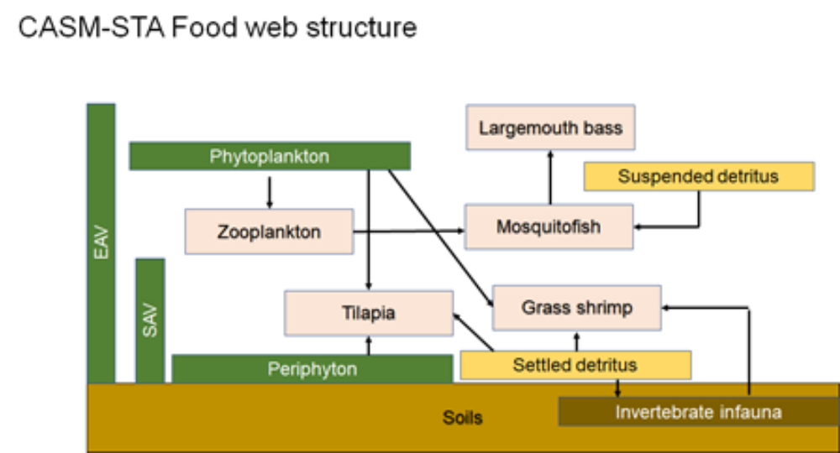
Figure Introduction-34. CASM-STA food web structure informed by SFWMD studies (e.g., Barton et al. 2020, 2021; Evans et al. 2019).
Table CASM-STA MODEL Development-20. Length-weight parameters for fish and grass shrimp included in the CASM-STA food web.
Common | Species | Length | Length-weight |  | Weight*
Name | Name | cm | a | b | g ww | g C/ind
Mosquitofish | Gambusia affinis | 4 | 0.0068 | 3.1 | 0.50 | 0.057
Largemouth bass | Micropterus salmoides | 40 | 0.0105 | 3.11 | 1008.31 | 201.663
Tilapia | Oreochromis niloticus | 16 | 0.0355 | 2.94 | 123.12 | 24.625
Grass shrimp | P. pugio | 1.9 | 0.0178 | 3.025 | 0.124 | 0.028
*Log(wet weight, g) = log(a) + b log(length, cm); carbon is ~11-20% of wet weight

Table CASM-STA MODEL Development-21. Bioenergetics parameters for fish species and grass shrimp included in the CASM-STA food web: consumption and respiration.
Common | Species | Consumption |  |  | Respiration
name | name | CA | CB | Cmax  (d⁻¹) | RA | RB | Rmax  (d⁻¹)
Mosquitofishª | Gambusia affinis | 0.450 | -0.670 | 0.72 | 0.0196 | -0.2 | 0.03119
Largemouth bass^{b} | Micropterus salmoides | 0.330 | -0.325 | 0.03 | 0.00279 | -0.355 | 0.00029
Tilapia^{b} | Oreochromis niloticus | 0.150 | -0.36 | 0.03 | 0.0274 | -0.348 | 0.00484
Grass shrimp | Palaemonetes paludosus |  |  | 0.01^{d} |  |  | 0.00229e
ªChipps and Wahl (2004)
^{b}Deslauriers et al. (2017)
^{c}Cmax = CA (weight ^{CB}); Rmax = RA (weight^{RB}); as in Deslauriers et al. (2017)
^{d}Vernberg and Piyatiratitivorakul (1998)
^{e}Methot et al. (2012)

Table CASM-STA MODEL Development-22. Bioenergetics parameters for fish species and grass shrimp included in the Phase II CASM-STA food web: egestion and excretion.
Common | Species | Egestion, F | Excretion, U
Name | name | (unitless) | (day⁻¹)
Mosquitofishª | Gambusia affinis | 0.200 | 0.0700
Largemouth bass^{b} | Micropterus salmoides | 0.104 | 0.0680
Goeke et al. 2023^{c} |  |  | 0.0848
Tilapia^{b} | Oreochromis niloticus | 0.194 | 0.0292
Goeke et al. 2023 |  |  | 0.0273
Grass shrimp^{d} | Palaemonetes paludosus | 0.04 | 0.029
Benthic infauna | Multiple species | 0.030 | 0.020
Zooplankton | Multiple species | 0.015 | 0.020
ªChipps and Wahl (2004)
^{b}Deslauriers et al. (2017)
^{c}Goeke et al. (2023), GEER 2023 presentation
^{d}Vernberg and Piyatiratitivorakul (1998)

    - Bioturbation
Jimenez-Montealegre et al. (2002) reported the results of pond studies, similar to Avnimelech et al. (1999), that measured bioturbation by tilapia. Jimenez-Montealegre et al. (2002) demonstrated a positive relationship between fish biomass and total suspended solids (Figure 3-11). The regression derived from analysis of the Jimenez-Montealegre et al. (2002) data is used by the current version of the CASM-STA. The function is used to suspend floc, litter, POPs, and PIPs as a function of tilapia biomass. The suspended material is added to the corresponding water column P pools and enters the biogeochemical processing of these pools. The current assumption is that floc, litter, POPs, and PIP_{s} are equally suspended as a result of bioturbation by tilapia.
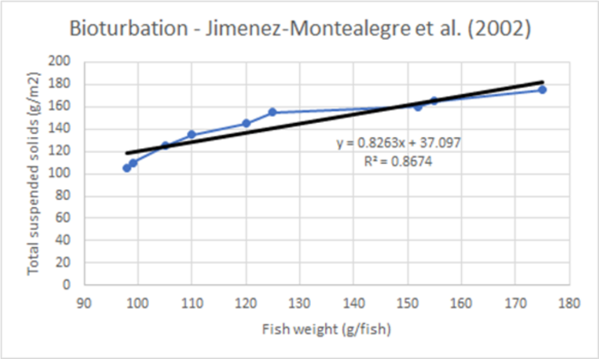
Figure Introduction-35. Regression analysis of total suspended solids versus fish weight based on data gleaned from Jimenez-Montealegre et al. (2002).

    - CASM-STA food web equations
The following differential equation describes the daily change in biomass of the modeled aquatic plant populations (Table 3-6). Nonlinear functions of daily values of water temperature, light intensity, and nutrient availability regulate the expression of plant photosynthesis. A fraction of gross photosynthesis is lost to photorespiration (presp). A fraction of plant biomass is lost daily to temperature-dependent dark respiration. Additional daily losses of population biomass are to sinking (phytoplankton only), non-grazing “natural mortality, and grazing.

Table CASM-STA MODEL Development-23. Governing equation for CASM-STA aquatic plants
(phytoplankton, periphyton, SAV, EAV).

dB_{i}/dt = B_{i} [Pmax_{i} {h(Tp), f(I), g(N), hmod}(1-presp_{i})] – B_{i} [dresp_{i} , h(Tp)] – B_{i} (s_{i} + m_{i}) – Gr(B_{i})

where, for plant population i,

B_{i} biomass of plant population i g C/m²
Pmax_{i} maximum photosynthetic rate g C/g C/d
h(Tp) temperature dependence of photosynthesis unitless
f(I) light dependence of photosynthesis unitless
g(N) nutrient dependence of photosynthesis unitless
hmod habitat quality modifier of growth unitless
presp_{i} photorespiration rate unitless
dresp_{i} dark respiration rate 1/d
s_{i} sinking rate (phytoplankton only) 1/d
m_{i} mortality rate 1/d
Gr grazing loss gC/m²/d

and,

Gr(Bi) = å_{j}[h(Tc) B_{j} Cm_{j} w_{ij} a_{ij} h_{ij} B_{i} )/ (B_{j} + å_{i}w_{ij} a_{ij} h_{ij} B_{i})],

where,

B_{j} biomass of grazer population j g C/m²
h(Tc) temperature dependence of consumption unitless
Cm_{j} max rate of consumption by grazer j g C/g C/d
w_{ij} preference of grazer j for producer I unitless
a_{ij} assimilation of producer i by grazer j unitless
h_{ij} handling efficiency unitless
å_{j} summed over j populations grazing on B_{i}

A similar “input – output” differential equation describes daily changes in the population biomass (carbon) of modeled invertebrates and fish (Table 3-7). Inputs to the population are modeled as consumption of prey populations according to a temperature-dependent feeding term. The calculation of consumption includes the relative preferences of the predator (grazer) for its prey populations and an efficiency that transforms consumption into new biomass of the modeled population. A fraction of daily consumption is lost to egestion and specific dynamic action (the energetic cost of digestion, primarily for fishes). Population biomass is lost daily to excretion and non-predatory “natural” mortality, temperature-dependent standard respiration, and predation.
Parameter values required by the food web equations were derived from the technical literature (Table 3-9 and 3-10).
  - Biogeochemical model
Developing the CASM-STA required the addition of specific soils/sediments and water column P pools as defined by the Biogeochemical model (BGC) modeling effort (Stantec 2024b, CELLC 2024) (Figure 3-12). The resulting CASM-STA added four soils/sediments pools including particulate organic P (POP_{s}), dissolved organic P (DOP_{s}), particulate inorganic P (PIPs), and dissolved inorganic P (DIPs). Separate floc and litter P pools were also added to the soils/sediments state variables in the CASM-STA. Corresponding water column P pools were added to the model, including POP_{w}, DOP_{w}, PIP_{w}, and DIPw. The dissolved inorganic pools, DIP_{s} and DIP_{w} are the principally bioavailable P pools that contribute to modeled productivity in the CASM-STA.
The BGC model specified the detailed physical, chemical and biological processes that transformed the daily values of the soils/sediments and water column P pools (Figure 3-12).
  - Model integration
A key challenge in the overall modeling effort was the integration of the bioenergetics-based food web model and the detailed biogeochemical model of P dynamics into a working CASM-STA. This was accomplished by completing the following tasks:
- Cross-walking the CASM-STA with the BGC model to ensure that the CASM-STA included the P state variables identified in the BGC
- Noting the inclusion of additional food web/ecosystem detail included in the CASM-STA, but represented by more aggregated description in the BGC model
- Including equations from the BGC model in the CASM-STA model code to create an analog of the BGC model internal to the CASM-STA model
- Making the functional connections to the BGC analog by modifying equations to add source/sink terms from the CASM equations
- Adding the needed BGC model parameter values to the input data files for the integrated CASM-STA
Table CASM-STA MODEL Development-24. Governing equation for CASM-STA consumers (zooplankton, benthic invertebrates, fish).

dB_{i}/dt = å_{j}[(B_{i} Cm_{i} h(Tc) w_{ij} a_{i} h_{ij} B_{j} )/(B_{i} + å_{j} w_{ij} a_{ij} h_{ij} B_{j})](1 - f_{i} - rsda_{i}) – B_{i} (u_{i} + m_{i}) – B_{i} [r_{i ,}h(Tr)] – Pr (B_{i})

where, for population i

B_{i} consumer population i biomass g C/m²
B_{j} prey population(s) biomass value(s) g C/m²
Cm_{i} maximum consumption rate 1/d
h(Tc) temperature dependence of consumption unitless
w_{ij} preference of consumer i for prey j unitless
a_{ij} assimilation efficiency for consumer i and prey j unitless
h_{ij} handling efficiency unitless
r_{i} standard respiration rate 1/d
h(Tr) temperature dependence of respiration unitless
u_{i} excretion rate 1/d
f_{i} egestion unitless
m_{i} natural mortality rate 1/d
rsda_{i} specific dynamic action (fish only) unitless
Pr loss to predation g C/m²/

and,

Pr(Bi) = åi[(Bj Cmj h(Tc) wij aij hij Bi )/(Bj + åiwij aij hij Bi)]

where,

Bj biomass of predator population j g C/m2
h(Tc) temperature dependence of consumption unitless
Cij rate of consumption by grazer j g C/m2/d
wij preference of grazer j for producer i unitless
aij assimilation of producer i by grazer j unitless
hij handling efficiency unitless
åi sum over prey populations

Table CASM-STA MODEL Development-25. Cross-comparison of CASM and Biogeochemical Model state variables and modeled consumer populations.

Model State Variables
State variable | BGC |  |  | CASM-STA
DIPw | X |  |  | X
DOPw | X |  |  | X
PIPw | X |  |  | X
POPw | X |  |  | XXª
DIPs | X |  |  | X
DOPs | X |  |  | X
PIPs | X |  |  | X
POPs | X |  |  | XX
Floc | X |  |  | X
Litter | X |  |  | X
EAV shoots | X |  |  | X
EAV roots | X |  |  | X
SAV | X |  |  | X
Periphyton | X |  |  | X
Phytoplankton | X |  |  | X
Modeled Consumer Populations
State variable |  | BGC | CASM-STA
Zooplankton |  | grazing | X
Infauna |  | grazing | X
Grass shrimp |  | grazing | X
Largemouth bass |  | grazing | X
Tilapia |  | grazing | X
Mosquitofish |  | grazing | X
ªXX denotes additional complexity in CASM-STA which includes suspended
POC and sediment POC

Table CASM-STA MODEL Development-26. List of CASM-STA bioenergetics-based parameters for aquatic plants.
Plant  population | Pmax | Topt | Light  Sat-uration | kP | kN | Mort | Photo-resp | Dark-  Resp | Sinking
 | 1/d | deg C | Eins/m2/d | mg P/L | mg N/L | 1/d | unitless | 1/d | m/d
Phyto-plankton | 1.150 | 14-34 | 10 | 0.010 | 0.02 | 0.071 | 0.020 | 0.002 | 0.25^{c}
Peri-phyton | 0.250 | 14-32 | 8 | 0.020 | 0.40 | 0.063 | 0.030 | 0.005 | -
SAV | 0.026 | 16-34 | 8 | 0.005^{b} | 0.05^{b} | 0.004 | 0.035 | 0.005 | -
EAV | 0.024 | 20-30 | -ª | 0.004^{b} | 0.05^{b} | 0.004 | 0.035 | 0.004 | -
ªEAV assumed not light limited; BGC model uses a light saturation value of 150 µmoles m⁻² s⁻¹
^{b}units are g P/m² for SAV and EAV; kP values taken from the BGC model (Table 2-7).
^{c}phytoplankton only

Table CASM-STA MODEL Development-27. List of CASM-STA bioenergetics-based parameters for aquatic consumer populations.
Consumer  population | Cmax | Topt | Specific dynamic action | Standard resp | Egestion | Excretion | Mortality
 | 1/d | deg C | unitless | 1/d | 1/d | 1/d | 1/d
Zooplankton | 1.150 | 16-33 | - | 0.0125 | 0.015 | 0.020 | 0.0100
Mosquitofish | 0.250 | 18-32 | 0.172 | 0.0196 | 0.200 | 0.030 | 0.0016
Largemouth bass | 0.026 | 16-33 | 0.140 | 0.0028 | 0.200 | 0.030 | 0.0003
Tilapia | 0.024 | 18-32 | 0.172 | 0.0020 | 0.019 | 0.029 | 0.0013
Infauna | 0.200 | 18-30 | - | 0.0200 | 0.030 | 0.020 | 0.0100
Grass shrimp | 0.080 | 21-31 | - | 0.0230 | 0.040 | 0.018 | 0.0130

The resulting integrated CASM-STA retained the historical food web/ecosystem functionality of previous CASM applications and added the structure and P transformation processes of the BGC model. The BGC provided DIP for plant uptake and growth. The CASM provided egestion, excretion, and bioturbation inputs to the BGC (Figure 3-13). This integration was implemented for each of the physical model segments and water column state variables were subject to simple advective transport using the daily transport coefficients described in the hydrodynamics section (e.g., Figures 3-7 through 3-9). The integrated model computed daily changes in all modeled state variables with Euler integration performed using a 0.1-day time step.
The cross-walk between the structure of the two models was summarized in Table 3-8. The integrated CASM-STA includes state variables for each of the soils/sediments and water column P pools identified in the BGC model (Figure 3-12). The integrated model includes explicit representation of the consumer populations representative of the FW1 food web that are represented as an aggregated grazing term in the BGC model (Table 3-10). In addition to explicitly modeling grazing and predation in the food web, the consumer populations contribute egested (partially ingested prey) biomass to the water column POP_{w} pool and excretion to the DIP_{w} pool. Finally, tilapia production functionally determines suspension of floc, litter, POPs, and PIPs for subsequent transformation and cycling within each physical segment water column.
Figure Introduction-36. Conceptual biogeochemical (BGC) model of an STA wetland (CELLC 2024).
The equations that describe P dynamics in the BGC modeled state variables were adapted and included in the integrated CASM-STA (Tables 3-10 and 3-11). The coded connections of the BGC to the structure and functionality of the CASM-STA are indicated in bold.
The integration of the CASM-STA and BGC models was completed by cross-comparing initial conditions for model state variables and corresponding parameter values (Table 3-13). These values served as initial points of departure in subsequent calibration efforts where the final values of the parameters may differ from Table 3-13.
  - CASM-STA Implementation
    - Calibration
Calibration of the CASM-STA was performed by systematically adjusting parameter values to improve the agreement between model results and target P values derived for FW1 (CELLC 2024). Target values were developed initially for locations in FW1 that represented inflow, midflow, and outflow P concentrations for modeled state variables (Table 3-14). Subsequent targets were simply described by mean and standard deviations derived for the entire FW1 (Table 3-14). In many instances, the mean values and standard deviations were computed from the initial spatial target values.
Table CASM-STA MODEL Development-28. Equations for floc, litter and soils phosphorus state variables (g P m⁻²) added in developing the CASM-STA.
Floc P ΔPflc = fsnk_{PHYTO} PHYTO P + fmrt_{PERI} PERI + rstl_{PFLC} POPw – (rlsf_{POPs}
Δt + fsuf_{POPw} + fbtb_{POPw}) Pflc

Litter P ΔPlit = fsls_{VEG} SHOOT P + fmrt_{SAV} SAV – (rlsl_{FLOC} + rlsl_{POPs} + fsul_{POPw} + fbtb_{POPw}) Plit
Δt

POPs ΔPOPs = rlsf_{POPs} Pflc + rlsl_{POPs} Plit + fslr_{VEG} ROOT – (fsuo_{POPw} +rhyd_{DOPs}
Δt + rdep_{POPs} + fbtb_{POPw}) POPs

DOPs ΔDOPs = rhyd_{DOPs} POPs – (rrem_{DIPs} + rpht_{DIPs} + rdif_{DOPw}) DOPs
Δt

DIPs ΔDIPs = (rrem_{DIPs} + rpht_{DIPs}) DOPs + rdes_{DIPs} PIPs – (fupt_{VEG} + rsor_{PIPs} + rdif_{DIPw}) DIPs
Δt

PIPs ΔPIPs = rsor_{PIPs} DIPs + rsnk_{PIPs} PIPw – (fsup_{PIPw} + rdes_{DIPs} + rdep_{PIPs} + fbtb_{POPw}) PIPs
Δt

Table CASM-STA MODEL Development-29. Equations for water column phosphorus state variables (g P m⁻²) added in developing the CASM-STA.
POPw ΔPOPw = fegs_{FAUNA} FAUNA +fsul_{POPw} Plit + fsuf_{POPw} Pflc + fsuo_{POPw} POPs
Δt + fbtb_{POPw} Plit + fbtb_{POPw} Pflc + ftfb_{POPw} POPs - (rstl_{PFLC} + rhyd_{DOPw}) POPw +
(Inflow – Outflow) POPw

DOPw ΔDOPw = rxud_{PHYT} PHYT + rxud_{PERI} PERI + rhyd_{DOPw} POPw + rdif_{DOPw} DOPs –
Δt (rpht_{DIPw} + rrem_{DIPw}) DOPw + (Inflow – Outflow) DOPw

DIPw ΔDIPw = (rpht_{DIPw} + rrem_{DIPw}) DOPw + rdif_{DIPw} DIPs + rsor_{DIPw} PIPw +fexc_{FAUNA} FAUNA
Δt - coprc DIPw - fupt_{PHYT} PHYT – fupt_{PERI} PERI – fupt_{SAV} SAV -rsor_{PIPw} DIPw
+ (Inflow – Outflow) DIPw

PIPw ΔPIPw = rsor_{PIPw} DIPw + fbtb_{PIPw} PIPs + fsup_{PIPw} PIPs – (rdes_{DIPw} + rsnk_{PIPs}) PIPw
Δt + coprc DIPw (Inflow – Outflow) PIPw

Table CASM-STA MODEL Development-30. Cross-comparison of shared BGC and CASM-STA parameters.
BGC model |  |  | CASM-STA
Name | Definition | Value | Name | Value | Units
INIT CEAVSH | Initial C EAV Shoot (g C/m²) | 800 | bpinit(4,1) | 800 | (g C/m²)
INIT CEAVRR | Initial C EAV RR (g C/m²) | 200 |  | 200 | (g C/m²)
INIT CSAVSH | Initial SAV Shoot (g C/m²) | 100 | bpinit(3,1) | 100 | (g C/m²)
INIT CPERI | Initial C Peri (g C/m²) | 30 | bpinit(2,1) | 30 | (g C/m²)
INIT PLITTER | Initial P Litter (g P/m²) | 0.75 | LitP_init | 0.75 | (g P/m²)
INIT PFLOC | Initial P Floc (g P/m²) | 0.25 | FlcP_init | 0.25 | (g P/m²)
INIT POPs | Initial POPS (g P/m²) | 3 | POPs_init | 2 | (g P/m²)
INIT DOPs | Initial DOPS (g P/m²) | 0.5 | DOPs_init | 0.5 | (g P/m²)
INIT DIPs | Initial DIPS (g P/m²) | 0.1 | DIPs_init | 0.1 | (g P/m²)
INIT PIPs | Initial PIPS (g P/m²) | 1.5 | PIPs_init | 1.5 | (g P/m²)
INIT CPHYTO | Initial C Phyto (g C/m²) | 0.1 | bpinit(1,1) | 0.1 | (g P/m²)
INIT POPw | Initial POPW (g P/m²) | 0.02 | POPw_init | 0.02 | (g P/m²)
INIT DOPw | Initial DOPW (g P/m²) | 0.007 | DOPw_init | 0.007 | (g P/m²)
INIT DIPw | Initial DIPW (g P/m²) | 0.01 | DIPw_init | 0.01 | (g P/m²)
INIT PIPw | Initial PIPW (g P/m²) | 0.05 | PIPw_init | 0.05 | (g P/m²)
kLPLIT | Constant for P litter loss | 0.008 | rlsl_pops | 0.006 | (day⁻¹)
kRES | Constant for resuspension | 5.00e-04 | kRES | 5.00e-04 | (day⁻¹)
kLPFLOC | Constant for P floc loss | 0.01 | rlsf_pops | 0.01 | (day⁻¹)
kHYD | Constant for hydrolysis | 0.0075 | rhyd_dops | 0.01 | (day⁻¹)
kDEPPOP | Constant for POPs deposition | 1.00e-04 | rdep_pops | 2.00e-04 | (day⁻¹)
kDOPWSWX | Constant for DOPs diffusion to water column | 0.005 | rdif_dopw | 0.002 | (day⁻¹)
kREM | Constant for remineralization | 0.01 | rrem_dips,  rrem_dipw | 0.02 | (day⁻¹)
kPHT | Constant for photolysis | 0.5 | rpht_dips,  rpht_dipw | 0.5 | (day⁻¹)
kDIPSWX * | Constant for DIPS diffusion to water column | 0.005 | rdif_dipw | 0.035 | (day⁻¹)
SBday | Daily rate of DIP sorption | 1.456 | rsor_pipw | 0.01 | (day⁻¹)
kDSB | Constant for desorption | 0.07 | rdes_dipw | 0.05 | (day⁻¹)
kDEPPIP * | Constant for PIPS deposition | 0.001 | rdep_pips | 0.0007 | (day⁻¹)
kPIPwS * | Constant for PIPW sinking | 1.00 | rsnk_pips | 1.00 | (day⁻¹)
kPOPwS | Constant for POPW sinking | 0.1 | rstl_pflc | 0.25 | (day⁻¹)
kEXPERI | Constant for Periphyton exudation | 0.01 | rxud_peri | 0.01 | (day⁻¹)
kEXPHYTO | Constant for Phytoplankton exudation | 0.35 | rxud_phyt | 0.35 | (day⁻¹)
kSPHYTO | Constant for Phytoplankton sinking | 0.01 | snk | 0.01 | (day⁻¹)
IkEAV | Half saturation irradiance for EAV Shoot | 150 | Is - EAVª | 10.0 | (eins PAR/m²/d)
Topt25 | Optimal temperature | 25 | Topt^{b} | 20 - 34 | (range, C)
PMXEAV | Maximum photosynthetic rate for EAV | 0.3 | pmax(4,1) | 0.028 | (day⁻¹)
kREAVSH | Constant for EAV Shoot respiration | 0.006 | resp(4,1) | 0.045 | (day⁻¹)
kLEAVSH | Constant for EAV Shoot loss | 0.004 | mort(4,1) | 0.002 | (day⁻¹)
Table 3-13. Continued.
BGC model |  |  | CASM-STA
Name | Definition | Value | Name | Value | Units
kREAVRR | Constant for EAV RR respiration | 0.002 | resp(4,1) | 0.045 | (day⁻¹)
kLEAVRR | Constant for EAV RR loss | 0.005 | mort(4,1) | 0.002 | (day⁻¹)
IkSAV | Half saturation irradiance for SAV Shoot | 147 | Is - SAV | 8 | (eins PAR/m²/d)
kPSAVSH | Half saturation DIP for SAV | 0.02 | kP(3,1)^{c} | 0.1 | (mg P/L)
PMXSAV | Maximum photosynthetic rate for SAV | 0.25 | pmax(3,1) | 0.042 | (day⁻¹)
kRSAVSH | Constant for SAV respiration | 0.018 | resp(3,1) | 0.035 | (day⁻¹)
kLSAVSH | Constant for SAV loss | 0.001 | mort(3,1) | 0.004 | (day⁻¹)
IkPERI | Half saturation irradiance for Periphyton | 100 | Is - peri | 10.0 | (eins PAR/m²/d)
kPPERI | Half saturation DIP for Periphyton | 0.015 | kP(2,1) | 0.02 | (mg P/L)
PMXPERI * | Maximum photosynthetic rate for Periphyton | 2 | pmax(2,1) | 2.5 | (day⁻¹)
kRPERI * | Constant for Periphyton respiration | 0.2 | resp(2,1) | 0.03 | (day⁻¹)
kLPERI * | Constant for Periphyton loss | 0.2 | mort(2,1) | 0.005 | (day⁻¹)
IkPHYTO | Half saturation irradiance for Phytoplankton | 100 | Is - phyto | 20.0 | (eins PAR/m²/d)
kPPHYTO | Half saturation DIP for Phytoplankton | 0.005 | kP(1,1) | 0.001 | (mg P/L)
PMXPHYTO | Maximum photosynthetic rate for Phytoplankton | 2.00 | pmax(1,1) | 4.0 | (day⁻¹)
kRPHYTO | Constant for Phytoplankton respiration | 0.1 | resp(1,1) | 0.02 | (day⁻¹)
kLPHYTO | Constant for Phytoplankton loss | 0.05 | mort(1,1) | 0.010 | (day⁻¹)

¹Evans et al. (2019) Appendix 5C; Tables 4-9; Cells 3-6 in STA-2; wet weight to carbon coefficient of 0.084 from Anderson et al. (2019)
²Goeke et al. (2023), GEER 2023 presentation
³Calculated using daily CASM-STA modeled values from calibration year 1 (2005) in model Segment A
⁴Standard deviation, calculated from monthly samples in Cells 3-6 (Evans et al. 2019); SDs were reported by Goeke et al. (2023)

Table CASM-STA MODEL Development-31. Cross-comparison of shared BGC and CASM-STA parameters.
P Pools | Target  mean, SD | Inflow | Mid-point | Outflow
Plants
P_{PHYTO} (g P m⁻²) | 0.002, 0.001 | 0.001 | 0.0005 | 0.0005
P_{PERI} (g P m⁻²) | 0.050, 0.030 | 0.12 | 0.08 | 0.07
P_{EAVSH} (g P m⁻²) | 1.950, 0.870 | 1.44 | 1.20 | 1.76
P_{EAVRR} (g P m⁻²) | 0.830, 0.620 | 0.36 | 0.30 | 0.44
P_{SAV} (g P m⁻²) | 0.160, 0.040 | 0.20 | 0.20 | 0.15
Soils/sediments
P_{LITTER} (g P m⁻²) | 0.700, 0.320 | 3.00 | 2.30 | 1.70
P_{FLOC} (g P m⁻²) | 1.640, 0.650 | 1.90 | 1.91 | 1.12
POP_{S} (g P m⁻²) | 2.570, 2.160 | 2.80 | 2.40 | 2.50
DOP_{S} (g P m⁻²) | 0.150, 0.120 | 0.007 | 0.008 | 0.004
DIP_{S} (g P m⁻²) | 0.100, 0.080 | 1.90 | 0.24 | 0.006
PIP_{S} (g P m⁻²) | 0.440, 0.270 | 0.56 | 0.42 | 0.34
Water column
POP_{w} (g P m⁻³) | 0.100, 0.0100 | 0.012 |  | 0.007
DOP_{w} (g P m⁻³) | 0.014, 0.0074 | 0.007 |  | 0.005
DIP_{w} (g P m⁻³) | 0.026, 0.0282 | 0.014 |  | 0.007
PIP_{w} (g P m⁻³ | 0.006, 0.0025 | 0.003 |  | 0.0014
TP_{W} (g P m⁻³) | 0.056, 0.0120 | 0.036 |  | 0.002

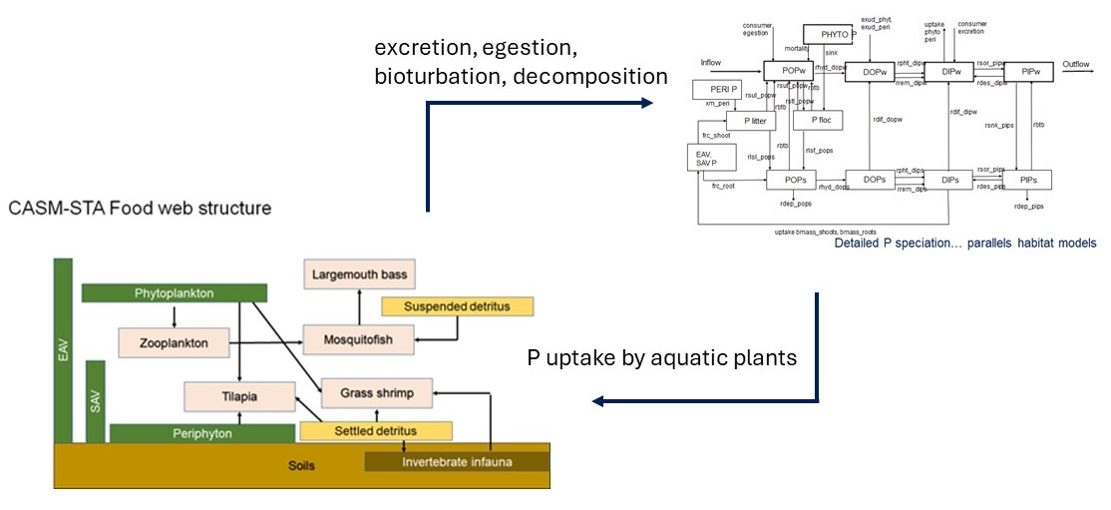
Figure Introduction-37. Integration of the historical CASM and the biogeochemical (BGC) model of an STA wetland to produce the CASM-STA.

The calibration began with the values of the BGC parameters defined in the calibration of the BGC model (Stantec 2024e, CELLC 2024). Parameters were adjusted by working through the P pools beginning with floc P and proceeding through the soils/sediment pools to the water column pools. Parameters that defined source and sink terms were adjusted with a focus on an individual pool P concentration, but with the recognition that other P pools are simultaneously affected.
Initial efforts in calibrating the CASM-STA divided the 16 years of daily P input loadings and hydrodynamics (e.g., segment water volumes, segment depths) into a calibration period (2005 – 2012) and validation period (2013 – 2020). Following the same process used in calibrating the BGC, annual averages of daily CASM-STA results were computed for modeled state variables and compared with the target values. The entire process was repeated until further improvements in the accuracy of one state variable substantially reduced the accuracy for other variables. The result defined a set of calibration CASM-STA parameters that best agree with the target values throughout the entire model (Table 3-15). The CASM-STA includes processes that influence the internal cycling dynamics of P but are not simple rate constants (Table 3-16). The values of these processes reflect primarily the food web production in the CASM-STA, which is determined mainly by the bioenergetics-based parameters for the modeled populations (i.e., Tables 3-8 and 3-9).
Table CASM-STA MODEL Development-32. CASM-STA calibrated internal P cycling parameters (d⁻¹) compared to values from the calibrated BGC (CELLC 2024).
CASM-STA  Parameter | CASM-STA  Valueª | BGC  Value^{b} | Description
rlsf_pops | 0.00065 | 0.010 | Floc loss (decomposition) to POPs
rlsl_pops | 0.00100 | 0.010 | Litter loss to POPs
rhyd_dops | 0.01000 | 0.0075 | POPs hydrolysis to DOPs
rdep_pops | 0.00002 | 0.0001 | POPs deposition to sediments
rrem_dips | 0.02000 | 0.010 | DOPs remineralization to DIPs
rpht_dips | 0.50000 | 0.50 | DOPs photolysis to DIPs
rdif_dopw | 0.00200 | 0.010 | DOPs diffusion to DOPw
rsor_pips | 0.30000 | 1.46 | DIPs sorption PIPs
rdif_dipw | 0.03500 | 0.010 | DIPs diffusion to DIPw
rsnk_pips | 0.97500 | 1.00 | PIPw sinking to PIPs
rdes_dips | 0.00500 | 0.02 | PIPs desorption to DIPs
rdep_pips | 0.00070 | 0.03 | PIPs loss to deep sediments
rxud_phyt | 0.35000 | 0.350 | Exudation of phytoplankton to DIPw
rxud_peri | 0.01000 | 0.010 | Exudation of periphyton to DIPw
rstl_pflc | 0.25000 | 0.010 | POPw settling to floc
rhyd_dopw | 0.01000 | 0.02 | Hydrolysis of POPw to DOPw
rpht_dipw | 0.05500 | 0.50 | DOPw photolysis to DIPw
rrem_dipw | 0.05000 | 0.010 | DOPw remineralization to DIPw
rsor_pipw | 0.01000 | 1.46 | DIPw sorption to PIPw
rdes_dipw | 0.01000 | 0.02 | PIPw desorption to DIPw
ªTask 9.2 resulting calibration value
^{b}Corresponding parameter values in BGC model (CELLC (2024)
Table CASM-STA MODEL Development-33. Parameters/process rates that vary in relation to CASM-STA food web dynamics used in internal cycling among sediment and water column P state variables.
Parameter | Value  (g P/m²/d⁻¹) | Description
fsnk_{PHYTO} | Variable | phytoplankton sinking input to floc P
fsuf_popw | Variable | floc resuspension to POPw
fsls_{VEG} | Variable | Input of shoot P to litter P
frmt_{PHYT} | Variable | phytoplankton mortality P input to POPw
fslr_{VEG} | Variable | Input of root P to POPs
fsul_popw | Variable | litter resuspension to POPw
fmrt_{PERI} | Variable | Periphyton mortality P input to floc P
fsuo_popw | Variable | POPs resuspension to POPw
fegs_{FAUNA} | Variable | consumer egestion to POPw
fsup_pipw | Variable | PIPs resuspension to PIPw
fupt_{VEG} | Variable | DIPs uptake by SAV, EAV shoots and roots
fexc_{FAUNA} | Variable | consumer excretion to DIPw
fupt_{PHYTO} | Variable | DIPw uptake by phytoplankton
fupt_{PERI} | Variable | DIPw uptake by periphyton
fbtb | Variable | bioturbation of floc P, litter P, POPs to POPw and PIPs to PIPw

      - Consumer populations
The calibrated values of modeled consumer population biomass (g C/m²) compared reasonably with data relevant to FW1 (Table 3-17). The minimum and maximum values for largemouth bass were nearly identical to the available data, while the mean population biomass was slightly greater than reported values. Similarly favorable comparisons were evident for Eastern mosquitofish, although the modeled minimum value 0.049 was about six times greater than the reported estimate (Evans et al. 2019). The mean biomass of tilapia was similar to the value reported by Evans et a. (2019), but two orders of magnitude lower than the value estimated from Goeke et al. (2023). The modeled minimum value substantially greater than the reported value, while the modeled maximum tilapia biomass was nearly identical to the data. The accuracy of the modeled values of tilapia biomass is important because this fish biomass drives the calculation of sediments resuspended by bioturbation.
The calibration results for the modeled invertebrates were similarly in agreement with the reported values (Table 3-17). Mean grass shrimp biomass was very nearly the same as values estimated from Evans et al. (2019). The range of modeled grass shrimp biomass was also similar to that derived from the data. The mean infauna biomass was essentially equal to the upper estimate from Evans et al. (2019), although the modeled minimum was nearly 3-fold greater than the data; maximum values were nearly the same. Data that quantify zooplankton production in FW1 were not identified during the course of the modeling project. The CASM-STA results suggest zooplankton population biomass in the same order of magnitude as the benthic infauna, perhaps not entirely unrealistic for modeling purposes.
The reasonable comparisons of modeled and measured values of biomass for fish and invertebrates suggest that corresponding modeled values of P egestion, excretion and bioturbation are likely within at least order-of-magnitude accuracy. These results provide a basis for comparing the relative importance of different processes (e.g., remineralization, co-precipitation, deposition to deep sediments) in influencing the internal P dynamics within FW1.
Table CASM-STA MODEL Development-34. Measured and modeled biomass (g C/m²) of STA-2 fish, grass shrimp, benthic infauna, and zooplankton included in the CASM-STA.
 | Mean | Minimum | Maximum
Largemouth bass
Evans et al. 2019 | 0.039 (0.050)⁴ | 0.001 | 0.171
Goeke et al. 2023 | 0.028 (0.014)⁴
Phase II CASM-STA | 0.059 | 0.001 | 0.142
Eastern mosquitofish
Evans et al. 2019 | 0.050 (0.038) | 0.008 | 0.124
Phase II CASM-STA | 0.084 | 0.049 | 0.112
Blue Tilapia
Evans et al. 2019 | 0.003 (0.004) | 0.0001 | 0.011
Goeke et al. 2023 | 0.102 (0.130)
Phase II CASM-STA | 0.0094 | 0.0088 | 0.010
Grass shrimp
Evans et al. 2019 | 0.064 (0.059) | 0.006 | 0.181
Phase II CASM-STA | 0.074 | 0.027 | 0.118
Benthic infauna
Evans et al. 2019 | 0.14 – 0.24 | 0.050 | 0.380
Phase II CASM-STA | 0.25 | 0.137 | 0.300
Zooplankton
CASM-STA | 0.154 | 0.010 | 0.183

      - Soils/sediments
The average daily values of the modeled sediment P pools were summarized for each spatial segment as well as the combined three segments used to represent FW1 (Table 3-18). Calibrated CASM-STA values of floc P were slightly greater than the 1.64 g P/m² target value (Table 3-18). The overall modeled FW1 mean value for floc was 2.07 (SD 0.75) g P/m². Comparison between modeled and target litter P values were quite similar, 1.34 vs 0.70 for the FW1 mean values. The modeled values of POPs were very similar to the target value, modeled FW1 mean 3.49 (SD 2.03) 0.462 compared favorably with the 2.57 (SD 2.16) g P/m² target value. The model calibration underpredicted values of DOP_{s} by about half, with a modeled mean FW1 value of 0.067 g P/m² compared to the target value of 0.15 (SD 0.12) g P/m². The modeled and target values for the calibration of DIPs were nearly identical with a modeled mean FW1 value of 0.107 (SD 0.055) g P/m² compared to the target value of 0.10 (SD 0.08) (Table 3-18). The calibrated CASM-STA overestimated PIP_{s} by about ten-fold (Table 3-18), which might result from an overestimation of the settling rate of PIPw or the dynamics of net sorption-desorption to DIPs.

Table CASM-STA MODEL Development-35. Comparison of FW1 soil P pool target values and results from the Phase III CASM-STA model calibration (g P/m²).
 | FW1 Target values |  | Segment A |  | Segment B |  | Segment C |  | FW1
 | mean | SD | mean | SD | mean | SD | Mean | SD | mean | SD
Floc P | 1.64 | 0.65 | 1.94 | 0.56 | 1.95 | 0.79 | 2.32 | 1.00 | 2.07 | 0.75
Litter P | 0.70 | 0.32 | 1.23 | 0.46 | 1.20 | 0.48 | 1.58 | 0.92 | 1.34 | 0.66
POPs | 2.57 | 2.16 | 2.95 | 0.98 | 3.11 | 1.34 | 4.40 | 2.96 | 3.49 | 2.03
DOPs | 0.15ª | 0.12 | 0.057 | 0.019 | 0.060 | 0.026 | 0.084 | 0.057 | 0.067 | 0.039
DIPs | 0.10^{b} | 0.08 | 0.15 | 0.041 | 0.097 | 0.044 | 0.119 | 0.075 | 0.107 | 0.055
PIPs | 0.440 | 0.27 | 6.340 | 2.724 | 5.556 | 2.472 | 6.614 | 3.948 | 6.170 | 3.082
ªPrevious targets were 0.004 – 0.007 g P/m²
^{b}Previous targets were 0.006 – 0.19 g P/m²

      - Water column
The calibration of the CASM-STA presented in the draft Final Report overestimated POPw by two orders of magnitude (modeled FW1 mean of 0.212 versus target value of 0.010 g P/m³) and was not accepted by the SFWMD (T. James, personal communication) and led to the re-calibration of the model that serves as the basis for a revised Final Report. The re-calibration more accurately represented the target value for POPw with a mean model FW1 value of 0.009 g P/m3 compared to a target value of 0.010 (Table 3-19). Improving the agreement between the calibrated values of POPw also changed the results for the remaining water column P pools (Table 3-19). Model values for DOPw were about a third of the target values with a mean modeled value of 0.005 (SD 0.003) g P/m3 compared to a target value of 0.014 (SD 0.007) (Table 3-19). Values of the calibrated model DIPw compared favorably with the target values with a mean modeled FW1 value of 0.034 (SD 0.041) g P/m³ versus a target value of 0.026 (SD 0.028). The calibration for PIPw produced a mean modeled FW1 value of 0.015 (SD 0.010) g P/m³ which was about double the target value of 0.006 (SD 0.003). The net result of improving the water column calibration across the P pools was a more accurate calibration for water column TP, the overall management endpoint. The mean model FW1 value for TP was 0.064 (SD 0.050) g P/m³ compared to the target value of 0.056 (SD 0.012) (Table 3-19).
Table CASM-STA MODEL Development-36. Comparison of FW1 water column P pool target values and results from the Phase III CASM-STA model calibration (g P/m³).
 | FW1 Target values |  | Segment A |  | Segment B |  | Segment C |  | FW1
 | mean | SD | mean | SD | Mean | SD | Mean | SD | mean | SD
POPw | 0.010 | 0.010 | 0.007 | 0.003 | 0.009 | 0.003 | 0.012 | 0.006 | 0.009 | 0.005
DOPw | 0.014ª | 0.007 | 0.003 | 0.001 | 0.004 | 0.001 | 0.007 | 0.001 | 0.005 | 0.003
DIPw | 0.026^{b} | 0.028 | 0.011 | 0.008 | 0.027 | 0.017 | 0.063 | 0.057 | 0.034 | 0.041
PIPw | 0.006 | 0.003 | 0.019 | 0.014 | 0.012 | 0.005 | 0.015 | 0.008 | 0.015 | 0.010
TP | 0.056 | 0.012 | 0.041 | 0.014 | 0.053 | 0.022 | 0.097 | 0.074 | 0.064 | 0.050
ªPrevious targets were 0.005 – 0.080 g P/m³
^{b}Previous targets were 0.007 – 0.20 g P/m³

      - Food web components
Values for the re-calibrated biological P pool are given in Table 3-20. The model underestimates phytoplankton production in FW1 by an order of magnitude with the added recognition that phytoplankton are not an important contribution to the overall aquatic primary productivity or internal P cycling in FW1. The model value for periphyton P of 0.100 (SD 0.081) g P/m² is about double the target value of 0.050 (SD 0.030) (Table 3-20). The CASM-STA similarly produces greater SAV P than observed in FW1 with a mean model value of 0.693 (SD 0.809) g P/m² compared to a measured value of 0.160 (SD 0.040). The re-calibrated values for EAV P are also greater than the observed values with a mean model FW1 value of 4.762 (SD 2.893) g P/m² compared to 1.95 (SD 0.870). While the calibration appears to overstate the production of periphyton, SAV, and EAV, the variability implied in the target values largely overlap the modeled variability. The mean aggregate modeled consumer P for FW1 was 0.616 (SD 0.266) g P/m². A target value was not developed for FW1.
Table CASM-STA MODEL Development-37. Comparison of FW1 biological P pool target values and results from the Phase III CASM-STA model calibration (g P/m²).
 | FW1 Target values |  | Segment A |  | Segment B |  | Segment C |  | FW1
 | Mean | SD | mean | SD | mean | SD | Mean | SD | mean | SD
Phyto P | 0.002 | 0.001 | 0.0001 | 0.003 | 0.0001 | 0.0002 | 0.00006 | 0.00002 | 0.0001 | 0.002
Peri P | 0.050 | 0.030 | 0.065 | 0.022 | 0.080 | 0.039 | 0.153 | 0.117 | 0.100 | 0.081
SAV P | 0.160 | 0.040 | 1.299 | 1.175 | 0.505 | 0.216 | 0.275 | 0.073 | 0.693 | 0.809
EAV P | 1.950 | 0.870 | 3.521 | 0.767 | 4.393 | 1.872 | 6.371 | 4.192 | 4.762 | 2.893
Consumer Pª |  |  | 0.544 | 0.179 | 0.600 | 0.243 | 0.703 | 0.341 | 0.616 | 0.266
ªTotal consumer biomass (aggregate zooplankton, benthic invertebrates, and fish biomass as P)

      - Modeled FW1 gradients
The re-calibration produced different results for each of the modeled segments which imply spatial gradients in P pool values across FW1 (Tables 3-18 – 3-20). Depending on the selected P state variable, the modeled gradients go in both directions, increasing or decreasing in mean value from segment A to C. The modeled gradients might simply be an artifact of similar internal P cycling within segments that differ in mean depth. It was assumed that the same BGC process-level cycling parameters applied equally across the segments. Initial P values and food web component biomass were also identical for each segment. Transport factors differed daily and for each segment but produced similar values of flow when adjusted for decreasing water depths in flow calculations across the segments for each modeled day.

The boundary condition that was originally specified for inputs to segment A was set to zero in the most recent versions of the CASM-STA. This assumption avoided the creation of “phantom P” associated with previously modeled boundary inputs of phytoplankton, zooplankton, and POC. However, a by-product of relaxing the boundary condition was to deplete these state variables simply due to advection from segment A. This contributes as well to setting up a gradient of decreasing values from segments A to C.

The combination of these limitations and assumptions may have produced spatial differences in model results that bear little resemblance to any demonstrated gradients for STA-2 in FW1.

      - Mass-balance
Multiple lines of evidence were developed to assess the overall mass-balance of the CASM-STA. The model is not programmed to track and report P flux along all individual pathways of biomass (carbon) and P transport and transformation calculated in the model. Nevertheless, some inferences may be drawn concerning mass-balance from the following analyses:
The CASM-STA equations were inspected to ensure that process-based biomass or P losses from one state variable were defined as corresponding inputs to receiving state variables (e.g., Tables 3-10 and 3-11).
The CASM-STA was simulated using initial conditions set to zero for all the model state variables. The simulation results demonstrated that the model-maintained values of zero. The model does not create biomass (carbon) or P during the course of the 16-y simulation period (Stantec 2024c).
Simulations of 20 years were performed using constant inputs of P and constant values for light, temperature, and other model inputs. The results showed that modeled population biomass and P pool concentrations initially oscillated and then tended toward a dynamic steady-state, although all state variables had not achieved steady-state after the 20-year model period. Demonstration of steady-state behavior under conditions of constant inputs additionally suggest overall mass-balance (Stantec 2024c).
Analysis of changes in the annual average P pool concentrations for the 16-year simulation period provides additional insights concerning mass-balance (Table 3-21). For each year, the annual changes of all the sediment P state variables were computed across the 2006-2020 period using 2005 values as a reference point. Corresponding annual P inputs were tabulated for reference. Calculations were performed for all three spatial segments in the CASM-STA, but the corresponding average values (i.e., modeled FW1) are presented. Similar calculations were performed for the water column P pools and the biological P pools (Table 3-22). The TPw is the sum of all the water column P pools and the other pools that contribute to TPw were therefore not tabulated. The magnitudes of annual changes (increases or decreases) can be interpreted as a measure of the importance of the state variable and its associated input-output processes in determining the internal cycling of P within the modeled FW1. The results indicate that the overall dynamics were driven by deposition to deep sediments (i.e., burial) (Table 3-21) and the growth of EAV (Table 3-22). Importantly, the model results demonstrate both increases and decreases from year-to-year for the state variables. That is, the CASM-STA internal P dynamics are being influenced by the modeled environmental conditions (e.g., flows, depths, temperatures, trophic interactions) specific to each year as well as yearly P inputs. There are no consistent patterns of increase or decrease for individual state variables that would suggest significant mass-balance issues with the CASM-STA. The summation of annual changes across the state variables averaged across the modeled FW1 are on the order of the modeled inputs, generally less than and certainly on the same order of magnitude as the corresponding annual P input – also suggesting minimal mass-balance issues if any.
    - Sensitivity analysis
The overall approach in performing the sensitivity analysis of the Phase III CASM-STA model paralleled the approach used by CELLC (2024). The analysis focused on model response to systematic alterations of FW1 flows, input P loading values, and selected GBC internal cycling parameters, as well as impacts on EAV initial biomass on overall EAV production. In addition, the analysis of the CASM-STA included the effects of alterations in the maximum photosynthetic rate of modeled periphyton growth (Pmax) and the impacts of systematic alterations of the initial (day 1) values of the soils/sediments and water column P pools (Stantec 2024x).
The sensitivity analysis of the CASM-STA was performed using the input values for the 2005-2102 calibration period. The Task 9.2 calibration (2005 – 2012) simulation is used as the baseline in evaluating model sensitivity (Stantec 2024x). The following summarizes the Task 9.3 sensitivity analysis report, where detailed comprehensive tables of model results are tabulated (Stantec 2024f).

Table CASM-STA MODEL Development-38. Mass-balance evaluation for Phase III CASM-STA sediment pools.
 | Δ g P/m2/y
Year | TP in | Burial | Floc | Litter | POPs | DOPs | DIPs | PIPs
2006 | 4.44 | 0.87 | 0.072 | 0.043 | 0.090 | -0.0001 | 0.009 | 1.32
2007 | 2.02 | 1.11 | 0.118 | 0.170 | 0.162 | 0.0032 | 0.000 | 0.47
2008 | 2.87 | 1.12 | 0.160 | 0.124 | 0.076 | 0.0014 | -0.010 | -0.25
2009 | 2.15 | 1.05 | 0.175 | 0.072 | 0.024 | 0.0004 | -0.006 | -0.35
2010 | 1.06 | 1.03 | 0.172 | 0.036 | 0.323 | 0.0063 | 0.012 | 0.34
2011 | 1.54 | 1.07 | 0.170 | 0.070 | -0.149 | -0.0029 | -0.009 | -0.19
2012 | 2.98 | 1.03 | 0.075 | -0.022 | 0.226 | 0.0043 | 0.009 | 0.15
2013 | 1.60 | 1.09 | 0.056 | 0.024 | 0.046 | 0.0008 | -0.012 | -0.07
2014 | 4.31 | 1.23 | 0.061 | 0.022 | 0.948 | 0.0183 | 0.063 | 1.81
2015 | 2.08 | 1.81 | 0.069 | 0.092 | -0.147 | -0.0029 | 0.026 | 2.01
2016 | 2.47 | 2.09 | 0.133 | 0.279 | 0.469 | 0.0090 | -0.022 | 0.23
2017 | 4.37 | 2.05 | 0.261 | 0.271 | 0.432 | 0.0081 | 0.024 | -0.03
2018 | 3.35 | 2.38 | 0.242 | 0.029 | 0.673 | 0.0130 | 0.010 | 1.82
2019 | 3.01 | 2.57 | 0.291 | 0.571 | 1.237 | 0.0237 | 0.012 | 0.14
2020 | 2.79 | 3.02 | 0.477 | 0.468 | 1.846 | 0.0353 | 0.058 | 3.33

Table CASM-STA MODEL Development-39. Mass-balance evaluation for Phase III CASM-STA biota and TPw pools.
 | Δ g P/m2/y
Year | TP in | Periphyton P | SAV P | EAV P | Consumer P | TPw
2006 | 4.44 | 0.011 | 0.094 | 0.507 | 0.215 | -0.0003
2007 | 2.02 | -0.019 | 0.060 | 0.704 | 0.016 | -0.0004
2008 | 2.87 | -0.003 | -0.002 | 0.437 | 0.031 | -0.0004
2009 | 2.15 | -0.005 | -0.042 | 0.188 | -0.052 | -0.0004
2010 | 1.06 | 0.008 | 0.024 | 0.209 | 0.180 | 0.0033
2011 | 1.54 | -0.004 | -0.037 | 0.206 | -0.107 | -0.0028
2012 | 2.98 | 0.015 | 0.010 | -0.144 | 0.013 | 0.0010
Table 3-22. Continued.
2013 | 1.60 | -0.024 | -0.014 | 0.202 | -0.132 | -0.0002
2014 | 4.31 | 0.073 | -0.007 | 0.155 | 0.158 | 0.0136
2015 | 2.08 | 0.024 | 0.140 | 0.083 | 0.016 | 0.0109
2016 | 2.47 | -0.025 | 0.270 | 1.389 | 0.094 | -0.0122
2017 | 4.37 | 0.031 | 0.025 | 0.329 | -0.075 | 0.0099
2018 | 3.35 | 0.002 | 0.145 | 0.637 | 0.291 | -0.0040
2019 | 3.01 | -0.014 | 0.542 | 1.804 | -0.194 | 0.0056
2020 | 2.79 | 0.079 | 0.398 | 1.653 | 0.687 | 0.0120

      - Flows
Increasing or decreasing daily flows by 25 and 50% produced minimal changes in the values of floc P, litter P, and the soils/sediment P pools; P concentrations changed by <5% across all of these pools. Generally, increasing flows by 50% translated into changes in the soils/sediment pools by <10%, except for floc P, which increased by 22.6%. The results for increased flows of by 100% substantially increased the value of floc P in relative terms, although the P concentration increased in absolute terms only from 0.291 g P/m² (baseline) to 0.719. The remaining soils/sediment P pools and litter P decreased by 25% or less.
Reducing flows by 25 and 50% had minimal impact on the water column P pools. The P pools were changed by <10%. The results for flow increases of 50 and 100% showed that only the PIP_{w} (-39%) value was changed by >20% for the water column P pools, although DIP_{w} increased by 19%. The overall impact of flow alterations on concentrations of TPw in segment C (i.e., outflow TPw) were less than 10% of the baseline simulation. The model results are due to lower simulated water depths; sediment-water interactions are not a function of depth in the CASM-STA
Reducing flows by 25 and 50% correspondingly reduced the values of the aquatic plant and total consumer production by <20%. Increased flows by 50 and 100% produced a dramatic relative increase (>1000%) in phytoplankton biomass values, although absolute increases in biomass (g P/m2) indicated that phytoplankton remained a small component of the overall FW1 aquatic plants assemblage.
      - External P loading
As observed in the sensitivity analysis of the BGC model (CELLC 2024), the state variables in the CASM-STA were generally insensitive to reductions (25, 50%) or increases (50, 100%) in external P loading, while flows were not correspondingly adjusted, to the modeled FW1 (Tables 3-4, 3-5 and 3-6). None of the results were >20% difference from the baseline P values; sensitivities were generally <1% for soils/sediments, water column, and aquatic plants and consumers.
      - Co-precipitation slope
Simulations with slope values of 0.001, 0.002 (baseline), 0.003, 0.004, and 0.005 were performed with the CASM-STA. The resulting values of floc P, litter P, and the soils/sediment P pools were not sensitive to the different values used to define the slope in the formulation of co-precipitation of DIP_{w} to PIP_{w}. Percentage changes in P pool values were <20% and for the most part around or below 10% compared to the baseline model simulation.
The CASM-STA values for DIP_{w} and PIP_{w}, which are directly affected by the slope of the co-precipitation function, demonstrated sensitivity to the selected slope. Decreasing the slope had the expected effect of increasing DIPw (38.8%) and decreasing PIP_{w} by approximately the same amount (39.8%). Correspondingly, increasing the slope and the amount of daily DIP_{w} co-precipitation reduced DIP_{w} (-63.9%) and increased PIP_{w} by 56.4%.
Reducing the slope to 0.001 from 0.002 made more DIP_{w} available to support phytoplankton and periphyton growth and these populations correspondingly increased, but by <10%. Increasing the slope values reduced DIP_{w} values and reduced phytoplankton and periphyton. Slope values of 0.004 and 0.005 reduced periphyton annual average P (g P/m²) values by 27.2 and 45.6%. The slope of 0.005 translated periphyton losses to decreased consumer production by 29.9%.
      - Soils/sediments diffusion constants
rdif_DOPw - The diffusion of DOPs from the soils/sediments to the water column DOP_{w} pool is determined in part by the value of the rdif_DOP_{w} parameter in the CASM-STA. Simulations using rdif_DOP_{w} values of the baseline 0.0001 (d⁻¹), and values of 0.0005, 0.0010, 0.0015, and 0.0020 were performed. The resulting values of floc P, litter P, and the soils/sediment P pools proved to be relatively insensitive to variations in the value of this diffusion coefficient.
Increasing the value of rdif_DOP_{w} did result in modeled increases in the water column P pools, particularly DOP_{w} and DIP_{w}, but by <20%. All of the modeled plant and consumer responses to variations in rdif_DOP_{w} were <10% of baseline.
rdif_DIPw – Simulations were performed using the baseline value of 0.0005 (d⁻¹), 0.001, 0.0010, 0.0015, and 0.0020. CASM-STA responses to variations in the assigned values of rdif_DIP_{w} were <5% for the soils/sediments state variables. Increasing the values of the diffusion rate constant from the DIP_{s} to the DIP_{w} pool did increase the annual average value of the DIPw pool, but by <20%. Increasing the rate of DIPs diffusion to DIP_{w} slightly increased phytoplankton (1.3%), periphyton (3.4%), and consumer (1.4%) production compared to baseline.
      - EAV initial biomass
The CASM-STA was used to determine the impacts of EAV removal on subsequent production by setting the initial EAV biomass to 400 g C/m² (50% reduction) and 200 g C/m² (75% reduction) in separate simulations. The calibration baseline initial value was 800 g C/m². The time-varying pattern of EAV production in the two treatment simulations essentially paralleled the baseline simulation and suggested an overall decrease in EAV biomass during the 2005-2012 simulated CASM-STA calibration period.
The calibration value of EAV Pmax is 0.024 d⁻¹ and was based on the 8-y average annual biomass, which compared reasonably with the target value (Stantec 2024x). However, the overall trajectory of declining biomass suggests that the calibrated value of Pmax might be insufficient to sustain growth given the environmental conditions specified for the 2005-2012 period. However, the Task 9.2 simulation for the validation period showed an overall increasing trend for EAV production for the 2013-2020 environmental conditions, which indicates that the 0.024 d⁻¹ value of Pmax is not entirely unrealistic.
      - Periphyton growth rate
The bioenergetics-based models are typically sensitive to the parameters that determine energy (or biomass equivalent) inputs to the corresponding population state variable (Bartell et al. 1988a, b; 1986). For the CASM-STA, these parameters include the values of Pmax, maximum photosynthetic (growth) rate for modeled plant populations. Decreasing the maximum growth rate of periphyton from 0.25 d⁻¹ (baseline) to 0.10 and 0.05 d⁻¹ reduced periphyton annual average biomass by >95% with corresponding increases in phytoplankton biomass. Similarly, increasing the Pmax value for periphyton to 0.35 and 0.50 d⁻¹ increased annual average periphyton biomass by 36.5 and 71.5%, respectively. These increases were accompanied by 17% decreases in phytoplankton and an 18.9% increase in total consumer biomass for the Pmax of 0.5.

Conclusions and Management implications
The BGC Model was developed in three Phases to integrate accumulated STA data and information, simulate patterns of and changes in the internal P biogeochemical concentrations, and evaluate wetland TP loading and removal at the flow-way scale. The model was based on a 744-hectare, cattail dominated flow-way with a comprehensive empirical database which removes ~86% of incoming TP annually (STA-2 FW1). It evolved from the initial conceptualization (Phase I) into a first-generation mathematical model to simulate changes in P concentrations among the water, periphyton, SAV, Typha, and soils from 1/1/2005 to 12/31/2020 (Phase II). A Hydrologic Model and equation syntax to ensure mass balance were added so the simulated P concentrations could be calibrated, validated, and tested (Phase III).
The Phase III BGC Model was used to generate the daily time series of P concentrations and calculate the grand averages for comparison to the empirical targets (Figure 2-25). P_{EAVSH}, P_{LITTER}, P_{FLOC}, and POP_{S} ranged from 0.5-4.0 g P m⁻² over the fifteen water years (5/1/2005 to 4/30/2020). P_{PERI}, P_{EAVRR}, P_{SAV}, DOP_{S}, DIP_{S}, and PIP_{S} ranged from 0.01-0.75 g P m⁻². Finally, PPHYTO, POP_{W}, DOP_{W}, DIP_{W}, PIP_{W}, and TP_{W} ranged from near zero to ~0.25 g P m⁻³. All of the phosphorus pools exhibited regular seasonal-annual periodicity except for POP_{W} (and thus TP_{W}). The oscillations resulted from the intra-annual variations in temperature indicative of the sub-tropical climate. While most of the model biogeochemical processes were driven by temperature predicted using a smooth trigonometric function, POP_{W} was largely driven by daily changes in depth and sinking from the water column (Figure 2-25).
The average model P concentrations more closely resembled the targets from STA-2 FW1 (Table 2-19) following the series of calibration steps. The series of calibration steps Model averages for P_{PHYTO}, P_{EAVSH}, P_{LITTER}, P_{FLOC}, P_{EAVRR}, P_{SAV}, POP_{S}, DIP_{S}, and PIP_{S} were very similar to the average target concentrations. The model periphyton (0.12 ± 0.02 g P m⁻²) was elevated relative to the empirical average although the periphyton community and biomass vary greatly along the longitudinal axis of the flow-way. While POP_{W} (0.0150 ± 0.0357 g P m⁻³) and DIP_{W} (0.0335 ± 0.0059 g P m⁻³) were similar to the target P concentrations, model DOP_{W} (0.0031 ± 0.0037 g P m⁻³) and PIP_{W} (0.0022 ± 0.0022 g P m⁻³) were greater than the data averages (Table 2-19). Model TP_{W} was calculated daily by summing each of the four constituents (POP_{W}, DOP_{W}, DIP_{W}, PIP_{W}) and averaged over the entire 5488-day simulation (0.0974 ± 0.0355 g P m⁻³; Table 2-19). Despite the redefined targets and parameter adjustments, soil DOP predicted by the model (0.62 ± 0.09 g P m⁻²) was approximately three times greater than expected (0.15 ± 0.12 g P m⁻²). DOP dynamics were perhaps the most uncertain processes in the BGC Model with implications for understanding potential responses to variable external TP loads (see below).
The average concentrations of POP_{W}, DOP_{W}, DIP_{W}, PIP_{W}, and TP_{W} were 0.026, 0.010, 0.024, 0.006, and 0.066 g P m⁻³, respectively (Table 2-20). POP_{W} had greater annual average concentrations for the first half of the model time period and was overall more variable than the other three constituents (0.026 ± 0.030 g P m⁻³). DOP_{W} (0.010 ± 0.003 g P m⁻³) and PIP_{W} (0.006 ± 0.002 g P m⁻³) did not vary greatly. Average annual DIP_{W} ranged from 0.019 ± 0.008 g P m⁻³ (WY2009 and WY2011) to 0.046 ± 0.003 g P m⁻³ (WY2015). TP_{W} concentrations ranged from a minimum of 0.040 ± 0.011 g P m⁻³ (WY2016) to 0.118 ± 0.085 g P m⁻³ (WY2009) when the POPW concentration was greatest (0.084 ± 0.091 g P m⁻³; Table 2-20).
The model TP_{W} concentrations had wide and skewed distributions in multiple water years leading up to WY2011 (Figure 2-26A). Except for WY2015 and WY2018, the ranges in predicted internal TP_{W} narrowed and declined over time. This was due to the stabilization of depth and POP_{W} concentrations in the Validation period from 2013-2020 (Figure 2-9; Figure 2-25). Average TP_{W} was least (<0.06 g P m⁻³) in WY2006, WY2011, WY2014, WY2016, and WY2017 (Figure 28B). In contrast, TP_{W} was greatest (>0.10 g P m⁻³) in WY2008, WY2009, WY2011, WY2015, and WY2018. It was evaluated relative to hydrologic variables and TP loading to the model flow-way.
The output from the base BGC Model over 15 water years was used to assess the inter-annual variations in and potential correlations among Q_{TP} inflow and outflow (g P m⁻² y⁻¹), TP_{W} (g P m⁻³), depth (m), hydraulic loading rate (HLR; m d⁻¹), the percentage of Q_{TP} removed by the flow-way, and TP_{W} ( g P m⁻³; Figure 2-26B; Table 2-21). [TP]_{OUT} (g P m⁻³) was also calculated using the observations from outflow structure G335 for each water year by dividing the annual net outgoing TP load (Q_{TPOUT}; P m⁻³ y⁻¹) by the annual net outflow (Q_{OUT}; m⁻³ y⁻¹). Associations among these variables could be used to help optimize TP removal by STA flow-ways and cells.
The maintenance of flow-way depth ~0.5 m promoted more predictable relationships among Q_{TP}, HLR, and TP_{W} (Figure 2-26B). While the average annual h_{MOD} started at 0.46 m in WY2006, it was reduced until WY2012 (Table 2-21). The average HLR generally tracked the inter-annual fluctuations in depth during the first half of the simulation. The model flow-way removed only 58-63% of the annual TP load from WY2007=WY2012. The concentrations for both the internal water column TP concentrations (TP_{W}; 0.074-0.118 g P m⁻³) and the outflow TP concentration ([TP]_{OUT}; 0.009-0.021 g P m⁻³) were elevated during this time (Table 2-21). Annual average depth was greater during the second half of the simulation period. Except for two high loading years (WY2015 and WY2018), the flow-way removed 84-89% of the Q_{TP} (Figure 2-26B). Q_{TP}, HLR, and TPW were more closely aligned from WY2014-WY2020. It appears that the model flow-way performance (greatest removal and lowest TPW) was optimal when h_{MOD} and Q_{TP} were 0.5 and HLR was 0.03. The BGC Model provided a platform to assess relationships between external TP loading (Q_{TP}) and the resulting T_{PW} and [TP]_{OUT}.
The assessments between QTP and TP concentrations led to a final calibration series to better understand and apply the results of the BGC Model. Linear regressions between the average annual TP loads and the resulting internal and outflow TP concentrations were applied (Figure 2-27). The Phase III BGC Model predicted that the TP concentrations generally increased linearly with Q_{TP}. This result was expected based on the patterns in the multiple variable time series (Figure 2-26B). In particular, all three variables tracked during the second half of the simulation time. However, the thorough calibration and testing pointed to the rate of soil DOP efflux (k_{DOPSWX}) as perhaps the most pivotal parameter in the BGC Model. TP_{W} and [TP]_{OUT} increased non-linearly with greater values for k_{DOPSWX} (Figure 2-18E and Figure 2-24). Moreover, there was added uncertainty regarding DOP processes since the data and targets for soil DOP and DIP were extremely variable and the model generally overestimated soil dissolved concentrations. Thus, simulations and regressions were performed for three different values of k_{DOPSWX} (0.001, 0.003, 0.005 d-1; Figure 2-27). The comparative results indicated that increased rates of soil DOP efflux led to a more robust statistical relationship between Q_{TP} and TPW and [TP]_{OUT}. While TP_{W} was not associated with increased TP loading at the lowest value of k_{DOPSWX} (0.001 d⁻¹), the model results suggested that [TP]_{OUT} was responsive when soil DOP efflux was minimal.
  - CASM-STA Management Implications
    - TP loadings
A key motivation for undertaking the development of the CASM-STA was to provide a process-level model that could be used to explore the possible outcomes of management actions used to affect the performance of the STAs in relation to meeting the WQBEL. One likely management is controlling the input of P into the STAs with the expectation that the treatment wetlands would correspondingly reduce output P concentrations. The results of the CASM-STA suggest that on average 63% of the input P is retained in the soil P pools, primarily in the PIPs and deep sediments (burial). This value ranged from 20-98% depending on the model year (2005-2020).
The calibrated results indicate that the modeled STA-2 is highly efficient in retaining input P (Table 4-1). The flow-weighted mean (FWM) input concentrations (TP in) were computed as the total reported P mass entering segment A divided by the reported total FW1 flow for the modeled years. The FWM values of TP out were computed as the CASM-STA modeled mass of TP leaving segment C divided by the corresponding modeled volume a segment C. The corresponding CASM-STA mass flows (g P/m²/y) for TP in (input to segment A) and TP out (outflow from segment C) were summarized and used to compute annual retention efficiencies for the modeled years (Table 4-1). The average retention efficiency over the 2005-2020 period was 77% compared to reported efficiencies on the order of 87%.

Table Conclusions and Management implications-40. Flow-weighted mean (FWM) concentrations and mass flux of TP in and TP out in FW1 and corresponding retention efficiencies.
Year | FWM TP in | FWM TP out | TP in | TP out | Retention efficiency
 | (g P/m³) | (g P/m³) | (g P/m²/y) | (g P/m²/y) | %
2005 | 0.1157 | 0.0046 | 2.38 | 0.27 | 88
2006 | 0.2359 | 0.0026 | 4.44 | 0.20 | 96
2007 | 0.1200 | 0.0023 | 2.02 | 0.23 | 88
2008 | 0.1987 | 0.0044 | 2.87 | 0.23 | 92
2009 | 0.1795 | 0.0036 | 2.15 | 0.14 | 93
2010 | 0.1178 | 0.0046 | 1.06 | 0.21 | 80
2011 | 0.1007 | 0.0020 | 1.54 | 0.23 | 85
2012 | 0.1732 | 0.0051 | 2.98 | 0.31 | 90
2013 | 0.1842 | 0.0020 | 1.60 | 0.19 | 88
2014 | 0.1573 | 0.0085 | 4.31 | 1.05 | 76
2015 | 0.1303 | 0.0099 | 2.08 | 1.17 | 43
2016 | 0.1524 | 0.0101 | 2.47 | 0.68 | 72
2017 | 0.2946 | 0.0235 | 4.37 | 1.07 | 75
2018 | 0.1711 | 0.0274 | 3.35 | 1.24 | 63
2019 | 0.1867 | 0.0151 | 3.01 | 1.22 | 59
2020 | 0.1959 | 0.0259 | 2.79 | 1.70 | 39

Analysis of the results of the 16-y simulations indicates a relationship between annual loading of TP and average daily concentrations of TP in the outflow (Figure 4-1). Inputs to segment A were computed from the provided daily loading values of the water column P pools (Figure 4-2). Daily TP outflow concentrations from segment C were computed as a flow-weighted concentration by dividing as the TP mass flux (g P/d) transported from segment C by the volume transported (m³ d⁻¹) from segment C to outside of FW1. Outflow TP concentrations from segment C appear positively correlated with annual inputs to segment A and account for about 17% of the variance in the outflow (Figure 4-1a). The relationship is increasingly variable for annual minimum (Figure 4-1b) and maximum (Figure 4-1c) outflow concentrations. The increased variability might simply reflect values of modeled outflows associated with the assumed lower threshold depth defined as 0.10 m used in the calculations of flows and flow-weighted concentrations.
Regardless of the simplifications, assumptions, and inaccuracies in the CASM-STA, the model results (Figure 4-1a-c) demonstrate that TP inputs to segment A are internally cycled, transformed, and transported through the modeled system to outflow from segment C.

Figure Introduction-38. Relationships between annual TP loading (g P/m²/y) to segment A and average daily flow-weighted TP concentration (g P/m³) in the outflow from segment C, (a) mean outflow P concentration, (b) minimum outflow P concentration, and (c) maximum P concentration.
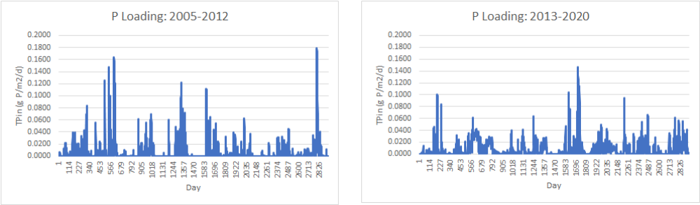
Figure Introduction-39. Daily TP loadings (g P/m2/d) to segment A in the CASM-STA.

The model could in theory be used to explore the relationship of different TP loads to FW1 and outflow TP concentrations.
    - Consumer dynamics
A key motivation for developing the CASM-STA was to explore the implications of consumer population dynamics on internal P cycling within FW1. The estimates of daily excretion for modeled consumer populations were originally derived for the CASM-STA using published values from the general literature. Recent publication of data for these species in the STAs permitted re-evaluation (Barton e t al. 2023). The estimates based on excretion measurements in the STAs were all less (but remarkably similar) than the values used in the original CASM-STA development, except for the eastern mosquitofish (Table 4-1). The STA-specific value was approximately twice that of the original model. The excretion rate for mosquitofish was updated in the most recent CASM-STA to use the value derived from Barton et al. (2023), 0.148 d⁻¹; the original values for the other modeled species excretion rates were retained to provide maximum opportunity (i.e., consistent positive bias) for fish excretion to influence P cycling in the modeled STA-2.
Table Conclusions and Management implications-41. Comparison of CASM-STA modeled excretion based on original parameter (U) estimate and estimates derived from Barton et al. (2023)
Species | Length | Weight | Excretion rate, U (d⁻¹)
 | cm | g ww | Original | Barton et al.
Mosquitofish | 4 | 0.50 | 0.070 | 0.148
Largemouth bass | 40 | 1,008 | 0.068 | 0.014
Tilapia | 16 | 123 | 0.029 | 0.011
Grass shrimp | 1.9 | 0.124 | 0.029 | 0.027

The revised model results show that consumer excretion was on the order of 0.034 g P/m² of annual load for segment C over the course of the 2005 – 2020 simulation period (Table 4-2). The current model results indicate that bioturbation accounts for an approximate 0.020 g P/m². T
Table 4-2 also provides the corresponding values for remineralization and co-precipitation for context. These processes are about an order of magnitude or more greater than the current estimates of excretion and bioturbation. Co-precipitation dominates the internal cycling processes in the current CASM-STA. At the same time, the model only includes three species of fish and grass shrimp; Barton et al. (2023) analyzed excretion contributions from many large- and small-bodied fish and invertebrates that inhabit the STAs. Taken together, these species process substantial amounts of P in the STAs. The model food web could be amended to include more of the species examined by Barton et al. (2023). The initial model results suggest that management actions undertaken to manage fish populations in relation to their contributions to excretion and bioturbation could have measurable impacts on overall P cycling within FW1.

Table Conclusions and Management implications-42. Comparison of CASM-STA modeled excretion, bioturbation, remineralization, and co-precipitation for segment C for 2005 – 2020.
Process | mean daily g P/m² | minimum daily g P/m² | maximum daily g P/m² | mean annual g P/m²
Excretion | 0.00009 | 0 | 0.00011 | 0.034
Bioturbation | 0.00006 | 0.00002 | 0.00017 | 0.020
Remineralization | 0.00169 | 0.00056 | 0.00819 | 0.615
Co-precipitation | 0.03584 | 0. | 0.03072 | 13.082

  - Summary
The current status of the CASM-STA demonstrates the possibility of integrating detailed phosphorus biogeochemistry together with biological and ecological processes to describe P dynamics within a spatially segmented physical representation of FW1. The coupling of modeled hydrodynamics (e.g., daily volumes, depths, and flows) produced by the BGC model and used to drive transport through the segmented CASM-STA appears as a useful balance between hydrodynamic and biogeochemical-ecological complexity in model structure and functionality.
The CASM-STA exists as a working model to: 1) quantitatively characterize P dynamics in the constructed wetlands; 2) contribute to increased understanding of the relative importance of modeled processes in determining P dynamics; and 3) permit exploration of alternative management actions (e.g., manage STA fish populations) as they might influence the likelihood of sustaining water quality regulatory criteria (WQBEL) and meeting overall STA management objectives. Importantly, the CASM-STA could be used in its present form to examine the implications of climate-change induced changes in water temperature and hydrology (e.g., altered precipitation, flows, depth) on future functioning of the STAs in relation to meeting regulatory requirements and sustaining the functional integrity of the managed wetlands. These applications of the CASM-STA are currently possible, but it should be recognized that the model remains open for future revisions and refinements. The current status of the CASM-STA calibration and characterization of model sensitivities can guide the interpretation of the results of simulations performed to address the above management issues.

References
Associated Consent Order (OGC 12-1149). Florida Department of Environmental Protection, Tallahassee, FL. September 10, 2012.
Avnimelech Y, Kochva M, Hargreaves JA. 1999. Sedimentation and resuspension in earthen fish ponds. Journal of the World Aquaculture Society 30:
Bartell, S.M., Brenkert, A.L., Breck, J.E, Gardner, R.H. 1986. Comparison of numerical sensitivity and uncertainty analyses of bioenergetic models of fish growth. Canadian Journal of Fisheries and Aquatic Sciences 43:160 168.
Bartell, S.M., Brenkert, A.L., Carpenter, S.R. 1988a. Parameter uncertainty and the behavior of a size-dependent plankton model. Ecological Modelling 40:85-95.
Bartell, S.M., Brenkert, A.L., O’Neill, R.V., Gardner, R.H. 1988b. Temporal variation in regulation of production in a pelagic food web model, pp. 101-118. In Carpenter, S.R. (Ed.), Complex interactions in lake communities. Springer-Verlag, New York.
Barton M, Trexler J, Cook M, Newman S. 2020. Appendix 5C-1: Estimating phosphorus and nitrogen excretion in fishes in the Everglades Stormwater Treatment Areas. 2020 South Florida Environmental Report – Volume I. South Florida Water Management District, Gun Club Road, West Palm Beach, FL.
Barton, M., Trexler, J., Cook, M. and Newman, S. 2020. Appendix 5C-1: Estimating Phosphorus and Nitrogen Excretion in Fishes in the Everglades Stormwater Treatment Areas. In: 2020 South Florida Environmental Report – Volume I, South Florida Water Management District, West Palm Beach, FL. 18 pp.
Barton, M., Trexler, J., Cook, M., and Newman, S. 2021. Investigation of the effects of abundant faunal species on phosphorus cycling in the stormwater treatment areas (Faunal study). Chapter 5. 2021 South Florida Environment Report – Volume I.
Bhomia, R.K., Inglett, P.W., and Reddy, K.R. 2015. Soil and phosphorus accretion rates in sub-tropical wetlands: Everglades Stormwater Treatment Areas as a case example. Science of the Total Environment 533:297-306.
Brix, H., Lorenzen, B., Mendelssohn, I.A., McKee, K.L, and Miao, S. 2010. Can differences in phosphorus uptake kinetics explain the distribution of cattail and sawgrass in the Florida Everglades? BMC Plant Biology 10:23 http://www.biomedcentral.com/1471-2229/10/23.
Buzzelli, C. 1998. Dynamic simulation of littoral zone habitats in lower Chesapeake Bay. I. An ecosystem characterization related to model development. Estuaries 21B(4):659-672.
Buzzelli, C., Childers, D.L., Dong, Q., and Jones, R.D. 2000. Simulation of periphyton phosphorus dynamics in Everglades National Park. Ecological Modelling 134(1):103-115.
Buzzelli, C., Gorman, P., Doering, P.H., Wan, Y., and Chen, Z. 2015. The application of oyster and seagrass models to evaluate alternative inflow scenarios related to Everglades restoration. Ecological Modelling 297:154-170.
Buzzelli, C., Holland, A.F., Sanger, D.M., and Conrads, P.C. 2007. Hydrographic characterization of tidal creeks with implications for watershed land use, flushing times, and benthic production. Estuaries and Coasts 30(2):321-330.
CELLC (Coastal Ecosystems, LLC) 2024. Technical Memorandum: Phase III development of models for Everglades stormwater treatment areas (STAs). Task 8.5. Biogeochemical model sensitivity analysis. May 2024.
CELLC. 2021. Development of Simulation Model for Everglades Stormwater Treatment Areas (STAs). Data Integration & Analysis Phase I. Report to Environmental Science Associates for the South Florida Water Management District.
CELLC. 2022. Development of Simulation Model for Everglades Stormwater Treatment Areas (STAs). Data Integration & Analysis Phase II. Report to Environmental Science Associates for the South Florida Water Management District.
Chen, H. and Vaughan, K. 2014. Influence of inundation depth on Typha domingensis and its implication for phosphorus removal in the Everglades Stormwater Treatment Area. Wetlands 34:325-334.
Chen, H., Zamorano, M.F., and Ivanoff, D. 2010. Effect of flooding depth on growth, biomass, photosynthesis, and chlorophyll fluorescence of Typha domingensis. Wetlands 30:957-965.
Chimney, M.J. 2019. Chapter 5B: Performance and Operation of the Everglades Stormwater Treatment Areas. South Florida Environmental Report, 2021. Volume I. South Florida Water Management District, West Palm Beach, FL.
Chimney, M.J. 2020. Chapter 5B: Performance and Operation of the Everglades Stormwater Treatment Areas. South Florida Environmental Report, 2021. Volume I. South Florida Water Management District, West Palm Beach, FL.
Chimney, M.J. 2021. Chapter 5B: Performance and Operation of the Everglades Stormwater Treatment Areas. South Florida Environmental Report, 2021. Volume I, South Florida Water Management District.
Chimney, M.J., and Pietro, K.C. 2006. Decomposition of macrophyte litter in a subtropical constructed wetland in south Florida (USA). Ecological Engineering 27:301-320.
Chipps SR, Wahl DH. 2004. Development and evaluation of a western mosquitofish bioenergetics model. Transactions of the American Fisheries Society 133:1150-1162.
Clark, M. 2019. Literature Review of Formation Factors and Management of Floating Wetlands. Task2a of Work Order: 4600003031-WO04 submitted to the South Florida Water Management District, West Palm Beach, FL. 33 pp.
Clark, M. and Glodzik, K. 2020. Data mining and statistical analysis of environmental factors related to floating tussock formation. Task 1 of Work Order 4600004016-W001. Submitted to the South Florida Water Management District, West Palm Beach, FL 40 pp.
Coastal Ecosystems (CE), LLC. 2022. STA Modeling Phase II: Data Integration and Analysis. March, 2022. Wilmington, NC.
Cummins, KW. 1973. Trophic relations of aquatic insects. Annual Review of Entomology 18:183-206.
DB Environmental (DBE), Inc. 2015. Quantifying Operational Boundaries: Depth and P Loading Effects. Prepared for the South Florida Water Management District, West Palm Beach, Fl. 38 pp.
Deslauriers D, Chipps SR, Breck JE, Rice JA, Madenjian CP. 2017. Fish Bioenergetics 4.0: An R-Based Modeling Application. Fisheries 42, 586–596. https://doi.org/10.1080/03632415.2017.1377558
Diaz, O. 2018. Appendix 5C-5: Evaluation of Inundation Depth and Duration Threshold for Cattail Sustainability: In Situ Study. In: 2018 South Florida Environmental Report – Volume I, South Florida Water Management District, West Palm Beach, FL. 19 pp.
Diaz, O.A.; Chimney, M.J.; Nigel, A.T.; Vaughan, K.A.; Chen, H. 2023. Evaluation of Water Depth and Inundation Duration on Typha domingensis Sustainability in the Ever-glades Stormwater Treatment Areas: A Test Cell Study. Ecological Engineering. 197.
Diaz, O. and Vaughan, K. 2019. Appendix 5C-2: Evaluation of Inundation Depth and Duration for Cattail Sustainability: In Situ Study. In 2019 South Florida Environmental Report – Volume I, South Florida Water Management District, West Palm Beach, FL. 23 pp.
Dierberg, F.E., DeBusk, T.A., Kharbanda, M.D., Potts, J.A., Grace, K.A., Jerauld, M.J., and Ivanoff, D.B. 2021. Long-term sustainable phosphorus (P) retention in a low-P stormwater wetland for Everglades restoration. Science of the Total Environment. 756.
Dodds, W.K. 2003. The role of periphyton in phosphorus retention in shallow freshwater aquatic systems. J. Phycology 39:840-849.
Dombrowski, J. 2019. Antecedent Land Use of the Everglades Stormwater Treatment Areas. South Florida Water Management District Technical Publication WR-2019-002.
Dombrowski, J., Powers, P., Wilson, J., King, J., Grace, K., Myles, J. Sierer Finn, D., Hellman, K., Eyeington, I, Frye, A, Kharbanda, M., and Chimney, M. 2020. Appendix 5B-4: Submerged Aquatic Vegetation Coverage in the Stormwater Treatment Areas. In: 2020 South Florida Environmental Report – Volume I, South Florida Water Management District, West Palm Beach, FL. 22 pp.
Eid, E.M., Shaltout, K.H., and Asaeda, T. 2012. Modeling growth dynamics of Typha domingensis (Pers.) Poir. ex Steud. In Lake Burullius, Egypt. Ecological Modelling 243:63-72.
Evans-White, M.A., Stelzer, R.S., and Lamberti, G.A. 2005. Taxonomic and regional patterns in macroinvertebrate elemental composition in streams. Freshwater Biology 50:1786-1799.
FDEP and USEPA. 2012. Everglades Water Quality Restoration Framework Agreement between U.S. Environmental Protection Agency, Region IV, Atlanta, GA, and Florida Department of Environmental Protection, Tallahassee, FL. June 12, 2012.
FDEP. 2012a. STA National Pollutant Discharge Elimination System (NPDES) Watershed Permit (No. FL0778451) and Associated Consent Order (OGC 12-1148). Florida Department of Environmental Protection, Tallahassee, FL. September 10, 2012.
FDEP. 2012b. STA Everglades Forever Act (EFA) Watershed Permit (No. 0311207) and Associated Consent Order (OGC 12-1149). Florida Department of Environmental Protection, Tallahassee, FL. September 10, 2012.
FDEP. 2017. Everglades Forever Act Permit, Everglades Construction Project: Stormwater Treatment Area (STA) 1 East, 1 West, 2, 3/4, 5 and 6 (No 0311207). Florida Department of Environmental Protection, Tallahassee, FL. August 18, 2017.
FDEP. 2012a. STA National Pollutant Discharge Elimination System (NPDES) Watershed Permit (No. FL0778451) and Associated Consent Order (OGC 12-1148). Florida Department of Environmental Protection, Tallahassee, FL. September 10, 2012.
FDEP. 2012b. STA Everglades Forever Act (EFA) Watershed Permit (No. 0311207) and
FDEP. 2017. Everglades Forever Act Permit, Everglades Construction Project: Stormwater Treatment Area (STA) 1 East, 1 West, 2, 3/4, 5 and 6 (No 0311207). Florida Department of Environmental Protection, Tallahassee, FL. August 18, 2017.
Fitz, H.C., DeBellevue, E.B., Costanza, R., Boumans, R., Maxwell, T., Wainger, L., and Sklar, F.H. 1996. Development of a general ecosystem model for a range of scales and ecosystems. Ecological Modeling 88:263-295.
Fugate, D.C., Thomas, S., and Scinto, L.J. 2021. Particle dynamics in stormwater treatment areas. Ecological Engineering 160:106-131.
Garcia, J., Solimeno, A.,. Zhang, L., Marois, D., Mitsch, W.J. 2020. Constructed wetlands to solve agricultural drainage pollution in South Florida: Development of an advanced simulation tool for design optimization. Journal of Cleaner Production 258 (2020) 120868.
Grace, K. 2003. Phosphorus Removal and Soil Stability within Emergent and Submerged Vegetation Communities in Treatment Wetlands. University of Florida M.S. Thesis. 147 pp.
Gupta, H.V., Kling, H., Yilmaz, K.K., Martinez, G.F. 2009. Decomposition of the mean squared error and NSE performance criteria: Implications for improving hydrologic modelling. Journal of Hydrology 377:80-91.
Hagerthey, S. 2011. Everglades Periphyton: A Biogeochemical Perspective. Critical Reviews in Environmental Science and Technology 41(S1):309-343.
Hagerthey, S., Cole, J.J., and Kilbane, D. 2010. Aquatic metabolism in the Everglades: Dominance of water column heterotrophy. Limnol. Oceanogr. 55(2):653-666.
Hargrave BT, Geen GH. 1968. Phosphorus excretion by zooplankton. Limnology and Oceanography 13:332-343.
Havens KE. 1991. Fish-induced sediment resuspension: effects on phytoplankton biomass and community structure in a shallow hypereutrophic lake. Journal of Plankton Research 13:1163-1176.
James, R.T.; Armstrong, C.; Piccone, T.; King, J.; Chimney, M.J.; Reddy, K.R.; White, J.R. 2024. Everglades stormwater treatment area research: Synthesis, conclusions, and potential management options. Ecological Engineering. 204, 107256
James, R.T., Armstrong, C., King, J., Mason, S. Piccone, T. and Villapando, O. 2021. Chapter 5C: Restoration Strategies Science Plan, In: 2021 South Florida Environmental Report – Volume I, South Florida Water Management District, West Palm Beach, FL. 37 pp.
James, R.T., Armstrong, C., King, J., O’Dell, K., Piccone, T. and Villapando, O. 2020. Chapter 5C: Restoration Strategies Science Plan, In: 2020 South Florida Environmental Report – Volume I, South Florida Water Management District, West Palm Beach, FL. 39 pp.
James, R.T., Bierman, V.J., Erickson, M.J., and Hinz, S.C. 2005. The Lake Okeechobee water quality model (LOWQM): Enhancements, calibration, validation, and analysis. Lake and Reservoir Management 21(3):231-260.
James, R.T., Ivanov, D., Piccone, T and King, J. 2019. Chapter 5C: Restoration Strategies Science Plan, In: 2019 South Florida Environmental Report – Volume I, South Florida Water Management District, West Palm Beach, FL. 29 pp.
Jawitz, J.W., Munoz-Carpena, R., Muller, S., Grace, K.A., and James, A.I. 2008. Development, Tesing, and Sensitivity and Uncertainty Analyses of a Transport and Reaction Simulation Engine (TaRSE) for Spatially Distributed Modeling of Phosphorus in the Peat Marsh Wetlands of Southern Florida: U.S. Geological Survey Scientific Investigations Report 2008-5029, 109 pp.
Ji, Z-G., Jin, K-R. 2016. An integrated environmental model for a surface flow constructed wetland: Water quality processes. Ecological Engineering 86:247-261.
Jimenez-Montealegre R, Verdegem M, Zamora JE, Verreth J. 2002. Organic matter sedimentation and resuspension in tilapia (Oreochromis niloticus) ponds during a production cycle. Aquaculture Engineering 26:1-12.
Juston, J.M.; DeBusk, T.A.; Grace, K.A.; Jackson, S.D. 2013. A model of phosphorus cycling to explore the role of biomass turnover in submerged aquatic vegetation wetlands for Everglades restoration. Ecological Modelling. 251, 135-149
Juston, J.M.; Kadlec, R.H. 2019. Data-driven modeling of phosphorus (P) dynamics in low-P stormwater wetlands. Environmental Modelling & Software. 118, 226-240
Kadlec, R.H, Knight, L. 1996. Treatment Wetlands. CRC Press, Inc., Boca Raton, FL, 893pp
Kelble, C.R., Ortner, P.B., Hitchcock, G.L, and Boyer, J.B. 2005. Attenuation of photosynthetically available radiation (PAR) in Florida Bay: Potential for light limitation of primary producers. Estuaries 28(4):560-571.
Kitchell JF, O’Neill RV, Webb D, Gallepp GW, Bartell SM, Koonce JF, Ausmus BS.1979. Consumer regulation of nutrient cycling. BioScience 29:28-34.
Larios, K.; S. Gerber; R. Munoz-Carpena; P.W. Inglett; K. R. Reddy; Chimney, M.J. 2024. Effects of increasing complexity in biogeochemistry and hydrology on variability of total phosphorus water quality in the Everglades Stormwater Treatment Areas. Ecological Engineering. 198,
Malone, S.L., Keough, C., Staudhammer, C.L., Ryan, M.G., Parton, W.J., Olivas, P., Oberbauer, S.F., Schedlbauer, and J., Starr, G. 2015. Ecosystem resistance in the face of climate change: A case study from the freshwater marshes of the Florida Everglades. Ecosphere 6(4; A57):1-23.
Marois, D.E. and Mitsch, W.J. 2016. Modeling phosphorus retention at low concentrations in Florida Everglades mesocosms. Ecological Modelling 319:42-62.
Meyers, M.B. and Fitzpatrick, J.J. 2004. Predicted phosphorus removal in a Stormwater Treatment Area using a wetland water quality model. Bridging the Gap, Journal of the American Society of Civil Engineers.
Mitsch, W.J. and Gosselink, J.G. 1993. Wetlands (2nd Edition), VanNostrand Reinhold, New York. 722 pp.
Paudel, R. and Jawitz, J.W. 2012. Does increased model complexity improve description of phosphorus dynamics in a large treatment wetland? Ecological Engineering 42:283-294.
Perillo, G.M.E., Wolanski, E., Cahoon, D.R., and Hopkinson, C.S. 2011. Coastal Wetlands: A Synthesis. pgs 5-44 In: Coastal Wetlands: An Integrated Ecosystem Approach (2nd Edition). Elsevier.
Phillips, G., Willby, N., and Moss, B. 2016. Submerged macrophyte decline in shallow lakes: What have we learnt in the last forty years?" Aquatic Botany 135: 37-45.
Ranghunathan, R., Slawecki, T., Fontaine, T.D., Chen, Z., Dilks, D.W., Biermann, V.J., and Wade, S. 2001. Exploring the dynamics and fate of total phosphorus in the Florida Everglades using a calibrated mass balance model. Ecological Modelling 142:247-259.
Richardson, C.J. 2010. The Everglades: North America’s sub-tropical wetland. Wetlands Ecology & Management. 18:517-542.
Robson, B.J., Hamilton, D.P., Webster, I.T., and Chan, T. 2008. Ten steps applied to development and evaluation of process-based biogeochemical models of estuaries. Environmental Modeling and Software 23:369-384.
Scinto, L.J. and Reddy, K.R. 2003. Biotic and abiotic uptake of phosphorus by periphyton in a subtropical freshwater wetland. Aquatic Botany 77:203-222.
SFWMD 4600004014-WO05 ESA CELLC TASKS 4.4-4.6 4/01/202267
SFWMD. 2012. Synopsis of the Everglades Stormwater Treatment Areas, Water Year 1996-2012. Water Quality Treatment Technologies Section, South Florida Water Management District. West Palm Beach, FL. 56 pp.
SFWMD. 2018. Science Plan for the Everglades Stormwater Treatment Areas. South Florida Water Management District, West Palm Beach, FL. 130 pp.
SFWMD. 2012. Synopsis of the Everglades Stormwater Treatment Areas, Water Year 1996-2012. Water Quality Treatment Technologies Section, South Florida Water Management District. West Palm Beach, FL. 56 pp.
Stantec. 2024a. STA Modeling Phase III. Data integration and analysis. Task 9.1.1. Coordination of hydrology in the biogeochemical and CASM-STA models. Stantec Inc.
Stantec. 2024b. STA Modeling Phase III. Data integration and analysis. Task 9.1.2. Coordination of structural and process modifications in the biogeochemical and CASM-STA models. Stantec Inc.
Stantec. 2024c. STA Modeling Phase III. Data integration and analysis. Task 9.1.3. CASM-STA update and steady-state modeling. Stantec Inc.
Stantec. 2024d. STA Modeling Phase III. Data integration and analysis. Task 9.1.4. CASM-STA revised hydrology. Stantec Inc.
Stantec. 2024e. STA Modeling Phase III. Data integration and analysis. Task 9.2. CASM-STA simulations. Stantec Inc.
Stantec. 2024f. STA Modeling Phase III. Data integration and analysis. Task 9.3. CASM-STA sensitivity analysis. Stantec Inc.
Trexler, J.C. and Loftus, W.F. 2016. Invertebrates of the Florida Everglades, pp. 321-356, in Invertebrates in Freshwater Wetlands.
Turner, A.M., Trexler, J.C., Jordan, C.F., Slack, S.J., Geddes, P., Chick, J.H. and Loftus, W.F., 1999. Targeting ecosystem features for conservation: standing crops in the Florida Everglades. Conservation Biology 13:898-911.
UF-WBL. 2019. Evaluation of Soil Biogeochemical Properties Influencing Phosphorus Flux in the Everglades Stormwater Treatment Areas (STAs). Final Report. Work Order 46000003031-WO01, South Florida Water Management District, West Palm Beach, FL. 962 pgs.
UF-WBL. 2019. Evaluation of Soil Biogeochemical Properties Influencing Phosphorus Flux in the Everglades Stormwater Treatment Areas (STAs). Final Report. Work Order 46000003031-WO01, South Florida Water Management District, West Palm Beach, FL. 962 pgs.
Vernberg FJ, Piyatiratitivorakul S. 1998. Effects of salinity and temperature on the bioenergetics of adult stages of the grass shrimp (Palaemonetes pugio Holthuis) from the North Inlet Estuary, South Carolina. Estuaries 21:176-193.
Villapando, O. and King, J. 2019. Evaluation of Phosphorus Sources, Forms, Flux, and Transformation Processes in the Stormwater Treatment Areas. Appendix 5C-1 In: 2019 South Florida Environmental Report – Volume I, South Florida Water Management District, West Palm Beach, FL. 88 pp.
Villapando, R and King. J. 2018. Evaluation of Phosphorus Sources, Forms, Flux, and Transformation Processes in the Stormwater Treatment Areas. Appendix 5C-3 In: 2018 South Florida Environmental Report – Volume I, South Florida Water Management District, West Palm Beach, FL.
Walker, W.W. and Kadlec, R.H. 2011. Modeling phosphorus dynamics in Everglades wetlands and stormwater treatment areas. Critical Reviews in Environmental Science and Technology 41(SI):430-446.
Wang H, Meselhe EA, Waldon MG, Harwell MC, Chen C. 2012. Compartment-based hydrodynamics and water quality modeling of a Northern Everglades Wetland, Florida, USA. Ecological Modelling 247:273-285.
Wang. H., Meselhe, E.A., Waldon, M.G., Harwell, M.C., and Chen, C. 2012. Compartment-based hydrodynamics and water quality modeling of a Northern Everglades wetland, Florida USA. Ecological Modelling 247:273-285.
Wen YH, Peters RH. 1994. Empirical models of phosphorus and nitrogen excretion rates by zooplankton. Limnology and Oceanography 39:1669-1679.
Wessell KJ. 1999. The distribution, diel migration, and growth of the grass shrimp Palaemonetes paludosus in the Kissimmee River floodplain ecosystem. MS Thesis, Michigan State University, East Lansing, MI.
Wiegert, R.G. 1975. Simulation Models of Ecosystems. Annual Review of Ecology, Evolution, and Systematics Vol. 6:311-338.
WSP, Inc. 2021. Cattail Test Cell Study - Evaluation of Inundation Depth and Duration for Cattail Sustainability in the Everglades STAs, Final Draft. Task 3. Work Order 4600004323-WO01R3. submitted to South Florida Water Management District, West Palm Beach, FL. 32 pp
Zhao, H. and Piccone, T. 2018. Appendix 5C-6: in Summary report for Stormwater Treatment Area 2 Flow-ways 1, 2, and 3 Water and Total Phosphorus Budget Analyses. 2018 South Florida Environment Report – Volume I, South Florida Water Management District, West Palm Beach, FL.
Zhao, H., Piccone, T., 2019a. Water and Total Phosphorus Budget and Performance Analysis for STA-2 Treatment Cells. South Florida Water Management District, West Palm Beach, FL.
Zhao, H., Piccone, T., 2019b. Water and Total Phosphorus Budget and Performance Analysis for STA-3/4 Treatment Cells. South Florida Water Management District, West Palm Beach, FL.
Zhao, H. and Piccone, T. 2020. Large scale constructed wetlands for phosphorus removal, an effective nonpoint source pollution treatment technology. Ecological Engineering 145: 1057.

APPENDIX A
SFWMD ESA CELLC STA BGC MODEL 9100 CODE

{Top model}

{Reservoirs}
d/dt (VMOD) = + QINM + QRAINM + QSPM - QOUTM - QETM + QRSDM
INIT VMOD = 2600000
d/dt (CEAVSH) = + GEAV - REAVSH - LEAVSH - TRSEAV - GZEAVSH + NEAVSH
INIT CEAVSH = 800
d/dt (CEAVRR) = + TRSEAV2 - REAVRR - LEAVRR
INIT CEAVRR = 200
d/dt (CSAVSH) = + GSAV - RSAVSH - GZSAVSH - LSAVSH - TRSSAV
INIT CSAVSH = 100
d/dt (CPERI) = + GPERI - RPERI - GZPERI - LPERI - EXPERI
INIT CPERI = 30
d/dt (PLITTER) = + PPLIT - LPLIT
INIT PLITTER = 0.75
d/dt (PFLOC) = + PPFLOC + SPFLOC - LPFLOC - RESPFLOC
INIT PFLOC = 1
d/dt (POPs) = + POPsP - POPsHYD - POPsDEP + POPsS
INIT POPs = 3.0
d/dt (DOPs) = + DOPsP - DOPsSWX - DOPsREM - DOPsPHT
INIT DOPs = 0.5
d/dt (DIPs) = + DIPsP - DIPsSWX - DIPsEAV + DIPsDSB - DIPsSB
INIT DIPs = 0.1
d/dt (PIPs) = + PIPsSB + PIPsSINK - PIPsDSB - PIPsDEP
INIT PIPs = 0.75
d/dt (CPHYTO) = + GPHYTO + PHYTOIN - PHYTOOUT - RPHYTO - GZPHYTO - EXPHYTO - SPHYTO - LPHYTO + PHYTORSD
INIT CPHYTO = 0.1
d/dt (POPw) = + POPwIN + POPwP + POPwINRSD - POPwOUT - POPwHYD - POPwS - POPwOUTRSD + POPwRES
INIT POPw = 0.02
d/dt (DOPw) = + DOPwIN + DOPwP + DOPwRSDIN - DOPwRSDOUT - DOPwOUT - DOPwREM - DOPwPHT + DOPwSWX + DOPwEXU + DOPwSPIN - DOPwSPOUT + DOPwRAIN
INIT DOPw = 0.007
d/dt (DIPw) = + DIPwIN + DIPwRSDIN + DIPwREM + DIPwPHT + DIPwSWX + DIPwGRZ + DIPwDSB - DIPwRSDOUT - DIPwOUT - DIPwSB - DIPwPRC - DIPwUP + DIPwRAIN + DIPwSPIN - DIPwSPOUT
INIT DIPw = 0.01
d/dt (PIPw) = + PIPwIN + PIPwRSDIN - PIPwRSDOUT - PIPwOUT + PIPwSB - PIPwDSB - PIPwS + PIPwPRC
INIT PIPw = 0.05

{Flows}
QINM = QIN
QRAINM = QRAIN
QSPM = IF(VMOD>VMIN)THEN(QSP)ELSE(0.0)
QOUTM = IF(VMOD>VMIN)THEN((QOUTLIM*QOUTEXP)+QRSDOUT)ELSE(0.0)
QETM = if(VMOD>VMIN)THEN(QET)ELSE(0.0)
QRSDM = QRSDIN
GEAV = (CEAVSH*PMXEAV*(1-SFBEAV)*fIEAV*Tfx*fEAV*fPEAVRR)
REAVSH = CEAVSH*kREAVSH*Tfx
LEAVSH = (CEAVSH*kLEAVSH)+fEAVLX
TRSEAV = IF(NPPEAV>0)THEN(kTRSEAV*NPPEAV)ELSE(0.0)
GZEAVSH = kGZEAV*CEAVSH^2
NEAVSH = GEAV*fPEAVRR
TRSEAV2 = TRSEAV*(CPEAVSH/CPEAVRR)
REAVRR = CEAVRR*kREAVRR*Tfx
LEAVRR = CEAVRR*kLEAVRR*Tfx
GSAV = CSAVSH*Tfx*PMXSAV*fISAV*fPSAVSH*(1-fCSAV)
RSAVSH = kRSAVSH*Tfx*CSAVSH
GZSAVSH = kGZSAVSH*(CSAVSH^2)
LSAVSH = CSAVSH*kLSAVSH
TRSSAV = CSAVSH*kTRSSAV
GPERI = MAX((CPERI*Tfx*PMXPERI*fPPERI*(1-fCPERI)),0.0)
RPERI = Tfx*CPERI*kRPERI
GZPERI = CPERI^2*kGZPERI
LPERI = CPERI*kLPERI
EXPERI = kEXPERI*GPERI
PPLIT = PLITSOURCE
LPLIT = PLITTER*kLPLIT*Tfx
PPFLOC = LPLIT+LPPERI+LPPHYTO
SPFLOC = POPwS
LPFLOC = kLPFLOC*PFLOC*Tfx
RESPFLOC = kRES*PFLOC*fWIND/hMOD
POPsP = LPFLOC+LPLIT+(TRSPSAV*(1-fAEAV))+(fAEAV*LPEAVRR)
POPsHYD = Tfx*kHYD*POPs
POPsDEP = (kDEPPOP*POPs)
DOPsP = POPsHYD
DOPsSWX = (DOPs*kDOPSWX)
DOPsREM = DOPs*Tfx*kREM
DOPsPHT = DOPs*kPHT*fDOPsPHT
DIPsP = DOPsPHT+DOPsREM
DIPsSWX = IF(DIPs>DIPsSWXC)THEN(DIPsSWXC*fDIPsSWX)ELSE(DIPs*fDIPsSWX)
DIPsEAV = IF(DIPs>GPEAV)THEN(GPEAV*fDIPsEAV)ELSE(DIPs*fDIPsEAV)
DIPsDSB = PIPsDSB
DIPsSB = IF(DIPs>DIPsSBC)THEN(DIPsSBC*fDIPsSB)ELSE(DIPs*fDIPsSB)
PIPsSB = DIPsSB
PIPsSINK = PIPwS
PIPsDSB = IF(PIPs>PIPsDSBC)THEN(PIPsDSBC*fPIPsDSB)ELSE(PIPs*fPIPsDSB)
PIPsDEP = IF(PIPs>PIPsDEPC)THEN(PIPsDEPC*fPIPsDEP)ELSE(PIPs*fPIPsDEP)
GPHYTO = IF(VMOD>VMIN)THEN(Cphyto*PMXPHYTO*Tfx*fIPHYTO*fPPHYTO*(1-fCPHYTO))ELSE(0.0)
PHYTOIN = CPHYTOK*QINM/VMOD
PHYTOOUT = IF(CPHYTO>PHYTOOUTC)THEN(PHYTOOUTC*fPHYTLOUT)ELSE(0.0)
RPHYTO = IF(VMOD>VMIN)AND(CPHYTO>RPHYTOC)THEN(RPHYTOC*fPHYTLR)ELSE(0.0)
GZPHYTO = IF(VMOD>VMIN)AND(CPHYTO>GRZPHYTOC)THEN(GRZPHYTOC*fPHYTLGRZ)ELSE(0.0)
EXPHYTO = IF(VMOD>VMIN)AND(CPHYTO>EXPHYTOC)THEN(EXPHYTOC*fPHYTLEXP)ELSE(0.0)
SPHYTO = IF(CPHYTO>SPHYTOC)THEN(SPHYTOC*fPHYTLS)ELSE(0.0)
LPHYTO = IF(VMOD>VMIN)AND(CPHYTO>LPHYTOC)THEN(LPHYTOC*fPHYTLL)ELSE(0.0)
PHYTORSD = CPHYTOK*QRSDM/VMOD
POPwIN = POPINCF*POPINC2*QINM/VMOD
POPwP = IF(VMOD>VMIN)THEN(SPPHYTO)ELSE(0.0)
POPwINRSD = POPwRSDPOS*0
POPwOUT = IF(POPw>POPwOUTC)THEN(POPwOUTC*fPOPwOUT)ELSE(0)
POPwHYD = IF(VMOD>VMIN)AND(POPw>POPwHYDC)THEN(POPwHYDC*fPOPwHYD)ELSE(0)
POPwS = IF(POPw>POPwSC)THEN(POPwSC)ELSE(POPw*fPOPwS)
POPwOUTRSD = IF(POPw>POPwRSDNEG)THEN(POPwRSDNEG*fPOPwRSDOUT)ELSE(0)
POPwRES = IF(VMOD>VMIN)THEN(RESPFLOC)ELSE(0.0)
DOPwIN = DOPINCF*DOPINC2*QINM/VMOD
DOPwP = POPwHYD
DOPwRSDIN = DOPwRSDPOS*0
DOPwRSDOUT = IF(DOPw>DOPwRSDNEG)THEN(DOPwRSDNEG*fDOPwRSDOUT)ELSE(DOPw*fDOPwRSDOUT)
DOPwOUT = IF(DOPw>DOPwOUTC)THEN(DOPwOUTC*fDOPwOUT)ELSE(DOPw*fDOPwOUT)
DOPwREM = IF(VMOD>VMIN)AND(DOPw>DOPwREMC)THEN(DOPwREMC*fDOPwREM)ELSE(DOPw*fDOPwREM)
DOPwPHT = IF(VMOD>VMIN)AND(DOPw>DOPwPHTC)THEN(DOPwPHTC*fDOPwPHT)ELSE(DOPw*fDOPwPHT)
DOPwSWX = DOPsSWX
DOPwEXU = IF(VMOD>VMIN)THEN(EXPPHYTO+EXPPERI)ELSE(0.0)
DIPwIN = DIPINCF*DIPINC2*QINM/VMOD
DIPwRSDIN = DIPwRSDPOS*0
DIPwREM = DOPwREM
DIPwPHT = DOPwPHT
DIPwSWX = DIPsSWX
DIPwGRZ = IF(VMOD>VMIN)THEN(GZPPHYTO+GZPPERI+GZPSAVSH)ELSE(0.0)
DIPwDSB = PIPwDSB
DIPwRSDOUT = IF(DIPw>DIPwRSDNEG)THEN(DIPwRSDNEG*fDIPwRSDOUT)ELSE(DIPw*fDIPwRSDOUT)
DIPwOUT = IF(DIPw>DIPwOUTC)THEN(DIPwOUTC*fDIPwOUT)ELSE(DIPw*fDIPwOUT)
DIPwSB = IF(VMOD>VMIN)AND(DIPw>DIPwSBC)THEN(DIPwSBC*fDIPwSB)ELSE(DIPw*fDIPwSB)
DIPwPRC = IF(VMOD>VMIN)AND(DIPw>DIPwPRCC)THEN(DIPwPRCC*fDIPwPRC)ELSE(DIPw*fDIPwPRC)
DIPwUP = IF(VMOD>VMIN)AND(DIPw>DIPwUPC)THEN(DIPwUPC*fDIPwUP)ELSE(DIPw*fDIPwUP)
PIPwIN = PIPINCF*PIPINC2*QINM/VMOD
PIPwRSDIN = PIPwRSDPOS*0
PIPwRSDOUT = IF(PIPw>PIPwRSDNEG)THEN(PIPwRSDNEG*fPIPwRSDOUT)ELSE(PIPw*fPIPwRSDOUT)
PIPwOUT = IF(PIPw>PIPwOUTC)THEN(PIPwOUTC*fPIPwOUT)ELSE(PIPw*fPIPwOUT)
PIPwSB = DIPwSB
PIPwDSB = IF(VMOD>VMIN)AND(PIPw>PIPwDSBC)THEN(PIPwDSBC*fPIPwDSB)ELSE(PIPw*fPIPwDSB)
PIPwS = IF(PIPw>PIPwSC)THEN(PIPwSC*fPIPwS)ELSE(PIPw*fPIPwS)
PIPwPRC = DIPwPRC
DOPwSPIN = DOPwSPPOS
DOPwSPOUT = IF(DOPw>DOPwSPNEG)THEN(DOPwSPNEG*fDOPwSPOUT)ELSE(DOPw*fDOPwSPOUT)
DOPwRAIN = DOPRAINK*QRAINM/VMOD
DIPwRAIN = DIPRAINK*QRAINM/VMOD
DIPwSPIN = DIPwSPPOS
DIPwSPOUT = IF(DIPw>DIPwSPNEG)THEN(DIPwSPNEG*fDIPwSPOUT)ELSE(DIPw*fDIPwSPOUT)
POPsS = POPwS*0

{Functions}
QIN = Qin
QOUT = Qout
hREF = hREF
QET = QET
AFW1 = 7446215
QRAIN = QRAIN
VREF = hREF2*AFW1
JD = INT(TIME)
QOUTEXP = (aQOUT*WFW1*(hMOD-hMIN)^bQOUT)
aQOUT = 3000
bQOUT = 3.5
WFW1 = 1721
hMOD = MAX(hMIN,(VMOD/AFW1))
QOUTLIM = QOUTEXP>= 0
QSP = SPALL
VMIN = hMIN*AFW1
CCHL = 25
fCOLOR = 0.000424
COLOR = 112
fTURB = 0.062
kWATER = 0.0384
fCHL = 0.012
kT = kCOLOR+kWATER+kCHL+kTURB
TURB = 2.5
CPHYTOK = 0.025
CHLCALC = CPHYTOK/CCHL*1000
kCHL = CHLCALC*fCHL
kCOLOR = fCOLOR*COLOR
kTURB = fTURB*TURB
parz = par0*EXP(-kt*hMOD)
par0 = MAX(parA*COS(2*PI*(hour-parPHS)/(2*pperiod)),0.0)
parPHS = 12
hour = (MOD(TIME, 1))*24
pperiod = photoX - photoA*COS(2*PI*(JD- photoPHS)/photoT)
photoT = 365
photoPHS = 0
photoX = 12
photoA = 2
parA = (parAX - parAA*COS(2*PI*(JD- parAPHS)/parAT))
parAA = 1000
parAPHS = 0
parAX = 1750
parAT = 365
parPERI = IF( sinB > 0.0) THEN (parz*EXP(-aPERI*(CPERIK)/sinB)) ELSE (0.0)
aPERI = 0.002
CPERIK = 45
sinB = SIN(LAT)*SIN(Declination*PI/180)-COS(LAT)*COS(Declination*PI/180)*COS(tau)
declination = 0.39637-22.9133*cos(psi)+4.02543*sin(psi)-0.3872*cos(2*psi)+0.052*sin(2*psi)
psi = (MOD((JD-1),365))/365*2*pi
tau = hour/24*2*PI
LAT = 27*(PI/180)
Tcos = TempX-TempA*COS(2*PI*(JD-TempPHS)/TempT)
TempA = 5
TempX = 25
TempPHS = 32
TempT = 365
IkEAV = 150
fIEAV = parz/(IkEAV+parz)
Topt25 = 25
KtB = 0.069
Tfx = EXP(KtB*(Tcos-Topt25))
hMIN = 0.1
EAVka = 1.84
EAVkb = 2.95
fEAV = IF(hMOD>=hMIN) THEN (EAVka*EXP(-EAVkb*hMOD)) ELSE (1.0)
PMXEAV = 0.3
CMXEAV = 1000
SFBEAV = (CEAVSH/CMXEAV)
fPEAVRR = (DIPs/(kPEAV+DIPs))
kPEAV = 0.0035
DIPsK = 0.18
kREAVSH = 0.006
kLEAVSH = 0.004
kGZEAV = 1E-06
kTRSEAV = 0.75
NPPEAV = GEAV-REAVSH
CPEAVSH = 453
kREAVRR = 0.002
kLEAVRR = 0.005
CPEAVRR = 529
DIPsJD = DIPsJD
PEAVSH = CEAVSH/CPEAVSH
GPEAV = GEAV/CPEAVSH
RPEAV = REAVSH/CPEAVSH
LPEAV = LEAVSH/CPEAVSH
TRSPEAV = TRSEAV/CPEAVSH
NPEAV = NEAVSH/CPEAVSH
GZPEAVSH = GZEAVSH/CPEAVSH
PEAVRR = CEAVRR/CPEAVRR
RPEAVRR = REAVRR/CPEAVRR
LPEAVRR = LEAVRR/CPEAVRR
TRSPEAVRR = TRSEAV2/CPEAVRR
IkSAV = 147
kPSAVSH = 0.005
fISAV = PARPERI/(IkSAV+PARPERI)
DIPwJD = DIPwJD
CMXSAV = 200
fCSAV = (CSAVSH/CMXSAV)
fPSAVSH = MAX((DIPw/(kPSAVSH+DIPw)),0.0)
PMXSAV = 0.25
kRSAVSH = 0.005
kGZSAVSH = 0.00001
kLSAVSH = 0.005
kTRSSAV = 0
CPSAVIN = 103
CPSAVMID = 227
CPSAVOUT = 901
CPSAV = IF (CPSAVX=1) THEN(CPSAVIN) ELSE IF (CPSAVX=2) THEN(CPSAVMID) ELSE(CPSAVOUT)
CPSAVX = 1
PSAVSH = CSAVSH/CPSAV*fASAV
GPSAV = GSAV/CPSAV*fASAV
RPSAVSH = RSAVSH/CPSAV*fASAV
GZPSAVSH = GZSAVSH/CPSAV*fASAV
TRSPSAV = TRSSAV/CPSAV*fASAV
LPSAVSH = LSAVSH/CPSAV*fASAV
IkPERI = 100
fIPERI = PARPERI/(IkPERI+PARPERI)
kPPERI = 0.015
fPPERI = MAX((DIPw/(kPPERI+DIPw)),0.0)
PMXPERI = 1.5
fCPERI = (CPERI/CMXPERI)
CMXPERI = 100
kEXPERI = 0.01
kRPERI = 0.05
kGZPERI = 0.001
kLPERI = 0.05
CPPERIX = 2
CPPERIIN = 186
CPPERIMID = 500
CPPERIOUT = 1000
CPPERI = IF (CPPERIX=1) THEN(CPPERIIN) ELSE IF (CPPERIX=2) THEN(CPPERIMID) ELSE(CPPERIOUT)
PPERI = CPERI/CPPERI
GPPERI = GPERI/CPPERI
RPPERI = RPERI/CPPERI
GZPPERI = GZPERI/CPPERI
LPPERI = LPERI/CPPERI
EXPPERI = EXPERI/CPPERI
PLITSOURCE = LPEAV+LPSAVSH
kLPLIT = 0.01
POPwSNKJD = POPwSNKJD
WIND = WIND
kRES = 0.0005
fWIND = EXP(kWOPT*(WIND-WOPT))
WOPT = 3
kWOPT = 0.5
kLPFLOC = 0.01
PLITFLOC = PFLOC+PLITTER
fAEAV = 0.93
AEAV = AFW1*fAEAV
kHYD = 0.0075
kDEPPOP = 0.0001
kDOPSWX = 0.003
kREM = 0.02
kPHT = 0.5
kDIPSWX = 0.01
PIPsDSBJD = PIPsDSBJD
SBday = 1.456
DIPsSOURCE = DIPsDSB+DIPsP
DIPsSINK = DIPsEAV+DIPsSWX+DIPsSB
fDIPsSWX = DIPsSWXC/DIPsLSUM
fDIPsSB = DIPsSBC/DIPsLSUM
fDIPsEAV = GPEAV/DIPsLSUM
DIPsSWXC = DIPs*kDIPSWX
DIPsSBC = SBday*DIPs*dt
kDSB = 0.02
PIPwSINK = PIPwSINK
CPPHYTO = 41
DOPsK = 0.01
DIPsBOUND = 0.15
kLPHYTO = 0.2
kRPHYTO = 0.2
kGRZPHYTO = 0.5
kEXPHYTO = 0.35
PMXPHYTO = 2
IkPHYTO = 100
kPPHYTO = 0.005
kSPHYTO = 0.05
DIPINK = 0.02
fIPHYTO = parz/(IKPHYTO+parz)
fPPHYTO = DIPw/(KPPHYTO+DIPw)
fCPHYTO = MIN((CPHYTO/CMXPHYTO),1.0)
CMXPHYTO = 0.1
CPHYTOSOURCE = PHYTOIN+GPHYTO
DIPsLSUM = DIPsSWXC+GPEAV+DIPsSBC
CPHYTOSINK = LPHYTO+GZPHYTO+SPHYTO+PHYTOOUT+RPHYTO+EXPHYTO
CHL = CPHYTO/CCHL*1000
SPHYTOC = IF(hMOD>hMIN)THEN(Cphyto*kSPHYTO/hMOD)ELSE(0.0)
EXPHYTOC = GPHYTO*kEXPHYTO
GRZPHYTOC = kGRZPHYTO*Cphyto^2
RPHYTOC = CPHYTO*kRPHYTO*Tfx
PHYTOOUTC = CPHYTO*QOUTM/VMOD
LPHYTOC = CPHYTO*kLPHYTO
CPHYTLOSS = EXPHYTOC+SPHYTOC+LPHYTOC+GRZPHYTOC+RPHYTOC+PHYTOOUTC
fPHYTLOUT = PHYTOOUTC/CPHYTLOSS
fPHYTLR = RPHYTOC/CPHYTLOSS
fPHYTLGRZ = GRZPHYTOC/CPHYTLOSS
fPHYTLEXP = EXPHYTOC/CPHYTLOSS
fPHYTLS = SPHYTOC/CPHYTLOSS
fPHYTLL = LPHYTOC/CPHYTLOSS
PPHYTO = CPHYTO/CPPHYTO
POPINK = 0.01
PHYTOOUTP = PHYTOOUT/CPPHYTO
RPPHYTO = RPHYTO/CPPHYTO
LPPHYTO = LPHYTO/CPPHYTO
GZPPHYTO = GZPHYTO/CPPHYTO
EXPPHYTO = EXPHYTO/CPPHYTO
SPPHYTO = SPHYTO/CPPHYTO
GPPHYTYO = GPHYTO/CPPHYTO
PHYTOINP = PHYTOIN/CPPHYTO
kPOPwS = 0.001
aTYPHA = 0.006
bTYPHA = 351.4
POPwSNK = POPw*kPOPwS/hMOD
fTYPHA = IF(hMOD>hmin)THEN(aTYPHA*(CEAVSH/(bTYPHA+CEAVSH)))ELSE(0.0)
POPwSC = POPwSNK+fTYPHA
POPwOUTC = POPw*QOUTM/VMOD
POPwHYDC = POPw*kHYD
POPwTLOSS = POPwHYDC+POPwSC+POPwOUTC+POPwRSDNEG
fPOPwS = POPwSC/POPwTLOSS
fPOPwOUT = POPwOUTC/POPwTLOSS
fPOPwHYD = POPwHYDC/POPwTLOSS
POPwRSDNEG = IF(QRSDM<0.0)THEN(POPw*QRSDM*(-1)/VMOD)ELSE(0.0)
fPOPwRSDOUT = POPwRSDNEG/POPwTLOSS
POPwRSDPOS = IF(QRSDM>0.0)THEN(POPINK*QRSDM/VMOD)ELSE(0.0)
POPwSOURCES = POPwIND+POPwRESD+POPwINRSDD+POPwPD
POPwSINKS = POPwHYDD+POPwSD+POPwOUTRSDD+POPwOUTD
DOPwRSDNEG = IF(QRSDM<0.0)THEN(DOPw*QRSDM*(-1)/VMOD)ELSE(0.0)
DOPwRSDPOS = IF(QRSDM>0.0)THEN(DOPINK*QRSDM/VMOD)ELSE(0.0)
DOPINK = 0.002
DOPwPHTC = kPHT*DOPw
DOPwREMC = kREM*DOPw
DOPwOUTC = DOPw*QOUTM/VMOD
DOPwTLOSS = DOPwOUTC+DOPwRSDNEG+DOPwPHTC+DOPwREMC+DOPwSPNEG
fDOPwPHT = DOPwPHTC/DOPwTLOSS
fDOPwREM = DOPwREMC/DOPwTLOSS
fDOPwOUT = DOPwOUTC/DOPwTLOSS
fDOPwRSDOUT = DOPwRSDNEG/DOPwTLOSS
DOPwSOURCES = DOPwSWXD+DOPwPD+DOPwIND+DOPwRSDIND+DOPwRAIND+DOPwSPIND+DOPwEXUD
DOPwSINKS = DOPwOUTD+DOPwRSDOUTD+DOPwPHTD+DOPwREMD+DOPwSPOD
DIPwRSDPOS = IF(QRSDM>0.0)THEN(DIPINK*QRSDM/VMOD)ELSE(0.0)
DIPwRSDNEG = IF(QRSDM<0.0)THEN(DIPw*QRSDM*(-1)/VMOD)ELSE(0.0)
DIPwOUTC = DIPw*QOUTM/VMOD
DIPwSBC = SBday*DIPw*dt
DIPwPRCC = fPRC2
DIPwUPC = GPSAV+GPPHYTYO+GPPERI
DIPwTLOSS = DIPwPRCC+DIPwUPC+DIPwOUTC+DIPwSBC+DIPwRSDNEG+DIPwSPNEG
fDIPwUP = DIPwUPC/DIPwTLOSS
fDIPwRSDOUT = DIPwRSDNEG/DIPwTLOSS
fDIPwPRC = DIPwPRCC/DIPwTLOSS
fDIPwSB = DIPwSBC/DIPwTLOSS
fDIPwOUT = DIPwOUTC/DIPwTLOSS
fPRECIP = IF(GTOTAL>0.0)THEN(aPRECIP/(1+EXP(-(GTOTAL-x0PRECIP)/bPRECIP)))ELSE(0.0)
GTOTAL = GPERI+GPHYTO+GSAV
aPRECIP = 0.56
bPRECIP = 11.3
X0PRECIP = 34.8
DIPwSOURCES = DIPwREMD+DIPwRSDIND+DIPwGRZD+DIPwRAIND+DIPwSPIND+DIPwDSBD+DIPwIND+DIPwPHTD+DIPwSWXD
DIPwSINKS = DIPwPRCD+DIPwUPD+DIPwRSDOUTD+DIPwSPOUTD+DIPwOUTD+DIPwSBD
PIPINK = 0.003
PIPwTLOSS = PIPwOUTC+PIPwSC+PIPwDSBC+PIPwRSDNEG
PIPwOUTC = PIPw*QOUTM/VMOD
PIPwSC = PIPw*kPIPwS/hMOD
fPIPwOUT = PIPwOUTC/PIPwTLOSS
PIPwDSBC = PIPw*kDSB
fPIPwRSDOUT = PIPwRSDNEG/PIPwTLOSS
fPIPwDSB = PIPwDSBC/PIPwTLOSS
fPIPwS = PIPwSC/PIPwTLOSS
PIPwRSDPOS = IF(QRSDM>0.0)THEN(PIPINK*QRSDM/VMOD)ELSE(0.0)
PIPwRSDNEG = IF(QRSDM<0.0)THEN(PIPw*QRSDM*(-1)/VMOD)ELSE(0.0)
kPIPwS = 1
PIPwSOURCES = PIPwRSDIND+PIPwIND+PIPwSBD+PIPwPRCD
PIPwSINKS = PIPwOUTD+PIPwDSBD+PIPwSD+PIPwRSDOUTD
TPgm3 = DIPw+POPw+PIPw+DOPw
DOPwSPPOS = IF(QSPM>0.0)THEN(DOPSPK*QSPM/VMOD)ELSE(0.0)
DOPwSPNEG = IF(QSPM<0.0)THEN(DOPw*QSPM*(-1)/VMOD)ELSE(0.0)
DOPSPK = 0.0125
DIPSPK = 0.05
DOPRAINK = 0.005
DIPRAINK = 0.005
fDOPwSPOUT = DOPwSPNEG/DOPwTLOSS
DIPwSPPOS = IF(QSPM>0.0)THEN(DIPSPK*QSPM/VMOD)ELSE(0.0)
DIPwSPNEG = IF(QSPM<0.0)THEN(DIPw*QSPM*(-1)/VMOD)ELSE(0.0)
fDIPwSPOUT = DIPwSPNEG/DIPwTLOSS
kDEPPIP = 0.05
fASAV = 1-fAEAV
PIPsDEPC = PIPs*kDEPPIP
PIPsDSBC = kDSB*PIPs
PIPsLSUM = PIPsDEPC+PIPsDSBC
fPIPsDEP = PIPsDEPC/PIPsLSUM
fPIPsDSB = PIPsDSBC/PIPsLSUM
hREF2 = hREF2
fPRC2 = GTOTAL*aPRC2
aPRC2 = 0.001
QRSD = (hMOD-hREF2)*AFW1
QRSDIN = IF(QRSD>0)THEN(QRSD*fRSDIN)ELSE(0.0)
fRSDIN = 1
fRSDOUT = 1
QRSDOUT = IF(QRSD<=0)THEN(fRSDOUT*QRSD*(-1))ELSE(0.0)
tFW1 = (QINM/VMOD)
POPINC2 = POPINC2
DOPINC2 = DOPINC2
DIPINC2 = DIPINC2
PIPINC2 = PIPINC2
POPwOUTD = POPwOUT*DT
POPwOUTRSDD = POPwOUTRSD*DT
POPwHYDD = POPwHYD*DT
POPwSD = POPwS*DT
POPwPD = POPwP*DT
POPwRESD = POPwRES*DT
POPwIND = POPwIN*DT
POPwINRSDD = POPwINRSD*DT
DOPwREMD = DOPwREM*DT
DOPwRSDOUTD = DOPwRSDOUT*DT
DOPwOUTD = DOPwOUT*DT
DOPwPHTD = DOPwPHT*DT
DOPwSPOD = DOPwSPOUT*DT
DOPwPD = DOPwP*DT
DOPwEXUD = DOPwEXU*DT
DOPwSWXD = DOPwSWX*DT
DOPwSPIND = DOPwSPIN*DT
DOPwIND = DOPwIN*DT
DOPwRSDIND = DOPwRSDIN*DT
DOPwRAIND = DOPwRAIN*DT
DIPwRSDIND = DIPwRSDIN*DT
DIPwRAIND = DIPwRAIN*DT
DIPwSPIND = DIPwSPIN*DT
DIPwREMD = DIPwREM*DT
DIPwPHTD = DIPwPHT*DT
DIPwSWXD = DIPwSWX*DT
DIPwGRZD = DIPwGRZ*DT
DIPwIND = DIPwIN*DT
DIPwDSBD = DIPwDSB*DT
DIPwSBD = DIPwSB*DT
DIPwRSDOUTD = DIPwRSDOUT*DT
DIPwPRCD = DIPwPRC*DT
DIPwSPOUTD = DIPwSPOUT*DT
DIPwUPD = DIPwUP*DT
DIPwOUTD = DIPwOUT*DT
PIPwPRCD = PIPwPRC*DT
PIPwIND = PIPwIN*DT
PIPwDSBD = PIPwDSB*DT
PIPwRSDOUTD = PIPwRSDOUT*DT
PIPwSBD = PIPwSB*DT
PIPwSD = PIPwS*DT
PIPwOUTD = PIPwOUT*DT
PIPwRSDIND = PIPwRSDIN*DT
QTPIN = DOPwIND+POPwIND+DIPwIND+PIPwIND
QTPOUT = PIPwOUTD+DOPwOUTD+DIPwOUTD+POPwOUTD
fTPIN = 1
QIN025 = QIN025
QIN050 = QIN050
QIN150 = QIN150
QIN200 = QIN200
GEAVD = GEAV*DT
NEAVSHD = NEAVSH*DT
EAVSSOURCE = GEAVD+NEAVSHD
GZEAVSHD = GZEAVSH*DT
REAVSHD = REAVSH*DT
LEAVSHD = LEAVSH*DT
TRSEAVD = TRSEAV*DT
EAVSSINK = LEAVSHD+GZEAVSHD+TRSEAVD+REAVSHD
TRSEAV2D = TRSEAV2*DT
REAVRRD = REAVRR*DT
LEAVRRD = LEAVRR*DT
EAVRRSINK = REAVRRD+LEAVRRD
EAVRRSOURCE = TRSEAV2D
fEAVLX = IF(JD<JDEAVLX)THEN(CEAVSH*kEAVLX)ELSE(0.0)
kEAVLX = 0.002
JDEAVLX = 30
RPERID = RPERI*DT
GZPERID = GZPERI*DT
LPERID = LPERI*DT
EXPERID = EXPERI*DT
GPERID = GPERI*DT
CPERISOURC = GPERID
CPERISINK = EXPERID+LPERID+GZPERID+RPERID
POPsDEPD = POPsDEP*DT
PIPsDEPD = PIPsDEP*dt
DOPsREMD = DOPsREM*DT
TPsnetD = PIPsDEPD+POPsDEPD
POPINCF = 1
DOPINCF = 1
DIPINCF = 1
PIPINCF = 1
fDOPsPHT = 0
QOUTD = QOUT*DT
QIND = QIN*DT
QINMD = QINM*DT
QRAINMD = QRAINM*DT
QETMD = QETM*DT
QOUTMD = QOUTM*DT
QRSPMD = QSPM*DT
QRSDMD = QRSDM*DT

{Globals}
Qin=#Qin(JD)
Qout=#Qout(JD)
hFW1=#hFW1(JD)
VRES28IN=#VRES28IN(JD)
SPALL=#SPALL(JD)
QRAIN=#QRAIN(JD)
QET=#QET(JD)
DIPsJD=#DIPsJD(JD)
DIPwJD=#DIPwJD(JD)
hREF=#hREF(JD)
POPwSNKJD=#POPwSNKJD(JD)
WIND=#WIND(JD)
PIPsDSBJD=#PIPsDSBJD(JD)
PIPwSINK=#PIPwSINK(JD)
POPIN=#POPIN(JD)
DIPIN=#DIPIN(JD)
PIPIN=#PIPIN(JD)
POP=#POP(JD)
DIP=#DIP(JD)
PIP=#PIP(JD)
hREF2=#hREF2(JD)
POPINC2=#POPINC2(JD)
DOPINC2=#DOPINC2(JD)
DIPINC2=#DIPINC2(JD)
PIPINC2=#PIPINC2(JD)
QIN025=#QIN025(JD)
QIN050=#QIN050(JD)
QIN150=#QIN150(JD)
QIN200=#QIN200(JD)

APPENDIX B
CASM STA
Control & Program Files

Filename: .\casm_STA_cntrl_750.dat for use with CASM_STA versions 6.50 and above
CASM_STA Program Version 7.50 control file
Enter the number of nodes (cells) used to describe the STA system: (i3 format)
003 Number of nodes
Enter the number of simulated years (format i3) - must be 20 or less years w/o editing program array dimensions
016
Specify the output interval in days (format i3)
001
Provide a message that describes the particular simulation (a80)
Message: CASM_STA version 7.50
Specify information on derivatives (i3:000=no info,111=give info); specify debug station (1-6) (format i3,1x,i1)
000 1
Specify time step (units = days e.g., 1.0, 0.1, 0.01) (format f5.3)
0.100
Specify zero-state test or steady-state test or year 1 initialization to (izr_test = 01; iss_test = 01 gives test; ian_test = 01)
00 00 00
Specify initial biomass input file:
.\casmSTA_bio_binit_BGC85.dat
Specify bioenergetics parameter input file:
.\casm_bioparms_STA_BGC85_C750EXP.dat
Specify food web input file:
.\web_casmSTA.dat
Specify environment input files for each station:
.\STA-Node001-G329BEnvData2005-2020Wind.prn
.\STA-Node002-G329BEnvData2005-2020Wind.prn
.\STA-Node003-G329BEnvData2005-2020Wind.prn
Specify geomorphology input file:
.\STA_geo_rev.dat
Specify daily advection coefficients and segment volumes
.\STA2_FW1_BGC8500_SegmentInputs_All_24May2024.prn
Specify P-loading input file:
.\STA2-FW1DailyLoads2005-2020.prn
Specify system summary output file
.\casmSTA_sysV750_Base.out
Specify system bottom-line result file
.\casmSTA_BLN-2005-2020V750Base.out
Specify simulation output files for each node:
.\STA_Node001_2005-2020V750Base.out
.\STA_Node002_2005-2020V750Base.out
.\STA_Node003_2005-2020V750Base.out
Specify simulation mass-balance files for each node:
.\STA_Node001_2005-2020V750MassBalBase.out
.\STA_Node002_2005-2020V750MassBalBase.out
.\STA_Node003_2005-2020V750MassBalBase.out
Specify factors to modify inflow (flow_mod) and input P concentrations (Pin_mod) (f4.2,1x,f4.2)
1.00 1.00
Specific factor to modify initial P pool values (Pinit_mod) (f4.2)
1.00

c
Program CASM_STA750
c (Version 7.50)
c (August 2024)
c CASM_STA Version 7.00 reinitializes phytoplankton to initial
biomass each year, adds BGC depth effects on Typha growth,
c further addresses relative importance of
consumer excretion vs bioturbation
c CASM_STA Version 6.70 adds additional checks on mass-balance
c CASM_STA Version 6.60 summarizes annual P loadings for analysis
similar to BGC loadings vs TPw and TPout
c summarizes outflows (g P/m2/d) through the
model segments
c CASM_STA Version 6.50 computes daily segemnt depths from daily
input volumes and extends the simulation period to 2005-2020
c with corresponding creation of daily input
data for the entire period and specifes ....cntrl_650.dat
c CASM_STA Version 6.00 adds option to modify inflows and input P
concentrations and initial P pool for sensitivity analysis
c CASM_STA Version 5.75 adds option (ian_test) to initialize each
year to year 1 initial conditions
c CASM_STA Version 5.50 revises V 5.00MY to include updated target
values (CELLC 2024) and adds co-precipitation of DIPw
c also revises shading function for aquatic
plants;
c CASM_STA Version 5.00MY revises V 5.00 to simulate an indefinite
number of years for the mass balance simulations
c adds DEPs as deep sediment P pool
c CASM_STA Version 5.00 revises the hyrological inputs and adds code
to address mass balance for P
c CASM_STA Version 4.00 revises P pool calculations and annual
resetting of biomass; adds target values to BLN file
c CASM_STA Version 3.00 updates P pool calculations and adds
resuspension function from EAVSAV habitat model
c CASM_STA Version 2.50 is a modification of CASM_LT Version 2.90
developed for Lake Texoma
c
c The Comprehensive Aquatic Simulation Model (CASM) simulates the
daily
c production dynamics of populations inhabiting a water column,
c a littoral zone or benthic zone.
c
c The CASM also describes the dynamics of dissolved organic matter,
c particulate organic matter, settled detritus and
c concentrations of nitrogen, phosphorus, silica and dissolved
oxygen.
c
c Author: S.M. Bartell
c Jan 2022
c
c Main Program
parameter (maxsegs=3) !maximum number of spatial segments
parameter (maxyrs=16) !maximum number of simulated years
implicit real*4(a-h,o-z)
character*12 st_nam(maxsegs)
character*80 ruler,comment,message
character*80 fil_name,fil_geo,fil_sum,fil_cl,fil_bln,
. bintfil,parmfil,fil_wid,webfil,dlutfil,fil_pin,
. fil_trans !contains daily values of transport
coefficients and segment volumes
character*80 fil_out(maxsegs) !output files for segments
character*80 fil_env(maxsegs) !environmental data input files
character*80 fil_mas(maxsegs) !mass-balance segment output files
c
common/dbg/idebug,ksegdb
common/csm1/nsegs !number of spatial segments ('boxes') used to
describe modeled aquatic system
common/csm2/nyrs,ndays,incr_out !nyrs - number of simulatetd
years (range: 1-50); ndays=nyrs*365
common/blksta/st_nam
common/lblout/fil_out
common/csm3/delta_t !time step, units = days
c
common/test/izr_test,iss_test,ian_test
common/sen/flow_mod,Pin_mod,Pinit_mod !factors that mutliply
input flows, input P loadings, and initial P pool values
c
c Control input file for casm_STA simulations
open(3,file='.\casm_STA_cntrl_750.dat',
. status ='unknown')
c
c File reports casm program status
open(10,file='.\p_stat.out',
. status ='unknown')
c
c De-bugging output from casm_dh simulation
open(96,file='.\casmSTA_debug.out',
. status ='unknown')
c
Write(*,*)'Comprehensive Aquatic Systems Model'
Write(*,*)'CASM STA'
Write(*,*)'STA Phosphorus Dynamics'
Write(*,*)' '
c
c input number of segments from CASM_STA Control file
read(3,23)comment
read(3,23)comment
read(3,23)comment
23 format(a80)
read(3,'(i3)')nsegs
c
c input number of simulated years
read(3,23)comment
read(3,25)nyrs
25 format(i3)
c
write(*,26)nyrs,nsegs
26 format('Number of simulated years: ',i3/
. 'Number of simulated nodes: ',i3)
write(*,*)
c
ndays=nyrs*365 !total number of simulated days
c
c define output increment in days
read(3,23)comment
read(3,25)incr_out
c
c input message that describes details of the simulation
read(3,23)comment
read(3,23)message !as many as 80 characters
c
c
c input switch for printing derivatives, debugging
read(3,23)comment
read(3,'(i3,1x,i1)')idebug,ksegdb
c
c CASM time step
read(3,23)ruler
read(3,'(f5.3)')delta_t
write(*,*)'Time step (d): ',delta_t
c
c switches for zdro-state and steady-state simulations
read(3,23)ruler
read(3,'(i2,1x,i2,1xi2)')izr_test,iss_test,ian_test !values of 00
do nothing; values of 01 setup simulations
c
if(idebug.ne.0) open(97,file=
. '.\casmSTA_derivs.out',
. status='unknown')
c
read(3,23)ruler
read(3,28)bintfil !initial biomass values
open(7,file=bintfil, status ='unknown')
c
read(3,23)ruler
read(3,28)parmfil !bioenergetics parameter file
open(5,file=parmfil, status ='unknown')
c
read(3,23)ruler
read(3,28)webfil !food web interactions file
open(9,file=webfil, status ='unknown')
c
c input names and define environmental data files for each station
read(3,23)comment
do 29 i=1,nsegs
junit=100+i
read(3,28)fil_env(i)
fil_name=fil_env(i)
open(junit,file=fil_name, status='unknown')
29 continue
28 format(a80)
c
c input file for node geomorphology
read(3,23)comment
read(3,28)fil_geo
fil_name=fil_geo
open(50,file=fil_name, status='unknown')
c
c input file for daily advection coefficients and segment volumes
read(3,23)comment
read(3,28)fil_trans
fil_name=fil_trans
open(52,file=fil_name, status='unknown')
c
c input file for P loadings
read(3,23)comment
read(3,28)fil_pin
fil_name=fil_pin
open(55,file=fil_name, status='unknown')
c
c Output file for advective transfer rates
open(56,file='.\casmSTA_trans.out',
. status ='unknown')
c
c
c define file for output of system summary
read(3,23)comment
read(3,28)fil_sum
fil_name=fil_sum
open(300,file=fil_name, status='unknown')
write(300,23)message
write(300,34)nyrs,nsegs
c
c define file bottom-line annual summary
read(3,23)comment
read(3,28)fil_bln
fil_name=fil_bln
open(302,file=fil_name, status='unknown')
c
write(302,23)message
write(302,34)nyrs,nsegs
34 format('Number of simulated years: ',i3/
. 'Number of nodes: ',i3)
c
c output simulation results to node output files
c define output files for each node
read(3,23)comment
do 30 i=1,nsegs
junit=200+i
read(3,28)fil_out(i)
fil_name=fil_out(i)
open(junit,file=fil_name, status='unknown')
write(junit,23)message
30 continue
c
c define mass-balance output files for each node
read(3,23)comment
do 36 i=1,nsegs
junit=400+i
read(3,28)fil_mas(i)
fil_name=fil_mas(i)
open(junit,file=fil_name, status='unknown')
write(junit,23)message
36 continue
c
c option to modify inflow and input P concentrations
read(3,23)comment
read(3,'(f4.2,1x,f4.2)')flow_mod,Pin_mod
c
c option to modify initial values of P pools
read(3,23)comment
read(3,'(f4.2)')Pinit_mod

write(302,40)flow_mod,Pin_mod,Pinit_mod
40 format('flow_mod: ', f4.2,2x,
. 'Pin_mod: ', f4.2,2x,
. 'Pinit_mod: ',f4.2)
c
c input CASM_STA parameter values
print*,'Call Subroutine INPUT...'
call input
print*,'Subroutine INPUT completed...'
c
c perform CASM_STA simulation
print*,'CASM_STA simulations initiated...'
print*,' '
c
do i=1,nyrs
iy=i
call casm(iy)
write(*,4)i
4 format('CASM_STA completed for year: ',i3)
enddo !end year loop
c
print*,'All CASM_STA simulations completed.'
print*,' '
c
print*,'Begin CASM_STA post-processing...'
c
c generate system summary for simulation for each model year
call SystemSummary(nsegs)
write(*,31)
31 format(' CASM_STA ecosystem summary generated.')
c
c
if(nyrs.eq.1)call ratsum(nsegs)
c
close(3)
close(5)
close(7)
close(9)
c
close(50)
close(55)
close(56)
c
close(300)
close(302)
c
close(97)
do i=1,nsegs
jj=i+100
kk=i+200
nn=i+400
close(jj)
close(kk)
close(nn)
enddo
c
write(*,33)
33 format(' CASM_STA post-processing completed.')
write(*,35)
35 format(' CASM_STA Normal exit.')
c
C stop
end
c
c
Block Data
implicit real*4(a-h,o-z)
parameter (npops=12, maxsegs=3)
character*16 popnam(npops),znam(17),pnam(35)
character*12 st_nam(maxsegs)
common/blknam/popnam
common/blksta/st_nam
common/blkznm/znam
common/blkpnm/pnam
c
data st_nam/
c
.'STA 2 Node 1',
.'STA 2 Node 2',
.'STA 2 Node 3'/
c
c water quality parameters
data znam/
.'DINepi(mg/L) ',
.'DIPepi(mg/L) ',
.'DOepi(mg/L) ',
.'DO%sat-epi ',
.'DINhyp(mg/L) ',
.'DIPhyp(mg/L) ',
.'DOhyp(mg/L) ',
.'DO%sat-hyp ',
.'DOCepi(mg/L) ',
.'POCepi(mg/L) ',
.'DOChyp(mg/L) ',
.'POChyp(mg/L) ',
.'TISepi(mg/L) ',
.'TIShyp(mg/L) ',
.'Chlor(ug/L) ',
.'Secchi(m) ',
.'Depth (m) '/
c
c phosphorus pools
data pnam/
.'FlcP(gP/m2) ',
.'LitP(gP/m2) ',
.'POPs(gP/m2) ',
.'DOPs(gP/m2) ',
.'DIPs(gP/m2) ',
.'PIPs(gP/m2) ',
.'DEPs(gP/m2) ',
.'POPw(gP/m2) ',
.'DOPw(gP/m2) ',
.'DIPw(gP/m2) ',
.'PIPw(gP/m2) ',
.'TotP(gP/m2) ',
.'POPw-v(gP/m3) ',
.'DOPw-v(gP/m3) ',
.'DIPw-v(gP/m3) ',
.'PIPw-v(gP/m3) ',
.'TotP-v(gP/m3) ',
.'POPw_outfl ',
.'DOPw_outfl ',
.'DIPw_outfl ',
.'PIPw_outfl ',
.'TotP_outab ',
.'TotP_outbc ',
.'TotP_outfl ',
.'Deposit(gP/m2) ',
.'Remineraliz ',
.'Excretion ',
.'Bioturbation ',
.'Resuspension ',
.'Co-precipitation',
.'Phyto-P(gP/m2) ',
.'Perip-P ',
.'SAV-P ',
.'EAV-P ',
.'Con-P '/

c
data popnam/
c Phytoplankton
. 'Phytoplankton ',
c Periphyton
. 'Periphyton ',
c Macrophytes
. 'SAV ',
c Emergents
. 'EAV ',
c Pelagic consumers
. 'Zooplankton ',
. 'Mosquitofish ',
. 'LrgmouthBass ',
. 'Bacterioplankton',
c Benthic consumers
. 'Infauna ',
. 'GrassShrimp ',
. 'Tilapia ',
. 'SedBacteria '/
c
end
c
c
c Input program control variables, model parameters,
c initial conditions, and environmental data
c
c Begin input
Subroutine input
parameter (maxsegs=3,maxyrs=16) !maximum number of spatial
segments
c !maximum number of simulated years
parameter (np=4,nc=8) !np=number of plant categories, nc=number of
consumer categories
parameter (npops=12, nall=npops+8,nfacs=8)
c
implicit real*4(a-h,o-z)
real*4 LitP_init
character rem*1,comment*40
character*10 seg_nam
character*40 seg_name
character*80 ruler
character*265 header2
character*152 header3
character*16 popnam(npops)
character*14 name1
character*80 fil_bio,fil_web,fil_env,fil_name,fil_geo,fil_gas
c
common/csm1/nsegs !number of spatial segments ('boxes')
common/csm2/nyrs,ndays,incr_out !nyrs - number of simulated years
(range: 1-50); ndays=nyrs*365
c
common/blknam/popnam
c
c initial biomass values and bioenergetics parameters
common/p/ bp(4,10,maxsegs), !initial biomass
. ps(4,10), !max photosyhnethetic rate
. pte1(4,10),pxk1(4,10), !Thornton-Lessem temperature
parameters
. pte2(4,10),pxk2(4,10),
. pte3(4,10),pxk3(4,10),
. pte4(4,10),pxk4(4,10),
. si(4,10), !Light saturation intensity
. snk(4,10), !Sinking rate
. xkp(4,10),xkn(4,10),xks(4,10), !Michaelis-Menten
constants for P, N, and Si
. pm(4,10), !Mortality rate
. resp(4,10), !Photorespiration rate
. resd(4,10), !Dark respiration rate
c
c Habitat factors for salinity, current velocity, and depth
. psplt(4,10),pspol(4,10),pspou(4,10),psput(4,10), !salinity
. ppvlt(4,10),ppvol(4,10),ppvou(4,10),ppvut(4,10), !velocity
. ppdlt(4,10),ppdol(4,10),ppdou(4,10),ppdut(4,10), !depth
c
c Phenology
. ddi(4,10), !Degree-days required for growth initiation
. dds(4,10), !Degree-days for onset of senescence
. xlk
c
common/c/ bc(8,5,maxsegs), !Initial biomass
. cmx(8,5), !max consumption rate
. cte1(8,5),cxk1(8,5), !Thornton-Lessem temperature
parameters
. cte2(8,5),cxk2(8,5),
. cte3(8,5),cxk3(8,5),
. cte4(8,5),cxk4(8,5),
. rsda(8,5), rs(8,5), !specific dynamic action
rate, respiration rate
. tro(8,5), trm(8,5), !temperature dependence
of respiration
. f(8,5), u(8,5), cm(8,5), !egestion, excretion,
mortality rates
c
c Habitat factors for dissolved oxygen, salinity, current
velocity, and depth
. DOlt(8,5), DOol(8,5), DOou(8,5), DOut(8,5), !dissolved
oxygen
. psclt(8,5),pscol(8,5),pscou(8,5),pscut(8,5), !salinity
. ccvlt(8,5),ccvol(8,5),ccvou(8,5),ccvut(8,5), !velocity
. ccdlt(8,5),ccdol(8,5),ccdou(8,5),ccdut(8,5), !depth
. bxkn, bxkp
c
common/dd/Boptp(8,5),Bmaxp(8,5)
common/cl/ w(84,40), a(84,40),he(84,40)
c
common/p_init/ fpp,fpn,fps,fpdo,fpp_per,fpp_sav,fpp_eav,
. eni, epi,
. esi, z,
. om1, om2,
. om3, om4
c
common/c_init/ fcp,fcn,fcs,fcdo,fcp_DOC,fcp_POC
common/tis/stl !TIS settling rate (1/d)
common/t/nsp(np),nsc(nc)
common/adv/ segarea(maxsegs)
common/gs4/P_owat(maxsegs),P_inter(maxsegs),
. P_wetl(maxsegs),P_mrsh(maxsegs)
common/rsk/ fktrN(maxsegs),fktrP(maxsegs), fktrS(maxsegs)
common/dbg/idebug,ksegdb
c
common/extinct/exH2O,exDOC,exPOC,exTIS !light extinction
parameters
common/decomp/rdle,trdle_opt,trdle_max, !decomposition parameters
. rdre,trdre_opt,trdre_max,
. rdlh,trdlh_opt,trdlh_max,
. rdrh,trdrh_opt,trdrh_max
c
common/exb1/exPHYT,exPERI,exMACR
common/angio1/frc_shoot
c STA phosphorus pools, parameters
c
common/Ppool_init/ !initial STA P pool values
. FlcP_init(maxsegs),
. LitP_init(maxsegs),
. DIPs_init(maxsegs),
. DOPs_init(maxsegs),
. PIPs_init(maxsegs),
. POPs_init(maxsegs),
. DIPw_init(maxsegs),
. DOPw_init(maxsegs),
. PIPw_init(maxsegs),
. POPw_init(maxsegs),
, DEPs_init(maxsegs)
c
common/pparms/
. rlsf_pops,
. rlsl_floc,
. rlsl_pops,
. rhyd_dops,
. rdep_pops,
. rrem_dips,
. rpht_dips,
. rdif_dopw,
. rsor_pips,
. rdif_dipw,
. rsnk_pips,
. rdes_dips,
. rdep_pips,
. rxud_phyt,
. rxud_peri,
. rstl_pflc,
. rhyd_dopw,
. rpht_dipw,
. rrem_dipw,
. rsor_pipw,
. rdes_dipw
c
common/coprecip/slope_prc !slope of the gross pruduction - DIPw
precipitation function (CELLC 2024, Task 8.4)
common/bioturb/fbtb_mod ! modifier of bioturbation rate -
calibration
c
common/phy0/boy_phy(maxsegs)
c
read(5,12)ruler
write(96,12)ruler
read(5,12)ruler
write(96,12)ruler
12 format(a80)
c
read(5,*) (nsp(i), i=1,np)
99 format(9I6)
write(96,99) np,(nsp(i), i=1,np)
c
c Reading the number of consumer categories
c followed by the number of consumers in each category
read(5,12)ruler
write(96,12)ruler
read(5,12)ruler
write(96,12)ruler
c
read(5,99) (nsc(i), i=1,nc)
write(96,99) nc,(nsc(i), i=1,nc)
c pause
c
c input initial biomass values for all stations
do i=1,3
read(7,12)ruler
enddo
c
do j=1,np !initial producer biomass
read(7,12)ruler
nn=nsp(j)
do i=1,nn
read(7,251) (bp(j,i,k),k=1,nsegs) !initial biomass
enddo
enddo
251 format(15x,7(1x,e8.2))
c
c capture initial phytoplankton biomass
do i=1,nsegs
boy_phy(i)=bp(1,1,i)
enddo
c
do i=1,3
read(7,12)ruler
enddo
c
do j=1,nc !initial consumer biomass
read(7,12) ruler
nn=nsc(j)
do i=1,nn
read(7,251) (bc(j,i,k),k=1,nsegs) ! initial biomass, gC/m3
enddo
enddo
c
c
c Input bioenergetics parameters values
c Primary producers: phytoplankton, periphyton, macrophytes,
emergents
write(96,*)' '
write(96,*)
. 'Bioenergetic Growth Parameters for the CASM STA:'
write(96,*)' '
write(96,68)
68 format('Producer Population Parameters:'/)
c
c
do m=1,4
read(5,13)header2
write(96,13)header2
13 format(a265)
enddo
c
do j=1,np
read(5,12)ruler
write(96,12)ruler
nn=nsp(j)
do i=1,nn
read(5,51) name1, ! species name
. ps(j,i), !max photosyhnethetic rate
. pte1(j,i),pxk1(j,i), !Thornton-Lessem temperature
parameters
. pte2(j,i),pxk2(j,i),
. pte3(j,i),pxk3(j,i),
. pte4(j,i),pxk4(j,i),
. si(j,i), !Light saturation intensity
. snk(j,i), !Sinking rate
. xkp(j,i),xkn(j,i),xks(j,i), !Michaelis-Menten constants
for P, N, and Si
. pm(j,i), !Mortality rate
. resp(j,i), !Photorespiration respiration rate
. resd(j,i), !Dark respiration rate
c
c Habitat factors for salinity, current velocity, and depth
. psplt(j,i),pspol(j,i),pspou(j,i),psput(j,i), !salinity
. ppvlt(j,i),ppvol(j,i),ppvou(j,i),ppvut(j,i), !velocity
. ppdlt(j,i),ppdol(j,i),ppdou(j,i),ppdut(j,i), !depth
c
c Phenology parameters
. ddi(j,i),dds(j,i)
c
51 format(a14,10x,f7.3,2x,4(1x,f3.0,1x,f4.2),f6.0,8x,f4.2,
. 3x,3f7.3,f8.3,f9.3,4x,f8.3,3x,4(4x,f3.0),1x,4(2x,f4.1),
. 5x,4(1x,f5.2),2(5x,f6.0))
c
write(96,51)name1,
. ps(j,i), !max photosyhnethetic rate
. pte1(j,i),pxk1(j,i), !Thornton-Lessem temperature
parameters
. pte2(j,i),pxk2(j,i),
. pte3(j,i),pxk3(j,i),
. pte4(j,i),pxk4(j,i),
. si(j,i), !Light saturation intensity
. snk(j,i), !Sinking rate
. xkp(j,i),xkn(j,i),xks(j,i), !Michaelis-Menten constants
for P, N, and Si
. pm(j,i), !Mortality rate
. resp(j,i), !Dark respiration rate
. resd(j,i), !Dark respiration rate
c
c Habitat factors for salinity, current velocity, and depth
. psplt(j,i),pspol(j,i),pspou(j,i),psput(j,i), !salinity
. ppvlt(j,i),ppvol(j,i),ppvou(j,i),ppvut(j,i), !velocity
. ppdlt(j,i),ppdol(j,i),ppdou(j,i),ppdut(j,i), !depth
. ddi(j,i), dds(j,i)
c
c
c -------------------------------------------------------------------
--------------
c IMPORTANT NOTE: In this version of the CASM, the M-M constants are
in mg/L = g/m3
c -------------------------------------------------------------------
--------------
c
enddo
enddo
c
read(5,'(a14,2x,f4.2)') name1, xlk
write(96,'(a14,2x,f4.2)') name1, xlk
c
c print*,'past producer input'
c
write(96,78)
78 format(/'Consumer Population Parameters:'/)
c
do m=1,5
read(5,17) header2
if(m.ne.1)write(96,17) header2
17 format(a265)
enddo
c
c Consumers: zooplankton, planktivores, bacterioplankton,
c benthic invertebrates, fish, sed. bacteria
c
do j=1,nc
read(5,12) ruler
write(96,12)ruler
nn=nsc(j)
do i=1,nn
read(5,52) name1, ! species name
. cmx(j,i), ! max feeding rate, gC/gC/day
. cte1(j,i),cxk1(j,i), !Thornton-Lessem temperature
parameters
. cte2(j,i),cxk2(j,i),
. cte3(j,i),cxk3(j,i),
. cte4(j,i),cxk4(j,i),
. rsda(j,i), rs(j,i), !specific dynamic action
rate, respiration rate
. tro(j,i), trm(j,i), !temperature dependence
of respiration
. f(j,i), u(j,i), cm(j,i), !egestion, excretion,
mortality rates
c
c Habitat factors for dissolved oxygen, salinity, current
velocity, and depth
. DOlt(j,i), DOol(j,i), DOou(j,i), DOut(j,i), !dissolved
oxygen
. psclt(j,i),pscol(j,i),pscou(j,i),pscut(j,i), !salinity
. ccvlt(j,i),ccvol(j,i),ccvou(j,i),ccvut(j,i), !velocity
. ccdlt(j,i),ccdol(j,i),ccdou(j,i),ccdut(j,i), !depth
. Boptp(j,i),Bmaxp(j,i)
c
52 format(a14,10x,f6.2,3x,4(1x,f3.0,1x,f4.2),f7.3,4x,f7.5,5x,
. 2(2x,f3.0),8x,f5.3,5x,f5.3,6x,f7.5,2x,4(2x,f4.1),1x,
. 4(3x,f4.1),2x,4(2x,f4.1),2x,4(2x,f4.1),4x,f7.4,2x,f7.4)
c
write(96,52)name1,cmx(j,i),
. cte1(j,i),cxk1(j,i), !Thornton-Lessem temperature
parameters
. cte2(j,i),cxk2(j,i),
. cte3(j,i),cxk3(j,i),
. cte4(j,i),cxk4(j,i),
. rsda(j,i), rs(j,i), !specific dynamic action
rate, respiration rate
. tro(j,i), trm(j,i), !temperature dependence
of respiration
. f(j,i), u(j,i), cm(j,i), !egestion, excretion,
mortality rates
c
c Habitat factors for dissolved oxygen, salinity, current
velocity, and depth
. DOlt(j,i), DOol(j,i), DOou(j,i), DOut(j,i), !dissolved
oxygen
. psclt(j,i),pscol(j,i),pscou(j,i),pscut(j,i), !salinity
. ccvlt(j,i),ccvol(j,i),ccvou(j,i),ccvut(j,i), !velocity
. ccdlt(j,i),ccdol(j,i),ccdou(j,i),ccdut(j,i), !depth
. Boptp(j,i),Bmaxp(j,i)
c
c
enddo
enddo
c
read(5,12) ruler
c reading in the half saturation value for N and P (mg/L)for
bacterioplankton
read(5,54) name1,bxkn,bxkp
write(96,54)name1,bxkn,bxkp
54 format(a14,1x,f5.0,1x,f5.0)
c
c input initial conditions for:
c fpp = fraction of plant carbon that is P
c fpn = fraction of plant carbon that is N
c fps = fraction of plant carbon that is Si
c fpdo= plant carbon equivalent in diss. oxygen
c fcp = fraction of consumer carbon that is P
c fcn = fraction of consumer carbon that is N
c fcs = fraction of consumer carbon that is Si
c fcdo= consumer carbon equivalent in diss. oxygen
c fcp_DOC = P fraction of decomposed DOC
c fcp_POC = P fraction of decomposed POC
c
read(5,12) ruler
read(5,12) ruler
read(5,911) fpp,fpn,fps,fpdo,fpp_per,fpp_sav,fpp_eav
write(96,911)fpp,fpn,fps,fpdo,fpp_per,fpp_sav,fpp_eav
c
read(5,12) ruler
read(5,12) ruler
read(5,911) fcp,fcn,fcs,fcdo,fcp_DOC,fcp_POC
write(96,911)fcp,fcn,fcs,fcdo,fcp_DOC,fcp_POC
c
911 format(7(f10.4,1x))
c
read(5,12) ruler
read(5,12) ruler
read(5,911) exH2O,exDOC,exPOC,exTIS !light extinction parameters
write(96,911)exH2O,exDOC,exPOC,exTIS !light extinction parameters
c
read(5,12) ruler
read(5,12) ruler
read(5,914) rdle,trdle_opt,trdle_max !decomposition parameters
write(96,914)rdle,trdle_opt,trdle_max !decomposition parameters
read(5,12) ruler
read(5,12) ruler
read(5,914) rdre,trdre_opt,trdre_max
write(96,914)rdre,trdre_opt,trdre_max
read(5,12) ruler
read(5,12) ruler
read(5,914) rdlh,trdlh_opt,trdlh_max
write(96,914)rdlh,trdlh_opt,trdlh_max
read(5,12) ruler
read(5,12) ruler
read(5,914) rdrh,trdrh_opt,trdrh_max
write(96,914)rdrh,trdrh_opt,trdrh_max
c
914 format(f10.4,1x,f4.1,7x,f4.1)
c
read(5,12) ruler
read(5,12) ruler
read(5,915) stl !TIS settling rate, 1/d
write(96,915)stl
915 format(f5.3)
c
read(5,12) ruler
read(5,12) ruler
read(5,916) exPHYT,exPERI,exMACR !shading coefficients
write(96,916)exPHYT,experi,exMACR
916 format(3(f6.3,1x))
c
read(7,12) ruler
read(7,12) ruler
read(7,12) ruler
c initial STA P pool values
read(7,917) (FlcP_init(k),k=1,nsegs)
read(7,917) (LitP_init(k),k=1,nsegs)
read(7,917) (DIPs_init(k),k=1,nsegs)
read(7,917) (DOPs_init(k),k=1,nsegs)
read(7,917) (PIPs_init(k),k=1,nsegs)
read(7,917) (POPs_init(k),k=1,nsegs)
read(7,917) (DIPw_init(k),k=1,nsegs)
read(7,917) (DOPw_init(k),k=1,nsegs)
read(7,917) (PIPw_init(k),k=1,nsegs)
read(7,917) (POPw_init(k),k=1,nsegs)
read(7,917) (DEPs_init(k),k=1,nsegs)
c
917 format(12x,6(4x,f5.3))
c
c iput internal cycling P parameters for the CASM STA
read(5,12) ruler
write(96,12) ruler
read(5,1000) rlsf_pops
read(5,1000) rlsl_floc
read(5,1000) rlsl_pops
read(5,1000) rhyd_dops
read(5,1000) rdep_pops
read(5,1000) rrem_dips
read(5,1000) rpht_dips
read(5,1000) rdif_dopw
read(5,1000) rsor_pips
read(5,1000) rdif_dipw
read(5,1000) rsnk_pips
read(5,1000) rdes_dips
read(5,1000) rdep_pips
read(5,1000) rxud_phyto
read(5,1000) rxud_peri
read(5,1000) rstl_pflc
read(5,1000) rhyd_dopw
read(5,1000) rpht_dipw
read(5,1000) rrem_dipw
read(5,1000) rsor_pipw
read(5,1000) rdes_dipw
c
1000 format(9x,f9.5)
c
write(96,1001)rlsf_pops,rlsl_floc,rlsl_pops,rhyd_dops,rdep_pops,
. rrem_dips,
. rpht_dips,rdif_dopw,rsor_pips,rdif_dipw,rsnk_pips,
. rdes_dips,rdep_pips,rxud_phyto,rxud_peri,rstl_pflc,
. rhyd_dopw,rpht_dipw,rrem_dipw,rsor_pipw,rdes_dipw
c
1001 format(
. 'rlsf_pops',f9.5,' floc loss to POPs '/
. 'rlsl_floc',f9.5,' litter deomposition to floc '/
. 'rlsl_pops',f9.5,' litter loss to POPs '/
. 'rhyd_dops',f9.5,' POPs hydrolysis to DOPs '/
. 'rdep_pops',f9.5,' POPs deposition to deep storage '/
. 'rrem_dips',f9.5,' DOPS remineralization to DIPs '/
. 'rpht_dips',f9.5,' DOPs photolysis to DIPs '/
. 'rdif_dopw',f9.5,' DOPs diffusion to DOPw '/
. 'rsor_pips',f9.5,' DIPs sorption to PIPs '/
. 'rdif_dipw',f9.5,' DIPs loss diffusion to DIPw '/
. 'rsnk_pips',f9.5,' input sinking of PIPw '/
. 'rdes_dips',f9.5,' loss desorption to DIPs '/
. 'rdep_pips',f9.5,' loss to deep deposition '/
. 'rxud_phyt',f9.5,' phytoplankton exudation '/
. 'rxud_peri',f9.5,' periphyton exudation '/
. 'rstl_pflc',f9.5,' POPw settling to floc '/
. 'rhyd_dopw',f9.5,' POPw loss hydrolysis to DOPw '/
. 'rpht_dipw',f9.5,' DOPw loss photolysis to DIPw '/
. 'rrem_dipw',f9.5,' DOPw loss reminerlization to DIPw '/
. 'rsor_pipw',f9.5,' DIPw loss sorption to PIPw '/
. 'rdes_dipw',f9.5,' PIPw loss desorption to DIPw ')
c
read(5,12) ruler
read(5,'(f4.2)')frc_shoot !fraction of SAV and EAV shoot
productivity
c
read(5,12) ruler
read(5,'(f5.3)')slope_prc !slope of co-precipitation function
(CELLC 2024, Task 8.4)
write(96,1002) slope_prc
1002 format('slope_prc',f9.5,' slope of co-precipitation fnc')
c
read(5,12) ruler
read(5,'(f5.3)')fbtb_mod !bioturbation calibration modifier
write(96,1004) fbtb_mod
1004 format('fbtb_mod ',f5.3,' bioturbation modifier')
c
write(96,*)' '
write(96,*)' '
c
c
c The following code defines the foodweb connections
c throughout the model and can be used to modify
c foodweb relations for site specific applications
c of the model. Values range between 0. and 1.0 for
c both w(,) and a(,).
c w(i,j) --- preference of prey i by predator j
c a(i,j) --- assimlation of ingested prey i
c by predator j
c he(i,j)--- handling efficiency of predator j to prey i
c
c
do i=1,84 ! initialize
do j=1,40
w(i,j)=0.
a(i,j)=0.
he(i,j)=1.0
enddo
enddo
c pause
c
2 read(9,9997, END=3) rem
if(rem.ne.';') then
backspace (9)
read(9,9999,END=3,ERR=4)
. k,l,w(k,l),a(k,l),he(k,l),comment
c pause
9999 format(2i3,3(f10.2),a40)
9997 format(a1)
if (k.gt.84.or.l.gt.40) then
write(*,*) 'Error in the food web interaction file'
write(*,*) 'Too large indices'
elseif (k.eq.0.or.l.eq.0) then
go to 2
endif
endif
go to 2
3 continue
go to 5
4 write(*,*) 'Error in the foodweb interaction input file'
5 continue
c
close(9)
c
c input node physical information
c
write(96,*)' '
read(50,12)ruler
write(96,12)ruler
read(50,19)header3
19 format(a152)
write(96,19)header3
do m=1,nsegs
read(50,75)seg_nam,segarea(m),P_owat(m), !segarea input as
hectares
. P_inter(m),P_wetl(m),P_mrsh(m)
write(96,75)seg_nam,segarea(m),P_owat(m),
. P_inter(m),P_wetl(m),P_mrsh(m)
segarea(m)=segarea(m)*10000. !convert area to m2 1 ha
= 10,000 m2
75 format(a10,8x,f9.3,4(8x,f4.0))
enddo
c
return
end
c
c
c -----------------------------------------------------------
c The following subroutines execute the CASM STA model for all
modeled nodes
c
Subroutine casm(iyear)
parameter (npops=12,maxsegs=3) !maximum number of spatial nodes
parameter (maxyrs=20) !maximum number of simulated years
parameter (np=4,nc=8)
implicit real*4(a-h,o-z)
real*4 LitP_init
character*152 header3
character*80 ruler
character*16 popnam(npops)
character*12 st_nam(maxsegs)
character*16 znam(17),pnam(35)
common/blknam/popnam
common/blksta/st_nam
common/blkznm/znam
common/blkpnm/pnam
common/csm3/delta_t !time step, units = days
common/test/izr_test,iss_test,ian_test
c
common/csm1/nsegs !number of spatial elements
common/csm2/nyrs,ndays,incr_out !nyrs - number of simulatetd years
(range: 1-50); ndays=nyrs*365
common/t/nsp(np),nsc(nc)
common/ntprd1/anetprod(npops,maxsegs,maxyrs) !population annual net
productivity (gC/m2/y)
c
c initial biomass values and bioenergetics parameters
common/p/ bp(4,10,maxsegs), !initial biomass
. ps(4,10), !max photosyhnethetic rate
. pte1(4,10),pxk1(4,10), !Thornton-Lessem temperature
parameters
. pte2(4,10),pxk2(4,10),
. pte3(4,10),pxk3(4,10),
. pte4(4,10),pxk4(4,10),
. si(4,10), !Light saturation intensity
. snk(4,10), !Sinking rate
. xkp(4,10),xkn(4,10),xks(4,10), !Michaelis-Menten
constants for P, N, and Si
. pm(4,10), !Mortality rate
. resp(4,10), !Photorespiration rate
. resd(4,10), !Dark respiration rate
c
c Habitat factors for salinity, current velocity, and depth
. psplt(4,10),pspol(4,10),pspou(4,10),psput(4,10), !salinity
. ppvlt(4,10),ppvol(4,10),ppvou(4,10),ppvut(4,10), !velocity
. ppdlt(4,10),ppdol(4,10),ppdou(4,10),ppdut(4,10), !depth
c
c Phenology
. ddi(4,10), !Degree-days required for growth initiation
. dds(4,10), !Degree-days for onset of senescence
. xlk
c
common/c/ bc(8,5,maxsegs), !Initial biomass
. cmx(8,5), !max consumption rate
. cte1(8,5),cxk1(8,5), !Thornton-Lessem temperature
parameters
. cte2(8,5),cxk2(8,5),
. cte3(8,5),cxk3(8,5),
. cte4(8,5),cxk4(8,5),
. rsda(8,5), rs(8,5), !specific dynamic action
rate, respiration rate
. tro(8,5), trm(8,5), !temperature dependence
of respiration
. f(8,5), u(8,5), cm(8,5), !egestion, excretion,
mortality rates
c
c Habitat factors for dissolved oxygen, salinity, current
velocity, and depth
. DOlt(8,5), DOol(8,5), DOou(8,5), DOut(8,5), !dissolved
oxygen
. psclt(8,5),pscol(8,5),pscou(8,5),pscut(8,5), !salinity
. ccvlt(8,5),ccvol(8,5),ccvou(8,5),ccvut(8,5), !velocity
. ccdlt(8,5),ccdol(8,5),ccdou(8,5),ccdut(8,5), !depth
. bxkn, bxkp
c
common/dd/Boptp(8,5),Bmaxp(8,5)
common/extinct/exH2O,exDOC,exPOC,exTIS !light extinction
parameters
common/decomp/rdle,trdle_opt,trdle_max, !decomposition parameters
. rdre,trdre_opt,trdre_max,
. rdlh,trdlh_opt,trdlh_max,
. rdrh,trdrh_opt,trdrh_max
c
common/p_init/ fpp,fpn,fps,fpdo,fpp_per,fpp_sav,fpp_eav,
. eni, epi,
. esi, z,
. om1, om2,
. om3, om4
c
common/c_init/ fcp,fcn,fcs,fcdo,fcp_DOC,fcp_POC
common/env2/degdays_aq(maxsegs)
common/tis/stl !TIS settling rate (1/d)
c
common/adv/ segarea(maxsegs) !constant segment area (ha)
common/rsk/ fktrN(maxsegs),fktrP(maxsegs), fktrS(maxsegs)
common/gs1/sum_o2(maxyrs,maxsegs), !net oxygen produced by all
plants
. sum_c (maxyrs,maxsegs), !total carbon fixation by all
plants
. sum_N(maxyrs,maxsegs),sum_P(maxyrs,maxsegs)
!bioaccumulated N and P
common/gs3/secchi(maxsegs) !Secchi depth
c
common/arg1/om(2,2,maxsegs),yo(40),egn(40),
. cl(84),tux(40),trsdax(40)
common/hstry/bmass(84,maxsegs),znut(17,maxsegs),
. O2se(maxsegs),O2sh(maxsegs)
common/r_env/en,ep,edo,es,hn,hp,hdo,hs,tise,tish
common/dbg/idebug,ksegdb
common/rat1/fg(4,10,maxsegs)
common/plt1/chl(maxsegs)
c
common/sys1/
. Chlmx(maxsegs,maxyrs), !maximum phytoplankton
chlorophyll
. Chlav(maxsegs,maxyrs), !average phytoplankton
chlorophyll
. SDmean(maxsegs,maxyrs), !Secchi depth - average (m)
. SDmax(maxsegs,maxyrs), !Secchi depth - maximum (m)
. SDmin(maxsegs,maxyrs), !Secchi depth - minimum (m)
. DOmean(maxsegs,maxyrs), !dissolved oxygen conc. - mean
(mg/L)
. DOmin(maxsegs,maxyrs), !dissolved oxygen conc. -
minimum (mg/L)
. DOpmn(maxsegs,maxyrs) !dissolved oxygen sat - mean
(% saturation)
c
common/pparms/
. rlsf_pops,
. rlsl_floc,
. rlsl_pops,
. rhyd_dops,
. rdep_pops,
. rrem_dips,
. rpht_dips,
. rdif_dopw,
. rsor_pips,
. rdif_dipw,
. rsnk_pips,
. rdes_dips,
. rdep_pips,
. rxud_phyt,
. rxud_peri,
. rstl_pflc,
. rhyd_dopw,
. rpht_dipw,
. rrem_dipw,
. rsor_pipw,
. rdes_dipw
c
common/coprecip/slope_prc !slope of the gross pruduction - DIPw
precipitation function (CELLC 2024, Task 8.4)
common/bioturb/fbtb_mod ! modifier of bioturbation rate -
calibration
c
common/Ppool_init/ !initial STA P pool values
. FlcP_init(maxsegs),
. LitP_init(maxsegs),
. DIPs_init(maxsegs),
. DOPs_init(maxsegs),
. PIPs_init(maxsegs),
. POPs_init(maxsegs),
. DIPw_init(maxsegs),
. DOPw_init(maxsegs),
. PIPw_init(maxsegs),
. POPw_init(maxsegs),
. DEPs_init(maxsegs)
c
common/angio1/frc_shoot
common/sen/flow_mod,Pin_mod,Pinit_mod !factors that mutliply input
flows, input P loadings, and initial P pool values
c
common/phy0/boy_phy(maxsegs)
c
dimension ein(maxsegs),te(maxsegs),th(maxsegs),
. xne(maxsegs), xnh(maxsegs),
. xpe(maxsegs), xph(maxsegs),
. xse(maxsegs),depth(maxsegs), cvel(maxsegs),
. xtise(maxsegs),
. POCe(maxsegs), wind(maxsegs), salinity(maxsegs)
dimension pltref(npops,maxsegs)
dimension ss(12),bpinit(4,10,maxsegs),
. bcinit(8,5, maxsegs)
dimension pp(4,10,maxsegs)
integer bpflag(4,10,maxsegs), bcflag(8,5,maxsegs)
c
dimension en(maxsegs),ep(maxsegs),es(maxsegs),
. hn(maxsegs),hp(maxsegs),hs(maxsegs)
dimension ttxp(maxsegs),ttxn(maxsegs),ttxs(maxsegs),
. ttdp(maxsegs),ttdn(maxsegs),ttds(maxsegs)
dimension edo(maxsegs),hdo(maxsegs),tise(maxsegs),tish(maxsegs)
c
dimension xpload(maxsegs), flowin(maxsegs),flowout(maxsegs)
dimension DIPw_in(maxsegs),DOPw_in(maxsegs),
. PIPw_in(maxsegs),POPw_in(maxsegs)
c
c STA phosphorus pools
dimension pflc(maxsegs), plit(maxsegs), pops(maxsegs),
!daily values, g P/m2
. dops(maxsegs), dips(maxsegs), pips(maxsegs), popw(maxsegs),
. dopw(maxsegs), dipw(maxsegs), pipw(maxsegs), totp(maxsegs),
. deps(maxsegs),
. dopw_v(maxsegs), dipw_v(maxsegs),
. pipw_v(maxsegs), popw_v(maxsegs),
. totp_v(maxsegs) !g P/m3
c
dimension dav_pflc(maxsegs),dav_plit(maxsegs),dav_pops(maxsegs),
!daily average values, g P/m2
. dav_dops(maxsegs),dav_dips(maxsegs),dav_pips(maxsegs),
. dav_popw(maxsegs),dav_dopw(maxsegs),dav_dipw(maxsegs),
. dav_pipw(maxsegs),dav_totp(maxsegs),
. dav_deps(maxsegs),
. dav_dopw_v(maxsegs), dav_dipw_v(maxsegs),
. dav_pipw_v(maxsegs), dav_popw_v(maxsegs),
. dav_totp_v(maxsegs) !g P/m3
c
dimension dmn_pflc(maxsegs),dmn_plit(maxsegs),dmn_pops(maxsegs),
!annual min values, g P/m2
. dmn_dops(maxsegs),dmn_dips(maxsegs),dmn_pips(maxsegs),
. dmn_popw(maxsegs),dmn_dopw(maxsegs),dmn_dipw(maxsegs),
. dmn_pipw(maxsegs),dmn_totp(maxsegs),
. dmn_deps(maxsegs),
. dmn_dopw_v(maxsegs), dmn_dipw_v(maxsegs),
. dmn_pipw_v(maxsegs), dmn_popw_v(maxsegs),
. dmn_totp_v(maxsegs) !g P/m3
c
dimension dmx_pflc(maxsegs),dmx_plit(maxsegs),dmx_pops(maxsegs),
!annual max values, g P/m2
. dmx_dops(maxsegs),dmx_dips(maxsegs),dmx_pips(maxsegs),
. dmx_popw(maxsegs),dmx_dopw(maxsegs),dmx_dipw(maxsegs),
. dmx_pipw(maxsegs),dmx_totp(maxsegs),
. dmx_deps(maxsegs),
. dmx_dopw_v(maxsegs), dmx_dipw_v(maxsegs),
. dmx_pipw_v(maxsegs), dmx_popw_v(maxsegs),
. dmx_totp_v(maxsegs) !g P/m3
c
dimension P_phy(maxsegs),P_per(maxsegs),P_sav(maxsegs),
. P_eav(maxsegs),totcon_P(maxsegs)
dimension dav_phyP(maxsegs),dav_perP(maxsegs),dav_savP(maxsegs),
. dav_eavP(maxsegs)
dimension dmx_phyP(maxsegs),dmx_perP(maxsegs),dmx_savP(maxsegs),
. dmx_eavP(maxsegs)
dimension dmn_phyP(maxsegs),dmn_perP(maxsegs),dmn_savP(maxsegs),
. dmn_eavP(maxsegs)
dimension dav_totc_p(maxsegs),dmx_totc_p(maxsegs),
. dmn_totc_p(maxsegs) !total consumer population biomass, g
P/m2
c
dimension tan_dep(maxsegs), tan_rem(maxsegs)
c
dimension eoy_mos(maxsegs),eoy_lmb(maxsegs),eoy_bce(maxsegs),
. eoy_grs(maxsegs),eoy_til(maxsegs),eoy_bcs(maxsegs),
. eoy_phy(maxsegs),eoy_per(maxsegs),
. eoy_sav(maxsegs),eoy_eav(maxsegs),
. eoy_zoo(maxsegs),eoy_inf(maxsegs)
c
dimension eoy_pflc(maxsegs),eoy_plit(maxsegs),eoy_pops(maxsegs),
. eoy_dops(maxsegs),eoy_dips(maxsegs),eoy_pips(maxsegs)
dimension eoy_popw(maxsegs),eoy_dopw(maxsegs),eoy_dipw(maxsegs),
. eoy_pipw(maxsegs),eoy_deps(maxsegs)
c
dimension eoy_en(maxsegs),eoy_ep(maxsegs),eoy_es(maxsegs),
. eoy_hn(maxsegs),eoy_hp(maxsegs),eoy_hs(maxsegs)
c
dimension eoy_DOCe(maxsegs),eoy_POCe(maxsegs),
. eoy_DOCh(maxsegs),eoy_POCh(maxsegs),
. eoy_TISe(maxsegs),eoy_TISh(maxsegs)
c
dimension TSegP(maxsegs) !total segment P on day i
dimension TSegP_init(maxsegs) ! on day 1
dimension Pmass_res(maxsegs), Prcnt_res(maxsegs) !P residuals for
mass balance
dimension tdelp_P(maxsegs),tdelc_P(maxsegs) !derivatives used in
mass balance calculations
c
dimension TPin(maxsegs),dav_TPin(maxsegs),
. dmx_TPin(maxsegs),dmn_TPin(maxsegs)
dimension totp_outab(maxsegs),dav_totp_outab(maxsegs),
. dmx_totp_outab(maxsegs),dmn_totp_outab(maxsegs)
dimension totp_outbc(maxsegs),dav_totp_outbc(maxsegs),
. dmx_totp_outbc(maxsegs),dmn_totp_outbc(maxsegs)
dimension totp_outfl(maxsegs),dav_totp_outfl(maxsegs),
. dmx_totp_outfl(maxsegs),dmn_totp_outfl(maxsegs)
c
dimension check_mb(5,10)
c
iyr=iyear
c
nperday=ifix(0.001+(1.0/delta_t)) !the number of sub-daily loops,
inverse of the time step, delta_t
dt=delta_t
c
c an array for local mass-balance checking
do i=1,5
do j=1,10
check_mb(i,j)=0.
enddo
enddo
c
c calculate the beginning and ending day for the simulated year
i_begin=(iyear-1)*365 + 1
i_end= (i_begin)+364
i_doy=0 !counter for day of year (1-365)
c
c Initialize over all segments
do 1000 kseg=1,nsegs
c
degdays_aq(kseg)=0. !initialize degree-days for aquatic plants
sum_O2(iyr,kseg)=0. !initialize net oxygen produced by all plants
sum_C (iyr,kseg)=0. !initialize total carbon fixation by all plants
sum_N(iyr,kseg)=0.
sum_P(iyr,kseg)=0. !initialize bioaccumulated N and P
c
Chlmx(kseg,iyr) =0. !maximum phytoplankton chlorophyll
Chlav(kseg,iyr) =0. !average phytoplankton chlorophyll
SDmean(kseg,iyr)=0. !Secchi depth - average (m)
SDmax(kseg,iyr) =0. !Secchi depth - maximum (m)
SDmin(kseg,iyr) =60. !Secchi depth - minimum (m)
DOmean(kseg,iyr)=0. !dissolved oxygen conc. - mean (mg/L)
DOmin(kseg,iyr) =60. !dissolved oxygen conc. - minimum (mg/L)
DOpmn(kseg,iyr) =0. !dissolved oxygen sat - mean (% saturation)
c
c
do i=1,84 !initialize the biomass vs kseg array
bmass(i,kseg)=0.
enddo
c
do m=1,npops !initialize annual net productivity array
anetprod(m,kseg,iyr)=0. !note: annual net prod does not include
losses to grazing or predation
enddo
c
c
c initialize phys-chem tracking arrays
do i=1,17
znut(i,kseg)=0.
enddo
c
c initial nutrient conditions, mg/L = g/m3
en(kseg)=0.
ep(kseg)=0.
es(kseg)=0.
hn(kseg)=0.
hp(kseg)=0.
hs(kseg)=0.
c
c organic matter pools, g C/m2
om(1,1,kseg)=0.
om(1,2,kseg)=0.
om(2,1,kseg)=0.
om(2,2,kseg)=0.
c
c total inorganic solids, g/m2
tise(kseg)=0.
tish(kseg)=0.
c
popw_v(kseg)=0.
dopw_v(kseg)=0.
dipw_v(kseg)=0.
pipw_v(kseg)=0.
c
totp(kseg)=0. !TP g P/m2
tan_dep(kseg)=0. !total annual deposition, g P/m2/y
tan_rem(kseg)=0. !total annual remineralization, g P/m2/y
tdelp_P(kseg)=0.
tdelc_P(kseg)=0.
c
dav_pflc(kseg)=0.
dav_plit(kseg)=0.
dav_pops(kseg)=0.
dav_dops(kseg)=0.
dav_dips(kseg)=0.
dav_pips(kseg)=0.
dav_deps(kseg)=0.
dav_popw(kseg)=0.
dav_dopw(kseg)=0.
dav_dipw(kseg)=0.
dav_pipw(kseg)=0.
dav_totp(kseg)=0.
dav_popw_v(kseg)=0.
dav_dopw_v(kseg)=0.
dav_dipw_v(kseg)=0.
dav_pipw_v(kseg)=0.
dav_totp_v(kseg)=0.
dav_totc_p(kseg)=0. !annual daily average consumer population
biomass as g P/m2
c
dmx_pflc(kseg)=0.
dmx_plit(kseg)=0.
dmx_pops(kseg)=0.
dmx_dops(kseg)=0.
dmx_dips(kseg)=0.
dmx_pips(kseg)=0.
dmx_deps(kseg)=0.
dmx_popw(kseg)=0.
dmx_dopw(kseg)=0.
dmx_dipw(kseg)=0.
dmx_pipw(kseg)=0.
dmx_totp(kseg)=0.
dmx_popw_v(kseg)=0.
dmx_dopw_v(kseg)=0.
dmx_dipw_v(kseg)=0.
dmx_pipw_v(kseg)=0.
dmx_totp_v(kseg)=0.
dmx_totc_p(kseg)=0. !annual maximum consumer population biomass
as g P/m2
c
dmn_pflc(kseg)=1000.
dmn_plit(kseg)=1000.
dmn_pops(kseg)=1000.
dmn_dops(kseg)=1000.
dmn_dips(kseg)=1000.
dmn_pips(kseg)=1000.
dmn_deps(kseg)=1000.
dmn_popw(kseg)=1000.
dmn_dopw(kseg)=1000.
dmn_dipw(kseg)=1000.
dmn_pipw(kseg)=1000.
dmn_totp(kseg)=1000.
dmn_popw_v(kseg)=1000.
dmn_dopw_v(kseg)=1000.
dmn_dipw_v(kseg)=1000.
dmn_pipw_v(kseg)=1000.
dmn_totp_v(kseg)=1000.
dmn_totc_p(kseg)=1000. !annual minimum consumer population
biomass as g P/m2
c
P_phy(kseg)=0.
P_per(kseg)=0.
P_sav(kseg)=0.
P_eav(kseg)=0.
totcon_P(kseg)=0.
c
dav_phyP(kseg)=0.
dav_perP(kseg)=0.
dav_savP(kseg)=0.
dav_eavP(kseg)=0.
dav_TPin(kseg)=0.
dav_totp_outab(kseg)=0.
dav_totp_outbc(kseg)=0.
dav_totp_outfl(kseg)=0.
c
dmx_phyP(kseg)=0.
dmx_perP(kseg)=0.
dmx_savP(kseg)=0.
dmx_eavP(kseg)=0.
dmx_TPin(kseg)=0.
dmx_totp_outab(kseg)=0.
dmx_totp_outbc(kseg)=0.
dmx_totp_outfl(kseg)=0.
c
dmn_phyP(kseg)=1000.
dmn_perP(kseg)=1000.
dmn_savP(kseg)=1000.
dmn_eavP(kseg)=1000.
dmn_TPin(kseg)=1000.
dmn_totp_outab(kseg)=1000.
dmn_totp_outbc(kseg)=1000.
dmn_totp_outfl(kseg)=1000.
c
c Accumulators for tracking nutrients and calls to Ration:
ttxp(kseg)=0.
ttxn(kseg)=0.
ttxs(kseg)=0.
ttdp(kseg)=0.
ttdn(kseg)=0.
ttds(kseg)=0.
c
if(iyr.eq.1)then
c Initial P-pools, g P/m2
pflc(kseg)=FlcP_init(kseg)*Pinit_mod
plit(kseg)=LitP_init(kseg)*Pinit_mod
pops(kseg)=POPs_init(kseg)*Pinit_mod
dops(kseg)=DOPs_init(kseg)*Pinit_mod
dips(kseg)=DIPs_init(kseg)*Pinit_mod
pips(kseg)=PIPs_init(kseg)*Pinit_mod
popw(kseg)=POPw_init(kseg)*Pinit_mod
dopw(kseg)=DOPw_init(kseg)*Pinit_mod
dipw(kseg)=DIPw_init(kseg)*Pinit_mod
pipw(kseg)=PIPw_init(kseg)*Pinit_mod
deps(kseg)=DEPs_init(kseg)*Pinit_mod
c
c Initial biomass condition - defined for year 1
c
eoy_pflc(kseg)=0. !sediment P pools
eoy_plit(kseg)=0.
eoy_pops(kseg)=0.
eoy_dops(kseg)=0.
eoy_dips(kseg)=0.
eoy_pips(kseg)=0.
eoy_deps(kseg)=0.
c
eoy_popw(kseg)=0. !water column P pools
eoy_dopw(kseg)=0.
eoy_dipw(kseg)=0.
eoy_pipw(kseg)=0.
c
totp_outab(kseg)=0.
totp_outbc(kseg)=0.
totp_outfl(kseg)=0.
c
eoy_phy(kseg)=0. !phytoplankton
eoy_per(kseg)=0. !periphyton
eoy_sav(kseg)=0. !SAV
eoy_eav(kseg)=0. !EAV
eoy_mos(kseg)=0. !mosquitofish
eoy_lmb(kseg)=0. !largemouth bass
eoy_inf(kseg)=0. !infauna
eoy_grs(kseg)=0. !grass shrimp
eoy_til(kseg)=0. !Tilapia
eoy_bce(kseg)=0. !bacteria - water column
eoy_bcs(kseg)=0. !bacteria - sediments
c
eoy_DOCe(kseg)=0. !DOCe(gC/m2,kseg)
eoy_POCe(kseg)=0. !POCe(gC/m2,kseg)
eoy_DOCh(kseg)=0. !DOCh(gC/m2,kseg)
eoy_POCh(kseg)=0. !POCh(gC/m2,kseg)
eoy_TISe(kseg)=0. !TISe(g/m2,kseg)
eoy_TISh(kseg)=0. !TISh(g/m2,kseg)
c
eoy_en(kseg)=0. !DIN, DIP, Si
eoy_ep(kseg)=0.
eoy_es(kseg)=0.
eoy_hn(kseg)=0.
eoy_hp(kseg)=0.
eoy_hs(kseg)=0.
c
do k=1,np
do ki=1,10
bpflag(k,ki,kseg)=0
enddo
enddo
c
do k=1,nc
do ki=1,5
bcflag(k,ki,kseg)=0
enddo
enddo
c
do j=1,np
nn=nsp(j)
do i=1,nn
if(bp(j,i,kseg).gt.0.0) bpflag(j,i,kseg)=1
bpinit(j,i,kseg)=bp(j,i,kseg) !initial biomass used as refuge
value
enddo
enddo
c
c
do j=1,nc
nn=nsc(j)
do i=1,nn
if(bc(j,i,kseg).gt.0.0) bcflag(j,i,kseg)=1
bcinit(j,i,kseg)=bc(j,i,kseg) !initial biomass used as
refuge value
enddo
enddo
c
endif !year 1
c
if(iyr.gt.1 .and. ian_test.eq.0)then
c Initial conditions - defined for all years > 1
write(10,9000)iyr,ian_test,kseg
9000 format('BOY Check Year: ',i3,' IANT: ',i2,' Segment: ',i2)
write(10,9001) eoy_pflc(kseg),eoy_plit(kseg),eoy_pops(kseg),
. eoy_dops(kseg),eoy_dips(kseg),eoy_pips(kseg),eoy_deps(kseg),
. eoy_popw(kseg),eoy_dopw(kseg),eoy_dipw(kseg),eoy_pipw(kseg)
c
write(10,9001)boy_phy(kseg),eoy_per(kseg),eoy_sav(kseg),
. eoy_eav(kseg),eoy_zoo(kseg),eoy_mos(kseg),eoy_lmb(kseg),
. eoy_bce(kseg),eoy_inf(kseg),eoy_grs(kseg),eoy_til(kseg),
. eoy_bcs(kseg)
c
write(10,9001) eoy_en(kseg),eoy_ep(kseg),eoy_es(kseg),
. eoy_hn(kseg),eoy_hp(kseg),eoy_hs(kseg)
c
write(10,9001) eoy_DOCe(kseg),eoy_POCe(kseg),eoy_DOCh(kseg),
. eoy_POCh(kseg),eoy_TISe(kseg),eoy_TISh(kseg)
c
9001 format(12(e10.4,1x))
c
do j=1,np
nn=nsp(j)
do i=1,nn
bp(j,i,kseg)=0.
bpflag(j,i,kseg)=0
bpinit(j,i,kseg)=0.
enddo
enddo
c
bp(1,1,kseg)=boy_phy(kseg) !phytoplankton initialized to inital
year 1 input value
bp(2,1,kseg)=eoy_per(kseg) !periphyton
bp(3,1,kseg)=eoy_sav(kseg) !SAV
bp(4,1,kseg)=eoy_eav(kseg) !EAV
c
bpinit(1,1,kseg)=boy_phy(kseg) !phytoplankton initialized to
inital year 1 input value
bpinit(2,1,kseg)=eoy_per(kseg) !periphyton
bpinit(3,1,kseg)=eoy_sav(kseg) !SAV
bpinit(4,1,kseg)=eoy_eav(kseg) !EAV
c
do j=1,np
nn=nsp(j)
do i=1,nn
if(bpinit(j,i,kseg).gt.0.)bpflag(j,i,kseg)=1
enddo
enddo
c
c
do j=1,nc
nn=nsc(j)
do i=1,nn
bc(j,i,kseg)=0.
bcflag(j,i,kseg)=0
enddo
enddo
c
bc(1,1,kseg)=eoy_zoo(kseg) !zooplankton
bc(2,1,kseg)=eoy_mos(kseg) !mosquitofish
bc(3,1,kseg)=eoy_lmb(kseg) !largemouth bass
bc(4,1,kseg)=eoy_bce(kseg) !bacteria - water column
bc(5,1,kseg)=eoy_inf(kseg) !infauna
bc(5,2,kseg)=eoy_grs(kseg) !grass shrimp
bc(6,1,kseg)=eoy_til(kseg) !Tilapia
bc(8,1,kseg)=eoy_bcs(kseg) !bacteria - sediment
c
bcinit(1,1,kseg)=eoy_zoo(kseg) !zooplankton
bcinit(2,1,kseg)=eoy_mos(kseg) !mosquitofish
bcinit(3,1,kseg)=eoy_lmb(kseg) !largemouth bass
bcinit(4,1,kseg)=eoy_bce(kseg) !bacteria - water column
bcinit(5,1,kseg)=eoy_inf(kseg) !infauna
bcinit(5,2,kseg)=eoy_grs(kseg) !grass shrimp
bcinit(6,1,kseg)=eoy_til(kseg) !Tilapia
bcinit(8,1,kseg)=eoy_bcs(kseg) !bacteria - sediment
c
do j=1,nc
nn=nsc(j)
do i=1,nn
if(bcinit(j,i,kseg).gt.0.)bcflag(j,i,kseg)=1
enddo
enddo

c
en(kseg)=eoy_en(kseg) !DIN, DIP, Si
ep(kseg)=eoy_ep(kseg)
es(kseg)=eoy_es(kseg)
hn(kseg)=eoy_hn(kseg)
hp(kseg)=eoy_hp(kseg)
hs(kseg)=eoy_hs(kseg)
c
om(1,1,kseg)=eoy_DOCe(kseg) !DOCe(gC/m2,kseg)
om(1,2,kseg)=eoy_POCe(kseg) !POCe(gC/m2,kseg)
om(2,1,kseg)=eoy_DOCh(kseg) !DOCh(gC/m2,kseg)
om(2,2,kseg)=eoy_POCh(kseg) !POCh(gC/m2,kseg)
c
tise(kseg)=eoy_TISe(kseg) !TISe(g/m2,kseg)
tish(kseg)=eoy_TISh(kseg) !TISh(g/m2,kseg)
c
pflc(kseg)=eoy_pflc(kseg)
plit(kseg)=eoy_plit(kseg)
pops(kseg)=eoy_pops(kseg)
dops(kseg)=eoy_dops(kseg)
dips(kseg)=eoy_dips(kseg)
pips(kseg)=eoy_pips(kseg)
deps(kseg)=eoy_deps(kseg)
c
popw(kseg)=eoy_popw(kseg)
dopw(kseg)=eoy_dopw(kseg)
dipw(kseg)=eoy_dipw(kseg)
pipw(kseg)=eoy_pipw(kseg)
c
popw_v(kseg)=0.
dopw_v(kseg)=0.
dipw_v(kseg)=0.
pipw_v(kseg)=0.
c
totp_outab(kseg)=0.
totp_outbc(kseg)=0.
totp_outfl(kseg)=0.
c
endif !all other years
c
if(iyr.gt.1 .and. ian_test.eq.1)then
c Initial biomass condition - defined using year 1
c
c
eoy_pflc(kseg)=0. !sediment P pools
eoy_plit(kseg)=0.
eoy_pops(kseg)=0.
eoy_dops(kseg)=0.
eoy_dips(kseg)=0.
eoy_pips(kseg)=0.
eoy_deps(kseg)=0.
c
eoy_popw(kseg)=0. !water column P pools
eoy_dopw(kseg)=0.
eoy_dipw(kseg)=0.
eoy_pipw(kseg)=0.
c
eoy_phy(kseg)=0. !phytoplankton
eoy_per(kseg)=0. !periphyton
eoy_sav(kseg)=0. !SAV
eoy_eav(kseg)=0. !EAV
eoy_mos(kseg)=0. !mosquitofish
eoy_lmb(kseg)=0. !largemouth bass
eoy_inf(kseg)=0. !infauna
eoy_grs(kseg)=0. !grass shrimp
eoy_til(kseg)=0. !Tilapia
eoy_bce(kseg)=0. !bacteria - water column
eoy_bcs(kseg)=0. !bacteria - sediments
c
eoy_DOCe(kseg)=0. !DOCe(gC/m2,kseg)
eoy_POCe(kseg)=0. !POCe(gC/m2,kseg)
eoy_DOCh(kseg)=0. !DOCh(gC/m2,kseg)
eoy_POCh(kseg)=0. !POCh(gC/m2,kseg)
eoy_TISe(kseg)=0. !TISe(g/m2,kseg)
eoy_TISh(kseg)=0. !TISh(g/m2,kseg)
c
do k=1,np
do ki=1,10
bpflag(k,ki,kseg)=0
enddo
enddo
c
do k=1,nc
do ki=1,5
bcflag(k,ki,kseg)=0
enddo
enddo
c
do j=1,np
nn=nsp(j)
do i=1,nn
if(bp(j,i,kseg).gt.0.0) bpflag(j,i,kseg)=1
c bpinit(j,i,kseg)=bp(j,i,kseg) !initial biomass used as refuge
value
enddo
enddo
bpinit(1,1,kseg)=boy_phy(kseg)
c
c
do j=1,nc
nn=nsc(j)
do i=1,nn
if(bc(j,i,kseg).gt.0.0) bcflag(j,i,kseg)=1
c bcinit(j,i,kseg)=bc(j,i,kseg) !initial biomass used as
refuge value
enddo
enddo
c
endif !year 1 annual re-initialization
c

1000 continue
c
c End - Define Initial biomass and system conditions
c --------------------------------------------------------------------
---------
c
c Loop over days in the model year
do 10 i=i_begin,i_end
c
iday=i !cumulative day number for all simulated years
i_doy=i_doy+1 !day of year within each model year (1-365)
c
c
c ------------------------------------------------------------------
----------
c Version 5.00 - input daily advection
c input daily transport coefficients (1/d) and segment volumes (km3)
if(i.eq.1)then
read(52,18)ruler
read(52,18)ruler
endif
c
segvol_a=0.
segvol_b=0.
segvol_c=0.
c
c --------------------------------------------Multi-year steady-state
simulations
if(iyr.le.16)then
if(i.eq.1)write(56,158)
read(52,157)trans_ab,trans_bc,trans_cout,
. segvol_a,segvol_b,segvol_c
c
trans_ab =trans_ab*flow_mod !for sensitivity analysis of inflows
trans_bc =trans_bc*flow_mod
trans_cout=trans_cout*flow_mod
c
segvol_a=segvol_a*flow_mod
segvol_b=segvol_b*flow_mod
segvol_c=segvol_c*flow_mod
c
write(56,1590)i,trans_ab,trans_bc,trans_cout,
. segvol_a,segvol_b,segvol_c
c
endif ! multi-year
c
157 format(16x,3(2x,f6.4),8x,3(1x,f7.5))
158 format('Day trans_ab trans_bc trans_cout',
. ' segvol_a segvol_b segvol_c')
1590 format(i4,3(3x,f6.4),6x,3(f7.5,2x))
c
c
if(iss_test.eq.01)then !steady-state uses constant mean volume 2005
- 2012
segvol_a=0.00156
segvol_b=0.00141
segvol_c=0.00128
endif
c

c Loop over spatial segments
do 1010 kseg=1,nsegs
c
c
segvol=0.
trate=0.
if(kseg.eq.1)then
trate=max(0.,trans_ab) !constrained to non-negative flow
rates (no reverse flow)
segvol=segvol_a*1000000000. !convert km3 to m3
endif
if(kseg.eq.2)then
trate=max(0.,trans_bc)
segvol=segvol_b*1000000000.
endif
if(kseg.eq.3)then
trate=max(0.,trans_cout)
segvol=segvol_c*1000000000.
endif
c
POPw_in(kseg)=0. !initialize daily P loading to water column, g
P/m2
PIPw_in(kseg)=0.
DOPw_in(kseg)=0.
DIPw_in(kseg)=0.
c
c
totp_outab(kseg)=0.
totp_outbc(kseg)=0.
totp_outfl(kseg)=0.
c
fbtb=0. !initialize daily bioturbation
c
c Input segment environmental parameters
kunit=kseg+100
c
c -----------------------------Multi-year steady-state simulations---
--------------
if(iyr.le.16)then
if(i.eq.1)then
read(kunit,18)ruler
18 format(a80)
read(kunit,'(6x,f7.4)')fktrN(kseg)
read(kunit,'(6x,f7.4)')fktrP(kseg)
read(kunit,'(6x,f7.4)')fktrS(kseg)
read(kunit,19)header3
read(kunit,19)header3
19 format(a152)
endif
c
c daily environmental input parameters
read(kunit,191)
. i1, !cumulative day number
. i2, !year
. i3, !day of year
. te(kseg), !temperature - epilimnion (deg C)
. th(kseg), !temperature - hypolimnion (deg C)
. ein(kseg), !surface light - PAR (eins/m2/d)
. xne(kseg), !dissolved inorganic N - epilimnion (mg/L)
. xpload(kseg), !dissolved inorganic P - epilimnion (tonnes)
. xse(kseg), !dissolved inorganic silica - epil (mg/L)
. depth(kseg), !water column depth (m)
NOTE: input but not used in V 6.50 - use computed depth instead
. flowin(kseg), !inflow (m3/d)
. flowout(kseg), !outflow (m3/d)
. xtise(kseg), !inorganic solids - epilimnion (mg/L)
. POCe(kseg), !particulate organic carbon - epil (mg C/L)
. wind(kseg), !surface wind velocity (m/s)
. salinity(kseg) !salinity (psu)
c
endif !multi-year
191 format(1x,i5,i6,6x,i3,3x,3f8.1,f8.4,
. f8.5,f8.1,f6.2,f10.1,f8.1,f8.4,3f8.2)
c
c setup zero-state or steady-state simulations
if(izr_test.eq.01)then !zero-state inputs
xne(kseg)=0.
xpload(kseg)=0.
xse(kseg)=0.
xtise(kseg)=0.
POCe(kseg)=0.
endif
c
if(iss_test.eq.01)then !for steady-state, mean values for 2005 -
2012, except wind is max value
te(kseg) = 25.
th(kseg) = 25.
ein(kseg)= 81.
xne(kseg)= 0.54
xpload(kseg)= 0.00001
xse(kseg)= 10.
depth(kseg)= 0.35
flowin(kseg)= 0.
flowout(kseg)= 0.
xtise(kseg)= 0.
POCe(kseg)= 0.
wind(kseg)= 0.95
salinity(kseg)= 0.
endif
c
c calculate accumulated degree-days
degdays_aq(kseg)=degdays_aq(kseg)+te(kseg)
c
c Version 6.50 computes depth to replace input value
depth(kseg)=0.10 !default minimum value
depth(kseg)=segvol/segarea(kseg)
depth(kseg)=depth(kseg)*flow_mod !sensitivity analysis
if(depth(kseg).lt.0.10)depth(kseg)=0.10 !FW1 minimum depth
assumption
c
tise(kseg)=tise(kseg)*depth(kseg) !convert mg/L to g/m2
POCe(kseg)=POCe(kseg)*depth(kseg) !convert mg C/L to g C/m2
c
c calculate wind-driven resuspension of P pool (Buzzelli 2022 model)
fsul_popw=0. !litter P resuspension to POPw
fsuf_popw=0. !floc P resuspension to POPw
fsuo_popw=0. !POPs P resuspension to POPw
fsup_pipw=0. !PIPs P resuspension to PIPw
c
Wopt = 3.0
xkWopt= 0.5
xkRES = 0.000125
c
xw = 0.
fRES = 0.
RES = 0.
c
if(wind(kseg).gt.Wopt)then
xw=xkWopt*(wind(kseg)-Wopt)
fRES=exp(xw)
RES=min(1.0,fRES*xkRES)
c
fsul_popw=RES
fsuf_popw=RES
fsuo_popw=RES
fsup_pipw=RES
c
write(96,6013)i,kseg,wind(kseg),xw,fRES,RES
6013 format('WIND > Wopt ',i2,1x,i2,4(1x,e10.4))
endif
c
c ----------------------------Multi-year steady-state simulations----
------------
if(iyr.le.16)then
c input daily P loading data (g P/day) for segment 1 (e.g., STA-2 FW1
section A)
c convert to g P/m2/d
if(kseg.eq.1)then
if(i.eq.1)read(55,18)ruler
read(55,155)POPw_in(kseg),PIPw_in(kseg),
. DOPw_in(kseg),DIPw_in(kseg)
c
POPw_in(kseg)=POPw_in(kseg)*Pin_mod !Pin_mod for sensitiivity
analysis to P loading
PIPw_in(kseg)=PIPw_in(kseg)*Pin_mod
DOPw_in(kseg)=DOPw_in(kseg)*Pin_mod
DIPw_in(kseg)=DIPw_in(kseg)*Pin_mod
c
if(POPw_in(kseg).ge.0.)POPw_in(kseg)=POPw_in(kseg)/segarea(kseg)
if(PIPw_in(kseg).ge.0.)PIPw_in(kseg)=PIPw_in(kseg)/segarea(kseg)
if(DOPw_in(kseg).ge.0.)DOPw_in(kseg)=DOPw_in(kseg)/segarea(kseg)
if(DIPw_in(kseg).ge.0.)DIPw_in(kseg)=DIPw_in(kseg)/segarea(kseg)
c
155 format(32x,f15.3,2f12.3,f13.3)
endif !input daily P loads
endif ! multi-year
c
c -------------------Zero-state and steady-state simulation inputs---
--------
if(kseg.eq.1 .and. izr_test.eq.01)then !uses zero inputs
POPw_in(kseg)= 0.
PIPw_in(kseg)= 0.
DOPw_in(kseg)= 0.
DIPw_in(kseg)= 0.
endif
c
c if(kseg.eq.1 .and. iss_test.eq.01)then !uses mean values for 2005
as inputs
c POPw_in(kseg)= 3811./segarea(kseg)
c PIPw_in(kseg)= 953./segarea(kseg)
c DOPw_in(kseg)= 2837./segarea(kseg)
c DIPw_in(kseg)=10250./segarea(kseg)
c endif
if(kseg.eq.1 .and. iss_test.eq.01)then !uses zero inputs for
steady-state
POPw_in(kseg)= 0.
PIPw_in(kseg)= 0.
DOPw_in(kseg)= 0.
DIPw_in(kseg)= 0.
endif
c
if(kseg.eq.1)TPin(kseg)=
. POPw_in(kseg)+PIPw_in(kseg)+DOPw_in(kseg)+DIPw_in(kseg) !total P
daily input g P/m2 to segment 1
if(kseg.gt.1)TPin(kseg)=0.
c
xtran=0. !initialize transport coefficients !1/day
tran_popw=0.
tran_dopw=0.
tran_dipw=0.
tran_pipw=0.
c
tran_ep=0. !CASM state variables subject to transport
tran_en=0.
tran_es=0.
tran_phyt=0.
tran_zoop=0.
tran_POCe=0.
tran_DOCe=0.
c
ep_outfl=0.
en_outfl=0.
es_outfl=0.
phyt_outfl=0.
zoop_outfl=0.
POCe_outfl=0.
DOCe_outfl=0.
c
popw_outfl=0.!initialize outflow water column P pools (g P/m2)
dopw_outfl=0.
dipw_outfl=0.
pipw_outfl=0.
c -----------------------------------------------------
c
c Conversion from gm/2 to mg/L (same as g/m3): used to convert
biomass to
c nutrient equivalents, e.g., excretion, respiration, etc.
c mg/L = 1/depth(m) * g/m2 * 1000 mg/g * m3/1000 L
cnv=1.0/depth(kseg)
c
c initialize P pool derivs
dlta_pflc=0.
dlta_plit=0.
c
dlta_pops=0.
dlta_dops=0.
dlta_dips=0.
dlta_pips=0.
dlta_deps=0.
c
dlta_popw=0.
dlta_dopw=0.
dlta_dipw=0.
dlta_pipw=0.
c
tdp=0. !daily accumulator for DIP utilization by phyto and peri
(mg/L)
tdp_sav=0. !DIPs utilization by SAV (g P/m2)
tdp_eav=0. !DIPs utilization by EAV (g P/m2)
tdp_m2=0. !
(g P/m2)
tdn=0. !daily accumulator for DIN utilization by phyto and peri
(mg/L)
tds=0. !daily accumulator for SI utilization by phyto and peri
(mg/L)
spe=0. !daily accumulator for plant gross production (g C/m2)
c
xm_phyt=0. !phytoplankton daily mortality
xm_peri=0. !periphyton daily mortality
xm_sav =0. !SAV daily mortality
xm_eav =0. !EAV daily mortality
c
phyt_gpp=0. !phytoplankton gross productivity (g C/m2/d) for
DIPw co-precipitation calculations
peri_gpp=0. !periphyton gross productivity (g C/m2/d) for
DIPw co-precipitation calculations
savt_gpp=0. !SAV gross productivity (g C/m2/d) for
DIPw co-precipitation calculations
c
phyt_delp=0. !phytoplankton net productivity (g C/m2/d) for
exudation
peri_delp=0. !periphyton net productivity (g C/m2/d) for
exudation
savt_delp=0. !SAV net productivity (g C/m2/d) for
exudation
bmass_shoot=0. !SAV and EAV shoot daily net productivity
bmass_roots=0. !SAV and EAV roots daily net productivity
c
c Consumer populations
xm= 0. ! mortality
sre=0. ! epil. accumulator for respiration,
sfe=0. ! egestion
sue=0. ! ecretion
sme=0. ! mortality
srh=0. ! hypol. accumulator for respiration,
sfh=0. ! egestion
suh=0. ! ecretion
smh=0. ! mortality
c
fbtb=0.
dy_dep=0. !daily deposition to deep sediments, g P/m2
dy_rem=0. !daily sediment remineralization
dy_exc=0. !daily excretion by consumers
dy_btb=0. !daily bioturbation
dy_rsp=0. !daily resuspension
dy_prc=0. !daily DIPw co-precipitation to PIPw
dy_con=0. !daily total consumption
c
c
c
if(iyr.eq.1)then
if(idebug.ne.0 .and. kseg.eq.ksegdb)write(97,2000)
2000 Format(//1x,'Day i j cdp cdn cds tmp',
.' gi hsal hvel hdep hmod ddmod',
.' xft ps fg bp')
endif
c
c depth
z=depth(kseg)
c temperature input data
wte=te(kseg) ! wte = water temperature for day i, segment j
wth=th(kseg)
c
c
c solar radiation input data, assume constant over entire segment
rr=ein(kseg)*0.5 ! assume PAI is approx 50% of irradiance
c
c nutrient concentrations from input data (mg/L)
c adjust p, n, si, and TIS concentrations (mg/L)
c ---------------------
c initial day
c Initial oxygen concentration assumed at temperature-dependent
saturation
if(i.eq. i_begin)edo(kseg)=O2sat(te(kseg)) !O2 conc (mg O2/L) in
epilminionn
c
if(i.eq.1)ep(kseg)=DIPw_init(kseg)*cnv !initial DIPw on day 1 of
simulation for all segments
if(kseg.eq.1) ep(kseg)=ep(kseg)+(DIPw_in(kseg)*cnv) !loading P
to segment 1, convert g P/m2 to mg P/L
c
en(kseg)=en(kseg)+(xne(kseg)*fktrN(kseg)) !mg DIN/L
es(kseg)=es(kseg)+(xse(kseg)*fktrS(kseg)) !mg Si/L
c
tise(kseg)=tise(kseg)+xtise(kseg) !g total inorganic
sediments input TIS/m3
c inputs of POC
om(1,2,kseg)=om(1,2,kseg)+ POCe(kseg) !g C/m2
c
c
c Total Inorganic Solids
c
dlta_tis=0.
dlta_tis=stl*tise(kseg)
tise(kseg)=max(0.,tise(kseg) - dlta_tis)
tish(kseg)=tish(kseg)+dlta_tis
c
ttxp(kseg)=ttxp(kseg)+ep(kseg) !DIP for day i, segment j
ttxn(kseg)=ttxn(kseg)+en(kseg) !DIN
ttxs(kseg)=ttxs(kseg)+es(kseg) !Si
c
c
c adjust dissolved oxygen for air:water exchange
d=0.5*z
w=wind(kseg)
call reaer_L(d,w,xkaer) !calculates reaeration coefficient (1/d)
c
O2se(kseg)=O2sat(wte)
O2sh(kseg)=O2sat(wth)
edo(kseg)=edo(kseg)+xkaer*(O2se(kseg)-edo(kseg))
hdo(kseg)=hdo(kseg)+xkaer*(O2sh(kseg)-hdo(kseg))
c
if(edo(kseg).gt.O2se(kseg)) edo(kseg)=O2se(kseg)
if(hdo(kseg).gt.O2sh(kseg)) hdo(kseg)=O2sh(kseg)
c
xkx=0.
y1=0.
y2=0.
y3=0.
y4=0.
c light extinction due to daily values of non-bio components of
extinction
y1=exH2O !extinction by water color
y2=exDOC*om(1,1,kseg)*cnv !extinction by dissolved organic
carbon, mg C/L
y3=exPOC*om(1,2,kseg)*cnv !extinction by particulate organic
carbon, mg C/L
y4=exTIS*tise(kseg)*cnv !extinction by inorganic solids, mg/L
c
xkx=y1+y2+y3+y4 !Adapted from Park and Clough 2004
c
c sum different plant biomass for shading effects
c phytoplankton, z1
z1=0.
do jjj=1,nsp(1)
z1=z1+bp(1,jjj,kseg) !phytoplankton biomass (shades
phytoplankton, periphyton)
enddo
c periphyton, z2
z2=0.
do jjj=1,nsp(2)
z2=z2+bp(2,jjj,kseg) !periphyton biomass (shades phytoplankton,
periphyton)
enddo
c macrophytes, z3
z3=0.
do jjj=1,nsp(3)
z3=z3+bp(3,jjj,kseg) !macrophyte biomass (shades phytoplankton,
periphyton, macrophytes)
enddo
c EAV, z4
z4=0.
do jjj=1,nsp(4)
z4=z4+bp(4,jjj,kseg) !EAV biomass (shades EAV)
enddo
c
xke=0.
do 50 ii=1,np
nn=nsp(ii)
c
if(ii.eq.1)h=depth(kseg)*0.50 !phytoplankton mid-water
column
if(ii.eq.2)h=depth(kseg) !assumes bottom for periphyton
if(ii.eq.3)h=0. !macrophytes get surface Phar
if(ii.eq.4)h=0. !emergents get surface Phar
c
c light limitation of photosynthesis
z5=0.
xke=0.
z5=exBIO(ii,z,z1,z2,z3,z4) !recall: z is depth(i)
c
xke=xkx+z5
c
if(ii.eq.1) secchi(kseg)=0.
if(ii.eq.1 .and. xke.gt.0.)secchi(kseg)=
. min(depth(kseg),1.65/xke) !Approximation from Giesen et al.
1990
c
c -----------------------------------
reff=rr*exp(-xke*h) !Thomann and Mueller 1987
c -----------------------------------
do j=1,nn
fg(ii,j,kseg)=0. !initialize
c
c phenology check for initiation
ddmod=0.
c
if(degdays_aq(kseg).ge.ddi(ii,j))ddmod=1.0 !if accumulated degree-
days < requirement for initiation,
c
c for phytoplankton, periphyton, macrophytes and emergents
c
gi=0.
gi=(reff/si(ii,j))*exp((-reff/si(ii,j)) + 1.0) !Thomann and
Mueller 1987
gi=max(0.,gi)
c
c
111 continue
c
c nutrient limitation of phytoplankton and periphyton photosynthesis
condp=ep(kseg)/(ep(kseg)+(xkp(ii,j))) ! P-limitation:
unitless (0-1)
condn=en(kseg)/(en(kseg)+(xkn(ii,j))) ! N-limitation:
unitless (0-1)
c
conds=1.0 ! Si-limitiation:
unitless: assume 1 for non-diatoms
if(xks(ii,j).gt.0.)
. conds=es(kseg)/(es(kseg)+(xks(ii,j))) ! Si-limitation:
unitless (0-1)
c
c assume macrophytes and emergents utilize sediment DIPs, but N or Si
limited
if(ii.gt.2)then
condp=dips(kseg)/(dips(kseg)+(xkp(ii,j))) ! P-
limitationby DIPs: unitless (0-1)
condn=1.0
conds=1.0
endif
c
cond=min(condp,condn,conds) ! assume Liebig Law of
Minimum for nutrient limitation
c
c
c producer gross photosynthesis
c temperature effects
te1=pte1(ii,j) !Thornton-Lessem input parameters
te2=pte2(ii,j)
te3=pte3(ii,j)
te4=pte4(ii,j)
c
xk1=pxk1(ii,j)
xk2=pxk2(ii,j)
xk3=pxk3(ii,j)
xk4=pxk4(ii,j)
c
wt_ht=wte !use epilimnetic temperatures for aquatic plants
temp=ht2(te1,xk1,te2,xk2,te3,xk3,te4,xk4,wt_ht) !temperature
modifier
c
c salinity effects
hsal=1.0
x1=psplt(ii,j)
x2=pspol(ii,j)
x3=pspou(ii,j)
x4=psput(ii,j)
sal=salinity(kseg)
c
hsal=tz(x1,x2,x3,x4,sal) !salinity modifier
c
c velocity effects
hvel=1.0
x1=ppvlt(ii,j)
x2=ppvol(ii,j)
x3=ppvou(ii,j)
x4=ppvut(ii,j)
vel=cvel(kseg)
c
hvel=tz(x1,x2,x3,x4,vel) !velocity modifier
c
c depth effects
hdep=1.0
hx=1.00
x1=ppdlt(ii,j)
x2=ppdol(ii,j)
x3=ppdou(ii,j)
x4=ppdut(ii,j)
dep=depth(kseg)
c
hdep=tz(x1,x2,x3,x4,dep) !depth modifier
c
c -----------------------------------------------
c include BGC 2024 depth effects on Typha growth
if(ii.eq.4 .and. j.eq.1)then
hx=1.84*(exp(-2.95*dep))
hdep=min(1.00,hx)
endif
c -----------------------------------------------
c
c define habitat modification as minimum of modifiers
hmod=min(hsal,hvel,hdep)
c
xft=0.
xft_g=ddmod*(temp*cond*gi*hmod)**0.25 ! use geometric mean of
temp, nutrient, light regulation of growth: unitless
xft_m=ddmod*(temp*cond*gi*hmod) ! use simple product of
temp, nutrient, light regulation of growth: unitless
xft=(xft_g+xft_m)/2.
c
fg(ii,j,kseg)=ps(ii,j)*xft
c
xslf=0.
sluff=0. !sloughing (1/d * gC/m2)
c
if(iyr.eq.1)then
if(idebug.ne.0 .and. kseg.eq.ksegdb .and. bpflag(ii,j,kseg).eq.1)
. write(97,2222)i,ii,j,condp,condn,conds,temp,gi,
. hsal,hvel,hdep,hmod,ddmod,
. xft,ps(ii,j),fg(ii,j,kseg),bp(ii,j,kseg)
endif
c
2222 format(1x,i5,2(1x,i2),14(1x,e8.3))
enddo
50 continue
c
52 continue
c
pplus_phy=0. !phytoplankton gross production, g C/m2/d
pplus_per=0. !periphyton
pplus_sav=0. !SAV
pplus_eav=0. !EAV

c
do 12344 istep=1,nperday
c
c CASM PRIMARY PRODUCER POPULATION DYNAMICS
do 56 ii=1,np
c
nn=nsp(ii)
do 561 j=1,nn
c phenology check for initiation
pp(ii,j,kseg)=0.
c
if(degdays_aq(kseg).lt.ddi(ii,j))goto 56 !aquatic plant degree day
initiation
c
c population net gain
pp(ii,j,kseg)=dt*(bp(ii,j,kseg)*fg(ii,j,kseg)*(1.0-resp(ii,j)))
!gC/m2 * 1/d = gC/m2/d
if(pp(ii,j,kseg).lt.0.) pp(ii,j,kseg)=0.
spe=spe+pp(ii,j,kseg)
c population gross production
if(ii.eq.1) pplus_phy=bp(ii,j,kseg)*fg(ii,j,kseg)*dt
if(ii.eq.2) pplus_per=bp(ii,j,kseg)*fg(ii,j,kseg)*dt
if(ii.eq.3) pplus_sav=bp(ii,j,kseg)*fg(ii,j,kseg)*dt
if(ii.eq.4) pplus_eav=bp(ii,j,kseg)*fg(ii,j,kseg)*dt
c ------------------------------------------------------------------
c update total nutrient demands by phytoplankton and periphyton
if(ii.eq.1)tdp=tdp+(pplus_phy*fpp*cnv) ! DIP demand (mg/L)
by phytoplankton
if(ii.eq.2)tdp=tdp+(pplus_per*fpp_per*cnv) ! DIP demand (mg/L)
by periphyton
if(ii.eq.1)tdn=tdn+(pplus_phy*fpn*cnv) ! DIN demand (mg/L)
by phytoplankton
if(ii.eq.2)tdn=tdn+(pplus_per*fpn*cnv) ! DIN demand (mg/L)
by phytoplankton
if(xks(ii,j).gt.0.) tds=tds+(pplus*fps*cnv) ! Si demand (mg/L)
by phytoplankton and periphyton diatoms
c sediment P demands by SAV and EAV
if(ii.eq.3)tdp_sav=tdp_sav+(pplus_sav*fpp_sav) !DIPs demand by
SAV (g P/m2)
if(ii.eq.4)tdp_eav=tdp_eav+(pplus_eav*fpp_eav) !DIPs demand by
SAV (g P/m2)
c
c ------------------------------------------------------------------
561 continue
56 continue
c
c -------------Version 5.0 revision to include SAV and EAV in P
limiting allocations
do mm=1,2 !mm=1: phytoplankton and periphyton; m=2: SAV and EAV
c
if(mm.eq.1)iguild=12 !guilds 1 and 2: phytoplankton and periphyton
if(mm.eq.2)iguild=34 !guilds 3 and 4: SAV and EAV
c
c adjust access to nutrient supply if demand > supply
if(mm.eq.1)ep_lim=ep(kseg)
if(mm.eq.2)ep_lim=dips(kseg)
en_lim=en(kseg)
es_lim=es(kseg)
c
tdpx=0.
if(mm.eq.1)tdpx=tdp
if(mm.eq.2)tdpx=tdp_sav+tdp_eav
c
if(tdpx.gt.ep_lim .or.
. tdn.gt.en_lim .or.
. tds.gt.es_lim) then
c
if(mm.eq.1)epr=ep(kseg)
if(mm.eq.2)epr=dips(kseg)
enr=en(kseg)
esr=es(kseg)
c
kguild=iguild
ks=kseg
ix=i
c
xcnv=cnv
tdnr=tdn
tdpr=tdpx
tdsr=tds
call new_ration(kguild,ks,ix,
. xcnv,tdnr,tdpr,tdsr,epr,enr,esr)
c
c reset accumulators after nutrient rationing
c
c recalculate production after nutrient rationing
tdp=0 !accumulator for DIP utilization (mg/L)
tdpsed=0. !accumulator for DIPS utilization (g P/m2)
tdn=0. !accumulator for DIN utilization (mg/L)
tds=0. !accumulator for SI utilization (mg/L)
spe=0. !accumulator for plant gross production (gC/m2)
c
pplus_phy=0.
pplus_per=0.
pplus_sav=0.
pplus_eav=0.
c
do 57 ii=1,4 !recalculate primary production
c
nn=nsp(ii)
do 571 j=1,nn
c phenology check for initiation
pp(ii,j,kseg)=0.
if(degdays_aq(kseg).lt.ddi(ii,j))goto 571 !aquatic plant degree
day initiation
c
c population net gain
pp(ii,j,kseg)=dt*(bp(ii,j,kseg)*fg(ii,j,kseg)*(1.0-resp(ii,j)))
!gC/m2 * 1/d = gC/m2/d
if(pp(ii,j,kseg).lt.0.) pp(ii,j,kseg)=0.
c
if(ii.eq.1)pplus_phy=pplus_phy+(bp(ii,j,kseg)*fg(ii,j,kseg)*dt)
!gross primary production, g C/m2/d
if(ii.eq.2)pplus_per=pplus_per+(bp(ii,j,kseg)*fg(ii,j,kseg)*dt)
if(ii.eq.3)pplus_sav=pplus_sav+(bp(ii,j,kseg)*fg(ii,j,kseg)*dt)
if(ii.eq.4)pplus_eav=pplus_eav+(bp(ii,j,kseg)*fg(ii,j,kseg)*dt)
c
if(ii.le.3)spe=spe+bp(ii,j,kseg)*fg(ii,j,kseg)*dt
c total gross production
if(ii.le.3) pplus=bp(ii,j,kseg)*fg(ii,j,kseg)*dt
if(pplus.lt.0.) pplus=0.
c ------------------------------------------------------------------
c update total nutrient demands
c
if(ii.eq.1)tdp=tdp+(pplus_phy*fpp*cnv) ! DIP demand (mg/L)
if(ii.eq.2)tdp=tdp+(pplus_per*fpp_per*cnv) ! DIP demand (mg/L)
if(ii.le.2)tdp_m2=tdp_m2+(tdp/cnv) ! (g
P/m2) for CASM STA
if(ii.eq.3)tdpsed=tdpsed+(pplus_sav*fpp_sav) !DIPS demand by SAV
(g p/m2)
if(ii.eq.4)tdpsed=tdpsed+(pplus_eav*fpp_eav) !DIPS demand by EAV
(g p/m2)
c
if(ii.le.2)tdn=tdn+(pplus*fpn*cnv) ! DIN demand (mg/L)
if(xks(ii,j).gt.0.) tds=tds+(pplus*fps*cnv) ! Si demand (mg/L)
c ------------------------------------------------------------------
c
571 continue
c
57 continue
endif
enddo
c
61 continue
c
c -------------------------------------------------------------------
--------------------------------------
c Calculate consumption for all predators and prey
ks=kseg
xdt=dt
t1=wte
t2=wth
call cns(ks,t1,t2,xdt)
c
c Note that cns() calculates daily consumption, assimilation,
egestion, and excretion components
c for all consumer populations, as well as population losses to
grazing and predation, array cl(): gC/m2/d
c
c -------------------------------------------------------------------
--------------------------------------
if(iyr.eq.1)then
if(idebug.ne.0 .and. kseg.eq.ksegdb)write(97,2002)
2002 Format(//1x,'Day i j kk delp pp fg rsp',
.' sink pmrt sluff cl')
endif
c
c
trsp=0. !accumulator for dark plant respiration (gC/m2)
c
isp=0
do 59 ii=1,np ! Update producer biomass
nn=nsp(ii)
do 591 j=1,nn
isp=isp+1
kspp=(ii-1)*10+j ! species tag
c phenology check for initiation
if(degdays_aq(kseg).lt.ddi(ii,j))goto 159 !aquatic plant degree day
initiation,
c
kk=j+(ii-1)*10
rsp=dt*resd(ii,j)*bp(ii,j,kseg) !dark respiration
! Respiration loss (1/d * gC/m2)
if(ii.le.3)trsp=trsp+rsp ! Accumulate respiration to
calculate DO uptake
if(ii.eq.1)
. sink=min(1.0,dt*(snk(ii,j)/z))*bp(ii,j,kseg) ! Sinking loss
(m/d *1/m * gC/m2) for phytoplankton only
pmrt=min(1.0,dt*(pm(ii,j))) *bp(ii,j,kseg) ! Mortality loss
(1/d * gC/m2)
if(ii.eq.1)xm_phyt=xm_phyt+pmrt !track phytoplankton
mortality
c if(ii.eq.2)xm_peri=xm_peri+pmrt !track periphyton
mortality for CASM STA
c
if(ii.ge.3 .and. degdays_aq(kseg).gt.dds(ii,j))
. pmrt=dt*2.0*pm(ii,j)*bp(ii,j,kseg) !assume senescence is
double the natural SAV or EAV mortality rate
if(ii.eq.3)xm_sav=xm_sav+pmrt !track SAV mortality
if(ii.eq.4)xm_eav=xm_eav+pmrt !track EAV mortality
c
sluff=dt*xslf*bp(ii,j,kseg)
c
c update organic carbon pools, g C/m2
if(ii.eq.4)
. om(1,2,kseg)=om(1,2,kseg)+(pmrt) !POCe receives emergent
mortality C loss, which then settles to POCh
if(ii.ne.4)
. om(2,2,kseg)=om(2,2,kseg)+(sink+pmrt) !POCh receives
phytoplankton, periphtyon and macrophyte sinking (=0) and mortality C
losses
c
c NOTE: emergent respiration assumed lost to atmosphere
c emergent mortality assumed added to POCe
c
c plant population daily growth increment, delp
delp=pp(ii,j,kseg)-(rsp+sink+pmrt+sluff+cl(kk)) ! gC/m2/d -
gC/m2/d
c
if(iss_test.eq.01)then
fpx=0.
if(ii.eq.1)fpx=fpp
if(ii.eq.2)fpx=fpp_per
if(ii.eq.3)fpx=fpp_sav
if(ii.eq.4)fpx=fpp_eav
c if(delp.lt.0.)tdelp_P(kseg)=tdelp_P(kseg)+(abs(delp)*fpx)
c if(delp.ge.0.)tdelp_P(kseg)=tdelp_P(kseg)-( delp* fpx)
tdelp_P(kseg)=tdelp_P(kseg)+(pp(ii,j,kseg)*fpx) !gross
photosynthesis P demand
endif
c
if(isp.le.4)
. anetprod(isp,kseg,iyr)=anetprod(isp,kseg,iyr)+
. max(0.,delp) ! update producer population net productivity
c
c accumulate photosynthesis for G&S
sum_c(iyr,kseg)=sum_c(iyr,kseg)+max(0.,pp(ii,j,kseg)) !gC/m2
sum_N(iyr,kseg)=sum_N(iyr,kseg)+max(0.,pp(ii,j,kseg)*fpn) !gN/m2
sum_P(iyr,kseg)=sum_P(iyr,kseg)+max(0.,pp(ii,j,kseg)*fpp) !gP/m2
c
c
if(iyr.eq.1)then
if(idebug.ne.0 .and. kseg.eq.ksegdb .and. bpflag(ii,j,kseg).eq.1)
. write(97,2003)i,ii,j,kk,delp,pp(ii,j,kseg),fg(ii,j,kseg),
. rsp, sink,pmrt,sluff,cl(kk)
2003 format(1x,i5,3(1x,i2),8(1x,e10.2))
endif
c
bp(ii,j,kseg)=max(bpinit(ii,j,kseg)*0.010,bp(ii,j,kseg)+delp)
! update biomass, NOTE: 1% of initial biomass used as refuge value
c
if(ii.eq.1)phyt_delp=phyt_delp+max(0.,delp) !phytoplankton net
productivity for exudation
if(ii.eq.2)peri_delp=peri_delp+max(0.,delp) !periphyton net
productivity for exudation
if(ii.eq.3)savt_delp=savt_delp+max(0.,delp) !SAV net
productivity for exudation
c
if(ii.eq.1)phyt_gpp=phyt_gpp+max(0.,pplus_phy) !phytoplankton
gross productivity for co-precipitation
if(ii.eq.2)peri_gpp=peri_gpp+max(0.,pplus_per) !periphyton
if(ii.eq.3)savt_gpp=savt_gpp+max(0.,pplus_sav) !SAV
c
if(ii.gt.2)bmass_shoot=bmass_shoot+max(0.,delp*frc_shoot)
!SAV and EAV shoot productivity
if(ii.gt.2)bmass_roots=bmass_roots+max(0.,delp*(1.0-frc_shoot))
!SAV and EAV roots productivity
c
159 if(bpflag(ii,j,kseg).eq.0) bp(ii,j,kseg)=0.
bmass(kspp,kseg)=bp(ii,j,kseg) ! biomass vs segment
array
ss(ii)=ss(ii)+bp(ii,j,kseg) ! update trophic
levels
c
591 continue
59 continue
c
c For aquatic plants
c Update nutrients and dissolved oxygen, units = mg/L
ttdp(kseg)=ttdp(kseg)+tdp
ttdn(kseg)=ttdn(kseg)+tdn
ttds(kseg)=ttds(kseg)+tds
ep(kseg)=max(0.,ep(kseg)-tdp) ! Update nutrients
en(kseg)=max(0.,en(kseg)-tdn)
es(kseg)=max(0.,es(kseg)-tds)
edo(kseg)=max(0.,edo(kseg)+((spe-trsp)*fpdo*cnv)) ! Aquatic
producer influences on DO
if(edo(kseg).gt.O2se(kseg))edo(kseg)=O2Se(kseg)
hdo(kseg)=edo(kseg)
c
c Phytoplankton chlorophyll (converted from mg/L to ug/L)
chl(kseg)=
.(bmass(1,kseg)/z)*0.03*1000. !includes conversion from g C/m2to mg
C/L
c
if(chl(kseg).gt.Chlmx(kseg,iyr))Chlmx(kseg,iyr)=chl(kseg)
Chlav(kseg,iyr)=Chlav(kseg,iyr)+(0.00274*chl(kseg))
c
c Accumulate O2 produced
sum_o2(iyr,kseg)=sum_o2(iyr,kseg)+max(0.,(spe-trsp)*fpdo) !g
oxygen/m2
c
c
if(iyr.eq.1)then
if(idebug.ne.0 .and. kseg.eq.ksegdb)
. write(97,4001)
4001 format(//1x,'Day ii j b(0) cgn tx rsp',
.' xm emg drift delc')
endif
c
c CASM CONSUMER POPULATION DYNAMICS
isp=nsp(1)+nsp(2)+nsp(3)+nsp(4) !index for consumer populations
do ii=1,nc
nn=nsc(ii)
do j=1,nn
k1=j+(ii-1)*5
k2=k1+(np*10)
isp=isp+1
c
c salinity effects
x1=psclt(ii,j)
x2=pscol(ii,j)
x3=pscou(ii,j)
x4=pscut(ii,j)
sal=salinity(kseg)
c
hsal=tz(x1,x2,x3,x4,sal) !salinity modifier
c
c velocity effects
x1=ccvlt(ii,j)
x2=ccvol(ii,j)
x3=ccvou(ii,j)
x4=ccvut(ii,j)
vel=cvel(kseg)
c
hvel=tz(x1,x2,x3,x4,vel) !velocity modifier
c
c depth effects
x1=ccdlt(ii,j)
x2=ccdol(ii,j)
x3=ccdou(ii,j)
x4=ccdut(ii,j)
dep=depth(kseg)
c
hdep=tz(x1,x2,x3,x4,dep) !depth modifier
c
c dissolved oxygen effects
x1=DOlt(ii,j)
x2=DOol(ii,j)
x3=DOou(ii,j)
x4=DOut(ii,j)
if(ii.le.4) diso2=edo(kseg)
if(ii.gt.4) diso2=hdo(kseg)
c
hdiso=tz(x1,x2,x3,x4,diso2) !DO modifier
c
c
c define habitat modification as minimum of modifiers
hmod=min(hsal,hvel,hdep,hdiso)
c
c
b_0=bc(ii,j,kseg)
c
tm1=tro(ii,j) !temperature effects on respiration
tm2=trm(ii,j)
wte_ht=wte
wth_ht=wth
if(ii.le.4)tx=ht(wte_ht,tm1,tm2)
if(ii.gt.4)tx=ht(wth_ht,tm1,tm2)
rsp=dt*rs(ii,j)*bc(ii,j,kseg)*tx ! standard respiration
loss: 1/d * gC/m2 = gC/m2/d
xm= dt*cm(ii,j)*bc(ii,j,kseg) ! mortality loss:
1/d * gC/m2 = gC/m2/d
c
c
cgain=yo(k1)*hmod ! consumption gain:
gC/m2/d (from cns subroutine, which includes dt)
c
c density dependent consumption
xif=0.
bopt=Boptp(ii,j)
bmax=Bmaxp(ii,j)
if(bopt .ne. 0.)then
if(bc(ii,j,kseg).le.bopt)xif=0.0
if(bc(ii,j,kseg).gt.bmax)xif=1.0
if(bc(ii,j,kseg).gt.bopt .and. bc(ii,j,kseg).le.bmax)
. xif=(bc(ii,j,kseg)-bopt)/(bmax-bopt)
cgain=cgain*(1.0-xif)
endif !density dependence
c
c adjust benthic insects for emergence and drift
emerg=dt*bc(ii,j,kseg)*0.0
drift=dt*bc(ii,j,kseg)*0.0
c
c consumer population daily growth increment, delc (gC/m2/d)
delc=cgain-(cl(k2)+rsp+xm+drift+emerg)
c
if(iss_test.eq.01)then
if(delc.lt.0.)tdelc_P(kseg)=tdelc_P(kseg)+(abs(delc)*fcp)
if(delc.ge.0.)tdelc_P(kseg)=tdelc_P(kseg)-( delc* fcp)
endif
c
dy_con=dy_con+cgain !track total dailly consumption for entire
food web
c
anetprod(isp,kseg,iyr)=anetprod(isp,kseg,iyr)+
. max(0.,delc) !population net productivity
c
if(iyr.eq.1)then
if(idebug.ne.0 .and. kseg.eq.ksegdb .and. bcflag(ii,j,kseg).eq.1)
. write(97,4002)i,ii,j,b_0,cgain,tx,rsp,xm,emerg,drift,delc
4002 format(1x,i5,2(1x,i2),2(1x,e9.3),1x,f5.3,5(1x,e9.3))
endif
c
bc(ii,j,kseg)=max(bcinit(ii,j,kseg)*0.10,(bc(ii,j,kseg)+delc))!
update biomass, NOTE: 10% of initial biomass used as refuge
c
if(bcflag(ii,j,kseg).eq.0)bc(ii,j,kseg)=0.
c
ss(ii+4)=ss(ii+4)+bc(ii,j,kseg) ! update trophic levels
kspp=(ii-1)*5+j+(np*10) ! species tag
bmass(k2,kseg)=bc(ii,j,kseg) ! biomass vs segment array
c
c Bioturbation
c Version 5.00 and later versions
if(k2.eq.66)then
fbtb=(0.8263*bmass(kspp,kseg))+37.097 !Jimenez-Montealagre
et al. (2002) regression, g sediment/m2/d
fbtb=fbtb_mod*(fbtb/10000.) !convert g sediment
to 1/day; assume sed density of 1 g/cm2, plus calibration factor
write(96,7013)k2,kspp,bmass(kspp,kseg),fbtb
7013 format('Bioturb ',i2,1x,i2,2(1x,e10.4))
endif !1 m2 = 10,000 cm2
c
c
c used to update organic matter state variables, g C/m2
if(k1.le.20)sfe=max(0.,sfe+egn(k1))
if(k1.le.20)sue=max(0.,sue+tux(k1))
if(k1.le.20)sme=max(0.,sme+xm)
c sum of epil respiration
if(k1.le.20)sre=max(0.,sre+rsp+trsdax(k1)) !later converted
to O2
c
if(k1.gt.20)sfh=max(0.,sfh+egn(k1))
if(k1.gt.20)suh=max(0.,suh+tux(k1))
if(k1.gt.20)smh=max(0.,smh+xm)
c sum of hypol respiration
if(k1.gt.20)srh=max(0.,srh+rsp+trsdax(k1)) !later converted
to O2
enddo
enddo
c
c -------------------------------------------------------------------
-
c CASM GENERIC DECOMPOSITION of DOC and POC
c Aggregated non-bacteria mediated decomposition of DOC and POC
(e.g., protozoa, fungi)
c Decomposition rate (1/d)- temperature dependent
dcle=0.
dcre=0.
dclh=0.
dcrh=0.
c DOCe rate - epil
dcle=dt*rdle*ht(wte,trdle_opt,trdle_max)
c POCe rate - epil
dcre=dt*rdre*ht(wte,trdre_opt,trdre_max)
c DOCh rate - hypol
dclh=dt*rdlh*ht(wth,trdlh_opt,trdlh_max)
c POCh rate - hypol
dcrh=dt*rdrh*ht(wth,trdrh_opt,trdrh_max)
c
c Units: g C/m2
del_om11=0.
del_om12=0.
del_om21=0.
del_om22=0.
c
c Epil DOC, om(1,1)
omxe=0.
omxe=dcle*om(1,1,kseg)
del_om11 = dcre*om(1,2,kseg)-dcle*om(1,1,kseg)-cl(81)+sue
c
c Epil POC, om(1,2)
pmxe=0.
pmxe=dcre*om(1,2,kseg)
del_om12 = sfe+sme-dcre*om(1,2,kseg)-stl*om(1,2,kseg)-cl(82)
c
c Hypol DOC, om(2,1)
omxh=0.
omxh=dclh*om(2,1,kseg)
del_om21 = dcrh*om(2,2,kseg)-dclh*om(2,1,kseg)-cl(83)+suh
c
c Hypol POC, om(2,2)
pmxh=0.
pmxh=dcrh*om(2,2,kseg)
del_om22 = sfh+smh
. +stl*om(1,2,kseg)-dcrh*om(2,2,kseg)-cl(84)
c
c Update state variables
om(1,1,kseg)=max(0.0,om(1,1,kseg)+del_om11)
om(1,2,kseg)=max(0.0,om(1,2,kseg)+del_om12)
om(2,1,kseg)=max(0.0,om(2,1,kseg)+del_om21)
om(2,2,kseg)=max(0.0,om(2,2,kseg)+del_om22)
c
c Add decomposed labile carbon nutrient equivalents to nutrient pools
(mg/L)
ep(kseg)=ep(kseg)+omxe*fcp*cnv !cnv conversion from g C/m2to mg/L
en(kseg)=en(kseg)+omxe*fcn*cnv
es(kseg)=es(kseg)+omxe*fcs*cnv
dipw(kseg)=dipw(kseg)+omxe*fcp_DOC !connect CASM water column
decomposition to STA DIPw ans POPw pools
popw(kseg)=popw(kseg)+pmxe*fcp_POC
c
hp(kseg)=hp(kseg)+omxh*fcp*cnv
hn(kseg)=hn(kseg)+omxh*fcn*cnv
hs(kseg)=hs(kseg)+omxh*fcs*cnv
dips(kseg)=dips(kseg)+omxh*fcp_DOC !connect CASM sediment
decomposition to STA DIPs and POPs pool
pops(kseg)=pops(kseg)+pmxh*fcp_POC
c
c Dissolved oxygen cost of decomposition (mg/L)
edo(kseg)=max(0.0,edo(kseg)
. -(dcle*om(1,1,kseg)+dcre*om(1,2,kseg))*(fcdo))*cnv
hdo(kseg)=max(0.0,hdo(kseg)
. -(dclh*om(2,1,kseg)+dcrh*om(2,2,kseg))*(fcdo))*cnv
if(edo(kseg).gt.O2Se(kseg))edo(kseg)=O2Se(kseg)
if(hdo(kseg).gt.O2Sh(kseg))hdo(kseg)=O2Sh(kseg)
c ...............................................................
c
c add consumer excretion to nutrients (mg/L)
ep(kseg)=max(0.0,ep(kseg)+(sue*fcp*cnv)) ! eplimnetic P, N,
Si (mg/L)
en(kseg)=max(0.0,en(kseg)+(sue*fcn*cnv))
es(kseg)=max(0.0,es(kseg)+(sue*fcs*cnv))
hp(kseg)=max(0.0,hp(kseg)+(suh*fcp*cnv)) ! hypolimnetic P, N,
Si (mg/L)
hn(kseg)=max(0.0,hn(kseg)+(suh*fcn*cnv))
hs(kseg)=max(0.0,hs(kseg)+(suh*fcs*cnv))
c
edo(kseg)=max(0.0,edo(kseg)-(sre*fcdo*cnv)) ! consumer
respiration (mgO2/L)
hdo(kseg)=max(0.0,hdo(kseg)-(srh*fcdo*cnv)) ! demand on
oxygen (mgO2/L)
if(edo(kseg).gt.O2Se(kseg))edo(kseg)=O2Se(kseg)
if(hdo(kseg).gt.O2Sh(kseg))hdo(kseg)=O2Sh(kseg)
c
c Additional STA phosphorus pools derivatives (g P/m2/d)
c
tst01=0. !settling of POPw to floc
tst02=0. !phytoplankton sinking
tst03=0. !peripyton mortality input
tst04=0. !phytoplankton mortality
tst05=0. !decomposition of litter to floc
c
tst06=0 !floc loss to POPs
tst07=0. !bioturbation loss to POPw
tst08=0. !resuspension to POPw
c
c Floc P
src_pflc=0.
snk_pflc=0.
src_pflc=
. rstl_pflc*popw(kseg) !settling of POPw to floc
. + (sink*fpp) !phytoplankton sinking
. + (xm_peri*fpp_per) !peripyton mortality input
. + (xm_phyt*fpp) !phytoplankton mortality
. + rlsl_floc*plit(kseg) !decomposition of litter to floc
snk_pflc=
. rlsf_pops*pflc(kseg) !floc loss to POPs
. + fbtb*pflc(kseg) !bioturbation loss to POPw
. + fsuf_popw*pflc(kseg) !resuspension to POPw
dlta_pflc = dt*(src_pflc - snk_pflc)
c
tst01=rstl_pflc*popw(kseg) !settling of POPw to floc
tst02=(sink*fpp) !phytoplankton sinking
tst03=(xm_peri*fpp_per) !peripyton mortality input
tst04=(xm_phyt*fpp) !phytoplankton mortality
tst05=rlsl_floc*plit(kseg) !decomposition of litter to floc
c
tst06=rlsf_pops*pflc(kseg) !floc loss to POPs
tst07=fbtb*pflc(kseg) !bioturbation loss to POPw
tst08=fsuf_popw*pflc(kseg) !resuspension to POPw
c
c
c Litter P
src_plit=0.
snk_plit=0.
src_plit=
. (xm_eav*fpp_eav*frc_shoot) !EAV shoot mortality biomass input
. +(xm_sav*fpp_sav) !SAV mortality input
snk_plit=
. rlsl_pops*plit(kseg) !loss to POPs
. + rlsl_floc*plit(kseg) !decomposition of litter to floc
. + fsul_popw*plit(kseg) !resuspension to POPw
. + fbtb *plit(kseg) !bioturbation loss to POPw
dlta_plit = dt*(src_plit - snk_plit)
c
c POPs
src_pops=0.
snk_pops=0.
src_pops=
. rlsl_pops*plit(kseg) !input from litter
. + rlsf_pops*pflc(kseg) !input from floc
. + xm_eav*fpp_eav*(1.0-frc_shoot) !input from EAV root biomass
mortality
snk_pops=
. rhyd_dops*pops(kseg) !hydrolysis to DOPs
. + rdep_pops*pops(kseg) !deposition to deep storage/sediment
building
. + fbtb*pops(kseg) !bioturbation loss to POPw
. + fsuo_popw*pops(kseg) !resuspension to POPw NOTE: pathway not
included in BGC 8.4
dlta_pops = dt*(src_pops - snk_pops)
c
c DOPs
src_dops=0.
snk_dops=0.
src_dops=
. rhyd_dops*pops(kseg) !hydrolysis of POPs
snk_dops=
. rrem_dips*dops(kseg) !remineralization to DIPs
. + rpht_dips*dops(kseg) !photolysis to DIPs
. + rdif_dopw*dops(kseg) !diffusion to DOPw
dlta_dops = dt*(src_dops - snk_dops)
c
c DIPs
src_dips=0.
snk_dips=0.
src_dips=
. rrem_dips*dops(kseg) !remineralization of DOPs
. + rpht_dips*dops(kseg) !photolysis of DOPs
. + rdes_dips*pips(kseg) !desorption of PIPs
snk_dips=
. rsor_pips*dips(kseg) !sorption to PIPs
. + rdif_dipw*dips(kseg) !diffusion to DIPw
. + tdp_eav !EAV uptake
. + tdp_sav !SAV uptake NOTE: pathway not included in
BGC 8.4
dlta_dips = dt*(src_dips - snk_dips)
c
c PIPs
src_pips=0.
snk_pips=0.
fbtb_pips=fbtb*0.1
src_pips=
. rsor_pips*dips(kseg) !sorption of DIPs
. + rsnk_pips*pipw(kseg) !sinking of PIPw
snk_pips=
. rdes_dips*pips(kseg) !desorption to DIPs
. + rdep_pips*pips(kseg) !loss to deposition
. + fsup_pipw*pips(kseg) !resuspension to PIPw
. + fbtb_pips*pips(kseg) !bioturbation loss to PIPw
dlta_pips = dt*(src_pips - snk_pips)
c
c
c DEPs
src_deps=0.
snk_deps=0.
src_deps=
. rdep_pops*pops(kseg) !POPs deposition to deep storage/sediment
building
. + rdep_pips*pips(kseg) !PIPs loss to deposition
dlta_deps = dt*(src_deps - snk_deps)
c
c DOPw
src_dopw=0.
snk_dopw=0.
src_dopw=
. (rxud_phyt*phyt_delp*fpp) !phytoplankton exudation
. + (rxud_peri*peri_delp*fpp_per) !periphyton exudation
. + rhyd_dopw*popw(kseg) !hydrolysis of POPw
. + rdif_dopw*dops(kseg) !diffusion of DOPs to DOPw
c
snk_dopw=
. rpht_dipw*dopw(kseg) !photolysis of DOPw
. + rrem_dipw*dopw(kseg) !remineralization of DOPw
dlta_dopw = dt*(src_dopw - snk_dopw)
c
c DIPw
src_dipw=0.
snk_dipw=0.
dip_prc=0. !co-precipitation of DIPw
src_dipw=
. rpht_dipw*dopw(kseg) !photolysis of DOPw
. + rrem_dipw*dopw(kseg) !remineralization of DOPw
. + rdif_dipw*dips(kseg) !diffusion of DIPs
. + rdes_dipw*pipw(kseg) !desorption from PIPw
. + ((sue+suh)*fcp) !exretion inputs
c
dip_prc = (phyt_gpp+peri_gpp+savt_gpp)*slope_prc !co-precipitation
of DIPw to PIPw function
c
snk_dipw=
. rsor_pipw*dipw(kseg) !sorption to PIPw
. + tdp_m2 !uptake by phytoplankton and periphyton
c . + tdp_sav !SAV uptake NOTE: pathwayincluded in
BGC 8.4
. + dip_prc !co-precipitation of DIPw to PIPw
dlta_dipw = dt*(src_dipw - snk_dipw)
c
popw01=0. !litter resuspension
popw02=0. !floc resuspension
popw03=0. !resuspension of POPs
popw04=0. !bioturbation of floc P
popw05=0. !bioturbation of litter P
popw06=0. !bioturbation of POPs
popw07=0. !egestion inputs
popw08=0. !settling to floc
popw09=0. !hydrolysis to DOPw
c
c POPw
src_popw=0.
snk_popw=0.
src_popw=
. fsul_popw*plit(kseg) !litter resuspension
. + fsuf_popw*pflc(kseg) !floc resuspension
. + fsuo_popw*pops(kseg) !resuspension of POPs
. + fbtb*pflc(kseg) !bioturbation of floc P
. + fbtb*plit(kseg) !bioturbation of litter P
. + fbtb*pops(kseg) !bioturbation of POPs
. + (sfe+sfh)*fcp !egestion inputs
c
snk_popw=
. rstl_pflc*popw(kseg) !settling to floc
. + rhyd_dopw*popw(kseg) !hydrolysis to DOPw
dlta_popw = dt*(src_popw - snk_popw)
c
popw01=fsul_popw*plit(kseg) !litter resuspension
popw02=fsuf_popw*pflc(kseg) !floc resuspension
popw03=fsuo_popw*pops(kseg) !resuspension of POPs
popw04=fbtb*pflc(kseg) !bioturbation of floc P
popw05=fbtb*plit(kseg) !bioturbation of litter P
popw06=fbtb*pops(kseg) !bioturbation of POPs
popw07=(sfe+sfh)*fcp !egestion inputs
popw08=rstl_pflc*popw(kseg) !settling to floc
popw09=rhyd_dopw*popw(kseg) !hydrolysis to DOPw
c
c
c
c PIPw
src_pipw=0.
snk_pipw=0.
src_pipw=
. rsor_pipw*dipw(kseg) !sorption of DIPw
. + fbtb_pips*pips(kseg) !bioturbation of PIPs
. + fsup_pipw*pips(kseg) !resuspension of PIPs
. + dip_prc !co-precipitation of DIPw to PIPw
c
snk_pipw=
. rdes_dipw*pipw(kseg) !desorption to DIPw
. + rsnk_pips*pipw(kseg) !settling to PIPs
dlta_pipw = dt*(src_pipw - snk_pipw)
c
c daily P flux
dy_dep=dy_dep+dt*(rdep_pips*pips(kseg)+rdep_pops*pops(kseg))
!daily deposition to sediments
dy_rem=dy_rem+dt*(rrem_dips*dops(kseg)) !
remineralization of DOPs
dy_exc=dy_exc+((sue+suh)*fcp) !
excretion
dy_btb=dy_btb+
. dt*(fbtb*(pflc(kseg)+plit(kseg)+pops(kseg)+pips(kseg))) !
bioturbation
dy_rsp=dy_rsp+
. dt*(fsup_pipw*pips(kseg)+fsuf_popw*pflc(kseg)+ !
resuspension
. fsul_popw*plit(kseg)+fsuo_popw*pops(kseg))
dy_prc=dy_prc+dip_prc !
co-precipitation
c
tan_dep(kseg)=tan_dep(kseg)+dy_dep !total annual deposition
g P/m2/y
tan_rem(kseg)=tan_rem(kseg)+dy_rem !total annual remineralization
c
c update segment internal P pools
pflc(kseg)=max(0.,pflc(kseg)+dlta_pflc)
plit(kseg)=max(0.,plit(kseg)+dlta_plit)
c
pops(kseg)=max(0.,pops(kseg)+dlta_pops)
dops(kseg)=max(0.,dops(kseg)+dlta_dops)
dips(kseg)=max(0.,dips(kseg)+dlta_dips)
pips(kseg)=max(0.,pips(kseg)+dlta_pips)
deps(kseg)=max(0.,deps(kseg)+dlta_deps)
c
popw(kseg)=max(0.,popw(kseg)+dlta_popw)
dopw(kseg)=max(0.,dopw(kseg)+dlta_dopw)
dipw(kseg)=max(0.,dipw(kseg)+dlta_dipw)
pipw(kseg)=max(0.,pipw(kseg)+dlta_pipw)
c
c ---------------------------------------
c mass balance check
if(i_doy.eq.1 .and. kseg.eq.1 .and. istep.eq.10)then
check_mb(1,1)=pflc(1)
check_mb(1,2)=plit(1)
check_mb(1,3)=pops(1)
check_mb(1,4)=dops(1)
check_mb(1,5)=dips(1)
check_mb(1,6)=pips(1)
check_mb(1,7)=popw(1)
check_mb(1,8)=dopw(1)
check_mb(1,9)=dipw(1)
check_mb(1,10)=pipw(1)
endif
c
if(i_doy.eq.2 .and. kseg.eq.1 .and. istep.eq.10)then
check_mb(2,1)=pflc(1)
check_mb(2,2)=plit(1)
check_mb(2,3)=pops(1)
check_mb(2,4)=dops(1)
check_mb(2,5)=dips(1)
check_mb(2,6)=pips(1)
check_mb(2,7)=popw(1)
check_mb(2,8)=dopw(1)
check_mb(2,9)=dipw(1)
check_mb(2,10)=pipw(1)
c
c add source terms
check_mb(3,1)=src_pflc
check_mb(3,2)=src_plit
check_mb(3,3)=src_pops
check_mb(2,4)=src_dops
check_mb(3,5)=src_dips
check_mb(3,6)=src_pips
check_mb(3,7)=src_popw
check_mb(3,8)=src_dopw
check_mb(3,9)=src_dipw
check_mb(3,10)=src_pipw
c
c add sink terms
check_mb(4,1)=snk_pflc
check_mb(4,2)=snk_plit
check_mb(4,3)=snk_pops
check_mb(4,4)=snk_dops
check_mb(4,5)=snk_dips
check_mb(4,6)=snk_pips
check_mb(4,7)=snk_popw
check_mb(4,8)=snk_dopw
check_mb(4,9)=snk_dipw
check_mb(4,10)=snk_pipw
c
c calculate residuals
do jjj=1,10
check_mb(5,jjj)=
. check_mb(1,jjj)+check_mb(3,jjj)-
. check_mb(4,jjj)-check_mb(2,jjj)
enddo
c
c print results to file
write(10,*)' '
write(10,67001)iyr,i_doy,kseg,istep
67001 format('Mass balance check '/
. 'iyr = ',i2,' i_doy = ',i3,' kseg= ',i2,' istep = ',i2/9x,
. 'Pflc ','Plit ',
. 'POPs ','DOPs ','DIPs ','PIPs ',
. 'POPw ','DOPw ','DIPw ','PIPw')
c
write(10,67003)(check_mb(2,jjj),jjj=1,10)
write(10,67002)(check_mb(1,jjj),jjj=1,10)
write(10,67004)(check_mb(3,jjj),jjj=1,10)
write(10,67005)(check_mb(4,jjj),jjj=1,10)
write(10,67006)(check_mb(5,jjj),jjj=1,10)
c
67002 format('P t ',10(1x,e10.4))
67003 format('P t+1 ',10(1x,e10.4))
67004 format('Sources ',10(1x,e10.4))
67005 format('Sinks ',10(1x,e10.4))
67006 format('Residual',10(1x,e10.4))
c
write(10,*)' '
c
endif

c ---------------------------------------
c advective transport - x-dimension
xtran=max(0.,dt*trate) !1/day
if(iss_test.eq.01)xtran=0. !assume no transport in steady-state
simulations
c
tran_ep=xtran*ep(kseg) !CASM state variables
tran_en=xtran*en(kseg)
tran_es=xtran*es(kseg)
tran_phyt=xtran*bmass(01,kseg) !phytoplankton
tran_zoop=xtran*bmass(41,kseg) !zooplankton
tran_POCe=xtran*om(1,2,kseg) !POCe
tran_DOCe=xtran*om(1,1,kseg) !DOCe
tran_DOCh=xtran*om(2,1,kseg) !DOCh
c
tran_popw=xtran*popw(kseg) !CASM STA P pools
tran_dopw=xtran*dopw(kseg)
tran_dipw=xtran*dipw(kseg)
tran_pipw=xtran*pipw(kseg)
c
c
if(kseg.eq.1) then !assume upstream boundary
condition that balances outputs from segment 1
c ep(kseg)=ep(kseg)+tran_ep !NOTE: Version 6.60 removes the
upstream boundary conditions
c en(kseg)=en(kseg)+tran_en
c es(kseg)=es(kseg)+tran_es
c bmass( 1,kseg)=bmass( 1,kseg)+tran_phyt
c bmass(41,kseg)=bmass(41,kseg)+tran_zoop
c om(1,2,kseg)=om(1,2,kseg)+tran_POCe
c om(1,1,kseg)=om(1,1,kseg)+tran_DOCe
c om(2,1,kseg)=om(2,1,kseg)+tran_DOCh
c
c boundary conditions
c popw(kseg)=popw(kseg)+tran_popw
c dopw(kseg)=dopw(kseg)+tran_dopw
c dipw(kseg)=dipw(kseg)+tran_dipw
c pipw(kseg)=pipw(kseg)+tran_pipw

c ep(kseg)=max(0.,ep(kseg)-tran_ep)
en(kseg)=max(0.,en(kseg)-tran_en)
es(kseg)=max(0.,es(kseg)-tran_es)
bmass(01,kseg)=max(0.,bmass(01,kseg)-tran_phyt)
bmass(41,kseg)=max(0.,bmass(41,kseg)-tran_zoop)
om(1,2,kseg)=max(0.,om(1,2,kseg)-tran_POCe)
om(1,1,kseg)=max(0.,om(1,1,kseg)-tran_DOCe)
om(2,1,kseg)=max(0.,om(2,1,kseg)-tran_DOCh)
c
popw(kseg)=max(0.,popw(kseg)-tran_popw)
dopw(kseg)=max(0.,dopw(kseg)-tran_dopw)
dipw(kseg)=max(0.,dipw(kseg)-tran_dipw)
pipw(kseg)=max(0.,pipw(kseg)-tran_pipw)
c
ep(kseg+1)=ep(kseg+1)+tran_ep !advection from
segment 1 to segment 2
en(kseg+1)=en(kseg+1)+tran_en
es(kseg+1)=es(kseg+1)+tran_es
bmass( 1,kseg+1)=bmass( 1,kseg+1)+tran_phyt
bmass(41,kseg+1)=bmass(41,kseg+1)+tran_zoop
om(1,2,kseg+1)=om(1,2,kseg+1)+tran_POCe
om(1,1,kseg+1)=om(1,1,kseg+1)+tran_DOCe
om(2,1,kseg+1)=om(2,1,kseg+1)+tran_DOCh
c
popw(kseg+1)=popw(kseg+1)+tran_popw
dopw(kseg+1)=dopw(kseg+1)+tran_dopw
dipw(kseg+1)=dipw(kseg+1)+tran_dipw
pipw(kseg+1)=pipw(kseg+1)+tran_pipw
c
totp_outab(kseg)=totp_outab(kseg)+
. tran_popw+tran_dopw+tran_dipw+tran_pipw
endif
c
if(kseg.eq.2) then
c ep(kseg)=max(0.,ep(kseg)-tran_ep)
en(kseg)=max(0.,en(kseg)-tran_en)
es(kseg)=max(0.,es(kseg)-tran_es)
bmass(01,kseg)=max(0.,bmass(01,kseg)-tran_phyt)
bmass(41,kseg)=max(0.,bmass(41,kseg)-tran_zoop)
om(1,2,kseg)=max(0.,om(1,2,kseg)-tran_POCe)
om(1,1,kseg)=max(0.,om(1,1,kseg)-tran_DOCe)
om(2,1,kseg)=max(0.,om(2,1,kseg)-tran_DOCh)
c
popw(kseg)=max(0.,popw(kseg)-tran_popw)
dopw(kseg)=max(0.,dopw(kseg)-tran_dopw)
dipw(kseg)=max(0.,dipw(kseg)-tran_dipw)
pipw(kseg)=max(0.,pipw(kseg)-tran_pipw)
c
c ep(kseg+1)=ep(kseg+1)+tran_ep !advection from
segment 2 to segment 3
en(kseg+1)=en(kseg+1)+tran_en
es(kseg+1)=es(kseg+1)+tran_es
bmass( 1,kseg+1)=bmass( 1,kseg+1)+tran_phyt
bmass(41,kseg+1)=bmass(41,kseg+1)+tran_zoop
om(1,2,kseg+1)=om(1,2,kseg+1)+tran_POCe
om(1,1,kseg+1)=om(1,1,kseg+1)+tran_DOCe
om(2,1,kseg+1)=om(2,1,kseg+1)+tran_DOCh
c
popw(kseg+1)=popw(kseg+1)+tran_popw
dopw(kseg+1)=dopw(kseg+1)+tran_dopw
dipw(kseg+1)=dipw(kseg+1)+tran_dipw
pipw(kseg+1)=pipw(kseg+1)+tran_pipw
c
totp_outbc(kseg)=totp_outbc(kseg)+
. tran_popw+tran_dopw+tran_dipw+tran_pipw
c
if(i.eq.365)write(10,9649)i,kseg,totp_outbc(kseg),tran_popw,
. tran_dopw,tran_dipw,tran_pipw,xtran
if(i.eq.366)write(10,9649)i,kseg,totp_outbc(kseg),tran_popw,
. tran_dopw,tran_dipw,tran_pipw,xtran
9649 format('totp_outbc check: ', i4,i2, 6(1x,e10.4))
endif
c
if(kseg.eq.3) then
c ep(kseg)=max(0.,ep(kseg)-tran_ep)
en(kseg)=max(0.,en(kseg)-tran_en)
es(kseg)=max(0.,es(kseg)-tran_es)
bmass(01,kseg)=max(0.,bmass(01,kseg)-tran_phyt)
bmass(41,kseg)=max(0.,bmass(41,kseg)-tran_zoop)
om(1,2,kseg)=max(0.,om(1,2,kseg)-tran_POCe)
om(1,1,kseg)=max(0.,om(1,1,kseg)-tran_DOCe)
om(2,1,kseg)=max(0.,om(2,1,kseg)-tran_DOCh)
c
popw(kseg)=max(0.,popw(kseg)-tran_popw)
dopw(kseg)=max(0.,dopw(kseg)-tran_dopw)
dipw(kseg)=max(0.,dipw(kseg)-tran_dipw)
pipw(kseg)=max(0.,pipw(kseg)-tran_pipw)
c
c ep_outfl=ep_outfl+tran_ep !advection from segment 3
to the outflow segment
en_outfl=en_outfl+tran_en
es_outfl=es_outfl+tran_es
phyt_outfl=phyt_outfl+tran_phyt
zoop_outfl=zoop_outfl+tran_zoop
POCe_outfl=POCe_outfl+tran_POCe
DOCe_outfl=DOCe_outfl+tran_DOCe
c
popw_outfl=(popw_outfl+tran_popw)
dopw_outfl=(dopw_outfl+tran_dopw)
dipw_outfl=(dipw_outfl+tran_dipw)
pipw_outfl=(pipw_outfl+tran_pipw)
c
totp_outfl(kseg)=totp_outfl(kseg)+
. tran_popw+tran_dopw+tran_dipw+tran_pipw
endif
c
c ---------------------------------------
c
12344 continue !end delta-t loop
c
c
totp(kseg)=pipw(kseg)+dipw(kseg)+dopw(kseg)+popw(kseg) !segment
total phosphorus, g P/m2
if(depth(kseg).gt.0.)totp_v(kseg)=totp(kseg)/depth(kseg) !
g P/m3
c
if(depth(kseg).gt.0.)popw_v(kseg)=popw(kseg)/depth(kseg) !
g P/m3
if(depth(kseg).gt.0.)dopw_v(kseg)=dopw(kseg)/depth(kseg) !
g P/m3
if(depth(kseg).gt.0.)dipw_v(kseg)=dipw(kseg)/depth(kseg) !
g P/m3
if(depth(kseg).gt.0.)pipw_v(kseg)=pipw(kseg)/depth(kseg) !
g P/m3
c
dav_pflc(kseg)=dav_pflc(kseg)+(0.00274*pflc(kseg)) !daily
average, g P/m2
dav_plit(kseg)=dav_plit(kseg)+(0.00274*plit(kseg))
dav_pops(kseg)=dav_pops(kseg)+(0.00274*pops(kseg))
dav_dops(kseg)=dav_dops(kseg)+(0.00274*dops(kseg))
dav_dips(kseg)=dav_dips(kseg)+(0.00274*dips(kseg))
dav_pips(kseg)=dav_pips(kseg)+(0.00274*pips(kseg))
dav_deps(kseg)=dav_deps(kseg)+(0.00274*deps(kseg))
dav_popw(kseg)=dav_popw(kseg)+(0.00274*popw(kseg))
dav_dopw(kseg)=dav_dopw(kseg)+(0.00274*dopw(kseg))
dav_dipw(kseg)=dav_dipw(kseg)+(0.00274*dipw(kseg))
dav_pipw(kseg)=dav_pipw(kseg)+(0.00274*pipw(kseg))
dav_totp(kseg)=dav_totp(kseg)+(0.00274*totp(kseg))
c
dav_popw_v(kseg)=dav_popw_v(kseg)+(0.00274*popw_v(kseg))
dav_dopw_v(kseg)=dav_dopw_v(kseg)+(0.00274*dopw_v(kseg))
dav_dipw_v(kseg)=dav_dipw_v(kseg)+(0.00274*dipw_v(kseg))
dav_pipw_v(kseg)=dav_pipw_v(kseg)+(0.00274*pipw_v(kseg))
dav_totp_v(kseg)=dav_totp_v(kseg)+(0.00274*totp_v(kseg)) ! g
P/m3
c
dav_totp_outab(kseg)=
. dav_totp_outab(kseg)+(0.00274*totp_outab(kseg))
dav_totp_outbc(kseg)=
. dav_totp_outbc(kseg)+(0.00274*totp_outbc(kseg))
dav_totp_outfl(kseg)=
. dav_totp_outfl(kseg)+(0.00274*totp_outfl(kseg))
c
dav_TPin(kseg)=dav_TPin(kseg)+(0.00274*TPin(kseg))
c
if(pflc(kseg).gt.dmx_pflc(kseg))dmx_pflc(kseg)=pflc(kseg) !daily
max value, g P/m2
if(plit(kseg).gt.dmx_plit(kseg))dmx_plit(kseg)=plit(kseg)
if(pops(kseg).gt.dmx_pops(kseg))dmx_pops(kseg)=pops(kseg)
if(dops(kseg).gt.dmx_dops(kseg))dmx_dops(kseg)=dops(kseg)
if(dips(kseg).gt.dmx_dips(kseg))dmx_dips(kseg)=dips(kseg)
if(pips(kseg).gt.dmx_pips(kseg))dmx_pips(kseg)=pips(kseg)
if(deps(kseg).gt.dmx_deps(kseg))dmx_deps(kseg)=deps(kseg)
if(popw(kseg).gt.dmx_popw(kseg))dmx_popw(kseg)=popw(kseg)
if(dopw(kseg).gt.dmx_dopw(kseg))dmx_dopw(kseg)=dopw(kseg)
if(dipw(kseg).gt.dmx_dipw(kseg))dmx_dipw(kseg)=dipw(kseg)
if(pipw(kseg).gt.dmx_pipw(kseg))dmx_pipw(kseg)=pipw(kseg)
if(totp(kseg).gt.dmx_totp(kseg))dmx_totp(kseg)=totp(kseg)
c
if(TPin(kseg).gt.dmx_TPin(kseg))dmx_TPin(kseg)=TPin(kseg)
if(totp_outab(kseg).gt.dmx_totp_outab(kseg))
. dmx_totp_outab(kseg)=totp_outab(kseg)
if(totp_outbc(kseg).gt.dmx_totp_outbc(kseg))
. dmx_totp_outbc(kseg)=totp_outbc(kseg)
if(totp_outfl(kseg).gt.dmx_totp_outfl(kseg))
. dmx_totp_outfl(kseg)=totp_outfl(kseg)
c
if(popw_v(kseg).gt.dmx_popw_v(kseg))
. dmx_popw_v(kseg)=popw_v(kseg) !g P/m3
if(dopw_v(kseg).gt.dmx_dopw_v(kseg))
. dmx_dopw_v(kseg)=dopw_v(kseg) !g P/m3
if(dipw_v(kseg).gt.dmx_dipw_v(kseg))
. dmx_dipw_v(kseg)=dipw_v(kseg) !g P/m3
if(pipw_v(kseg).gt.dmx_pipw_v(kseg))
. dmx_pipw_v(kseg)=pipw_v(kseg) !g P/m3
if(totp_v(kseg).gt.dmx_totp_v(kseg))
. dmx_totp_v(kseg)=totp_v(kseg) !g P/m3
c
if(pflc(kseg).lt.dmn_pflc(kseg))dmn_pflc(kseg)=pflc(kseg) !daily
min value, g P/m2
if(plit(kseg).lt.dmn_plit(kseg))dmn_plit(kseg)=plit(kseg)
if(pops(kseg).lt.dmn_pops(kseg))dmn_pops(kseg)=pops(kseg)
if(dops(kseg).lt.dmn_dops(kseg))dmn_dops(kseg)=dops(kseg)
if(dips(kseg).lt.dmn_dips(kseg))dmn_dips(kseg)=dips(kseg)
if(pips(kseg).lt.dmn_pips(kseg))dmn_pips(kseg)=pips(kseg)
if(deps(kseg).lt.dmn_deps(kseg))dmn_deps(kseg)=deps(kseg)
if(popw(kseg).lt.dmn_popw(kseg))dmn_popw(kseg)=popw(kseg)
if(dopw(kseg).lt.dmn_dopw(kseg))dmn_dopw(kseg)=dopw(kseg)
if(dipw(kseg).lt.dmn_dipw(kseg))dmn_dipw(kseg)=dipw(kseg)
if(pipw(kseg).lt.dmn_pipw(kseg))dmn_pipw(kseg)=pipw(kseg)
if(totp(kseg).lt.dmn_totp(kseg))dmn_totp(kseg)=totp(kseg)
c
if(TPin(kseg).lt.dmn_TPin(kseg))dmn_TPin(kseg)=TPin(kseg)
if(totp_outab(kseg).lt.dmn_totp_outab(kseg))
. dmn_totp_outab(kseg)=totp_outab(kseg)
if(totp_outbc(kseg).lt.dmn_totp_outbc(kseg))
. dmn_totp_outbc(kseg)=totp_outbc(kseg)
if(totp_outfl(kseg).lt.dmn_totp_outfl(kseg))
. dmn_totp_outfl(kseg)=totp_outfl(kseg)
c
if(popw_v(kseg).lt.dmn_popw_v(kseg))
. dmn_popw_v(kseg)=popw_v(kseg) !g P/m3
if(dopw_v(kseg).lt.dmn_dopw_v(kseg))
. dmn_dopw_v(kseg)=dopw_v(kseg) !g P/m3
if(dipw_v(kseg).lt.dmn_dipw_v(kseg))
. dmn_dipw_v(kseg)=dipw_v(kseg) !g P/m3
if(pipw_v(kseg).lt.dmn_pipw_v(kseg))
. dmn_pipw_v(kseg)=pipw_v(kseg) !g P/m3
if(totp_v(kseg).lt.dmn_totp_v(kseg))
. dmn_totp_v(kseg)=totp_v(kseg) !mg P/L
c
c
c mix if wte = wth
if(wte.ne.wth)goto 9119
efrac=0.5
if(efrac.gt.1.0)efrac=1.0
hfrac=1.0-efrac
c
c ep(kseg)=(ep(kseg)*efrac)+(hp(kseg)*hfrac) !typical CASM
ep(kseg)=dipw(kseg)/depth(kseg) !STA modification: DIPw converted
from g P/m2 to mg P/L
hp(kseg)=ep(kseg)
c
en(kseg)=(en(kseg)*efrac)+(hn(kseg)*hfrac)
hn(kseg)=en(kseg)
c
es(kseg)=(es(kseg)*efrac)+(hs(kseg)*hfrac)
hs(kseg)=es(kseg)
c
edo(kseg)=(edo(kseg)*efrac)+(hdo(kseg)*hfrac)
hdo(kseg)=edo(kseg)
if(edo(kseg).gt.O2Se(kseg))edo(kseg)=O2Se(kseg)
if(hdo(kseg).gt.O2Sh(kseg))hdo(kseg)=O2Sh(kseg)
c
c
9119 continue
c
bmass(81,kseg)=om(1,1,kseg) !g C/m2
bmass(82,kseg)=om(1,2,kseg)
bmass(83,kseg)=om(2,1,kseg)
bmass(84,kseg)=om(2,2,kseg)
c
c
c water quality parameters
znut( 1,kseg)=en(kseg) !DINe(mg/L,kseg)
znut( 2,kseg)=ep(kseg) !DIPe(mg/L,kseg)
znut( 3,kseg)=edo(kseg) !DOe (mg/L,kseg)
znut( 4,kseg)=(edo(kseg)/O2Se(kseg))*100. !% DO saturation -
epilimnion
znut( 5,kseg)=hn(kseg) !DINh(mg/L,kseg)
znut( 6,kseg)=hp(kseg) !DIPh(mg/L,kseg)
znut( 7,kseg)=hdo(kseg) !DOh (mg/L,kseg)
znut( 8,kseg)=(hdo(kseg)/O2Sh(kseg))*100. !% DO saturation -
hypolimnion
znut( 9,kseg)=om(1,1,kseg) !DOCe(gC/m2,kseg)
znut(10,kseg)=om(1,2,kseg) !POCe(gC/m2,kseg)
znut(11,kseg)=om(2,1,kseg) !DOCh(gC/m2,kseg)
znut(12,kseg)=om(2,2,kseg) !POCh(gC/m2,kseg)
znut(13,kseg)=tise(kseg) !TISe(g/m2,kseg)
znut(14,kseg)=tish(kseg) !TISh(g/m2,kseg)
znut(15,kseg)=chl(kseg) !phytoplankton chlorophyll (ug/L)
znut(16,kseg)=secchi(kseg) !Secchi depth (m)
znut(17,kseg)=depth(kseg) !segment depth (m)
c
c
if(znut(7,kseg).lt.DOmin(kseg,iyr)) DOmin(kseg,iyr)=znut(7,kseg)
DOmean(kseg,iyr)=DOmean(kseg,iyr)+(0.00274*znut(7,kseg))
DOpmn(kseg,iyr)= DOpmn(kseg,iyr) +(0.00274*znut(8,kseg))
c
if(secchi(kseg).lt.SDmin(kseg,iyr))SDmin(kseg,iyr)=secchi(kseg)
if(secchi(kseg).gt.SDmax(kseg,iyr))SDmax(kseg,iyr)=secchi(kseg)
SDmean(kseg,iyr)=SDmean(kseg,iyr)+(0.00274*secchi(kseg))
!0.00274 =1/365
c
c producers
pltref( 1,kseg)=bmass( 1,kseg) !phytoplankton
pltref( 2,kseg)=bmass(11,kseg) !periphyton
pltref( 3,kseg)=bmass(21,kseg) !SAV
pltref( 4,kseg)=bmass(31,kseg) !EAV
c
c Plant P, g/m2
P_phy(kseg)=bmass( 1,kseg)*fpp
P_per(kseg)=bmass(11,kseg)*fpp_per
P_sav(kseg)=bmass(21,kseg)*fpp_sav
P_eav(kseg)=bmass(31,kseg)*fpp_eav
c
dav_phyP(kseg)=dav_phyP(kseg)+0.00274*P_phy(kseg) !daily average
values
dav_perP(kseg)=dav_perP(kseg)+0.00274*P_per(kseg)
dav_savP(kseg)=dav_savP(kseg)+0.00274*P_sav(kseg)
dav_eavP(kseg)=dav_eavP(kseg)+0.00274*P_eav(kseg)
c
if(P_phy(kseg).gt.dmx_phyP(kseg))dmx_phyP(kseg)=P_phy(kseg) !daily
max values
if(P_per(kseg).gt.dmx_perP(kseg))dmx_perP(kseg)=P_per(kseg)
if(P_sav(kseg).gt.dmx_savP(kseg))dmx_savP(kseg)=P_sav(kseg)
if(P_eav(kseg).gt.dmx_eavP(kseg))dmx_eavP(kseg)=P_eav(kseg)
c
if(P_phy(kseg).lt.dmn_phyP(kseg))dmn_phyP(kseg)=P_phy(kseg) !daily
min values
if(P_per(kseg).lt.dmn_perP(kseg))dmn_perP(kseg)=P_per(kseg)
if(P_sav(kseg).lt.dmn_savP(kseg))dmn_savP(kseg)=P_sav(kseg)
if(P_eav(kseg).lt.dmn_eavP(kseg))dmn_eavP(kseg)=P_eav(kseg)
c
c consumers
pltref( 5,kseg)=bmass(41,kseg) !zooplankton
pltref( 6,kseg)=bmass(46,kseg) !mosquitofish
pltref( 7,kseg)=bmass(51,kseg) !largemouth bass
pltref( 8,kseg)=bmass(56,kseg) !bacterioplankton
pltref( 9,kseg)=bmass(61,kseg) !infauna
pltref(10,kseg)=bmass(62,kseg) !grass shrimp
pltref(11,kseg)=bmass(66,kseg) !tilapia
pltref(12,kseg)=bmass(76,kseg) !sed bacteria
c
totcon_P(kseg)=
. (bmass(41,kseg)*fcp) + !zooplankton
. (bmass(46,kseg)*fcp) + !mosquitofish
. (bmass(51,kseg)*fcp) + !largemouth bass
. (bmass(56,kseg)*fcp) + !bacterioplankton
. (bmass(61,kseg)*fcp) + !infauna
. (bmass(62,kseg)*fcp) + !grass shrimp
. (bmass(66,kseg)*fcp) + !tilapia
. (bmass(76,kseg)*fcp) !sed bacteria
c
dav_totc_P(kseg)=dav_totc_P(kseg)+0.00274*totcon_P(kseg) !daily
average values
if(totcon_P(kseg).gt.dmx_totc_P(kseg))
. dmx_totc_P(kseg)=totcon_P(kseg) !daily max values
if(totcon_P(kseg).lt.dmn_totc_P(kseg))
. dmn_totc_P(kseg)=totcon_P(kseg) !daily max values
c
c save end-of-year values for selected species, use to initialize
next year
c
if(i_doy.eq.365)then
c
eoy_pflc(kseg)=pflc(kseg)
eoy_plit(kseg)=plit(kseg)
eoy_pops(kseg)=pops(kseg)
eoy_dops(kseg)=dops(kseg)
eoy_dips(kseg)=dips(kseg)
eoy_pips(kseg)=pips(kseg)
eoy_deps(kseg)=deps(kseg)
c
eoy_popw(kseg)=popw(kseg)
eoy_dopw(kseg)=dopw(kseg)
eoy_dipw(kseg)=dipw(kseg)
eoy_pipw(kseg)=pipw(kseg)
c
eoy_phy(kseg)=bmass(01,kseg) !phytoplankton
eoy_per(kseg)=bmass(11,kseg) !periphyton
eoy_sav(kseg)=bmass(21,kseg) !SAV
eoy_eav(kseg)=bmass(31,kseg) !EAV
c
eoy_zoo(kseg)=bmass(41,kseg) !zooplankton
eoy_mos(kseg)=bmass(46,kseg) !mosquitofish
eoy_lmb(kseg)=bmass(51,kseg) !largemouth bass
eoy_bce(kseg)=bmass(56,kseg) !bacteria - water column
eoy_inf(kseg)=bmass(61,kseg) !infauna
eoy_grs(kseg)=bmass(62,kseg) !grass shrimp
eoy_til(kseg)=bmass(66,kseg) !Tilapia
eoy_bcs(kseg)=bmass(76,kseg) !bacteria - sediment
c
eoy_en(kseg)=en(kseg) !DIN, DIP, Si
eoy_ep(kseg)=ep(kseg)
eoy_es(kseg)=es(kseg)
eoy_hn(kseg)=hn(kseg)
eoy_hp(kseg)=hp(kseg)
eoy_hs(kseg)=hs(kseg)
c
eoy_DOCe(kseg)=om(1,1,kseg) !DOCe(gC/m2,kseg)
eoy_POCe(kseg)=om(1,2,kseg) !POCe(gC/m2,kseg)
eoy_DOCh(kseg)=om(2,1,kseg) !DOCh(gC/m2,kseg)
eoy_POCh(kseg)=om(2,2,kseg) !POCh(gC/m2,kseg)
eoy_TISe(kseg)=tise(kseg) !TISe(g/m2,kseg)
eoy_TISh(kseg)=tish(kseg) !TISh(g/m2,kseg)
c
write(10,7000)iyr,i_doy,kseg
7000 format('EOY Check Year: ',i3,' Day: ',i4,' Segment: ',i2)
write(10,7001) eoy_pflc(kseg),eoy_plit(kseg),eoy_pops(kseg),
. eoy_dops(kseg),eoy_dips(kseg),eoy_pips(kseg),eoy_deps(kseg),
. eoy_popw(kseg),eoy_dopw(kseg),eoy_dipw(kseg),eoy_pipw(kseg)
c
write(10,7001)eoy_phy(kseg),eoy_per(kseg),eoy_sav(kseg),
. eoy_eav(kseg),eoy_zoo(kseg),eoy_mos(kseg),eoy_lmb(kseg),
. eoy_bce(kseg),eoy_inf(kseg),eoy_grs(kseg),eoy_til(kseg),
. eoy_bcs(kseg)
c
write(10,7001) eoy_en(kseg),eoy_ep(kseg),eoy_es(kseg),
. eoy_hn(kseg),eoy_hp(kseg),eoy_hs(kseg)
c
write(10,7001) eoy_DOCe(kseg),eoy_POCe(kseg),eoy_DOCh(kseg),
. eoy_POCh(kseg),eoy_TISe(kseg),eoy_TISh(kseg)
c
7001 format(12(e10.4,1x))
c
endif
c
c Output values for all nodes
c
lunit=kseg+200
if(i.eq.1)write(lunit,1211)st_nam(kseg)
1211 format(a12)
if(i.eq.1)write(lunit,1212)(popnam(ipop),ipop=1,npops),
. (znam(inut),inut=1,17),(pnam(ip),ip=1,35)
1212 format('Day ',64(a16,1x))
c
kout=mod(i,incr_out)
if(kout.eq.0)write(lunit,1213)i,(pltref(ipop,kseg),ipop=1,npops),
. (znut(inut,kseg),inut=1,17),
. pflc(kseg),plit(kseg),pops(kseg),dops(kseg),dips(kseg),
. pips(kseg),deps(kseg),
. popw(kseg),dopw(kseg),dipw(kseg),pipw(kseg),totp(kseg),
. popw_v(kseg),dopw_v(kseg),dipw_v(kseg),pipw_v(kseg),
. totp_v(kseg),
. popw_outfl,dopw_outfl,dipw_outfl,pipw_outfl,
. totp_outab(kseg),totp_outbc(kseg),totp_outfl(kseg),
. dy_dep,dy_rem,dy_exc,dy_btb,dy_rsp,dy_prc,
. P_phy(kseg),P_per(kseg),P_sav(kseg),P_eav(kseg),totcon_P(kseg)

1213 format(i5,1x,64(e10.4,7x))
c
xm1=0.
xm2=0.
xm3=0.
xm4=0.
xm5=0.
xm6=0.
xm7=0.
xm8=0.
xm9=0.
c
c mass-balance outputs by segment
TSegP(kseg)=0.
TSegP(kseg)=pflc(kseg)+plit(kseg)
. +dops(kseg)+pops(kseg)+dips(kseg)+pips(kseg)
. +deps(kseg)
. +dopw(kseg)+popw(kseg)+dipw(kseg)+pipw(kseg)
. +P_phy(kseg)+P_per(kseg)+P_sav(kseg)+P_eav(kseg)
. +totcon_P(kseg)
c . +rdep_pips*pips(kseg)
c . +rdep_pops*pops(kseg)
c . +(trsp*fpp) !producer respiration P
equivalent
c . +(sre*fcp) + (srh*fcp) !consumer respiration P
equivalent
c . +dy_con*fcp !food web consumption P
equivalent
c . +bmass(81,kseg)*fcp !DOCe P equivalent
c . +bmass(82,kseg)*fcp !POCe P equivalent
c . +bmass(83,kseg)*fcp !DOCh P equivalent
c . +bmass(84,kseg)*fcp !POCh P equivalent
c . +tdelp_P(kseg) + tdelc_P(kseg) !derivatives P
equivalent
c
c mass balance residual by segment
if(i.eq.1)TSegP_init(kseg)=TSegP(kseg)
Pmass_res(kseg)=TSegP(kseg)-TSegP_init(kseg)
Prcnt_res(kseg)=(Pmass_res(kseg)/TSegP(kseg))*100.
c TSegP(kseg)=TSegP(kseg)+Pmass_res(kseg)
c
xm1=totcon_P(kseg)
xm2=rdep_pips*pips(kseg)
xm3=rdep_pops*pops(kseg)
xm4=trsp*fpp
xm5=sre*fcp
xm6=srh*fcp
xm7=dy_con*fcp
xm8=tdelp_P(kseg)
xm9=tdelc_P(kseg)
c
res_pflc=0. !residual values
res_plit=0.
res_pops=0.
res_dops=0.
res_dips=0.
res_pips=0.
res_deps=0.
res_dopw=0.
res_dipw=0.
res_popw=0.
res_pipw=0.
c
res_pflc=src_pflc-snk_pflc !residual values
res_plit=src_plit-snk_plit
res_pops=src_pops-snk_pops
res_dops=src_dops-snk_dops
res_dips=src_dips-snk_dips
res_pips=src_pips-snk_pips
res_deps=src_deps-snk_deps
res_dopw=src_dopw-snk_dopw
res_dipw=src_dipw-snk_dipw
res_popw=src_popw-snk_popw
res_pipw=src_pipw-snk_pipw
c
munit=kseg+400
if(i.eq.1)write(munit,1211)st_nam(kseg)
if(i.eq.1)write(munit,1412)
1412 format('Day ','pflc src_pflc snk_pflc res_pflc ',
. 'plit src_plit snk_plit res_plit ',
. 'pops src_pops snk_pops res_pops ',
. 'dops src_dops snk_dops res_dops ',
. 'dips src_dips snk_dips res_dips ',
. 'pips src_pips snk_pips res_pips ',
. 'deps src_deps snk_deps res_deps ',
. 'dopw src_dopw snk_dopw res_dopw ',
. 'dipw src_dipw snk_dipw res_dipw ',
. 'popw src_popw snk_popw res_popw ',
. 'pipw src_pipw snk_pipw res_pipw ',
. 'TSegP P_res P_res %')
c
if(kout.eq.0)write(munit,1413)i,
. pflc(kseg),src_pflc,snk_pflc,res_pflc,
. plit(kseg),src_plit,snk_plit,res_plit,
. pops(kseg),src_pops,snk_pops,res_pops,
. dops(kseg),src_dops,snk_dops,res_dops,
. dips(kseg),src_dips,snk_dips,res_dips,
. pips(kseg),src_pips,snk_pips,res_pips,
. deps(kseg),src_deps,snk_deps,res_deps,
. dopw(kseg),src_dopw,snk_dopw,res_dopw,
. dipw(kseg),src_dipw,snk_dipw,res_dipw,
. popw(kseg),src_popw,snk_popw,res_popw,
. pipw(kseg),src_pipw,snk_pipw,res_pipw,TSegP(kseg),
. Pmass_res(kseg),Prcnt_res(kseg),
. xm1,xm2,xm3,xm4,xm5,xm6,xm7,xm8,xm9
1413 format(i4,1x,11(1x,e10.4,1x,e10.4,1x,e10.4,1x,e10.4,1x),
. 3(1x,e10.4),9(1x,e10.4))

write(*,3444)iyr,kseg,i
3444 format('Year ',i2,1x,'Segment ',i2,' Completed day: ',i5)
c
1010 continue !end segment loop
c
c
10 continue !end daily loop
c
c output annual daily mean, min and max values for STA P pools
if(iyear.eq.1)write(302,1918)
1918 format('Year Node PFlc',32x,'PLit',32x,'POPs',32x,'DOPs',32x,
. 'DIPs',32x,'PIPs',32x,'DEPs',
. 32x,'POPw',32x,'DOPw',32x,'DIPw',32x,
. 'PIPw',32x,'TotP',32x,
. 'POPw-v',30x,'DOPw-v',30x,'DIPw-v',30x,'PIPw-v',30x,
. 'TotP-v',30x,'PhyP',32x,'PerP',32x,
. 'SAVP',32x,'EAVP',32x,'ConP',32x,
. 'TPin',32x,'totp_outab',26x,'totp_outbc',26x,'totp_outfl',
. 26x,'Tot Dep '2x,'Tot Rem'/
. 10x,26(2x,'Mean Min Max '),
. 2x,'g P/m2/y')
if(iyear.gt.1)write(302,*)' '
c
do mm=1,nsegs
write(302,1919)iyear,mm,
. dav_pflc(mm),dmn_pflc(mm),dmx_pflc(mm),
. dav_plit(mm),dmn_plit(mm),dmx_plit(mm),
. dav_pops(mm),dmn_pops(mm),dmx_pops(mm),
. dav_dops(mm),dmn_dops(mm),dmx_dops(mm),
. dav_dips(mm),dmn_dips(mm),dmx_dips(mm),
. dav_pips(mm),dmn_pips(mm),dmx_pips(mm),
. dav_deps(mm),dmn_deps(mm),dmx_deps(mm),
. dav_popw(mm),dmn_popw(mm),dmx_popw(mm),
. dav_dopw(mm),dmn_dopw(mm),dmx_dopw(mm),
. dav_dipw(mm),dmn_dipw(mm),dmx_dipw(mm),
. dav_pipw(mm),dmn_pipw(mm),dmx_pipw(mm),
. dav_totp(mm),dmn_totp(mm),dmx_totp(mm),
. dav_popw_v(mm),dmn_popw_v(mm),dmx_popw_v(mm),
. dav_dopw_v(mm),dmn_dopw_v(mm),dmx_dopw_v(mm),
. dav_dipw_v(mm),dmn_dipw_v(mm),dmx_dipw_v(mm),
. dav_pipw_v(mm),dmn_pipw_v(mm),dmx_pipw_v(mm),
. dav_totp_v(mm),dmn_totp_v(mm),dmx_totp_v(mm),
. dav_phyP(mm),dmn_phyP(mm),dmx_phyP(mm),
. dav_perP(mm),dmn_perP(mm),dmx_perP(mm),
. dav_savP(mm),dmn_savP(mm),dmx_savP(mm),
. dav_eavP(mm),dmn_eavP(mm),dmx_eavP(mm),
. dav_totc_p(mm),dmn_totc_p(mm),dmx_totc_p(mm),
. dav_TPin(mm),dmn_TPin(mm),dmx_TPin(mm),
. dav_totp_outab(mm),dmn_totp_outab(mm),dmx_totp_outab(mm),
. dav_totp_outbc(mm),dmn_totp_outbc(mm),dmx_totp_outbc(mm),
. dav_totp_outfl(mm),dmn_totp_outfl(mm),dmx_totp_outfl(mm),
. tan_dep(mm),tan_rem(mm)
enddo
c
1919 format(i4,2x,i4,80(2x,e10.4))
c
if(iyr.eq.nyrs)then
c
c Target Values for STA_2 FW1
t_inp_phyto_d = 0.0010
t_inp_phyto_w = 0.0025
t_mid_phyto_d = 0.0005
t_mid_phyto_w = 0.0020
t_out_phyto_d = 0.0005
t_out_phyto_w = 0.0010
t_avg_phyto = 0.002
t_std_phyto = 0.001
c
t_inp_peri = 0.12
t_mid_peri = 0.08
t_out_peri = 0.07
t_avg_peri = 0.050
t_std_peri = 0.030
c
t_inp_shoot = 1.8
t_mid_shoot = 1.5
t_out_shoot = 2.2
t_avg_shoot = 1.95
t_std_shoot = 0.87
c
t_inp_root = 0.34
t_mid_root = 0.34
t_out_root = 1.10
t_avg_root = 0.83
t_std_root = 0.62
c
t_inp_sav = 0.20
t_mid_sav = 0.20
t_out_sav = 0.15
t_avg_sav = 0.16
t_std_sav = 0.04
c
t_inp_flc = 1.90
t_mid_flc = 1.91
t_out_flc = 1.12
t_avg_flc = 1.64
t_std_flc = 0.65
c
t_inp_ltr = 3.00
t_mid_ltr = 2.30
t_out_ltr = 1.70
t_avg_ltr = 0.70
t_std_ltr = 0.32
c
t_inp_pops = 2.80
t_mid_pops = 2.40
t_out_pops = 2.50
t_avg_pops = 2.57
t_std_pops = 2.16
c
t_inp_dops = 0.007
t_mid_dops = 0.008
t_out_dops = 0.004
t_avg_dops = 0.15
t_std_dops = 0.12
c
t_inp_dips = 0.190
t_mid_dips = 0.240
t_out_dips = 0.006
t_avg_dips = 0.10
t_std_dips = 0.08
c
t_inp_pips = 0.560
t_mid_pips = 0.420
t_out_pips = 0.340
t_avg_pips = 0.44
t_std_pips = 0.27
c
t_inp_deps = 9.999
t_mid_deps = 9.999
t_out_deps = 9.999
t_avg_deps = 9.999
t_std_deps = 9.999
c
t_inp_popw_d = 0.012
t_inp_popw_w = 0.024
t_out_popw_d = 0.007
t_out_popw_w = 0.008
t_avg_popw = 0.0100
t_std_popw = 0.0100
c
t_inp_dopw_d = 0.007
t_inp_dopw_w = 0.009
t_out_dopw_d = 0.005
t_out_dopw_w = 0.006
t_avg_dopw = 0.0140
t_std_dopw = 0.0074
c
t_inp_dipw_d = 0.014
t_inp_dipw_w = 0.023
t_out_dipw_d = 0.007
t_out_dipw_w = 0.008
t_avg_dipw = 0.0260
t_std_dipw = 0.0282
c
t_inp_pipw_d = 0.003
t_inp_pipw_w = 0.005
t_out_pipw_d = 0.0014
t_out_pipw_w = 0.002
t_avg_pipw = 0.0060
t_std_pipw = 0.0025
c
t_inp_tp_d = 0.036
t_inp_tp_w = 0.060
t_out_tp_d = 0.002
t_out_tp_w = 0.020
t_avg_tp = 0.0560
t_std_tp = 0.0120
c
write(302,1920)
1920 format('Targets: PFlc',32x,'PLit',32x,'POPs',32x,'DOPs',32x,
. 'DIPs',32x,'PIPs',32x,'DEPs',
. 32x,'POPw',32x,'DOPw',32x,'DIPw',32x,
. 'PIPw',32x,'TotP',176x,'TotP_v',30x,'PhyP',32x,'PerP',32x,
. 'SAVP',32x,'EAVP')
c
write(302,1922)t_inp_flc,t_inp_ltr,t_inp_pops,t_inp_dops,
. t_inp_dips,t_inp_pips,t_inp_deps,
. t_inp_popw_d,t_inp_dopw_d,
. t_inp_dipw_d,t_inp_pipw_d,t_inp_tp_d,t_inp_phyto_d,
. t_inp_peri,t_inp_sav,t_inp_shoot
1922 format(7x,'Inp ',12(e10.4,26x),180x,4(e10.4,26x))
c
write(302,1923)t_mid_flc,t_mid_ltr,t_mid_pops,t_mid_dops,
. t_mid_dips,t_mid_pips,t_mid_deps,
. t_mid_phyto_d,
. t_mid_peri,t_mid_sav,t_mid_shoot
1923 format(7x,'Mid ',7(e10.4,26x),360x,4(e10.4,26x))
c
write(302,1924)t_out_flc,t_out_ltr,t_out_pops,t_out_dops,
. t_out_dips,t_out_pips,t_out_deps,
. t_out_popw_d,t_out_dopw_d,
. t_out_dipw_d,t_out_pipw_d,t_out_tp_d,t_out_phyto_d,
. t_out_peri,t_out_sav,t_out_shoot
1924 format(7x,'Out ',12(e10.4,26x),180x,4(e10.4,26x))
c
write(302,1925)t_avg_flc,t_avg_ltr,t_avg_pops,t_avg_dops,
. t_avg_dips,t_avg_pips,t_avg_deps,
. t_avg_popw,t_avg_dopw,
. t_avg_dipw,t_avg_pipw,t_avg_tp,t_avg_phyto,
. t_avg_peri,t_avg_sav,t_avg_shoot
1925 format(7x,'Ave ',12(e10.4,26x),180x,4(e10.4,26x))
c
write(302,1926)t_std_flc,t_std_ltr,t_std_pops,t_std_dops,
. t_std_dips,t_std_pips,t_std_deps,
. t_std_popw,t_std_dopw,
. t_std_dipw,t_std_pipw,t_std_tp,t_std_phyto,
. t_std_peri,t_std_sav,t_std_shoot
1926 format(7x,'Std ',12(e10.4,26x),180x,4(e10.4,26x))
endif
c
return
end
c
c
c This subroutine calculates the feeding rates of all
c consumer populations in the casm_px model using the second
c order feeding equation derived by DeAngelis et al. 1975.
Subroutine cns(kseg,te,th,dt)
parameter (maxsegs=3) !maximum number of spatial segments
parameter (np=4,nc=8)
implicit real*4(a-h,o-z)
c
c initial biomass values and bioenergetics parameters
common/p/ bp(4,10,maxsegs), !initial biomass
. ps(4,10), !max photosyhnethetic rate
. pte1(4,10),pxk1(4,10), !Thornton-Lessem temperature
parameters
. pte2(4,10),pxk2(4,10),
. pte3(4,10),pxk3(4,10),
. pte4(4,10),pxk4(4,10),
. si(4,10), !Light saturation intensity
. snk(4,10), !Sinking rate
. xkp(4,10),xkn(4,10),xks(4,10), !Michaelis-Menten
constants for P, N, and Si
. pm(4,10), !Mortality rate
. resp(4,10), !Photorespiration rate
. resd(4,10), !Dark respiration rate
c
c Habitat factors for salinity, current velocity, and depth
. psplt(4,10),pspol(4,10),pspou(4,10),psput(4,10), !salinity
. ppvlt(4,10),ppvol(4,10),ppvou(4,10),ppvut(4,10), !velocity
. ppdlt(4,10),ppdol(4,10),ppdou(4,10),ppdut(4,10), !depth
c Phenology
. ddi(4,10), !Degree-days required for growth initiation
. dds(4,10), !Degree-days for onset of senescence
. xlk
c
common/c/ bc(8,5,maxsegs), !Initial biomass
. cmx(8,5), !max consumption rate
. cte1(8,5),cxk1(8,5), !Thornton-Lessem temperature
parameters
. cte2(8,5),cxk2(8,5),
. cte3(8,5),cxk3(8,5),
. cte4(8,5),cxk4(8,5),
. rsda(8,5), rs(8,5), !specific dynamic action
rate, respiration rate
. tro(8,5), trm(8,5), !temperature dependence
of respiration
. f(8,5), u(8,5), cm(8,5), !egestion, excretion,
mortality rates
c
c Habitat factors for dissolved oxygen, salinity, current
velocity, and depth
. DOlt(8,5), DOol(8,5), DOou(8,5), DOut(8,5), !dissolved
oxygen
. psclt(8,5),pscol(8,5),pscou(8,5),pscut(8,5), !salinity
. ccvlt(8,5),ccvol(8,5),ccvou(8,5),ccvut(8,5), !velocity
. ccdlt(8,5),ccdol(8,5),ccdou(8,5),ccdut(8,5), !depth
. bxkn, bxkp
c
common/cl/ w(84,40), a(84,40),he(84,40)
c
common/p_init/ fpp,fpn,fps,fpdo,fpp_per,fpp_sav,fpp_eav,
. eni, epi,
. esi, z,
. om1, om2,
. om3, om4
common/c_init/ fcp, fcn,fcs,fcdo,fcp_DOC,fcp_POC
common/adv/ segarea(maxsegs)
common/rsk/ fktrN(maxsegs),fktrP(maxsegs), fktrS(maxsegs)
c
common/arg1/om(2,2,maxsegs),yo(40),egn(40),
. cl(84),tux(40),trsdax(40)
common/env2/degdays_aq(maxsegs)
dimension pry(84),prd(40),c(84,40),
. tyo(40),
. trsda(40),tf(40),tu(40),sm(84),
. tempc(40)
c
do i=1,84
pry(i)=0.
cl(i)=0.
sm(i)=0.
do j=1,40
c(i,j)=0.
prd(j)=0. ! initialize
tyo(j)=0.
trsda(j)=0.
tf(j)=0.
tu(j)=0.
yo(j)=0.
egn(j)=0.
tux(j)=0.
trsdax(j)=0.
enddo
enddo
c prey array
nn=0
do i=1,4
do j=1,10
nn=nn+1
c phenology check: if plant growth not yet initiated, it is not
available for grazing
phen=1.0
if(degdays_aq(kseg).lt.ddi(i,j))phen=0. !aquatic plants
pry(nn)=bp(i,j,kseg)*phen
enddo
enddo
c consumer prey and predator arrays
nn=0
do i=1,8
do j=1,5
nn=nn+1
nnn=nn+40
pry(nnn)=bc(i,j,kseg)
prd(nn)= bc(i,j,kseg)
if(bc(i,j,kseg).le.0.)goto 10
tyo(nn)=cmx(i,j)*dt
trsda(nn)=rsda(i,j)*dt
tu(nn)=u(i,j)*dt
tf(nn)=f(i,j)*dt
c temperature effects on consumption
te1=cte1(i,j) !Thornton-Lessem input parameters
te2=cte2(i,j)
te3=cte3(i,j)
te4=cte4(i,j)
c
xk1=cxk1(i,j)
xk2=cxk2(i,j)
xk3=cxk3(i,j)
xk4=cxk4(i,j)
c
if(i.le.4)T=te ! epil. temperature function (unitless)
if(i.gt.4)T=th ! hypol.temperature function (unitless)
tempc(nn)=ht2(te1,xk1,te2,xk2,te3,xk3,te4,xk4,T) !temperature
modifier
10 continue
enddo
enddo
c
pry(81)=om(1,1,kseg)
pry(82)=om(2,1,kseg) ! POC epi
pry(83)=om(1,2,kseg)
pry(84)=om(2,2,kseg)
c loop over all consumers and decomposers
do j=1,40
d=0.
do i=1,84
d=d+w(i,j)*(pry(i)-0.02*pry(i))
enddo
d=d+prd(j)
do i=1,84
ci=tempc(j)*tyo(j)*prd(j)*w(i,j)*
. he(i,j)*
. (pry(i)-0.020*pry(i))
if(d.gt.0.) c(i,j)=ci/d
enddo
enddo
c
do i=1,84 ! check for prey conservation
sm(i)=0.
do j=1,40
sm(i)=sm(i)+c(i,j)
enddo
enddo
c
do 33 i=1,84
if(sm(i).eq.0.) goto 33
if(sm(i).le.pry(i)) goto 28
do j=1,40
c(i,j)=c(i,j)/sm(i)*(pry(i)-0.020*pry(i))
enddo
28 continue
c
sm(i)=0.
do j=1,40
sm(i)=sm(i)+c(i,j)
enddo
if(sm(i).gt.pry(i)) print*,'warning conservation ',
. kseg,sm(i),pry(i),i
c
do j=1,40 ! pathways:
cl(i)=cl(i)+c(i,j)
egn(j)=egn(j)+(tf(j)*c(i,j)) ! egestion
tux(j)=tux(j)+(tu(j) *(c(i,j)-egn(j))) ! excretion
trsdax(j)=trsdax(j)+(trsda(j)*(c(i,j)-egn(j)-tux(j))) ! specific
dynamic action
c(i,j)=max(0.,c(i,j)-(egn(j)+trsdax(j)+tux(j))) ! adjust
consumption
c
yo(j)=yo(j)+c(i,j)*a(i,j) ! assimilation
enddo
33 continue
return
end
c
c
c This subroutine allocates nutrient supplies according
c to the relative demand of the plant populations when
c total potential production exceeds nutrient availability
c
Subroutine new_ration(iguild,kseg,i_doy,
. cnv,tdn,tdp,tds,ep,en,es)
parameter (maxsegs=3)
implicit real*4(a-h,o-z)
integer Plim,Nlim,Slim
dimension rd(4,10)
c
common/p/ bp(4,10,maxsegs), !initial biomass
. ps(4,10), !max photosyhnethetic rate
. pte1(4,10),pxk1(4,10), !Thornton-Lessem temperature
parameters
. pte2(4,10),pxk2(4,10),
. pte3(4,10),pxk3(4,10),
. pte4(4,10),pxk4(4,10),
. si(4,10), !Light saturation intensity
. snk(4,10), !Sinking rate
. xkp(4,10),xkn(4,10),xks(4,10), !Michaelis-Menten
constants for P, N, and Si
. pm(4,10), !Mortality rate
. resp(4,10), !Photorespiration rate
. resd(4,10), !Dark respiration rate
c
c Habitat factors for salinity, current velocity, and depth
. psplt(4,10),pspol(4,10),pspou(4,10),psput(4,10), !salinity
. ppvlt(4,10),ppvol(4,10),ppvou(4,10),ppvut(4,10), !velocity
. ppdlt(4,10),ppdol(4,10),ppdou(4,10),ppdut(4,10), !depth
c
c Phenology
. ddi(4,10), !Degree-days required for growth initiation
. dds(4,10), !Degree-days for onset of senescence
. xlk
c
common/t/nsp(4),nsc(8)
common/p_init/ fpp,fpn,fps,fpdo,fpp_per,fpp_sav,fpp_eav,
. eni, epi,
. esi, z,
. om1, om2,
. om3, om4
common/rat1/fg(4,10,maxsegs)
common/rat2/ncalls(365,3,maxsegs)
c
write(96,2)kseg,i_doy
2 format('For segment ',i2,' Ration called on day ',i3)
c
c guild check
if (iguild.eq.12)then
n1=1
n2=2
endif
c
if (iguild.eq.34)then
n1=3
n2=4
endif
c
enut=0.
c
Plim=0
Nlim=0
Slim=0
LimSum=0
c
do i=1,4 !initialize
do j=1,10
rd(i,j)=0.
enddo
enddo
c
c identify most limiting nutrient
dlimP=(tdp-ep)
dlimN=(tdn-en)
dlimS=(tds-es)
c
zz=amax1(dlimP,dlimN,dlimS)
if(dlimP.eq.zz) Plim=1
if(dlimN.eq.zz) Nlim=1
if(dlimS.eq.zz) Slim=1
c
if(i_doy.le.365)then
if(Plim.eq.1 .and. iguild.eq.12)
. write(96,*)'P limitation - WC'
if(Plim.eq.1 .and. iguild.eq.34)
. write(96,*)'P limitation - Sed'
if(Nlim.eq.1)write(96,*)'N limitation'
if(Slim.eq.1)write(96,*)'Si limitation'
if(Plim.eq.1)ncalls(i_doy,1,kseg)=1
if(Nlim.eq.1)ncalls(i_doy,2,kseg)=1
if(Slim.eq.1)ncalls(i_doy,3,kseg)=1
endif
c
LimSum=Plim+Nlim+Slim ! check for multiple equally limiting
nutrients
if(LimSum.ne.1) write(96,10)Plim,Nlim,Slim
10 format('WARNING: Plim = ', i1,' Nlim = ',i1,' Slim = ',i1)
c
c calculate, prod_max the maximum carbon/m2 equivalent of the
exceeded nutrient
c
if(Plim.ne.1)goto 20
enut=ep
prod_max=ep*(1.0/fpp)*(1.0/cnv)
goto 100
20 if(Nlim.ne.1)goto 40
enut=en
prod_max=en*(1.0/fpn)*(1.0/cnv)
goto 100
40 if(Slim.ne.1)goto 100
enut=es
prod_max=es*(1.0/fps)*(1.0/cnv)
goto 150
100 continue
c
c calculate combined gross production of phytplankton and periphyton
c Note: if population growth has not yet initiated (i.e., degree-day
hypothesis),
c its corresponding fg(i,j) will have been set to zero by
subroutine casm()
c and the population will not enter into the ration of
nutrients
write(96,*)'Unadjusted values of bp , fg, tgp'
tgp =0.
do i=n1,n2
do j=1,nsp(i)
tgp=tgp+(bp(i,j,kseg)*fg(i,j,kseg))
write(96,*)kseg,i,j,bp(i,j,kseg),fg(i,j,kseg),tgp
c pause
enddo
enddo
c write(96,*)tgp
c
c calculate relative contribution of bp(i,j) and
c ration available nutrients according to relative demand
do i=n1,n2
do j=1,nsp(i)
rd(i,j)=1.
if(tgp.gt.0.)rd(i,j)=(bp(i,j,kseg)*fg(i,j,kseg))/tgp
enddo
enddo
c
c adjust fg(i,j) values according to nutrient demand
write(96,*)' '
write(96,*)'Adjusted values of bp, fg, rd, prod_max'
do i=n1,n2
do j=1,nsp(i)
fg(i,j,kseg)=(rd(i,j)*prod_max)/(bp(i,j,kseg))
write(96,*)kseg,i,j,bp(i,j,kseg),fg(i,j,kseg),rd(i,j),prod_max
c pause
enddo
enddo
goto 200
c
c
150 continue !Si limitation is a special case (only adjust diatoms)
tgp =0.
do i=n1,n2
do j=1,nsp(i)
if(xks(i,j).gt.0.)tgp=tgp+(bp(i,j,kseg)*fg(i,j,kseg))
write(96,*)kseg,i,j,bp(i,j,kseg),fg(i,j,kseg),tgp
enddo
enddo
c write(*,*)tgp
c
c calculate relative contribution of bp(i,j) and
c ration available nutrients according to relative demand
do i=n1,n2
do j=1,nsp(i)
rd(i,j)=1.
if(tgp.gt.0. .and. xks(i,j).gt.0.)
. rd(i,j)=(bp(i,j,kseg)*fg(i,j,kseg))/tgp
enddo
enddo
c
do i=n1,n2
do j=1,nsp(i)
if(tgp.gt.0. .and. xks(i,j).gt.0.)
. fg(i,j,kseg)=(rd(i,j)*prod_max)/(bp(i,j,kseg))
write(96,*)kseg,i,j,bp(i,j,kseg),fg(i,j,kseg),rd(i,j)
enddo
enddo
c
200 continue
c
return
end
c
c
c Subroutine ratsum summarizes calls to new_ration for reference and
treatment simulations
Subroutine ratsum(nsegs)
parameter (maxsegs=3)
common/rat2/ncalls(365,3,maxsegs) ! tracks calls to nutrient
rationing for N, P, Si
c
do 1000 mm=1,nsegs
c
write(96,*)' '
write(96,8)mm
8 format('Ration summary for segment: ',i2)
write(96,*)' '
c
isum=0
do i=1,365
jsum=0
if(ncalls(i,1,mm).eq.1)write(96,11)mm,i
if(ncalls(i,2,mm).eq.1)write(96,12)mm,i
if(ncalls(i,3,mm).eq.1)write(96,13)mm,i
jsum=ncalls(i,1,mm)+ncalls(i,2,mm)+ncalls(i,3,mm)
if(jsum.ne.0)isum=isum+1
enddo
c
11 format('Segment ',i2,' Day: ',i3,2x,'P limitation')
12 format('Segment ',i2,' Day: ',i3,2x,'N limitation')
13 format('Segment ',i2,' Day: ',i3,2x,'Si limitation')
c
write(96,*)' '
write(*,14)isum
write(96,14)isum
14 format('Total days of rationing: ',i3)
c
1000 continue
return
end
c
c This function modifies physiological maximum rates
c of photosynthesis, consumption, and respiration in relation
c to temperature deviations from the optimal and maximum
c temperature defined for each CASM population
c adapted from O'Neill et al. 1972 and Park et al. 1974
Function ht(t,topt,tmax)
implicit real*4(a-h,o-z)
data Q10/2.0/ ! assumes same Q10 for all populations and processes
c
v=(tmax-t)/(tmax-topt)
if(v.gt.0.) goto 31
ht=0.001
return
c
31 continue
w=log(Q10)*(tmax-topt)
y=log(Q10)*((tmax-topt)+2.0)
z=(1.0+sqrt(1.0+(40/y)))**2.0
x=(w**2.0)*z/400.
ht=(v**x)*exp(x *(1.0-v))
c
return
end
c
c
c Thornton-Lessem (1978) temperature function
Function ht2(te1,xk1,te2,xk2,te3,xk3,te4,xk4,T)
implicit real*4(a-h,o-z)
c
ht2=0.
if(T.lt.te1)return
if(T.gt.te4)return
c
tt7=1.0/(te4-te3)
tt5=1.0/(te2-te1)
c
t5=tt5*log(xk2*(1.0-xk1)/(0.02*xk1))
t7=tt7*log(xk3*(1.0-xk4)/(0.02*xk4))
t4=exp(t5*(T-te1))
t6=exp(t7*(te4-T))
c
gcta=(xk1*t4)/(1.0+xk1*(t4-1.0))
gctb=(xk4*t6)/(1.0+xk4*(t6-1.0))
c
ht2=gcta*gctb
c
return
end
c
c
c This trapezoidal function modifies growth in relation
c to habitat parameters: depth, velocity, salinity, dissolved oxygen
Function tz(x1,x2,x3,x4,x)
implicit real*4(a-h,o-z)
c
tz=1.0
if(x4.eq.0.)return !check to see if factor is applicable (x4=0 in
data implies x1=x2=x3=x4=0)
c
c habitat parameter lies outside feasible range
tz=0.
if(x.le.x1)return
if(x.ge.x4)return
c
c habitat parameter lies within optimal range
tz=1.0
if(x.ge.x2 .and. x.le.x3)return
c
c habitat parameter is less than optimal, but feasible
if(x.gt.x1 .and. x.lt.x2)
. tz=(x-x1)/(x2-x1)
c habitat parameter is greater than optimal, but feasible
if(x.gt.x3 .and. x.lt.x4)
. tz=1.0 - ((x-x3)/(x4-x3))
return
end
c
c
c Function for calculating plant biomass component of light
extinction
Function exBIO(ii,z,z1,z2,z3,z4)
implicit real*4(a-h,o-z)
common/exb1/exPHYT,exPERI,exMACR
c
if(ii.eq.1)exBIO=(exPHYT*z1)/z
if(ii.eq.2)exBIO=(exPHYT*z1 + exPERI*z2)/z
if(ii.eq.3)exBIO=(exPHYT*z1 + exMACR*z3)/z
c
c if(ii.eq.1)exBIO=(exPHYT*z1)/z !revision for CASMz-STA V5.50
c if(ii.eq.2)exBIO=(exPERI*z2)/z
c if(ii.eq.3)exBIO=(exMACR*z3)/z
if(ii.eq.4)exBIO=0.
return
end
c
c
c Function to calculate the saturation concentration (mg/L) for
dissolved oxygen
c as a function of temperature adapted from Park and Clough 2004
Function O2sat(t)
implicit real*4(a-h,o-z)
tK=273.15+t !Kelvin temperature
c
a1=-173.4927
a2=24963.39/tK
a3=143.3482*log(tK/100.)
a4=-0.21849*tK
c
O2sat=1.4277*exp(a1+a2+a3+a4)
c
return
end
c
c
c Subroutine to calculate reaeration coefficient for streams as
f(temp,depth,velocity)
c Adapted from Park and Clough 2004
Subroutine reaer_S(t,d,v,xkrT) !reaer_Streams
implicit real*4(a-h,o-z)
c t= temp (C)
c d=mean depth (m)
c v=current velocity (m/s)
c xkr=reaeration coefficient (1/d)
if(v.lt. 0.518) td=0.
if(v.ge. 0.518) td=4.411*(v**2.9135)
c
if(d.le.td) xkr=5.049*(v**0.97)*(d**(-1.67))
if(d.gt.td) xkr=3.930*(v**0.50)*(d**(-1.50))
c
if(d.lt.0.61) xkr=5.349*(v**0.67)*(d**(-1.85))
c
if(t.lt.3.0) xkr=0. !zero value under ice cover
c
xkrT=xkr*1.024**(t-20.) !temperature-dependence of reaeration
c
return
end
c
c
c Subroutine to calculate reaeration coefficient for lentic systems as
f(mixed layer depth,wind velocity)
c Adapted from Park and Clough 2004; based on Schwarzenbach et al.
1993
Subroutine reaer_L(d,w,xkrT) !rear_Lakes
implicit real*4(a-h,o-z)
c d=mixed layer depth (m)
c w=wind velocity (m/s)
c xkr=reaeration coefficient (1/d)
c
xkrT= (0.0004 +(0.00004*w**2))*864./d! reaeration
c
return
end
c
c
Subroutine SystemSummary(nsegs)
parameter (maxsegs=3, nrows=maxsegs+1) !maximum number of spatial
segments
parameter (maxyears=20)
parameter (npops=12,naggs=11)
implicit real*4(a-h,o-z)
character*12 st_nam(maxsegs)
common/hstry/bmass(84,maxsegs), znut(17,maxsegs),
. O2se(maxsegs),O2sh(maxsegs)
common/adv/segarea(maxsegs)
common/gs4/P_owat(maxsegs),P_inter(maxsegs),
. P_wetl(maxsegs),P_mrsh(maxsegs)
common/ntprd1/anetprod(npops,maxsegs,maxyears) !population annual
net productivity (gC/m2/y)
common/blksta/st_nam
common/csm2/nyrs,ndays,incr_out
c
common/sys1/
. Chlmx(maxsegs,maxyears), !maximum phytoplankton
chlorophyll
. Chlav(maxsegs,maxyears), !average phytoplankton
chlorophyll
. SDmean(maxsegs,maxyears), !Secchi depth - average (m)
. SDmax(maxsegs,maxyears), !Secchi depth - maximum (m)
. SDmin(maxsegs,maxyears), !Secchi depth - minimum (m)
. DOmean(maxsegs,maxyears), !dissolved oxygen conc. - mean
(mg/L)
. DOmin(maxsegs,maxyears), !dissolved oxygen conc. -
minimum (mg/L)
. DOpmn(maxsegs,maxyears) !dissolved oxygen sat - mean
(% saturation)
c
c
dimension Pprod(nrows,8) !production by modeled populations
dimension bl_prod(10,maxyears)
c
dimension area(maxsegs) !area (m2) of each hydrologic segment
c
data c1/1000000./ !convert gC to metric tons C
c
do 1000 iy=1,nyrs
c
c Phytoplankton
write(300, 111)iy
111 format(//
. 'STA System Summary for Year: ',i3/
. 'Primary producer net annual productivity (gC/m2/y):'/
. 'Node Phytoplank Periphyton SAV EAV',
. ' Node Total')
c
do k=1,nsegs
totprod=anetprod(1,k,iy)+anetprod(2,k,iy)+
. anetprod(3,k,iy)+anetprod(4,k,iy)
c
write(300,33)st_nam(k),anetprod(1,k,iy),anetprod(2,k,iy),
. anetprod(3,k,iy),anetprod(4,k,iy),totprod
enddo
33 format(a12,8(2x,e10.4))
c
c
write(300, 121)iy
121 format(//
. 'STA System Summary for Year: ',i3/
. 'Consumer net annual productivity (gC/m2/y):'/
. 'Node Zooplanktn Mosquitfsh LrgmthBass ',
. 'Infauna GrassShrmp Tilapia Node Total')
do k=1,nsegs
totprod=anetprod(5,k,iy)+anetprod(6,k,iy)+anetprod(7,k,iy)+
. anetprod(9,k,iy)+anetprod(10,k,iy)+anetprod(11,k,iy)
c
write(300,33)st_nam(k),anetprod(5,k,iy),anetprod(6,k,iy),
. anetprod(7,k,iy),anetprod(9,k,iy),
. anetprod(10,k,iy),anetprod(11,k,iy),totprod
enddo
c
c Calculate segment area
do k=1,nsegs
area(k)=segarea(k)*10000. !segment area in m2
enddo
c
do k=1,nsegs
c
c Aquatic plant productivity
c
c Phytoplankton
Pprod(k,1)=
. anetprod(1,k,iy)*area(k)/c1
c
c Periphyton
Pprod(k,2)=
. anetprod(2,k,iy)*area(k)/c1
c
c SAV
Pprod(k,3)=
. anetprod(3,k,iy)*area(k)/c1
c
c EAV
Pprod(k,4)=
. anetprod(4,k,iy)*area(k)/c1
c
c Total
Pprod(k,6)=Pprod(k,1)+Pprod(k,2)+Pprod(k,3)+Pprod(k,4)
c
enddo
c
write(300, 11)iy
11 format(//
. 'STA System Summary for Year: ',i3/
. 'Total Segment Plant Productivity (metric tons C):'/
. 'Node Phytoplank Periphyton SAV EAV',
. ' Node Total')
do k=1,nsegs
write(300,13)st_nam(k),Pprod(k,1),Pprod(k,2),Pprod(k,3),
. Pprod(k,4),Pprod(k,6)
enddo
13 format(a12,2x,7(e10.4,2x))
c
c System totals
sys1=0.
sys2=0.
sys3=0.
sys4=0.
sys6=0.
c
do k=1,nsegs
sys1=sys1+Pprod(k,1)
sys2=sys2+Pprod(k,2)
sys3=sys3+Pprod(k,3)
sys4=sys4+Pprod(k,4)
sys6=sys6+Pprod(k,6)
enddo
c
write(300,15)sys1,sys2,sys3,sys4,sys6
15 format(/'Total ',6(e10.4,2x))
c
bl_prod(1,iy)=sys1 !phytoplankton
bl_prod(2,iy)=sys2 !periphyton
bl_prod(3,iy)=sys3 !SAV
bl_prod(4,iy)=sys4 !EAV
c
c Consumer populations
c
do 20 k=1,nsegs
c
c Zooplankton
Pprod(k,1)=
. anetprod(5,k,iy)*area(k)/c1*(0.01*(P_wetl(k)))
c
c Mosquitofish
Pprod(k,2)=
. anetprod(6,k,iy)*area(k)/c1*(0.01*(P_wetl(k)))
c
c Largemouth bass
Pprod(k,3)=
. anetprod(7,k,iy)*area(k)/c1*(0.01*(P_wetl(k)+P_inter(k)))
c
c Infauna
Pprod(k,4)=
. anetprod(9,k,iy)*area(k)/c1*(0.01*(P_wetl(k)+P_inter(k)))
c
c Grass shrimp
Pprod(k,5)=
. anetprod(10,k,iy)*area(k)/c1*(0.01*(P_wetl(k)+P_inter(k)))
c
c Tilapia
Pprod(k,6)=
. anetprod(11,k,iy)*area(k)/c1*(0.01*(P_wetl(k)+P_inter(k)))
c
c Total zooplankton, zoobenthos, juvenile benthic inverts
Pprod(k,7)=Pprod(k,1)+Pprod(k,2)+Pprod(k,3)+
. Pprod(k,4)+Pprod(k,5)+Pprod(k,6)
c
20 continue
c
write(300, 21)iy
21 format(//
. 'STA System Summary for Year: ',i3/
. 'Total Segment Productivity (metric tons C):'/
. 'Node Zooplanktn MosquitFsh LrgmthBass ',
. 'Infauna Girasshrmp Tilapia Node Total')
do k=1,nsegs
write(300,13)st_nam(k),Pprod(k,1),Pprod(k,2),Pprod(k,3),
. Pprod(k,4),Pprod(k,5),Pprod(k,6),Pprod(k,7)
enddo
c
c System totals
sys1=0.
sys2=0.
sys3=0.
sys4=0.
sys5=0.
sys6=0.
sys7=0.
c
do k=1,nsegs
sys1=sys1+Pprod(k,1)
sys2=sys2+Pprod(k,2)
sys3=sys3+Pprod(k,3)
sys4=sys4+Pprod(k,4)
sys5=sys5+Pprod(k,5)
sys6=sys6+Pprod(k,6)
enddo
c
write(300,15)sys1,sys2,sys3,sys4,sys5,sys6
c
bl_prod(5,iy) = sys1 !total system zooplankton
bl_prod(6,iy) = sys2 !total system mosquitofish
bl_prod(7,iy) = sys3 !total system largemouth bass
bl_prod(8,iy) = sys4 !total system infauna
bl_prod(9,iy) = sys5 !total system grass shrimp
bl_prod(10,iy)= sys6 !total system Tilapia
c
c
write(300, 261)iy
261 format(//'CASM STA Water Quality Parameters for Year: ',i2/
.' Chlorophyll (ug/L) Dissolved Oxygen (mg/L)',
.' Secchi depth (m)'/'Node Maximum Mean',
.' Mean Mean %sat Minimum Mean ',
.'Maximum Minimum')
c
do k=1,nsegs
write(300,63)st_nam(k),Chlmx(k,iy),Chlav(k,iy),
. DOmean(k,iy),DOpmn(k,iy),DOmin(k,iy),
. SDmean(k,iy),SDmax(k,iy),SDmin(k,iy)
enddo
63 format(a12,2x,e10.4,8(2x,e10.4))
c
1000 continue !end year loop
c
c
return
end
c

