**Content:**   
 A. How to solve MYSQLdb.OperationalError   
 B. If you want to remove the password requirement from your MySQL root user

**A. How to solve MYSQLdb.OperationalError**

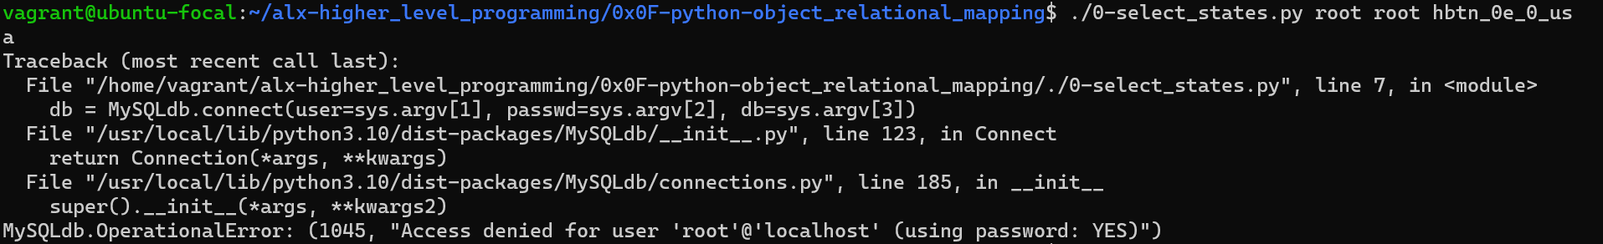

1. In the task ALx, arguments for the user, password and database in that order were provided to be run in the terminal and are to reference these arguments in our code.

|  |  |
| --- | --- |
| ./0-select_states.py root root hbtn_0e_0_usa | |
| 2. | On your Mysql, your password will most likely not be “root”(which is sys.argv[2]). |

Running it on your terminal, replace the root with your password. Examples:

|  |  |
| --- | --- |
| a. | If my MySQL password is “ALxprojects”, replace the code above with |

|  |  |
| --- | --- |
| ./0-select_states.py root "ALxprojects" hbtn_0e_0_usa | |
| b. | If my MSQL password contains special characters like “$”, example: “pas$word”, |

escape the character with a ’ \’:

|  |  |
| --- | --- |
| ./0-select_states.py root "pas\$word" hbtn_0e_0_usa | |
| c. | If my MySQL password if an empty string, replace with: |

|  |
| --- |
| ./0-select_states.py root "" hbtn_0e_0_usa |

**B. If you want to remove the password requirement from your MySQL root user**

|  |  |
| --- | --- |
| 1. | Enter your mysql normally with your password then type in the following commands |

|  |
| --- |
| UPDATE mysql.user SET authentication_string=null WHERE User='root'; |

|  |
| --- |
| flush privileges; |

Now your password is set to an empty string.

You can run your code with "" in place of the "root" provided by ALx as in 2C above

© Gbeminiyi Samagbeyi C-9   
 ALx Accountability Group