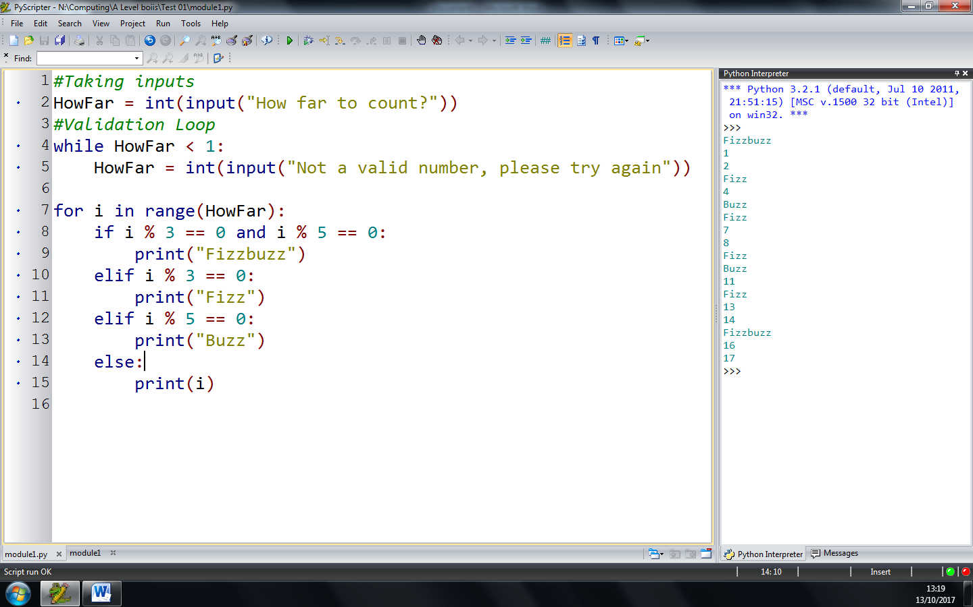

|  |  |  |
| --- | --- | --- |
| Input | Expected Outcome | Actual Outcome |
| 18 | 1, 2, Fizz, 4, Buzz, Fizz, 7, 8, Fizz, Buzz, 13, 14, FizzBuzz, 16, 17 | 1, 2, Fizz, 4, Buzz, Fizz, 7, 8, Fizz, Buzz, 13, 14, FizzBuzz, 16, 17 |
| -1 | Not a valid number, please try again | Not a valid number, please try again |