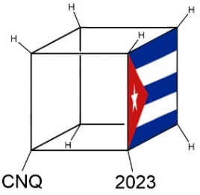 | NATIONAL CHEMISTRY CONTEST 2023
“Every aspect of the world today – even politics and international relations – is affected by chemistry.”
Linus Pauling

Name(s):______________________________ | Last name:______________________________
School:__________________________________________
Municipality:_____________________________ | Province:_______________________________
CODE:__________________________________ | Exam: Day 2. TENTH GRADE

Instructions
- Write clearly all your data in the appropriate place (names, last names, school, municipality, province). Do not write anything in the field CODE.
- Verify that your questions booklet is complete. This is the Day 2 problem set, with an individual exam for 10th grade. The exam has 4 problems (problem 8, 10 items; problem 9, 7 items; problem 10, 4 items; problem 11, 7 items) and a total of 6 pages.
- All data, constants, conversions and basic equations needed are included in the exam. You are allowed to use a scientific calculator.
- At the beginning of each problem its scoring (from a total of 100 points), and each item scoring (in marks) is indicated.
- Number the lower part of the exam, each page and indicate the number of total answer pages, for example, “1 of 7”, “2 of 7” and so on.
- You are only given four and a half hours, control timing carefully: pay attention that the exam has a large number of questions. Do not waste time on unnecessary answers!
Success!

 | Ministerio de Educación | 
 | República de Cuba

CONSTANTS, CONVERSIONS AND EQUATIONS

Avogadro’s constant | $$N_{A}=6,0221∙{10}^{23} {mol}^{-1}$$ | Ideal gas law |  | $$p∙V=n∙R∙T$$
Gasses’ constant | $$R=8,3145 J∙K^{-1}∙{mol}^{-1}$$ | First Principle of Thermodynamics |  | $$Q=∆U+W$$
Zeroth in the Celsius’s scale | $$273,15 K$$ | Gibbs’ energy |  | $$∆G=∆H-T∙∆S$$
Faraday’s constant | $$F=96485 C∙{mol}^{-1}$$ | Nernst’ equation |  | $$E=E°-\frac{R∙T}{z∙F}∙\ln{\frac{c_{red}}{c_{ox}}}$$
Water ionic product at 25 °C | $$K_{W}=1,00∙{10}^{-14}$$ | $$∆G°=-R∙T∙\ln{K°}=-z∙F∙∆E°$$
Standard conditions | $$p°=100 kPa=1 bar$$  $$c°=1 mol∙L^{-1}$$ | Van’t Hoff i factor | $$i=1+α∙(v-1)$$
Arrhenius’ equation | $$k=A∙exp⁡(-\frac{E_{A}}{R∙T})$$ | Cryoscopy | $$∆T_{c}=i∙K_{c}∙b$$
$$1 J=1 C∙1 V=1 kPa ∙1 L =1 W ∙1 s$$ |  | $1 C=1 A∙1 s$ $1 {dm}^{3}=1 L=1000 mL$
1 atm = 760 Torr = 760 mmHg = 101,325 kPa |  | $1 eV=96,485 kJ∙{mol}^{-1}$ $M ≡ mol/L$
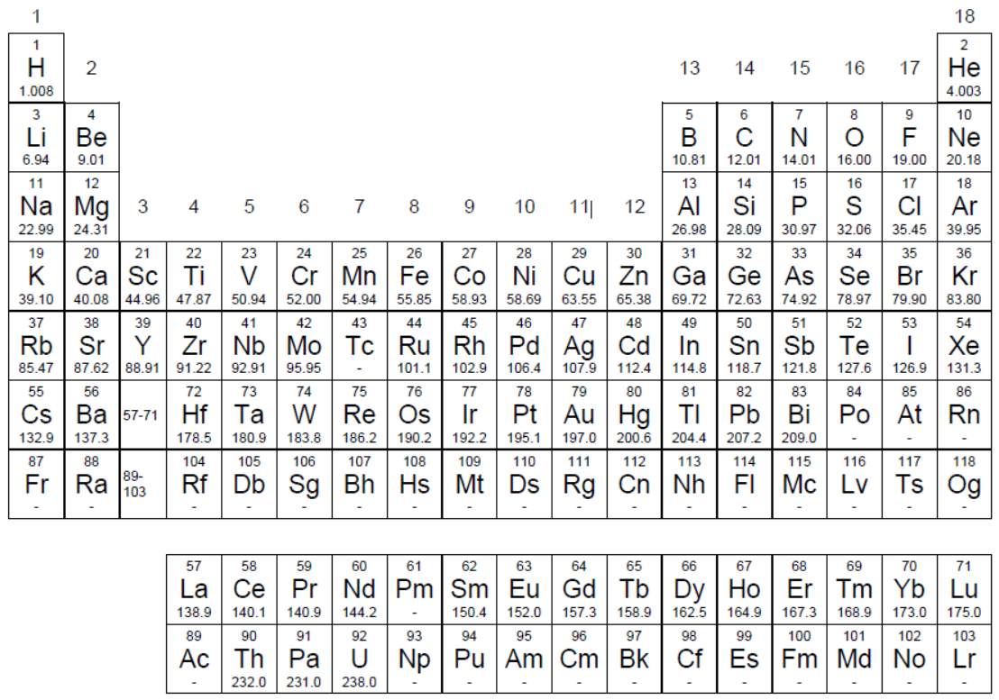
PERIODIC TABLE OF THE ELEMENTS

Problem 8. Miscellanea (10th grade)
8.1 | … | Total | Total
4 | idem | 40 | 10%
Select the most appropriate statement in each case. You do not need to justify your answer.
8.1. The compound whose 1,00 g sample contains the largest number of atoms is:
A) CO | B) C₂H₆ | C) C₆H₆ | D) Kr
8.2. Which species has the smallest bond angle?
A) NO₃– | B) NO₂– | C) FNO₂ | D) NF₃
8.3. Which solid has the highest melting point?
A) S₈ | B) MgF₂ | C) SiO₂ | D) P₄
8.4. What is the molar mass of a gas with density equal to 6,13 g/L at 25 °C and 101,325 kPa?
A) 10 g/mol | B) 20 g/mol | C) 150 g/mol | D) 190 g/mol
8.5. The lattice energy of Na₂O has a value of –2600 kJ/mol, while the lattice energy of another oxide MgO has a value of –3900 kJ/mol. What factors contribute to MgO having a higher lattice energy?
I) Mg²⁺ has a charge larger than Na⁺, II) Mg²⁺ is smaller than Na⁺
A) only I | B) only II | C) I and II | D) nor I nor II
8.6. What metal is resistant to rust in the open air because it forms a protective layer of oxide?
A) Al | B) Ca | C) Ag | D)Sr
8.7. Which molecule has the shortest C-N bond distance?
A) HCNO | B) HNCO | C) H₃CNO | D) H₃CNO₂
8.8. In the complex compound Na[V(CO)₅], what is the oxidation number of vanadium?
A) 1– | B) 3+ | C) 5+ | D) 6+
8.9. What is the coefficient for Zn when the equation is balanced to its minimum coefficients?
Zn + H⁺(ac) + NO₃– (ac) → Zn²⁺ (ac) + N₂O(g) + H₂O(l)
A) 2 | B) 4 | C) 6 | D) 8
8.10. Increasing order of acid strength:
A) H₃BO₃ < H₃PO₄ < HClO₃ | B) HClO₃ < H₃BO₃ < H₃PO₄
C) H₃PO₄ < HClO₃ < H₃BO₃ | D) H₃BO₃ < HClO₃ < H₃PO₄

Problem 9. Carbon compounds (10th grade)
9.1 | 9.2 | 9.3 | 9.4 | 9.5 | 9.6 | 9.7 | Total | Total
15 | 8 | 13 | 5 | 4 | 4 | 11 | 60 | 15%
Carbon is an essential element for life. Perhaps its best-known chemical property is to form long chains in organic molecules, however, this element also has rich inorganic chemistry. Different oxides of carbon are known, including monoxide, dioxide, and suboxide (C₃O₂). In these molecules the central atom is carbon and they are completely linear. Carbonic acid is unstable and in the presence of water it decomposes rapidly to form dissolved carbon dioxide. In basic aqueous medium, carbon dioxide loses its protons forming hydrogencarbonate and carbonate anions. Deltic acid has the formula C₃O(OH)₂ and it is also called trianglic acid, in reference to its highly symmetrical structure with a three-atom cycle. Squaric acid has the formula C₄O₂(OH)₂ and it is also called quadratic acid, in reference to its highly symmetrical structure with a four-atom cycle. Both acids are relatively strong, therefore, they lose two protons easily, originating the corresponding dianions, which are aromatic. Another important carbon acid is oxalic H₂C₂O₄, which is used as primary standard in redox titrations because it is readily oxidized to carbon dioxide.
Carbon compounds exist for most chemical elements with diverse stoichiometry. Ionic carbides originate with metals and they can be of different types. Methanides (C^{4–}) such as Li₄C are derivatives of methane. Acetylene or ethyne can react with various metals, releasing dihydrogen and forming the corresponding acetylides (C₂^{2–}), such as CaC₂. Allenides or sesquicarbides (C₃^{4–}) such as Mg₂C₃ and interstitial compounds of graphite with alkali metals MC_{8n} are also known. All these carbides hydrolyze in water forming metal hydroxides and a hydrocarbon (compound formed exclusively by carbon and hydrogen). With the transition elements, carbon forms interstitial compounds, which are good electrical conductors; for example, cementite (6,68% by mass of C) is a major constituent of steel and cast iron. With nonmetals, carbon forms a wide variety of compounds.
9.1. Represent the structures for the three oxides of carbon mentioned, carbonic acid, oxalic acid, deltic acid, and squaric acid.
9.2. Represent all the resonant structures of the carbonate CO₃^{2–}, oxalate C₂O₄^{2–}, deltate C₃O₃^{2–}, and squarate C₄O₄^{2–} dianions.
9.3. Write balanced chemical equations for the following processes.
9.3.a) The decomposition of magnesium oxalate under intense heating forming only oxides.
9.3.b) The reaction between potassium permanganate and oxalic acid, in the presence of sulfuric acid, if it is known to form manganese(II) sulfate and carbon dioxide.
9.3.c) The preparation of calcium acetylide from calcium oxide.
9.3.d) Hydrolysis of Li₄C, Na₂C₂ and Mg₂C₃.
9.4. Construct the molecular orbital diagram for the acetylide anion. Justify its formation by the calculation of the bond order. Predict its magnetic properties.
9.5. Use valence bond theory and the hybridization model to justify the bond formation in ethyne molecule. (H–C≡C–H).
9.6. Find the empirical formula of cementite.
9.7. Represent the structures of the phosgene compounds. COCl₂, cyanogen (CN)₂, cyanamide NH₂CN, dimethylcarbonate CO(OCH₃)₂ and methyl isocyanate CH₃NCO.

Problem 10. Nickel extraction (10th grade)
10.1 | 10.2 | 10.3 | 10.4 | Total | Total
8 | 6 | 22 | 4 | 40 | 10%
Cuba has important nickel deposits, mainly in the province of Holguín. This metal is widely used in the production of batteries. Nickel is found as part of laterites that are rich in iron and aluminum oxides. The composition of the mineral varies depending on the deposit in which it is found. The Caron process is used to isolate the component of interest from the rest of the matrix. Broadly speaking, the multi-stage process is summarized according to the following transformation ratio:
$$NiO∙{Fe}_{2}O_{3}∙{Al}_{2}O_{3}(s)→→→FeNi(s)$$
10.1. Determine the yield of the process if you start with 10,0 tons of laterite with empirical formula NiO∙Fe₂O₃∙Al₂O₃ and 1,20 ton of alloy with empirical formula FeNi are obtained. 1 ton = 10³ kg = 10⁶ g
It has been identified that one of the stages that most affects the performance of the process is leaching, due to the solubility of nickel in the ammonia solution used. The equation that represents this loss of metal can be represented as:
$${Ni}^{2+}(ac)+4{NH}_{3}(ac)={\left[Ni({NH}_{3})_{4}\right]}^{2+}(ac)$$
10.2. Determine the maximum mass of nickel that could be lost if 2,50 tons of ammonia are used to separate it from the ore.
More expensive alternatives would involve the use of an acid medium for separation.
10.3. Determine the mass of 30% by mass hydrochloric acid solution needed to dissolve 10,0 ton of laterite if its mass composition is NiO 1,0%, Fe₂O₃ (59,5%) and Al₂O₃ (11,5 %).
10.4. How much would it cost to use hydrochloric acid in this process? The ton of industrial hydrochloric acid has a value of $38,000.
M(X) in g/mol: NH₃ = 17,04; NiO = 74,69; Fe₂O₃ = 159,70; Al₂O₃ = 101,96; FeNi = 114,54; HCl = 36,46.

Problem 11. Thermochemistry of hydrocarbons (10th grade)
11.1 | 11.2 | 11.3 | 11.4 | 11.5 | 11.6 | 11.7 | Total | Total
8 | 8 | 8 | 12 | 4 | 4 | 16 | 60 | 15%
Cyclohexene (M = 82.14 g/mol) is a hydrocarbon that can react with potassium permanganate (M = 158.03 g/mol) according to the reaction
[1] $3C_{6}H_{10}\left(l\right)+8KMnO_{4}\left(s\right)+4H_{2}O\left(l\right)→3C_{6}H_{10}O_{4}\left(s\right)+8MnO_{2}\left(s\right)+8KOH(ac)$
The previous reaction can be divided for its thermodynamic study into three simpler reactions
[2] $4KMnO_{4}\left(s\right)+2H_{2}O\left(l\right)→7O_{2}\left(g\right)+4Mn\left(s\right)+4KOH\left(ac\right) {∆H}_{r}°=2123 kJ/mol$
[3] |  | $${∆H}_{r}°= ¿?$$
[4] $Mn\left(s\right)+O_{2}\left(g\right)→MnO_{2}\left(s\right) {∆H}_{r}°=-520 kJ/mol$
It is further known that ${∆H}_{r}°=\sum{v∙}{∆H}_{f}° {∆H}_{r}°≈\sum{E\left(broken bonds\right)- \sum{E\left(formed bonds\right)} }$
11.1. Using the values of the binding energies, calculate the enthalpy change of the reaction [3].
Bond | O-H | C-C | C-H | C=C | C-O | O=O | C=O
Energy (kJ/mol) | 460 | 347 | 414 | 610 | 555 | 494 | 760
Note: If you could not solve the previous item, use the approximate value of ΔH_{r}º[3] = –1100 kJ/mol to continue with the solution of the rest of the problem.
11.2. Using Hess' Law and enthalpy variations for reactions [2], [3] and [4], Calculate the enthalpy change for the reaction [1] between cyclohexene and potassium permanganate.
Note: If you could not solve the previous item, use the approximate value of ΔH_{r}º[1] = –3300 kJ/mol to continue with the solution of the rest of the problem.
11.3. Calculate the heat evolved during the reaction of 13,85 g of cyclohexene with 60,3 g of potassium permanganate at atmospheric pressure.
11.4. Calculate the lattice energy of manganese(IV) oxide using the Born-Haber cycle, the energy values below, and the enthalpy of formation of the oxide (the enthalpy change of the reaction [4]).
ΔH_{sublima}º(Mn) = 234 kJ/mol; I₁(Mn) = 717 kJ/mol; I₂(Mn) = 1509 kJ/mol; I₃(Mn) = 3248 kJ/mol; I₄(Mn) = 4940 kJ/mol; EA₁(O) = –141 kJ/mol; EA₂(O) = 791 kJ/mol; ΔH_{dis}º(O₂) = 498 kJ/mol
11.5. The value obtained above is unrealistic because it was considered that Mn⁴⁺ cations and O^{2–} anions are present in the solid. Which chemical bond model best describes MnO₂? Justify your thinking.
A 47,5 g sample of a certain alkane with the general formula C_{n}H_{2n+2} was completely combusted in a bomb calorimeter. As combustion products, only carbon dioxide and water were obtained and an energy of 2360 kJ was released, measured at constant pressure. The experiment was performed at 25,0 °C.
11.6. Estimate what the final temperature reached by the system was. It is known that the total heat capacity was equal to 1550 kJ/ºC.
11.7. Calculate the molecular formula of the alkane and its enthalpy of combustion in kJ/mol.
ΔHº_{f} (H₂O) = –286 kJ/mol, ΔHº_{f} (CO₂) = –394 kJ/mol, ΔHº_{f} (alkane) = –126 kJ/mol

