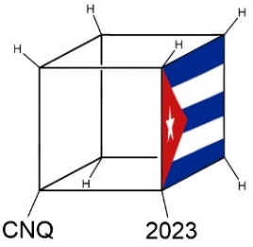 | NATIONAL CHEMISTRY CONTEST 2023
“Every aspect of the world today – even politics and international relations – is affected by chemistry.”
Linus Pauling

Name(s):______________________________ | Last name:______________________________
School:__________________________________________
Municipality:_____________________________ | Province:_______________________________
CODE:__________________________________ | Exam: Day 2. ELEVENTH GRADE

Instructions
- Write clearly all your data in the appropriate place (names, last names, school, municipality, province). Do not write anything in the field CODE.
- Verify that your questions booklet is complete. This is the Day 2 problem set, with an individual exam for 11th grade. The exam has 3 problems (problem 12, 5 items; problem 13, 13 items; problem 14, 15 items) and a total of 7 pages.
- All data, constants, conversions and basic equations needed are included in the exam. You are allowed to use a scientific calculator.
- At the beginning of each problem its scoring (from a total of 100 points), and each item scoring (in marks) is indicated.
- Number the lower part of the exam, each page and indicate the number of total answer pages, for example, “1 of 7”, “2 of 7” and so on.
- You are only given four and a half hours, control timing carefully: pay attention that the exam has a large number of questions. Do not waste time on unnecessary answers!
Success!

 | Ministerio de Educación | 
 | República de Cuba

CONSTANTS, CONVERSIONS AND EQUATIONS

Avogadro’s constant | $$N_{A}=6,0221∙{10}^{23} {mol}^{-1}$$ | Ideal gas law |  | $$p∙V=n∙R∙T$$
Gasses’ constant | $$R=8,3145 J∙K^{-1}∙{mol}^{-1}$$ | First Principle of Thermodynamics |  | $$Q=∆U+W$$
Zeroth in the Celsius’s scale | $$273,15 K$$ | Gibbs’ energy |  | $$∆G=∆H-T∙∆S$$
Faraday’s constant | $$F=96485 C∙{mol}^{-1}$$ | Nernst’ equation |  | $$E=E°-\frac{R∙T}{z∙F}∙\ln{\frac{c_{red}}{c_{ox}}}$$
Water ionic product at 25 °C | $$K_{W}=1,00∙{10}^{-14}$$ | $$∆G°=-R∙T∙\ln{K°}=-z∙F∙∆E°$$
Standard conditions | $$p°=100 kPa=1 bar$$  $$c°=1 mol∙L^{-1}$$ | Van’t Hoff i factor | $$i=1+α∙(v-1)$$
Arrhenius’ equation | $$k=A∙exp⁡(-\frac{E_{A}}{R∙T})$$ | Cryoscopy | $$∆T_{c}=i∙K_{c}∙b$$
$$1 J=1 C∙1 V=1 kPa ∙1 L =1 W ∙1 s$$ |  | $1 C=1 A∙1 s$ $1 {dm}^{3}=1 L=1000 mL$
1 atm = 760 Torr = 760 mmHg = 101,325 kPa |  | $1 eV=96,485 kJ∙{mol}^{-1}$ $M ≡ mol/L$
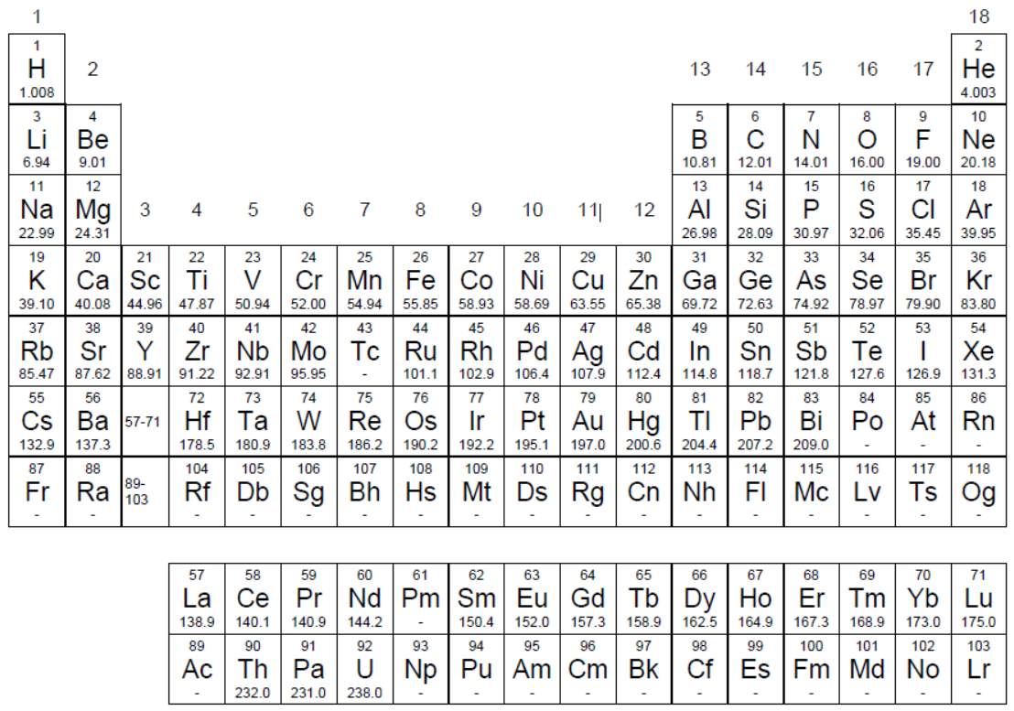
PERIODIC TABLE OF THE ELEMENTS

Problem 12. Chemical equilibrium (only 11th and 12th grades)
12.1 | 12.2 | 12.3 | 12.4 | 12.5 | Total | Total
9 | 9 | 8 | 7 | 7 | 40 | 10%
12.1. An 18,92% by mass aqueous solution of a strong and soluble metal chloride was prepared. The change in the melting point of the solution from that of pure water was about 13,68 ℃. Identify the metal chloride if it is known that K_{cryos} (H₂O) = 1,86 ℃·kg·mol^{–1}.
12.2. Three gases A, B, and C are in equilibrium according to $A\left(g\right) B\left(g\right)+C(g)$. A certain amount of A is introduced into an empty container. If the K_{p} at 298 K is 4,00 and the total pressure of the gases in equilibrium is 2,00 bar, calculate the ratio between the amounts of substance of B and of A in balance.
12.3. Calculate the pH of the solution resulting from mixing 25 mL of NH₃ 0,01 mol·L^{–1} with 15 mL of HCl 0,01 mol·L^{–1}. K_{b} (NH₃) = 1,8·10^{–5}
12.4. If the solubility of silver oxalate at 25 ℃ is 1,11·10^{–4} mol·L^{–1}, calculate the solubility product of the salt. Neglect any hydrolysis of the oxalate ion.
12.5. Calculate the solubility product constant of Hg₂Cl₂ in water at 25℃ if the reduction redox potentials are Eº ([Hg₂]²⁺/Hg(l)) = 0,789 V and Eº (Hg₂Cl₂(s)/Hg(l), Cl–) = 0,268 V.

Problem 13. Boric acid (11th grade)
13.1 | 13.2 | 13.3 | 13.4 | 13.5 | 13.6 | 13.7 | 13.8 | 13.9 | 13.10 | 13.11 | 13.12 | 13.13 | Total | Total
3 | 3 | 4 | 8 | 7 | 6 | 6 | 3 | 5 | 2 | 9 | 11 | 13 | 80 | 20%
One of the laboratory practices of Experimental Chemistry at the University of Havana consists in preparing boric acid (H₃BO₃, M = 61,83 g/mol) from the reaction between the mineral borax or sodium tetraborate decahydrate (Na₂B₄O₇·10H₂O, M = 381,37 g/mol, also formulated as Na₂B₄O₅(OH)₄.8H₂O) and hydrochloric acid. In this question we will use the results obtained by a Chemistry contestant in this practice in 2011.
13.1. Represent the structure of the anion [B₄O₅(OH)₄]^{2–} present in borax. This ion is known to be symmetric and is formed by a bridged bicycle in which oxygen atoms alternate with boron atoms and one oxygen atom acts as a bridge between two boron atoms. Also, all the boron atoms are attached to a hydroxide group.
13.2. Draw the structure of the cations present in borax, knowing that the remaining water molecules are covalently bound to sodium(I) ions.
The laboratory procedure used by the student was as follows.
1. 24,0 g of borax and 45,0 mL of water are added to a porcelain dish and gently heated under constant stirring until the solid is completely dissolved.
2. Add the hydrochloric acid in small portions to the hot borax solution, stirring constantly.
3. Once all the acid has been added, the acidity of the solution is tested, for which 2 or 3 drops of it are taken and methyl orange is added (it should take on a pink color). If the result is not positive, add hydrochloric acid in 1 mL portions until the result is positive.
4. Cool to 10 ℃ under stirring until as much boric acid as possible precipitates.
5. Filter the solid under reduced pressure.
6. The acidity of the filtrate is checked in a similar way to that described above. If the solution is not frankly acid, a sufficient amount of hydrochloric acid is added to achieve this, and it is filtered again. The boric acid obtained in this way is mixed with the initial found in the filter.
7. The total solid obtained is washed with 5-10 mL of cold water, well impregnating the crystals with the washing water before creating vacuum.
8. To purify the boric acid obtained by recrystallization, the solid is dissolved in the least amount of hot water, close to boiling temperature, and it is filtered by gravity while the solution is still hot.
9. The filtrate is poured into a 250 mL crystallizer, covered, and allowed to cool slowly.
10. Once crystallization is achieved, it is vacuum filtered to collect the crystals.
11. The filtrate from this last operation can be concentrated up to a third of its volume to obtain another portion of the product, which is filtered using the same paper that contains the previous solid portion.
12. The solid is washed with 5 ml of cold water repeatedly until the chlorides are removed. This is determined by testing with silver nitrate.
13. The pure crystals are dried on absorbent paper and weighed.
14. Finally, the filtrates or waste solutions are neutralized with sodium carbonate and disposed in the aqueous solution waste container.
13.3. Build a flowchart where the main operations performed by the student during the laboratory procedure are depicted and simplified.
13.4. Write the balanced equation for the reaction between borax and hydrochloric acid (2 equivalents of the latter react). Calculate the yield of the process if it is known that the student obtained a final mass of 10,2 g of boric acid.
13.5. Calculate the minimum volume of commercial hydrochloric acid (37% by mass, 1,19 g/mL) that you used.
13.6. This plot was drawn by the contestant. Indicate the zones that correspond to solutions: unsaturated, saturated and supersaturated.
13.7. Using the plot, calculate the total mass of dissolved boric acid that was lost during purification by recrystallization, if the mass of the solution was 45,0 g and its temperature 10 ℃.
To check the identity of the acid, X mixed a portion of the solid product, eight drops of ethanol, and four drops of concentrated sulfuric acid in a porcelain dish. Next, he stirred with a rod and then ignited the solution with a lighter. A green flame appeared, characteristic of the presence of boron compounds.
13.8. Represent the structure of the ethyl borate B(OCH₂CH₃)₃ formed.
13.9. In aqueous solution boric acid behaves as monoprotic due to the formation of a tetracoordinated complex with a water molecule. Represent the dissociation equilibrium of boric acid and the structure of the tetrahydroxydoborate ion. [B(OH)₄]–.
Boric acid is very weak and its direct titration with sodium hydroxide is not possible. For this reason, it is necessary to add mannitol, a polyhydric alcohol capable of forming stable tetracoordinate complexes with boric acid, which causes its acidity to increase and the pH change near the equivalence point (and consequently, the jump in the pH curve). rating) is larger. Equilibria are reported in the literature.
13.10. Why do you think the second constant is four times smaller than the first?
In order to determine the purity of the obtained boric acid, X proceeded to carry out an acid-base titration. He took 3,0905 g of the product and dissolved it in water to make a 500 mL solution in a volumetric flask. With a graduated pipette, 10,0 mL of the solution was transferred to a container. 1,0 g of mannitol, 30 mL of distilled water, and a few drops of phenolphthalein were added. It was then titrated with a 0,0963 mol/L sodium hydroxide solution, consuming an average volume of 10,5 mL.
13.11. Estimate the percent purity of the boric acid.
Immediately, our hero came up with a way to determine the formation constant of the complex between boric acid and mannitol. To do this, he repeated the previous assessment twice, with and without mannitol. This time, instead of using phenolphthalein, he used a pH-meter to build a titration curve (pH vs V) and determine the end point using the graphical method, with the help of the tangent method (the lines represented on the graph). The results obtained are shown in the figure.
13.12. Find the volume of equivalence using the data from the titration in the presence of mannitol and estimate the percent purity of the boric acid.
13.13. Use the titration plots obtained by X to answer the following questions.
13.13.a) Find the acid dissociation constant of boric acid in water.
13.13.b) Find the apparent acid dissociation constant of boric acid in the presence of mannitol.
13.13.c) Estimate the formation constant of mannitol borate from the above constants.

Problem 14. Thermodynamics of carbon (11th grade)
14.1 | 14.2 | 14.3 | 14.4 | 14.5 | 14.6 | 14.7 | 14.8 | 14.9 | 14.10 | 14.11 | 14.12 | 14.13 | 14.14 | 14.15 | Total | Total
8 | 2 | 5 | 3 | 2 | 6 | 6 | 7 | 2 | 7 | 6 | 10 | 3 | 6 | 7 | 80 | 20%
Species | ΔH_{f}º  (kJ∙mol^{–1}) | Sº  (J∙K^{–1}∙mol^{–1})
CO₂(g) | –393,5 | 213,7
CO₂(ac) | –412,9 | 121,3
C(s) | 0 | 5,7
CO(g) | –110,5 | 197,6
CaO(s) | –635,5 | 39,7
CaCO₃(s) | –1207,0 | 88,7
Carbon dioxide is partially soluble in water because it reacts to form a small amount of carbonic acid, which dissociates into the corresponding anions.
[1] $CO_{2}\left(ac\right)+H_{2}O\left(l\right) H_{2}CO_{3}\left(ac\right) K=1,70∙{10}^{-3}$
[2] $H_{2}CO_{3}\left(ac\right)H^{+}\left(ac\right)+{HCO_{3}}^{-}\left(ac\right) {pK}_{a1}=3,60$
[3] ${HCO_{3}}^{-}\left(ac\right)H^{+}\left(ac\right)+{CO_{3}}^{2-}\left(ac\right) {pK}_{a2}=10,25$

14.1. 14.1. Show that the constant for the dissolution of carbon dioxide in water at 25℃ is approximately equal to
[4] $CO_{2}\left(g\right)CO_{2}\left(ac\right) K_{H}= 3,50∙{10}^{–2}$
14.2. If the rate constant for the forward reaction at equilibrium [1] is 0,039 s⁻¹, find the value of the rate constant for the reverse reaction.
14.3. The coefficient α (atm^{–1}) is defined as the volume of gas if it were measured at TPN (0 ℃ and 101,325 kPa) that is dissolved in the unit volume of solvent at a gas partial pressure equal to 1.00 atm. Using the given value of K_{H}, calculate the value of α at 25℃. V_{m}(TPN) = 22,4 L/mol for an ideal gas.
Since the concentration of carbonic acid is small, for all practical purposes and calculations the first equilibrium of acid dissociation is considered only from dissolved carbon dioxide, according to
[5] $CO_{2}\left(ac\right)+H_{2}O\left(l\right)H^{+}\left(ac\right)+{HCO_{3}}^{-}\left(ac\right) {pK}_{a1}´= ???$
14.4. Show that the value of the acid dissociation constant of carbon dioxide is pK_{a1}´ = 6.37.
Carbonated beverages consist of aqueous solutions of carbon dioxide at high pressure, in the presence of different acidulants and flavorings. Usually, the pH of these preparations is close to 3,0.
14.5. Why does opening a soda can of a carbonated drink cause fizz?
14.6. Calculate the fractions of carbon dioxide, carbonic acid, and their two anions at pH equal to 3,0.
14.7. Calculate the volume of phosphoric acid (M = 97,99 g/mol) in 85% in mass and density 1,685 g/mL necessary to prepare 330 L carbonated soft drink pH 3,00. pK_{a1} = 2,12; pK_{a2} = 7,21 pK_{a3} = 12,30.
Calcium carbonate makes up different rocks and minerals. In industry it is used as a raw material to obtain quicklime (calcium oxide) by thermal decomposition.
14.8. Calculate the minimum temperature for the decomposition of calcium carbonate to be spontaneous.
14.9. Explain the cause of the increase in thermal stability of the following carbonates.
Substance | MgCO₃ | CaCO₃ | SrCO₃ | BaCO₃
Temp. decomposition | 350 ℃ | 840 ℃ | 1010 ℃ | 1340℃
ΔHº of decomposition | 117 kJ/mol | 178 kJ/mol | 235 kJ/mol | 267 kJ/mol
The table shows the results of the gravimetric thermal analysis of the hydrated calcium oxalate CaC₂O₄. This is a method in which the change in the mass of a sample is measured as the temperature changes. The changes in mass and the temperature at which the inflection occurs in the experimental curve are indicated in each case.
Temperature | 187 ℃ | 504 ℃ | 796 ℃
Δm (en %) | 11,86 | 19,01 | 30,19
14.10. Calculate the degree of hydration of the salt.
14.11. Formulate the chemical reactions that occur if a different gas is released in each stage of decomposition.
14.12. In nature, calcium carbonate dissolves slowly by the action of acid rain, forming grottoes and caves. Calculate the solubility of calcium carbonate in a saturated solution of carbon dioxide if the total pressure is 1,00 atm. Consider the vapor pressure of water 3,17 kPa at 25 ℃, the solubility product constant equal to 3,31∙10^{–9} and that the principal equilibrium is the following
[6] $CO_{2}\left(ac\right)+H_{2}O\left(l\right)+CaCO_{3}\left(s\right){Ca}^{2+}\left(ac\right)+2{HCO_{3}}^{-}\left(ac\right) K= ???$
14.13. Formalin is an aqueous solution of formaldehyde or methanal (HCHO). These solutions often contain up to 15% methanol to stabilize them as the corresponding (hemi)acetal. Justify numerically why formaldehyde is unstable from a redox point of view.
14.14. Oxalic acid (COOH)₂ is used as the primary standard to standardize permanganate solutions of unknown concentration. Formulate the ionic equation of the reaction and calculate the equilibrium constant at 25℃. Eº(MnO₄–/Mn²⁺) = 1,507 V.
It is possible to plot the values of the free energy variation for the oxidation reaction with 1 mol of oxygen as a function of temperature for the different chemical elements. This type of graph or Ellingham diagram allows to obtain valuable information. Below is the diagram obtained for the reaction between carbon, carbon monoxide and some metals with dioxygen.
14.15. With the help of the information provided by the diagram and your knowledge of inorganics, answer or complete.
14.15.a) The most reducing metal of all those represented.
14.15.b) The metal oxide which is easiest to reduce at room temperature.
14.15.c) The approximate temperature at which the three carbon species coexist in equilibrium.
14.15.d) The most stable carbon species at elevated temperatures.
14.15.e) In the graph, the phase changes are represented as …
14.15.f) The temperature at which carbon can reduce zinc oxide.
14.15.g) The free energy change changes differently for the three carbon reactions that are represented in the diagram because …

