ReadMe for installing Python and using MoCGF Framework

1. Download WinPython 64 bit Version (e.g. from <http://sourceforge.net/projects/winpython/files/WinPython_3.4/3.4.2.4/>)
2. Install WinPython
3. Run the “WinPython CommandPrompt” (you will find this in the installing folder e.g. C:\WinPython-64bit-3.4.2.4)
4. Run **“pip install mako”** 
5. Change folder to the „MoCGF“
6. Change your git branch to “issue19_pythonAPI” therefore run **“git checkout issue19_pythonAPI”**



1. Run **“python MoCGF-gui.py”**



1. Choose TestGenerator::0.1

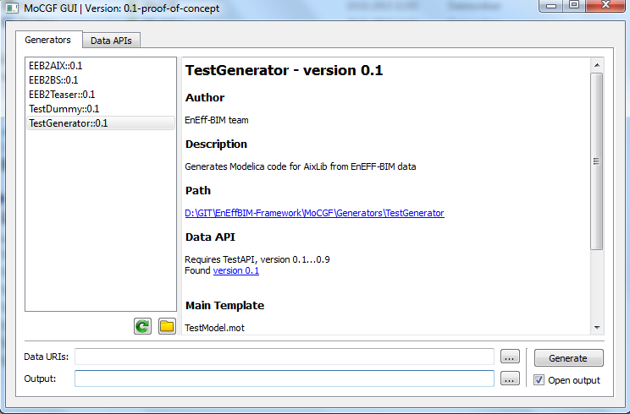

1. Push “Generate” and see the magic happens ☺

For any questions: Premmen@eonerc.rwth-aachen.de