JADE ANDROID ADD-ON

Guide

USAGE RESTRICTED ACCORDING TO LICENSE AGREEMENT.
Last update: 02-March-2007. JADE 3.4.1
Authors: Danilo Gotta (Telecom Italia), Tiziana Trucco (Telecom Italia), Marco Ughetti (Telecom Italia), ……

JADE - Java Agent DEvelopment Framework is a framework to develop multi-agent systems in compliance with the FIPA specifications. JADE successfully passed the 1st FIPA interoperability test in Seoul (Jan. 99) and the 2nd FIPA interoperability test in London (Apr. 01).
Copyright (C) 2000 CSELT S.p.A. (C) 2001 TILab S.p.A. (C) 2002 TILab S.p.A. (C) 2003 TILab S.p.A.
(C) 2004 TILab S.p.A (C) 2005 TILab S.p.A
This library is free software; you can redistribute it and/or modify it under the terms of the GNU Lesser General Public License as published by the Free Software Foundation, version 2.1 of the License.
This library is distributed in the hope that it will be useful, but WITHOUT ANY WARRANTY; without even the implied warranty of MERCHANTABILITY or FITNESS FOR A PARTICULAR PURPOSE. See the GNU Lesser General Public License for more details.
You should have received a copy of the GNU Lesser General Public License along with this library; if not, write to the Free Software Foundation, Inc., 59 Temple Place - Suite 330, Boston, MA 02111-1307, USA.

TABLE OF CONTENTS

Introduction
This document describes the rationale behind the Jade Android Add-On and how to install, configure and use it.
JADE ANDROID (version 1.0) is a JADE add-on that provides support for using JADED-LEAP on Android Platform. Android is the software stack for mobile devices including the operating system released by Google (Open Handset Alliance).
The main body of this guide focuses on the process of starting and configuring the JADE ANDROID Addon in order to connect to a running JADE platform. A dummy application (a sort of Dummy Agent) is also provided. Please refer to the api documentation for a complete description of the APIs that allow programmatic access to all features.
All bugs, issues and feature requests should be made to the main JADE bug reporting system, or sent to the standard JADE mailing lists.
Version 1.0 of the JADE ANDROID add-on was developed by the JADE Board and is only guaranteed to work with JadeLeap release 3.4.1 or later. and the Android SDK release m5-rc14

Target Audience
This document is intended for JADE users who are interested in ..
The reader is assumed to be familiar with JADE. For those new to JADE we strongly recommend first reading the JADE Administrators Guide and Programmers Guide or the JADE Programming Tutorial, available on the JADE web site (http://jade.tilab.com).

Rationale
While Java, and in particular the MIDP profile, is almost a de-facto standard for low cost mobile phones applications, .NET is becoming more and more popular as the development platform for PDAs and smart phones. Developing Java applications on a PDA is of course possible, but it requires installing a proper JVM (such as J9 or CrEme) on the device. Moreover a mobile application typically requires network connections (this is always the case when talking about JADE-based application) or SMS that can be tricky to be managed by some Java VM (this is an issue particularly for CDC Java VM).
Finally it is very likely that mobile applications in the coming years will require to manage other kind of resources like GPS API for localization issues, RFID tag reader in order to exchange information with physical tagged objects and so on. In a Windows Mobile PDA it is largely easier to manage this kind of resources using native code and in some case, at the moment and probably even in the next few years, there is no other choice.
Then, the Jade ANDROID Connector Add On has been thought as a library working on .NET Compact Framework (from version 1.0) useful to add to a .NET Windows Mobile Application the capability to connect to a remote JADE platform (based on JadeLeap). The aim is then to add to the Windows Mobile platform some JADE capabilities, particularly the ability to send and receive ACLMessage to/from agents running on a remote JADE Platform.

Current limitations
Version 1.0 of the Jade Android add-on as described in this document still has some limitations:
- The Jade ANDROID Add-On doesn’t support ontologies but only Frames (both Ordered and Qualified).

Contact
All issues regarding the JADE ANDROID should be addressed to the jade-develop mailing list.

JADE ANDROID Files
The Jade ANDROID Add-On comes with the typical directory structure:
- doc: containing this document and the API documentation
- lib: containing the JadeANDROID dll already compiled for .NET Compact Framework 1.0
- src: containing the following files:
  - source files of JadeANDROID.dll in directory JadeANDROID
  - source files of Dummy Client in directory DummyANDROID
  - Visual Studio project and solution files

How to use THE JADE ANDROID
This section provides instructions of how to set, configure and use the JADE ANDROID add-on. These instructions are related to configure, start and use the DummyClient in the ANDROID SDK Emulator

Getting the software
In order to compile JADE-LEAP for a the Android environment it’s necessary to download the JADE sources from the “Download” area of the JADE web site, the LEAP add-on and the JadeAdroid add-on from the “Add-ons” area of the JADE web site
The LEAP and the JadeAndroid add-ons must be unzipped in the JADE root directory. Once this has been done your JADE directory structure should look like:
jade/
|
|-add-ons/
|- …
|-android
|- demo
|- doc
|- lib
|- src

|-leap/
| |- …
| |-src/ includes the leap add-on source files
|- …
|-src/ includes the JADE source files

Note that, unlike other add-ons that are un-packaged under the jade/add-ons/ directory, the LEAP add-on is un-packaged directly under the jade root directory.
We will refer to the jade/add-ons/android directory as the “JadeAndroid root directory” and we will indicate it simply as android/.

Building and Configuring

Preliminary Steps
As for JADE, building JADE-LEAP for Android can be done using the program ‘ant’ (version 1.6 or later), a platform-independent version of make. ‘ant’ uses the file ‘build.xml’, which contains all the information about the files that have to be compiled, and that is located into the android root directory . The ‘ant’ program must be installed on your computer, and can be freely downloaded from the Jakarta Project at the Apache web site: http://ant.apache.org.
Using ant requires you to set the following environment variables (see the ant documentation for details).
- JAVA_HOME must point to your JDK1.4 or later.
- ANT_HOME must point to where you installed ant.

Build.properties file
Before building JADE-LEAP for Android it is typically necessary to edit the build.properties file included in the JadeAndroid root directory. This property file includes the properties that depend on the local environment such as
- Android-sdk-folder property to point to the directory where the Android SDK is installed
- jade-home-dir property to point to the directory where JADE is installed.

Building Jade Android add-on
To build JADE-LEAP for Android go in the JadeAndroid root directory and type
ant jar

Build process details
<To be done>

Starting the JADE ANDROID
The Visual Studio 2003-2005 installation with C# package is required.
The following steps are needed:
- Double click on Visual Studio slolution file: JadeANDROID.sln
- Modify the in the app.properties file the host and port properties
- Build the projetcs (F5 shortcut) and deploy in the emulator
- Start a JadeLeap Platform on localhost or on a remote one with the BEManagementService and optionally (in order to use the sniffer Agent) the NotificationService (see below the command line to start jadeLeap with these two services). The port where the BEManagementService is listening (the default is 2099) must be the same configured in app.properties file of DummyANDROID project.
- Start the Jade ANDROID Connector clicking on MyDevice\Prtogram Files\dummyANDROID\dummyANDROID.exe on the emulator.

You should see a windows form emulating the Dummy Agent GUI as in Figure 1.
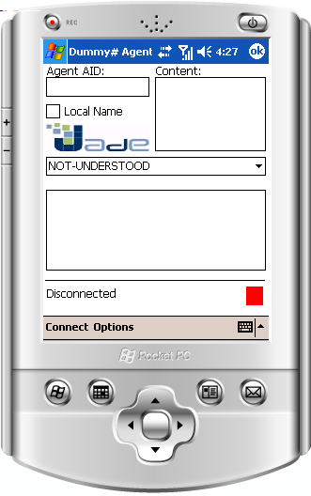
Figure 1: DummyANDROID Agent Emulator GUI.

Testing the JADE ANDROID
In order to test the JadeANDROID connector using the DummyANDROID agent emulator you have to:
- Connect DummyANDROID to the Jade Platform clicking on the Connect item on the emulator (see Picture 2)
- Start a Dummy Agent on Jade Platform
- Send an ACLMessage to DummyANDROID connector by DummyAgent and verify that it is received by him.
- Send an ACLMessage to DummyAgent from DummyANDROID and verify that it is received by him

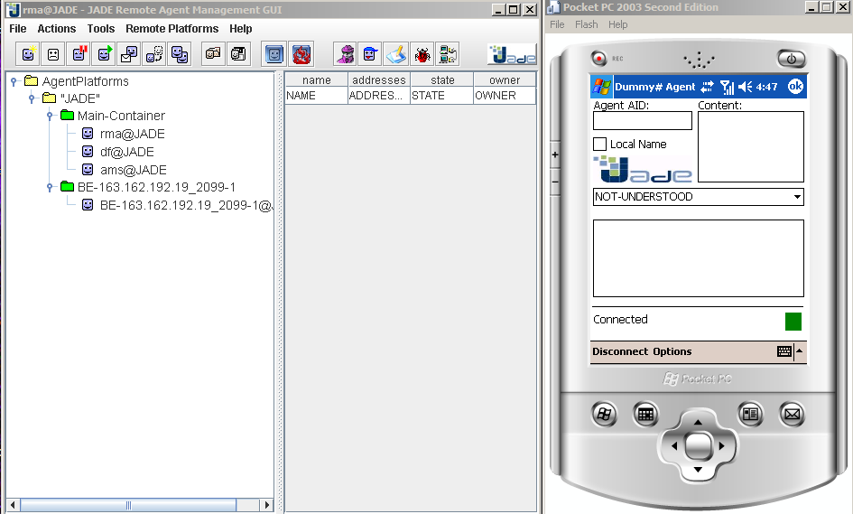
Figure 2: Dummy ANDROID Emulator connected to Jade Platform

command line: java -cp .\JadeLeap.jar jade.Boot –services jade.imtp.leap.nio.BEManagementService;jade.core.event.NotificationService -gui true

