JADE ADMINISTRATOr’s Guide

USAGE RESTRICTED ACCORDING TO LICENSE AGREEMENT.
last update: 21-March-2001. JADE 2.1
Authors: Fabio Bellifemine, Giovanni Caire, Tiziana Trucco (CSELT S.p.A.)
Giovanni Rimassa (University of Parma)

Copyright (C) 2000 CSELT S.p.A.

JADE - Java Agent DEvelopment Framework is a framework to develop multi-agent systems in compliance with the FIPA specifications.
Copyright (C) 2000 CSELT S.p.A.
This library is free software; you can redistribute it and/or modify it under the terms of the GNU Lesser General Public License as published by the Free Software Foundation, version 2.1 of the License.
This library is distributed in the hope that it will be useful, but WITHOUT ANY WARRANTY; without even the implied warranty of MERCHANTABILITY or FITNESS FOR A PARTICULAR PURPOSE. See the GNU Lesser General Public License for more details.
You should have received a copy of the GNU Lesser General Public License along with this library; if not, write to the Free Software Foundation, Inc., 59 Temple Place - Suite 330, Boston, MA 02111-1307, USA.

TABLE OF CONTENTS
1 Introduction 3
2 Running the Agent Platform 3
2.1 Software requirements 3
2.2 Getting the software 3
2.3 Running JADE from the binary distribution 3
2.3.1 Command line syntax 4
2.3.2 Options available from the command line 4
2.3.3 Launching agents from the command line 5
2.3.4 Example 5
2.4 Building JADE from the source distribution 6
2.4.1 Building the JADE framework 6
2.4.2 Building JADE libraries 6
2.4.3 Building JADE HTML documentation 7
2.4.4 Building JADE examples and demo application 7
2.4.5 Cleaning up the source tree 7
2.5 Support for inter-platform messaging with plug-in Message Transport Protocols 7
2.5.1 Command line options for MTP management 8
2.5.2 Configuring MTPs from the graphical management console. 8
2.5.3 Agent address management 9
2.5.4 Writing new MTPs for JADE 10
2.5.4.1 The Basic IIOP MTP 10
2.5.4.2 The Basic HTTP MTP 10
3 Graphical User Interface to Manage and Monitor the AP Activity 10
3.1 Remote Monitoring Agent 10
3.2 DummyAgent 13
3.3 DF GUI 14
3.4 Sniffer Agent 15

Introduction
This administrator's guide describes how to install and launch JADE. It is complemented by the HTML documentation available in the directory jade/doc and the JADE Programmer's Guide. If and where conflict arises between what is reported in the HTML documentation and this guide, preference should be given to the HTML documentation that is updated more frequently.

Running the Agent Platform

Software requirements
The only software requirement to execute the system is the Java Run Time Environment version 1.2
Further to the Java Compiler version 1.2, to build the system, the JavaCC parser generator (version 0.8pre or version 1.1; available from http://www.metamata.com), and the IDL to Java translator idltojava (available from the Sun Developer Connection) are also needed. However, pre-built IDL stubs and Java parser classes are included with the JADE source distribution such that the Java compiler is sufficient to build the full system.

Getting the software
All the software is distributed under the LGPL license limitations. It can be downloaded from the JADE web site http://sharon.cselt.it/projects/jade. Five compressed files are available:
- the source code of JADE
- the source code of the examples
- the documentation, including the javadoc of the JADE API and this programmer's guide
- the binary of JADE, i.e. the jar files with all the Java classes
- a full distribution with all the previous files

Running JADE from the binary distribution
Having uncompressed the archive file, a directory tree is generated whose root is jade and with a lib subdirectory. This subdirectory contains some JAR files that have to be added to the CLASSPATH environment variable.
Having set the classpath, the following command can be used to launch the main container of the platform. The main container is composed of the DF agent, the AMS agent, an RMI registry (that is used by JADE for intra-platform communication), and the ACC.
java jade.Boot [options] [AgentSpecifier list]
Additional agent containers can be then launched on the same host, or on remote hosts, that connect themselves with the main container of the Agent Platform, resulting in a distributed system that seems a single Agent Platform from the outside.
An Agent Container can be started using the command:
java jade.Boot –container [options] [AgentSpecifier list]
An alternative way of launching JADE is to use the following command, that does not need to set the CLASSPATH:
java –jar lib\jade.jar [options] [AgentSpecifier list]

Command line syntax
The full EBNF syntax of the command line is the following, where common rules apply for the token definitions:
java jade.Boot Option* AgentSpecifier*
Option = "-container"
| "-host" HostName
| "-port" PortNumber
| "-gui"
| "-mtp" ClassName "(" Argument* ")"
("," ClassName "(" Argument* ")")*
| "-nomtp"
| "-version"
| "-help"
| "-conf" FileName?
ClassName = PackageName? Word
PackageName = (Word ".")+
Argument = Word | Number | String
HostName = Word ( "." Word )*
PortNumber = Number
AgentSpecifier = AgentName ":" ClassName ("(" Argument* ")")?
AgentName = Word

Options available from the command line
-container specifies that this instance of JADE is a container and, as such, that it must join with a main-container (by default this option is unselected)
-host specifies the hostName where the RMI registry should be created (for the main-container) / located (for the ordinary containers); its value is defaulted to localhost. This option can also be used when launching the main-container in order to override the value of localhost; a typical example of this kind of usage is to include the full domain of the host (e.g. –host kim.cselt.it when the localhost would have returned just ‘kim’) such that the main-container can be contacted even from outside the local domain.
-port this option allows to specify the port number where the RMI registry should be created (for the main-container) / located (for the ordinary containers). By default the port number 1099 is used.
-gui specifies that the RMA (Remote Monitoring Agent) GUI of JADE should be launched (by default this option is unselected)
-mtp specifies a list of external Message Transport Protocols to be activated on this container (by default the JDK1.2 IIOP is activated on the main-container and no MTP is activated on the other containers)
-nomtp has precedence over -mtp and overrides it. It should be used to override the default behaviour of the main-container (by default the -nomtp option unselected)
-version print on standard output the versioning information of JADE (by default this option is unselected)
-help print on standard output this help information (by default this option is unselected)
-conf if no filename is specified after this option, then a graphical interface is displayed that allows to load/save all the JADE configuration parameters from a file. If a filename is specified, instead, then all the options specified in that file are used to launch JADE. By default this option is not selected.

Launching agents from the command line
A list of agents can be launched directly from the command line. As described above, the [AgentSpecifier list] part of the command is a sequence of strings separated by a space.
Each string is broken into three parts. The first substring (delimited by the colon ‘:’ character) is taken as the agent name; the remaining substring after the colon (ended with a space or with an open parenthesis) is the name of the Java class implementing the agent. This class will be dynamically loaded by the Agent Container. Finally, a list of string arguments can be passed delimited between parenthesis.
For example, a string Peter:myAgent means "create a new agent named Peter whose implementation is an object of class myAgent". The name of the class must be fully qualified, (e.g. Peter:myPackage.myAgent) and will be searched for according to CLASSPATH definition.
Another example is the string Peter:myAgent(“today is raining” 123) that means "create a new agent named Peter whose implementation is an object of class myAgent and pass an array of two arguments to its constructor: the first is the string today is raining and the second is the string 123". Notice that, according to the Java convention, the quote symbols have been removed and the number is still a string.

Example
First of all set the CLASSPATH to include the JAR files in the lib subdirectory and the current directory. For instance, for Windows 9x/NT use the following command:
set CLASSPATH=%CLASSPATH%;.;c:\jade\lib\jade.jar;
c:\jade\lib\jadeTools.jar;c:\jade\lib\Base64.jar;c:\jade\lib\iiop.jar
Execute the following command to start the main-container of the platform. Let's suppose that the hostname of this machine is "kim.cselt.it"
prompt> java jade.Boot –gui
Execute the following command to start an agent container on another machine, by telling it to join the AgentPlatform running on the host "kim.cselt.it", and start one agent (you must download and compile the examples agents to do that):
prompt> java jade.Boot -host kim.cselt.it -container
sender1:examples.receivers.AgentSender
where "sender1" is the name of the agent, while examples.receivers.AgentSender is the code that implements the agent.
Execute the following command on a third machine to start another agent container telling it to join the Agent Platform, called "facts" running on the host "kim.cselt.it", and then start two agents.
prompt> java jade.Boot –host kim.cselt.it –container
receiver2:examples.receivers.AgentReceiver
sender2:examples.receivers.AgentSender
where the agent named sender2 is implemented by the class examples.receivers.AgentSender, while the agent named receiver2 is implemented by the class examples.receivers.AgentReceiver.

Building JADE from the source distribution
If you downloaded JADE in source form and want to compile it, you basically have two methods: either you use the provided makefiles (for GNU make), or you run the Win32 .BAT files that you find in the root directory of the package. Of course, using makefiles yields more flexibility because they just build what is needed; JADE makefiles have been tested under Sun Solaris 7 with JDK 1.2.0 and under Linux under JDK 1.2.2 RC4. The batch files have been tested under Windows NT 4.0 and under Windows 95, both with JDK 1.2.2.

Building the JADE framework
If you use the makefiles, just type
make all
in the root directory; if you use the batch files, type
makejade
in the root directory. Beware that the batch file will not be able to check whether IDL stubs and parser classes already exist, so either you have idltojava and JavaCC installed, or you comment out them in the batch file.
You will end up with all JADE classes in a classes subdirectory. You can add that directory to your CLASSPATH and make sure that everything is OK by running JADE, as described in the previous section.

Building JADE libraries
With makefiles, type
make lib
With batch files, type
makelib
This will remove the content of the classes directory and will create some JAR files in the lib directory. These JAR files are just the same you get from the binary distribution. See section 2.3 for a description on how to run JADE when you have built the JAR files. Beware that, both with makefiles and batches, you must first build the classes and then the libraries, otherwise you will end up with empty JAR files.

Building JADE HTML documentation
With makefiles, type
make doc
With batch files, type
makedoc
You will end up with Javadoc generated HTML pages, integrated within the overall documentation. Beware that the Programmer’s Guide is a PDF file that cannot be generated at your site, but you must download it (it is, of course, in the JADE documentation distribution).

Building JADE examples and demo application
If you downloaded the examples/demo archive and have unpacked it within the same source tree, you will have to set your CLASSPATH to contain either the classes directory or the JAR files in the lib directory, depending on your JADE distribution, and then type:
make examples
with makefiles, or
makeexamples
with batch files.
In order to compile the Jess-based example, it is necessary to have the JESS system and to set the CLASSPATH to include it. The example can be compiled by typing:
make jessexample
with makefiles, or
makejessexample
with batch files.

Cleaning up the source tree
If you type
make clean
with makefiles, or if you type
clean
with batch files, you will remove all generated files (classes, HTML pages, JAR files, etc.) from the source tree. If you use makefiles, you will find some other make targets you can use. Feel free to try them, especially if you are modifying JADE source code, but be aware that these other make targets are for internal use only, so they have not been documented.

Support for inter-platform messaging with plug-in Message Transport Protocols
The FIPA 2000 specification proposes a number of different Message Transport Protocols (MTP for short) over which ACL messages can be delivered in a compliant way.
JADE comprises a framework to write and deploy multiple MTPs in a flexible way. An implementation of a FIPA compliant MTP can be compiled separately and put in a JAR file of its own; the code will be dynamically loaded when an endpoint of that MTP is activated. Moreover, every JADE container can have any number of active MTPs, so that the platform administrator can choose whatever topology he or she wishes.
JADE performs message routing for both incoming and outgoing messages, using a single-hop routing table that requires direct visibility among containers.
When a new MTP is activated on a container, the JADE platform gains a new address that is added to the list in the platform profile (that can be obtained from the AMS using the action get-description). Moreover, the new address is added to all the ams-agent-description objects contained within the AMS knowledge base.

Command line options for MTP management
When a JADE container is started, it is possible to activate one ore more communication endpoints on it, using suitable command line options. The –mtp option activates a new communication endpoint on a container, and must be given the name of the class that provides the MTP functionality. If the MTP supports activation on specific addresses, then the address URL can be given right after the class name, enclosed in brackets. If multiple MTPs are to be activated, they can be listed together using commas as separators.
For example, the following option activates an IIOP endpoint on a default address.
-mtp jade.mtp.iiop.MessageTransportProtocol
The following option activates an IIOP endpoint that uses an ORBacus-based IIOP MTP on a fixed, given address.
-mtp orbacus.MessageTransportProtocol(corbaloc:iiop:sharon.cselt.it:1234/jade)
The following option activates two endpoints: a basic IIOP MTP on a default address and an HTTP endpoint on a given address.
-mtp jade.mtp.iiop.MessageTrasportProtocol,jade.mtp.http.MessageTransportProtocol(http://sharon.cselt.it:8080/jade)
When a container starts, it prints on the standard output all the active MTP addresses, separated by a carriage return. Moreover, it writes the same addresses in a file, named:
MTPs-<Container Name>.txt.
If no MTP related option is given, by default a basic IIOP MTP is activated on the Main Container and no MTP are activated on an ordinary container. To inhibit the creation of the default IIOP endpoint, use the –nomtp option.

Configuring MTPs from the graphical management console.
Using the –mtp command line option, a transport endpoint lives as long as its container is up; when a container is shut down, all its MTPs are deactivated and the AMS information is updated accordingly. The JADE RMA console enables a more flexible management of the MTPs, allowing to activate and deactivate transport protocols during normal platform operations. In the leftmost panel of the RMA GUI, right-clicking on an agent container tree node brings up the popup menu with an Install a new MTP and Uninstall an MTP.
Choosing Install a new MTP shows a dialog where the user can select the container to install the new MTP on, the fully qualified name of the class implementing the protocol, and (if it is supported by the chosen protocol) the transport address that will be used to contact the new MTP. For example, to install a new IIOP endpoint, using the default JDK 1.2 ORB, one would write jade.mtp.iiop.MessageTransportProtocol as the class name and nothing as the address. In order to install a new IIOP endpoint, using the ORBacus based implementation, one would write orbacus.MessageTransportProtocol as the class name and (if the endpoint is to be deployed at host sharon.cselt.it, on the TCP port 1234, with an object ID jade) corbaloc:iiop:sharon.cselt.it:1234/jade as the transport address.
Choosing Uninstall an MTP shows a dialog where the user can select from a list one of the currently installed MTPs and remove it from the platform.

Agent address management
During its whole lifetime, a JADE agent can be contacted through different addresses. JADE automatic address propagation keeps both the platform profile and the AMS knowledge base consistent with the actual MTPs that are active in the platform at each moment. So, one agent can easily obtain the complete address list of another agent simply asking the AMS, either for the platform profile (with the get-description action) or with a regular search action.
In the first case, here is the ACL message that must be sent to the AMS:
( REQUEST
:sender (agent-identifier :name da0@Zadig:1099/JADE )
:receiver (set (agent-identifier :name ams@Zadig:1099/JADE ))
:content ((action
(agent-identifier :name ams@Zadig:1099/JADE )
(get-description ) ) )
:language FIPA-SL0
:ontology fipa-agent-management
:protocol fipa-request
)

However, an agent that is about to send a message to start a conversation could prefer to choose explicitly a subset of the available addresses for the subsequent replies. In some cases, the agent could even decide to activate some application specific MTP, that would not belong to the whole platform but only to itself. So, the preferred addresses of an agent are not necessarily the same as the available addresses for its platform.
To support this duplicity, the Agent class provides the getAID() method, which returns the agent identifier for an agent. When the agent is born, the agent ID contains all the available platform addresses, but then it is not updated anymore. Each agent is allowed to manage its own copy of agent ID as it wishes. If an agent wants to keep it up-to-date, it will contact the AMS to refresh the address list, otherwise it will put into its agent ID a suitable address set (taken from the platform list or not). In JADE, it is possible to use agent IDs with an empty address list.

Writing new MTPs for JADE
To write a new MTP that can be used by JADE, all that is necessary is to implement a couple of Java interfaces, defined in the jade.mtp package. The MTP interface models a bi-directional channel that can both send and receive ACL messages (this interface extends the OutChannel and InChannel interfaces that represent one-way channels). The TransportAddress interface is just a simple representation for an URL, allowing to separately read the protocol, host, port and file part.
This section is to be completed

The Basic IIOP MTP
An implementation of the FIPA 2000 IIOP-based transport protocol is included with JADE. This implementation relies on the JDK 1.2 ORB (but can also use the JDK 1.3 ORB, requiring recompilation of the jade.mtp.iiop package). This implementation supports only IOR representations such as IOR:000000000000001649444c644f4…, and does not allow to choose the port number or the object key. These limitations are due to the underlying ORB, and can be solved with other JADE MTPs exploiting more advanced CORBA ORBs. The MTP implementation is contained within the jade.mtp.iiop.MessageTransportProtocol class, so this is the name to be used when starting the protocol. Due to the limitation stated above, choosing the address explicitly is not supported.

The Basic HTTP MTP
This section is still to do.

Graphical User Interface to Manage and Monitor the AP Activity
To support the difficult task of debugging multi-agent applications, three tools have been developed. Each tool is packaged as an agent itself, obeying the same rules, the same communication capabilities, and the same life cycle of a generic application agent.

Remote Monitoring Agent
The Remote Monitoring Agent (RMA) allows controlling the life cycle of the agent platform and of all the registered agents. The distributed architecture of JADE allows also remote controlling, where the GUI is used to control the execution of agents and their life cycle from a remote host.
An RMA is a Java object, instance of the class jade.tools.rma.rma and can be launched from the command line as an ordinary agent (i.e. with the command java jade.Boot myConsole:jade.tools.rma.rma), or by supplying the ‘-gui’ option the command line parameters (i.e. with the command java jade.Boot –gui).
More than one RMA can be started on the same platform as long as every instance has a different local name, but only one RMA can be executed on the same agent container.

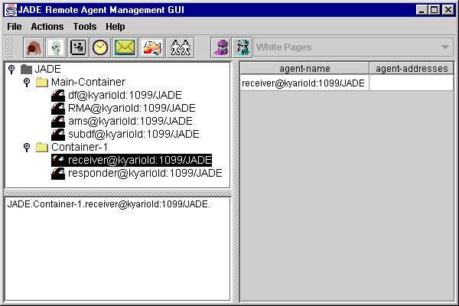
Figure 1 - Snapshot of the RMA GUI
The followings are the commands that can be executed from the menu bar (or the tool bar) of the RMA GUI.
- File menu:
This menu contains the general commands to the RMA.
- Close RMA Agent
Terminates the RMA agent by invoking its doDelete() method. The closure of the RMA window has the same effect as invoking this command.
- Exit this Container
Terminates the agent container where the RMA is living in, by killing the RMA and all the other agents living on that container. If the container is the Agent Platform Main-Container, then the whole platform is shut down.
- Shut down Agent Platform
Shut down the whole agent platform, terminating all connected containers and all the living agents.
- Actions menu:
This menu contains items to invoke all the various administrative actions needed on the platform as a whole or on a set of agents or agent containers. The requested action is performed by using the current selection of the agent tree as the target; most of these actions are also associated to and can be executed from toolbar buttons.
- Start New Agent
This action creates a new agent. The user is prompted for the name of the new agent and the name of the Java class the new agent is an instance of. Moreover, if an agent container is currently selected, the agent is created and started on that container; otherwise, the user can write the name of the container he wants the agent to start on. If no container is specified, the agent is launched on the Agent Platform Main-Container.
- Kill Selected Items
This action kills all the agents and agent containers currently selected. Killing an agent is equivalent to calling its doDelete() method, whereas killing an agent container kills all the agents living on the container and then de-registers that container from the platform. Of course, if the Agent Platform Main-Container is currently selected, then the whole platform is shut down.
- Suspend Selected Agents
This action suspends the selected agents and is equivalent to calling the doSuspend() method. Beware that suspending a system agent, particularly the AMS, deadlocks the entire platform.
- Resume Selected Agents
This action puts the selected agents back into the AP_ACTIVE state, provided they were suspended, and works just the same as calling their doActivate() method.
- Send Custom Message to Selected Agents
This action allows to send an ACL message to an agent. When the user selects this menu item, a special dialog is displayed in which an ACL message can be composed and sent, as shown in the figure.

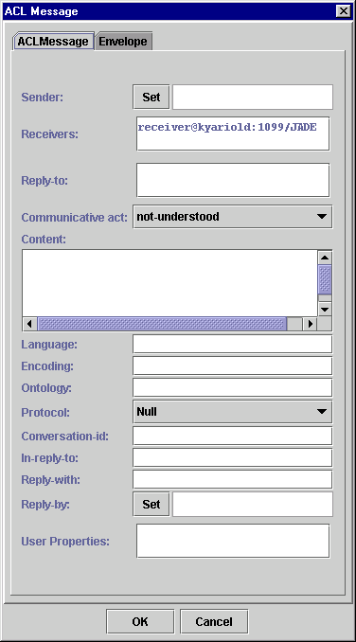
Figure 10 –The dialog box to send custom messages to other agents

- Migrate Agent
This action allows to migrate an agent. When the user selects this menu item, a special dialog is displayed in which the user must specify the container of the platform where the selected agent must migrate. Not all the agents can migrate because of lack of serialization support in their implementation. In this case the user can press the cancel button of this dialog.

- Clone Agent
This action allows to clone a selected agent. When the user selects this menu item a dialog is displayed in which the user must write the new name of the agent and the container where the new agent will start.

- Tools menu:
This menu contains the commands to start all the tools provided by JADE to application programmers. These tools will help developing and testing JADE based agent systems.

DummyAgent
The DummyAgent tool allows users to interact with JADE agents in a custom way. The GUI allows to compose and send ACL messages and maintains a list of all ACL messages sent and received. This list can be examined by the user and each message can be viewed in detail or even edited. Furthermore, the message list can be saved to disk and retrieved later. Many instances of the DummyAgent can be started as and where required.
The DummyAgent can both be launched from the Tool menu of the RMA and from the command line, as follows:
Java jade.Boot theDummy:jade.tools.DummyAgent.DummyAgent
The figure is a snapshot of the DummyAgent GUI.
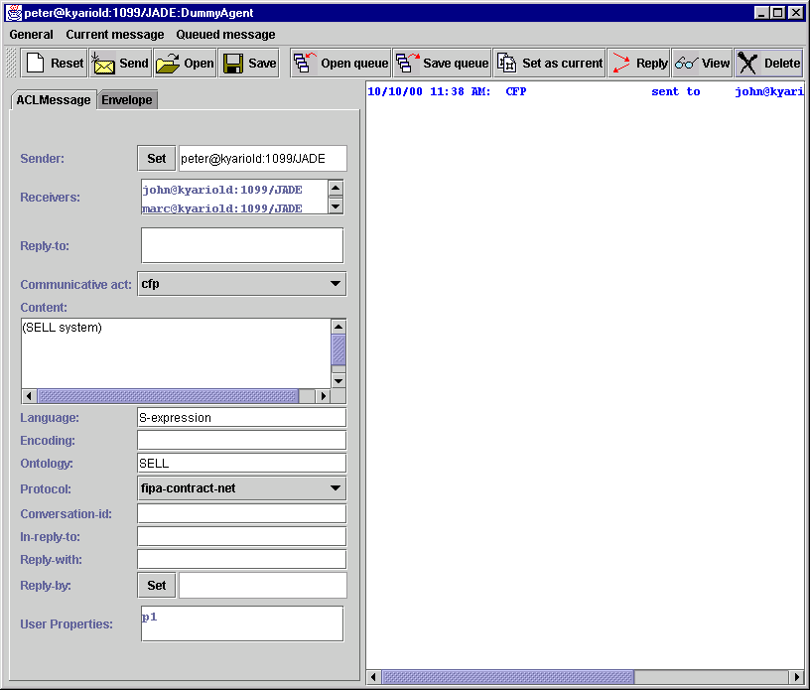

Figure 11 - Snapshot of the DummyAgent GUI

DF GUI
A GUI of the DF can be launched from the Tools menu of the RMA. This action is actually implemented by sending an ACL message to the DF asking it to show its GUI. Therefore, the GUI can just be shown on the host where the platform (main-container) was executed.
By using this GUI, the user can interact with the DF: view the descriptions of the registered agents, register and deregister agents, modify the description of registered agent, and also search for agent descriptions.
The GUI allows also to federate the DF with other DF's and create a complex network of domains and sub-domains of yellow pages. Any federated DF, even if resident on a remote non-JADE agent platform, can also be controlled by the same GUI and the same basic operations (view/register/deregister/modify/search) can be executed on the remote DF.
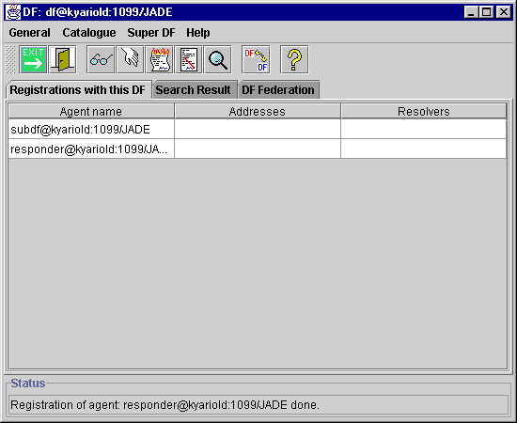
Figure 12 – Snapshot of the GUI of the DF

Sniffer Agent
As the name itself points out, the Sniffer Agent is basically a Fipa-compliant Agent with sniffing features.
When the user decides to sniff an agent or a group of agents, every message directed to/from that agent / agentgroup is tracked and displayed in the sniffer Gui. The user can view every message and save it to disk. The user can also save all the tracked messages and reload it from a single file for later analysis.
This agent can be started both from the Tools menu of the RMA and also from the command line as follows:
java jade.Boot sniffer:jade.tools.sniffer.Sniffer
The figure shows a snapshot of the GUI.
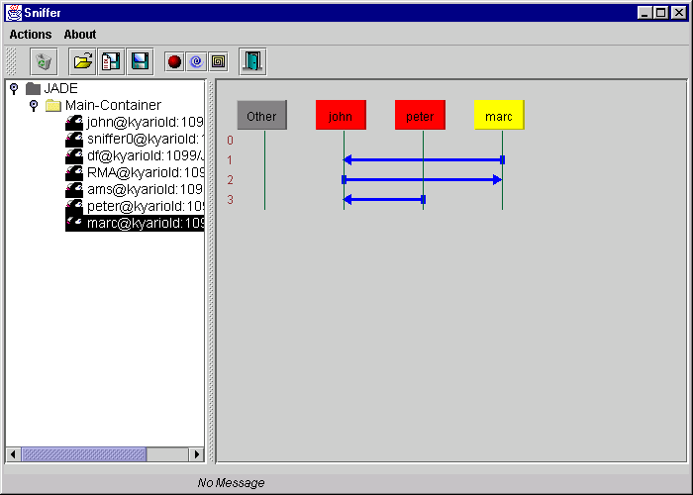
Figure 13 - Snapshot of the sniffer agent GUI

ORBacus is a CORBA 2.3 ORB for C++ and Java. It is available from Object Oriented Concepts, Inc. at http://www.ooc.com. An alternate IIOP MTP for JADE, exploiting ORBacus features, is available at JADE site: http://sharon.cselt.it/projects/jade.
How an agent can contact a foreign AMS in the first place is not clear, since FIPA does not specify a name resolution protocol. Anyway, once the agent knows a single way of contacting a foreign JADE AMS, it can obtain all the information it needs.

