DESIGN AND ANALYSIS OF ALGORITHM
23CSE211
WEEK 2- ACTIVITY
SORTING TECHNIQUES

1. Bubble Sort:

Program:
#include<stdio.h>
#define size 5
void bubblesort(int arr[], int n){
for(int i=0;i<n;i++){
for(int j=0;j<n-i-1;j++){
if(arr[j]>arr[j+1]){
int temp=arr[j];
arr[j]=arr[j+1];
arr[j+1]=temp; }
}
}
}
int main(){
int arr[size];
for(int i=0;i<size;i++){
printf("enter element %d: ",i);
scanf("%d",&arr[i]);
}
bubblesort(arr,size);
for(int i=0;i<size;i++){
printf("%d\n",arr[i]); }
return 0;
}

Output:
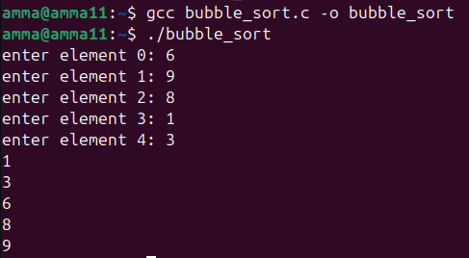

2. Insertion Sort:
Program:
#include<stdio.h>
#define size 5
void insertionsort(int arr[], int n){
for(int i=1;i<n;i++){
int key=arr[i];
int j=i-1;
while(j>=0 && arr[j]>key){
arr[j+1]=arr[j];
j--;
}
arr[j+1]=key;
}
}

int main(){
int arr[size];
for(int i=0;i<size;i++){
printf("enter element %d: ",i);
scanf("%d",&arr[i]);
}
insertionsort(arr,size);
for(int i=0;i<size;i++){
printf("%d\n",arr[i]);
}
return 0;
}
Output:
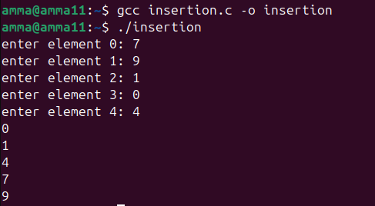

3. Selection Sort:

Program:
#include<stdio.h>
#define size 5
void selectionsort(int arr[], int n){
for(int i=0;i<n-1;i++){
int min=i;
for(int j=i+1;j<n;j++){
if(arr[j]<arr[min]){
min=j;
}
}
int temp=arr[i];
arr[i]=arr[min];
arr[min]=temp;
}
}
int main(){
int arr[size];
for(int i=0;i<size;i++){
printf("enter element %d: ",i);
scanf("%d",&arr[i]);
}
selectionsort(arr,size);
for(int i=0;i<size;i++){
printf("%d\n",arr[i]);
}
return 0;
}
Output:
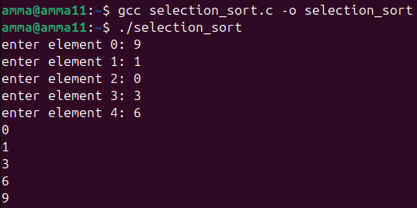

4. Bucket Sort:

Program:
#include<stdio.h>
#define size 5
void bucketsort(int arr[], int n){
int bucket[10]={0};
for(int i=0;i<n;i++){
bucket[arr[i]]++;
}
int index=0;
for(int i=0;i<10;i++){
while(bucket[i]--){
arr[index++]=i;
}
}
}
int main(){
int arr[size];
for(int i=0;i<size;i++){
printf("enter element %d: ",i);
scanf("%d",&arr[i]);
}
bucketsort(arr,size);
for(int i=0;i<size;i++){
printf("%d\n",arr[i]);
}
return 0;
}
Output:

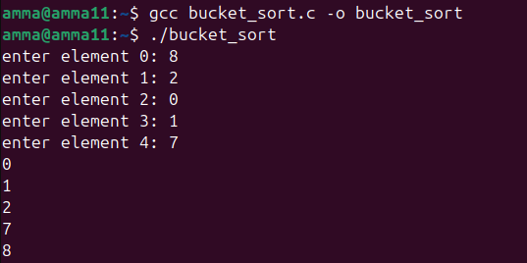

5. Heap Sort:

Program:
#include<stdio.h>
#define size 5
void heapify(int arr[], int n, int i){
int largest=i;
int left=2*i+1;
int right=2*i+2;
if(left<n && arr[left] > arr[largest]){
largest = left;
}
if(right<n && arr[right] > arr[largest]){
largest = right;
}
if(largest!=i){
int temp=arr[i];
arr[i] = arr[largest];
arr[largest]=temp;
heapify(arr,n,largest);
}
}

void heapsort(int arr[], int n) {
for (int i = n/2 - 1; i >= 0; i--) {
heapify(arr, n, i);
}
for (int i = n - 1; i > 0; i--) {
int temp = arr[0];
arr[0] = arr[i];
arr[i] = temp;
heapify(arr, i, 0);
}
}
int main() {
int arr[size];
for (int i = 0; i < size; i++) {
printf("enter element %d: ", i);
scanf("%d", &arr[i]);
}
heapsort(arr, size);
for (int i = 0; i < size; i++) {
printf("%d\n", arr[i]);
}
return 0;
}
Output:
