DESIGN AND ANALYSIS OF ALGORITHM
23CSE211
WEEK 4- ACTIVITY
MINIMUM SPANNING TREE ALGORITHMS

1.Prims Algorithm
Program:

#include <stdio.h>
#include <limits.h>

#define MAX 20 // Maximum vertices

int minKey(int key[], int mstSet[], int V) {
int min = INT_MAX, min_index = -1;

for (int v = 0; v < V; v++) {
if (mstSet[v] == 0 && key[v] < min) {
min = key[v];
min_index = v;
}
}
return min_index;
}

void printMST(int parent[], int graph[MAX][MAX], int V) {
printf("\nEdge \tWeight\n");
for (int i = 1; i < V; i++) {
printf("%d - %d \t%d\n", parent[i], i, graph[i][parent[i]]);
}
}

// Prim's Algorithm
void primMST(int graph[MAX][MAX], int V) {
int parent[MAX];
int key[MAX];
int mstSet[MAX];

for (int i = 0; i < V; i++) {
key[i] = INT_MAX;
mstSet[i] = 0;
}
key[0] = 0;
parent[0] = -1;
for (int count = 0; count < V - 1; count++) {
int u = minKey(key, mstSet, V);
mstSet[u] = 1;

for (int v = 0; v < V; v++) {
if (graph[u][v] &&
mstSet[v] == 0 &&
graph[u][v] < key[v]) {

parent[v] = u;
key[v] = graph[u][v];
}
}
}

printMST(parent, graph, V);
}
int main() {
int V;
int graph[MAX][MAX];

printf("Enter number of vertices: ");
scanf("%d", &V);

printf("Enter adjacency matrix (0 if no edge):\n");
for (int i = 0; i < V; i++) {
for (int j = 0; j < V; j++) {
scanf("%d", &graph[i][j]);
}
}

primMST(graph, V);
return 0;
}

Output:

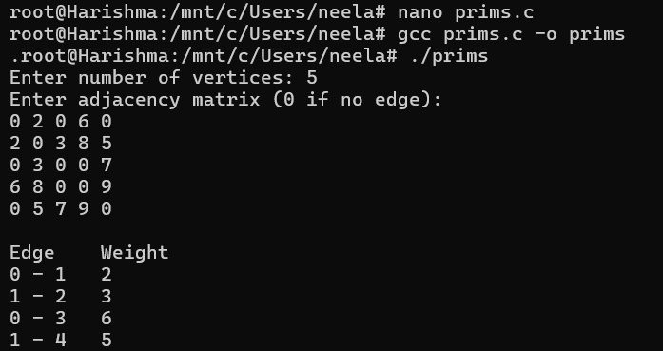

2.Kruskal’s Algorithm

Program:

#include <stdio.h>
#include <stdlib.h>

#define MAX 20

// Structure to represent an edge
struct Edge {
int src, dest, weight;
};

// Structure to represent a graph
struct Graph {
int V, E;
struct Edge edges[MAX];
};

// Find function (Disjoint Set)
int find(int parent[], int i) {
if (parent[i] == i)
return i;
return find(parent, parent[i]);
}

// Union function
void unionSet(int parent[], int x, int y) {
int xroot = find(parent, x);
int yroot = find(parent, y);
parent[xroot] = yroot;
}

// Sort edges by weight (Bubble Sort for simplicity)
void sortEdges(struct Graph* graph) {
for (int i = 0; i < graph->E - 1; i++) {
for (int j = 0; j < graph->E - i - 1; j++) {
if (graph->edges[j].weight > graph->edges[j + 1].weight) {
struct Edge temp = graph->edges[j];
graph->edges[j] = graph->edges[j + 1];
graph->edges[j + 1] = temp;
}
}
}
}

// Kruskal's Algorithm
void kruskalMST(struct Graph* graph) {
struct Edge result[MAX];
int parent[MAX];
int e = 0, i = 0;

// Initialize parent
for (int v = 0; v < graph->V; v++)
parent[v] = v;

// Sort edges
sortEdges(graph);

// Pick edges one by one
while (e < graph->V - 1 && i < graph->E) {
struct Edge nextEdge = graph->edges[i++];

int x = find(parent, nextEdge.src);
int y = find(parent, nextEdge.dest);

// If no cycle, include edge
if (x != y) {
result[e++] = nextEdge;
unionSet(parent, x, y);
}
}

printf("\nEdge \tWeight\n");
for (i = 0; i < e; i++)
printf("%d - %d \t%d\n", result[i].src,
result[i].dest,
result[i].weight);
}

// Main function
int main() {
struct Graph graph;

printf("Enter number of vertices: ");
scanf("%d", &graph.V);

printf("Enter number of edges: ");
scanf("%d", &graph.E);

printf("Enter edges (src dest weight):\n");
for (int i = 0; i < graph.E; i++) {
scanf("%d %d %d",
&graph.edges[i].src,
&graph.edges[i].dest,
&graph.edges[i].weight);
}

kruskalMST(&graph);

return 0;
}

Output:

