# Queries.java - User Manual

How to begin writing queries?

* Right Click on (Atlas Toolbox) workspace -> Atlas -> Open Shell

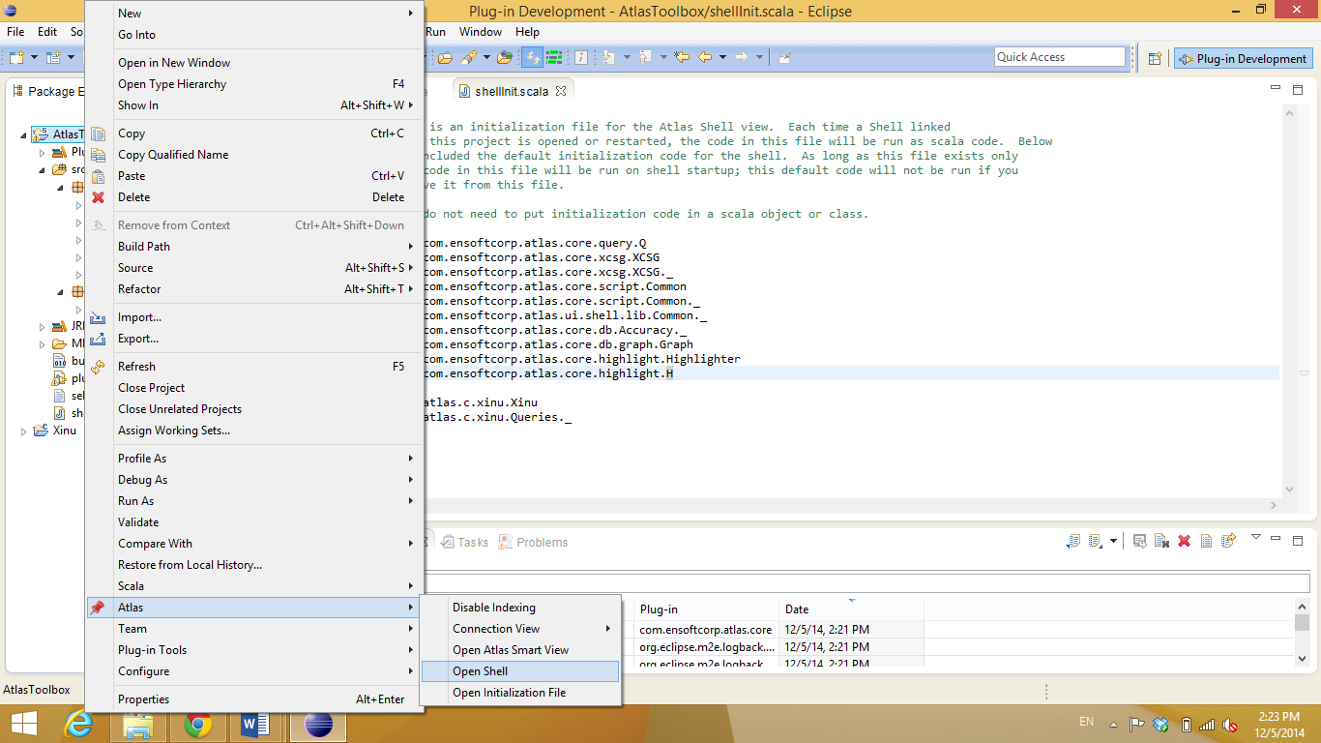

* Now, you can write your queries in the shell box highlighted below:

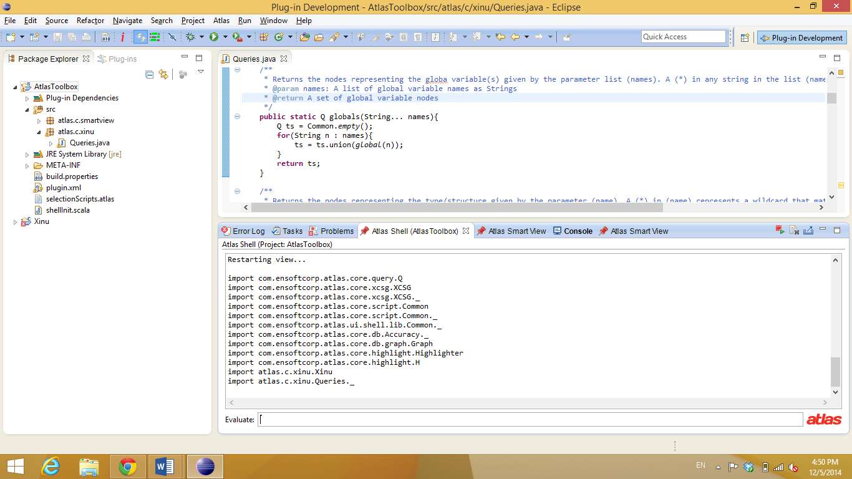

Queries:

|  |  |
| --- | --- |
| **Function** | functions |
| **Parameters** | Parameters (functionNames): A list of function names as Strings |
| **Description** | Returns the set of functions where their names matches the any of the names given (functionNames) list. A (*) in (functionNames) represents a wildcard that matches any string. |
| **Example (1)** | *Return the functions named “dswrite” and “dsread”*  var funcs = functions(“dswrite”, “dsread”) ⮠  show(funcs) ⮠ |
| **Example (2)** | *Return all functions where their names start with/match “ds*” or “dg*”*  var funcs = functions(“ds*”, “dg*”) ⮠  show(funcs) ⮠ |

|  |  |
| --- | --- |
| **Function** | globals |
| **Parameters** | Parameter (names): A list of global variable names as Strings |
| **Description** | Returns the nodes representing the global variables given by the parameter (name). A (*) in (name) represents a wildcard that matches any string. |
| **Example (1)** | *Return the global variable named “devtab”*  var globalVar = global(“devtab”) ⮠  show(globalVar) ⮠ |
| **Example (2)** | *Return all global variables where their names start with/match “dv*”*  var globalVars = global(“dv*”) ⮠  show(globalVars) ⮠ |

|  |  |
| --- | --- |
| **Function** | types |
| **Parameters** | Parameter (names): A list of type names as Strings |
| **Description** | Returns the nodes representing the types/structures given by the parameter list (names). A (*) in any string in the list (names) represents a wildcard that matches any string. |
| **Example (1)** | *Return all the types/structures named “dreq”, “epacket”*  var ts = types(“dreq”, “epacket”) ⮠  show(ts) ⮠ |
| **Example (2)** | *Return all the type/structures where their names start with/match “d*”, or “e*”*  show(types(“d*”, “e*”)) ⮠ |

|  |  |
| --- | --- |
| **Function** | ref |
| **Parameters** | Parameter (object): the set of global variables and/or types |
| **Description** | Returns the set of functions referencing (read/write) the given global variables and/or types (structures) given in parameter (object). |
| **Example** | *Return all functions referencing the structures/types “dreq”, “epacket”*  var ts = types(“dreq”, “epacket”) ⮠  var refFuncs = ref(ts) ⮠  show(refFuncs) ⮠ |

|  |  |
| --- | --- |
| **Function** | cfg |
| **Parameters** | Parameter (funcName): function name as a String |
| **Description** | Returns the control-flow graph (CFG) of the given function name in (funcName) |
| **Example** | *Returns the CFG of function “dswrite”*  var dswriteCFG = cfg(“dswrite”) ⮠  show(dswriteCFG) ⮠ |

|  |  |
| --- | --- |
| **Function** | cfg |
| **Parameters** | Parameter (funcs): function node(s) |
| **Description** | Returns the control-flow graph (CFG) of the given function node in (funcs) |
| **Example (1)** | *Returns the CFG of function “dswrite”*  var dswrite = function(“dswrite”) ⮠  var dswriteCFG = cfg(dswrite) ⮠  show(dswriteCFG) ⮠ |
| **Example (2)** | *Get the CFG of the function node selected from a previously produced graph*  var result= cfg(selected) ⮠  show(result) ⮠ |

|  |  |
| --- | --- |
| **Function** | cg |
| **Parameters** | Parameter (funcs): function node(s) |
| **Description** | Returns the call graph of the given function(s) in (funcs) |
| **Example (1)** | *Returns the Call Graph of function “dswrite”*  var dswrite = function(“dswrite”) ⮠  var callgraph = cg(dswrite) ⮠  show(callgraph) ⮠ |
| **Example (2)** | *Get the call graph of a function node selected from a previously produced graph*  var result= cg(selected) ⮠  show(result) ⮠ |

|  |  |
| --- | --- |
| **Function** | rcg |
| **Parameters** | Parameter (funcs): function node(s) |
| **Description** | Returns the reverse-call graph of the given function(s) in (funcs) |
| **Example** | *Returns the Reverse-Call Graph of function “freebuf”*  var func = function(“freebuf”) ⮠  var x = rcg(func) ⮠  show(x) ⮠ |
| **Example (2)** | *Get the reverse-call graph of a function node selected from a previously produced graph*  var result= rcg(selected) ⮠  show(result) ⮠ |

|  |  |
| --- | --- |
| **Function** | call |
| **Parameters** | Parameter (funcs): function node(s) |
| **Description** | Returns the direct callers of the given function (s) in (funcs) |
| **Example** | *Returns the direct callers of function “getbuf” and “freebuf”*  var funcs = functions(“freebuf”, “getbuf”) ⮠  var callers = call(funcs) ⮠  show(callers) ⮠ |

|  |  |
| --- | --- |
| **Function** | calledby |
| **Parameters** | Parameter (funcs): function node(s) |
| **Description** | Returns the set of functions directly called by the given function (s) in (funcs) |
| **Example** | *Returns the functions directly called by “dswrite”*  var func = function(“dswrite”) ⮠  var callees = calledby(func) ⮠  show(callees) ⮠ |

|  |  |
| --- | --- |
| **Function** | induce |
| **Parameters** | Parameter (funcs): function node(s) |
| **Description** | Induces a call edges between the given set of function(s) in (funcs) |
| **Example** | *Induce the call edges (if any) between functions “dswrite” and “dskenq”*  var funcs = functions(“dswrite”, “dskenq”) ⮠  var result = induce(funcs) ⮠  show(result) ⮠ |

|  |  |
| --- | --- |
| **Function** | inducecfg |
| **Parameters** | Parameter (nodes): control-flow node(s) |
| **Description** | Induces the control-flow edges between the given control-flow blocks in (nodes) |
| **Example** | *Induce the control-flow edges (if any) between selected blocks*  show(cfg(function(“dswrite”))) ⮠  *Select a subset of control-flow blocks in the produced graph, the selection can be accessed through the variable* (selected) *as follows:*  var result = inducecfg(selected) ⮠  show(result) ⮠ |

|  |  |
| --- | --- |
| **Function** | graph |
| **Parameters** | Parameter (roots): function node(s)  Parameter (leaves): function node(s) |
| **Description** | Returns the call graph between the functions in (roots) and functions in (leaves) |
| **Example** | *Return the call graph between “dswrite” as a root and “freebuf” as a leaf*  var callgraph = graph(function(“dswrite”), function(“freebuf”)) ⮠  show(callgraph) ⮠ |

|  |  |
| --- | --- |
| **Function** | mpg |
| **Parameters** | Parameter (e1Functions): L function node(s)  Parameter (e2Functions): U function node(s)  Parameter (object): type/structure |
| **Description** | Returns the matching-pair graph (MPG) that reference the structure given in (object) w.r.t L functions given in (e1Functions) and U functions given in (e2Functions) |
| **Example** | *Get the MPG for type/structure “dreq” and L function “getbuf” and U function “freebuf”*  var result = mpg(function(“getbuf”), function(“freebuf”), type(“dreq”)) ⮠  show(result) ⮠ |

|  |  |
| --- | --- |
| **Function** | dfg |
| **Parameters** | Parameter (functionContext): caller of functionSource  Parameter (functionSource): return value to use as origin in data-flow graph  Parameter (functionSink): stopping point for data-flow graph |
| **Description** | Returns the data-flow graph (inter-procedural forward slice) starting at the return value of Function “functionSource” in the calling function “functionContext”, stopping at Function “functionSink”. |
| **Example** | *Return the inter-procedural data-flow graph for the pointer allocated by “getbuf“ in function “dswrite”*  var result = dfg( “dswrite”, “getbuf”, “freebuf”) ⮠  show(result) ⮠ |

|  |  |
| --- | --- |
| **Function** | projectdfg |
| **Parameters** | Parameter (dfg): A previously computed inter-procedural data-flow graph  Parameter (func): function node(s) |
| **Description** | Returns the portion of data-flow graph within the given function (func). (aka intra-procedural data-flow graph) |
| **Example** | *Return the portion of DFG in function “dskenq” that is part of DFG for the allocated pointer by “getbuf” in function “dswrite”*  var result = dfg(function(“dswrite”), function(“getbuf”)) ⮠  var projection = projectdfg(result, function(“dskenq”)) ⮠  show(projection) ⮠ |

|  |  |
| --- | --- |
| **Function** | forwardSlice |
| **Parameters** | Parameter (projdfg): Intra-procedural data-flow graph  Parameter (node): the data-flow node where the forward slice starts |
| **Description** | Returns the intra-procedural forward slice starting at the given (node) from the given data-flow graph in (projdfg) |
| **Example** | var result = dfg(function(“dswrite”), function(“getbuf”)) ⮠  var projection = projectdfg(result, function(“dskenq”)) ⮠  show(projection) ⮠  *Select the data-flow node of interest from the produced graph, the selection can be accessed through the variable* (selected) *as follows:*  var forwardSlice = forwardSlice(selected) ⮠  show(forwardSlice) ⮠ |