1)

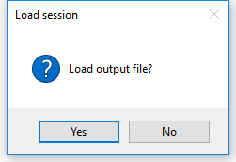

If you click ‘Yes’, you need to select a csv file to load. Say, you run the app to process the photos of one plot. However, for some reasons, you haven’t finished it. You saved the results as a csv file and quit the app. Next time, when you run the app, you can load the csv file and continue to process those photos.

**When you start to process a new plot, there is no csv file to load. So, click ‘No’.**

2)

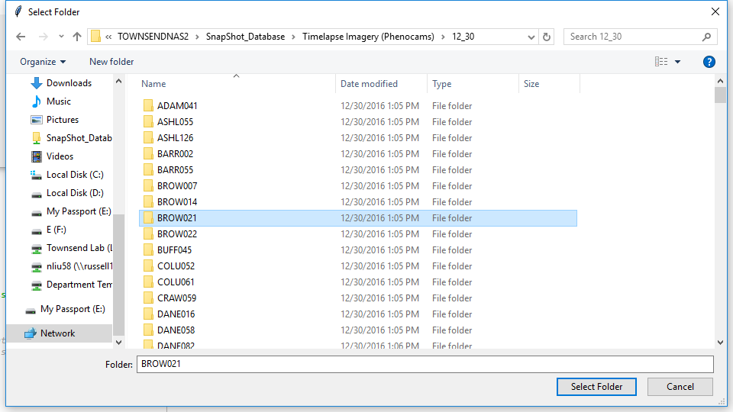

This is to load the photos of one plot to process.

‘\\TOWNSENDNAS2\SnapShot_Database\Timelapse Imagery (Phenocams)\12_30’ is the directory.

**‘ADAM041’, ‘ASHL055’, …, ‘DANE058’ are plots’ names. Select one plot to process (e.g., ‘BROW021’).**

3)

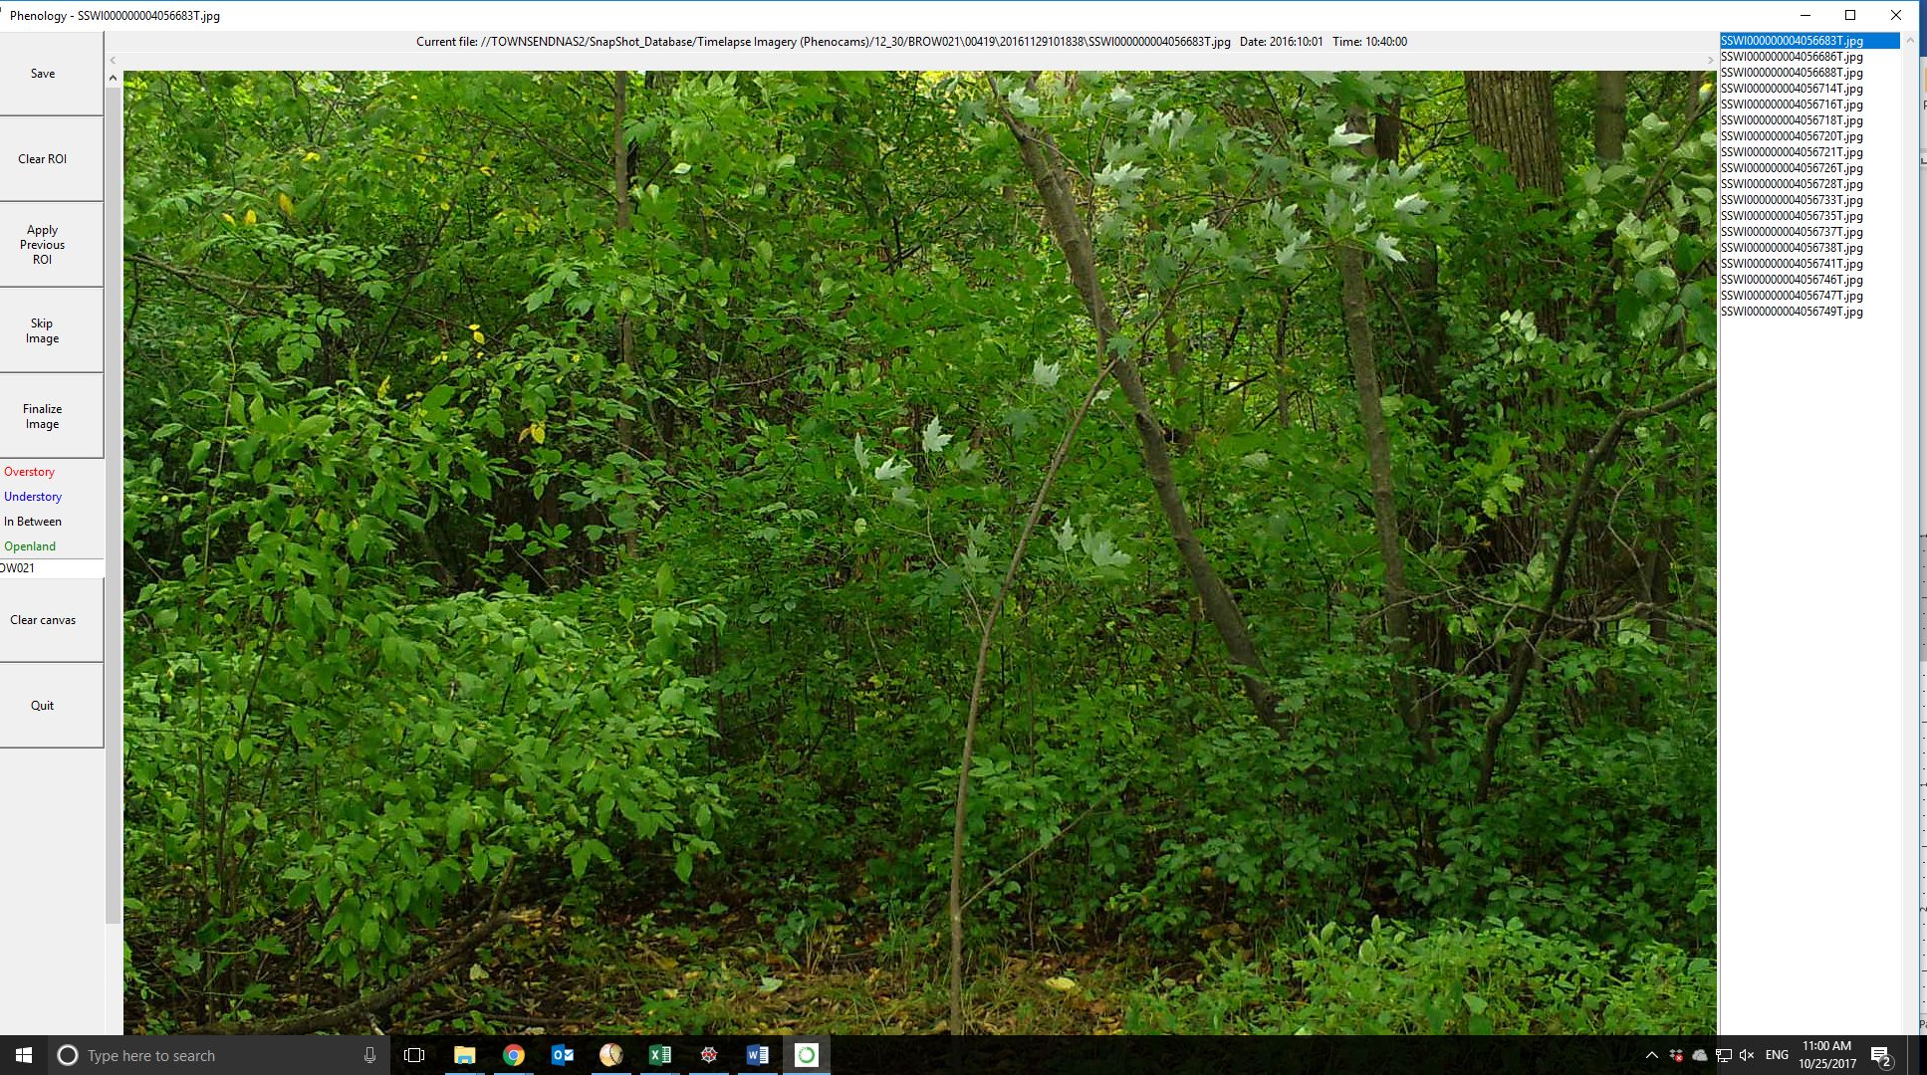

After you select the plot’s name, photos are loaded.

There are three parts:

1. Buttons (on the left)
2. Photos (in the middle)
3. Photo list (on the right)

4)

The first thing to do is left-click on the photo list and move the mouse from up to bottom to **go through the photos**.

Reasons for this:

Sometimes, one plot contains two cameras looking at different areas, taking pictures at the same time. Then, photos from these cameras will be loaded together and be ordered according to their acquisition dates. When you go through the photos, you will see a pattern like ‘**ABABABABABAB**’, i.e., the 1st photo from A camera (day = 1), the 2nd photo from B camera (day = 1), the 3rd from A (day = 2), the 4th from B (day = 2), and so on. This is not good for time series analysis, since we don’t know which photos are from which cameras.

A simple method to avoid this problem is quit the app, and just load the photos from the first camera. Ignore the second camera.

5)

Now it’s time to process the photos. Make sure you start from the **first** photo. That is the first *.jpg is **highlighted**.

BUT, if the first few pictures are bad, you can start with the first GOOD photo. Say, if the photos from ‘SSWI0000004056683T.jpg’ to ‘SSWI0000004056735T.jpg’ are bad, you can start with ‘SSWI0000004056737T.jpg’.

There are many reasons for bad photos. For instance, some cameras fell down and were looking at the ground. Some cameras were wrongly set up. They took pictures at nighttime.

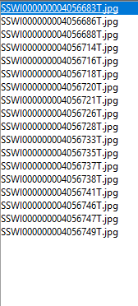

6)

Buttons:

‘Save’ to save results to a csv file.

‘Clear ROI’ to clear the ROIs. Say, you are not satisfied with the ROI you created and want to make a new one. Clear it first.

‘Apply Previous ROI’. If camera’s position doesn’t change too much, the ROI created for the previous photos can be applied to the current photo.

‘Skip Image’: if photos are bad, just skip it.

‘Finalize Image’: if you finish the ROIs, DON’T forget to finalize it. Otherwise, there is no ROIs made for the photos.

Hot keys:

- Enter: finalize image

- Space: apply previous ROI

- Right arrow: skip to next image