**mushroomVrekeen**

Processing file: mushroomVrekeen.txt, Run: 1

Processing file: **mushroomVrekeen**.txt, Run: 10

**Total time 15.732 s**

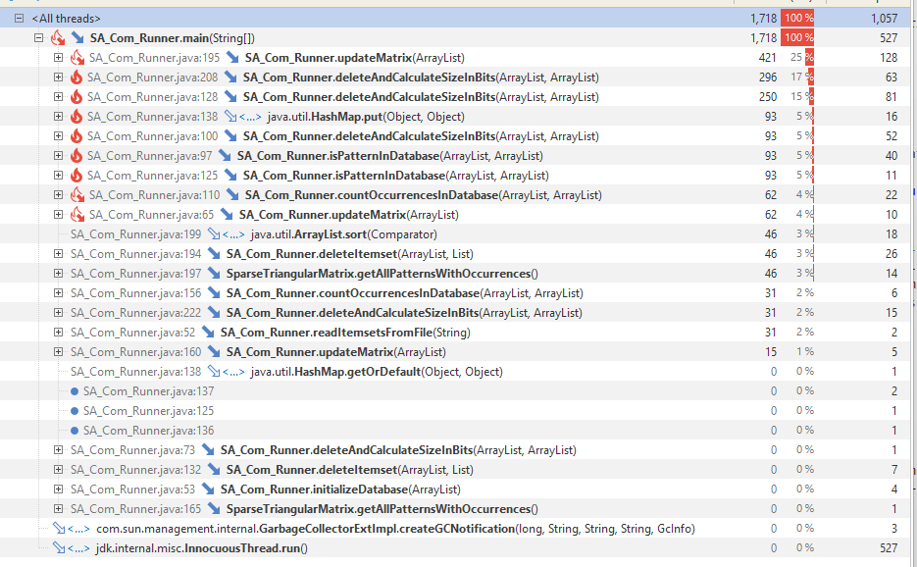

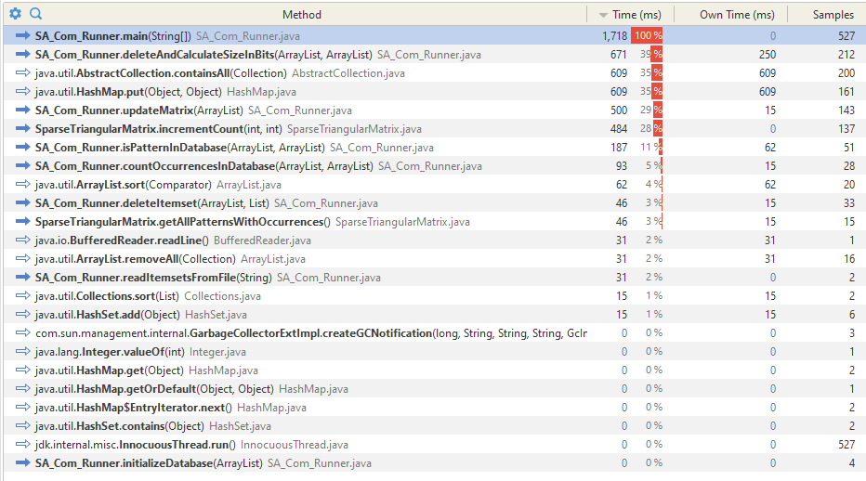

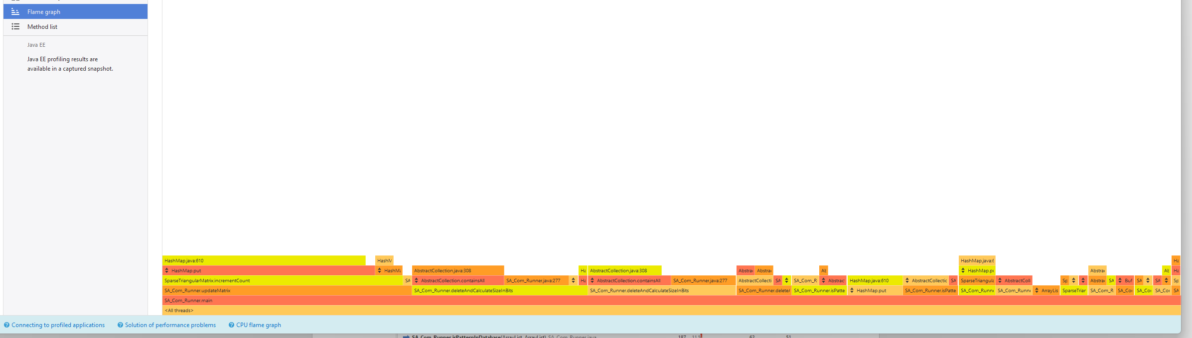

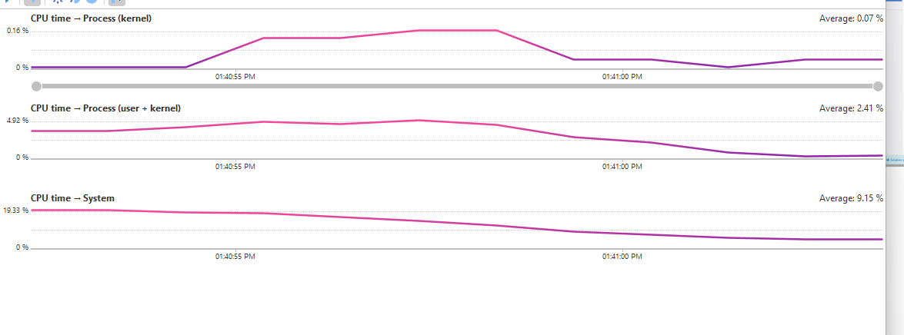 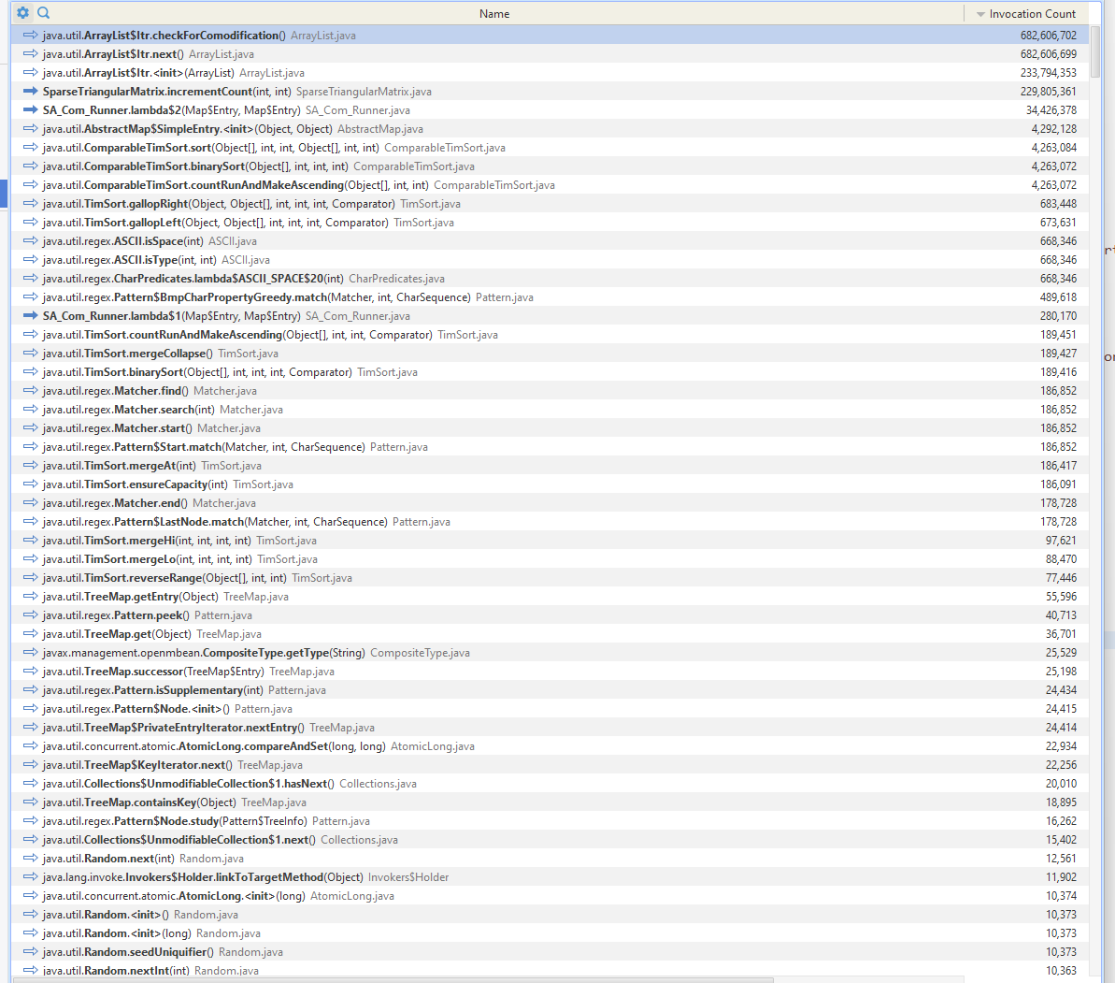

**Memory**

