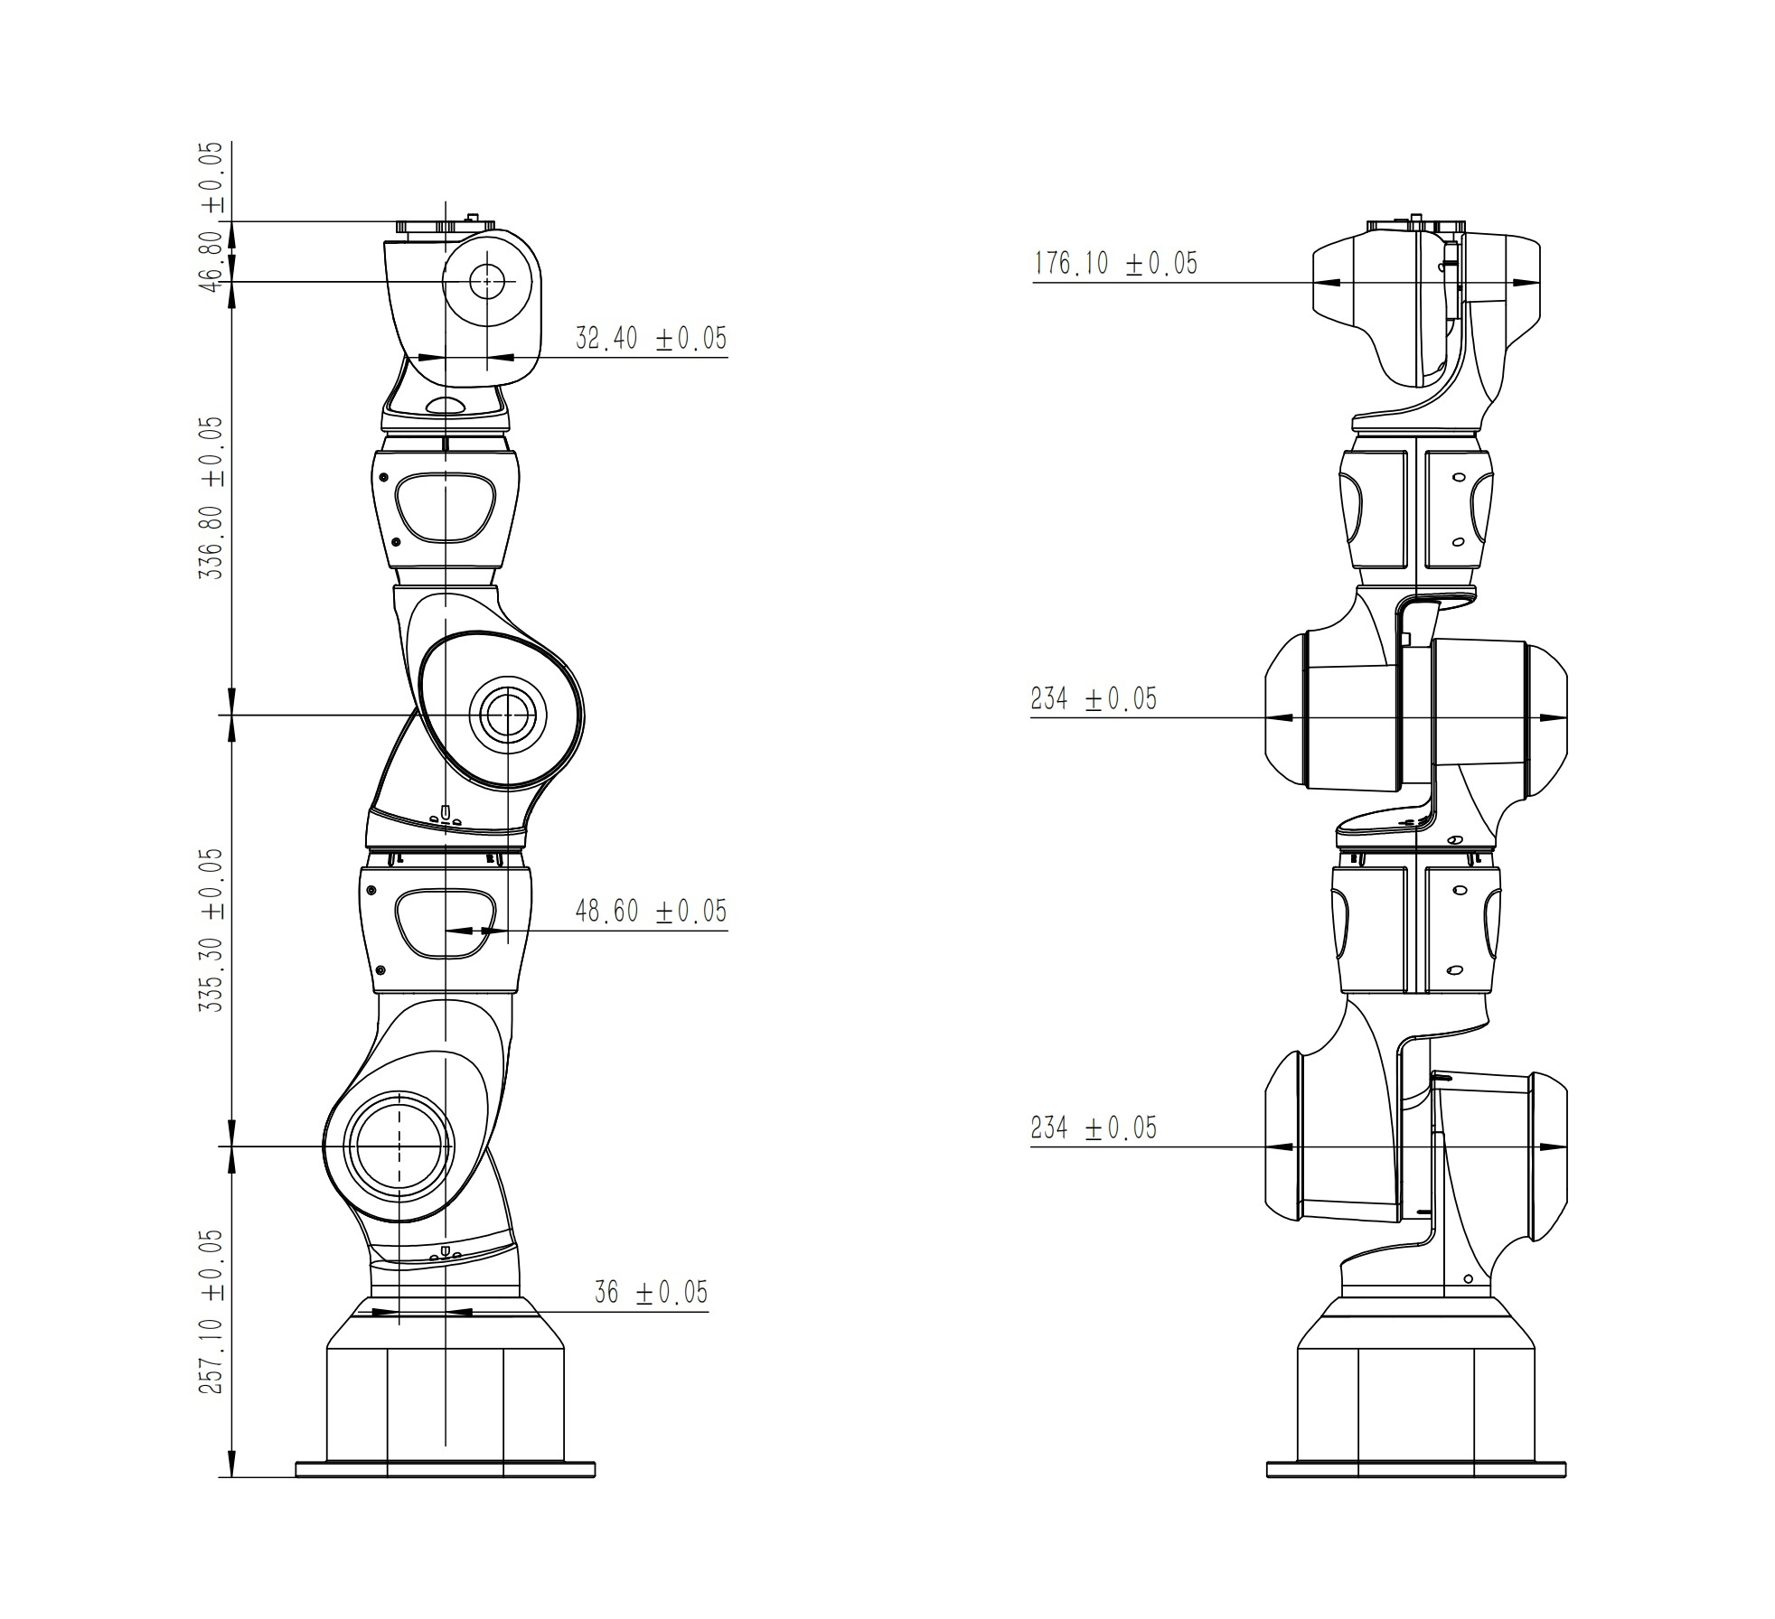

|  |  |  |  |  |
| --- | --- | --- | --- | --- |
| **SDH** | **θi** | **di** | **ai** | **αi** |
| **1** | θ1 | 257.10 | -36.00 | -90° |
| **2** | θ2 | 0.00 | 36.00 | 90° |
| **3** | θ3 | 335.30 | 48.60 | 90° |
| **4** | θ4 | 0.00 | -48.60 | -90° |
| **5** | θ5 | 336.80 | 32.40 | -90° |
| **6** | θ6 | 0.00 | -32.40 | 90° |
| **7** | θ7 | 46.80 | 0.00 | 0° |
|  |  |  |  |  |
| **MDH** | **αi-1** | **ai-1** | **θi** | **di** |
| **1** | 0° | 0.00 | 180°+θ1 | 257.10 |
| **2** | 90° | 36.00 | 180°+θ2 | 0 |
| **3** | 90° | 36.00 | θ3 | 335.30 |
| **4** | 90° | 48.60 | 180°+θ4 | 0 |
| **5** | 90° | 48.60 | θ5 | 336.80 |
| **6** | 90° | -32.40 | 180°+θ6 | 0 |
| **7** | 90° | -32.40 | θ7 | 46.80 |