Table of Contents
1. Introduction 3
1.1 Methodology 3
1.2 Tools Used 4
2. Target System Information 5
2.1 Kioptrix Level 1 5
2.2 Mr-Robot 1 8
3. Target Vulnerabilities 10
3.1 Kioptrix Level 1 10
3.2 Mr-Robot 15
3.3 Vulnerability Summary Table 18
4. Exploitation 20
4.1 Kioptrix Level 1 20
4.2 Mr-Robot 1 22
Conclusion 27
References 28

Introduction
Penetration testing is an authorized simulation of real-world attacks on systems to identify and report security vulnerabilities before malicious actors can exploit them. Organizations use penetration testing to validate their security controls, meet compliance requirements, and reduce risk.
A penetration tester is a cybersecurity professional who performs these authorized attacks, documents all findings, and provides remediation recommendations. The role requires knowledge of networking, operating systems, web applications, and exploitation techniques.
This report documents a penetration test conducted on two vulnerable virtual machines Kioptrix Level 1 and Mr-Robot 1 within an isolated lab environment for educational purposes.

1.1 Methodology
This engagement follows the Penetration Testing Execution Standard (PTES), which structures the test into six phases:
Phase | Description
Reconnaissance | Discover active hosts and identify the attack surface
Scanning & Enumeration | Identify open ports, services, versions, and system details
Vulnerability Assessment | Match discovered services against known vulnerabilities
Exploitation | Exploit confirmed vulnerabilities to gain access
Post-Exploitation | Escalate privileges and collect evidence of compromise
Reporting | Document all findings with evidence and recommendations

1.2 Tools Used
Tool | Purpose
Nmap | Port scanning, service detection, OS fingerprinting, vuln scripts
Netdiscover | ARP host discovery
Nikto | Web server vulnerability scanning
enum4linux | SMB enumeration
WPScan | WordPress scanning and brute force
Metasploit | Exploitation framework
Netcat | Reverse shell listener
John the Ripper | Password hash cracking
Searchsploit | Local exploit database search

Target System Information

2.1 Kioptrix Level 1
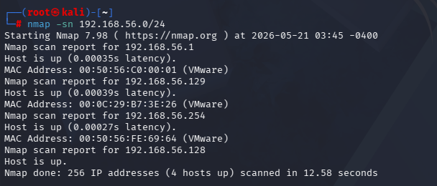
Kioptrix Level 1 was discovered on the 192.168.56.0/24 subnet using Nmap host discovery. A full port scan identified five open ports running significantly outdated services.
Figure 1: nmap -sn 192.168.56.0/24 — identifies all active hosts on the subnet and confirms the target IP.
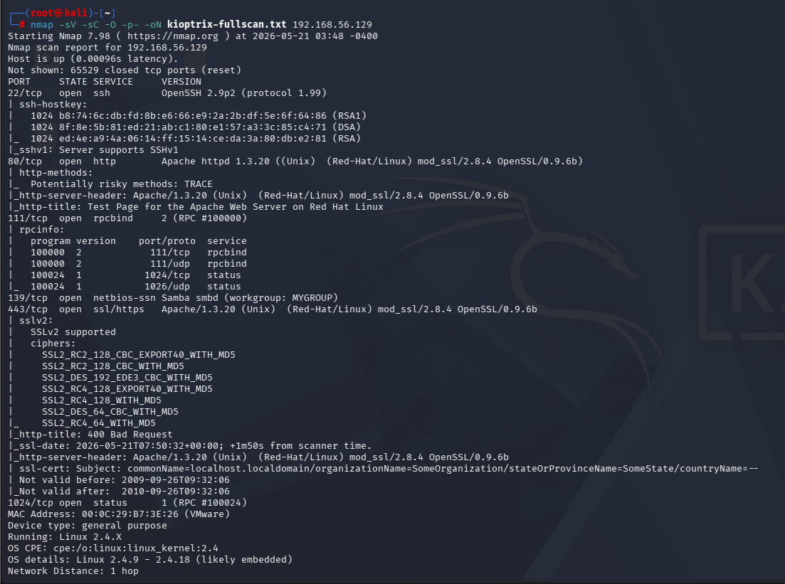
Figure 2: nmap -sV -sC -O -p- — reveals all open ports, service versions, OS, and SSL cipher details.
System Details:
Property | Value
IP Address | 192.168.56.129
MAC Address | 00:0C:29:B7:3E:26
Hostname | kioptrix.level1
Operating System | Linux 2.4.7-10 (Red Hat)
Architecture | i686 32-bit
Workgroup | MYGROUP
Open Ports and Services:
Port | Service | Version
22/tcp | SSH | OpenSSH 2.9p2
80/tcp | HTTP | Apache 1.3.20 / mod_ssl 2.8.4 / OpenSSL 0.9.6b
111/tcp | RPC | rpcbind 2
139/tcp | SMB | Samba smbd
443/tcp | HTTPS | Apache 1.3.20 / mod_ssl 2.8.4 / OpenSSL 0.9.6b

SMB enumeration using enum4linux confirmed the server allows null session authentication, meaning any unauthenticated user can retrieve system information. Password complexity is disabled with a minimum password length of zero. Local user accounts including root, john, and harold were enumerated without credentials.
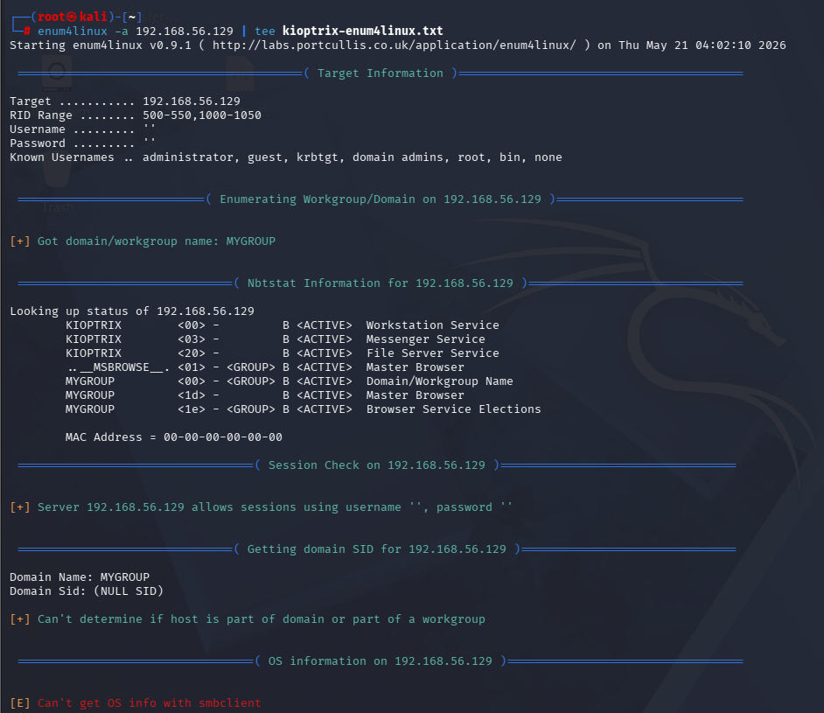
Figure 3: enum4linux -a — confirms null session access, workgroup name, hostname, and local user accounts.

2.2 Mr-Robot 1
Mr-Robot 1 was identified on the 192.168.180.0/24 subnet. The machine exposes only web services on ports 80 and 443, both running a WordPress application.
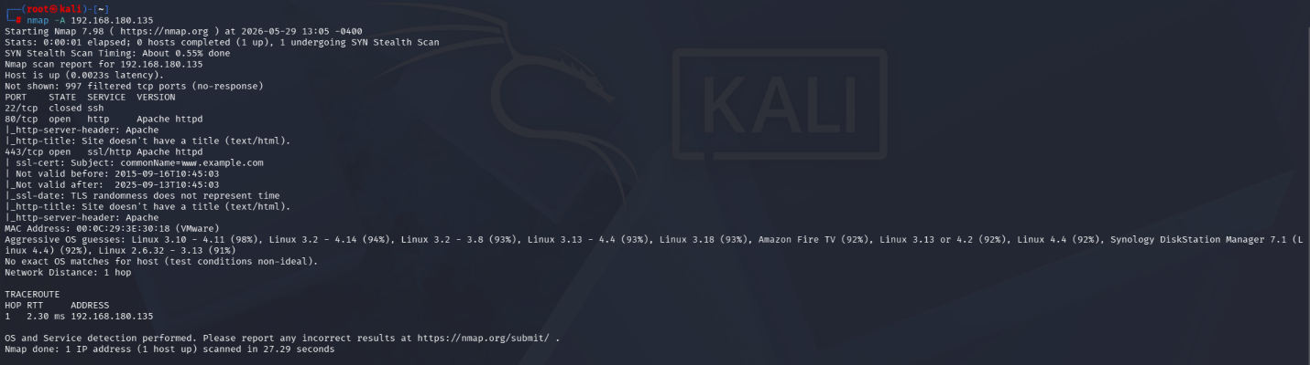
Figure 4: nmap -sV -O — confirms open ports, Apache web server, and Linux OS.
System Details:
Property | Value
IP Address | 192.168.180.135
MAC Address | 00:50:56:E9:91:A0
Operating System | Linux 3.x — 4.x
Web Server | Apache httpd
CMS | WordPress 4.3.1
PHP Version | 5.5.29
Open Ports and Services:
Port | Service | Notes
22/tcp | SSH | Closed
80/tcp | HTTP | WordPress 4.3.1
443/tcp | HTTPS | WordPress 4.3.1
The robots.txt file disclosed two sensitive entries: a wordlist file fsocity.dic (858,160 entries) and a secret key key-1-of-3.txt. WPScan identified WordPress 4.3.1 with the Twenty Fifteen theme and XML-RPC enabled. Nikto confirmed PHP 5.5.29 is outdated and five security headers are missing.
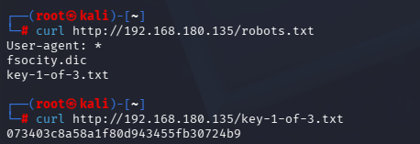
Figure 5: curl robots.txt — exposes the wordlist and first key, directly enabling the brute force attack.

Target Vulnerabilities

3.1 Kioptrix Level 1
V1 — Samba trans2open Buffer Overflow
CVE | Component | Severity
CVE-2003-0201 | Samba 2.2.x — Port 139 | Critical
Samba 2.2.x contains a buffer overflow in its trans2open request handler. An unauthenticated attacker can send a malformed SMB request to overflow the buffer and execute arbitrary code as root.
Impact: An unauthenticated remote attacker gains immediate root-level shell access to the system without requiring any credentials, resulting in complete system compromise.
Fix: Upgrade Samba to 2.2.8 or later. Restrict ports 139/445 via firewall to trusted hosts only.

V2 — Apache mod_ssl Remote Buffer Overflow (OpenFuck)
CVE | Component | Severity
CVE-2002-0082 | mod_ssl < 2.8.7 — Port 443 | Critical
Apache 1.3.20 with mod_ssl 2.8.4 is vulnerable to a remote buffer overflow triggered by a malformed SSL handshake. The exploit known as OpenFuck gives an attacker remote code execution as the Apache process user.
Impact: A remote attacker can execute arbitrary commands on the server, potentially escalating to full system control depending on the Apache process privileges.
Fix: Upgrade Apache to 2.4.x and OpenSSL to a current version. Disable SSLv2 and SSLv3.
V3 — SSL POODLE
CVE | Component | Severity
CVE-2014-3566 | OpenSSL 0.9.6b — Port 443 | High
SSLv3's CBC padding allows a man-in-the-middle attacker to decrypt encrypted session data through a padding oracle attack. The Nmap vuln script confirmed this system is VULNERABLE.
Impact: An attacker positioned between the client and server can decrypt sensitive session data, including authentication cookies and credentials transmitted over HTTPS.
Fix: Disable SSL 3.0 entirely. Enforce TLS 1.2 or higher.
V4 — SSL CCS Injection
CVE | Component | Severity
CVE-2014-0224 | OpenSSL 0.9.6b — Port 443 | High
OpenSSL improperly handles ChangeCipherSpec messages, allowing a man-in-the-middle attacker to force a zero-length master key and hijack TLS sessions. Confirmed VULNERABLE by Nmap.
Impact: A man-in-the-middle attacker can intercept and decrypt encrypted TLS traffic, enabling session hijacking and theft of sensitive information.
Fix: Upgrade OpenSSL to 0.9.8za or later.
V5 — Logjam DHE Downgrade
CVE | Component | Severity
CVE-2015-4000 | mod_ssl — Port 443 | High
Export-grade 512-bit DH parameters are supported, allowing a man-in-the-middle attacker to downgrade TLS to weak encryption. Confirmed VULNERABLE by Nmap.
Impact: An attacker can downgrade TLS connections to 512-bit encryption, which can be broken in hours, allowing full decryption of intercepted traffic.
Fix: Disable DHE_EXPORT ciphers. Use 2048-bit or larger DH parameters.
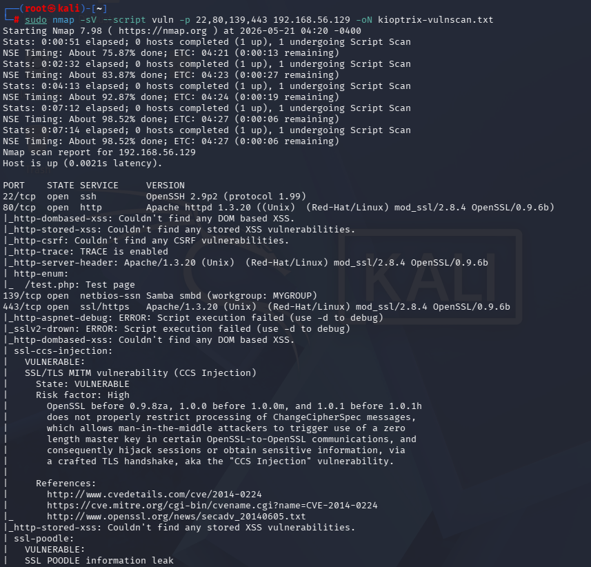
Figure 6: Nmap vuln script — confirms POODLE, CCS Injection, and Logjam simultaneously on port 443.
V6 — OpenSSH 2.9p2 Outdated
CVE | Component | Severity
CVE-2002-0083 | OpenSSH 2.9p2 — Port 22 | High
OpenSSH 2.9p2 is severely outdated and contains privilege escalation vulnerabilities. Current stable version is 9.x.
Impact: Known vulnerabilities in this version may allow privilege escalation or unauthorized remote access to the SSH service.
Fix: Upgrade OpenSSH. Disable root login. Use key-based authentication only.
V7 — Null SMB Session
CVE | Component | Severity
N/A | Samba — Port 139 | Medium
The server accepts SMB connections with no credentials, allowing any attacker to enumerate users, groups, and password policies without authentication.
Impact: An attacker can silently enumerate all local user accounts, group memberships, and system configuration details, directly supporting further targeted attacks.
Fix: Set restrict anonymous = 2 in smb.conf. Restrict SMB access by firewall.

V8 — No Password Policy
CVE | Component | Severity
N/A | System-wide | Medium
Password complexity is disabled and minimum length is zero, making brute force attacks trivial.
Impact: User accounts can be compromised through simple dictionary or brute force attacks with minimal effort, enabling unauthorized system access.
Fix: Enforce minimum 12-character passwords with complexity requirements. Implement account lockout.

3.2 Mr-Robot
V9 — WordPress Weak Administrator Credentials
CVE | Component | Severity
N/A | WordPress wp-login / xmlrpc.php | Critical
The WordPress admin password was present in a wordlist disclosed on the same server. No brute force protection existed. Credentials were recovered in under one minute.
Impact: Full WordPress administrator access was obtained, enabling complete control over the web application and serving as the entry point for server-level exploitation.
Fix: Use strong unique passwords. Disable XML-RPC if not needed. Enable login rate limiting.
V10 — Sensitive Files in robots.txt
CVE | Component | Severity
N/A | Web server | High
robots.txt listed a dictionary file and a secret key, directly enabling the brute force attack that compromised the administrator account.
Impact: The disclosed wordlist was used directly to recover the administrator password, and the key file confirmed the presence of sensitive data accessible without authentication.
Fix: Never list sensitive files in robots.txt. Move sensitive files outside the web root.
V11 — WordPress RCE via Theme Editor
CVE | Component | Severity
N/A | WordPress Theme Editor | Critical
Admin access allowed direct PHP file editing through the built-in theme editor. Injecting a reverse shell into a theme template gave server-level code execution.
Impact: A single compromised administrator account leads directly to remote code execution on the underlying server, bypassing all network-level controls.
Fix: Add define('DISALLOW_FILE_EDIT', true); to wp-config.php. Restrict wp-admin by IP.

V12 — WordPress 4.3.1 Outdated
CVE | Component | Severity
CVE-2015-5622 | WordPress CMS | High
WordPress 4.3.1 is end-of-life and contains XSS and CSRF vulnerabilities. No security patches are released for this version.
Impact: The system is permanently exposed to all known and future vulnerabilities in this version, as no patches will be issued by the vendor.
Fix: Update WordPress to the latest stable version. Enable automatic updates.
V13 — XML-RPC Enabled
CVE | Component | Severity
N/A | xmlrpc.php | High
XML-RPC supports multicall requests, allowing hundreds of password attempts per HTTP request. This was the vector used to brute force the administrator password.
Impact: The XML-RPC multicall feature allowed the attacker to test hundreds of passwords per request, reducing brute force time from hours to under one minute.
Fix: Disable XML-RPC unless required. Block access via .htaccess or firewall.
V14 — PHP 5.5.29 End of Life
CVE | Component | Severity
Multiple | PHP runtime | High
PHP 5.5.29 reached end-of-life in 2016 and receives no security patches.
Impact: Any newly discovered PHP vulnerability will remain unpatched permanently, leaving the web application and server continuously exposed to exploitation.
Fix: Upgrade to PHP 8.1 or higher.
V15 — SUID Nmap Privilege Escalation
CVE | Component | Severity
N/A | /usr/local/bin/nmap | Critical
nmap 3.81 has the SUID bit set and is owned by root. Its interactive mode can spawn a shell that inherits root privileges, allowing any local user to escalate to root.
Impact: Any user with local shell access can escalate to full root privileges instantly, rendering all user-level access controls on the system ineffective.
Fix: Run chmod -s /usr/local/bin/nmap. Audit all SUID binaries with find / -perm -4000 -type f.
V16 — Missing Security Headers
CVE | Component | Severity
N/A | Apache web server | Medium
Five HTTP security headers are absent: X-Content-Type-Options, Content-Security-Policy, Referrer-Policy, Permissions-Policy, and Strict-Transport-Security.
Impact: Users of the web application are exposed to client-side attacks including cross-site scripting, clickjacking, and protocol downgrade attacks that could compromise their sessions or data.
Fix: Add all recommended security headers to Apache configuration.
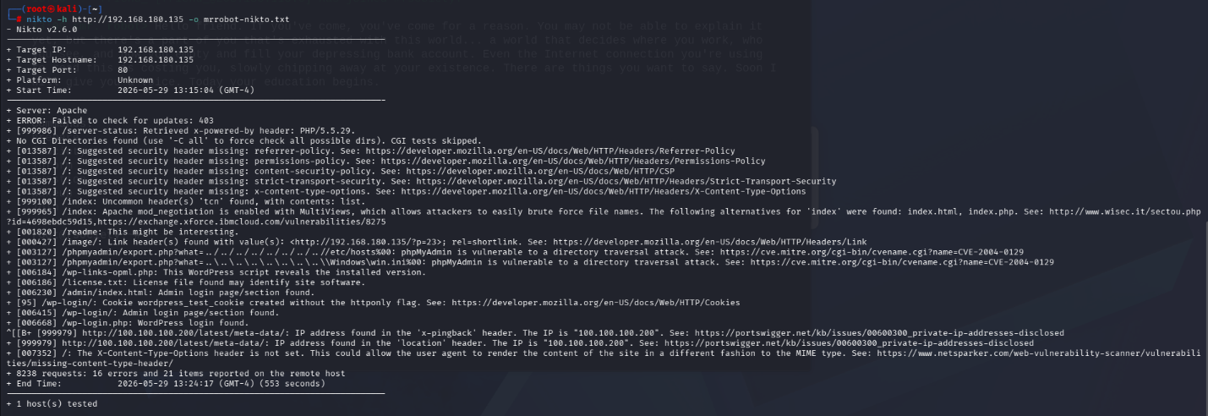
Figure 7: Nikto scan output confirming missing security headers, outdated PHP, and WordPress exposure.

3.3 Vulnerability Summary Table
# | VM | Vulnerability | CVE | Severity
1 | Kioptrix | Samba trans2open Overflow | CVE-2003-0201 | Critical
2 | Kioptrix | Apache mod_ssl OpenFuck | CVE-2002-0082 | Critical
3 | Kioptrix | SSL POODLE | CVE-2014-3566 | High
4 | Kioptrix | SSL CCS Injection | CVE-2014-0224 | High
5 | Kioptrix | Logjam DHE Downgrade | CVE-2015-4000 | High
6 | Kioptrix | OpenSSH 2.9p2 Outdated | CVE-2002-0083 | High
7 | Kioptrix | Null SMB Session | N/A | Medium
8 | Kioptrix | No Password Policy | N/A | Medium
9 | Mr-Robot | Weak WP Credentials | N/A | Critical
10 | Mr-Robot | Sensitive files in robots.txt | N/A | High
11 | Mr-Robot | RCE via Theme Editor | N/A | Critical
12 | Mr-Robot | WordPress 4.3.1 Outdated | CVE-2015-5622 | High
13 | Mr-Robot | XML-RPC Enabled | N/A | High
14 | Mr-Robot | PHP 5.5.29 EOL | Multiple | High
15 | Mr-Robot | SUID Nmap Escalation | N/A | Critical
16 | Mr-Robot | Missing Security Headers | N/A | Medium

Exploitation

4.1 Kioptrix Level 1
Exploit 1—Samba trans2open Buffer Overflow
Tool: Metasploit Framework CVE: CVE-2003-0201
The module exploit/linux/samba/trans2open was selected in Metasploit. RHOSTS was set to 192.168.56.129, LHOST to 192.168.56.128, and the payload linux/x86/shell_reverse_tcp was used. Running the exploit sent malformed trans2 requests until the buffer overflowed and the reverse shell connected back.
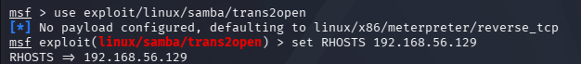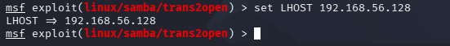
Figure 8: Metasploit options — shows the configured target IP, attacker IP, and payload before execution.
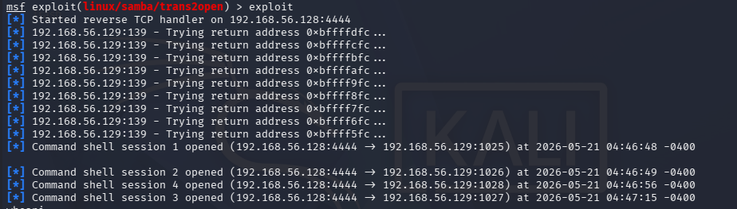
Figure 9: Exploit output — four shell sessions opened, confirming successful exploitation.
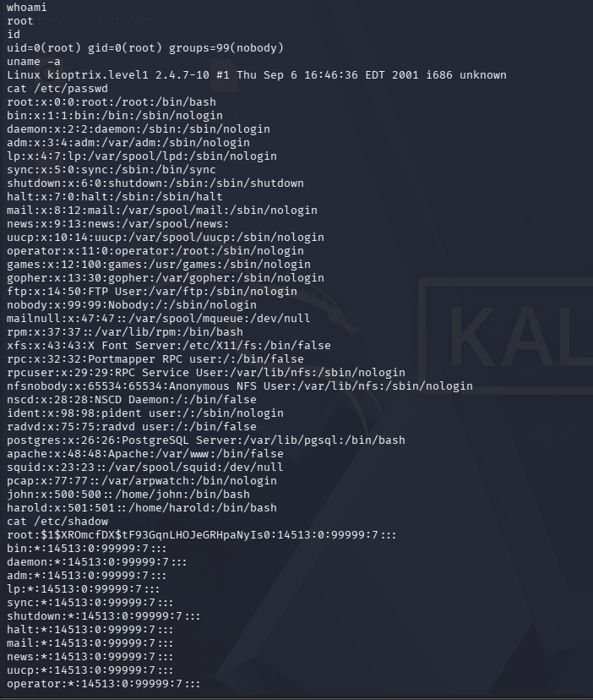
Figure 10: whoami returns root and id shows uid=0 — confirms full root access with no credentials required.

Figure 11: cat /etc/shadow showing the password hashes
Result: Root shell obtained on Kioptrix Level 1. The /etc/shadow file was read, exposing hashed passwords for all accounts including human users john and harold, confirming complete system compromise.

4.2 Mr-Robot 1
Exploit 2 — WordPress Brute Force
Tool: WPScan Vector: XML-RPC interface
The wordlist from robots.txt was deduplicated from 858,160 to 11,451 entries. WPScan brute forced the XML-RPC interface using the cleaned wordlist against the username elliot.
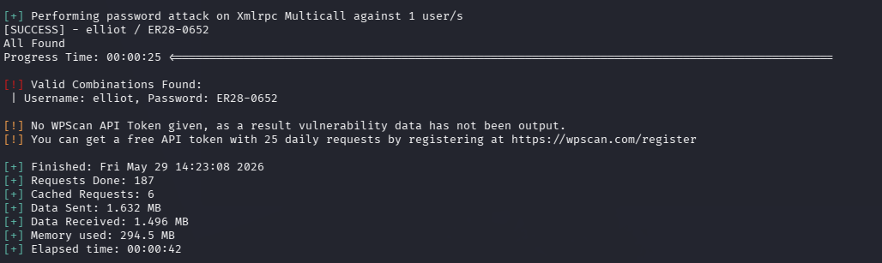
Figure 12: WPScan result — credentials elliot:ER28-0652 recovered. Confirms no rate limiting protection exists.
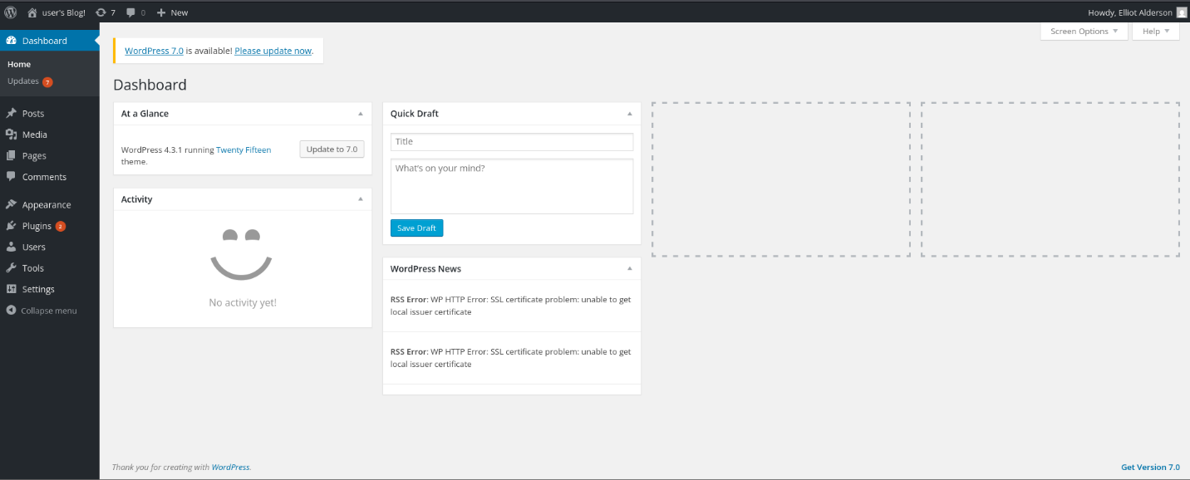
Figure 13: WordPress admin dashboard — confirms successful login with recovered credentials.
Result: Full WordPress administrator access gained using credentials elliot:ER28-0652. Key 1 retrieved: 073403c8a58a1f80d943455fb30724b9
Exploit 3 — Reverse Shell via Theme Editor
Tool: WordPress Theme Editor, Netcat, PHP reverse shell
A PHP reverse shell was injected into the 404.php template via Appearance → Theme Editor. The shell was configured to connect back to 192.168.180.133:4444. A Netcat listener was started on the attacker machine before triggering the shell by visiting a non-existent page.
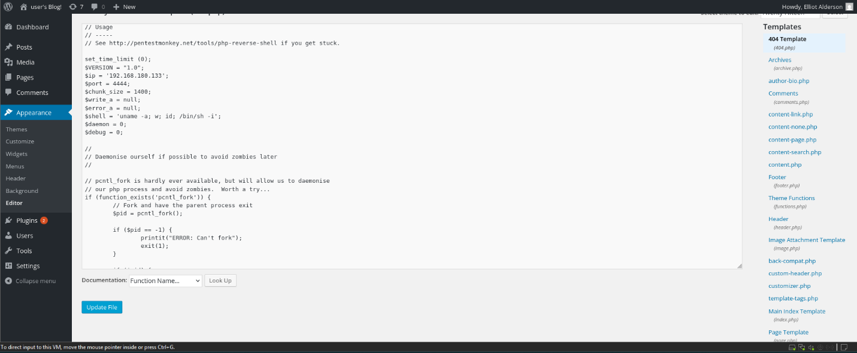
Figure 14: Theme editor showing the PHP reverse shell replacing the 404.php template.
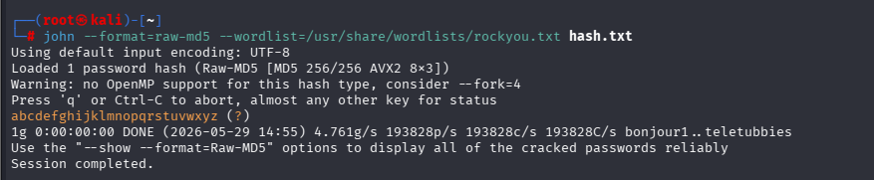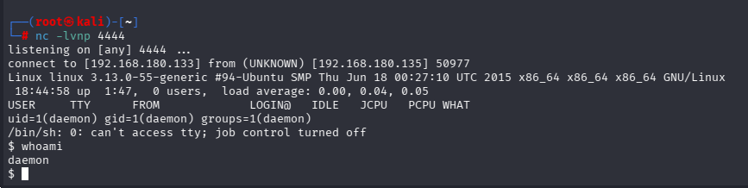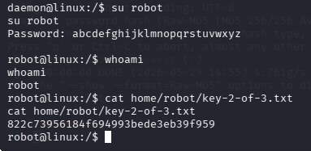
Figure 15: Reverse shell connection established as daemon user, password hash cracked, escalated to robot user, and Key 2 retrieved.
The file /home/robot/password.raw-md5 was found world-readable and contained the MD5 hash c3fcd3d76192e4007dfb496cca67e13b. John the Ripper cracked it to reveal the password abcdefghijklmnopqrstuvwxyz. The su robot command was used to switch users.
Result: Server shell as daemon, escalated to robot user. Key 2 retrieved: 822c73956184f694993bede3eb39f959
Exploit 4 — Privilege Escalation via SUID Nmap
Tool: Linux find, nmap interactive mode
The command find / -perm -u=s -type f 2>/dev/null identified /usr/local/bin/nmap as a SUID binary owned by root. Nmap 3.81 was launched with --interactive, then !sh was issued to spawn a root shell.
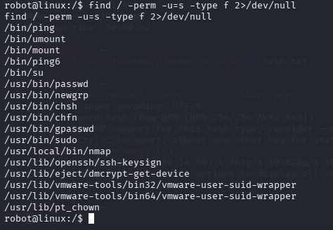
Figure 16: find command output — /usr/local/bin/nmap highlighted as SUID root binary.
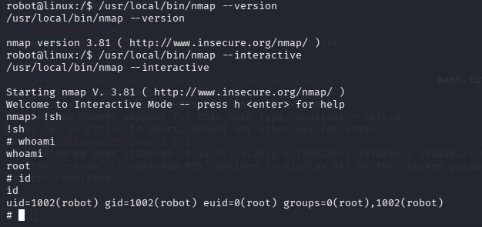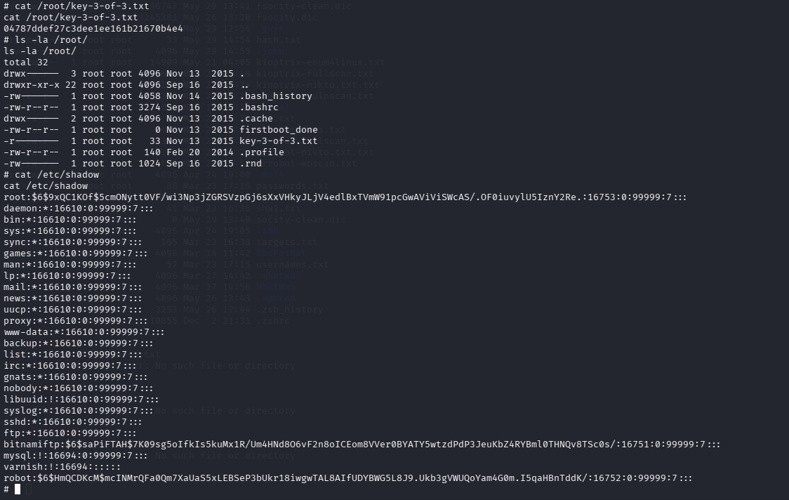
Figure 17: nmap --interactive then !sh — root shell spawned, whoami confirms root, and Key 3 retrieved.
Result: Root shell obtained on Mr-Robot 1. Full system compromise confirmed. Key 3 retrieved: 04787ddef27c3dee1ee161b21670b4e4

Conclusion
This penetration test identified a total of 16 vulnerabilities across two target systems 8 on Kioptrix Level 1 and 8 on Mr-Robot 1 including 5 rated Critical severity. Four vulnerabilities were successfully exploited, achieving full root-level access on both targets.
Kioptrix Level 1 was compromised through a single unauthenticated remote exploit against an outdated Samba service, highlighting the severe risk posed by unpatched legacy software. Mr-Robot 1 required a multi-stage attack chain combining information disclosure, authentication bypass, remote code execution, and privilege escalation demonstrating how individually low-severity misconfigurations can chain together into complete system compromise.
The findings confirm that both systems represent high-risk environments. Immediate remediation priorities include upgrading all outdated software, removing unnecessary SUID permissions, disabling unused services, and enforcing strong authentication policies.

References
Mitre Corporation. (2002). CVE-2002-0082. https://cve.mitre.org/cgi-bin/cvename.cgi?name=CVE-2002-0082
Mitre Corporation. (2003). CVE-2003-0201. https://cve.mitre.org/cgi-bin/cvename.cgi?name=CVE-2003-0201
Mitre Corporation. (2014). CVE-2014-0224. https://cve.mitre.org/cgi-bin/cvename.cgi?name=CVE-2014-0224
Mitre Corporation. (2014). CVE-2014-3566. https://cve.mitre.org/cgi-bin/cvename.cgi?name=CVE-2014-3566
Mitre Corporation. (2015). CVE-2015-4000. https://cve.mitre.org/cgi-bin/cvename.cgi?name=CVE-2015-4000
Mitre Corporation. (2015). CVE-2015-5622. https://cve.mitre.org/cgi-bin/cvename.cgi?name=CVE-2015-5622
National Institute of Standards and Technology. (2023). National Vulnerability Database. https://nvd.nist.gov
Offensive Security. (2023). Exploit Database. https://www.exploit-db.com
Penetration Testing Execution Standard. (2022). PTES technical guidelines. http://www.pentest-standard.org
VulnHub. (2010). Kioptrix Level 1. https://www.vulnhub.com/entry/kioptrix-level-1-1,22/
VulnHub. (2015). Mr-Robot: 1. https://www.vulnhub.com/entry/mr-robot-1,151/

