**Task 1**

**(a)**

There are three major options for providing the clinic network **.** But there are some difference between these three option.

***Ethernet***

1. 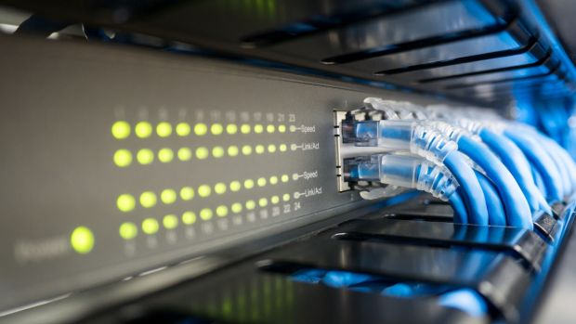maximum range of 328 feet.
2. 10 megabits per second (Mbps), which is 10 million bits of information each second.
3. Fast Ethernet can carry up to 100Mbps.
4. gigabit Ethernet can carry up to 1000Mbps.
5. Data is sent in packets.
6. One of the reasons Ethernet is so popular is because it supports the Transmission Control Protocol and Internet Protocol used by the Internet, a set of protocols familiarly known as TCP/IP.
7. Do not make traffic, Break pollution.
8. 1 network can divided into different network.

***Token ring***

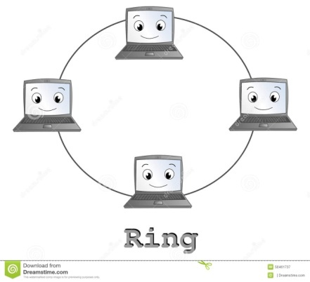

1. single token is continuously passed from computer to computer.
2. Make traffic in Network.
3. The token is then passed to the next computer in the ring until it reaches the recipient Computer.
4. This may sound slow, but was actually lightning fast for its time - up to 16Mpbs.

***Wi-fi***

1. 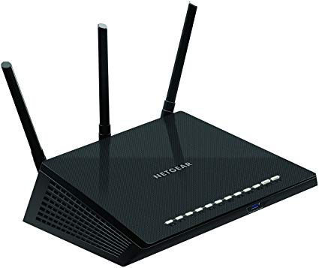All network devices are this time have wifi access.
2. Easy to access.
3. Sometimes make unnecessary traffics.
4. Range is generally up to 230 feet indoors and 800 feet outdoors.
5. Data transmit up to 300Mbps

**Recommendation:**

I want to recommended 1000Mbps gigabit Ethernet. Because it’s Do not make traffic in network, and data transfer is high. Network divided into different network so the network is safe.

(B)

The Open Systems Interconnection display (OSI demonstrate) is an applied model that describes and institutionalizes the correspondence elements of a media transmission or processing framework without respect to its basic inside structure and innovation.

|  |
| --- |
| Application Layer |
| Application Layer |
| Session Layer |
| Transport Layer |
| Network |
| Data Link |
| Physical |

Layer 7

Layer 6

Layer 5

Layer 4

Layer 3

Layer 2

Layer 1

***Figure: OSI Seven Layer Model***

Physical

Physical

Data Link

Network

Transport Layer

Session Layer

Presentation Layer

Application Layer

Data Link

Network

Transport Layer

Session Layer

Presentation Layer

Application Layer

***Figure: How OSI Work***

|  |  |
| --- | --- |
| Layers | Purpose |
| 7. Application | An application layer is an abstraction layer that specifies the communications protocols. |
| 6. presentation | The presentation layer is layer-6 of the 7- layer open system interconnection OSI model. |
| 5. session | Its main aim is to establish and maintain the interaction between communicating systems. |
| 4. transport | The transport layer is responsible for delivering data on hosting computers. |
| 3. network | The network layer provides the means of transferring variable- length network packets from a source. |
| 2. Data link | It’s makes sure the appropriate physical protocol is assigned to the data. |
| 1.physical | The physical layer translates logical communications requests from the data link layer. |

**(c)**

|  |  |  |
| --- | --- | --- |
| Protocols | Layer | explain |
| HTTPS | Application layer | Hyper Text Transfer Protocol Secure (HTTPS) is the secure version of HTTP, the protocol over which data is sent between your browser and the website that you are connected to. |
| FTP | Application layer | It will be used in file transferring working of protocols. |
| TCP | Transport layer | This protocol defines how to establish and maintain a network conversation via which application programs can exchange data. |
| IP- IPv4, IPv6 | Network Layer | Its routing function enables internetworking, and essentially establishes the Internet. |

**Task 2**

(a)

Difference between IPv4 and IPv6

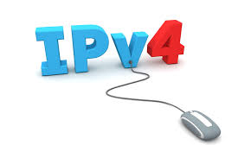**IPv4:**

1. is the fourth revision of the Internet Protocol (IP) used to to identify devices on a network through an addressing system.
2. The Internet Protocol is designed for use in interconnected systems of packet-switched computer communication networks.
3. 32 bit decimal address.
4. Range=2^32=4294967296
5. Example:192.168.10.0

**IPv6:**

1. 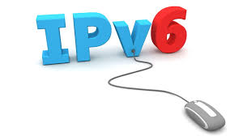A new Internet addressing system Internet Protocol version 6 (IPv6) is being deployed to fulfill the need for more Internet addresses.
2. It is also called IPng (Internet Protocol next generation) and it is the newest version of the Internet Protocol (IP).
3. 128 bit Hexadecimal address.
4. Range=2^128=3.402823669*10 to the power 38.
5. Example: FE80:0000:0000:0000:0202:B3FF:FE1E:8329.

In clear thinking network IP and Mac address will be used. IP and MAC address will be used in real computer networking.

(b)

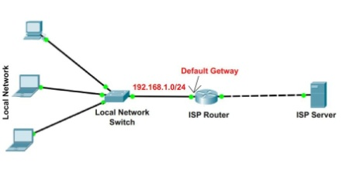

**Default gateway:** A default gateway serves as an access point or IP router that a networked computer uses to send information to a computer in another network or the internet.

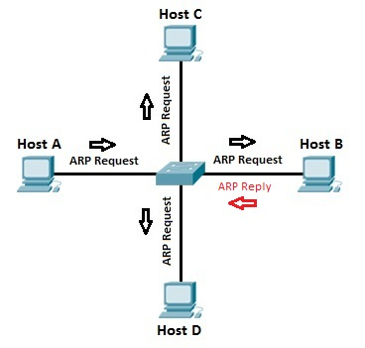

**ARP (Address Resolution Protocol):** is a network protocol used to find out the hardware (MAC) address of a device from an IP address.

**Gateway and ARP needed**

A default gateway serves as an access point or IP router that a networked computer uses to send information to a computer in another network or the internet.

And ARP is a function of the IP layer of the TCP/IP protocol stack. It is necessary to translate a host?s software address (IP address) to a hardware address (MAC address).

(c)

**Subnet mask:**

A subnet mask is a number that defines a range of IP addresses that can be used in a network. Subnet masks are used to designate subnetworks, or subnets, which are typically local networks LANs that are connected to the Internet.

it is required in this project for divided this one network to make many subnetwork, for make network safe.