Advanced Layer 3 VPN over Segment Routing (SR-MPLS L3VPN)
Author: Enam Ahmed
Date: June 6, 2026
Subject: Technical Analysis and Implementation of L3VPN Services over a Segment Routing Infrastructure

1. Introduction
Layer 3 VPN (L3VPN) is a fundamental technology used in service provider networks. Previously, these services used a complex combination of protocols: Interior Gateway Protocol (IGP) for network reachability, Label Distribution Protocol (LDP) for transport labels, and Multiprotocol BGP (MP-BGP) for VPN labels. Segment Routing (SR) simplifies this by integrating the transport layer into the IGP. This greatly reduces the complexity of the control plane and improves both scalability and resilience. This document explores the design, deployment, and advanced traffic management features of SR-L3VPN.

Network Topology
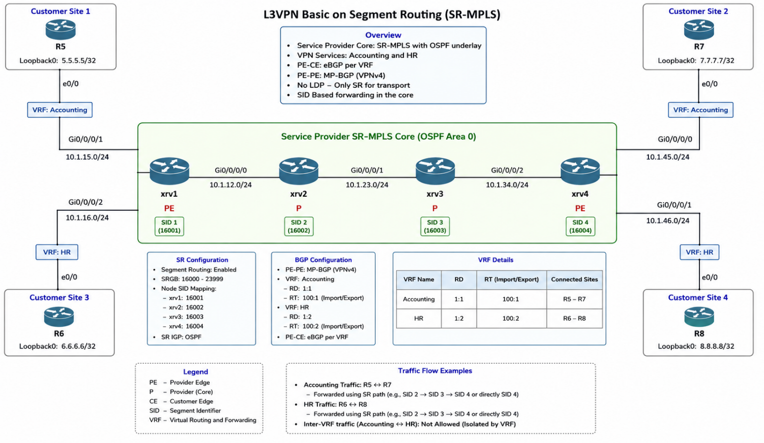

Device Role and SRGB Mapping
Device | Role | Loopback0 | Prefix-SID Index | SRGB Range | Egress Label
XRV1 | PE (Head-end) | 1.1.1.1/32 | 1 | 16000 - 23999 | 16001
XRV2 | P (Transit) | 2.2.2.2/32 | 2 | 16000 - 23999 | 16002
XRV3 | P (Transit) | 3.3.3.3/32 | 3 | 16000 - 23999 | 16003
XRV4 | PE (Tail-end) | 4.4.4.4/32 | 4 | 16000 - 23999 | 16004

3. Technical Deep Dive: The BGP Prefix-SID Attribute
The BGP Prefix-SID Attribute (RFC 8669) is a major improvement in SR-L3VPN. This optional feature allows BGP to signal segment identifiers for the prefixes it advertises.

3.1 BGP-LU vs. BGP Prefix-SID
BGP-LU (Labeled Unicast) traditionally distributed transport labels in Inter-AS Option C or large network designs. However, it generated a new label for each prefix at every hop, leading to increased network overhead. In contrast, BGP Prefix-SID uses a Global Index instead of a local label. This means every router in the domain uses the same index to calculate the label based on its local SRGB. As a result, a single, consistent label is maintained for a prefix across the entire domain, regardless of the number of hops.

4. Implementation Strategy
The deployment follows a layered approach:
- Underlay (IGP+SR),
- Overlay (MP-BGP),
- Service (VRF).

4.1 Underlay Activation
Enable SR within the IGP (OSPF ).

4.2 Overlay and Service Configuration
MP-BGP VPNv4 sessions are established between PEs. VRFs are configured with Route Targets (RT) to control prefix import/export.

5. Verification and Label Operations
In an SR-L3VPN, a packet carries a 2-label stack.
- Top Label (Transport): The Prefix-SID of the egress PE (XRV4). In this lab, if XRV1 sends to XRV4, the top label is 16004.
- Bottom Label (VPN): The label allocated by MP-BGP for the specific VRF prefix (e.g., 24002).

5.1 The “Penultimate Hop Popping” (PHP) Behavior
In SR-MPLS, the behavior of the top label depends on the configuration. If PHP is enabled, the penultimate router (XRV2 or XRV3) will pop the transport label, and the egress PE (XRV4) receives only the VPN label. However, in modern SR designs, Uniform Propagation or Explicit Null is often preferred to maintain the full label stack for OAM visibility.
6. Configuration Details

7. Conclusion
SR-MPLS L3VPN represents the pinnacle of service provider network evolution. By leveraging the BGP Prefix-SID attribute and consolidating transport into the IGP, operators can achieve massive scale, 100% coverage for fast-reroute (via TI-LFA), and a simplified operational model that is ready for the demands of 5G and cloud-scale networking.

