|  |  |
| --- | --- |
| **Sylhet Engineering College** | |
| Logo | |
| Computer Science and Engineering  Course Name: Database Management System Sessional  Course Code: CSE 502  { Project Report }  **Project Title: Retail Point of Sale System** | |
| **Submitted By:**  Name: Enamul Hasan  Reg: 2019331503  Name: Rubel Ahmod  Reg: 2019331545  Department: Computer Science & Engineering(CSE) | **Submitted To:**  Nayan Kumar Nath  Lecturer (CSE Department)  Sylhet Engineering College |

**POS System**

A POS system, short for Point of Sale system, is a combination of hardware and software used by businesses to facilitate and manage transactions at the point of sale, where customers make purchases and payments. It is commonly used in retail stores, restaurants, cafes, and various other businesses where goods or services are sold.

The primary components of a POS system include:

1. Hardware: This typically consists of a computer or tablet, a cash register or barcode scanner, receipt printer, and sometimes additional peripherals like card readers or scales.
2. Software: The software component of a POS system enables businesses to process sales, manage inventory, generate receipts, and perform various other functions related to customer transactions, employee management, reporting, and analytics.
3. Payment Processing: Modern POS systems allow customers to pay using various methods such as credit cards, debit cards, mobile payments, and sometimes even cryptocurrencies.
4. Inventory Management: Businesses keep track of their stock levels, automatically update inventory when sales are made, and trigger reorders when certain items reach low stock levels.
5. Sales Reporting and Analytics: POS systems often provide detailed reports and analytics, giving businesses insights into sales trends, popular products, and overall performance.
6. Customer Relationship Management (CRM): Some POS systems include CRM capabilities, allowing businesses to manage customer information, track purchase history, and implement loyalty programs.
7. Integration: POS systems can integrate with other business management software, such as accounting software, e-commerce platforms, and more, to streamline overall business operations.

The use of POS systems has become increasingly prevalent as they offer efficiency, accuracy, and better control over business operations. By automating various aspects of the sales process, businesses can focus more on providing excellent customer service and improving overall productivity.

**Retail POS System**

Retail POS (Point of Sale) System is a specific type of POS system designed to cater to the needs of retail businesses, such as brick-and-mortar stores, department stores, specialty shops, and chain stores. The retail POS system combines hardware and software to streamline the entire sales process and manage various aspects of retail operations efficiently.

Key features of a Retail POS system include:

1. Inventory Management: Retail POS systems allow businesses to track and manage their inventory in real-time. This feature helps retailers keep track of stock levels, monitor sales performance for each item, and automate reordering when inventory reaches predefined levels.
2. Sales Processing: Retail POS systems facilitate quick and accurate sales processing. They include barcode scanners or the ability to manually enter product details for faster checkout. The system calculates the total amount due, applies discounts or promotions, and handles multiple payment methods, including credit cards, debit cards, cash, and mobile payments.
3. Customer Management: Retail POS systems often come with built-in customer relationship management (CRM) features. This enables businesses to store customer information, track purchase history, and run loyalty programs or targeted marketing campaigns to enhance customer retention.
4. Reporting and Analytics: Retail POS systems generate detailed reports and analytics, offering insights into sales trends, peak selling periods, bestselling products, and other performance metrics. Retailers can use this data to make informed business decisions and strategize for the future.
5. Multi-Store Support: Many retail businesses operate multiple locations, and a robust POS system can support multi-store functionality, allowing centralized control and reporting across all locations.
6. Employee Management: Retail POS systems may include features for managing employee schedules, tracking sales performance, and handling commissions or incentives.
7. Integration: Integration capabilities are crucial for retail POS systems. They can be integrated with other business systems like accounting software, e-commerce platforms, and enterprise resource planning (ERP) systems, streamlining data flow and reducing manual data entry.
8. Security: Retail POS systems must adhere to strict security standards to protect sensitive customer data and financial transactions.

Overall, a retail POS system plays a vital role in improving operational efficiency, customer experience, and business profitability for retail establishments. It streamlines the sales process, provides valuable insights into business performance, and allows retailers to deliver better customer service.

**How Retail POS Works**

Retail POS systems work through a combination of hardware and software to facilitate the entire sales process and manage various aspects of retail operations. Here's a step-by-step overview of how a typical retail POS system works:

1. Product Setup and Inventory Management:

- The process begins with the setup of products in the POS system's database. Each product is assigned a unique identifier, such as a barcode or SKU (Stock Keeping Unit).

- The system also includes details like product name, price, description, and any applicable discounts or promotions.

- Inventory levels are set, and the system keeps track of stock in real-time.

2. Sales Processing:

- When a customer selects items for purchase, the cashier or salesperson scans the product's barcode or manually enters the product information into the POS system.

- The system retrieves the product details, including price and any applicable discounts, from the database.

- The POS system calculates the total amount due, including taxes, based on the items scanned and any promotions applied.

- If the customer is eligible for loyalty rewards or discounts, the system can apply them to the total.

3. Payment Processing:

- The customer selects a payment method, such as cash, credit card, debit card, mobile payment, or gift card.

- The POS system processes the payment and updates the transaction status accordingly.

- In case of electronic payments (e.g., credit card), the system communicates with the payment processor to authorize and complete the transaction securely.

4. Receipt Generation:

- The POS system generates a detailed receipt for the customer, listing the purchased items, prices, taxes, and the total amount paid.

- The receipt may also include store information, return policies, and other relevant details.

5. Inventory Update:

- After the transaction is completed, the POS system automatically updates the inventory levels, deducting the sold items from the stock.

6. Reporting and Analytics:

- The POS system stores transaction data, which can be accessed later for generating reports and analytics.

- Retailers can analyze sales trends, bestselling products, peak selling periods, and other performance metrics to make informed business decisions.

7. Customer Management and Loyalty Programs:

- Retail POS systems with CRM capabilities allow businesses to store customer information, such as contact details, purchase history, and preferences.

- Loyalty programs can be managed through the POS system, allowing retailers to reward loyal customers and offer personalized discounts or promotions.

8. Integration:

- Retail POS systems can be integrated with other business systems, such as accounting software, inventory management systems, e-commerce platforms, and more.

- Integration ensures seamless data flow between different parts of the business and reduces manual data entry.

Overall, a retail POS system streamlines the sales process, enhances customer service, optimizes inventory management, and provides valuable insights to help retailers run their businesses more efficiently.

**Objectives**

The objective of a retail POS (Point of Sale) system is to streamline and optimize various aspects of retail operations, providing numerous benefits to retailers and their customers. The main objectives of a retail POS system include:

1. Efficient Sales Processing: The primary goal of a retail POS system is to facilitate quick and accurate sales processing. By automating the checkout process, it reduces waiting times, enhances customer satisfaction, and increases the efficiency of the sales transaction.

2. Accurate Inventory Management: Retail POS systems aim to keep accurate track of inventory levels in real-time. By monitoring stock levels and automatically updating them with each sale, retailers can optimize inventory control, reduce stockouts, and minimize overstock situations.

3. Enhanced Customer Service: With features like quick checkout, easy access to product information, and personalized discounts through loyalty programs, retail POS systems contribute to improved customer service. Satisfied customers are more likely to become repeat customers and recommend the store to others.

4. Data Insights and Reporting: Retail POS systems provide valuable insights through reporting and analytics. Retailers can analyze sales trends, identify top-selling products, track customer buying behaviors, and make data-driven decisions to improve their overall business strategy.

5. Streamlined Employee Management: Retail POS systems often include features for managing employee schedules, tracking sales performance, and handling commissions or incentives. These tools help retailers optimize staff productivity and sales performance.

6. Integration with Business Systems: Another objective of a retail POS system is to seamlessly integrate with other business systems, such as accounting software, inventory management systems, and e-commerce platforms. Integration ensures data consistency across different parts of the business and reduces manual data entry.

7. Loss Prevention and Security: Retail POS systems are designed to enhance security and prevent fraud or theft. They can track transaction histories and monitor discrepancies, which helps identify potential issues and minimize losses.

8. Flexibility and Scalability: Retail businesses often grow and expand over time. A retail POS system aims to be flexible and scalable, accommodating the changing needs of the business, supporting multi-store operations, and adapting to new technologies.

9. Compliance and Reporting: Retail POS systems can assist with compliance to tax regulations and reporting requirements by generating accurate sales reports and transaction records.

Overall, the objective of a retail POS system is to create a seamless and efficient shopping experience for customers, improve inventory management, boost sales performance, and provide retailers with valuable data and insights to run their businesses successfully.

**Tools**

* Python.
* Django framework.
* HTML
* CSS
* BootStrap
* Javascript / JQuery
* SQLite
* Git and github
* Visual Studio code

**Methodology**

**Programming Language:** To build this blogging site we use the django framework. Django is a Free and open-source framework for building web apps with Python language. Django features:

* The admin site
* Object-relational mapper (ORM)
* Authentication
* Caching

That's why for back-end operations we use python code. For front-end we used HTML, CSS, BootStrap.

**Database:** SQLite Supports relational database . It is an open source database that stores data to a text file on a device. Android comes in with built in SQLite database implementation. SQLite is a local database. It stores data locally so In order to access this database, you don't need to establish any kind of connections for it like JDBC,ODBC etc.

**Result**

**Login layout:**

**Home Page:**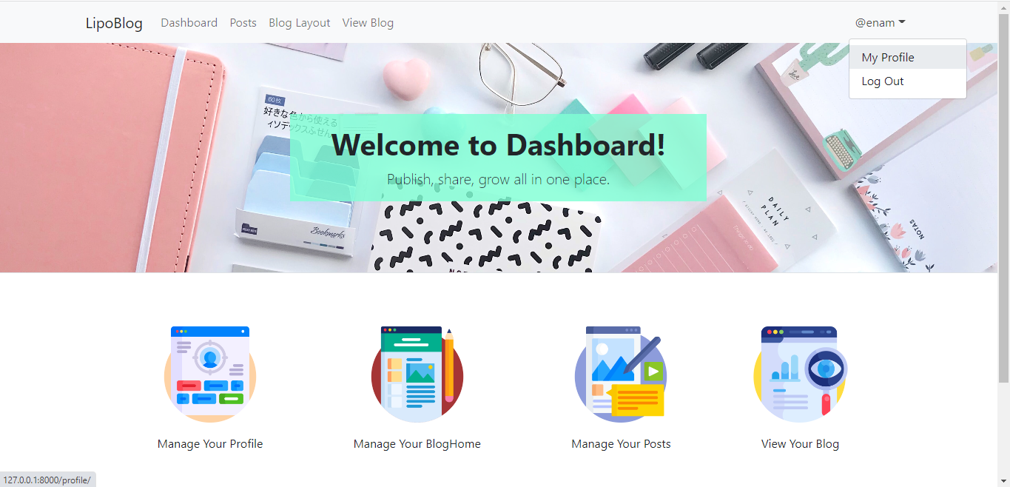

**Discussion**

The Point of Sale (POS) system software project has been successfully developed and implemented, catering to the specific needs of our retail business. In this section, we will delve into the key findings and observations arising from the project's execution, highlighting the strengths, limitations, and potential areas for improvement.

**Efficiency and Streamlined Operations:**

The POS system software has significantly improved the efficiency of our sales process. The intuitive user interface and seamless integration with various hardware components have expedited the checkout process, reducing customer waiting times. Additionally, the real-time inventory management feature has proven invaluable in maintaining optimal stock levels, minimizing stockouts, and avoiding excess inventory costs.

**Enhanced Customer Experience:**

With the implementation of the POS system, our customers have enjoyed a more personalized and satisfactory shopping experience. The system's ability to store customer data, track purchase history, and offer tailored discounts through loyalty programs has resulted in increased customer retention and improved brand loyalty.

**Data-Driven Decision Making:**

One of the standout features of the POS system software is its robust reporting and analytics capabilities. The detailed sales reports, product performance insights, and customer behavior data have empowered our management team to make informed decisions. The data-driven approach has helped identify top-selling products, peak selling periods, and formulate targeted marketing strategies, contributing to increased revenue and profitability.

**Employee Management and Performance Tracking:**

The employee management functionalities of the POS system have allowed us to optimize staffing levels and track individual sales performance. By assessing staff productivity and offering incentives based on performance metrics, we have fostered a more motivated and engaged workforce, positively impacting overall sales results.

**Integration with Existing Systems:**

The seamless integration of the POS system with our existing business systems, including inventory management and accounting software, has eliminated data silos and manual data entry errors. This integration has streamlined our operational processes, reducing administrative burdens and improving data accuracy.

**Limitations and Challenges:**

Although the POS system software has been largely successful, a few limitations and challenges have surfaced during the implementation phase. The system experienced occasional connectivity issues during peak hours, leading to brief service disruptions. Additionally, certain customizations required for specific business requirements proved to be time-consuming, affecting the project timeline.

**Potential Areas for Improvement:**

To enhance the effectiveness of the POS system software, several areas warrant attention. Firstly, additional efforts to improve system reliability and stability during high-traffic periods are essential to prevent service interruptions. Secondly, exploring opportunities for mobile POS solutions could enable a more flexible and dynamic checkout process, especially during busy seasons or special events. Lastly, continuous updates and feature enhancements to adapt to evolving customer preferences and industry trends will be critical in ensuring the system's long-term success.

**Conclusion:**

The implementation of the Point of Sale system software has undoubtedly been a transformative step for our retail business. With improved operational efficiency, enhanced customer experience, and data-driven decision-making capabilities, the system has positioned us competitively in the market. Addressing the identified limitations and proactively seeking opportunities for future improvement will further consolidate the success of this essential retail management tool.