

**Assignment: 1**

**Course:** [Artificial Intelligence and Expert Systems](https://classroom.google.com/u/2/c/MjQ5NTA4OTE0MTgy) Lab

**Course Code:** CSE 404

**Submitted to:**

Dr. Nasima Begum

Assistant Professor

University of Asia pacific

Dept. of CSE

**Submitted By:**

Rashik Rahman

ID: 17201012

Section: A2

Year: 4th, Semester: 1st

Problem Statement: Develop a program using prolog that will show relationship of family tree i.e., sibling, father, grandfather, first cousin, second cousin, third cousin, first cousin once removed, first cousin twice removed.

Tools used: Prolog, VScode.

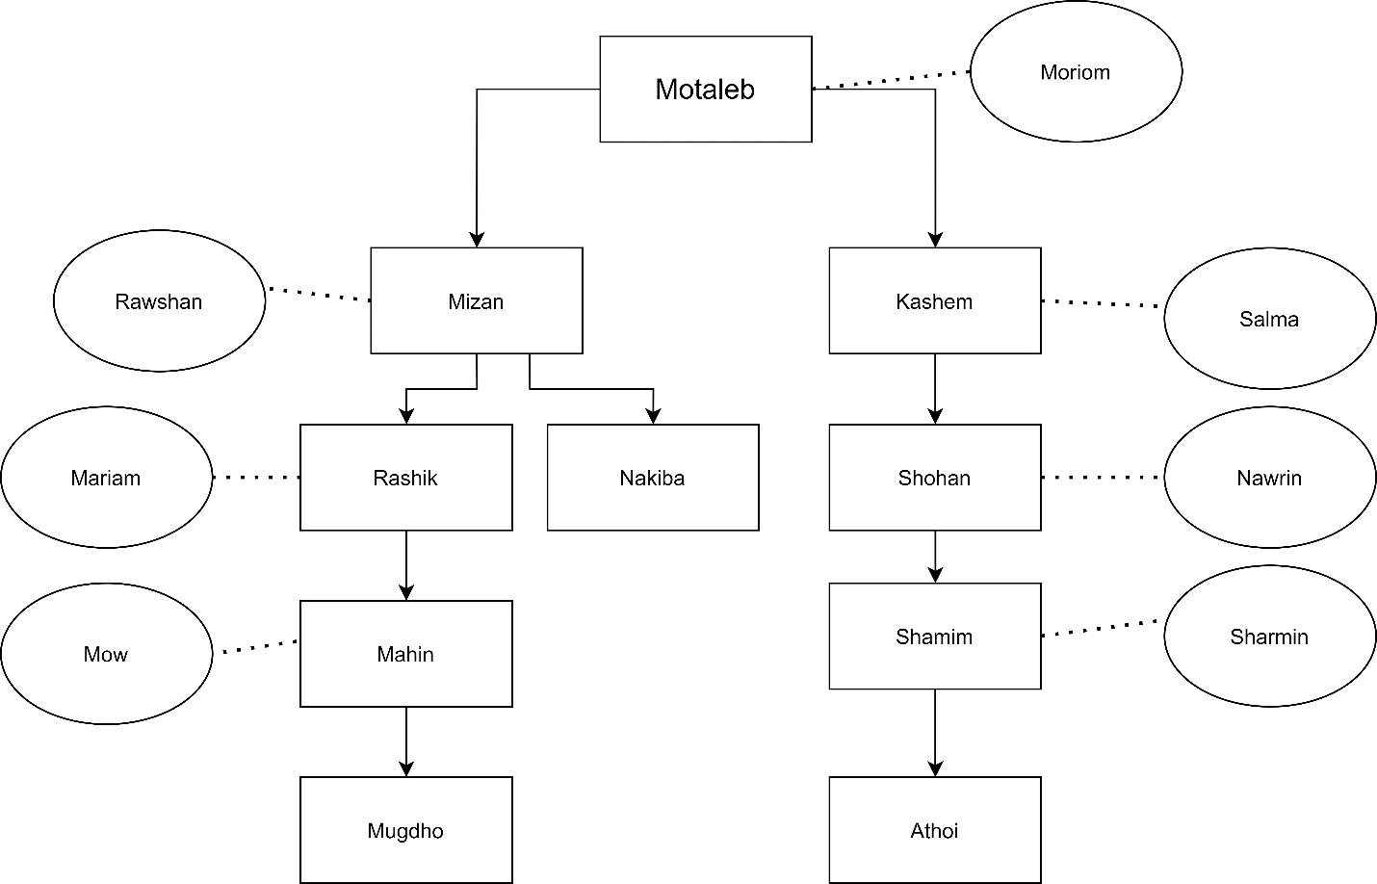

Figure: Family Tree

Result:

