

**Assignment: 1**

**Course:** [Artificial Intelligence and Expert Systems](https://classroom.google.com/u/2/c/MjQ5NTA4OTE0MTgy" \t "_blank) Lab

**Course Code:** CSE 404

**Submitted to:**

Dr. Nasima Begum

Assistant Professor

University of Asia pacific

Dept. of CSE

**Submitted By:**

Rashik Rahman

ID: 17201012

Section: A2

Year: 4th, Semester: 1st

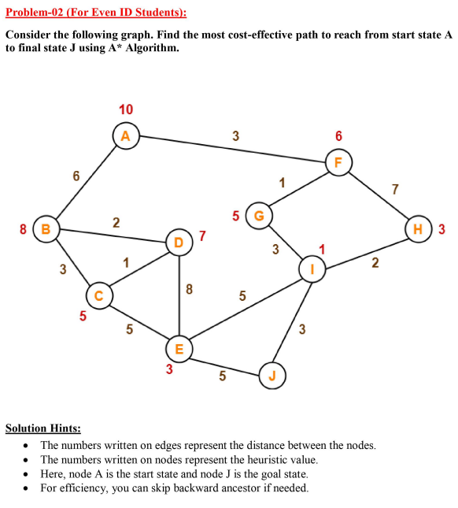

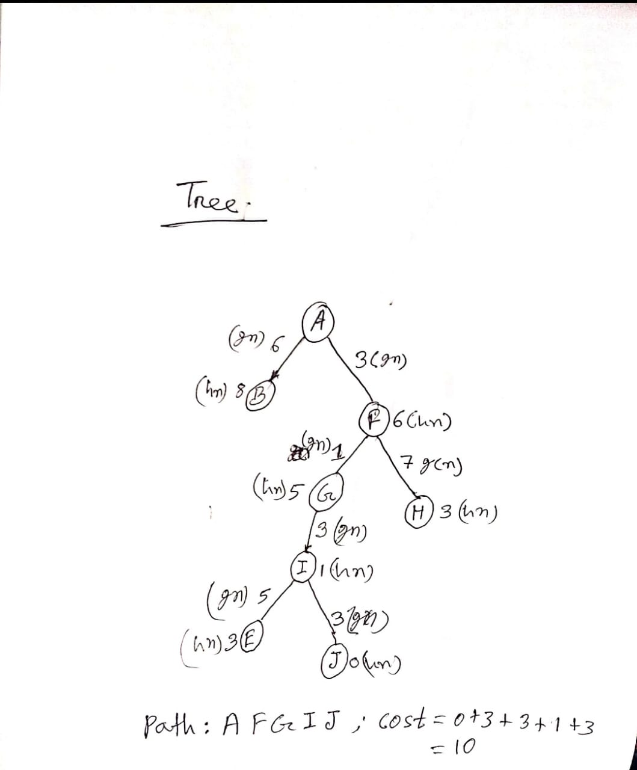

To solve this problem I have used python and environment was JupyterLab. So the submitted file is an .ipynb file which is considered as a notebook file. It can be opened in JupyterLab or Google Colab. It can also be opened in VSCode but in VScode the outputs may not be visible thus JupyterLab or Google Colab is the best option to open the attached file. I am attaching screenshot of my output that is the shortest path and total path cost below.

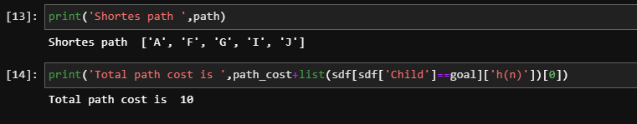

You can see the whole code in the notebook file.