1.

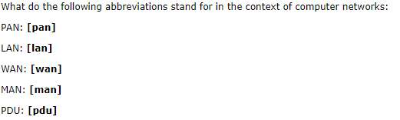

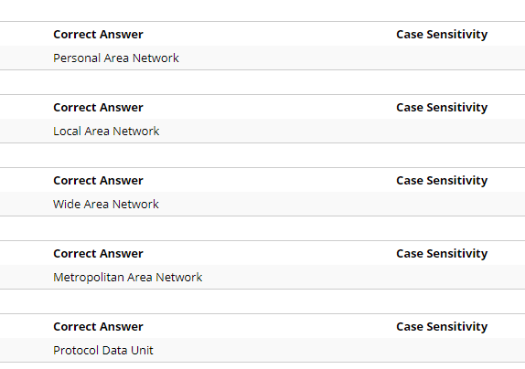

2.

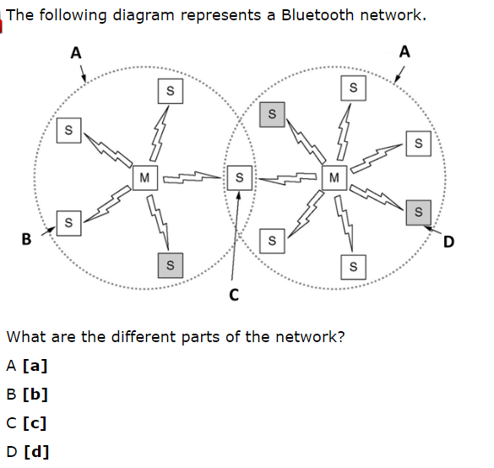

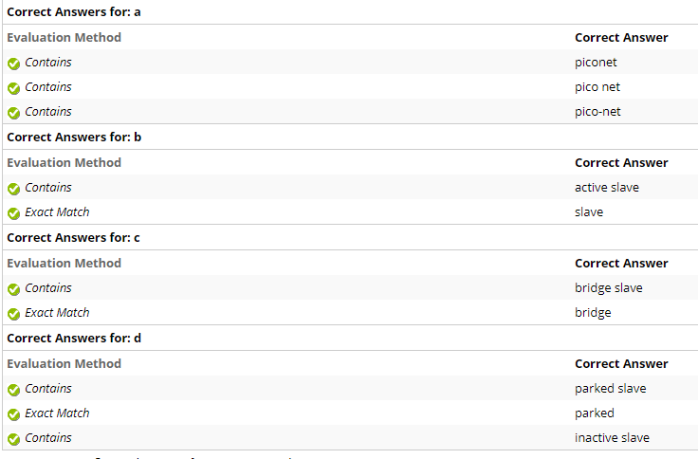

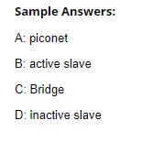

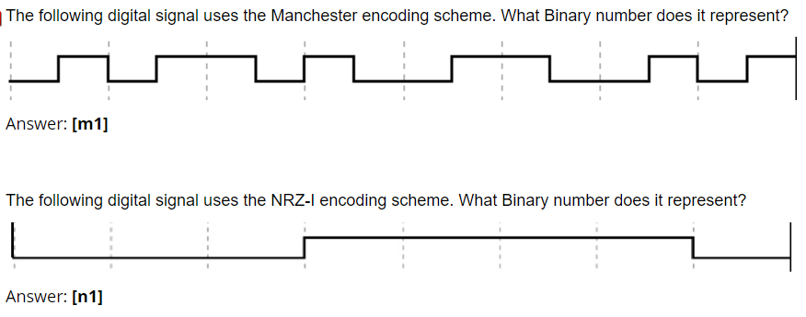

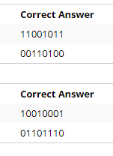

Manchester: 看中间的升降，我使用的规则为：下降为1，上升为0

NRZ-I：我使用的规则为：无变化为0，有变化为1

1. Discuss the principles behind limited contention protocols stating why they are a better choice for Ethernet than purely collision-based or collision-free protocols.

Collision-based protocols have a low delay when loading is light. As load increases, collisions are more common and performance drops. Collision-free methods have a longer delay but under heavy loads, have a better channel efficiency.

Limited-contention protocols combine the best properties of the collision-based and collision-free protocols, arriving at a new protocol that uses contention at low loads to provide low delay, but uses a collision-free technique at high loads to provide good channel efficiency. Ethernets have a highly unpredictable load so a limited-contention protocol can adapt to varying loads.

5

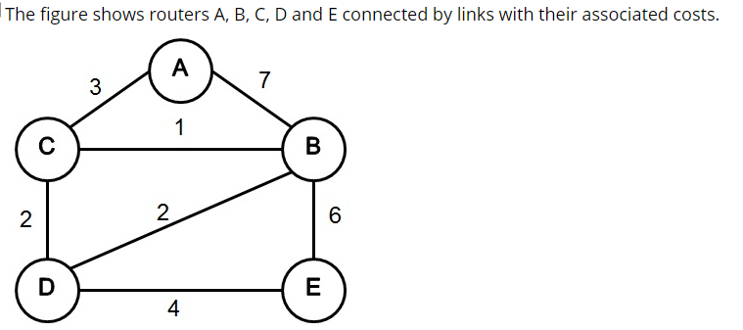

Use the Distance Vector Algorithm to compute the least cost from every node to every other node. Show the distance vector, DX, for each node X. Do this for 2 iterations of the algorithm (i.e. fill 2 tables for each node)( Use "inf" as shown in the example in the table to represent infinity where applicable).

这个做完把表填好，答案太乱

6.

Describe the operation of the Binary Exponential Backoff protocol where two or more hosts try to transmit at the same time.

After the first collision, each host independently waits either 0 or 1 slot times before trying again. If two stations collide and each one picks the same random number (0 or 1), they will collide again.

After the second collision, each one picks either 0, 1, 2 or 3 at random and waits that number of slot times.

If a third collision occurs, then the number of slots to wait is chosen from the interval 0 to 23 – 1.

After 10 collisions, the number is frozen at 210 - 1(1023) slots.

After 16 collisions, report failure to the computer. Further recovery handled by higher layers.

7.

screen image measures 1024 x 1024 pixels with 10 Bytes/pixel. Calculate how long it would take to transmit the image uncompressed over each of the following media, ignoring protocol overheads (where b is for “bits”). Give each answer to the nearest integer value:

56kbps dial-up modem (Answer in seconds). Answer: [m]

2Mbps broadband modem (Answer in seconds). Answer: [b]

10Mbps Ethernet (Answer in seconds). Answer: [e]

Gigabit Ethernet (Answer in milliseconds). Answer: [g]

10 Gigabit Ethernet (Answer in milliseconds). Answer: [t]

m:1498/1463 b:42/40 e: 8/8 g:84/78 t:8/8

8.

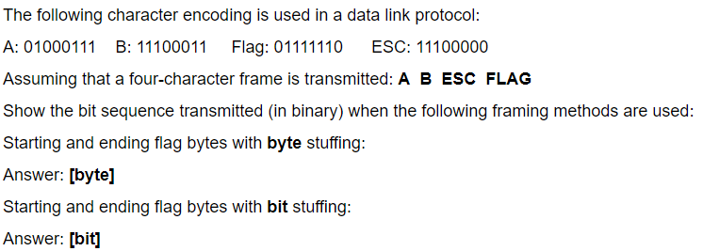

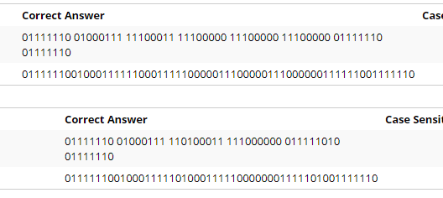

9.

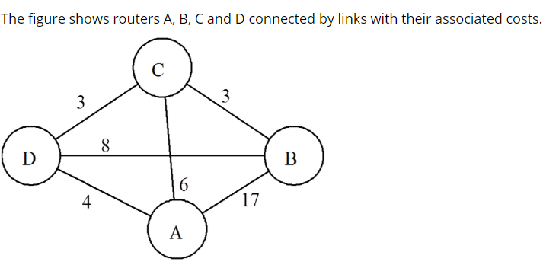

1. Complete the routing tables (in terms of destination, cost, next hop) over 2 rounds for router A, assuming that the routers are using the distance vector technique. (Enter INF to represent infinity where applicable)

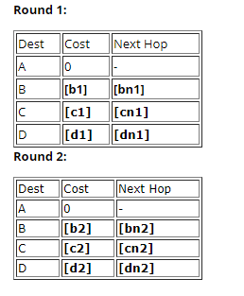

1. How does A modify its routing table if the link between A and C breaks, and the algorithm is re-run from the beginning? Complete the new tables for A after each of 3 rounds.

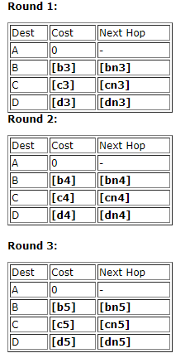

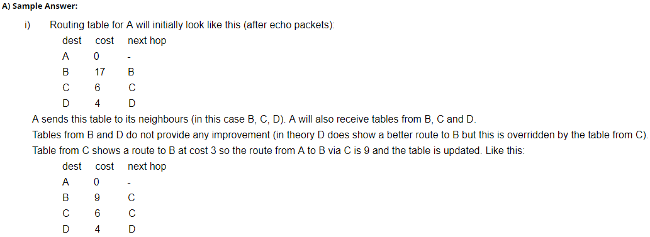

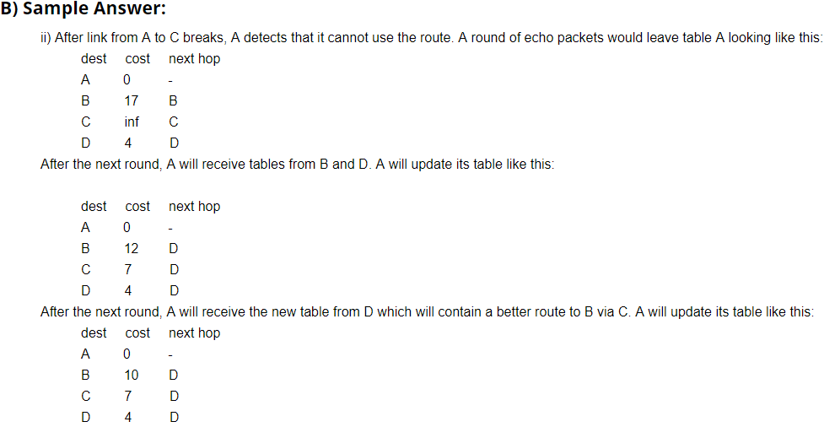

10.

The Transmission Control Protocol (TCP) implements flow control using a sliding window protocol where window sizes may change dynamically. The Diagram shows a sequence of messages sent between the sender and receiver, which implement this protocol.

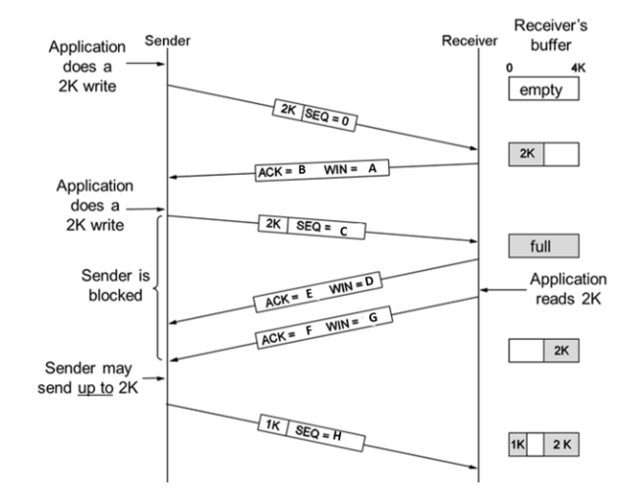

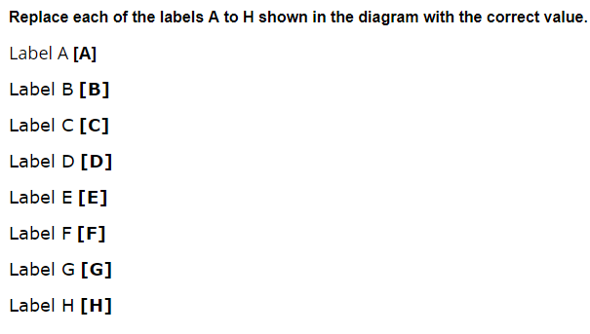

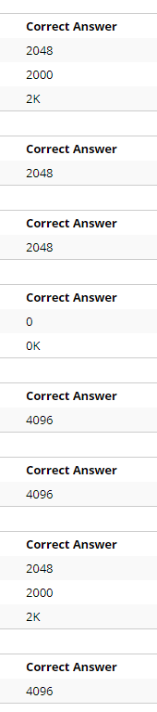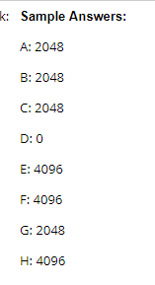

11.

Describe by example the operation of the Adaptive Tree Walk protocol in a network of eight hosts (A to H) where hosts A, D, and F try to transmit at the same time. Use the shown diagram to aid with your description.

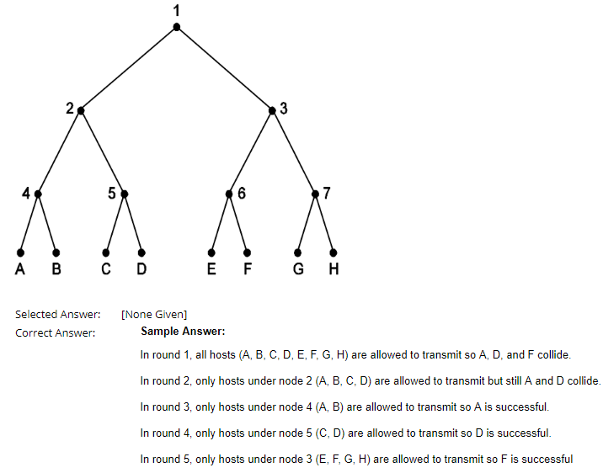

就是遍历一下啦。。。

12.

