Q1

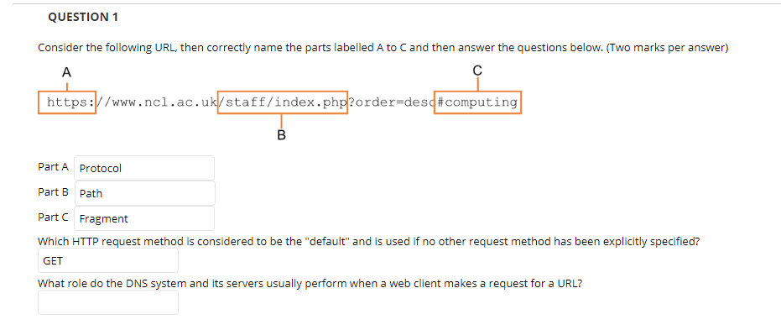

Q2

What does the presence of a DTD declaration at the top of a web document trigger in most common desktop web clients?

Identifies the document version to the user-agent

Q3

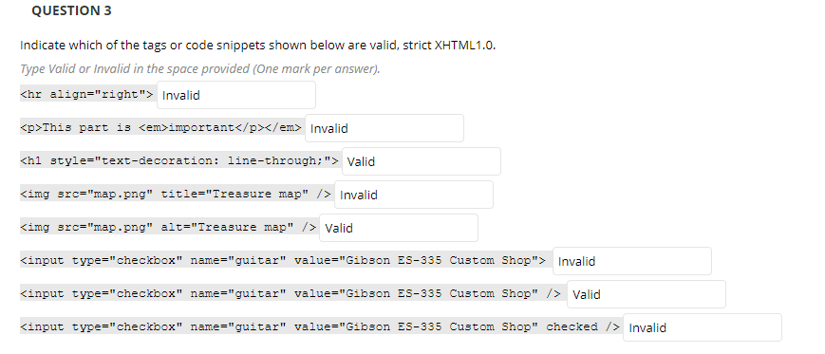

1F 2 F 3 T 4 .F 5. T 6.F 7.T 8 F

Q4

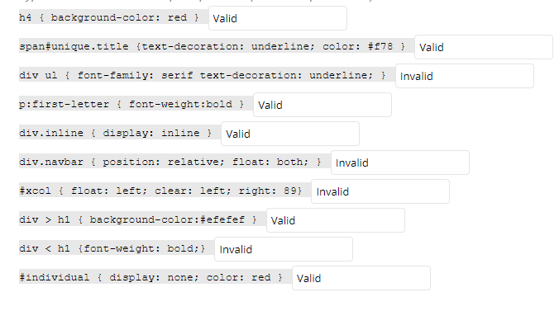

1. T 2.T 3. F 4. T 5.T 6. F 7. F 8.T 9. F 10.T
2. Serif;少分号 6.布局冲突 7.right：89px 9.<这是什么鬼

Q5

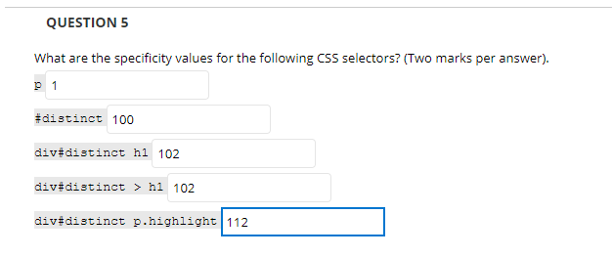

从后看起来 https://www.cnblogs.com/iloveyoucc/archive/2012/09/06/2673003.html