Q1

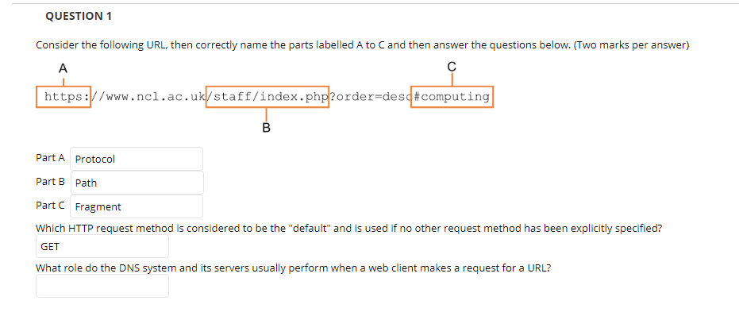

Q2

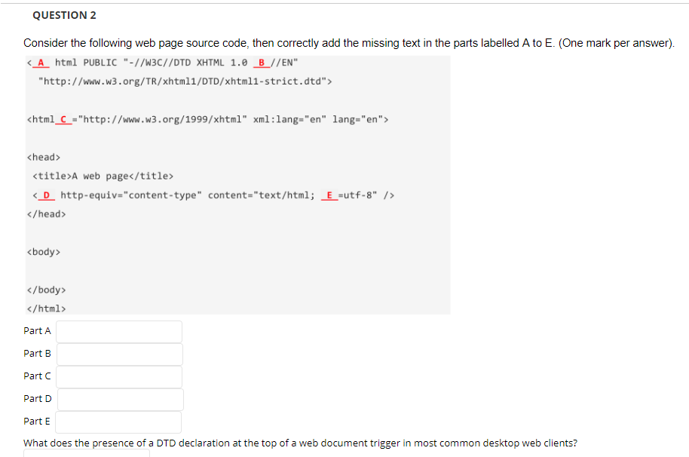

A:!DOCTYPE B:Strict C:xmlns D:meta E:charset

What does the presence of a DTD declaration at the top of a web document trigger in most common desktop web clients?

Identifies the document version to the user-agent

Q3

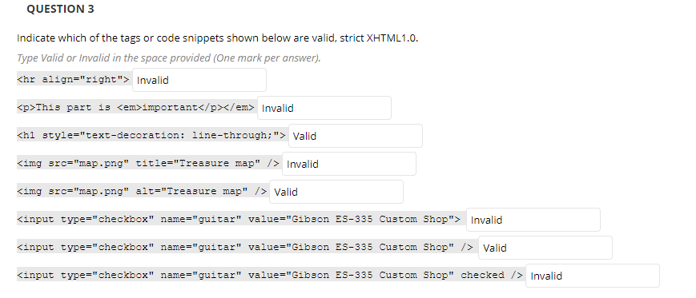

1F 2 F 3 T 4 .F 5. T 6.F 7.T 8 F

Q4

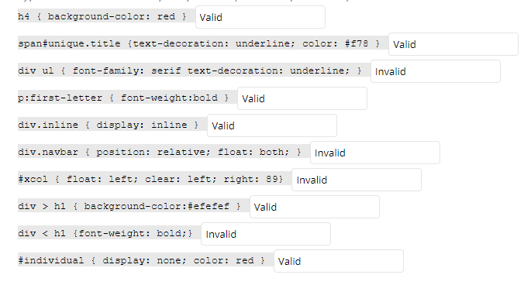

1. T 2.T 3. F 4. T 5.T 6. F 7. F 8.T 9. F 10.T
2. Serif;少分号 6.布局冲突 7.right：89px 9.<这是什么鬼

Q5

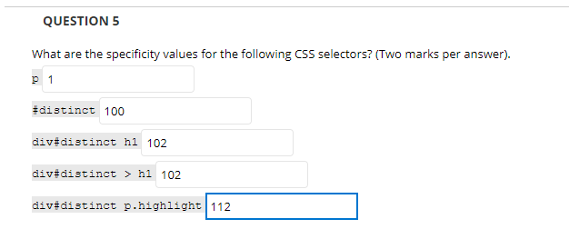

从后面看起来 <https://www.cnblogs.com/iloveyoucc/archive/2012/09/06/2673003.html>

Q6

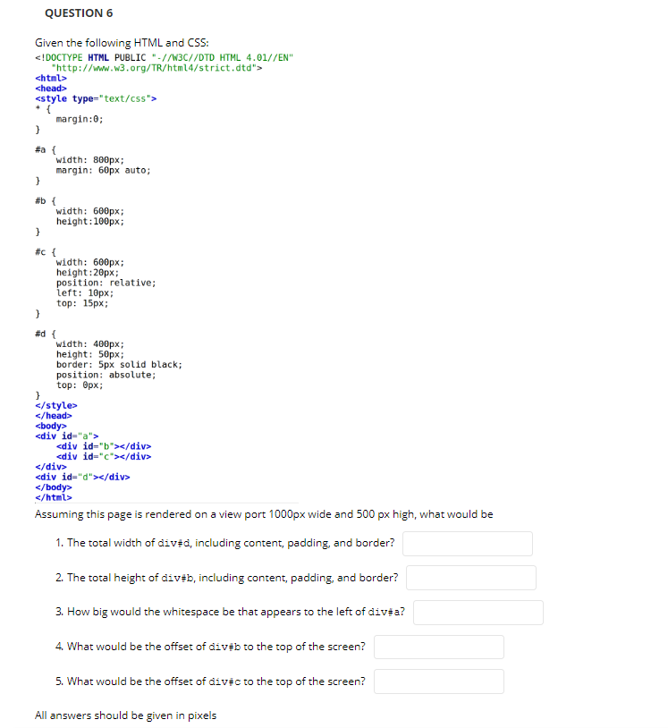

1.410 2 3.100 4.60 5 .175

Q7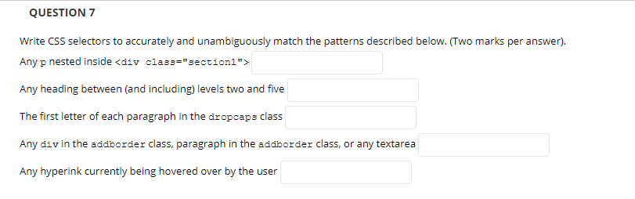

1 div.section1 p

2

3 .dropcaps p:first-letter

4

5 a:hover

Q8

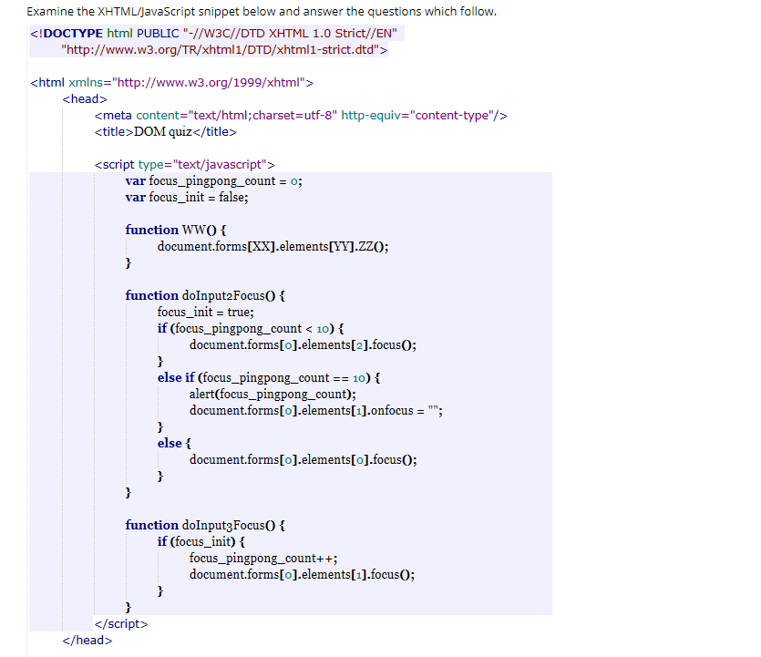

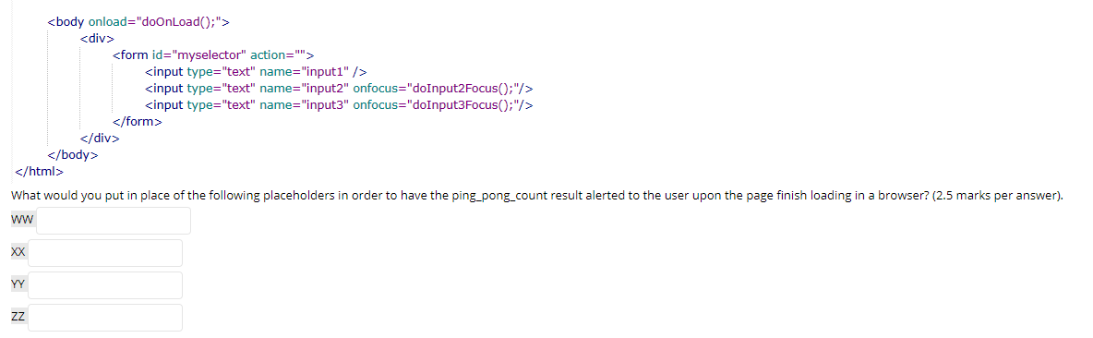

WW:doOnLoad

XX:0

YY:1 ZZ:focus

Q9

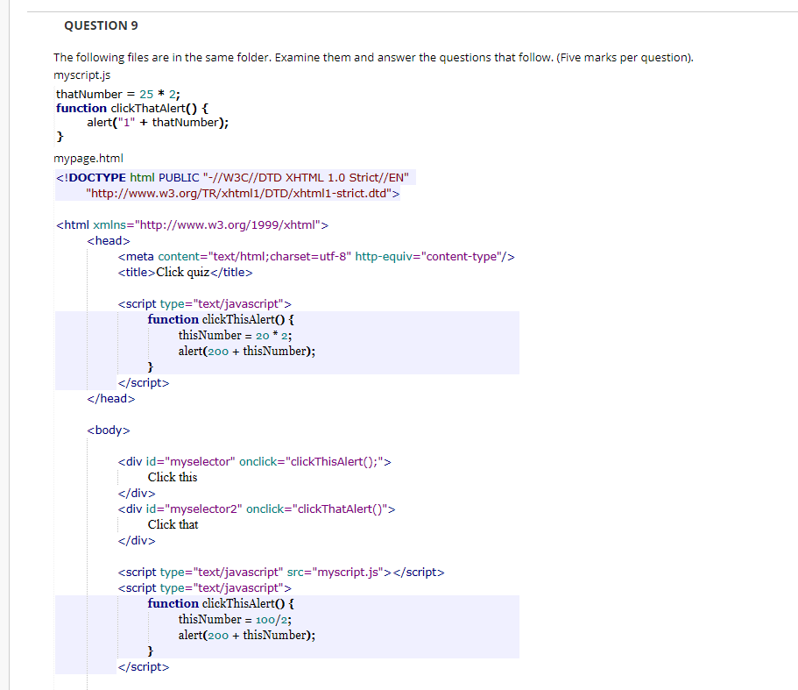

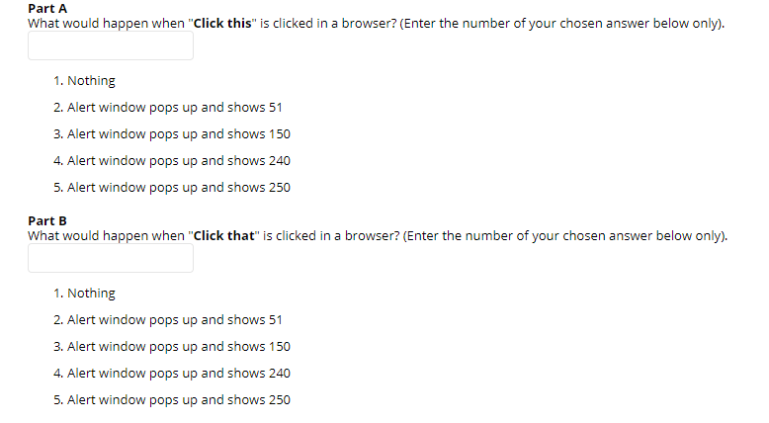

250 51 太贱了，居然不是输入序号

Q10

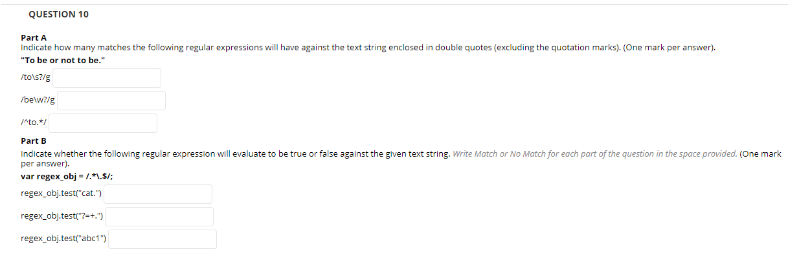

1. to 有一个空格，结果写1
2. 两个be 结果写2
3. 0
4. Match 5 match 6 no match